Bluetooth module F-6188 V4.0 User's Manual
1. Product Overview:
F-6188 Bluetooth module is a self-developed intelligent wireless audio data transmission product, which is a low-cost, cost-effective stand.
The body sound wireless transmission solution, the module uses BEKEN's BK8000L chip to provide high quality sound quality and compatibility for the module, and the overall performance is superior. The F-6188 Bluetooth module is driver-free. Customers only need to connect the module to the application, they can quickly realize the wireless transmission of music, enjoy the fun of wireless music, and support SPP programs.
2. Application areas:
This module is mainly used for short-distance music transmission, and can be easily set up with Bluetooth for digital products such as laptops, mobile phones, PDAs, etc.
Connected to achieve wireless transmission of music.
※ Bluetooth audio
※ Bluetooth stereo headset
※ Speakerphone
※ Bluetooth wireless transmission audio
3. Basic characteristics:
Bluetooth Profiles
※ Bluetooth v2.1+EDR specification support
※ A2DPv1.2
※ AVRCPv1.0
※ HFPv1.5
※GAVDP1.2
※HSP1.2
※IOP
- Performance parameters:
Model | F-6188 V4.0
Bluetooth specification | Bluetooth v2.1+EDR
Supply voltage | DC2.8-4.2V
Support Bluetooth protocol | HFPV1.5, A2DPV1.2,AVRCPV1.4，HSP1.2, GAVDP1.2，IOP
Working current | ≤45mA
Stand-by current | <500uA
Temperature range | -40ºC to +85ºC
Wireless transmission range | 大于 10 M
Transmission power | CLASS2，4dbm
Sensitivity | -80dBm<0.1%BER
Frequency Range | 2.4GHz-2.480GHz
External Interface | I2C, SPI and UART interface
Audio performance | SBC decoding
Audio signal to noise ratio | ≥75dB
Size | 25X13.5X1.8MM

- 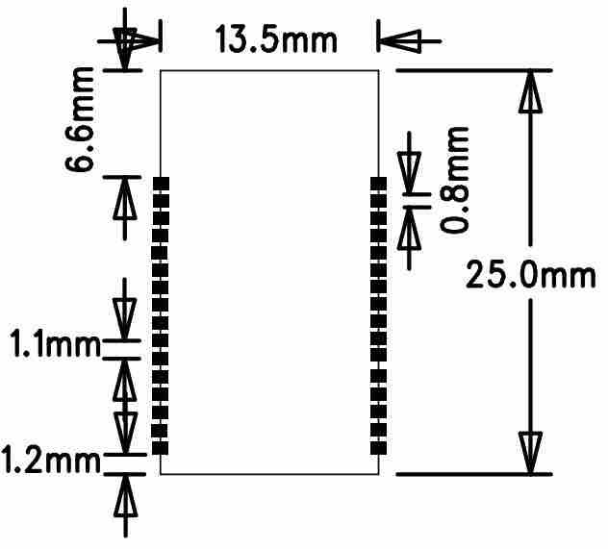
- 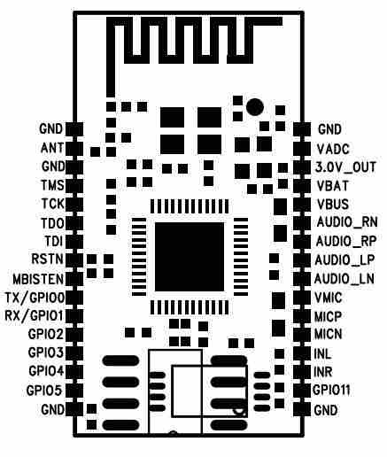
- PIN descriptions:
Pin | Symb | I/O | Description
1 | GND | GND | RF_GND
2 | ANT | ANT | ANT PORT
3 | GND | GND | RF_GND
4 | TMS(GPIO19) | Digital I/O | JTAG pin
5 | TCK(GPIO18) | Digital I/O | JTAG pin
6 | TDO(GPIO21) | Digital I/O | JTAG pin
7 | TDI(GPIO20 | Digital I/O | JTAG pin
8 | RSTN | Digital I/O | JTAG pin / Reset pin-low active
9 | MBISTEN | Digital I/O | Memory bit check
10 | GPIO0(TX) | Digital I/O | UART TX
11 | GPIO1(RX) | Digital I/O | UART RX
12 | GPIO2 | Digital I/O | GPIO2
13 | GPIO3 | Digital I/O | GPIO3
14 | GPIO4 | Digital I/O | GPIO4
15 | GPIO5 | Digital I/O | GPIO5
16 | GND | GND | Ground connect battery negative
17 | AGND | AGND | Ground connect battery negative
18 | GPIO11 | Digital I/O | GPIO11
19 | LINR | AUX_INPUT | LINR
20 | LINL | AUX_INPUT | LINL
21 | MICN | MIC- | MICN
22 | MICP | MIC+ | MICP
23 | VMIC | VMIC | VMIC
24 | AUDIOLN | Audio output | Left channel audio output negative
25 | AUDIOLP | Audio output | Left channel audio output positive
26 | AUDIORP | Audio output | Right channel audio output positive
27 | AUDIORN | Audio output | Right channel audio output negative
28 | VBUS | Charge port | VBUS
29 | VBAT | Power supply | Power supply
30 | 3V0 | Power | 3.0V output
31 | ADC | Power | ADC input
32 | GND | GND | GND
- 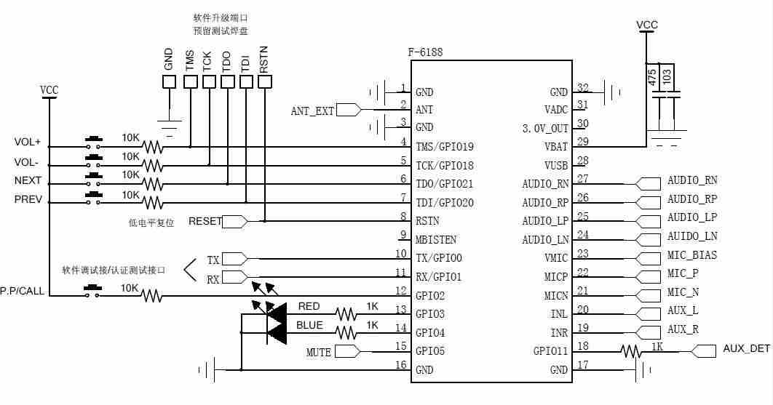
F-6188
- 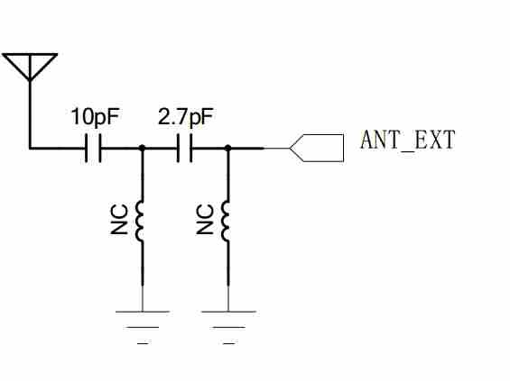
- MIC line:
MIC Recommended Specifications: Sensitivity -38dB/+-2dB DC2V Operating Voltage

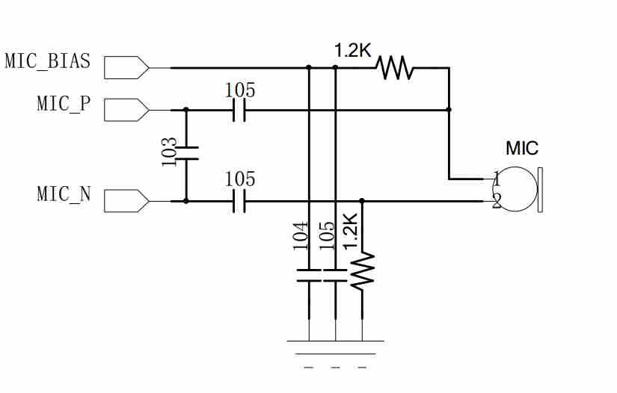
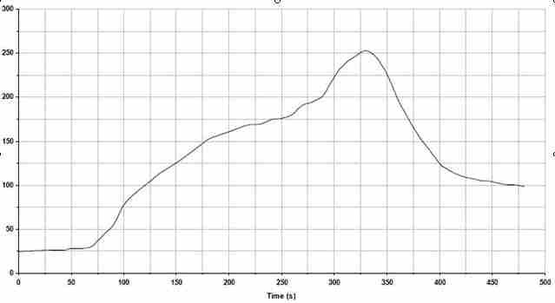

Key features of the profile:
-Initial Ramp=1-2.5℃/sec to 175℃ equilibrium
-Equilibrium time=60 to 80 seconds
-Ramp to Maximum temperature (250℃)=3℃/sec Max
-Time above liquidus temperature(217℃): 45 - 90 seconds
-Device absolute maximum reflow temperature: 250℃

