Transistor tester instructions
Iinput voltage: DC6.8V-12V
The operating current is about 30mA, input the 7.5V DC voltage to start the actual measurement.
Transistor tester control
The tester is controlled by a rotary encoder switch, rotary encoder switch can be a total of 4 kinds of operation, short press, long press, left rotation and right rotation. Short press once in the shutdown state to turn on the power and start to the test. Long press the switch or left and right rotary switch can enter the function menu if the device is not detected after a test is completed. Rotate left or right switch can selected menu items on or under, it can enter a certain function through short press a switch. Long press switch when it needs to exit from a function.
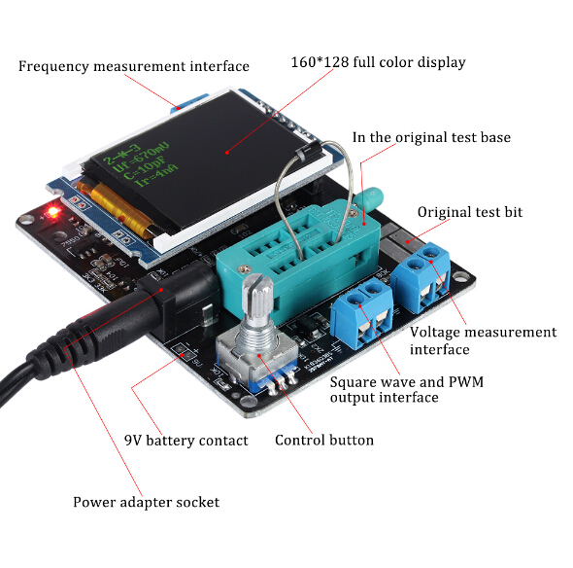
Test device
Test instrument a total of 3 test points TP1,TP2,TP3. The distribution of these three test points in the test stand is as follows
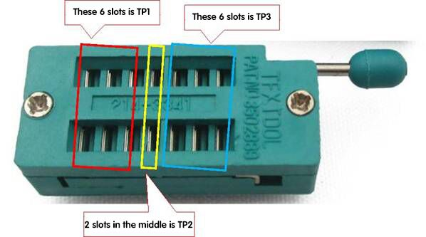

The test position of the patch element is on the right side of the test seat. There are above digital 1,2,3 , each representative TP1,TP2,TP3.Test only 2 pin components,pin no test order, 2 pins arbitrarily selected 2 test points. 3 pin device pins are placed in the three test points, pin no test order. After testing, pin name of the element and the location of the test point be identified automatically and displayed on the screen.
Test only 2 pin components, If use TP1 and TP3 two test points, atomatically enter the continuous test mode after the test is complete, like this,it can continuous synchronous measuring components on TP1 and TP3 no need to press the switch again. It can only be tested once if use "TP1 and TP2" or "TP2 and TP3" to test.It need to press a switch again to carry out the next test.

Capacitor discharge before capacitors testing, Finally insert test stand to carried out the measurement.
Oherwise, the single chip microcomputer is likely to be damaged.
Calibration
Tester calibration is used to eliminate the error of their components to make the final test result more accurate. Calibration is divided into fast calibration and full function calibration.
Fast calibration method of operation: Three test points TP1, TP2 and TP3 are connected by a wire，then press the test button and watched the screen at the same time. Screen color will become black background and white word,after the prompt message appears ”Selftest mode..?”, click the test button to enter into the rapid calibration process. After the prompt message appears ”Selftest mode..?”, a normal test procedure is carried out if no buttons action for about 2 seconds. The last show resistance value of wire where short connect TP1, TP2, TP3 three test point. After entering the rapid calibration process, there are will be some data on the screen, you don't have to deal with it. Wait until the flashing string appears on the screen
"Probes isolate!", remove the short connect TP1, TP2, TP3 of the wire. Until a string appears on the screen "End Test",quick calibration has finished. Please use full function calibration method for the first time calibration.
Full function calibration needs to be entered from the menu and also need to prepare a 220nf capacitor. Full function calibration to perform a more comprehensive calibration process will take longer. After entering the function menu, rotate the test button into the menu item "Selftest", then press the test button to enter the full function calibration process, first appeared on the screen flashing string“short Probes!”, three test points are connected by a wire, and wait the calibration process is carried out. When the screen flashes the string “isolate Probes!”remove the short wires connected to the three test points, continue to wait for the calibration process to carry out. When the screen appears "1-||-3 > 100nF", 220nf capacitors are installed in the test point TP1 and TP3. Until a string appears on the screen "End Test",quick calibration has finished.
Function menu
1.Switch off
2.Transistor: Transistor test, which is the default function after the boot.
3.Frequency: Measuring frequency
4.f-Generator: Square wave generator, there are multiple square wave frequency can be selected.
Switch the different square wave frequency by the left rotation or right rotation test button. Long press the test button to exit the square wave generator.
5. 10-bit PWM: Pulse signal generator, adjust pulse duty cycle by the left rotation or right rotation test button,from 1% to 99%. Long press the test button to exit the pulse signal generator.
6. C+ESR@TP1:3: Capacitance measurement function on line, two wires can be drawn from TP1 and TP3. On line measurement of the capacitance value and ESR for the 2uF-50mF capacitor.Note that capacitance be measured must be fully discharged before the test, if it is measurement online,the circuit needs to be cut off before the test.
7. 1- - 3: The way of continuous measurement of resistance.Constant testing that the resistance and inductance values installed on TP1 and TP3. The inductance will be measured when the measured resistance is less than 2100 ohm, Inductance measurement range from 0.01mH to 20H.Long press the test button to exit.
8. 1-||-3: The way of continuous measurement of capacitance. Constant testing that the Capacitance value installed on TP1 and TP3. For small capacity capacitors, We can get the measured capacitance value only in this way. For capacitor with greater than 90nF, measuring its equivalent series resistance (ESR), ESR resolution 0.01Ω. The capacitor is above in 5000pF shows the voltage drop rate.
9. Rotary encoder: Rotary encoder detection, Can test the coding value of the three wire rotary encoder switch.
10.SelfTest: Full function calibration function.
11. Voltage: DC voltage measurement, the maximum can be measured 50V.
12.FrontColor: Set foreground characters color,left or right rotation test button can change the value of the corresponding color component. Short press the test button to change the red, green and blue three base colors, 16 bit color coded using the RGB (565) format, respectively corresponding the red highest equals 31, green highest equals 63,blue highest equals 31. After the setup is complete, press the test button to save and exit. Be careful not to set the foreground color and background color to the same color, that can't see anything. If this happens, shut down immediately and then perform a quick calibration, sreen colors will turn into a black background with white foreground.Enter a quick calibration method to see the previous description. Immediately modify the color of the screen after the fast calibration has finished.
13.BackColor: The method is same as set foreground, just this is the background color is modified.
14.Show date: Display internal data of tester, the test function of the tester can be observed.

