DIATONE GTR 548 MK3
Exclusive customization. There's always one for you

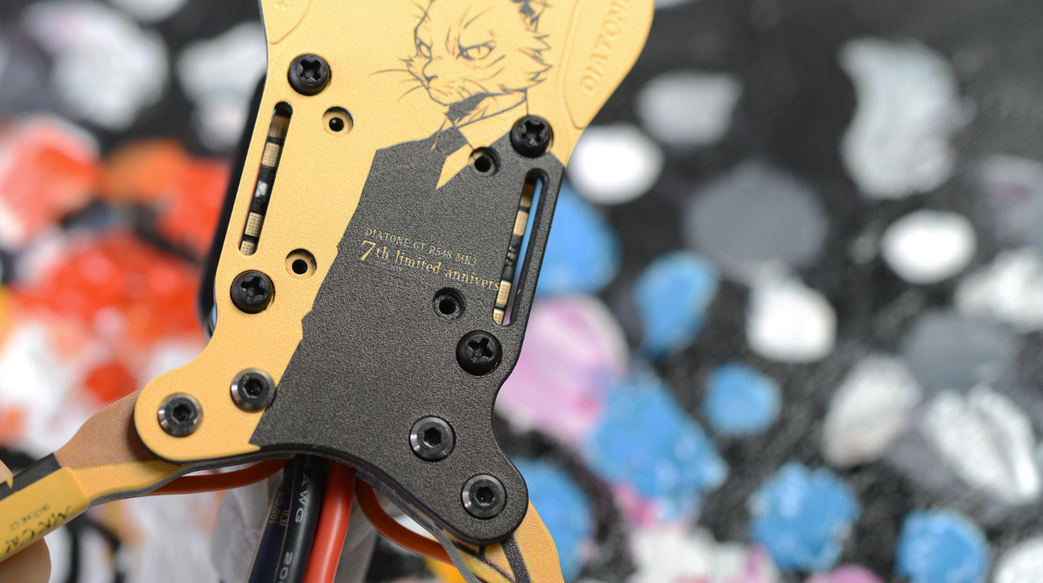
As the third generation of DIATONE GTR Series, GTR MK3 continues the design of AIO Arm. The 6 mm arm is more suitable for racing. You will find that the DIATONE team has made a lot of efforts to achieve better performance. The most important thing is that we have brought "barrier-free spraying technology" in our frame design, so that you can customize any IMAGE that you like. A Unique design of The MK3 just for you.

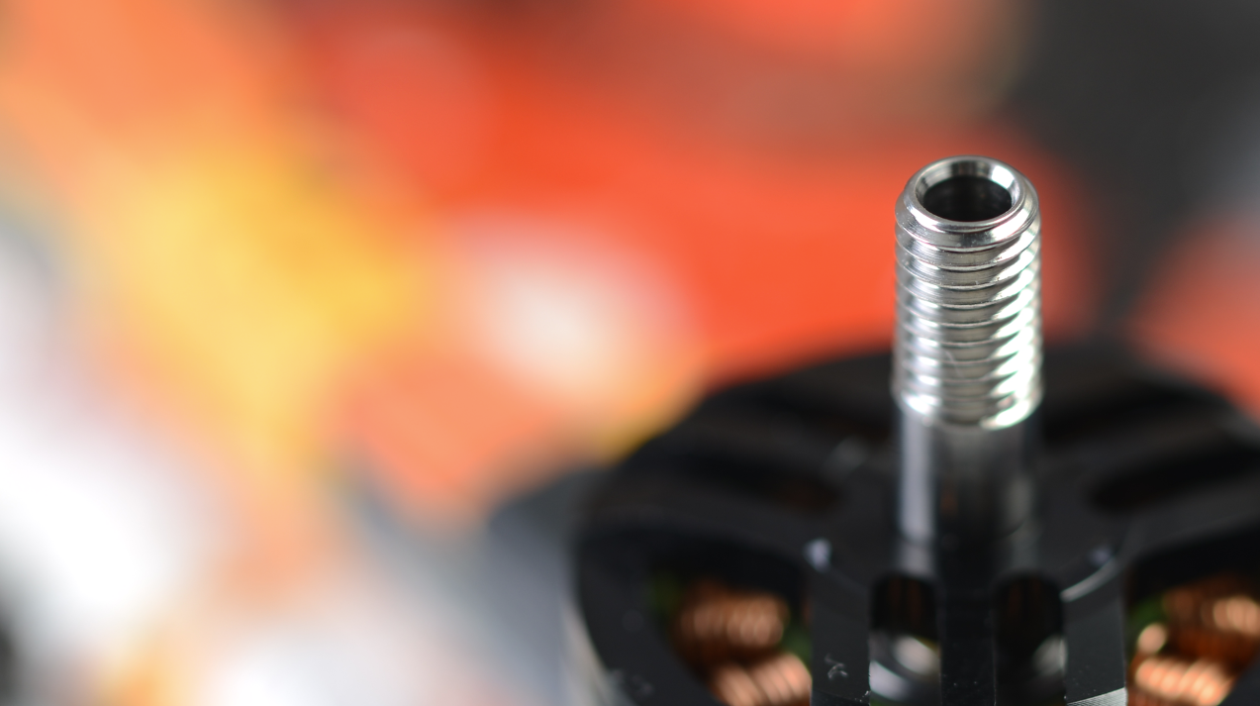
As a race ready model, GTR MK3 is equipped with the classic MAMBA SYSTEM F405 tower, which is known as the "most stable tower”. It works steadily under 6S Lipo (25V), which can provide 4000W rated power (25V*40A*4 ESC). Matched with The MAMBA 2207 motors, it can provides a total of over 7000g of rated thrust to the quad!

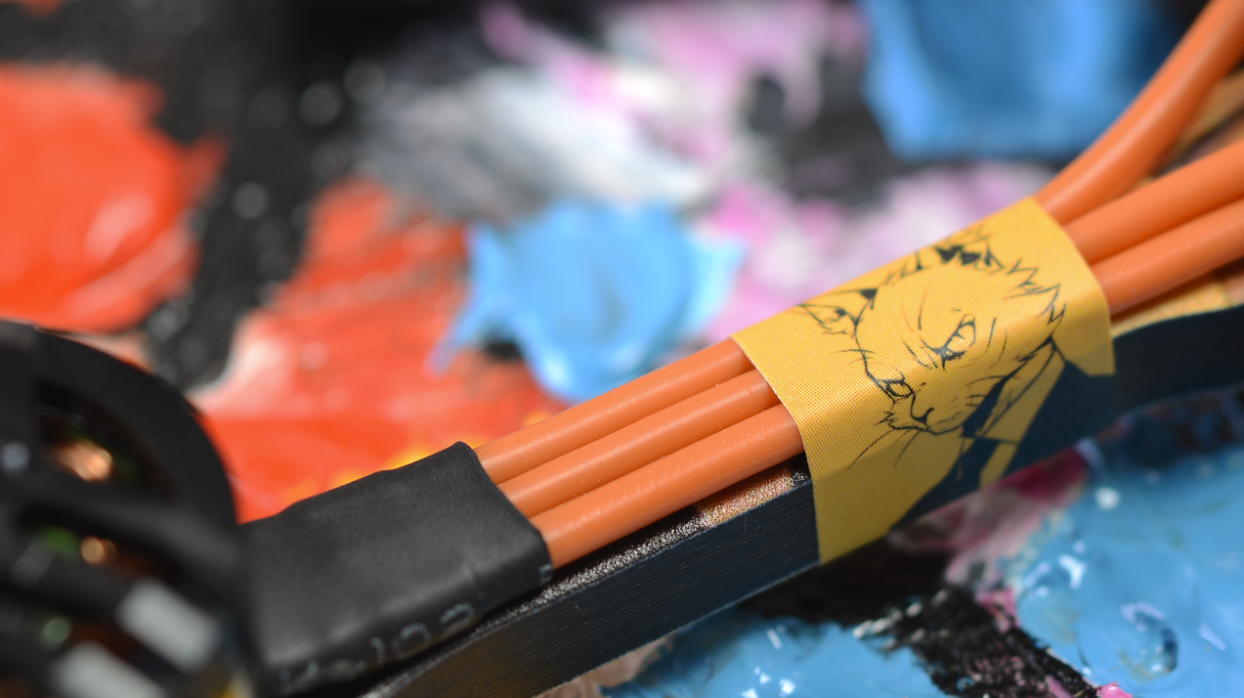
GTR is the newest model in the GT Series. We made it as a racing quad but also can be used in daily practice. The 8 mm wide arm is one of the characteristics of The MK3. Thinner arm can have less resistance. The increased chamfer of the edge further reduces the wind resistance. You will instantly feel that the quad’s launch speed is faster than other common arm.

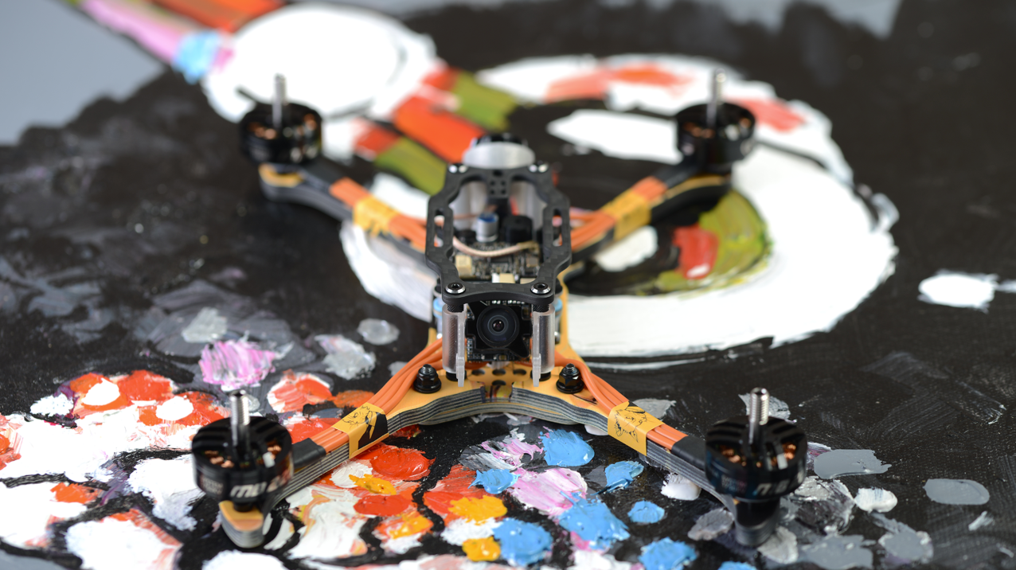The design principle of The GTR originate from "the simplest structure". There are only four main parts, which is amazingly simple. Because we use uni-body design, in the simplest assembling method, the frame can be installed only by removing and re installing 4 screws.
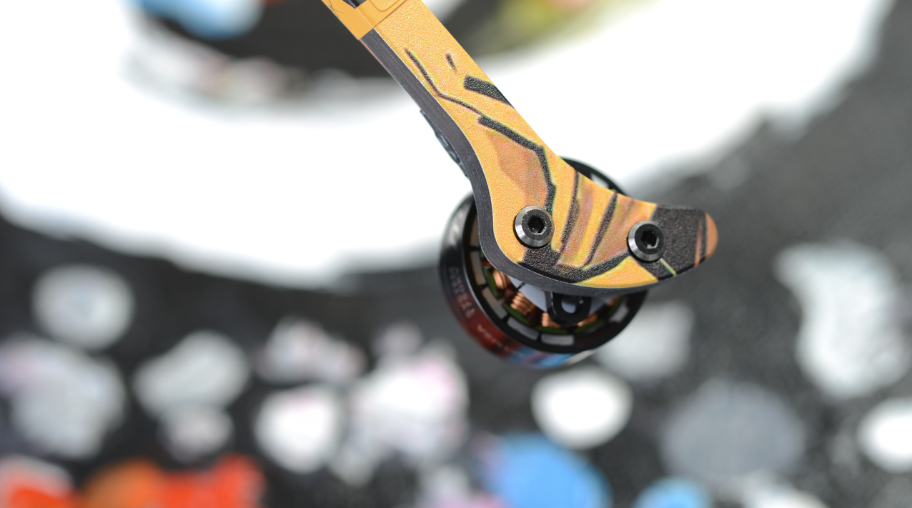
The enclosed motor mounting position is used to prevent dirt from entering bearing , which can keep the bearing in good working condition for longer time. Don't underestimate this detailed design, some dirt can enter into the motor during flights and landing. After a while, it will lead to bearing damage. With our enclosed motor base design, it will save you a lot of maintenance time and money.

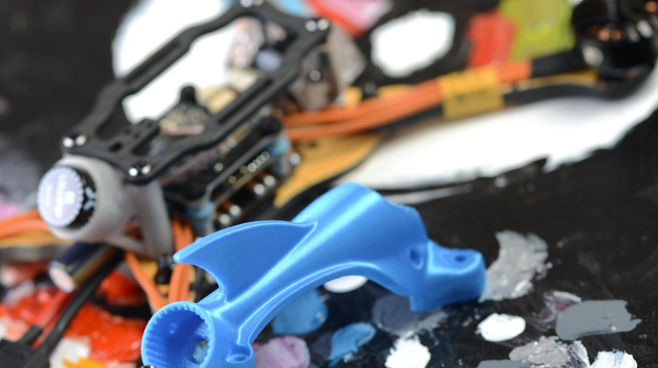It’s our first time we use 3D printing parts in our products. Although we always thought that 3D printing parts was not formal enough, many pilots still like this style. The GTR MK3's 3D printing canopy uses a 19 mm camera installation standard can Up to 14mm lenses. Most camera models can be installed, such as FOXEER Predator V3 and RUNCAM Micro series.

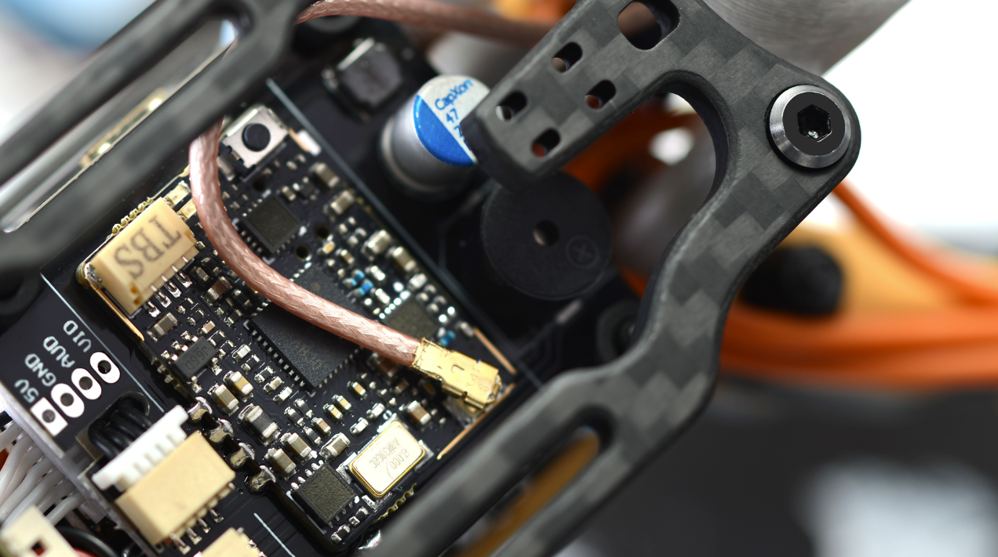In The GTR MK3 public review, many gave us feedback that the 3D printing shell is not strong enough, they suggest to use carbon fibre boards, so... We went on with the suggestion of a carbon canopy. In order to reduce weight, we have only kept the outer part of the carbon fibre board, through this 3 mm thick board, you can see the expensive TBS UNIFY VTX.

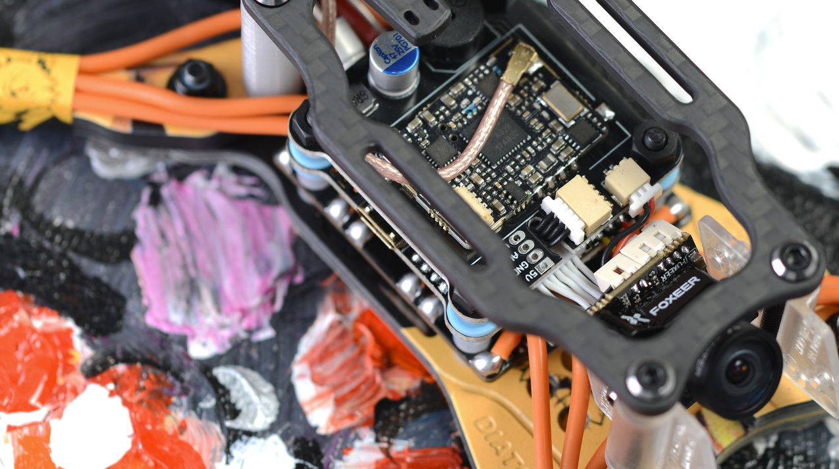We believe that TBS make the best VTX and have been using the TBS UNIFY 800mW version for two years. During the cooperation with TBS, we has witnessed the stability and excellent performance of this product. In all DIATONE models we have used a gray VTX shield and a special anti-interference board designed for TBS VTX. Considering that you may replace the 3D POD, this shield will be included in the accessories package. You can install it by yourself.

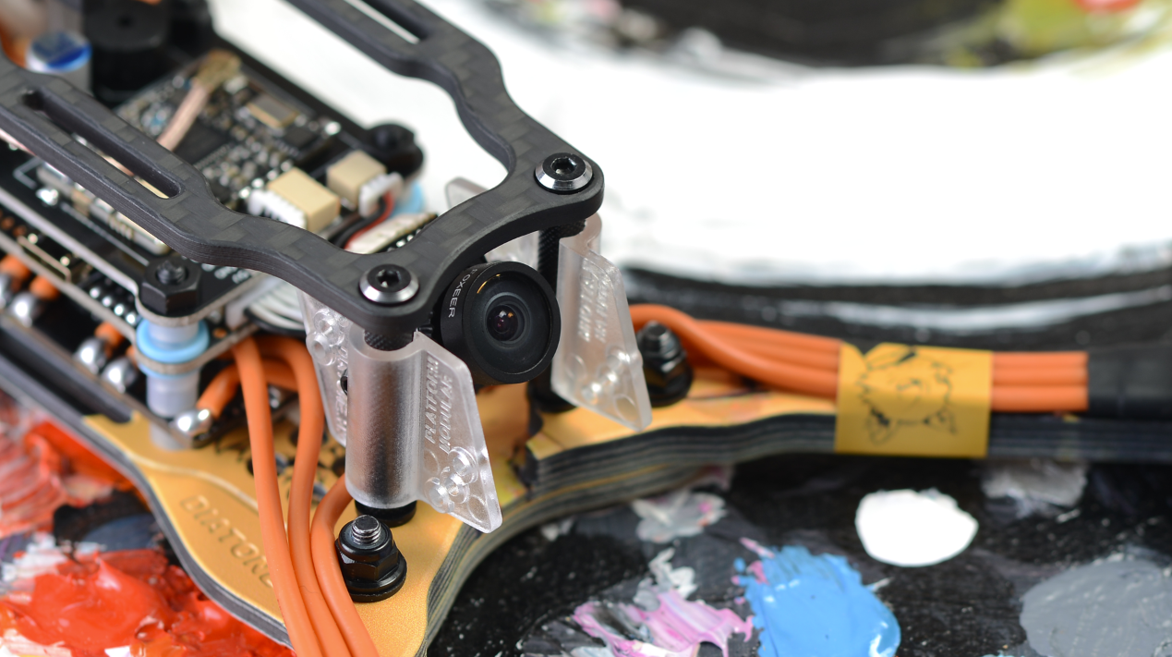In 2019, DIATONE started to cooperate with Foxeer. FOXEER gained market with its strong technical strength. Our 7th anniversary of GTR 548 MK3 uses FOXEER Predator V3 camera. This camera is made for racing with 1000 TVL and ultra-low latency. Besides that, it has an extraordinary image technology, the pixels are so much clearer than all the other 2018 CCD camera. 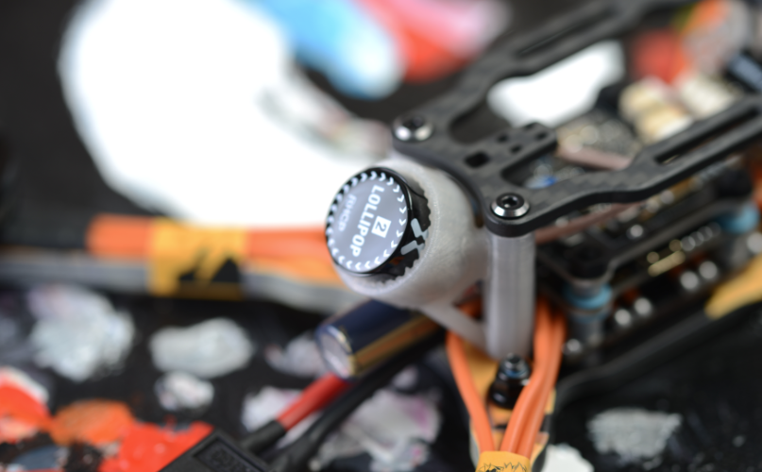
To go with The Camera, FOXEER's lollipop antenna is installed by default (according to customer’s request, it can be also installed with other types of antenna). This antenna is very light but with a high-strength structure design, it can handle lots of beating. The antenna frequency is 5.8 GHz. The 500 GHz bandwidth (5.5-6.0 GHz) can match most of the VTX on the market. It’s also possess a standing wave ratio of less than 1.2 and a radiation efficiency of 98%.

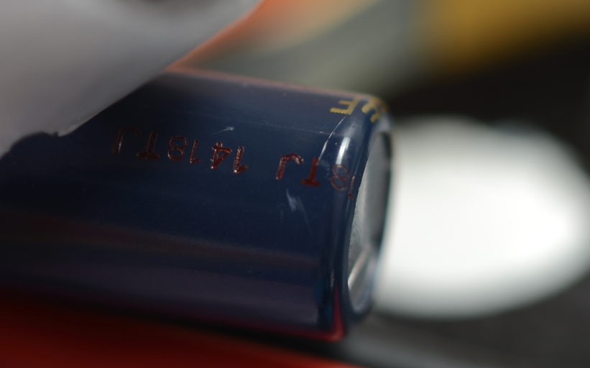
A small surprise. For better image quality, we have adopted the high frequency and low resistance capacitor of Panasonic FC series. It’s our first time we use it in our product line and this 35V 470UF Panasonic FC capacitor will be used in all models listed in 2019 (the limited version will use 35V 1000UF specifications or other models). Panasonic FC series capacitors are better than RUBYCON YXG and SANYO Gold capacitors, and of course the price is triple than others.

