ETX-2014 Thermocouple Calibrator
ETX-1814 Thermocouple Calibrator
Users Manual

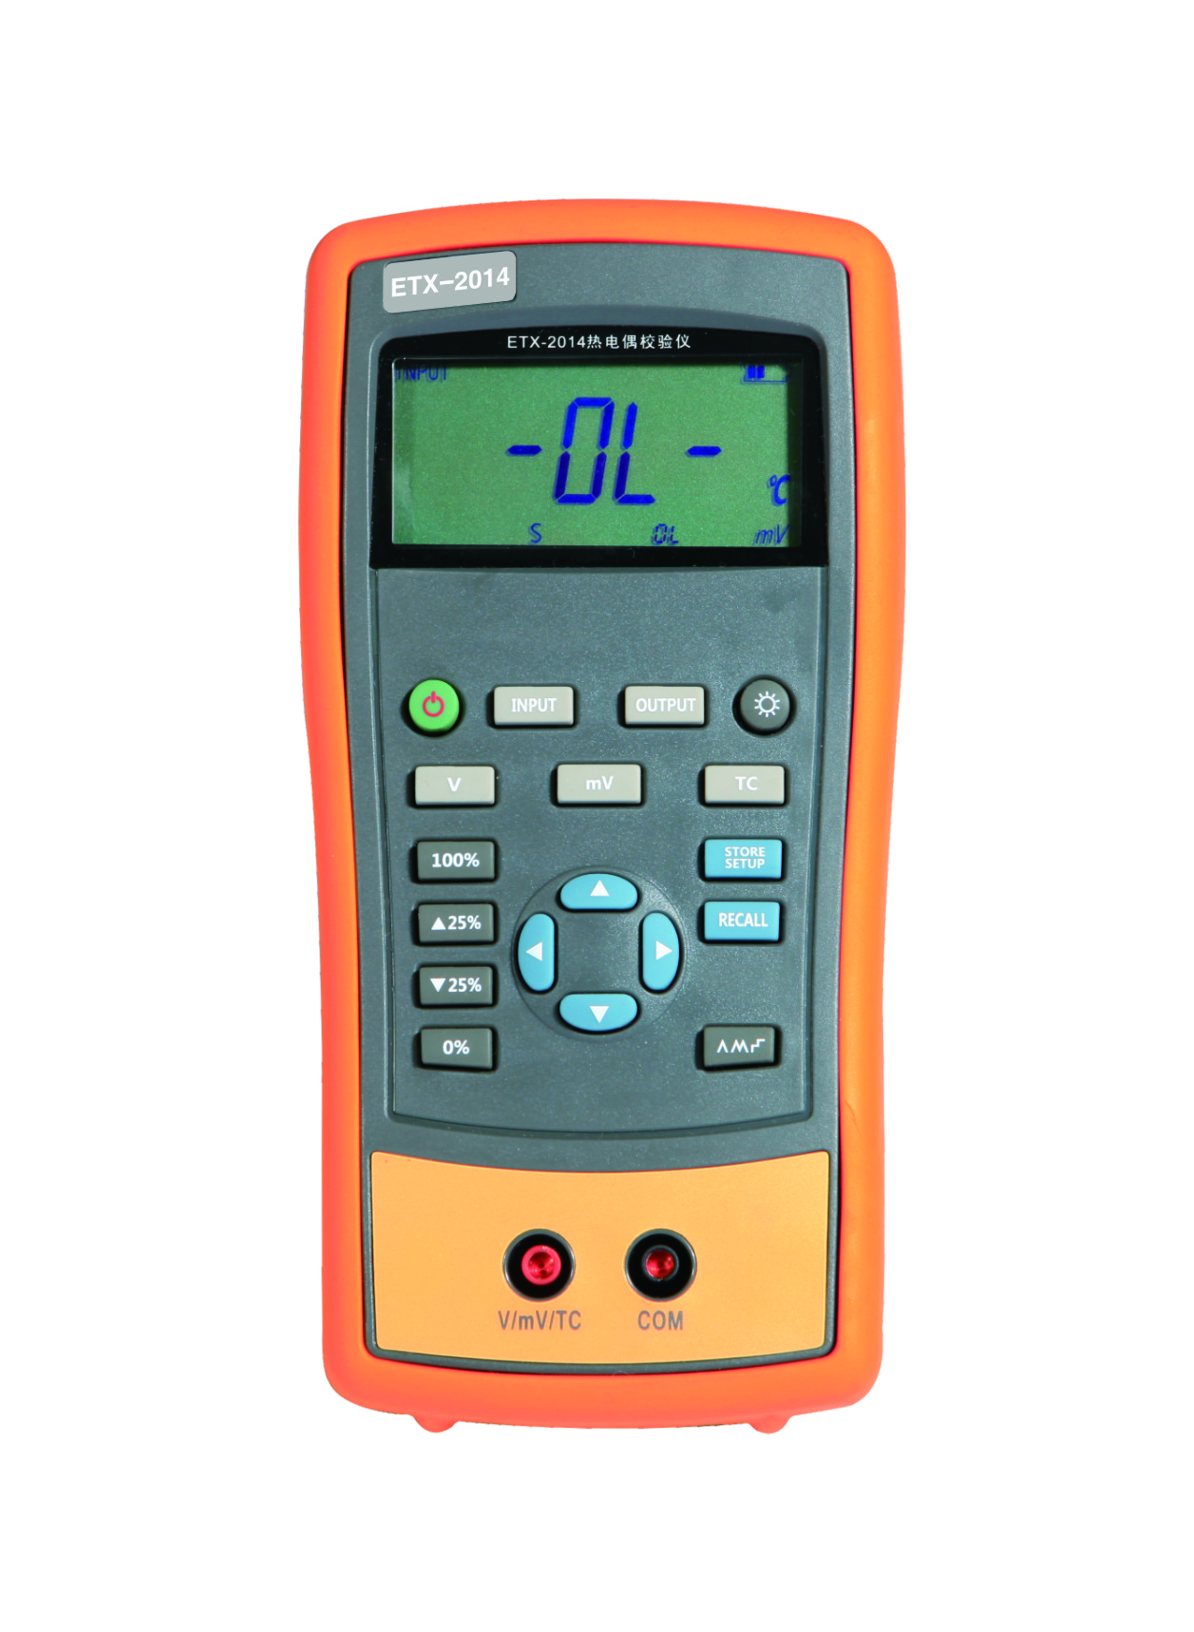

Hangzhou Zhongchuang Electron Co.,Ltd

Contents

1 Basic Introduction 1
1.1 Function 1
1.2 Summary of Source and Measure Functions 1
1.3 Terminal Description 2
1.4 Key Description 3
1.5 Display Screen 4
2 Basic Operation 5
2.1 Measure and Source 5
2.2 Shutdown Mode 7
2.3 Backlight Brightness Adjustment 7
3 Function Usage 9
3.1 DC V Measurement 9
3.2 DC mV Measurement 9
3.3 DC mV Source 9
4 Using Thermocouple (TC) 10
5 Simulating Thermocouples (TC) 12
6 Advanced Application 13
6.1 Setting 0 % and 100 % output parameters 13
6.2 Auto Ramping the Output 14
6.3 Factory Reset 14
7 Power 15
7.1 Charge 15
8 Specifications 16
8.1 DC Voltage Measurement 16
8.2 DC mV Output 16
8.3 Thermocouple 17
9 Product Accessories 18
9.1 Standard accessories 18
9.2 Optional Accessories 18
10 Warning 19

1 Basic Introduction

1.1 Function
- Output of DC mV and simulation of thermocouple output.
- Voltage, DC mV and thermocouple measurement.
- Thermocouple(TC) measurement provides cold-junction compensation.
- Manual stepping, automatic stepping, 0～100% phase step and slope output
- Support for PC communication

1.2 Summary of Source and Measure Functions
Function | Measure | Source
DC V | 0～30 V | Not available
DC mV | 0～100 mV | 0～100 mV
Thermocouple | E,J,K,T,B,R,S,N | E、J、K、T、B、R、S、N
Others | Stepping output, ramp, phase step output, user-defined range

1.3 Terminal Description
Figure 1.3-1
No. | Name | Description
① | Communication and charging connector | Connect the power adaptor to charge batteries or connect the calibrator to the computer.
② | COM terminal | Measurement and output public terminal
③ | V, mV, and TC terminal | Power supply, DC mV, thermal-resistance as well as DC mV and thermal couple output terminal.

1.4 Key Description
Figure 1.4-1
No. |  | Description
① |  | Turns the power on or off
② |  | Selects measurement mode
③ |  | Selects output mode
④ |  | Turns backlight on or off. Turns Contrast Adjust mode on when powering up.
⑤ |  | Selects thermo-couple mode
⑥ |  | Saves calibrator settings
⑦ |  | Retrieves a previous calibrator setup from a memory location
⑧ |  | Sets manual output

⑨ |  | Cycles through:  Slow repeating 0%-100%-0% ramp  Fast repeating 0 % - 100 % - 0 % ramp  Repeating 0 % - 100 % - 0 % ramp in 25 % steps
⑩ |  | Sets output by 0% of span, presses and holds to store the source value as the 0 % value.
⑾ |  | Decrements output according to 25% of span.
⑿ |  | Increments output according to 25% of span.
⒀ |  | Sets output by 100% of span. Press and hold to store the source value as the 100 % value.
⒁ |  | Selects voltage mode
⒂ |  | Selects DC mV mode

1.5 Display Screen
Figure 1.5-1

2 Basic Operation

2.1 Measure and Source
This section acquaints you with some basic operations of ETX-2014/ ETX-1814.
Proceed as follows:
- The connection of the calibrator as shown in Figure 2.1-1.
Figure 2.1-1
- Press for more than 2 seconds to turn on the calibrator. The calibrator checks itself, including check on internal circuit and LCD, during which, LCD displays all contents for 1s as shown in Figure 2.1-2:
Figure 2.1-2
- Then the type of product and automatic shutdown time will be displayed for 2 seconds as shown in Figure 2.1-3.
Figure 2.1-3
- Press , enter into output mode selection
- Press, switch to DC mV output mode. The screen will display as shown in Figure 2.1-4
Figure 2.1-4
- Press and to increase or decrease 1 of the horizontal line position (the number automatic carry but the position of the line have no change); press or to select a digit to change.
- Press until the buzzer work to enter 0mV as 0% value.
- Likewise, press to increase output value to be 100mV, and then press until the buzzer works and select 100mV as 100% value.
- Press or to step between 0 and 100% in 25% step increments. The screen will display as shown in Figure 2.1-5.
Figure 2.1-5

2.2 Shutdown Mode
The calibrator comes with the shutdown mode enabled for a time duration set to 30 minutes (displayed for about 2 seconds when the calibrator isinitially turned on). When the shutdown mode is enabled, the calibrator will automatically shutdown after the time duration has elapsed from the time the last key was pressed. To disable the shutdown mode, press and simultaneously. To enable the mode, press and simultaneously. To adjust the time duration, press and simultaneously, the screen will display as shown in Figure 2.2-1,then press and/or to adjust the time between 1 and 30 minutes and then press to store the new time duration (Without pressing any key for 5 seconds, the calibrator will quit from the adjustment automatically).
Figure 2.2-1

2.3 Backlight Brightness Adjustment
To adjust the brightness of backlight, proceed as follows:
- Please press until the buzzer works, then the screen will display as shown in Figure 2.3-1:
Figure 2.3-1
- Press and to adjust the brightness of backlight.
- Press to save brightness level, will appear and then the calibrator will enter into the work mode(Without pressing key for 5 seconds, the calibrator will exit from the adjustment automatically).

3 Function Usage

3.1 DC V Measurement
The default function of the calibrator after start-up is voltage measurement. If it is required, press to re-select the voltage measurement (the display unit is V).Please connect the lines after all functions are selected. The connection mode and interface are shown in Figure 3.1-1:
Figure 3.1-1

3.2 DC mV Measurement
Press to re-select the DC mV function (the display unit is mV), the connection mode is same to voltage measurement.

3.3 DC mV Source
Press and to select the DC mV output , the connection mode is same to that of voltage measurement. When the mill-volt is overload, there is sign of, meanwhile, the main display area flashes shown in Figure 3.3-1:
Figure 3.3-1

4 Using Thermocouple (TC)
The calibrator supports 11 types of standard thermocouples, including J, K, T, E, R, S, B, L, U and N. Lower table summarizes the ranges and characteristics of the supported thermocouples:
Graduation | Positive lead material | Positive wire (H) color |  | Negative lead material | Specified span℃
Graduation | Positive lead material | ANSI* | IEC** | Negative lead material | Specified span℃
E | Chrome-nickel | Mauve | Purple | Constantan | -200～950
N | Nickel-chrome-silicon | Orange | Pink | Nickel-silicon-magnesium | -200～1300
J | Iron | White | Black | Constantan | -200～1200
K | Chrome-nickel | Yellow | Green | Alumel | -200～1370
T | Copper | Blue | Brown | Constantan | -200～400
B | Platinum (30% rhodium) | Grey |  | Platinum (6% rhodium) | 600～1800
R | Platinum (13% rhodium) | Black | Orange | Platinum | -20～1750
S | Platinum (10% rhodium) | Black | Orange | Platinum | -20～1750
* Negative conductor (L) regulated as American National Standard (ANSI) is always red.
*Negative conductor (L) regulated as International Electro-technical Commission (L) is always white.
To measure temperature using thermocouple, the following steps shall be followed:
- Connect the thermocouple to the calibrator as shown in Figure 4-1:

Process Temperature
Figure 4-1
Attention:
If the calibrator and the thermocouple plug are at different temperatures, wait one minute or more for the connector temperature to stabilize after you plug the miniplug into the TC input/output.
- Press to select Measure mode.
- Press for TC display as shown in Figure 4-2. If desired, pressing continuously to select appropriate thermocouple type.
Figure 4-2

5 Simulating Thermocouples (TC)
Connect calibrator input/output terminal to the instrument to be tested using thermocouple. The connecting diagram is shown below, Proceed as follows to simulate a thermocouple:
- Connect thermocouple to the TC input/output plughole of calibrator as shown in Figure 5-1.
- If necessary, press to select mode.
- Press to select thermocouple function. If necessary, continue pressing the key to select thermocouple graduation.
- Press or to select temperature. Press or to select digit.
Figure 5-1

6 Advanced Application

6.1 Setting 0 % and 100 % output parameters
As for stepping operation and percentage display, 0% and 100% should be set before using. Some gear values have been set when delivered from the factory and set values are illustrated below:

Output function | 0% value | 100% value
DC mV | 0.00 mV | 100.00 mV
Thermocouple J type | 0.0 ℃ | 1000.0 ℃
Thermocouple K type | 0.0 ℃ | 1000.0 ℃
Thermocouple T type | 0.0 ℃ | 400.0 ℃
Thermocouple E type | 0.0 ℃ | 800.0 ℃
Thermocouple R type | 0 ℃ | 1500 ℃
Thermocouple S type | 0 ℃ | 1500 ℃
Thermocouple B model | 600 ℃ | 1800 ℃
Thermocouple N model | 0.0 ℃ | 1000.0 ℃

The default set values may not meet your requirements, so which can be reset. Then you can display the percentage with stepping or slope output as well as display the percentage. Adjust the output value with keys, press or for a long time until the buzzer works to define the new 0% or 100% values. The new defined span value is saved in the calibrator storage automatically and remains effective after restart. The flowing operations are available with the setting:
- Press or for manual steeping (increase or decrease) output based on 25% increment.
- Press or instantly to make output jump within the span of 0% to 100%.

6.2 Auto Ramping the Output
Automatic ramping gives you the ability to continuously apply a varying stimulus from the calibrator to a transmitter, while your hands remain free to test the response of the transmitter.
When you press, the calibrator produces a continuously repeating 0 % - 100 % - 0 % ramp in your choice of three ramp waveforms:
- 0%-100%-0% 40-second smooth ramp
- 0%-100%-0% 15-second smooth ramp
- 0%-100%-0% Stair-step ramp in 25 % steps, pausing 5 seconds at each step.
Exit the slop output function, please press any key.

6.3 Factory Reset
Factory reset consists of the following items:
- The working status recovers to the voltage measurement.
- Automatic shutdown time is reset to be 30 min, which is effective.
- LCD backlight brightness is set to be 60%.
- Output span is recovered to be factory default.
Start the calibrator and press until the buzzer works, and the recovery of factory default will enter working mode when the recovery is completed.

7 Power
The calibrator needs 6 disposable LR03 model (size 7) alkaline batteries or 6 R03 model (size 7) nickel-metal hydride batteries (or nickel-cadmium batteries). The longest service life of alkaline batteries can reach 50 hours.
A 12V/1A power adaptor is used for charging and providing working power for the calibrator.

7.1 Charge
When the battery indicator is pointed at , the remaining electric quantity is less than 20%. Charge is necessary for normal operation of the calibrator. The LCD backlight will start operation and the will display on the screen when the power adaptor is used. If the battery indicator flashes, the calibrator will be in the charging process, after which the battery indicator will stop flashing.
The calibrator will stop charge automatically in case of the following circumstances:
- Disposable batteries are used.
- Electric quantity is enough.

8 Specifications
Specifications are based on a one year calibration cycle and apply from +18℃ to +28 ℃ unless stated otherwise. All specifications assume a 10 minute warmup period.

8.1 DC Voltage Measurement
Range | Maximum measurement range | Resolution | Accuracy (% of reading + Counts)
Range | Maximum measurement range | Resolution | ETX-1814 | ETX-2014
30V | 0V～31V | 0.001V | 0.05+2 | 0.02+2
100mV | -15mV～80mV | 0.001mV | 0.05+20 | 0.02+20
100mV | 80mV～125mV | 0.01mV | 0.05+2 | 0.02+2
-10℃～18℃，+28℃～55℃ temperature coefficient,±0.005%FS/℃.
Input resistance: ＞1MΩ.

8.2 DC mV Output
Range | Maximum output range | Resolution | Accuracy (% of reading + Counts)
Range | Maximum output range | Resolution | ETX-1814 | ETX-2014
100mV | -15mV～99.999mV | 0.001mV | 0.05+20 | 0.02+20
100mV | 100mV～125mV | 0.01mV | 0.05+2 | 0.02+2
-10℃～18℃，+28℃～55℃ temperature coefficient,±0.005%FS/℃.
Maximum load: 1mA or 1kΩ （It should be based on the lower load.）

8.3 Thermocouple
Graduation | Range | Resolution | Accuracy (Ω)
Graduation | Range | Resolution | ETX-1814 | ETX-2014
J | -200℃～0℃  0℃～1200℃ | 0.1℃ | 1.5℃  1.0℃ | 1.0℃  0.7℃
K | -200℃～0℃  0℃～1370℃ | 0.1℃ | 1.8℃  1.2℃ | 1.2℃  0.8℃
T | -200℃～0℃  0℃～400℃ | 0.1℃ | 1.8℃  1.2℃ | 1.2℃  0.8℃
E | -200℃～0℃  0℃～950℃ | 0.1℃ | 1.5℃  1.0℃ | 0.9℃  0.7℃
R | -20℃～0℃  0℃～500℃  500℃～1750℃ | 0.1℃ | 4℃  2.5℃  2℃ | 2.5℃  1.8℃  1.4℃
S | -20℃～0℃  0℃～500℃  500℃～1750℃ | 0.1℃ | 4℃  2.5℃  2℃ | 2.5℃  1.8℃  1.5℃
B | 600℃～800℃  800℃～1000℃  1000℃～1800℃ | 0.1℃ | 3.5℃  2.5℃  2℃ | 2.2℃  1.8℃  1.4℃
N | -200℃～0℃  0℃～1300℃ | 0.1℃ | 2.0℃  1.2℃ | 1.5℃  0.9℃
Errors of cold-junction compensation are not included in the table.
Accuracy of cold-junction compensation: 1.5℃

9 Product Accessories

9.1 Standard accessories
ETX-2014/ETX-1814 calibrator also includes the following items:
- hard spot test leads (one set)
- alligator clip (one set)
- one 12V/1A power adaptor
- ETX-2014/ETX-1814 users manual
Alligator clip
Hard spot test leads
Figure 9.1-1

9.2 Optional Accessories
- 6 R03-model rechargeable batteries
- 1 Metal Box
- Communication line

10 Warning
To avoid possible electric shock or personal injury:
- Test a given voltage to confirm its normal operation of calibrator before using
- Please follow all the safety operation standards.
- Select correct function and span gear according to measurement requirements.
- Confirm the closing of battery door before calibrator application.
- Remove the test line of calibrator before opening the battery door.
- Check whether damaged or exposed metal exists in the test line and whether the test line has been conducted. Replace the damaged test line before using.
- Fingers should not touch the metal contact when the detector is used. Fingers should be behind the finger-protecting device.
- Connect the common line and then electric test line. As for wire removal, electric test line should be first removed.
- Don't use the calibrator in case of abnormal operation. Have the calibrator repaired because it may have been damaged.
- Don’t use the calibrator near explosive gases.
- Remove the test line before changing measurement or output function.
- 6 LR03 (7 size) alkaline batteries or R03 nickel-metal hydride batteries (or nickel-cadmium batteries) should be used in the calibrator and the battery should be placed inside the meter housing.
- Replace or charge the battery when the screen displays low pressure of battery, to avoid reading error and possible electric shock or personal injury.

