ETX-2025 Multifunction Process Calibrator
ETX-1825 Multifunction Process Calibrator
Users Manual

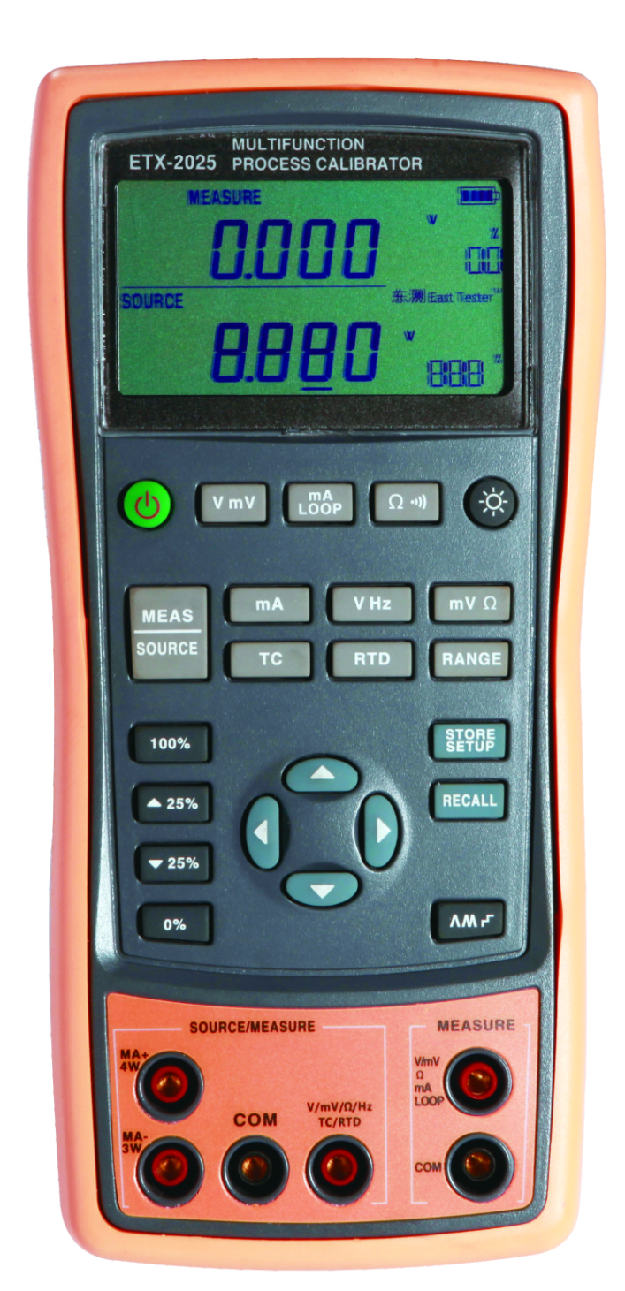

Hangzhou Zhongchuang Electron Co.,Ltd

Contents
1 Basic Introduction 3
1.1 Function 3
1.2 Summary of Source and Measure Functions 3
1.3 Terminal Description 4
1.4 Keys description 5
2 Basic Operation 7
2.1 Measure and Source 7
2.2 Shut Down Mode 9
2.3 Backlight brightness Adjustment 10
3 Functions of Upper Display 11
3.1 DC V and DC mV Measurement 11
3.2 DC mA Measurement 11
3.3 Current Measurement with Loop Power 11
3.4 Resistance measure and continuity test 12
4 Functions of Lower Display 13
4.1 Measure and Source of DC V and DC mV 13
4. 2 DC mA Measurement 13
4.3 DC mA Source（active） 14
4.4 Simulating a 4- to 20-mA Transmitter 15
4.5 Measure and Source of Resistane 16
4.6 Measure and Source of Frequency 17
5 Temperature Measurement 19
5.1 Using Thermocouples (TC) 19
5.2 Using Resistance Thermometer Detector (RTD) 23
6 Simulation of temperature sensor 24
6.1 Simulating Thermocouples 24
6.2 Simulating RTD 24

7 Advanced Application 26
7.1 Setting 0 % and 100 % Output Parameters 26
7.2 Auto Ramping the Output 27
7.3 Factory Reset 27
7.4 Calibrating a Transmitter 27
8 Power 29
8.1 Charge 29
9 Specifications 30
9.1 DC Voltage Measurement 30
9.2 DC Voltage Source 30
9.3 DC mA measurement 32
9.4 DC mA source 32
9.5 Resistance Measurement (upper display) 32
9.6 Resistance measurement (lower display) 33
9.7 Resistance source 33
9.8 Frequency measurement 34
9.9 Frequency source 34
9.10 Temperature, thermocouples 34
9.11 Temperature, RTD 35
10 Product Accessories 37
10.1 Standard Accessories 37
10.2 Optional Accessories 37
11 Warning 38

1 Basic Introduction

1.1 Function
- A split-screen display. The upper display allows you to measure volts, current (with loop power), resistance and continuity test. The lower display allows you to measure and source volts, current, resistance temperature detectors (RTD), thermocouples (TC), frequency, and ohms.
- Calibrates a transmitter using the split-screen.
- The measure of thermocouple provides automatic reference junction
- Automatic and manual cold end temperature compensation for TC.
- Manual stepping and automatic stepping and ramping.
- Super-strong protection：The waterproof grade is IP67. Automatic protection against the signal terminals connect to the 220V.
- Support for PC communication

1.2 Summary of Source and Measure Functions
Function | Measure | Source
DC V | 0～50V (the upper display ± 30V) | 0～10V
DC mA | 0～24mA (the upper display ± 24mA) | 0～24mA
Frequency | 1.000Hz ～ 100.00kHz | 0.00Hz～20.000kHz
Resistance | 0～3200Ω | 0～3200Ω
DC mV | 0～100mV (the upper display ± 200mV) | 0～100mV
RTD | Pt100, Pt1000, Cu50, Cu100 | Pt100, Pt1000, Cu50, Cu100
TC | E, J, K, T, B, R, S, N | E, J, K, T, B, R, S, N
Others | Loop supply, Step, Ramp, Dual display

1.3 Terminal Description
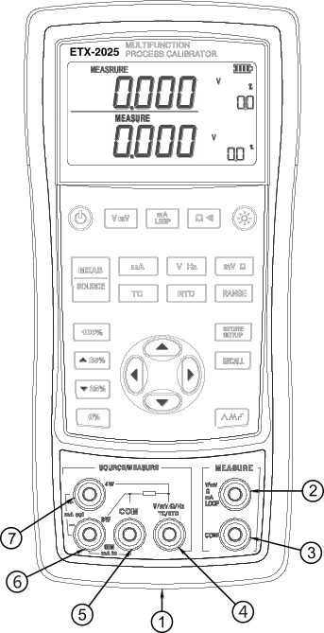
Figure 1.3-1
No. | Name | Description
① | Communication and Charging connector | Connect the power adaptor to charge batteries or connect the calibrator to the computer.
② ③ | Measure V, mV, mA, Loop, Ω and continuity test terminals | Input terminals for measuring voltage, current, resistance, and supplying loop power.The two terminals electrical isolate from the other terminals.
④ ⑤ | Measure and Source V, mV, Hz, Ω, TC and RTD terminals | Terminals for sourcing or measuring voltage, resistance, frequency, RTD and TC.  ⑤ is the common Terminal.
⑤ ⑥ | Measure and Source mA , and 3W for Ω terminals | Terminals for sourcing or measuring current ,and the terminal ⑥ is also used for the measure of 3W resistance.
⑥ ⑦ | Source mA and Measure 4W Ω terminals | Terminals for sourcing current, or for measuring resistance of 4W.

1.4 Keys description
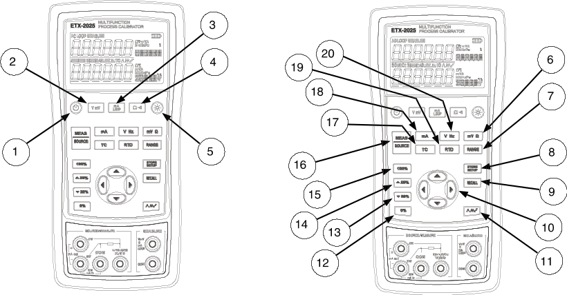
Figure 1-3
No. | Key | Description
1 |  | Turns the power on or off
2 | 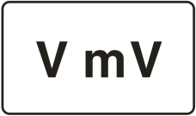 | Selects DC V or DC mV measurement function in the upper display
3 | 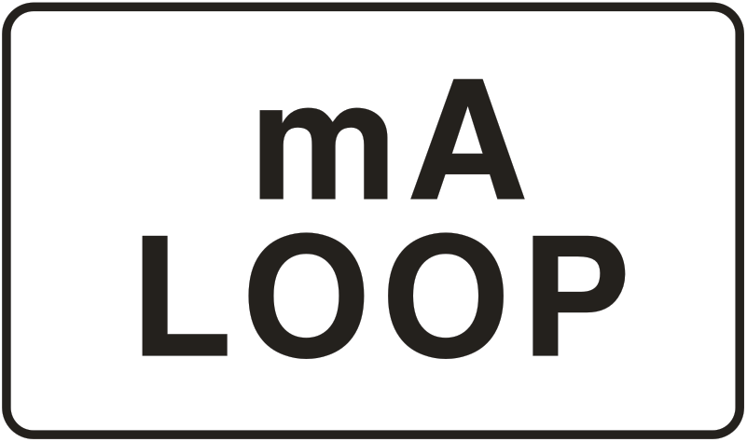 | Selects DC mA or Loop Power measurement function in the upper display
4 | 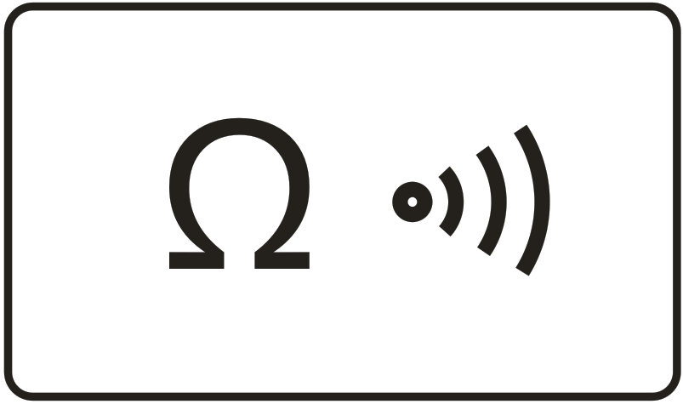 | Selects resistance measurement or continuity test function in the upper display
5 |  | Turns backlight on or off. Turns Contrast Adjust mode on when powering up.
6 | 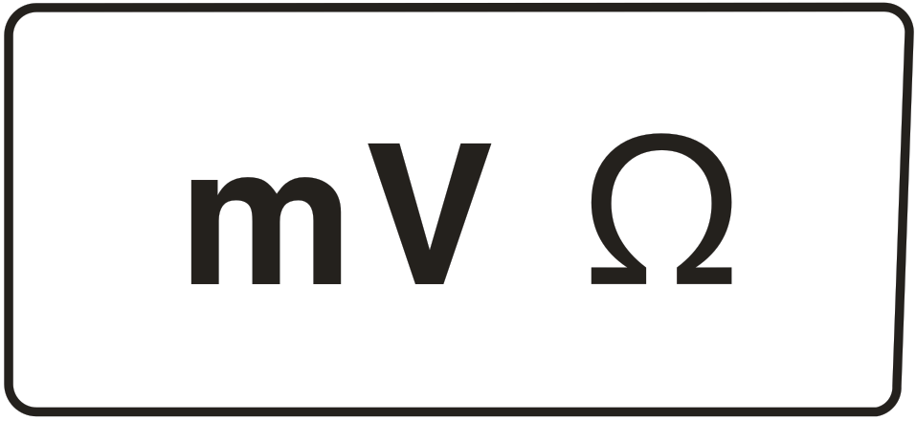 | Selects DC mV or resistance measurement function in the lower display
7 |  | Selects the range of source function in the lower display
8 |  | Saves the calibrator setup. Saves Contrast Adjust setup
9 |  | Retrieves a previous calibrator setup from a memory location
10 |  | Increases or decreases the source level
11 |  | Cycles through:  Slow repeating 0 % - 100 % - 0 % ramp  Fast repeating 0 % - 100 % - 0 % ramp  Repeating 0 % - 100 % - 0 % ramp in 25 % steps
12 | 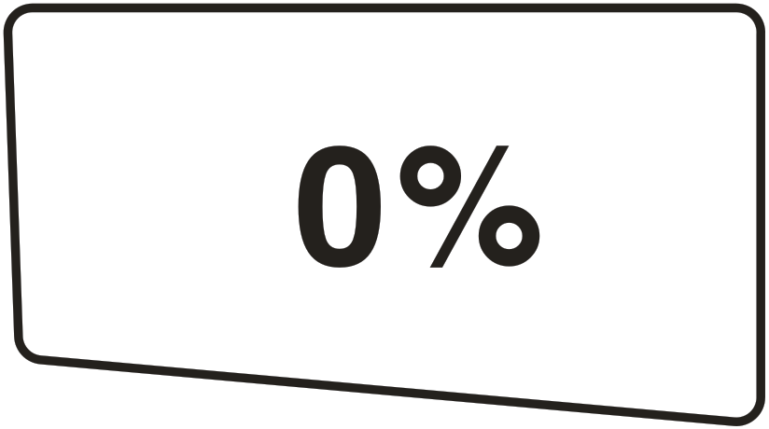 | Set output by 0% of span. Press and hold to store the source value as the 0 % value.
13 | 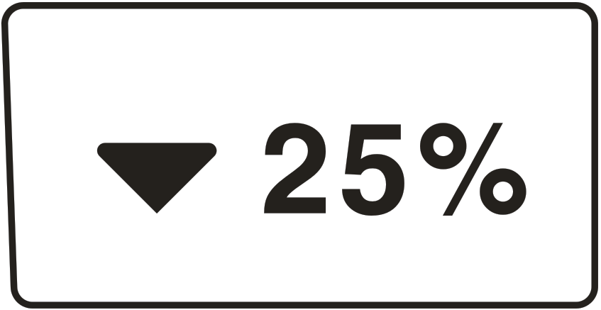 | Decrements output by 25 % of span.
14 | 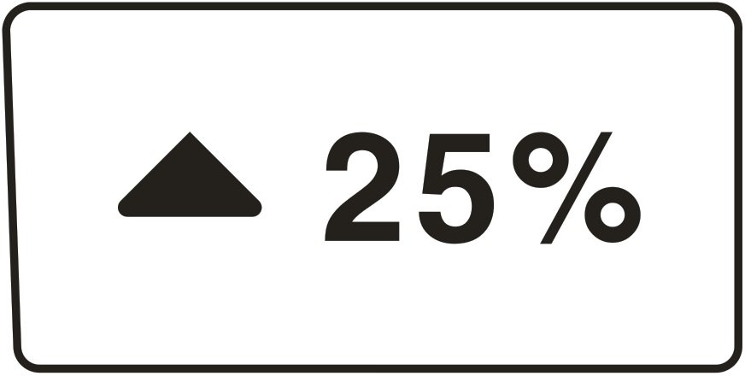 | Increments output by 25 % of span.
15 | 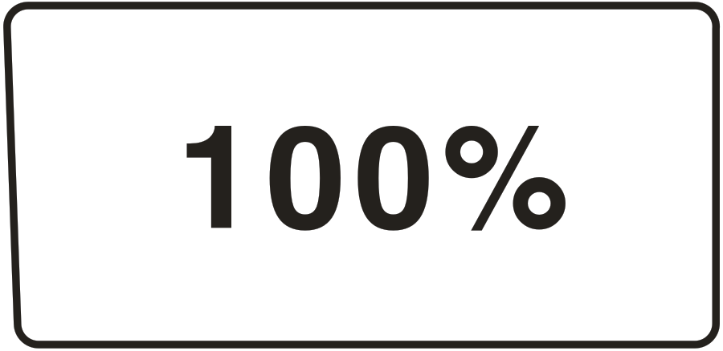 | Sets output by 100% of span. Press and hold to store the source value as the 100 % value.
16 |  | Cycles the calibrator through MEASURE and SOURCE modes in the lower display.
17 |  | Selects TC (thermocouple) measurement and sourcing function in the lower display. Repeated pushes cycle through  the thermocouple types.
18 |  | Selects current or transducer (SIM) function.
19 |  | Selects RTD (resistance temperature detector) measurement and sourcing function in lower display. Repeated pushes  cycle through the RTD types.
20 | 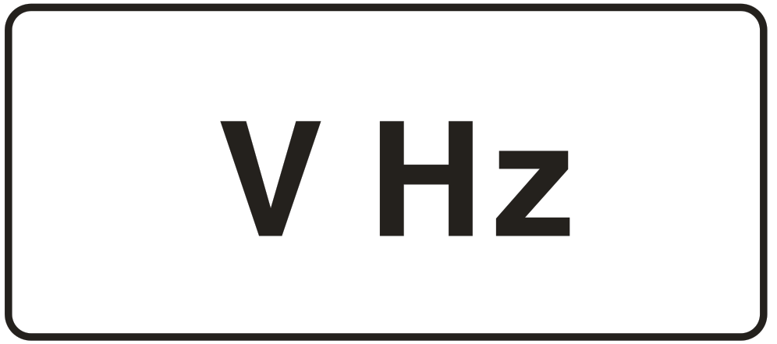 | Selects voltage or frequency function

2 Basic Operation

2.1 Measure and Source
This section acquaints you with some basic operations of ETX-2025/ ETX-1825.
Proceed as follows to perform a voltage-to-voltage test:
- Connect the calibrator’s the voltage output to its voltage input as shown in Figure 2.1-1.
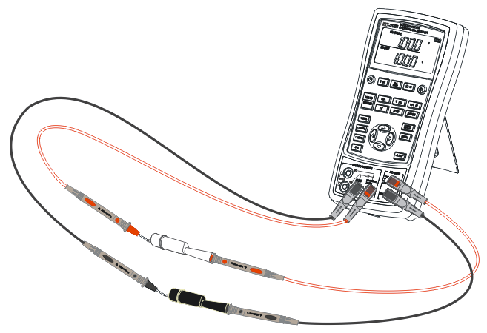
Figure 2.1-1
- Press  more than 2 seconds to turn on the calibrator. The screen will display all the contents for 1 second as shown in Figure 2.1-2.
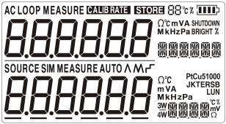
Figure 2.1-2
- Then the type of product and automatic shutdown time will be displayed for 2 seconds as shown in Figure 2.1-3.
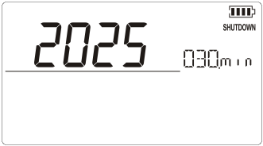
Figure 2.1-3
- Then the default interface of boot will be displayed as shown in Figure 2.1-4:
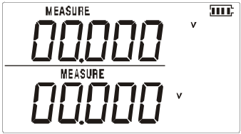
Figure 2.1-4
Attention: The upper and lower default modes are both based on DC voltage during turn on.
- Press for SOURCE mode (lower screen). The screen will display as shown in Figure 2.1-5.
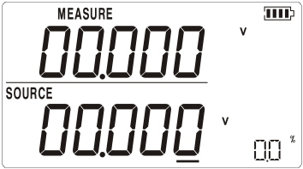
Figure 2.1-5
- Press or to increase or decrease 1 of the number that locates at the line (the number automatic carry but the position of the line have no change). Press or to select a digit to change.
- Press to select 1 V for the output value, and then press and hold until the buzzer work to enter 1V as the 0% value.
- Press to select 5 V for the output value, and then press and hold until the buzzer work to enter 5V as the 100% value.
- Press and to step between 0 and 100% in 25% step increments. The screen will display as shown in Figure 2.1-6
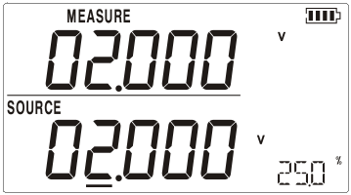
Figure 2.1-6

2.2 Shut Down Mode
The calibrator comes with the Shut Down mode enabled for a time duration set to 30 minutes (displayed for about 2 seconds when the calibrator is initially turned on). When the Shut Down mode is enabled, the calibrator will automatically shut down after the time duration has elapsed from the time the last key was pressed. To disable the Shut Down mode, press and simultaneously. To enable the mode, press and simultaneously. To adjust the time duration, press and simultaneously, the screen will display as shown in Figure 2.2-1,then press and/or to adjust the time between 1 and 30 minutes and press to store the new duration time (Without pressing any key for 5 seconds, the calibrator will exit automatically).
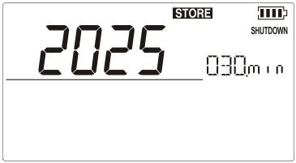
Figure 2.2-1

2.3 Backlight brightness Adjustment
To adjust the brightness of backlight, proceed as follows:
- Press and simultaneously until “BRIGHT” is displayed as shown in Figure 2.3-1.
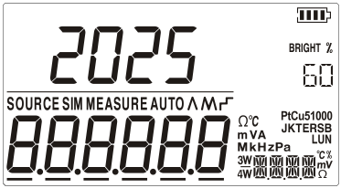
Figure 2.3-1
- Press and to adjust the brightness of backlight.
- Press to save brightness level, will appear and then the calibrator will enter into the work mode (Without pressing any key for 5 seconds, the calibrator will exit automatically).

3 Functions of Upper Display

3.1 DC V and DC mV Measurement
The default function of the upper screen is DC V measurement after turn on. Press to select DC V or DC mV and the connection is shown in Figure 3.1-1.
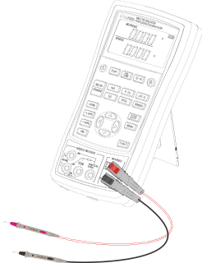
Figure 3.1-1

3.2 DC mA Measurement
Press to select DC mA(unit:),the sign should not be displayed and connection is same to that of DC V measurement.

3.3 Current Measurement with Loop Power
The loop power function activates a 24 V supply in series with the current measuring circuit, allowing you to test a transmitter when it is disconnected from plant wiring. To measure current with loop power, proceed as follows:
- Connect the calibrator to the transmitter current loop terminals as shown in Figure 3.3-1.
- Press until and appear simultaneously.
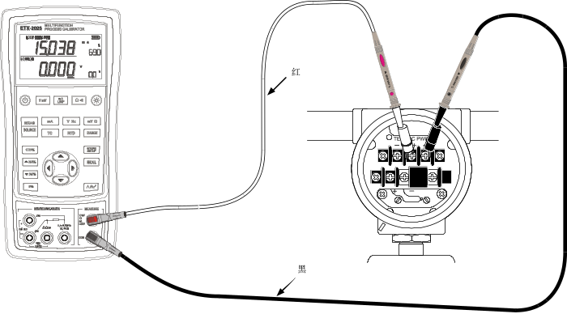
Figure 3.3-1

3.4 Resistance measure and continuity test
Press to select resistance measurement or continuity test function circularly with the unit of Ω and the connection is the same as DC V measurement. In the continuity test function, the buzzer works when the measured value less than 50Ω.

4 Functions of Lower Display
The state of the upper display remains unchanged during the operation of the lower display.

4.1 Measure and Source of DC V and DC mV
The lower display default function is DC V measurement after trun on. If necessary, press or to select DC V or DC mV function and press to switch measure and source mode. The connection is shown in Figure 4.1-1.
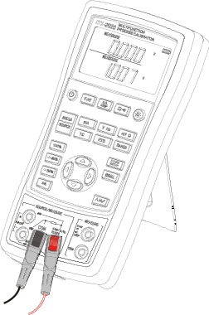
Figure 4.1-1

4. 2 DC mA Measurement
Press to select mode, press to select DC mA measuring function with the unit of . The connection is shown in Figure 4.2-1.
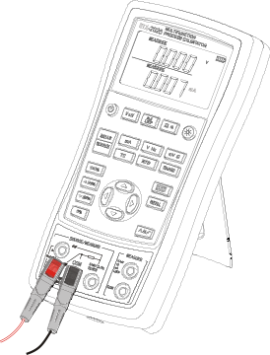
Figure 4.2-1

4.3 DC mA Source（active）
Press to select mode. If necessary, press to select DC mA source with the unit of and then the calibrator can implement current output. The connection is shown in Figure 4.3-1.
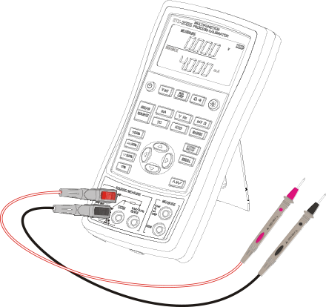
Figure 4.3-1
When the output load is too heavy,  sign will appear in the display as shown in Figure 4.3-2. and, at the same time, the main value of lower display will flash, which means that the actual output current cannot reach the set value, so you should check connection and load accordingly.
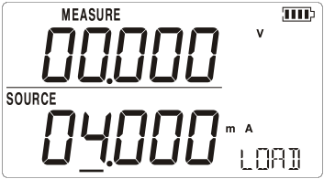
Figure 4.3-2

4.4 Simulating a 4- to 20-mA Transmitter
Simulate is a special mode of operation in which the calibrator is connected into a loop in place of a transmitter and supplies a known, settable test current.
Proceed as follows:
- Connect the 24 V loop power source as shown in Figure 4.4-1.
- If necessary, press to select mode.
- Press until and (simulation) are displayed in the screen.
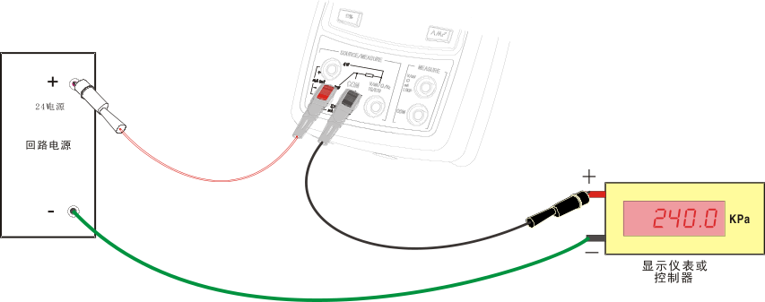
Loop
Power
Supply
Display device
Figure 4.4-1

4.5 Measure and Source of Resistane

Measure
Press to select mode. If necessary, press to select resistance function with the unit of . The interface is shown in Figure 4.5-1:
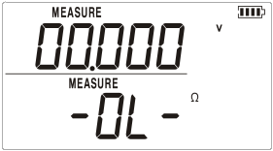
Figure 4.5-1
Attention: Over range indicate when the connection open.
Resistance measurement supports the connection types of two-wire, three-wire and four-wire. The calibrator can be switched to three-wire or four-wire according to actual connecting type. The respective connecting types are shown in Figure 4.5-2:
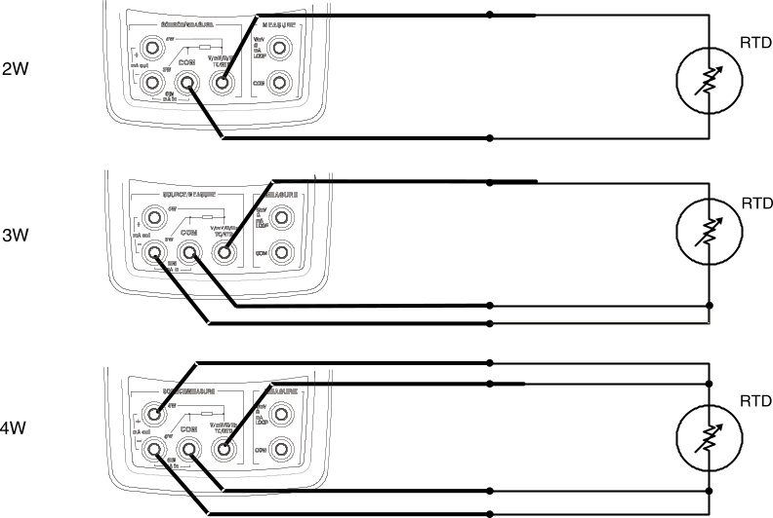
Figure 4.5-2
Press or to select a 2-, 3-, or 4- wire connection and then the calibrator will not detect the connecting type automatically unless you quit the mode of resistance measurement and reenter.

Source
Press to select mode. If necessary, press to select resistance function with the unit of . The connecting type is the same as DC V measurement. Press to switch resistance output range.(Resistance source includes 400 range and 3200 range, as shown in Figure 4.5-3 and Figure 4.5-4 )
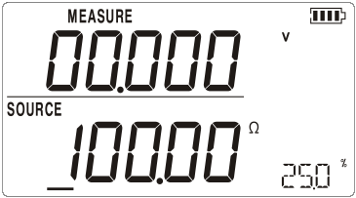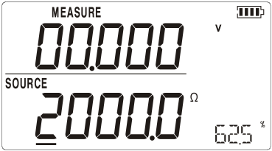
Figure 4.5-3 Figure 4.5-4
Attention: The Figure 4.5-3 is 400 range and the Figure 4.5-4 is 3200 range.

4.6 Measure and Source of Frequency

Measure
Press to select mode, press to select frequency, its unit is . The connection is same to DC V measurement. The screen will display as shown in Figure 4.6-1
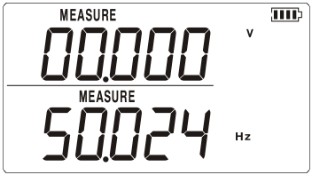
Figure 4.6-1

Source
Press to select mode. If necessary, press to select frequency, its unit is . The connection is same to DC V measurement. Press to select source range. The screen will display as shown in Figure 4.6-2.
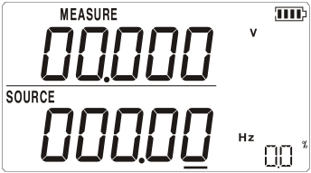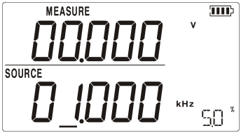
Figure 4.6-2
Attention: The left is of 200.00Hz range and the right is of 20.000kHz range.
5 Temperature Measurement

5.1 Using Thermocouples (TC)
The calibrator supports ten standard thermocouples, including type E, N, J, K, T, B, R, S, L, or U. Lower table summarizes the ranges and characteristics of the supported thermocouples.

Type | Positive Lead Material | Negative Lead Material | Specified Range（℃）
E | Chromel | Constantan | -200～950
N | Ni-Cr-Si | Ni-Si-Mg | -200～1300
J | Iron | Constantan | -200～1200
K | Chromel | Alumel | -200～1370
T | Copper | Constantan | -200～400
B | Platinum (30% rhodium) | Platinum (6% rhodium) | 600～1800
R | Platinum (13% rhodium) | Platinum | -20～1750
S | Platinum (10% rhodium) | Platinum | -20～1750
L | Iron | Constantan | -200～900
U | Copper | Constantan | -200～400

To measure temperature using a thermocouple, proceedas follows:
- Connect the thermocouple to the calibrator as shown in Figure 5.1-1:
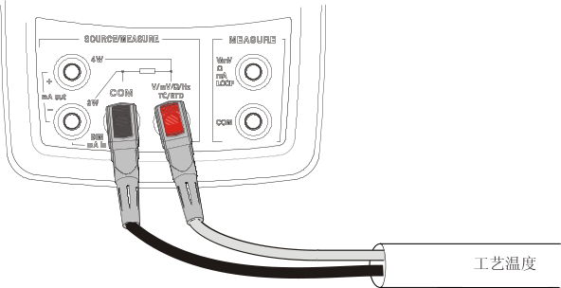
TC
Figure 5.1-1
Attention : If the calibrator and the thermocouple plug are at different temperatures, wait one minute or more for the connector temperature to stabilize after you plug the miniplug into the TC input/output.
- Press to select mode.
- Press for the TC display. If desired, continue pressing this key to select the desired thermocouple type as shown in Figure 5.1-2.
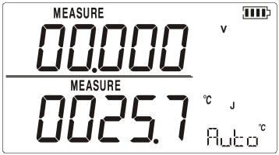
Figure 5.1-2
- Press to display the DC mV value reading as shown in Figure 5.1-3. The DC mV value continue to display for 3s and then automatically return to the original display.
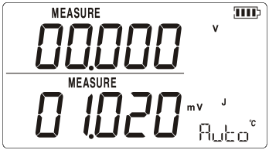
Figure 5.1-3
There are two kinds of cold end temperature compensation for thermocouple measurement, automatic compensation directly using machine internal cold end temperature compensation and manual compensation through the key to set the cold end temperature compensation by the user.

5.1.1 Automatic compensation
First entered the thermocouple measurement mode, the default of the cold end temperature compensation is automatic compensation reading as shown in Figure 5.1.1-1.The sign represents that the current cold end temperature compensation is automatic compensation. If you need further view current automatic cold end temperature compensation value,you have to operation  key. Reading as shown in Figure 5.1.1-1,after press key, the sign is replaced for current automatic cold end temperature compensation value as 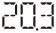. The value continue to display for 2s and then automatically return to the sign.
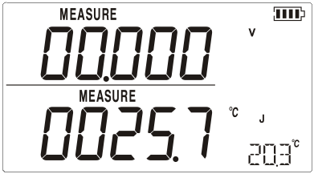
Figure 5.1.1-1

5.1.2 Manual compensation
Manual compensation through the key to set the cold end temperature compensation by the user, the following steps shall be followed:
- Press key to enter the set mode, reading as shown in Figure 5.1.2-1, the appear of sign shows that entering the setup mode, the assistant value 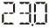 means the value of manual compensation.
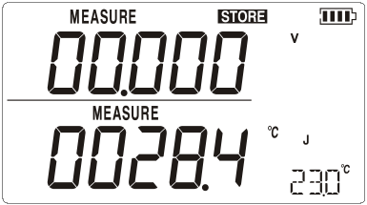
Figure 5.1.2-1
- If you need to adjust the manual compensation value, press  keys to adjust.
- Press key to save the value of manual compensation and exit from the setup mode at the same time, reading as shown in Figure 5.1.2-2.
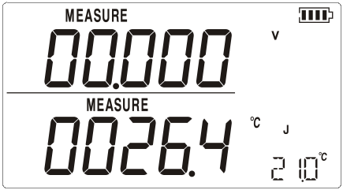
Figure 5.1.2-2
- If necessary, press key return to automatic compensation.

5.2 Using Resistance Thermometer Detector (RTD)
The calibrator accepts RTD types of Pt100, Pt1000, Cu50 and Cu100.The calibrator accepts RTD measurement inputs in two-, three-, or four-wire connections, with the three-wire connection the most common. A four-wire configuration provides the highest measurement precision, and two-wire provides the lowest measurement precision.
To measure temperature using an RTD input, proceed as follows:
- Press to select mode.
- Press for the RTD display. If desired, continue pressing this key to select the desired RTD type.
- The calibrator can detect the connecting type automatically,and you can Press or to select a 2-, 3-, or 4- wire manually.

6 Simulation of temperature sensor

6.1 Simulating Thermocouples
Connect calibrator input/output terminal to the instrument to be tested using the thermocouple. The connecting diagram is shown in Figure 6.1-1. Proceed as follows to simulate a thermocouple:
- Connect the thermocouple to the TC input/output plughole of the calibrator.
- If necessary, press to select mode.
- Press for the TC display. If desired, continue pressing this key to select the desired thermocouple type.
- Enter the temperature you want by pressing and keys. Press or keys to select a different digit to edit.
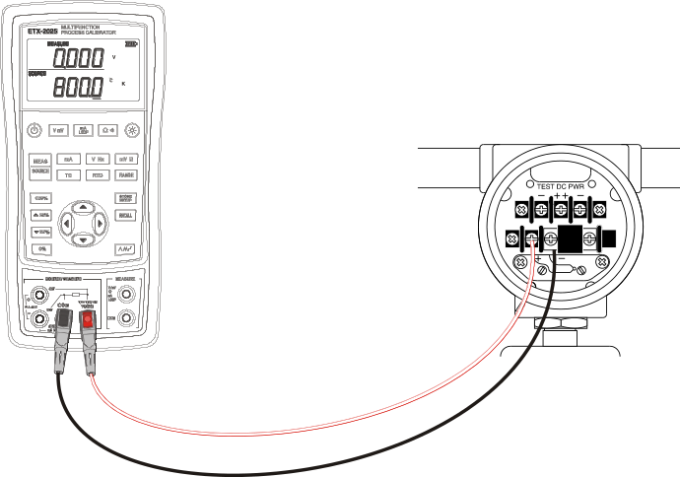
Figure 6.1-1
- Press to display the DC mV value. The DC mV value continue to display for 3s and then automatically return to the original display.

6.2 Simulating RTD
Connect the calibrator and the instrument to be tested according to the Figure 6.2-1. Proceed as follows to simulate RTD:
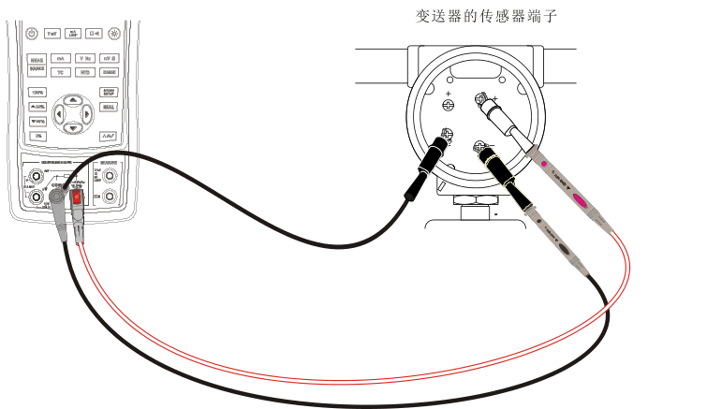

Figure 6.2-1
Attention:
Third-wire (3 W) and Fourth-wire (4 W) terminals are just for measurement, not simulation. The calibrator can simulate a two-wire RTD source in the front panel. To be connected to a third-wire or Fourth -wire transducer, folding cable can be sued to used as extra wiring.
- If necessary, press to select mode.
- Press for the RTD display. If desired, continue pressing this key to select the desired RTD type..
- Enter the temperature you want by pressing and keys. Press or keys to select a different digit to edit.
- In case that the calibrator displays or , the exciting current of calibrator has exceeded the limit. The screen will display as shown in Figure 6.2-2.
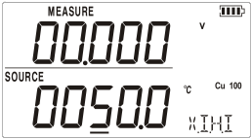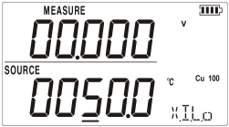
Figure 6.2-2

7 Advanced Application

7.1 Setting 0 % and 100 % Output Parameters
As for stepping operation and percentage display, 0% and 100% should be set before using. The default values have been set when delivered from the factory and set values are listed below:
Source function | 0% value | 100% value
DC V | 0.000 V | 10.000 V
DC mV | 0.00 mV | 100.00 mV
DC mA | 4.000 mA | 20.000 mA
Resistance 400Ω | 0.00 Ω | 400.00 Ω
Resistance 3200Ω | 0.0 Ω | 3200.0 Ω
Frequency 200Hz | 0.00 Hz | 200.00 Hz
Frequency 2,000Hz | 0.0 Hz | 2000.0 Hz
Frequency 20 kHz | 0.000 kHz | 20.000 kHz
TC - J model | 0.0 ℃ | 1000.0 ℃
TC - K model | 0.0 ℃ | 1000.0 ℃
TC - T model | 0.0 ℃ | 400.0 ℃
TC - E model | 0.0 ℃ | 800.0 ℃
TC - R model | 0 ℃ | 1500 ℃
TC - S model | 0 ℃ | 1500 ℃
TC - B model | 600 ℃ | 1800 ℃
TC - N model | 0.0 ℃ | 1000.0 ℃
Pt100 | 0.0 ℃ | 500.0 ℃
Pt1000 | 0.0 ℃ | 400.0 ℃
Cu50 | 0.0 ℃ | 150.0 ℃
Cu100 | 0.0 ℃ | 150.0 ℃
The default set values may not meet your requirements, so you can reset them. Press and hold or to reset 0% and 100% value until the buzzer works. The reset value will be stored in the storage space of the calibrator automatically and remains effective after restart. Now you can start operation with the reset value:
- Manually stepping an output with 25 % increments.
- Jump between the 0 and 100 % span points by momentarily pushing or .

7.2 Auto Ramping the Output
Auto ramping gives you the ability to continuously apply a varying stimulus from the calibrator to a transmitter, while your hands remain free to test the response of the transmitter. When you press , the calibrator produces a continuously repeating 0 % - 100 % - 0 % ramp in your choice of three ramp waveforms :
- 0%-100%-0% 40-second smooth ramp
- 0%-100%-0% 15-second smooth ramp
- 0%-100%-0% Stair-step ramp in 25 % steps, pausing 5 seconds at each step.
Press any key to quit ramp output function.

7.3 Factory Reset
Factory reset consists of the following items:
- The upper and lower working modes recover to DC V measurement function.
- Automatic shutdown time is reset to be 30 min and becomes effective.
- LCD backlight brightness is reset to be 60%.
- Output range is recovered to be factory default.
Press and simultaneously until the buzzer work and the factory reset is executed .

7.4 Calibrating a Transmitter
Use the measurement (upper display) and source (lower display) modes to calibrate a transmitter. This section applies to all but pressure transmitters. The following example shows how to calibrate a temperature transmitter.
Connect the calibrator to the instrument under test as shown in Figure 7.4-1. Proceed as follows to calibrate a transmitter:
- Press to select loop current (upper display) .
- Press (lower display). If desired, continue pressing this key to select the desired thermocouple type.
- If necessary, press to select source mode.
- Set your zero and span parameters by pressing and keys. Enter these parameters by pressing and holding and . For more information on
- setting parameters, see “Setting 0 % and 100 %” earlier in this manual
- Perform test checks at 0-25-50-75-100 % points by pressing or . Adjust the transmitter as necessary.

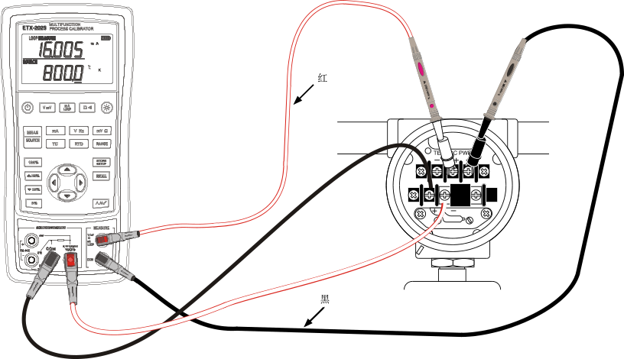
red
black
Figure 7.4-1

8 Power
The calibrator needs 6 disposable LR03 model (size 7) alkaline batteries or 6 R03 model (size 7) nickel-metal hydride batteries (or nickel-cadmium batteries). The longest service life of alkaline batteries can reach 50 hours.
A 12V/1A power adaptor is used for charging and providing working power for the calibrator.

8.1 Charge
When the battery indicator is pointed at , the remaining electric quantity is less than 20%. Charge is necessary for normal operation of the calibrator. The LCD backlight will start operation and the will display on the screen when the power adaptor is used. If the battery indicator flashes, the calibrator will be in the charging process, after which the battery indicator will stop flashing.
The calibrator will stop charge automatically in case of the following circumstances:
- Disposable batteries are used.
- Electric quantity is enough.
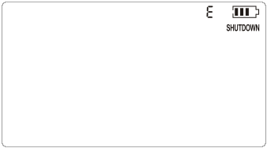
Figure 8.1-1
Interface of Charging indicator in the standby mode

9 Specifications
Specifications are based on a one year calibration cycle and apply from +18 C to +28 C unless stated otherwise. All specifications assume a 10 minute warmup period.

9.1 DC Voltage Measurement
Range | Maximum measurement range | Resolution | Accuracy ( % of reading + counts)
Range | Maximum measurement range | Resolution | ETX-1825 | ETX-2025
28V  (upper display) | -33V～33V | 0.001V | 0.05+2 | 0.025+2
200mV  (upper display) | -80mV～80mV | 0.001mV | 0.05+20 | 0.025+20
200mV  (upper display) | -200mV～200mV | 0.01mV | 0.05+2 | 0.025+2
50V  (lower display) | -1V～60V | 0.001V | 0.05+2 | 0.02+2
100mV  (lower display) | -15mV～80mV | 0.001mV | 0.05+20 | 0.02+20
100mV  (lower display) | 80mV～125mV | 0.01mV | 0.05+2 | 0.02+2
-10℃～18℃，+28℃～55℃ temperature coefficient,±0.005%FS/℃.
Input resistance: ＞1MΩ.

9.2 DC Voltage Source
Range | Maximum output range | Resolution | Accuracy ( % of reading + counts)
Range | Maximum output range | Resolution | ETX-1825 | ETX-2025
100mV | -15mV～99.999mV | 0.001mV | 0.05+20 | 0.02+20
100mV | 100mV～125mV | 0.01mV | 0.05+2 | 0.02+2
10V | 0～11V | 0.001V | 0.05+2 | 0.02+2
-10℃～18℃，+28℃～55℃ temperature coefficient,±0.005%FS/℃.
Maximum load: 1mA or 1kΩ （It should be based on the lower load.）

9.3 DC mA measurement
Range | Maximum measurement range | Resolution | Accuracy ( % of reading + counts)
Range | Maximum measurement range | Resolution | ETX-1825 | ETX-2025
20mA  (upper display) | -24mA～24mA | 0.001mA | 0.05+2 | 0.025+2
20mA  (loop of upper display) | 0～24mA | 0.001mA | 0.05+2 | 0.025+2
20mA  (lower display) | 0～24mA | 0.001mA | 0.05+2 | 0.02+2
-10℃～18℃，+28℃～55℃ temperature coefficient,±0.005%FS/℃..

Input resistance:＜100Ω.

9.4 DC mA source
Range | Maximum output range | Resolution | Accuracy ( % of reading + counts)
Range | Maximum output range | Resolution | ETX-1825 | ETX-2025
20mA | 0～24mA | 0.001mA | 0.05+2 | 0.02+2
20mA  (Transducer simulation) | 0～24mA | 0.001mA | 0.05+2 | 0.02+2
-10℃～18℃，+28℃～55℃ temperature coefficient,±0.005%FS/℃.
Maximum load voltage: 20V, equivalent to voltage of 20mA on 1000Ω load resistance.

9.5 Resistance Measurement (upper display)
Range | Maximum output range | Resolution | Accuracy ( % of reading + counts)
Range | Maximum output range | Resolution | ETX-1825 | ETX-2025
400Ω | 0～440Ω | 0.1Ω | 0.05+2
3200Ω | 420Ω～3300Ω | 1Ω
On-off test | 0～200Ω | 1Ω | 0.05+1
-10℃～18℃，+28℃～55℃ temperature coefficient,±0.005%FS/℃.
Maximum load voltage: 20V, equivalent to voltage of 20mA on 1000Ω load resistance.

9.6 Resistance measurement (lower display)
Range | Maximum measurement range | Resolution | Accuracy（Ω）
Range | Maximum measurement range | Resolution | ETX-1825 |  | ETX-2025
Range | Maximum measurement range | Resolution | Two-wire, three-wire | Four-wire | Two-wire, three-wire | Four-wire
400Ω | 0～440Ω | 0.01Ω | 0.25 | 0.15 | 0.15 | 0.10
3200Ω | 420Ω～3600Ω | 0.1Ω | 1.5 | 1.0 | 1.0 | 0.5
-10℃～18℃，+28℃～55℃ temperature coefficient,±0.005%FS/℃.
Exciting current during measurement:
400Ω：0.4mA±10%；
3200Ω：0.2mA±10%。
Two-wire: Does not include lead resistance.
Three-wire: Assumes matched leads with a total resistance not exceeding 25Ω.

9.7 Resistance source
Range | Maximum output range | Resolution | External exciting current | Accuracy (Ω)
 |  |  |  | ETX-1825 | ETX-2025
400Ω | 0～440Ω | 0.01Ω | 0.40mA～2.50mA | 0.25 | 0.15
3200Ω | 400～3600Ω | 0.1Ω | 0.1mA～0.6mA | 1.0 | 0.50
-10℃～18℃，+28℃～55℃ temperature coefficient,±0.005%FS/℃.

9.8 Frequency measurement
Range | Maximum measurement range | Resolution | Accuracy ( % of reading + counts)
Range | Maximum measurement range | Resolution | ETX-1825 | ETX-2025
100Hz | 1~99.999Hz | 0.001Hz | 0.02+1 | 0.01+1
1000Hz | 100~999.99Hz | 0.01Hz | 0.02+1 | 0.01+1
10kHz | 1k~9.9999kHz | 0.1Hz | 0.02+1 | 0.01+1
100kHz | 10k~99.999kHz | 1Hz | 0.02+1 | 0.01+1
Sensitivity: 10Hz～10kHz，Vp-p≥1V; rest:Vp-p≥2V.
Wave form: Square wave. 5 counting points should be added to errors of other wave forms. Commercial frequency can be measured directly.

9.9 Frequency source
Range | Maximum output range | Resolution | Accuracy ( % of reading + counts)
Range | Maximum output range | Resolution | ETX-1825 | ETX-2025
200Hz | 0~200Hz | 0.01Hz | 0.02+1 | 0.01+1
2000Hz | 0~2000Hz | 0.1Hz | 0.02+1 | 0.01+1
20kHz | 0~20kHz | 1Hz | 0.02+1 | 0.01+1
Output amplitude: ≥4.5Vp-p；
Wave form: Square wave

9.10 Temperature, thermocouples
Graduation | Range | Resolution | Accuracy (℃)
Graduation | Range | Resolution | ETX-1825 | ETX-2025
J | -200℃～0℃  0℃～1200℃ | 0.1℃ | 1.5℃  1.0℃ | 1.0℃  0.7℃
K | -200℃～0℃  0℃～1370℃ | 0.1℃ | 1.8℃  1.2℃ | 1.2℃  0.8℃
T | -200℃～0℃  0℃～400℃ | 0.1℃ | 1.8℃  1.2℃ | 1.2℃  0.8℃
E | -200℃～0℃  0℃～950℃ | 0.1℃ | 1.5℃  1.0℃ | 0.9℃  0.7℃
R | -20℃～0℃  0℃～500℃  500℃～1750℃ | 0.1℃ | 4℃  2.5℃  2℃ | 2.5℃  1.8℃  1.4℃
S | -20℃～0℃  0℃～500℃  500℃～1750℃ | 0.1℃ | 4℃  2.5℃  2℃ | 2.5℃  1.8℃  1.5℃
B | 600℃～800℃  800℃～1000℃  1000℃～1800℃ | 0.1℃ | 3.5℃  2.5℃  2℃ | 2.2℃  1.8℃  1.4℃
N | -200℃～0℃  0℃～1300℃ | 0.1℃ | 2.0℃  1.2℃ | 1.5℃  0.9℃
Errors of cold-junction compensation are not included in the table.
Accuracy of cold-junction compensation: 1.5℃

9.11 Temperature, RTD
Graduation | Range | Resolution | Accuracy (℃)
Graduation | Range | Resolution | ETX-1825 |  |  | ETX-2025
Graduation | Range | Resolution | 2-wire  3-wire | 4-wire | Output | 2-wire  3-wire | 4-wire | Output
Pt100 | -200℃～850℃ | 0.1℃ | 0.7 | 0.4 | 0.7 | 0.4 | 0.3 | 0.3
Pt1000 | -200℃～650℃ | 0.1℃ | 0.4 | 0.3 | 0.3 | 0.3 | 0.15 | 0.15
Cu50 | -50℃～150℃ | 0.1℃ | 1.2 | 0.8 | 0.8 | 0.8 | 0.5 | 0.5
Cu100 | -50℃～150℃ | 0.1℃ | 0.7 | 0.4 | 0.4 | 0.4 | 0.25 | 0.25
As for exciting current during measurement, please refer to resistance measurement function.
As for allowable external exciting current during output, please refer to resistance output function.
2-wire: Does not include lead resistance.
3-wire: Assumes matched leads with a total resistance not exceeding 25Ω.

10 Product Accessories

10.1 Standard Accessories
ETX-2025/ETX-1825 multifunction process calibrator also includes the following:
- hard spot test leads (two sets)
- alligator clips (two sets)
- One 12V/1A power adaptor
- ETX-2025/ETX-1825 Users Manual
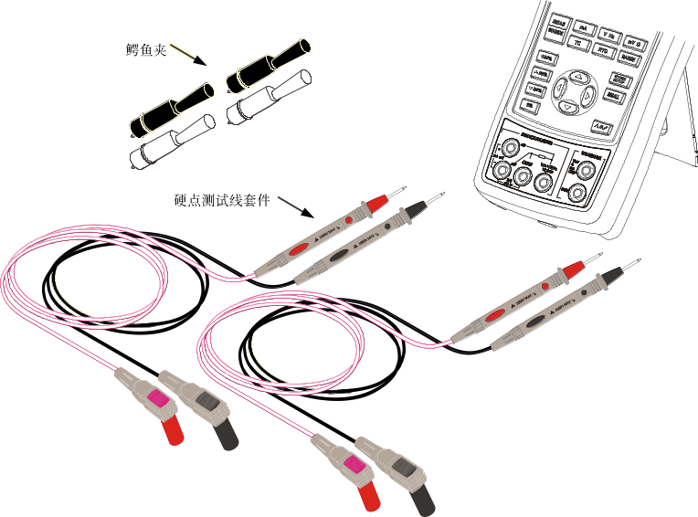
Hard spot test leads
Alligator clip
Figure 10.1-1

10.2 Optional Accessories
- 6 R03-model rechargeable batteries
- 1 Metal Box
- Communication line

11 Warning
To avoid possible electric shock or personal injury:
- Test a given voltage to confirm its normal operation before using. Mutual authentication of the upper and lower display data, for instance.
- Please follow all the safety operation procedures.
- Select the proper function and range gear according to measurement requirements.
- Confirm that the battery door has been closed before application.
- Remove the test line of the calibrator before opening the battery door.
- Check whether damaged or exposed metal exists in test line and whether the test line has been conducted. Replace the damaged test line before using.
- Do not touch the metal contact when the detector is used.
- Connect the common line and then electric test line. As for wire removal, electric test line should be removed first.
- Don't use the calibrator under any abnormal conditions. Calibrator should be repaired because it may have been damaged.
- Don’t use the calibrator near explosive gases.
- Remove test line before changing measurement or output function.
- 6 LR03-model (size 7) alkaline batteries or R03-model nickel-metal hydride batteries (or nickel-cadmium batteries) should be used in the calibrator and the battery should be placed inside the meter housing.
- To avoid reading error and possible electric shock or personal injury when the screen displays the battery under-voltage, please replace or charge the battery.

