EC1840 Electronic clock manual -V1.01
Because this clock has many functions, please read this manual carefully. Thank you for your cooperation。

目录
I. A Brief Introduction to the Principle of the Clock 2
II. Function introduction 2
1. Digital tube display 2
2. clock precision 2
3. Time setting 2
4. Clock calibration 2
5. Voice output 2
6. Download ring 2
7. Broadcast time 2
8. Hourly Alarm 2
9. Alarm clock 2
10. Boot music 3
11. Temperature display 3
12. Temperature Broadcasting Function 3
13. Brightness Adjustment Function 3
14. 12/24hours system 3
15. Sunday display 3
16. Stopwatch 3
17. Count down 3
18. Restore Factory Defaults 3
19. Some possible errors 3
III. Hardware introduction 4
IV. Electrical properties 5
V. Electronic clock display and key function 6
1. Time display 6
2. Time setting 6
3. Hourly alarm and Alarm Clock Settings 6
4. Function Settings 10
5. Stopwatch and countdown 11
VI. Bell download tutorial 13
1. Audio Processing Software 13
2. Download ring 16
(1). Connect computer 16
(2). Increase or decrease ringtone 17
(3). Put the bell back to the clock 17
(4). Restart Clock 18

- A Brief Introduction to the Principle of the Clock
Using digital tube to display the time which is read from the clock chip by MCU and the temperature collected by thermistor ,and the parameters are displayed when you setting the parameters.
The parameters of time and clock are all set by keys.The clock chip is powered by the backup battery to keep the clock running normally after the power is cut off. So you don't have to set the time every time you turn on the power. The single chip computer collects the brightness of the environment through the photoresistor,And control the time of the digital tube is on and off to realize automatic brightness display. The singlechip reads the audio files in the memory chip, and then outputs them to the speaker after data processing, so that the music can be played. When the clock enters the download mode of ringtone, the clock will become a U disk, and the ringtone can be increased or decreased on the computer.
- Function introduction
- Digital tube display
There are red, green, blue and white digital tubes to choose . Users can also switch to other color digital tubes by themselves.
Power-on defaults to the time, temperature, year, month, day, week display, through the button can be set only to show time or only show time and temperature (set in the "time display settings".
- clock precision
There are DS1302 and DS3231 clock modules can be choose .
When using DS1302 module as clock, the cost is relatively low, but the travel time accuracy can not be guaranteed. Some modules may have errors of several seconds a day, which is a normal phenomenon. It is not recommended to buy the clock of DS1302 edition because of the high requirement of travel time accuracy.
When using DS3231 module as clock, the cost will be higher, but the travel time is accurate. Officially declared accuracy is +2 ppm (that is, an error of about 1 minute per year). Please refer to the technical data of DS3231 for detailed parameters. It is recommended to buy the clock of DS3231 version for high travel time accuracy.
- Time setting
You can set the time by pressing the button. When the battery is installed correctly on the clock module, even when the clock is powered off, it will run normally, and the time will be reset every time the power is turned on.
- Clock calibration
Because this clock is a suite, the clock will inevitably have errors after welding, in order to maximize the accuracy of the clock, so do this function.
Clock error can be corrected by setting error time and error amount.For example, if the clock is 2 seconds faster every 24 hours, then the error time is set to 24, and the error amount is set to -2.If every 24 hours is 8 seconds slower, the error time can be set to 3, and the error is set to 1.
- Voice output
Use the speaker to output voice. Since the speaker needs a cavity to produce a loud and pleasant sound, it is recommended to buy a clock with a case. There are many music in the memory chip, which can be set to the alarm clock, the hourly alarm and the ring tone of the boot. Volume size can be set.
- Download ring
This suite can download music to the clock as a ringtone. See the bell download tutorial for more details.
- Broadcast time
Press the PLUS key to broadcast the current time. Timing can be set in Chinese or English.
- Hourly Alarm
Can turn on/off. When on, when the current time meets both the hour point and the time-reporting period, the time-reporting period can be set (for example, when 8 a.m. to 22 p.m., the other time is not alarm). Timing bells and language (Chinese or English) can be set.
- Alarm clock
There are four independent alarm clocks, which can be closed or opened separately. The alarm time, alarm tone and alarm mode can be set separately.
When the alarm clock is turned on and the current time meets the alarm clock's hour, minute and mode at the same time, the alarm will ring.
When the alarm time exceeds the set alarm time or when alarm, press the MODE button to stop the alarm.
Snooze function: when the alarm is ringing Press PLUS key then the ring will pause , it will ring again after five minutes.
There are Six alarm clock modes to meet various needs.
Alarm mode 0: Ordinary alarm clock will ring every day.
Alarm mode 1: Workday alarm clock 1, Monday to Friday ring, Saturday, the day does not ring.
Alarm clock mode 2: weekend alarm clock 1, alarm happen on Saturdays and Sundays, Monday to Friday no alarm.
Alarm mode 3: Workday alarm 2, alarm happen on Monday to Saturday, Sunday no alarm.
Alarm mode 4: weekend alarm 2, alarm happen on Sunday alarm, Monday to Saturday no alarm.
Alarm mode 5: A single alarm clock will automatically turn off the alarm clock after one alarm.
- Boot music
When turn on clock , a piece of music will be played automatically. You can choose any music in the memory chip as boot music. Of course, if you don't like it, you can also set it not play music on power.
- Temperature display
The ambient temperature is measured by a thermistor. Can be set to Celsius or Fahrenheit display. Temperature calibration can be done when the temperature is not correct (set in "Temperature Calibration Settings") (for example, when the display temperature is 3 degrees higher than the actual temperature, set the temperature calibration value to - 3).
- Temperature Broadcasting Function
Broadcast the current temperature after the time broadcast. The temperature can also be set without broadcasting.
- Brightness Adjustment Function
The ambient brightness is measured by a photoresistor. When the automatic brightness function is turned on, the brightness of the clock can be automatically changed with the brightness of the ambient light. When the automatic brightness function is turned off, the clock brightness can be manually adjusted (a total of 100 levels of brightness can be adjusted).
- 12/24hours system
The default is 24-hour system, which can be set to 12-hour system by keystrokes (set in 12/24 setting mode).
- Sunday display
It's incorrect to show Sunday as 7. The correct display should be “日”, but considering people's habits and foreigners may not familiar with “日”. When the clock is showing Sunday, press the MODE key to set Sunday to “日” or 7.
- Stopwatch
Stopwatch minimum timing 0.01 seconds, maximum timing 48 hours.
- Count down
The maximum countdown time is 48 hours. There will be music playing after the countdown.
- Restore Factory Defaults
Turn off the clock and remove the memory battery. Wait for about two minutes, then turn on the clock.
- Some possible errors
(1). Display“Err1”.The clock module is not welded properly or incorrectly.
(2). Display“Err2”.Thermistor (Temperature Measuring Circuit) not welded well or welded incorrectly
(3). Display“Err3”.Photoresistor (photoelectric circuit) has not been welded well or has been welded incorrectly.
(4). Display“Err4”.Sound memory chip error.
(5). Display“Err5”.The number of sound files in sound memory chips is insufficient.

- Hardware introduction
Size ：
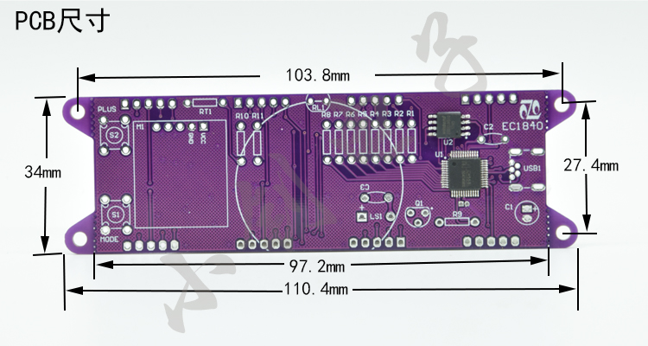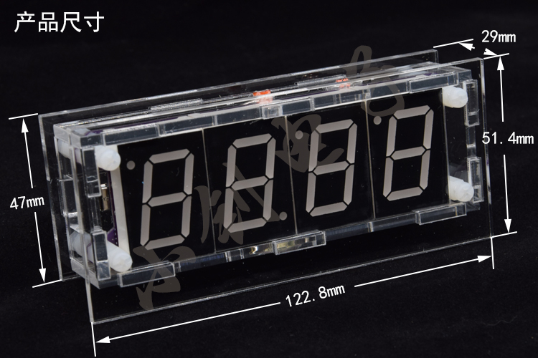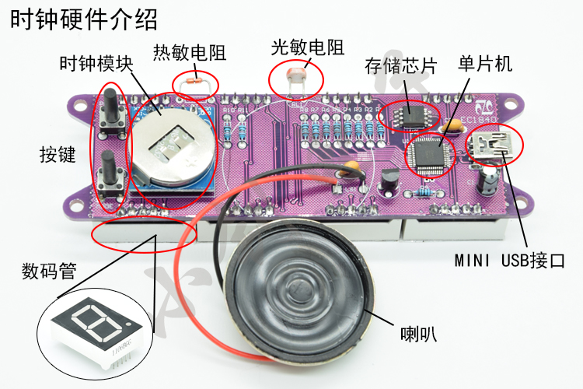
Weight ：
Finished product without shell: 82g
The finished product contains shell: 168g
- Electrical properties
Power supply: DC5V
Working current ：<60MA
Alarm current ：<300mA
working temperature ：0~40℃

- Electronic clock display and key function
- Time display
 | Display description | MODE Key Function | PLUS Key Function
Time display mode (power-on default mode) | There are three display modes: 1. Time, temperature, year, month, day and week. 2. Wheel display of time and temperature. 3. Display time only. | 1.Long press for 1 second to Enter the time setting mode.  2.Long press for 3 second seconds to enter the hourly and clock alarm.  3.Long press for 5 seconds to enter Function settings  4.When displaying Sunday, the displaying mode of Sunday can be changed.  5.When displaying temperature, it can be switched to Celsius or Fahrenheit. | 1、 Temperature, year, month, day and week rotation display  2、 Hold the MODE key first and then press the PLUS key to enter Seconds mode setting.  3、Broadcast time  4、When the alarm rings, enter the snooze mode (the alarm clock is suspended and will ring again in 5 minutes).

- Time setting
This setting can modify the time of the clock. If there is no button to press for 10 seconds under each setting, the time display will be automatically returned and the time before it will be restored.
Mode | Display description | MODE Key Function | PLUS Key Function
Time display mode |  |  | Long press 1 second into Year Setting
Year Setting | Four digital tube flashing shows “Year” | Set “Year”, long press can quickly set | Into Month Setting
Month Setting | front two tube flashing shows “Month”, after two tube always shows “Day” | Set “Month”, long press can quickly set | Into Day Setting
Day Setting | Front two tube always shows “Month”, after two tube flashing shows “Day” | Set “Day”, long press can quickly set | Into Hour Setting
Hour Setting | Front two tube flashing shows “Hour”, after two tube always shows “H” when 24 hour system, when 12 hour system shows ”A” in am, shows “P” in pm. | Set “Hour”, long press can quickly set | Into Minute Setting
Minute Setting | Front two tube always shows “Hour”, after two tube flashing shows “Minute” | Set “Minute”, long press can quickly set | Into Second Setting
Second Setting | Front two tube always shows “--”, after two tube flashing shows “Second” | Set “Second”, long press can quickly set | If there is a time to adjust, save the settings, otherwise not save the settings, and return time display mode.
For example, when we want to set the clock to 8:00:00/1/1/2009, the value of "year" will set to 2019, the value of "month" to 1, the value of "day" to 1, the value of "hour" to 8, the value of "minute" to 0 and the value of "second" to 0.

- Hourly alarm and Alarm Clock Settings
Under every setting mode, if the MODE key is pressed for 3 seconds or 10 seconds without any buttons, the time display mode will be returned automatically and the settings will be saved.
Mode | Display description | MODE Key Function | PLUS Key Function
Time display mode |  |  | Long Press MODE Key for 3 seconds to Enter Hourly alarm Switch Settings
Hourly alarm Switch Settings | The first two digital tubes display "01" , and the second two digital tubes display "ON" or "OF" in flicker, indicating that the function of turning on or off the hourly alarm. | Turn on or off the hourly alarm | When the hourly alarm is turned on, enter the start time of the hourly alarm setting.  When turning off the hourly alarm, enter to set Chinese or English as time report language .
Hourly alarm Start Time Settings | The first two digital tubes display "02" , and the second two digital tubes flashing display the start time . | Set the start time (e.g. set the start time to 8 and the end time to 22, then every whole point hour from 8:00 to 22:00 a.m. will alarm). | Enter the Hourly alarm end Time Settings
Hourly alarm end Time Settings | The first two digital tubes display "03" , and the last two digital tubes flashing display the end time . | Set the end time (for example, set the start time to 8, the end time to 22, then every whole point of the day from 8:00 to 22:00 will be reported). | Enter the Hourly alarm Ring Settings
Hourly alarm Ring Settings | The first two digital tubes display "04" , and the second two digital tubes flicker to display the name of the bell. | Setting the Hourly alarm bell | Enter Chinese/English report time setting
Chinese/English report time setting | The first two digital tubes display "05" , while the second two digital tubes display "ON" or "OF" in flicker, indicating the time in English or Chinese . | Setting alarm in Chinese or English | Enter alarm clock 1switch setting.
Alarm clock 1 switch setting. | The first two digital tubes display "10" , and the second two digital tubes display "ON" or "OF" in flicker, respectively, to turn on or off alarm clock 1. | Turn on or off alarm clock 1 | When the alarm clock 1 is turned on, the alarm clock 1 is set.  当关闭闹钟1时，进入闹钟2开关设置。  When the alarm clock 1 is turned off, enter the alarm clock 2 switch setting.
The hour of alarm clock 1 setting | The first two digital tubes display "11", while the second two digital tubes flicker to show the hour of alarm clock 1. | When setting hour of alarm clock 1, long press can be set quickly. | Enter the minute of alarm clock 1 setting
The minute of alarm clock 1 setting | The first two digital tubes display "12" in length, and the second two digital tubes flicker to show the minute of alarm clock 1. | Set the minute of alarm clock 1, long press can be set quickly. | Enter alarm time for alarm clock 1 setting
Alarm time for alarm clock 1 setting | The first two digital tube show "13", and the second two digital tubes flicker to show the alarm time of alarm clock 1. | Can set the alarm time of alarm clock 1’s range is 1 to 20 minutes. | Enter the ring of alarm clock 1 setting
The bell of alarm clock 1 setting | The first two digital tubes display "14" in length, and the second two digital tubes flicker to show the name of the bell of alarm clock 1. | Set the bell of alarm clock 1. | Enter alarm clock 1 mode settings
Alarm clock 1 mode settings | The first two digital tubes display "15" in length, and the second two digital tubes flicker to show the mode of alarm clock 1. | Set alarm mode of alarm clock 1. | Enter alarm clock 2 switch settings
Alarm clock 2 switch settings | The first two digital tubes display "20" in length, and the second two digital tubes display "ON" or "OF" in flicker, indicating that the alarm clock 2 is turned on or off. | Turn on or off alarm clock 2 | When the alarm clock 2 is turned on,enter the hour of alarm clock 2 setting.  When the alarm clock 2 is turned off, enter the alarm clock 3 switch setting.
The hour of alarm clock 2 setting. | The first two digital tubes display "21" in length, while the second two digital tubes display the hour of alarm clock 2 in flicker. | When setting the hour of alarm clock 2, long press can be set quickly. | Enter the minute of alarm clock 2 setting
The minute of alarm clock 2 setting | The first two digital tubes show "22", and the second two digital tubes flicker to show the minute of alarm clock 2 . | Set the minute of alarm clock 2 points, long press can be quickly set. | Enter alarm time for alarm clock 2 setting
Alarm time for alarm clock 2 setting | The first two digital tube show "23", and the second two digital tubes flicker to show the alarm time of alarm clock 2. | Can set the alarm time of alarm clock 1’s range is 1 to 20 minutes. | Enter the ring of alarm clock 2 setting
The ring of alarm clock 2 setting | The first two digital tubes display "24" in length, and the second two digital tubes flicker to show the name of the alarm clock 2. | Set the bell of alarm clock 2 | Enter alarm clock 2 mode settings
Alarm clock 2 mode settings | The first two digital tubes display "25" in length, and the second two digital tubes flicker to display alarm clock 2’s mode. | Set alarm mode of alarm clock 2. | Enter alarm clock 3 switch settings
Alarm clock 3 switch settings | Front 2 bits of digital tube  always shows”30”,after two  tube flashing shows”ON”or “ OF”indicates Turn on or off  the alarm clock 3. | Turn on or off the alarm clock  3 | When the alarm clock 3 is turned on ， enter the alarm clock 3 setting. When the alarm clock 3 is turned  off ，enter the alarm clock 4 setting.
Alarm clock 3’s hour  setting | Front 2 bits of digital tube  always shows”31”,after two  tube flashing display shows  Alarm clock 3’s hour | Set Alarm clock 3’s hour ，  Long press can be set quickly | Enter the alarm clock 3’s minute  setting
Alarm clock 3’s  minute setting | Front 2 bits of digital tube  always shows”32”,after two  tube flashing display shows  Alarm clock 3’s minute | Set alarm clock 3’s minute ，  Long press can be set quickly. | Enter the alarm clock 3’s bell rings  time length setting
Alarm clock 3’s bell  rings time length  setting | Front 2 bits of digital tube  always shows”33”,after two  tube flashing display shows  alarm clock 3’s bell rings time  length | Set the alarm clock 3’s bell  rings time length ,Set the  range from 1 to 20 minute. | Enter the alarm clock 3’s bell setting
Alarm clock 3’s bell  setting | Front 2 bits of digital tube  always shows”34”,after two  tube flashing display shows  alarm clock 3’s bell name | Set the alarm clock 3’s bell | Enter the alarm clock 3’s mode  setting
Alarm clock 3’s mode  setting | Front 2 bits of digital tube  always shows”35”,after two  tube flashing display shows  alarm clock 3’s mode | Set the alarm clock 3’s mode. | Enter alarm clock 4 switch setting
Alarm clock 4 switch  setting | Front 2 bits of digital tube  always shows”40”,after two  tube flashing shows”ON”or “ OF”indicates Turn on or off  the alarm clock 4. | Turn on or off the alarm clock  4 | When the alarm clock 4 is turned on ， enter the alarm clock 4 setting. When the alarm clock 4 is turned  off,Return time display mode.
Alarm clock 4’s hour  setting | Front 2 bits of digital tube  always shows”41”,after two  tube flashing display shows  Alarm clock 4’s hour. | Set Alarm clock 4’s hour ，  Long press can be set quickly. | Enter the alarm clock 4’s minute  setting
Alarm clock 4’s  minute setting | Front 2 bits of digital tube  always shows”42”,after two  tube flashing display shows  Alarm clock 4’s minute | Set alarm clock 3’s minute ，  Long press can be set quickly. | Enter the alarm clock 4’s bell rings  time length setting
Alarm clock 4’s bell  rings time length  setting | Front 2 bits of digital tube  always shows”43”,after two  tube flashing display shows  alarm clock 4’s bell rings time  length | Set the alarm clock 4’s bell  rings time length ,Set the  range from 1 to 20 minute. | Enter the alarm clock 4’s bell setting
Alarm clock 4’s bell  setting | Front 4 bits of digital tube  always shows”44”,after two  tube flashing display shows  alarm clock 4’s bell name . | Set the alarm clock 4’s bell | Enter the alarm clock 4’s mode  setting
Alarm clock 4’s mode  setting | Front 2 bits of digital tube  always shows”45”,after two  tube flashing display shows  alarm clock 4’s mode. | Set the alarm clock 4’s mode. | Return to time display mode and  save settings

- Function Settings
In each setting mode, if the MODE key is pressed for 3 seconds or 10 seconds without any buttons, the time display mode will be
returned automatically and the settings will be saved.
Mode | Display description | MODE Key Function | PLUS Key Function
Time display mode |  |  | Press the MODE for 5 seconds to Enter automatic brightness switch settings .
Automatic brightness  switch setting | Front 2 bits of digital tube  always shows”1-”,after two  tube flashing display shows “ON”or“OF”to express turn  on or off Automatic brightness  function. | Turn on or off Automatic brightness  function. | When Automatic brightness function is turned off，Enter brightness settings.  When Automatic brightness function is turned on，Enter temperature calibration settings.
Brightness setting | Front 2 bits of digital tube  always shows”2-”,after two tube flashing display shows Optical control class parameters. | Brightness setting（Range from 01 to 100 and when 100 is shown to be 00).  This feature is not effective until the automatic brightness function is turned off. | Enter temperature calibration settings.
Temperature calibration setting | Front 2 bits of digital tube  always shows”3-”,after two tube flashing display shows Temperature calibration value | Setting temperature calibration values，The range is -9～10.For example, when the display temperature is 3 degrees higher than the actual temperature,，Set the calibration value to -3. | Enter temperature broadcast switch setting
Temperature broadcast switch setting | The first two digital tubes always display "4-" , and the second two digital tubes display "ON" or "OF" in flicker,indicating the function of turning on and off the temperature report | Turn on or off temperature reporting function | Enter 12/24 hour Display setting
12/24 hour Display setting | Front 2 bits of digital tube  always shows”5-”,after two tube flashing display shows“ON”or“OF”to express 12 hour or 24 hour display. | 12/24 hours display setting | Enter time display mode setting
Time display mode setting | Front 2 bits of digital tube  always shows”6-”,after two tube flashing display shows time display mode | Set display mode(3 kinds in total )0：Display time only.1:Time, temperature, year, month, day, week display in turn.2：Time, temperature in turn. | Enter volume settings
Volume settings | The first two digital tubes always display "7-" and the second two digital tubes flicker to display volume. | Set Volume (Level 5 Volume | Enter boot music switch settings
Boot music switch settings | The first two digital tubes always display "8-" , and the second two digital tubes display "ON" or "OF" in flicker, which means playing music or not playing music when booting up,. | Set up to play or not play music on boot | When setting the boot music playing, enter the boot music setting.  当设置开机不播放音乐时，返回时间显示模式并保存设置。  When setting boot-up without playing music, return to time display mode and save settings.
Boot music setting | The first two digital tubes always show the "9-" and the second two digital tubes flicker to show the name of the boot music. | Set up boot music | Enter Error Time Settings
Error Time Settings | The first two digital tubes always display "A-" , while the second two digital tubes display the error time of the flickering clock | Set the error time (range 0-96). For example, if the clock is 2 seconds faster every 24 hours, then the error time is set to 24 and the error amount is set to -2. | Enter Error amount Settings
Error amount Settings | The first two digit tubes display "b-", and the second two digit tubes flickering display the error amount . | Set the error (range - 6 ~ 6). For example, if the clock is 2 seconds faster every 24 hours, then the error time is set to 24 and the error amount is set to -2. | Return the time display mode and save the settings.

- Stopwatch and countdown
Mode | display mode | PLUS Key Function in Current Mode | MODE Key Function in Current Mode
Time display mode |  | Press the MODE key first, then the PLUS key to enter the second display.
Second display | Stopwatch | Short press can start or pause timing, long press more than 1 second can start timing again。 | Enter the next mode (Countdown Settings
Countdown Settings | The first two digital tubes always display "A1" , and the second two digital tubes flicker to show countdown’s hour. | Set the value of countdown’s hour | Enter the next mode (countdown’s minute settings)
Countdown’s minute settings | The first two digital tubes always show "A2" and the second two digital tubes flicker to show the countdown’s minute. | Set the value of countdown minutes | Enter the next mode (countdown’s second settings
Countdown’s second settings | The first two digital tubes always display "A3" , and the second two digital tubes flicker to show the countdown second. | Set the value of countdown seconds | Enter the next mode (Countdown End Ring Settings
Countdown End Ring Settings | The first two digital tubes always display "A4" , and the second two digital tubes flicker to show the serial number of the end of the countdown bell. | Set the ringing tone at the end of the countdown | Enter the next mode (countdown display mode
Countdown display mode | Count down |  | Return time display mode

- Bell download tutorial
This clock can update its internal ringtone by using our downloader. The specific operation is as follows, please follow the order, otherwise the download may not be successful.
- Audio Processing Software
Due to the limited processing capacity of MCU, it can not process all audio files. At present, only WAV files can be processed, and the audio sampling rate can not exceed 16K, the sampling number is 8 bits, mono channelThis parameter file is hard to find on the internet, so it's better to convert it by software itself.
Here we recommend to use GoldWave software, the official download address is http://www.goldwave.com, this software is not free, if you want to use it for a long time, it is recommended to buy. Please click Installation after downloading. Installation is simple. Just follow the next step and finish it. After installation, the interface is as follows:
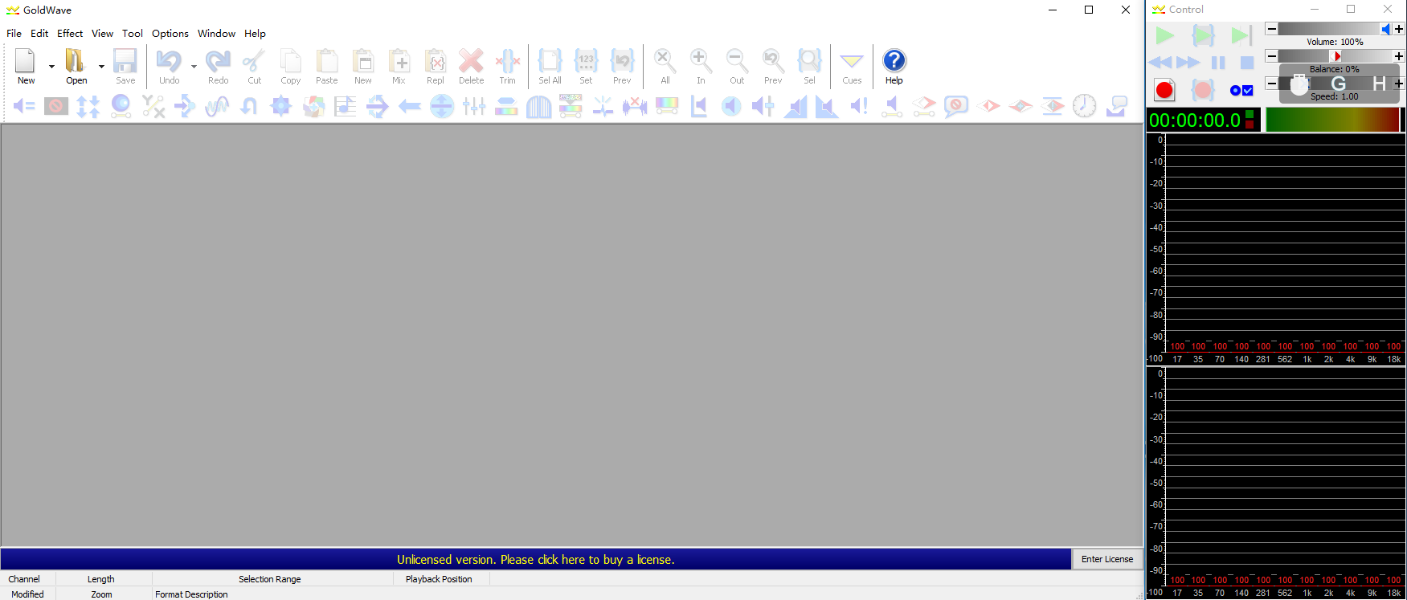
After installation, you can modify the parameters of an audio file.
首先打开一个音频文件。
First, open an audio file.
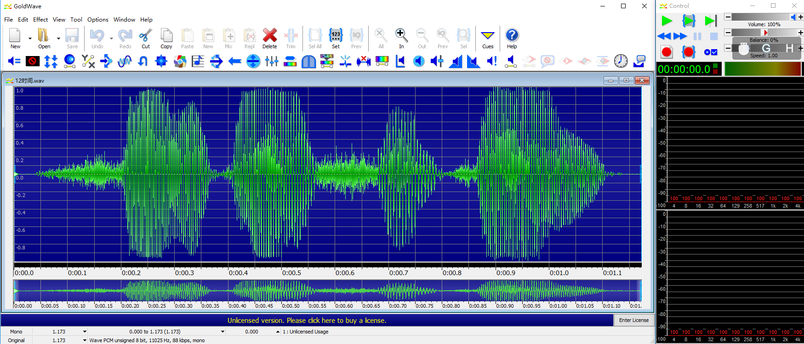
Modify the sampling rate first and click Effect - > Resample. Following this picture
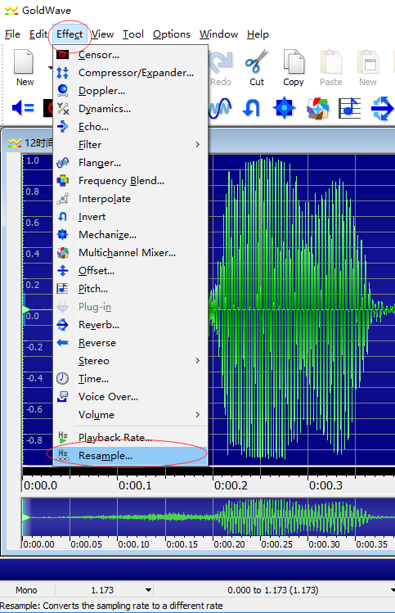
Then the sampling rate is selected in the large pop-up dialog box, and the maximum sampling rate supported by the MCU is 16 000. Click OK after selection.
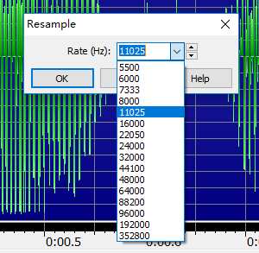
Next Select File -> Save as
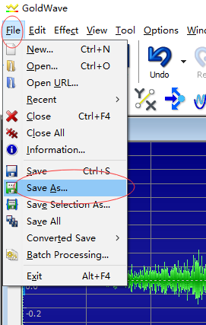
Select the saved file type in the pop-up dialog box as wav。
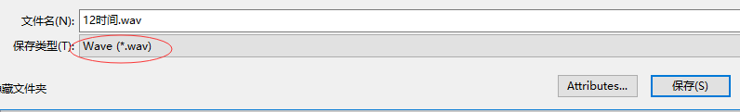
Click Attributes select PCM unsigned 8bit, mono,Just click OK and save it.
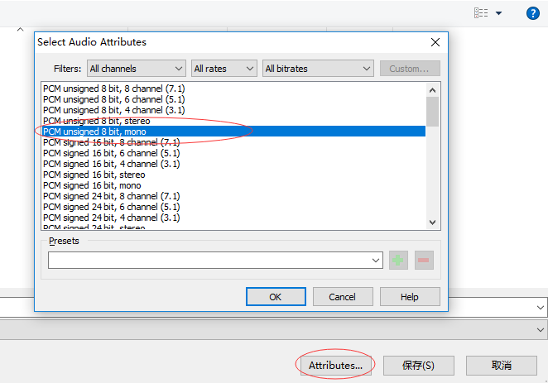

- Download ring
小钊电子出品
小钊电子出品

(1). Connect computer
Hold the MODE key of the clock and connect the clock to the computer with a USB cable. The clock will display A001, and the computer will Identify the clock as a U disk. As shown in the following figure ：
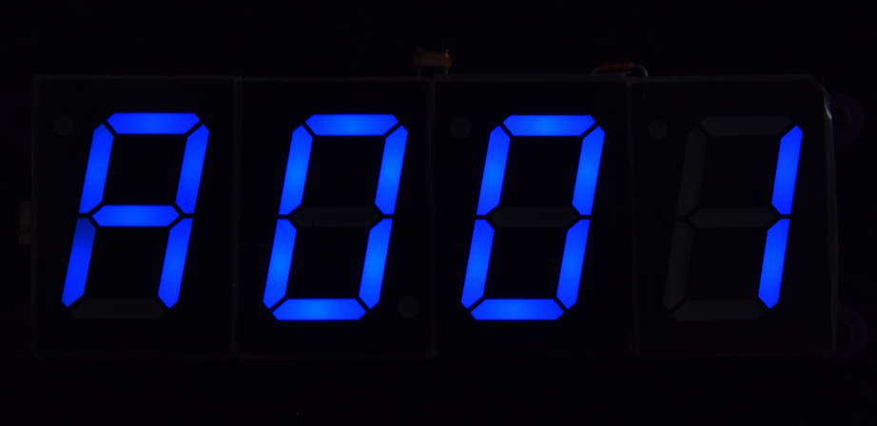

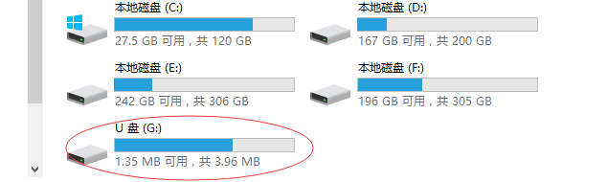
点开后，里面有3个文件夹：
Among them, 01 folder is Chinese voice file, 02 folder is English voice file, 03 folder is ringtone file.
Some computers will prompt you to format the U disk. At this time, it should be formatted according to the steps of putting ring back to the clock, and then download the sound from the network disk into the clock.

(2). Increase or decrease ringtone
Then all the folders are copied to the computer and the ringtone files are added or deleted on the computer. The contents of folders 01 and 02 can not be changed. If the change may cause a time error, only the ringing tone can be added or reduced in folder 03.
There should be at least two ringtones in folder 03 or the clock will fail. The first two word of ringtone files must be numbers, and the length of the file name should not exceed 8 characters (one Chinese character is two characters). After adding or subtracting, the total size of all files can not exceed the capacity of U disk, otherwise it can not be put in. As shown in the following figure ：
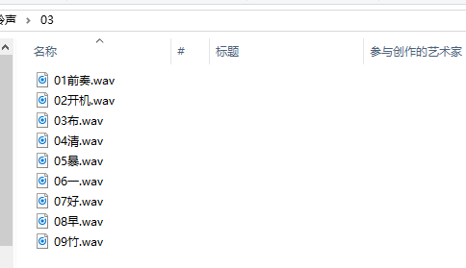

(3). Put the bell back to the clock
After the ringtone modification is completed, the sound file can be put back into the clock. First, format the U disk, right-click on the U disk, choose formatting.
On the pop-up dialog box, select the default configuration size,then click start button, and wait for the formatting to complete.
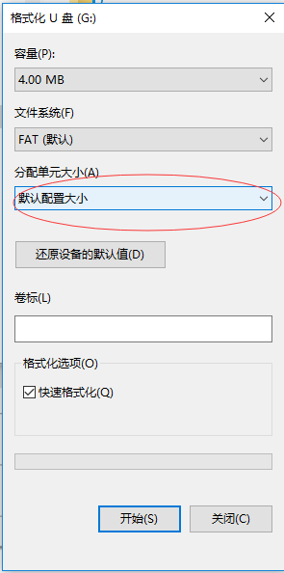
Once be formatted, it becomes an empty U disk. Then put all the sound files together with the folder and just copied back into the U disk.

(4). Restart Clock
Finally, power the clock back on.

