TGC201 Intelligent Signal Generator
This instrument is mainly used in the industrial field PLC and process instrument electric valve and so on, the operation is simple, the standby time is long, the volume is small, the weight is light, the precision is good, and so on.
1, Technical Parameters:
MA : active current 0-24mA output, resolution 0.01mA, the maximum load of 750 euro, 0.1%FS.
MAK : passive current 0-24mA output, resolution 0.01mA, the maximum negative power supply 30V, 0.1%FS.
V : voltage 0-12V output, resolution 0.01V, maximum current 0.1%FS, 24mA.
24V : 24V voltage output, drive current 24mA, error 10%
0-24V output resolution, 0.01mA input impedance of 100 ohm, 0.1%FS.
0-30V input resolution, 0.01V input impedance is 2.5MK, 0.2%FS.
Single 3.7V lithium battery power supply, the specific use of time according to the use of the situation, the 20mA output lasts about 10 hours.
Using the environment of 0 ℃ -50 ℃.
USB power supply and charging.
The output has a reverse connection with over current protection, the protection voltage 30V.
Meter size: 90*70*28mm.
2, Operation Panel
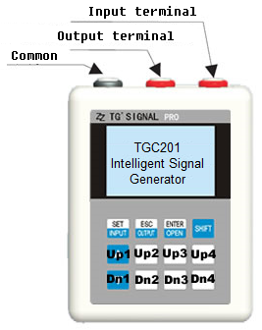 | 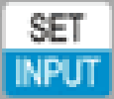 | When the input signal switching /  setting parameter to edit keys
The output signal switching /
setting parameters Exit
Output switching /
setting parameters saved Exit
 |  | Key combination
 | Upx | Separately for each digit addition and subtraction
 | Dnx
3, Basic Operation
Picture 1(Single task mode) | Picture 2(Double task mode)
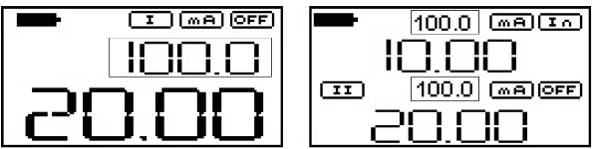
Picture 1: only the input or output of a signal, the purpose is to show a large number of body. | Picture 2: at the same time input or output for in regulating valve and some special applications on the screen as the input signal, the second half of the screen for output signal.
Screen Description: instrument at the factory default screen 2 to screen 2 will be described here, the figure can be ignore digital picture frames, large digital signal output and input on half the screen as the input signal, the lower half of the screen the output signal, MA figure represents current output, can be switched by oUTPUT key.
Icon indicates that the output is turned OFF, press the OPEN button to open the output, then OFF will turn ON, then it indicates signal is output to be worth noting here that, in mA / mAk / 24V output, ON icon and OC when alternating, it represents an open, will become OUT Once connected to the load and the output value is not zero, it indicates ON when the display is connected directly to the load, the voltage output.

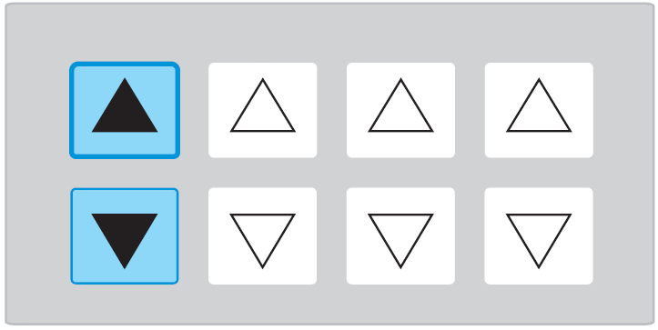 | Panel operation: on the panel: the four groups of 4 digit plus or minus key corresponding to each of the addition and subtraction operation.
4, Corresponding to the set range (in order to remove the test range conversion calculation and design)
For the range displayed in the work of digital picture frame (above), it just does not affect the output corresponding to the output range display, 4-20mA output in the regulation, it can display the corresponding range 4-20mA, 4-20mA such correspondence 0-100.0 display or can be modified to correspond -50,0-50.0 4-20mA, this feature eliminates the need to calculate the amount of the requirements of the instrument to display makes setup easy input function well.
■SHFIT+ INPUT keys: Outgoing set the current input signal.
Current Input Settings | Voltage Input Settings | Explanation
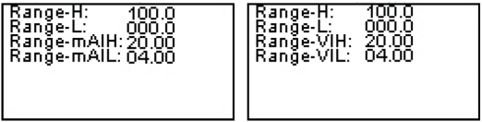 |  |  | Rang-H: to show the upper limit,
 |  |  | Rang-L: lower limit display.
 |  |  | Range-mAIH / Range-VIH: upper limit corresponding to the output,
 |  |  | Range-mAIL / Range-VIL: the lower limit of the corresponding output.
Instance： when current input setting screen how to set up, when adjusting the output, the output of 4-20mA corresponds to 0.12mA (median) showed 50,20mA display 100.
Output range setting function and input range basically the same function | Explanation
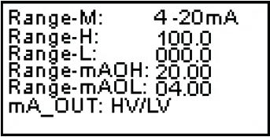 | Range-M: a signal indicating the amount of output range  Current: 0-24mA / 4-20mA / 0-20mA / 0-10mA / USER  Voltage: 0-12V / 0-10V / 1-5V / 0-5V / USER  Select the USER, the output range is determined by the Range-mAOH.
Current picture: mA_OUT voltage current output no-load, when choosing HV is 24V, the choice LV is 16V, this feature is designed to reduce power consumption, 24V time will shorten battery life, but in some demanding situations is necessary to load voltage of 24V can be driven.
■SHFIT + OUTPUT keys: Outgoing set the current output signal.
■Panel INPUT / SET key is the edit key, after the modification is completed, press again INPUT / SET to finish.
■Panel OUTPUT / ESC keyboard to exit without saving.
■Panel OPEN / ENTER to exit the keyboard to save.

5, SHIFT keys use
Learn to use key combinations, bring a lot of convenience to the user when debugging.
Press the SHIFT key on your keyboard and hold it down, will appear on the screen FN +.
SHFIT + XXX indicates SHFIT press release after press a combination of other keys.
SHFIT & XXX represents hold SHFIT combination.

No. | Composite key | Function Description
1 | SHFIT + INPUT keys | Outgoing set the current input signal
2 | SHFIT + OUTPUT keys: | Outgoing set the current output signal.
3 | SHFIT + OPEN key: | Clear output value of the current settings.
4 | SHFIT + UP1 key: | Output signal 25% of the increment.
5 | SHFIT + DN1 key: | Output signal 25% of the reduction operation.
6 | SHFIT + UP2 key: | Quick output signal of 0% semaphore.
7 | SHFIT + DN2 key: | Quick output signal 25% of the semaphore.
8 | SHFIT + UP3 key: | Quick output signal 50% of the semaphore.
9 | SHFIT + DN3 key: | Quick output signal 75% of the semaphore.
10 | SHFIT + UP4 key: | Quick output signal 100% of the semaphore.
11 | SHFIT + DN4 key: | Quick output signal 125% of the semaphore.
12 | SHFIT + SHFIT: | SHFIT + screen icon disappears.
13 | SHFIT & UP1 key: | Output quickly switch to mA.
14 | SHFIT & UP2 key: | Output to quickly switch to Voltage.
15 | SHFIT & UP3 key: | Output quickly switch to mAk.
16 | SHFIT & UP4 key: | Output 24V.
17 | SHFIT & DN1 key: | The input signal is mA.
18 | SHFIT & DN2 key: | The input signal is Voltage.
19 | SHFIT & DN3 keys: | Preset settings.
20 | SHFIT & DN3 key: | Backlight switch.
21 | SHFIT & OPEN key: | Work screen change.
22 | SHFIT & INPUT key: | ATOA signal conversion feature set.
23 | SHFIT & OUTPUT keys: | programmable output settings.
6, Application Examples
Output voltage and current to the meter or PLC | Electric control valve testing, output current, and feedback current measure
Passive Current Output
Two-wire sensor connection Description | In this case the instrument analog two-wire transmitter
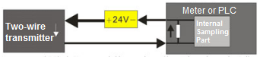 | 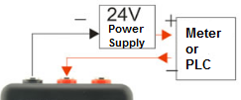
Here the two-wire sensor requires an external 24V voltage enables correct sampling instrument
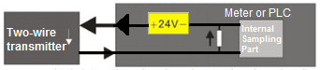
Part Instrumentation and PLC in order to reduce the external power supply measuring sensor wiring, 24V integrated in the inside of the instrument

24V Output Test Sensor
Two-wire transmitter test methods | Three-wire sensor test method
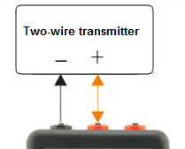 | 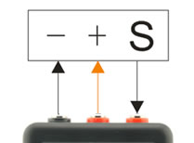
Meter output 24V, for the two-wire transmitter power supply, measured feedback current | In this case, the application can be flexible, such as sensor supply 12V, output voltage function using output 12V, and can measure the output signal of the sensor. If the 24V power supply, you can select 24V output, but only if the current sensor does not work more than 24ma, it may cause the success rate is less than the phenomenon, or sensor not working properly

7, Programmable Output (PROG)
Programmable output can be programmed to automatically change the order of output, mainly used for valve aging, automatic process of testing and other functions, just set the parameters, you can automatically output function rule consists of several parts: test start value is automatically increased the amount of the step value, the incremental delay, the end of the incremental value, the end of the residence time, auto-decrement step value, decreasing the delay, the delay is decremented to the initial value of the composition, for current, voltage, passive current output , you can set the parameters, easy to set up all kinds of signals, 24V unavailable programmable outputs.
■Hold down the SHIFT key, press the OUTPUT key to exhale, programmable output settings menu.
No. | Settings | Explanation
1 | Number OT: 00000 | Measuring cycles (0, unlimited output)
2 | Start Val: 00.00 | Test start value
3 | UP step: 00.00 | To automatically increment step value
4 | Step Time： 000.00S | Incremental delay
5 | Stop Val： 00.00 | Incremental end value
6 | Stop Time： 000.00S | End residence time
7 | Down Step: 00.00 | Auto decrement step value
8 | Step Time： 000.00S | Decreasing delay
9 | Stop Time： 000.00S | Decremented to delay the initial value of the composition
■After the parameter setting, press the OPEN key to exit, parameters are saved automatically.
■After return to the main screen, press OUTPUT key, you can open the programmable output function, the following is a description of the
various function keys:
UP1: Program Begins.
DN1: Program Pause.
UP4: Program Reset.
DN4: Exit the Program.
You can get a special output waveform timing by the parameter.
●Rising sawtooth:
Simply drop decrement step value change value of the entire process, for example, the end is the beginning is 4mA 20mA, then simply auto-decrement step value to 16, rising sawtooth occur.
●Sawtooth decline:
And rising sawtooth similar principle, but under the automatic incremental step value changes, you can let the program step to the end value, and then drop by the timing.
●Square wave output:
Start end value is 4mA 20mA, then just change automatically in incremental steps and auto-decrement step value is 16mA, and then set up residence time, you can get a square wave.
Setting the delay time change affects wave frequency, frequency control within 10HZ, frequency too high will produce a waveform not smooth phenomenon.
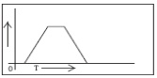 | 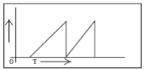 | 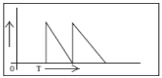
Normal output timing | Rising sawtooth | Decline sawtooth
 | 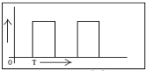
 | Square-wave output timing

8,The Signal Conversion Function (A TO A):
TG201 can be used for signal conversion functions, such as 0-10V input into 4-20mA output, for some temporary conversion function can play a significant role.
Hold down the SHFIT key while pressing INPUT button outgoing signal conversion menu, set just a script, in addition to other 24V output signal outputs are valid.
No. | Settings | Explanation
1 | Iput-H : 00.00 | Input limit.
2 | Output-H : 00.00 | Output limit.
3 | Iput-L: 00.00 | Input limit.
4 | Output-L: 00.00 | Output limit.
5 | Over range: OFF / ON | Overrange allowed
6 | ADC-Fast: OFF / ON | Fast acquisition on.
●Over range Function Description: If you set the input signal is 4-20mA output 1-5V when, Over rang to OFF, the input signal is less than 4mA, the output is still 1V, Over rang is ON, output still follows the input changes. But it will not exceed the limit, such as maximum output voltage 12V, after exceeding the limit output is still 12V. Press INPUT button to start signal conversion script, press DN4 exit the script.
9, Output Function Setting
Application: When in use, only a few to a few fixed amount of test signals on the line, do not need to continuously adjustable output, so users need to use this feature, please learn function described below.
●Use in the previous page 5.SHFIT bonds have a fixed semaphore quick output function, and then press the SHFIT key combination can subtract the output signal of a fixed amount, in fact, this feature can also be pre-set output semaphores, so this menu you can switch this function, which switches the fixed value and the setpoint.
●When the instrument is turned on through four sets of plus or minus keys to modify the output signal of continuous quantity, through the menu settings to boot as fast signal output.
●Semaphore save, semaphores can be saved by setting the time and are not saved when power off.
●The instrument has an output switch function, you can set up, you can save the output of the last shutdown was on and off.
Parameter Description:
No. | Settings | Explanation
1 | Per_ch：Fixed/PerSet | Fixed / PreSet fixed value (Fixed) and pre-pre-set value (PerSet) Select
2 | Chest：Adj/per | Adj / per continuously modify the output power (Adj) / boot fixed or pre-set semaphore (Per) Select
3 | VAL Save：NO/YES | NO / YES if the semaphore off to save the current settings
4 | OF Save：NO/YES | NO / YES if the power to save the current state of the output on and off
5 | Per-1：00.00 | The first group of pre-set
6 | Per-2：00.00 | The second set of pre-set
7 | Per-3：00.00 | Third set of pre-set
8 | Per-4：00.00 | Fourth set of pre-set
9 | Per-5：00.00 | Fifth set of pre-set
10 | Per-6：00.00 | Sixth set of pre-set
11 | Per-7：00.00 | Seventh set of pre-set
12 | Per-8：00.00 | Eighth set of pre-set
Default position description:
Middle row of four keys plus the up key head from the left to right are the first, second, third and fourth set of pre-settings.
Lowermost row of four keys down by the head of the Save button left to right are fifth, six, seven, eight preset groups.
Note: When the cursor to select where to set the pre-set value, and enter the output function is set to open before the output state is a case, press OUTPUT key panel were selected preset will be exported, either in the modification or choice, are output, quick tests.
10. Charging Precautions
Plug in the USB cable in the boot, powered by USB power source, for a long time, while 300mA charging current to the battery, the battery is automatically disconnected the battery after charging full hang. Instrument by the USB-powered, long-term use, at shutdown, plug in the USB cable, then to 500mA current to the battery, charging time is slightly faster, this function is to avoid the computer's USB port overcurrent protection arising . If you use the phone charger Make sure charger output current is 1000mA.

Conclusion:
The sources mainly in commissioning tests and development, can be used to debug PLC signal calibration, instrument commissioning process, the positioner commissioning calibration, instrument calibration for high accuracy is not suitable for use, in a suitable occasion.

