Operating Manual

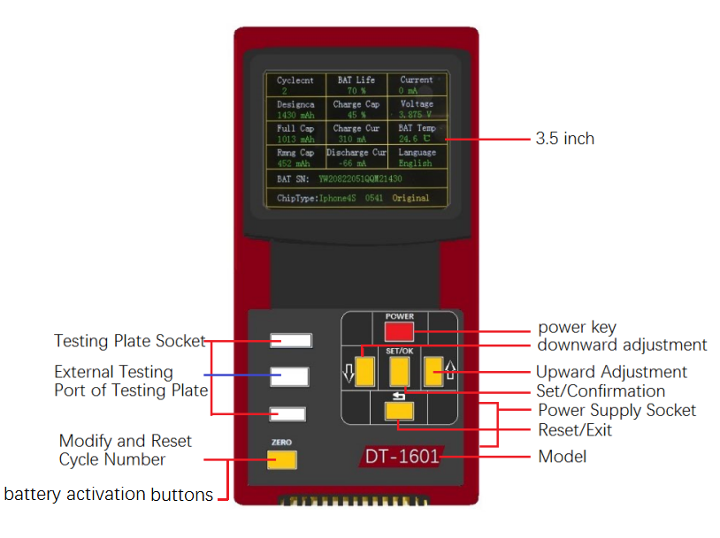

Ⅰ.Technical Parameter
Test contents: cycle numbers, design capacity, full charge capacity, residual capacity, battery efficiency, charging quantity, charging current, discharge current, static electric current, voltage, temperature, serial number, chipmodel, discrimination between original and fake , modify and Reset Cycle Number;
Languages: Chinese and English;
Power Supply Voltage：5V（DC)；
Power supply mode: mobile power, mobile phone charger, built-in 3.7V rechargeable batteries (optional);
Working environment ：-10—40℃；
Standby power consumption：≤1W。
Ⅱ. Appearance Introduction
1. This product uses a 3.5 inch color display, and displayed parameters are intuitive and clear;
2. Total six keys on device, Power (red) is serviced as the Power button, for the downward adjustment Settings which can reduce the value, for the upward adjustment Settings, which can increase the value, for exit and return, press this button then the test interface is shown after parameter is set through button, for manual reset and modify cycle number button;
3. 2 pcs of socket holes and 1pc of USB hole on the left, two testing plate sockets with pins, 1 pc of external Testing Port of Testing Plate can externally contact testing plate, which is convenient and flexible mobile for testing plate;
4. Both 2 pcs of sockets on the right side are 5V power supply port, which of small USB hole can be used for upgrading program in the future.
Ⅲ. Battery Parameters Instruction
Now a lot of customers don't know exactly meaning of these parameters, what is good and what isbad, therefore, we make a simple explanation for 13 pcs of testing data of instrument.1. The cycle number is charge and discharge times of battery .The greater the value, the longer it can be used.2. The designed capacity is an inherent nominal capacity of the battery,which is just capacity shown on battery . Designed capacity of different battery is not the same.3. The full charge capacity is the real capacity of battery (The premise is that cycle test is done or the battery is used one) , the closer this value is for the design capacity, the better; In general, full charge capacity of a new battery are higher than design capacity. Note: this data can be false, for the modified capacity, the capacity can decrease apparently after it charged for 2-3 times. Since capacity data written on the protection plate capacity is greater than the real capacity of battery, mobile phone is likely to be turned off when it does not reach 1% .4.The residual capacity is the remaining electric quantity of current battery; If the remaining capacity is insufficient, please charge timely, customers can make charging and discharging according to their own requirements of shipment.5. Battery efficiency is also called the battery life, it is the ratio of full charged capacity and designed capacity, the smaller the percentage the value is, the closer the product becomes end-of-life.6. Charged capacity is that the remaining capacity is showed in the form of percentage in order to convenient and intuitive.7. Charged current is shown whether the battery can be normally charged or not.8. Discharge current is shown whether current of the battery can be normally output or not; If current is not output, mobile phone cannot be switched on.9. The static current is divided into positive, negative and zero. The static current of good battery is zero, but if static current of some battery show positive value comes as, the battery is charged without sufficiency, which also means that standby time is short. If the static current is negative value, the battery will be shut down and the standby time is short when it is not discharged completely. In general, we think that the range between -10 to + 10 is not problem.10. As we all know the parameters of battery voltage, the mobile phone cannot be normally switched on when voltage is below 3.5V; When the battery is fully charged, low voltage battery is 4.2V and high voltage is 4.35V .11. Temperature which is tested normally is room temperature; As long as it is no more than 45 degrees, we all think that it is OK; If the temperature is too high, please do not use it, or temperature error will be shown after mobile phone is switched on .12. Each battery has different serial number, which is the same as ID number. As for the fake battery, it is possible that it has not serial number. If you find that a batch of battery serial number is the same, it is can be assured that the battery is not original.13. The chip model, battery corresponding mobile phone model ,which are used to judge whether it is original battery or not; At present, there are three kinds of IPHONE original chip of TI BQ(SQ)27541/27545/27546; If the test result is not the above 3 kinds of chips, that battery must be fake. If customer feedbacks that 4S is shown when the battery of his/her mobile phone is 5S one, which means whether your instrument is accurate or not? In fact,5S battery is used with 4S protection board , it is not the reason which the instrument is not accurate .
Ⅳ. Operating Instruction
Device is connected to the 5V power supply (mobile phone charger, mobile power supply), if there is a built-in battery, can press directly power button (power) to make display to be operated, insert the battery test plate into test board port , and inset the battery into the corresponding test base.
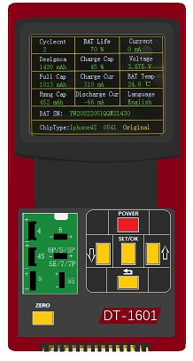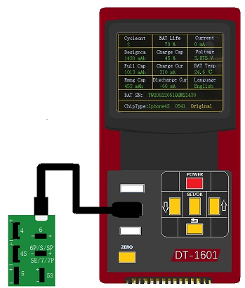
Installation Mode 1 of Testing Board Installation Mode 2 of Testing Board
Set the acceptable range of the battery, press the SET/OK button, cycle number window will appear blue background,
press up and down buttons to choose parameter you want to set , press again the SET/OK button to enter the parameter Settings interface, press up and down arrow to the item which you want to set , press the SET/OK, font will become yellow, press up and down arrow to adjust , press the SET/OK to save the Settings after adjustment is completed well ; Press to exit Setting after saving is completed well; if complete withdrawal is needed , press 2 times .Using the following specific diagram to illustrate the method of modifying and setting cycle number :

Press SET/OK Button
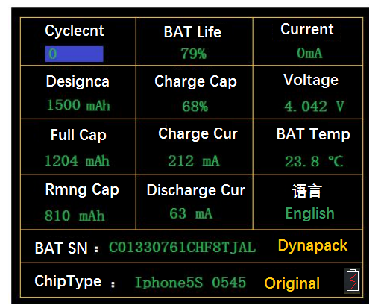

Press Again SET/OK Button
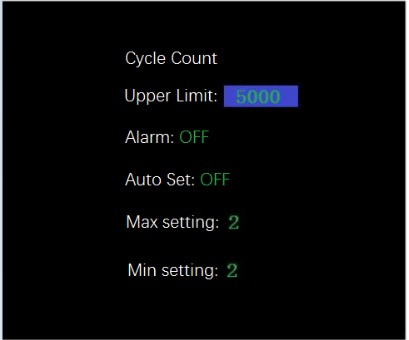
Press the arrow
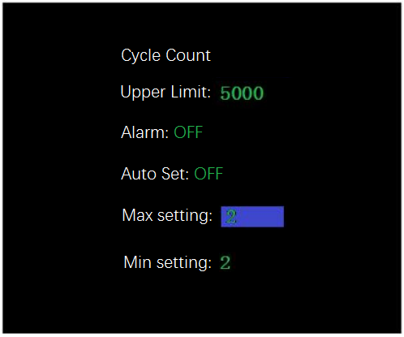
Press the SET/OK button, font will change from green to yellow, press up and down arrow to adjust the numerical value, press again SET / "OK" to save,
Press the arrow ,which is moved to position of lower limit which need to be changed.
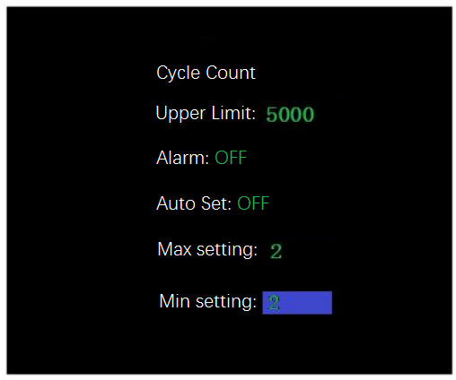

After lower limit is set with the same method, press for 2 times, then exit. The same methods for changing upper limit and lower limit settings, put in battery, and press, cycle number will be modified to the set value. If you want to reset, change the upper limit and the lower limit into 0. Biggest characteristics of the instrument is cycle number can be modified randomly, open automatic changing setting, change setting of upper limit into 20, change setting of lower limit into 0, put in battery, cycle number will be changed into the range between 0-20; Cycle number will be randomly changed when one pc of battery is put in .There are upper limit and judgment in set menu, alarm will occur and font will be change into red when cycle number is over upper limit value on the conditions that the judgment is open . Alarm sound can be closed and open in the language menu.
Introduce charge and discharge test now: charging of the instrument is open, and discharge of it is close , put in battery, the instrument will activate and charge the battery; Charging of the instrument is close, and discharge of it is open , the instrument will discharge the battery; when both of charging and discharging of the instrument are open , the instrument will charge battery for a few seconds then discharge battery for a few seconds so that the data of charge and discharge can be captured.
Ⅵ. Accessories
1.Host（1 pc）
2.Testing Base（2 pcs）
3. USB Wire（1pc）
4.Charge Battery（Optional）
Ⅶ. Warranty and Maintenance
From the date of product factory, and product is not damaged by any man-made factors, distributor can be given 18 months warranty for host, customer can be given 12 months warranty for host. If failure occurs on product in three months, we bear the freight back and forth; If failure occurs on product between 3 months and 12 months, two parties: We and customer will bear half of freight respectively (freight only within China); Customer will bear the freight back and forth when the date is beyond 12 months.

Shenzhen DiTu Electronic Technology Co.,Ltd

