Guide: How to Upgrade the Y-Carriage Plate (Ender-3)

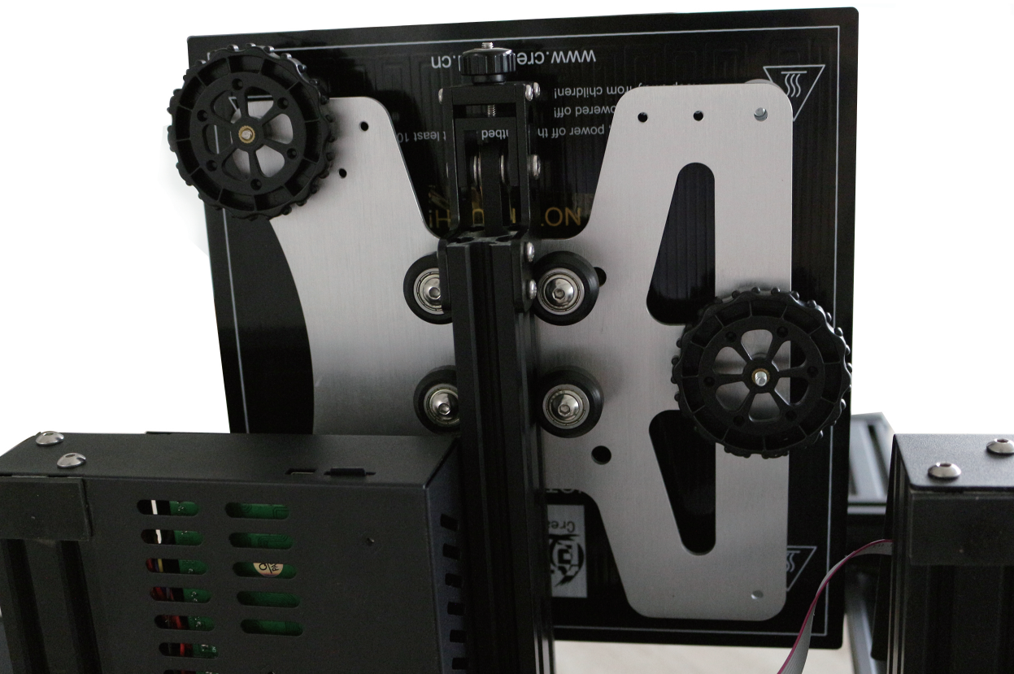
In contrast to most budget 3D Printers, the Ender-3 doesn’t require an aftermarket Y-Carriage Plate to fix problems. Considering this machine is among the cheapest on the market, Creality3D did an excellent job on the build quality and the stock carriage is perfectly sufficient. There is always room for improvement though and the traditional 4-point leveling is not just inferior, it can be problematic as well.
That is where the new Aluminum Y-Carriage Plate Kit becomes a direct upgrade. Featuring a unique bar design, it creates an additional mounting point that supports both 3-point and 4-point bed leveling configurations. If we go back to geometry class for a second, remember that 3 points are all we need to create a plane, that 4th point just creates trouble.
So why is this still being used on almost every 3D Printer? No clue. Compared to the hassle of tweaking 4 corners while thrusting a sheet of paper, 3-point leveling is a almost a miracle. You only have to level one side with the nozzle, then adjust the 3rd point on the parallel side to bring it into alignment. It makes complete sense but thus far, manufacturers just started supporting it.

Instructions
To access the Y-Carriage Plate, we need to first remove the heated bed. Since this is held in place by thumb wheels in each corner, we can just loosen each of them (turning clockwise) until they spin free and fall off. The upwards pressure pulls them against the carriage, so you may need to press down gently on the corner of the bed to give it some slack.
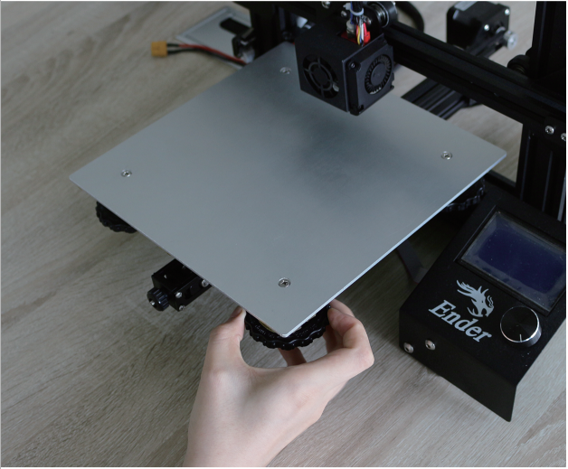
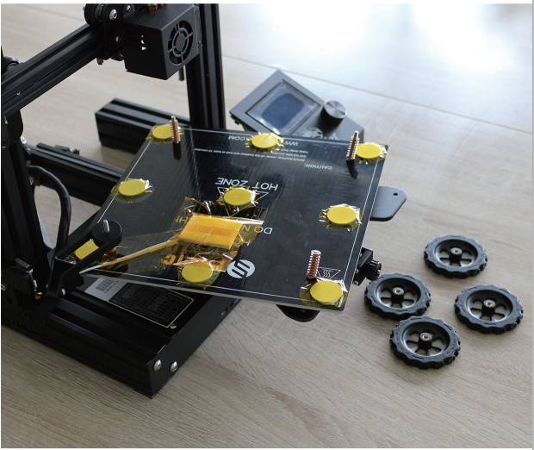
Carefully lift the build plate until the screws in each corner slide out of the carriage. Once separated, turn it upside down and place it behind the machine to clear some space, making sure not to stress the wires when doing so. Collect the springs & thumb wheels and set them aside for reassembly.

Using an 8mm socket wrench, loosen the nuts on top of the Y-Carriage Plate. We only need to remove (2) v-wheels on one side for now, the rest can be done once it is taken off the machine.
The carriage is still held in place by tension from the belt, so we also need to loosen the belt tensioner to create slack. Using a hex wrench, unscrew the 3 bolts on the side of the tensioner bracket until it can slide inwards, then slip the gold belt ends out of the Y-Carriage Plate grooves. Take the carriage plate of the Y axis and finish removing the other (2) v-wheels.

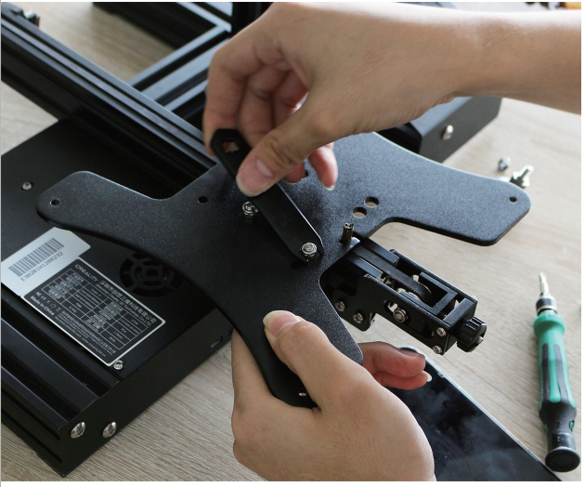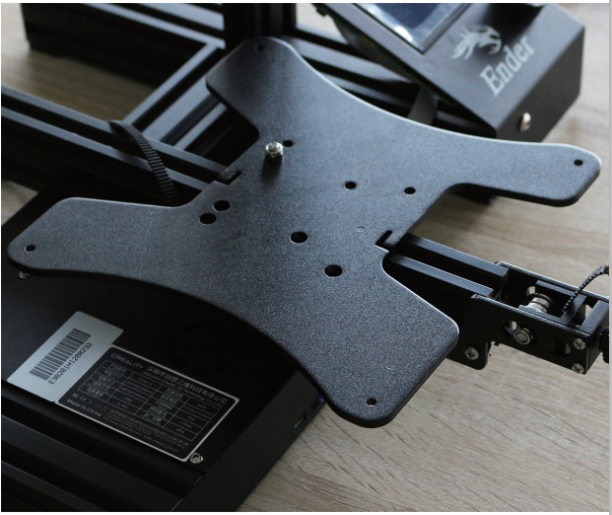
Go ahead and grab the new aluminum Y-Carriage Plate and start assembling it with the original v-wheels. It’s important to pay attention to the design of this plate as it isn’t symmetrical, the left side is curved and the right side is straight. There is also a hole in one corner, which will be located in the back right of the Ender-3 after we have reassembled the machine.
Since the belt tensioner is already loose from the previous steps, I opted to just go ahead and remove it for now. Doing so will allow you to roll the v-wheels in to the extrusion channels and push the carriage on from the front, which is quite a bit easier than trying to reassemble it on the frame. If the v-wheels are too tight, use the spanner wrench and loosen the eccentric nuts.
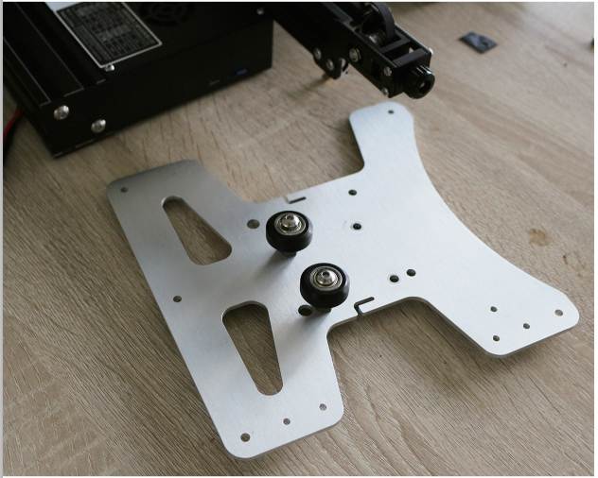
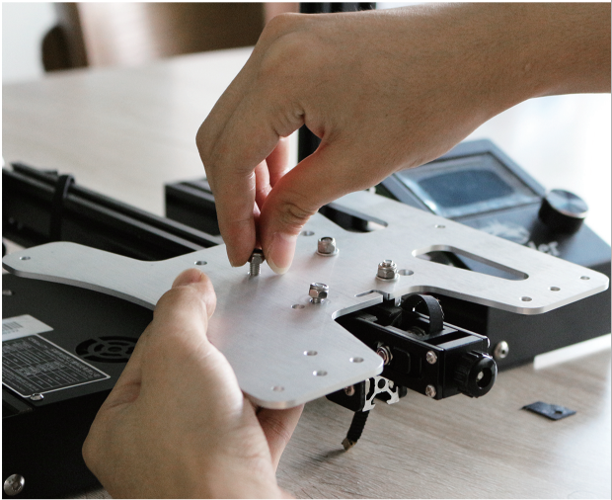
When installing the v-wheels on the new Y-Carriage Plate, the eccentric nuts go on the right of the plate. If you are unfamiliar with eccentric nuts, look at the second picture below and compare the right side to the left. These can be turned either direction to tighten/loosen the wheels as needed, where they will clamp in to the channel on the metal extrusion.

With the new Y-Carriage Plate installed, go ahead and adjust the eccentric nuts until they are tight. Make sure there is absolutely no wiggle in the carriage when you push down on the corners, it should be locked firmly in place but still able to roll forwards and backwards with a smooth motion.
Once finished, the last step is to reinstall the rubber belt. If you removed the belt tensioner on the front as I did, slide this back in to place and wrap the belt around the pulleys on the front and back of the machine. Insert the golden ends in to the L shaped grooves on the carriage to secure them in place, and then tension and tighten the belt.
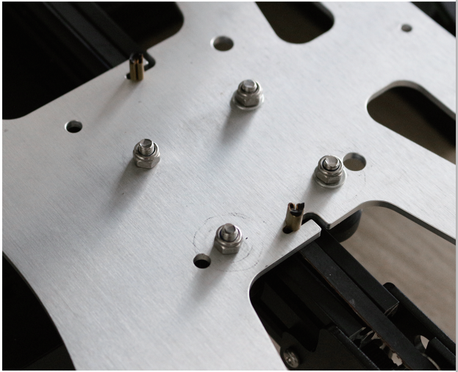
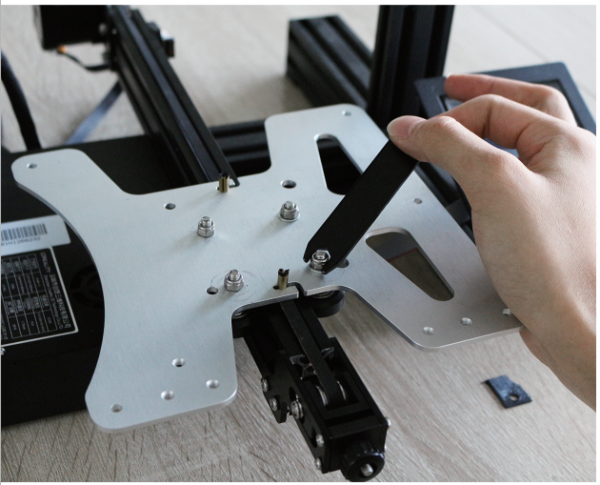
At this point we are finished with the Y-Carriage Plate installation, but use the picture and checklist below to make sure that everything is correct.
Flat edge is located on the right side
Eccentric nuts are located on the right side
Washers are located on the right side
Carriage plate hole located in the back right corner

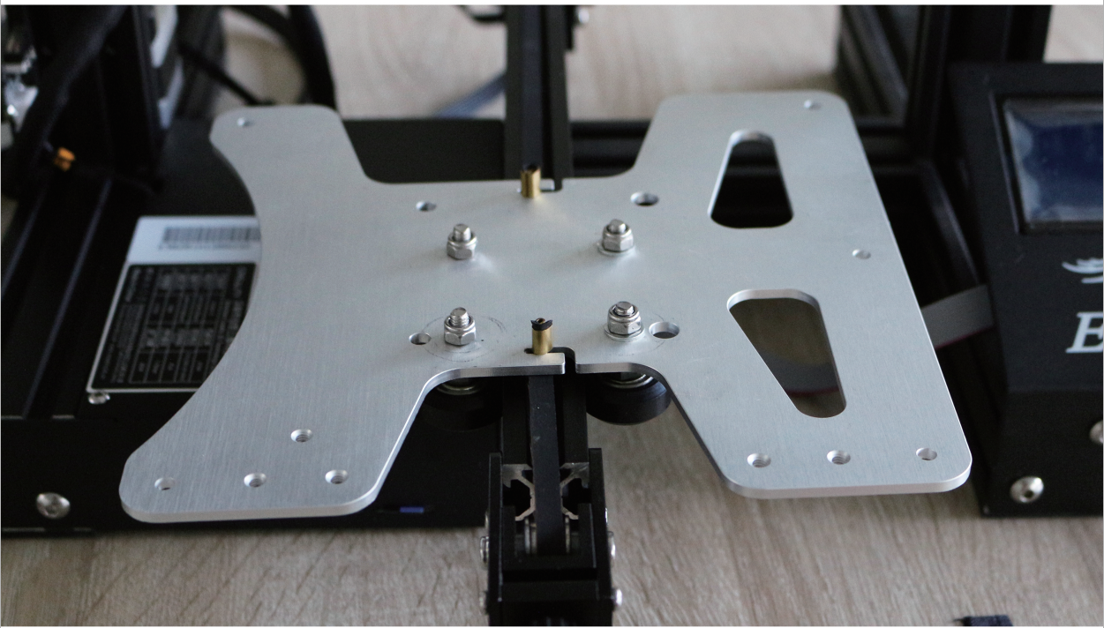
The magic of this Y-Carriage Plate is the support for 3-point bed leveling, and the unique bar design is what makes that possible. To install it, insert the included screw through the mounting bar’s center hole. Holding this in place, position it on the right side of the heated bed (left side when it is upside down) as shown below.
The kit includes (2) M4 nuts and (2) M4 lock washers, where these are placed at the ends on the original bed screws to secure it.
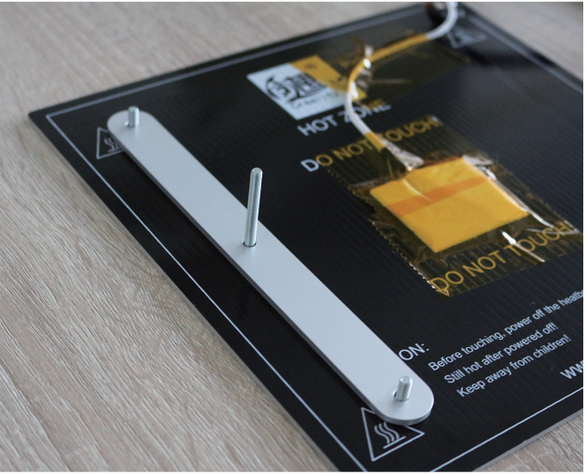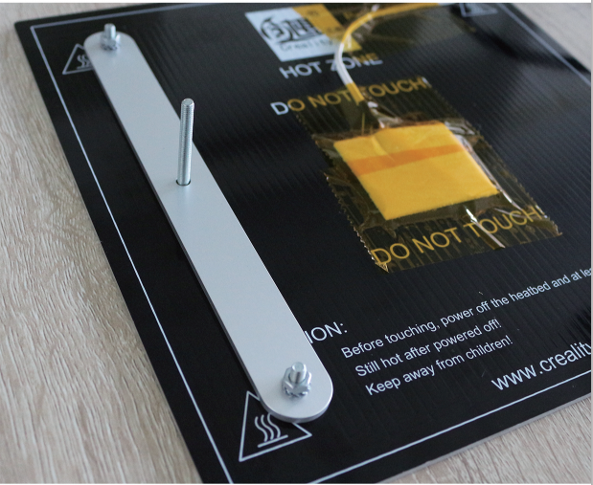
At this point, you have the choice between the improved 3-point leveling or the original 4-point approach. As 3-point leveling is the purpose of this upgrade it is definitely recommended, but you can always switch back and fourth as it does support both. Put the original bed springs on the screws where appropriate, then turn it over (while holding them in place) and set it on the new Y-Carriage Plate.
It may take some maneuvering to get all 5 screws in to the carriage, but once they have passed through the holes, go ahead and screw the thumb wheels back on to wrap things up.
