**Instruction Manual**

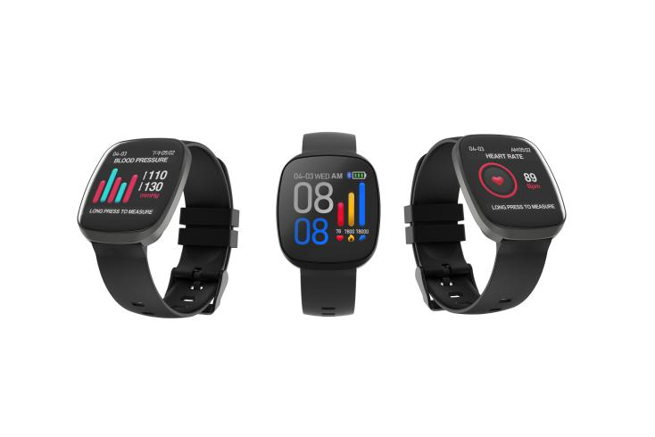

1. Although the smart watch can detect real-time dynamic heart rate and blood pressure, it cannot be used for any medical function.

2. Equipment requirements: Android supports 5.0 and above systems; ios supports 8.0 and above systems; Bluetooth hardware 4.0 and above

3. Charging: Please charge the opponent ring before use to ensure the battery is fully charged. Please confirm that the two chargers of the magnetic charger are for the two charging contacts of the quasi-host. Use the charging clip to insert the USB adapter (adapter 5V 500mA) That is, charging starts, and the charging time is about 1.5 hours. In order to ensure good charging contact, the metal contacts must be free of dirt, oxidation and impurities. The charging screen will display the charging icon when charging. If the equipment is not used for a long time, please make sure to recharge it once every three months.

4. Do not charge the power adapter with an output current exceeding 2A, otherwise the watch will be damaged.

5. Do not put a hot shower on the watch or put the watch in a high temperature environment. The high temperature will cause the watch to be poorly waterproof.

6. Do not charge in case of moisture or product with water

**Product charging diagram**

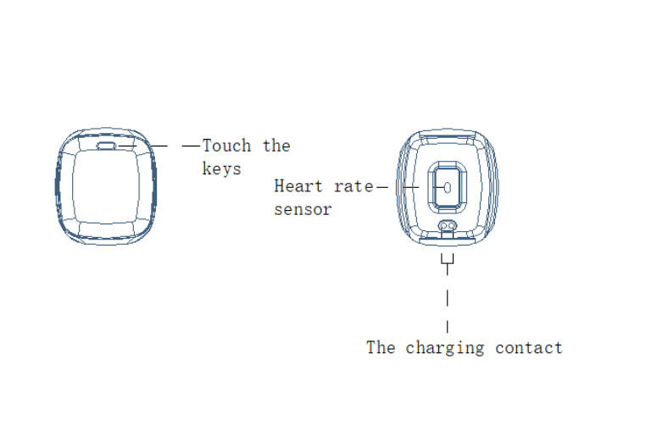

**Function Description**

1.Exercise step

Accurately calculate the number of exercise steps per day, exercise mileage, and calorie consumption;

2.Sleep monitoring

Accurately monitor the quality of sleep every day;

Note: The watch is activated at 9 o'clock every night; there is sleep data when wearing the watch to sleep;

3.Health measurement

Accurately monitor current health information, including heart rate, blood oxygen, and blood pressure (for reference only, not for medical use).

4.Alarm clock / message reminder

Alarm clock, phone, SMS, QQ, WeChat, sedentary and other reminders.

5.Remote control photo

Support mobile phone remote photography.

6.Firmware upgrade

It is used to detect whether there is a new version of the wristband firmware. During the upgrade process, it takes about 1-2 minutes to complete the upgrade in the Bluetooth connection state, during which the Bluetooth device is turned off.

7.Restore factory settings

The data of the watch and APP will all be cleared and the APP will be restarted.

**APP installation instructions**

Please use your Android phone to search for the Happy Sports app in App Store, Google Play, Apple Mobile, or scan the QR code to download and install the App.



Note: Android supports 5.0 and above systems; ios supports 8.0 and above systems; Bluetooth hardware 4.0 and above

**Watch and mobile phone binding**

Bind the watch, click on the binding device selection, and find the watch . If multiple watchs wristbands are nearby, when the device is bound, select the MAC ID number of the wristband to bind it. The Bluetooth icon appears on the top of the wristband, that is, the watch is successfully bound to the mobile phone.

**Smart Wacth Features**

|  |  |
| --- | --- |
| Time main interface: date. time. battery. Bluetooth status (when the Bluetooth icon appears on the main screen, the watch is connected) | 2主页二 设置 关于信息  1.Short time interface switch to settings interface;  2.Long press entry ，View MAC ID in the information interface . |
| Main interface switching | 1主页一 2主页二 3主页三  Long press .Main interface switching . |
| Sports information interface:  Show the number of steps in the day. Sport mileage and calories burned | 记步 卡路里 距离 |
| Sleep monitoring interface:  Show the quality of sleep the night before | 睡眠 |
| Heart rate interface:  Display heart rate measurement | 心率  Long press .Start heart rate measurement, after about 15s, start showing the current heart rate.. |
| Blood pressure interface:  Display blood pressure measurement values | 血压  Long press .Start measuring blood pressure, after 40s monitoring to show blood pressure values. |
| Blood oxygen interface:  Display oximetry values | 血氧  Long press .Start measuring blood oxygen, after 10s monitoring to show blood oxygen value. |
| Photo interface | 瑶瑶拍照  The phone turns on the smart shot; the hand ring shakes and takes a picture. |
| Sports mode interface | 运动模式  Long press open ,There are many sports modes to be chosen. |
| Message interface | 信息  Long press entry view. |
| Shut down | 关机  Long press the touch button to close the watch. |

The blood pressure measured by the same posture can be compared with each other.

It is not advisable to measure immediately after smoking, drinking, drinking tea or drinking coffee.

It is not suitable for measurement when exercise and fatigue.

Try to relax as much as possible, avoid anxiety, excitement, urinating and medication. Take a few deep breaths before measuring to keep your mood relaxed.

The watch blood pressure algorithm is suitable for healthy people to measure their own blood pressure; the measurement results are not suitable for people with high blood pressure as a criterion for determining whether or not to take antihypertensive drugs, please test and treat under the guidance of a doctor.

Product measurement results are for reference only and are not intended for medical use.

Why do you wear tight when testing heart rate?

The watch uses the principle of light reflection. After the light source penetrates the skin, the signal reflected to the sensor is collected to calculate your heart rate. If it is not tightly worn, ambient light will enter the sensor, which will affect the measurement accuracy.

It is not recommended to take a hot bath

One of the main factors: the water vapor generated when taking a hot bath

The temperature of the bath water is relatively high, and it is easy to produce a lot of water vapor, and the water vapor is a gas. The molecular radius is small, and it is easy to infiltrate from the gap of the shell of the watch. When the temperature is lowered, it will gradually condense into water droplets and damage the watch. The board, which in turn damages the watch;

The second major factor: temperature

When electronic products are affected by high temperature, low temperature, high and low temperature cycle changes, the temperature changes will cause changes in the parameters of the internal components and parts of the machine, directly affecting the normal operation of the watch and even damage the watch. So please pay more attention when you use it.

**Basic parameters**

Equipment type: Smart Watch

Size： 42*36.5*11mm

Weight： 47g

Display size： 1.22″TFT

Resolution： 240*240 dpi

Battery type： lithium polymer

Battery capacity: 170mAh

Working time: 8-12 days

Standby time: 60 days

Synchronization method: BLE 4.0

Working temperature: 0℃-40℃

Waterproof rating: IP67

**Electronic information products toxic and hazardous substances declaration**

|  |  |  |  |  |  |  |
| --- | --- | --- | --- | --- | --- | --- |
| Part Name | Toxic and harmful substances and elements | | | | | |
| (Pb) | （Hg） | (Cd） | （Cr(VI)） | （PBB） | （PBDE） |
| Watch body | ╳ | ○ | ○ | ○ | ○ | ○ |
| battery | ○ | ○ | ○ | ○ | ○ | ○ |
| Wristband | ○ | ○ | ○ | ○ | ○ | ○ |
| Wriststrap buckle | ○ | ○ | ○ | ○ | ○ | ○ |
| Charging Cable | ╳ | ○ | ○ | ○ | ○ | ○ |

○:Indicates that the content of the toxic substance in all materials of the part is in the limit specified in GB/T 26572.

  Ask for the following.

╳:Indicates that the toxic substance is at least in a homogeneous material of the part exceeding the GB/T 26572 standard

  The required limit requirements.

The copper alloy contacts of the body of the watch and the charging wire contain trace amounts of lead.

This product meets EU RoHS environmental protection requirements; there is no mature technology in the world to replace or reduce copper and copper.

Lead content in the alloy.

The figures in this logo indicate that the product's environmental protection use period under normal use is 10 years. certain

Some parts may also have an environmentally friendly use period indicator, and their environmental protection life is based on the number in the label.