Click the "MODE" button to turn the function of the keyboard up and down in turn, and there will be a corresponding function map at the bottom of the screen.The display of the standard is divided into two modes
The scaling function of the waveform is to adjust the vertical sensitivity and time base. Under this mode, the upper and lower keys adjust the vertical sensitivity (the amplification or attenuation of the signal), the left and right keys adjust the time base (sampling rate).

Waveform movement function, the waveform will move with the direction of the button direction.

Combination button usage description
1：In any mode, hold down "MODE" and "RUN/STOP" at the same time, toggle trigger rising edge and falling edge.
2：In any mode, the "MODE" and "up" are simultaneously pressed into the horizontal baseline correction interface (the horizontal baseline refers to a signal waveform with no signal input, usually the oscilloscope is a straight line without signal input, and this line is located at the position indicated by the 0V indicator arrow (yellow arrow), if the position is located. If there is an offset, it will need to be corrected to correct the 0V baseline to the direction indicated by the 0V arrow). The screen top P appears "Calibration? Please pull out the signal probe, press K K) to ask for correction," please pull out the probe first, and then press "zero" key to continue. Press the key to cancel, and the "K" key is the "MODE" key. For better calibration, please pull out the MINI USB line, so that the interference will be minimal and the correction will be more accurate. After pressing "MODE", the system will self - adjust, if the screen will pop up "successful", it means that the calibration is successful, if the failure may be due to the failure to unplug the probe or the USB charge line.
3：Open and hide the display of Vmax and Vmin in any mode while holding "MODE" and "left" at the same time.
4：In any mode, hold down "MODE" and "down" at the same time, switch the input coupling into DC coupling or AC coupling.
5：In any mode, hold "MODE" and "right" at the same time, switch the probe 1X input or 10X input. Note that if you switch to 1X input, please dial the wave switch on the probe to 1X, if set to 10X, the probe will also dial to 10X, otherwise the waveform display and the measured data are inaccurate.

Usage method
1：One button automatic regulation: in any mode, press "AUTO" to automatically adjust.
2：Pause: in any mode, press "RUN/STOP" to switch between pause and run.
3：Vertical amplification or reduction waveform: in zoom mode, vertically amplify waveform according to "up", and vertically reduce the waveform according to "down".
Horizontal amplification or reduction waveform: in scaling mode, press the "right" level to amplify the waveform and reduce the waveform according to the "left" level.
4：Waveform movement: in mobile mode, when the button is pressed in the corresponding direction, the waveform will follow the corresponding direction.
move
5：Set trigger edge: in any mode, press "MODE" + "RUN_STOP" to switch to rising or falling edges.
6：Set the input coupling: in any mode, switch DC coupling and AC coupling baseline offset by "MODE" + "lower": in the case of no signal input, if the white horizontal baseline of the oscilloscope and the yellow indicator arrow on the right are offset, it needs to be calibrated, and then "MODE" + "on" the baseline calibration interface, and unplug the probe and US first. B charge wire, again Calibration by "MODE"
7：Display Vmax and Vmin: in any mode, press "MODE" + "left" to turn on or off the display of \/max and \/min.
8：Set 1X or 10X mode: in any mode, press "MODE" + "right" to switch between 1X mode and 10X mode.When set to 1X mode, the probe is also allocated to 1X. When set to 10X mode, the probe should also be set to 10X.
9：Charging requirements: use mobile phone general 5V/1A or 2A or 4A charger, computer USB power is too small will be filled with dissatisfaction.

Key and icon indication
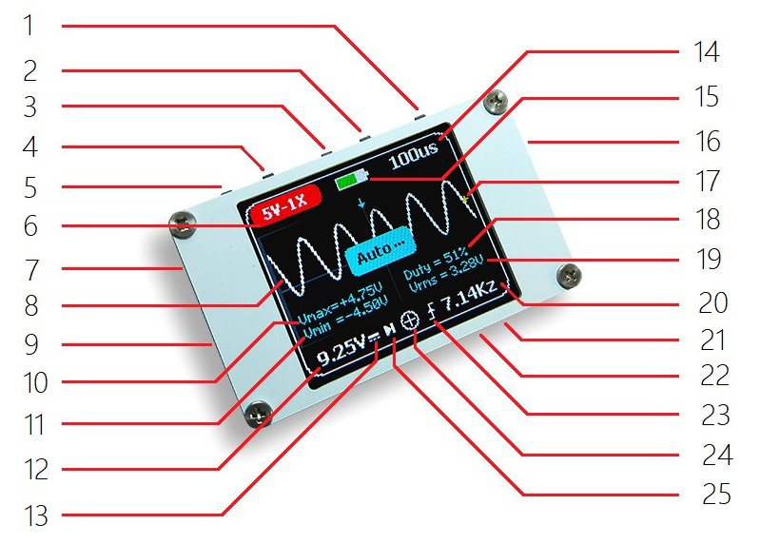

1：Key “MODE”
2：Key “Right”
3：Key “Left”
4：Key “Up”
5：Key “Down”
6：The vertical sensitivity, where the "/div" unit is omitted, can be switched to 1X mode and 10X mode by combination keys, the 1X mode is the highest measurable 40V, and the 10X mode is the highest measurable 800V. Note: don't input more than 40 V voltage under the 1X probe, otherwise you may burn the oscilloscope.
7：MICRO USB charging port can be recharged with Android mobile charger. Do not charge with computer USB.
8：Measured signal waveform
9：MCX probe interface
10：The maximum voltage of the measured signal is Vmax, for reference only.
11：The minimum voltage of the measured signal is Vmin, for reference only.
12：The peak peak of the measured signal is Vpp, which is only for reference. Note: only when the screen displays at least one complete waveform, the peak and peak data are reliable. The premise that the higher accuracy is guaranteed is that the screen shows at least 1 to 3 complete periodic waveforms.
13：Input coupling indicator icon, horizontal line indicates DC DC coupling input, triangle wave icon list AC AC coupling input.
14：Time base is used to adjust the sampling rate, where the "/div" unit is omitted.
15：The battery power shows the green part of the battery.
16：Power switch, turn up and turn on, turn down and turn off.
17：The horizontal baseline of the waveform, where the voltage is 0V
18：The duty ratio of the measured signal is only for reference (can be displayed and hidden by combination of key buttons). Attention: only when the screen displays at least 2 complete waveforms, the data of the duty ratio is reliable. The premise that the higher precision is guaranteed is that the screen displays at least 2 complete periodic waves.
19：The valid value of the measured signal is only for reference (can be displayed and hidden by combination of key buttons). Note that only when the screen displays at least one complete waveform, the data of the valid value is reliable. The premise that the higher accuracy is guaranteed is that the screen displays at least 1 complete periodic waves.
20：The frequency of the measured signal is for reference only. Note: only when the screen displays at least one complete waveform, the data of the frequency value is reliable. The premise that the higher accuracy is guaranteed is that the screen shows at least 1 to 3 complete periodic waves.
21：The key is "AUTO". This function is very practical, fast and convenient, and it can display the waveform clearly without the need of complicated adjustment.
22： button 'pause', click switch run and pause
23：trigger edge indicator icon, upward arrow indicates rising edge trigger, downward arrow indicates falling edge trigger.
24：The mode indicator icon can switch between the two modes of "MODE" in the waveform scaling and waveform movement.
25：Run and pause icon, two parallel lines indicate the operation, and the triangle plus line indicates the pause.

Serious warning: do not use the crocodile clip probe to test the signal above 40V, especially the 220V power. If you want to test the signal above 40V, please purchase the 10X probe separately.

parameter
Model | FNIRSI-188
Display | 1.8 Inch High Definition TFT LCD screen
Number of channels | 1
Input impedance | 1MΩ
Analog bandwidth | 1MHz
Maximum rice sample rate | 5MSps
rise time | <=100nS
Storage depth | 40KB
Vertical sensitivity | 50mV/div ~ 200V/div
Time base range | 100mS/div ~ 2uS/div
Trigger type | Rising edge / descending edge
Coupling mode | AC/DC
Maximum test voltage | 1X:40V 10X:600V
Cursor Type | Level, trigger x
Battery capacity | 230mAH Lithium battery (2.5 hours for continuous use)
Power Supply | 5V/1A, 5V/2A, 5V/4A, do not use computer USB to charge
Fuselage size | 57mm * 34mm * 11 mm
Shipping list | Host + MCX switch head + USB data line + instructions

