Geekcreit Uno Ultimate Starter Kits Tutorial

Contents

Components List 1
Lesson 0 Installing IDE 13
Lesson 1 Blink 21
Lesson 2 Button 28
Lesson 3 Flowing LED Lights 32
Lesson 4 Active Buzzer 35
Lesson 5 Passive Buzzer 38
Lesson 6 Photoresistor 41
Lesson 7 RGB LED 44
Lesson 8 Relay 47
Lesson 9 Tilt-Switch 50
Lesson 10 Servo 52
Lesson 11 LCD1602 54
Lesson 12 Thermistor 57
Lesson 13 Voltmeter 60
Lesson 14 Ultrasonic 62
Lesson 15 Stopwatch 65
Lesson 16 74HC595 And Segment Display 68
Lesson 17 IR Remote 73
Lesson 18 MAX7219 Module 75
Lesson 19 JOYSTICK 77
Lesson 20 Keypad Module 79
Lesson 21 HC-SR501 PIR Sensor Module 81
Lesson 22 DHT11 TEMP AND HUMIDITY MODULE 84
Lesson 23 NE555 Timer 87
Lesson 24 Rotary Encoder 91
Lesson 25 ADXL335 95
Lesson 26 DC Motors 98
Lesson 27 DC Motors Reversing 103
Lesson 28 Steeper Motor 108
Lesson 29 Control a stepper motor using a rotary encoder 113
Lesson 30 control a Stepper Motor with an IR Remote control 115
Lesson 31 Simple Creation - Light Alarm 117
Lesson 32 Simple Creation - Traffic Light 120
Lesson 33 Simple Creation - Digital Dice 124
Lesson 34 Simple Creation - Small Fan 127
Lesson 35 Simple Creation - Automatically Tracking Light Source 130
Lesson 36 Simple Creation - Packing 133

Components List

No | Product Name | Quantity | Picture
1 | RobotLinking Uno R3 Controller Board | 1 | 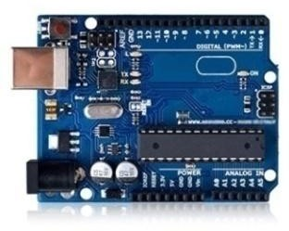
2 | Prototype Expansion Board | 1 | 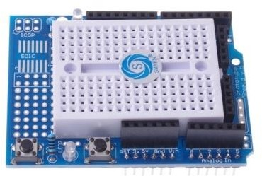
3 | 9V 1A Power Supply | 1 | 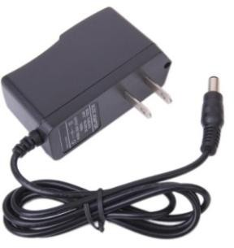
4 | LCD1602 Module | 1 | 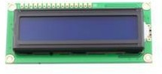
5 | USB Cable | 1 | 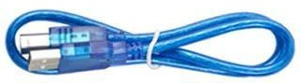

6 | MAX7219 Module | 2 | 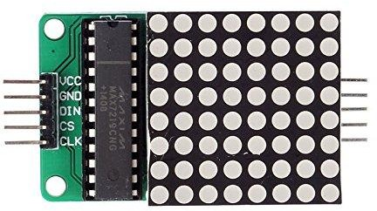
7 | Breadboard | 1 | 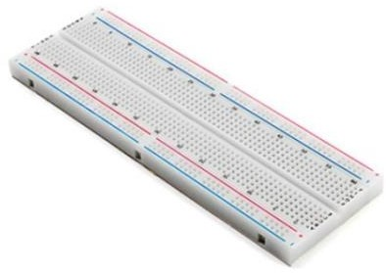
8 | 65 jumper wire | 1 | 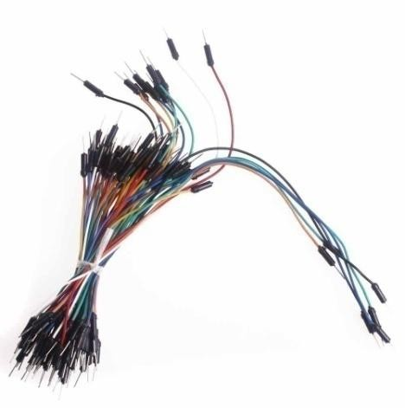
9 | Female-to-Female Dupont Wire | 10 | 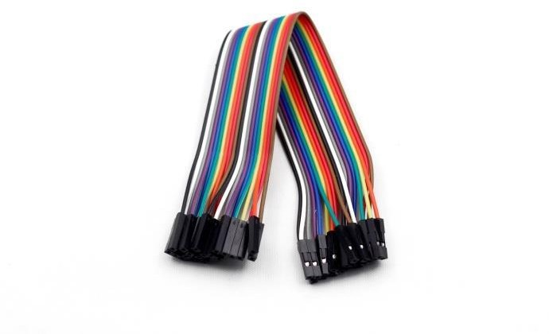

10 | 9v battery with DC | 1 | 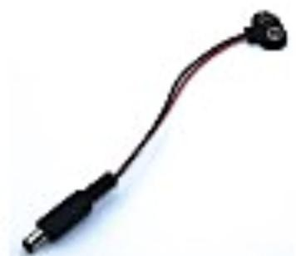
11 | ULN2003 Stepper Motor Driver Board | 1 | 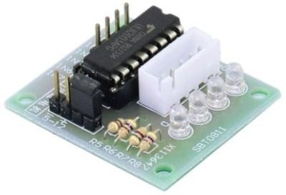
12 | DHT11 Temperature and Humidity Module | 1 | 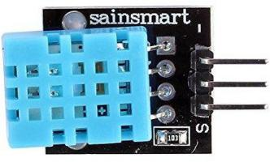
13 | Keypad module | 1 | 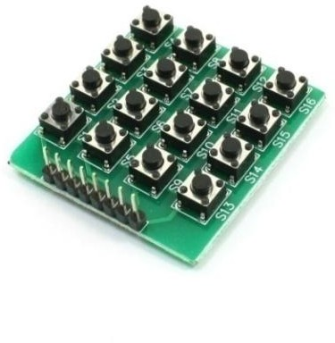

14 | Ultrasonic Sensor | 1 | 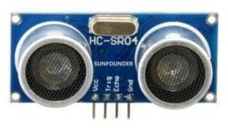
15 | Ultrasonic Holder | 1
16 | Joystick Module | 1 | 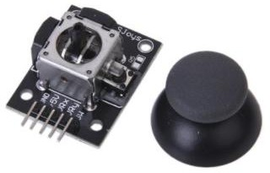
17 | Relay | 1 | 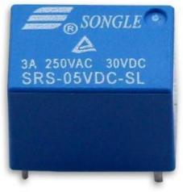
18 | Rotary Encoder Module | 1 | 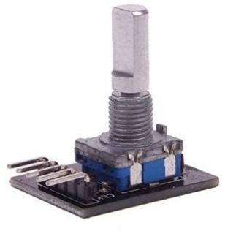

19 | HC-SR501 PIR  Motion Sensor | 1 | 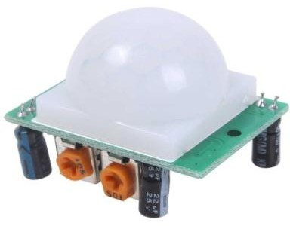
20 | Rotary Encoder Module | 1 | 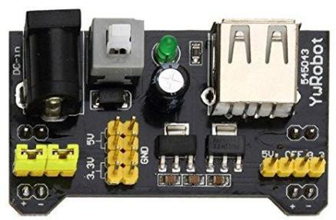
21 | IR Receiver Module | 1 | 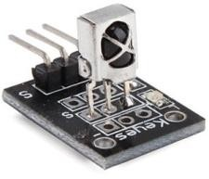
22 | Remote | 1 | 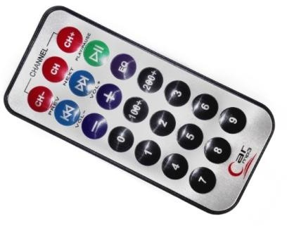
23 | Servo Motor | 1 | 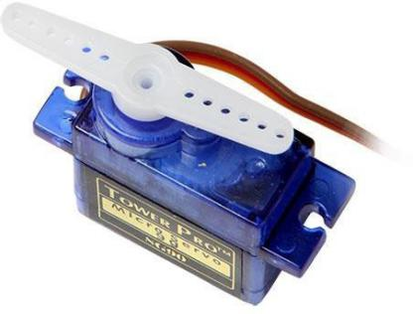

24 | Stepper motor | 1 | 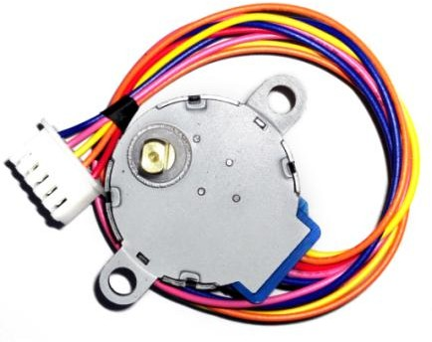
25 | 130 Servo Motor | 1 | 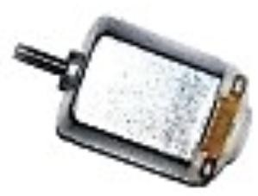
26 | Resistor (220Ω) | 10 | 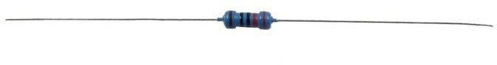
27 | Resistor (1KΩ) | 10
28 | ]  Resistor (10KΩ) | 10
29 | Resistor (100KΩ) | 10
30 | Resistor (1MΩ) | 10

31 | Resistor (5.1MΩ) | 10
32 | Resistor (20KΩ) | 10
33 | Resistor (100KΩ) | 10
34 | Resistor (200KΩ) | 10
35 | Resistor (10KΩ) | 10
36 | 1 digit 7-segment display | 1 | 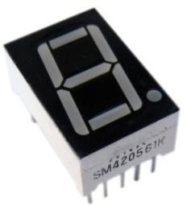
37 | 4 digit 7-segment display | 1 | 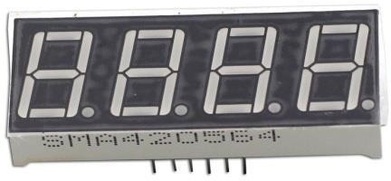

38 | Pn2222 | 5 | 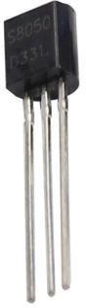
39 | NPN Transistor (S8050) | 5
40 | Diode Rectifier (1N4007) | 5 | 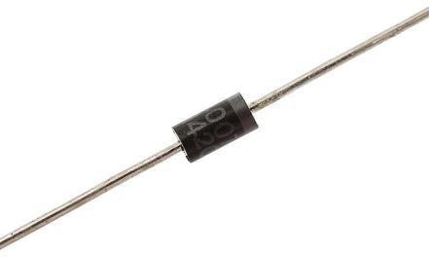
41 | L293D | 1 | 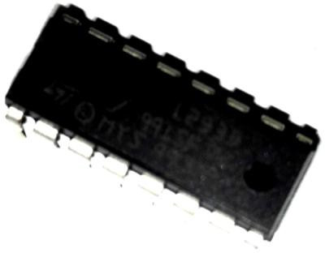
42 | 74HC595 | 1 | 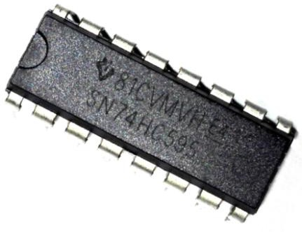

43 | NE555 | 1 | 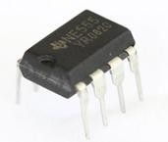
44 | 100UF 50V | 2 | 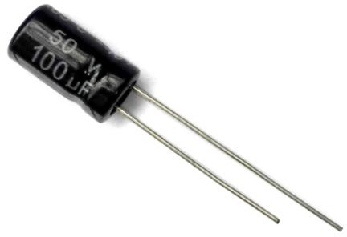
45 | 10UF 50V | 2 | 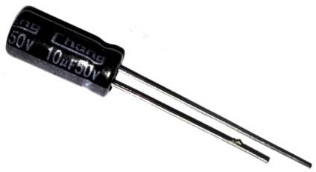
46 | 104 ceramic capacitor | 5 | 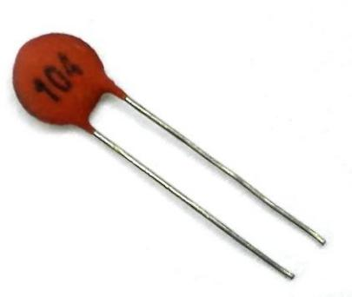
47 | 22pf ceramic capacitor | 5 | 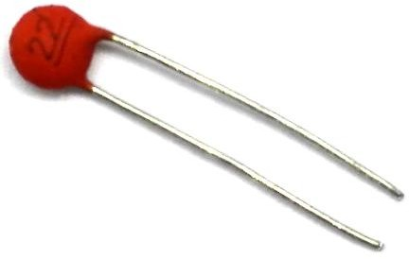

48 | Tilt Switch | 1 | 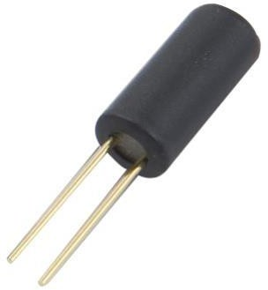
49 | Photoresistor (Photocell) | 2 | 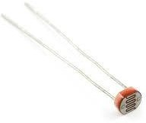
50 | Thermistor | 1 | 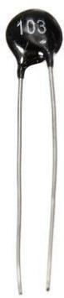
51 | Button (Small) | 5 | 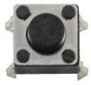
52 | Rotary Knob (Potentiometer) | 2 | 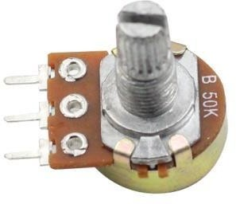

53 | RGB LED | 1 | 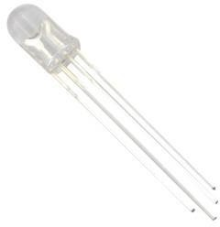
54 | White LED | 5 | 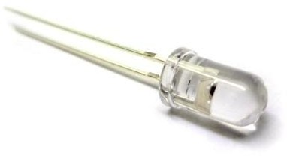
55 | Green LED | 5 | 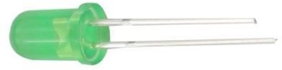
56 | Red LED | 5 | 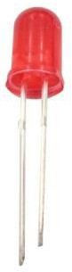
57 | Yellow LED | 5 | 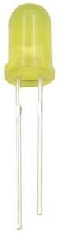
58 | Blue LED | 5 | 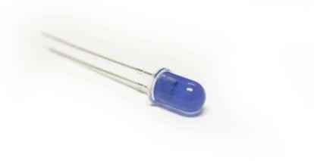

59 | Passive Buzzer | 1 | 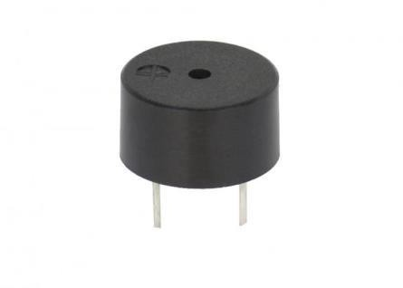
60 | Active Buzzer | 1 | 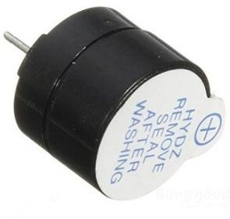
61 | Pin Header | 40 | 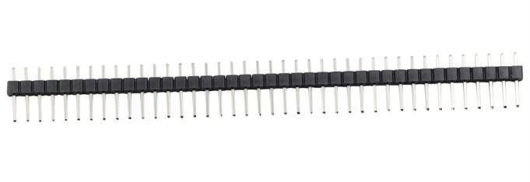
62 | ADXL335 Module | 1 | 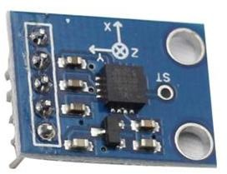
63 | Fan | 1 | 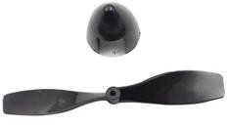

Note:
After unpacking, please check that the number of components is correct and that all components are in good condition.

Introduction

Lesson 0 Installing IDE

In this lesson, you will learn how to setup your computer to use Arduino and how to set about the lessons that follow.

Installing Arduino (Windows)
The Arduino software that you will use to program your Arduino is available for Windows, Mac and Linux. The installation process is different for all three platforms and unfortunately there is a certain amount of manual work to install the software. There is no installer program, but rather you have to unzip a folder which gives you an Arduino folder that contains the Arduino program and a few other items.
In a separate step, you must then install USB drivers, which is the only bit that is a bit fiddly.
Get started by visiting the Arduino.cc website. As of April 2014 we suggest v1.05 as 1.5 is still in beta. If 1.5 is no longer in beta when you read this you can try it out!
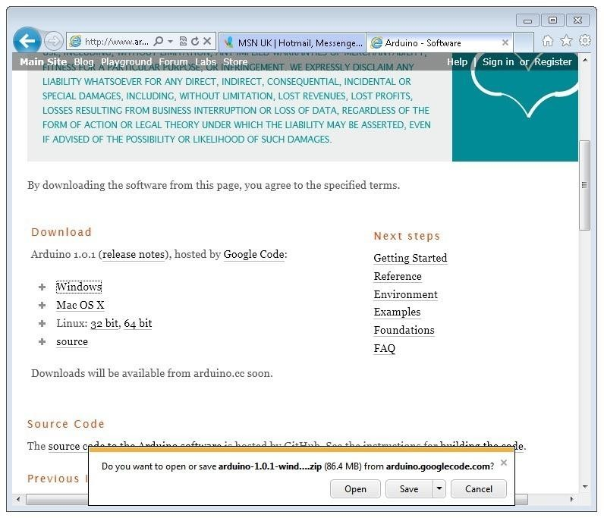
Start by downloading the the zip file for Windows. There is only one version of the software, whether you are using Windows XP through to Windows 7.

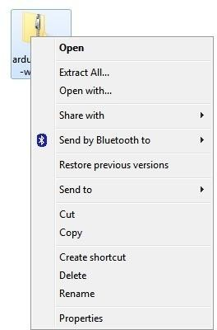
When the zip file has downloaded, extract the contents onto the Desktop, by right-clicking on the file and selecting 'Extract All...' from the pop-up menu.

Next select your Desktop and click 'Extract'. You can move it somewhere else onto your computer later, just by moving the folder, but for now, just keep it on the Desktop.

The Arduino folder contains both the Arduino program itself and also the drivers that allow the Arduino to be connected to your computer by a USB cable. Before we launch the Arduino software, you are going to install the USB drivers.

Plug one end of your USB cable into the Arduino and the other into a USB socket on your computer. The power light on the LED will light up and you may get a 'Found New Hardware' message from Windows. Ignore this message and cancel any attempts that Windows makes to try and install drivers automatically for you.

The most reliable method of installing the USB drivers is to use the Device Manager. This is accessed in different ways depending on your version of Windows. In Windows 7, you first have to open the Control Panel, then select the option to view Icons, and you should find the Device Manager in the list.

Under the section „Other Devices‟ you should see an icon for „unknown device‟ with a little yellow warning triangle next to it. This is your Arduino.

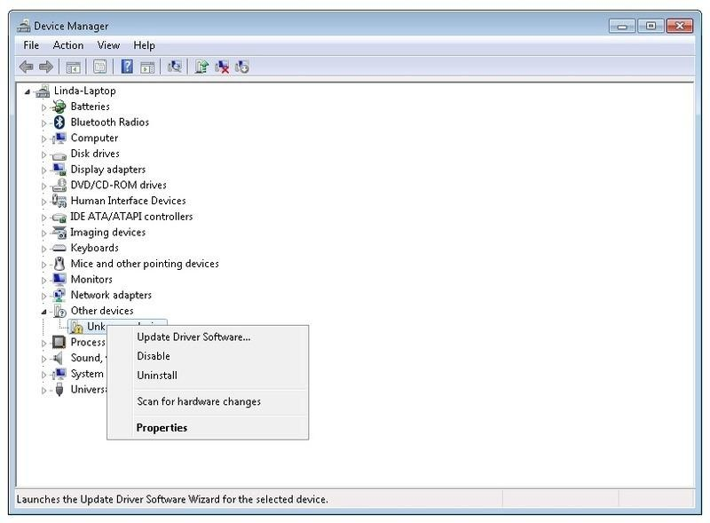
Right-click on the device and select the top menu option (Update Driver Software...). You will then be prompted to either „Search Automatically for updated driver software‟ or
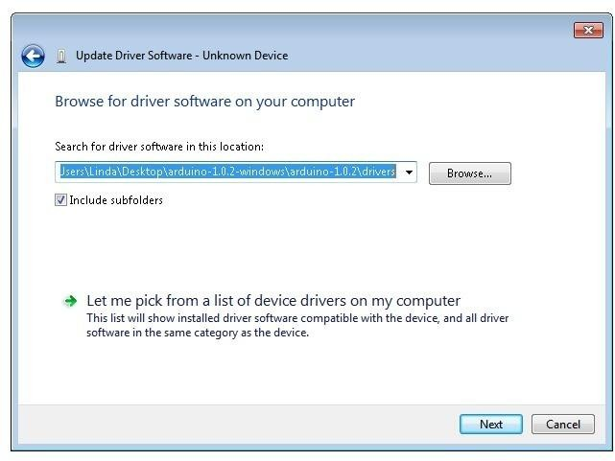
„Browse my computer for driver software‟. Select the option to browse and navigate to the arduino-1.0.2-windows\arduino1.0.2\drivers.

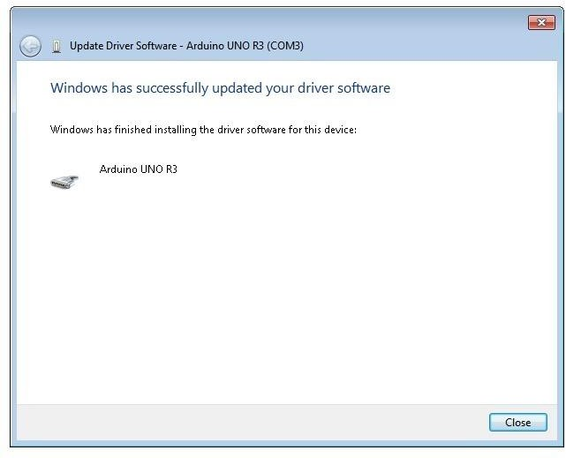
Click 'Next' and you may get a security warning, if so, allow the software to be installed. Once the software has been installed, you will get a confirmation message.
That's it, you are now ready for action, so Skip the next section on installation on Mac and Linux and move straight on to 'Boards and Ports'.

Installing Arduino (Mac and Linux)
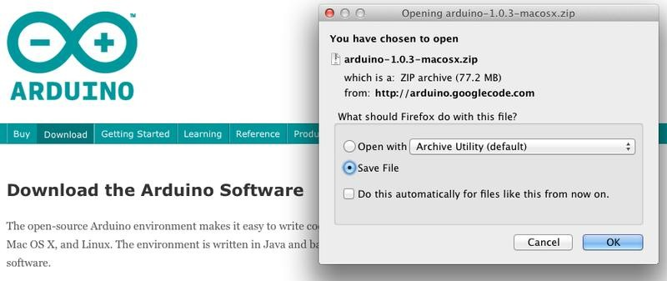
Get started by visiting the Arduino.cc website and downloading the matching IDE for your operating system. As of April 2014 we suggest v1.05 as 1.5 is still in beta. If 1.5 is no longer in beta when you read this you can try it out!

Save the install software to your desktop or wherever
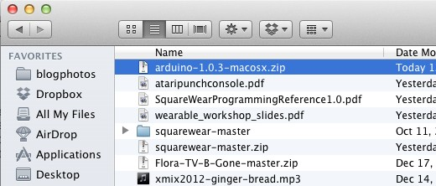
The process for installing the Arduino software on the Mac is a lot easier than on the PC. As before, the first step is to download the file. In the case of the Mac, it is a zip file.
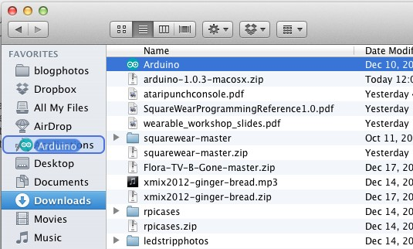
Once downloaded, double-click on the zip file, which will extract a single file called
„Arduino.app‟. This is the whole Arduino application, just drag it into your Applications Folder.

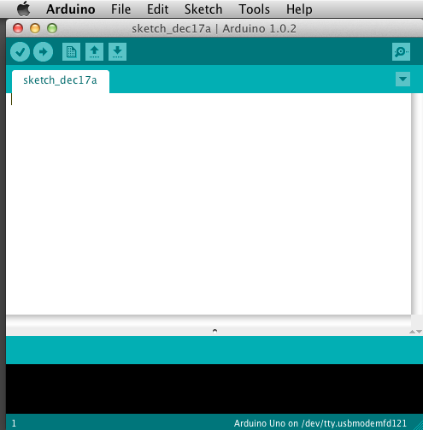
You can now find and launch the Arduino software in your Applications folder. As you are going to use it frequently, you may wish to right-click its icon in the dock and set it to Keep In Dock.

There are many different LINUX distributions and the instructions for each distribution are a little different. The Arduino community has done a great job of putting together sets of instructions for each distribution. So follow the link below and select one of the ten or more distributions on offer.

Boards and Ports
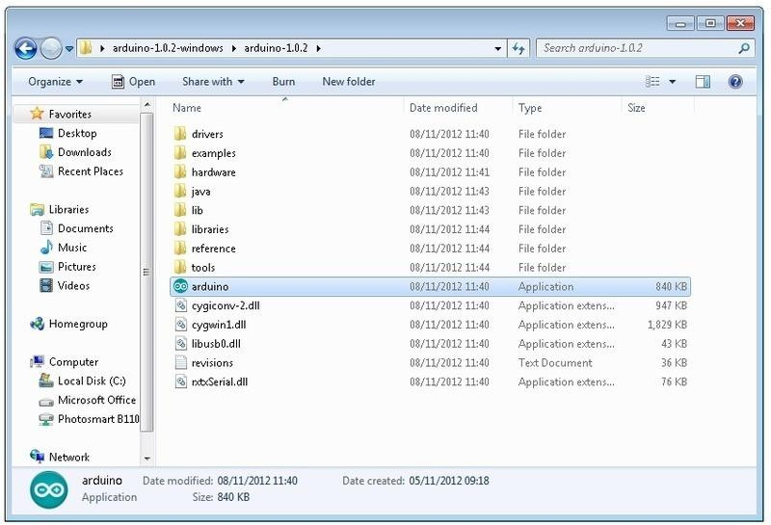
You are now ready to start the Arduino Software, so whatever platform you are using, open the Arduino folder and open the Arduino application contained within it.

This will start the Arduino IDE, but before you can get programming, you have to tell the Arduino software which type of Arduino board you are using and also select the port it is connecting to.

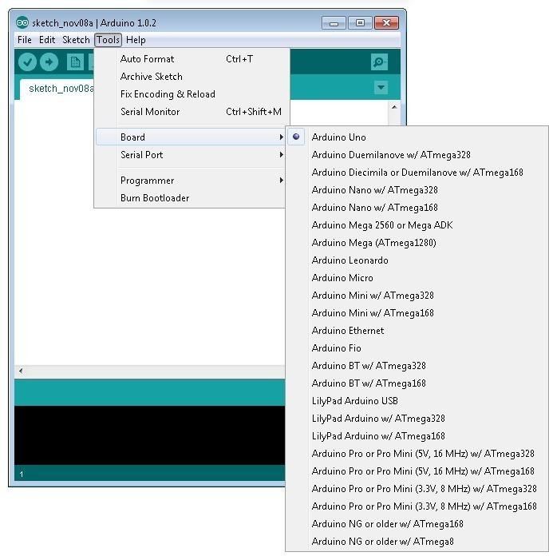
To tell the Arduino IDE which type of board you are using. From the 'Tools' menu, select Board and then 'Arduino Uno' or 'Leonardo' as appropriate.
Also on the 'Tools' menu, you will find the 'Serial Port' option. Select this option.
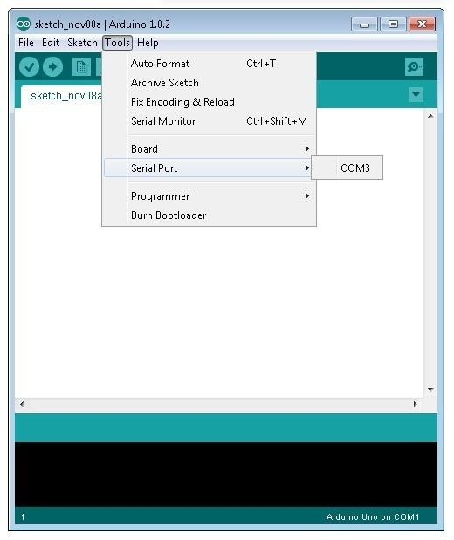

If you are using Windows, there will probably only be one option here and it will either say COM3 or COM4. Even though there is only one option, you will still need to select it.

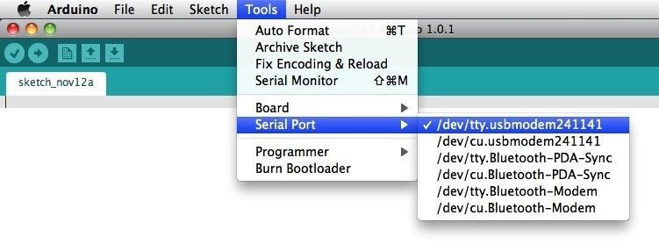
If you are using a Mac or Linux, there will be more options there, but it will usually be the top option in the list, as this will be the device most recently plugged in. This is useful, as the name of the port may not look like it has anything to do with Arduino. It will probably be called something like /dev/tty.usbmodemXXXX or /dev/ttyUSBn

In the next lesson, you will start by programming your Arduino board to make its built-in LED blink.

Lesson 1 Blink

Introduction
In this lesson, you will learn how program your Uno R3 controller board to make the Arduino's built-in LED blink.

Components
- 1 * RobotLinking Uno board
- 1 * USB cable

Principle
The Arduino has rows of connectors along both sides that are used to connect to electronic devices and plug-in 'shields' that allow the Arduino to do more.

However, the Arduino also has a single LED that you can control from your sketches. This LED is built onto the Arduino board and is often referred to as the 'L' LED as this is how it is labelled on the board.

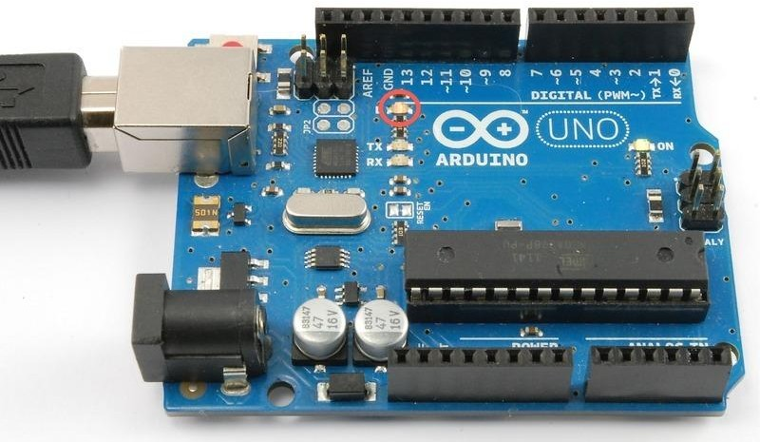

You may find that your Arduino board's 'L' LED already blinks when you connect it to a USB plug. This is because Arduino boards are generally shipped with the 'Blink' sketch pre- installed.

In this lesson, we will reprogram the Arduino with our own Blink sketch and then change the rate at which it blinks.

In lesson 0, you setup your Arduino IDE and made sure that you could find the right serial port for it to connect to your Arduino board. The time has now come to put that connection to the test and program your Arduino board.

The Arduino IDE includes a large collection of example sketches that you can load up and use. This includes an example sketch for making the 'L' LED blink.

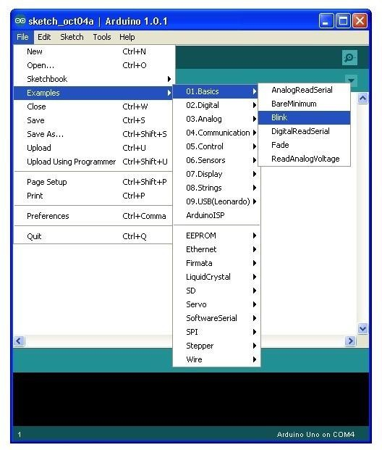
Load the 'Blink' sketch that you will find in the IDE's menu system under File → Examples → 01.Basics

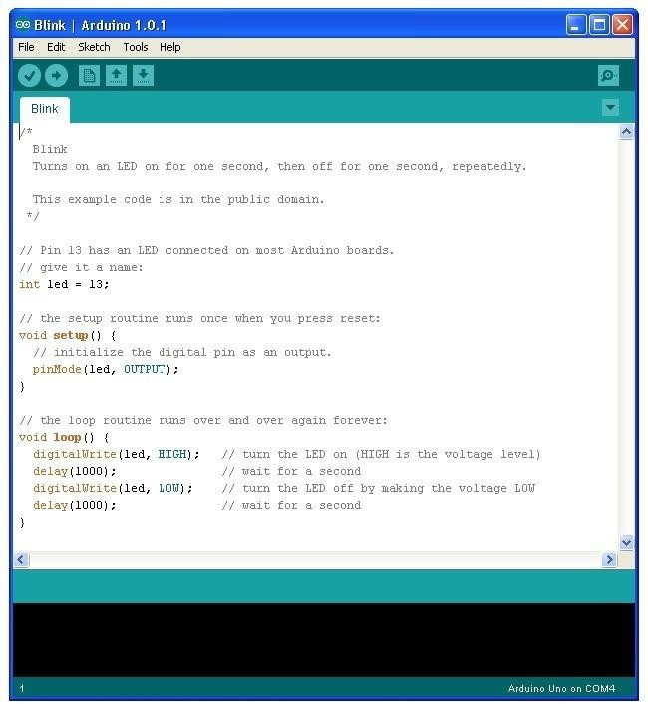
When the sketch window opens, enlarge it so that you can see the whole of the sketch in the window.
The example sketches included with the Arduino IDE are 'read-only'. That is, you can upload them to an Arduino board, but if you change them, you cannot save them as the same file.

We are going to change this sketch, so, the first thing you need to do is save your own copy that you can change however you like.

From the File menu on the Arduino IDE select the option 'Save As..' and then save the sketch with the name 'MyBlink'.

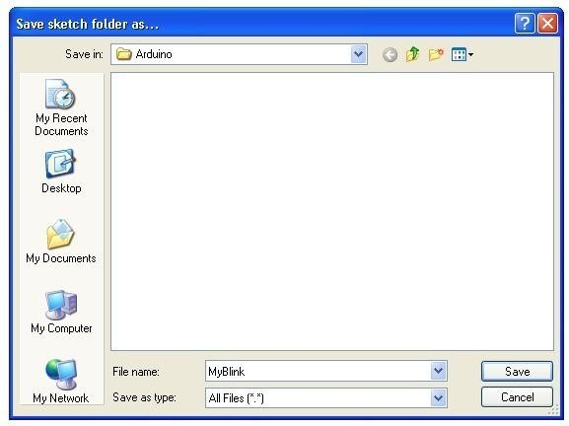
You have saved your copy of 'Blink' in your sketchbook. This means that if you ever want to find it again, you can just open it using the File → Sketchbook menu option.
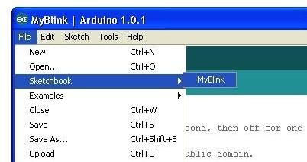
Attach your Arduino board to your computer with the USB cable and check that the 'Board Type' and 'Serial Port' are set correctly. You may need to refer back to Lesson 0.

The Arduino IDE will show you the current settings for board at the bottom of the window.
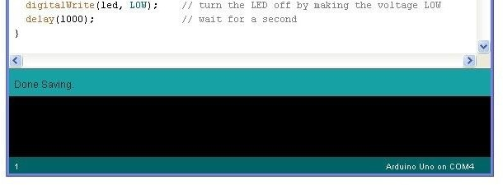

Click on the 'Upload' button. The second button from the left on the toolbar.
If you watch the status area of the IDE, you will see a progress bar and a series of messages. At first it will say 'Compiling Sketch..'. This converts the sketch into a format suitable for uploading to the board.
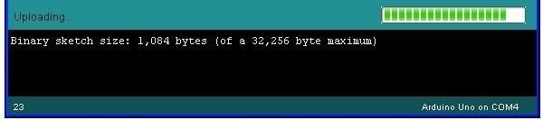
Next, the status will change to 'Uploading'. At this point, the LEDs on the Arduino should start to flicker as the sketch is transferred.
Finally, the staus will change to 'Done'.
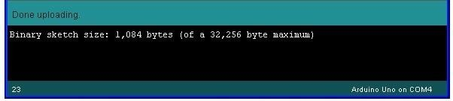
The other message tells us that the sketch is using 1,084 bytes of the 32,256 bytes available.After the 'Compiling Sketch..' stage you could get the following error message:
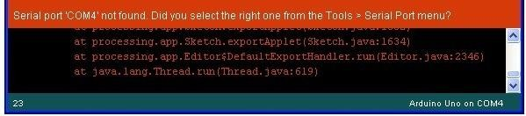
The clue is at the top here, it probably means that your board is not connected at all, or the drivers have not been installed (if necessary) or that the wrong serial port is selected.

If you get this, go back to Lesson 0 and check your installation.
Once the upload has completed, the board should restart and start blinking. Open the code
The first thing to note is that quite a lot of this sketch is what is called 'comments'. Comments are not actual program instructions, they are just comments about how the program works. They are there for out benefit, so that there is some explanation to accompany the sketch. Everything between /* and */ at the top of the sketch is a block comment, that explains what the sketch is for.
There are also single line comments that start with // and everything up intil the end of the line counts as being a comment.
The first actual line of code is: Copy Code
  - int led = 13;
As the comment above explains, this is giving a name to the pin that the LED is attached to. This is 13 on most Arduinos, including the Uno and Leonardo.
Next, we have the 'setup' function. Again, as the comment says, this is run when the reset button is pressed. It is also run whenever the board resets for any reason, such as power first being applied to it, or after a sketch has been uploaded.
Copy Code
- void setup() {
- // initialize the digital pin as an output.
- pinMode(led, OUTPUT); 4. }
Every Arduino sketch must have a 'setup' function, and the part of it where you might want to add instructions of your own is between the { and the }.
In this case, there is just one command there, which, as the comment states tells the Arduino board that we are going to use the LED pin as an output. It is also mandatory for a sketch to have a 'loop' function. Unlike the 'setup' function that only runs once, after a reset, the 'loop' function will, after it has finished running its commands, immediately start again.
Copy Code
- void loop() {
- digitalWrite(led, HIGH); // turn the LED on (HIGH is the voltage level)
- delay(1000); // wait for a second

- digitalWrite(led, LOW); // turn the LED off by making the voltage LOW
- delay(1000); // wait for a second 6. }
Inside the loop function, the commands first of all turn the LED pin on (HIGH), then 'delay' for 1000 milliseconds (1 second), then turn the LED pin off and pause for another second.
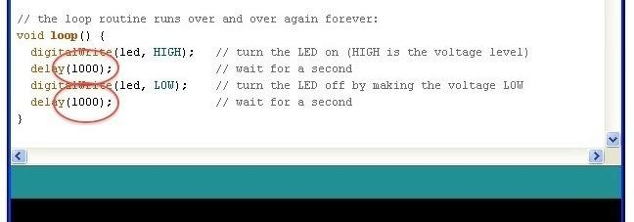
You are now going to make your LED blink faster.As you might have guessed, the key to this lies in changing the parameter in () for the 'delay' command.
This delay period is in milliseconds, and so if you want the LED to blink twice as fast, change the value of 1000 to 500. This would then pause for half a second each delay rather than a whole second.
Upload the sketch again and you should see the LED start to flash more quickly.

Lesson 2 Button

Introduction
In this experiment, we will learn how to turn a single LED on or off by using an I/O port and button switch. The "I/O port" refers to the INPUT and OUTPUT port. We will use the input function of the RobotLinking Uno I/O port to read the output of an external device. Since the RobotLinking Uno board itself has an LED (connected to Pin 13), we will use the LED to accomplish this experiment for convenience.

Components
- 1 * RobotLinking Uno board
- 1 * USB cable
- 1 * Button
- 1 * Resistor (10kΩ)
- Jumper wires
- 1 * Breadboard

Principle
Buttons are a common component used to control electronic devices. They are usually used as switches to connect or disconnect circuits. Although buttons come in a variety of sizes and shapes, the one used in this experiment will be a 6mm mini-button as shown in the following pictures. Pins pointed out by the arrows of same color are meant to be connected.
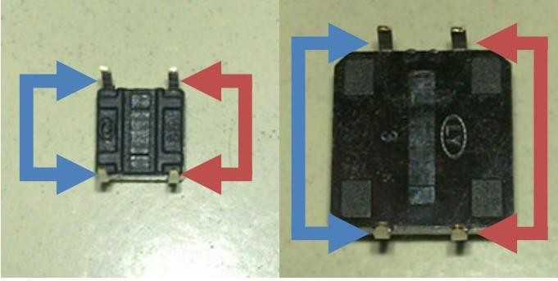

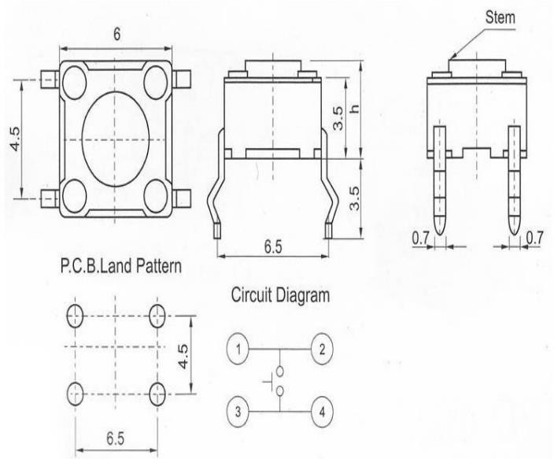

When the button is pressed, the pins pointed by the blue arrows will connect to the pins pointed by the red arrows.

Generally, the button switch is directly connected in an LED circuit in order to turn the LED on or off. This connection is relatively simple. However, sometimes the LED will light up automatically without pressing the button, which is caused by various interferences. In order to avoid these external interferences, we will connect a pull-down resistor, that is, connect a 1K–10KΩ resistor between the button port and the GND. The function of the pull-down resistor is to consume external interferences while connected to the GND for as long as the button switch is turned off.

This circuit connection is widely used in numerous circuits and electronic devices. For example, if you press any button on your mobile phone, the backlight will light up.

Experimental Procedures
Step 1: Connect circuit as shown in the following diagram:

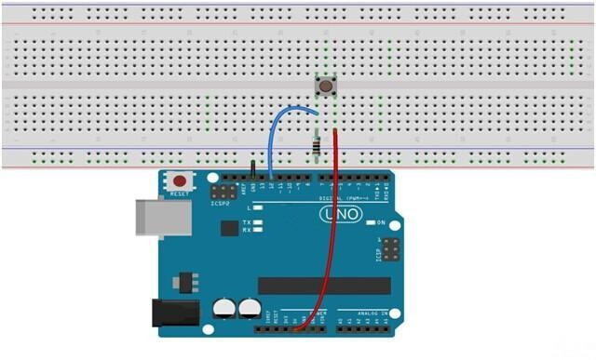

The corresponding schematic diagram is as follows:

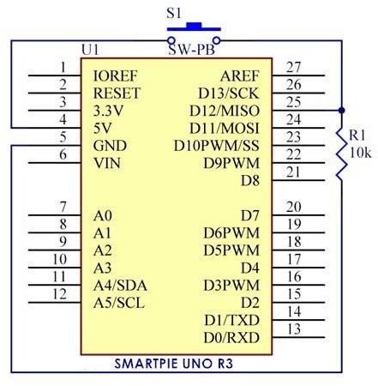

Step 2: Program (please refer to the example code on the CD or official website)
Step 3: Compile the program
Step 4: Burn the program into RobotLinking Uno board

If you press the button, the LED on the RobotLinking Uno board will light up.
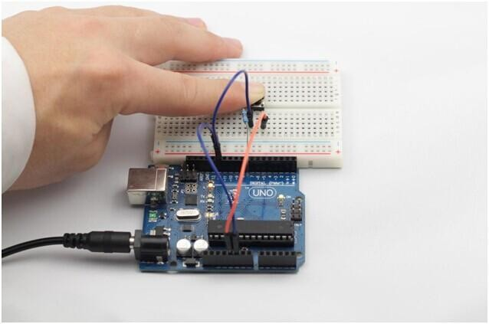

Experimental Summary
Buttons are a very simple, very practical technology that is surprisingly easy to master. If you feel as though you're struggling, check out our video tutorials on www.RobotLinking.com or ask us questions on our forum.

Lesson 3 Flowing LED Lights

Introduction
In this lesson, we‟ll conduct a simple yet interesting experiment – using LEDs to create flowing LED lights. As the name implies, these flowing lights are made up of eight LEDs in a row which successively light up and dim one after another like flowing water.

Components
- 1 * RobotLinking Uno board
- 1 * Breadboard
- Jumper wires
- 8 * LED
- 8 * Resistor (220Ω)
- 1 * USB cable

Principle
The principle of this experiment is simply to turn eight LEDs on in turn.

Experimental Procedures
Step 1: Connect circuit as shown in the following diagram
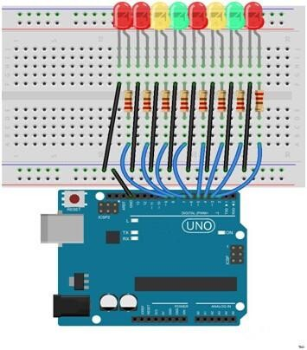

The corresponding schematic diagram is as follows:

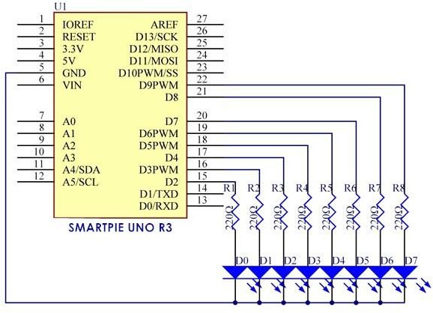

Step 2: Program (please refer to the example code on the CD or official website)
Step 3: Compile the program
Step 4: Burn the program into RobotLinking Uno board

Here you should see eight LEDs light up one by one from left to right, and then go out one by one from right to left. After that, the LEDs will light up one by one from right to left, and then go out one by one from left to right. This process will repeat indefinitely.

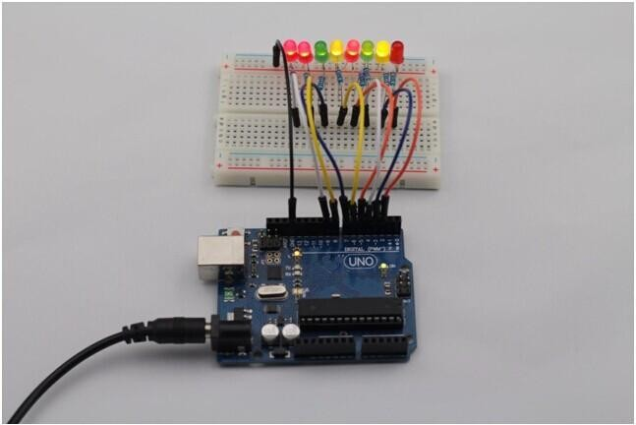

Experimental Summary
This simple experiment helps to increase proficiency in applying LEDs. Furthermore, you can modify the provided program to create all kinds of fantastic patterns!

Introduction

Lesson 4 Active Buzzer

You can use a buzzer whenever you want to make some noise.

Experimental Conditions
- 1 * RobotLinking Uno board
- 1 * Breadboard
- 1 * USB data cable
- 1 * Buzzer (Active)
- Jumper wires

Principle
As a type of electronic buzzer with integrated structure, buzzers, which are supplied by DC power, are widely used in computers, printers, photocopiers, alarms, electronic toys, automotive electronic devices, telephones, timers and other electronic products for voice devices. Buzzers can be categorized as active and passive ones (see the following picture). Turn the pins of two buzzers face up, and the one with a green circuit board is a passive buzzer, while the other enclosed with a black tape is an active one.

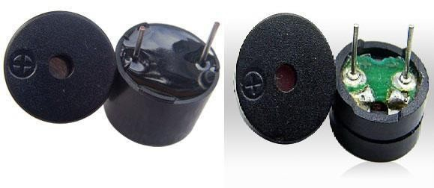

The difference between an active buzzer and a passive buzzer is:

An active buzzer has a built-in oscillating source, so it will make sounds when electrified. But a passive buzzer does not have such source, so it will not tweet if DC signals are used; instead, you need to use square waves whose frequency is between 2K and 5K to drive it. The active buzzer is often more expensive than the passive one because of multiple built-in oscillating circuits.

In this experiment, we use the active buzzer.

Experimental Procedures
Step 1: Connect circuit as shown in the following diagram:
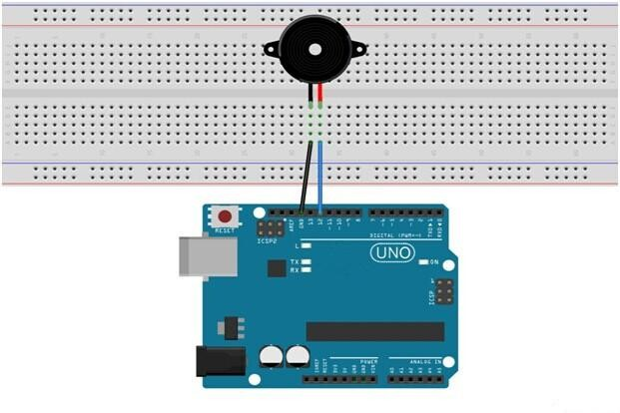

The corresponding schematic diagram is as follows:
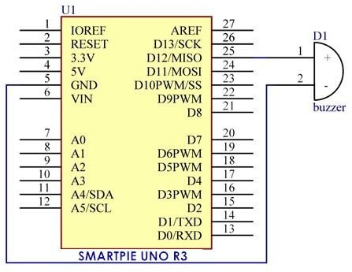

Step 2: Program (please refer to the example code on the CD or official website)
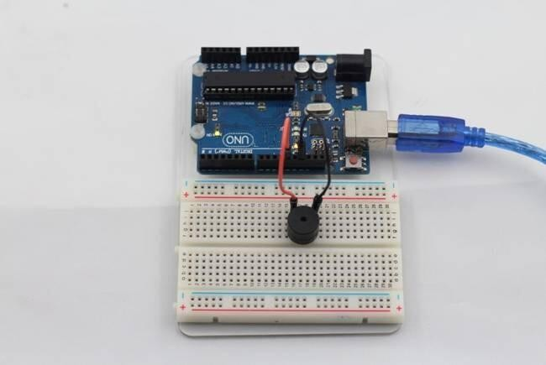
Step 3: Compile the program
Step 4: Burn the program into RobotLinking Uno board Now, you should hear the buzzer make sounds.

Lesson 5 Passive Buzzer

Introduction
Purpose of the experiment control buzzer, allowing the buzzer Alto Do (523Hz), Re (587Hz), Mi (659Hz), Fa (698Hz), So (784Hz), La (880Hz), Si (988Hz) to Treble Do (1047Hz) This scale of eight different sounds, each sound scale 0.5 seconds.

Components
- 1 * RobotLinking Uno board
- 1 * USB data cable
- 1 * Passive Buzzer
- Several jumper wires
- 1 * Breadboard

Experimental Principle
Principle buzzer, in fact, just use PWM generating audio, drives the buzzer, allowing the air to vibrate, can sound.Appropriately changed as long as the vibration frequency, it can generate different sound scale. For example, sending a pulse wave can be generated 523Hz Alto Do, pulse 587Hz can produce midrange Re, 659Hz can produce midrange Mi. If you then with a different beat, you can play a song. Here be careful not to use the Arduino analogWrite () function to generate a pulse wave, because the frequency analogWrite () is fixed (500Hz), no way to scale the output of different sounds.
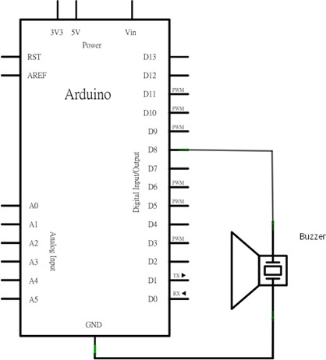

Experimental Procedures
Step 1: Connect circuit as shown in the following diagram:
Wiring the buzzer connected to the Arduino board, the red (positive) to the pin8, black wire (negative) to the GND
Description:
L04 ~ L05: definition of alto Do, Re, Mi, So, La, Si and treble Do eight octave frequency, the frequency of each scale is already defined in pitches.h file in, so just find the eight Constant scale and stored in the array to melody.
L06: definition of variable duration, representing each scale response time duration, because the scale to make each sound 0.5 seconds, so the duration is set to 500 (in milisecond)
L13 ~ L19: Let the buzzer Alto Do ( 523Hz), Re (587Hz), Mi (659Hz), Fa (698Hz), So (784Hz), La (880Hz), Si (988Hz) to treble Do (1047Hz) which eight voices of different scales, each scale ring 0.5 seconds
L22: every two seconds, and then replay the content pitches.h stalls:

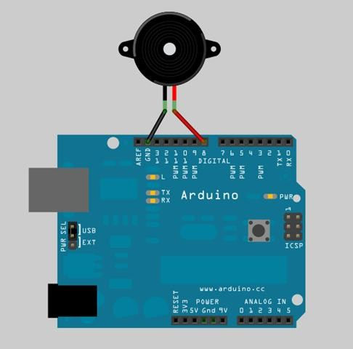

Step 2: Program (please refer to the example code on the CD or official website)
Step 3: Compile the program
Step 4: Burn the program into RobotLinking Uno board

Fixed brains
in this example is based, together with a few LED and modify the program, at the same time to play a sound control LED lights change, so that this paradigm has become a shot in the program. Try to generate an ambulance siren. Tip: Just let the buzzer continuously generate Alto Do (523Hz) and Alto Fa (698Hz), each about 0.8 seconds of sound, you can simulate ambulance siren.

Lesson 6 Photoresistor

Introduction
A photoresistor or photocell is a light-controlled variable resistor. The resistance of a photoresistor decreases with increasing incident light intensity; in other words, it exhibits photoconductivity. A photoresistor can be applied in light-sensitive detector circuits, and light- and dark-activated switching circuits.

Experimental Conditions
- 1 * RobotLinking Uno board
- 1 * USB data cable
- 1 * Photoresistor
- 1 * Resistor (10KΩ)
- 8 * LED
- 8 * Resistor (220Ω)
- Jumper wires
-1 * Breadboard

Experimental Principle
The resistance of the photoresistor changes with incident light intensity. If the incident light intensity is high, the resistance reduces; if low, increases.

In this experiment, we will use eight LEDs to indicate light intensity. The higher the light intensity is, the more the LED is lit. When the light intensity is high enough, all the LEDs will be lit. When there is no light, all the LEDs will go out.

Experimental Procedures
Step 1: Connect circuit as shown in the following diagram:

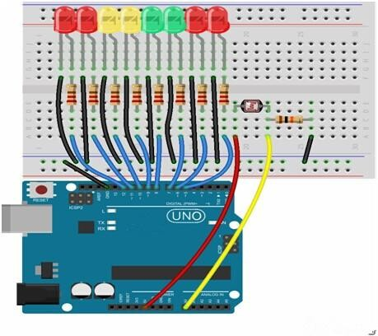

The corresponding schematic diagram is as follows:
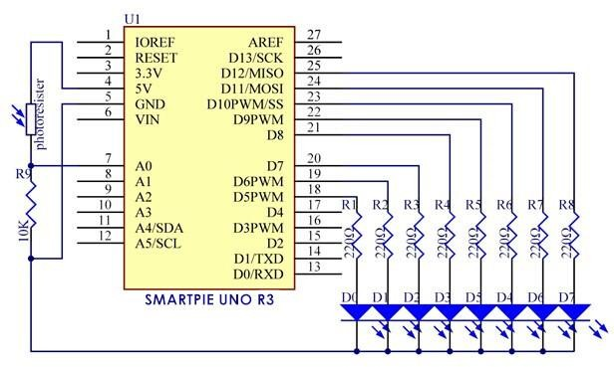

Step 2: Program (please refer to the example code on the CD or official website)
Step 3: Compile the program

Step 4: Burn the program into RobotLinking Uno board

Now, if you shine the photoresistor with a certain light intensity, you will see several LEDs light up. If you increase the light intensity, you will see more LEDs light up. When you place it in dark environment, all the LEDs will go out.
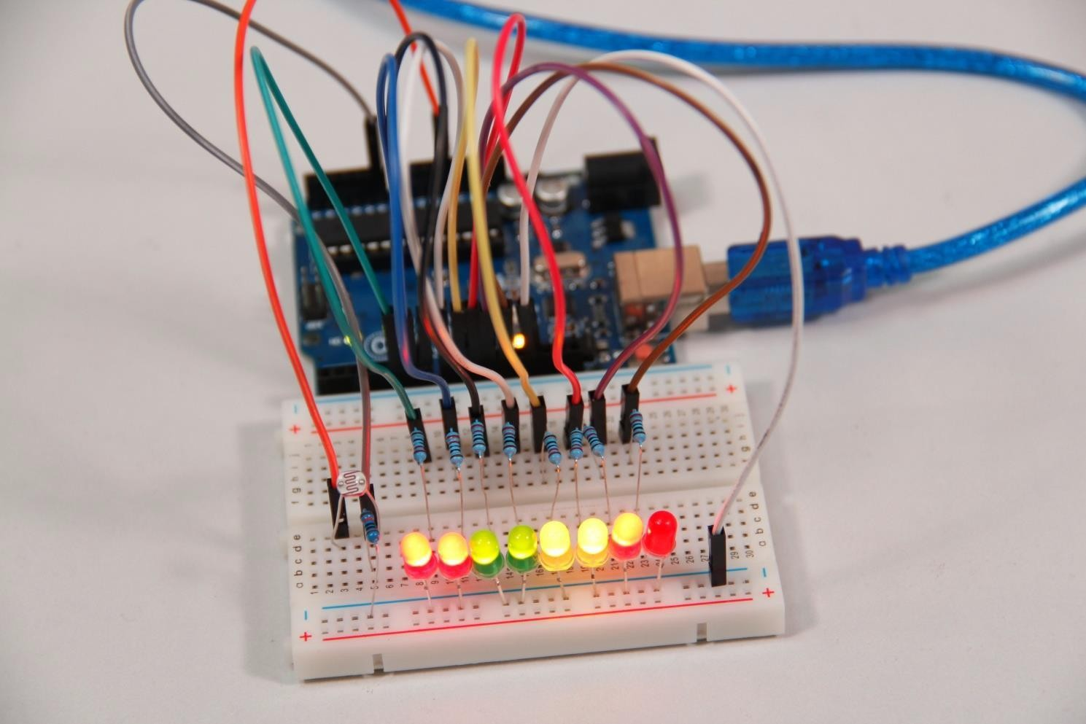

Exploration
In addition, you can replace the photoresistor with a microphone to use LEDs to indicate sound intensity. The higher the sound intensity is, the more LEDs are lit. You can realize this effect by yourself.

Lesson 7 RGB LED

Introduction
For this lesson, we will use PWM to control a RGB LED and cause it to display multiple colors.

Components
- 1 * RGB LED
- 3 * Resistor (220Ω)
- 1 * Breadboard
- 1 * RobotLinking Uno board
- Jumper wires
- USB cable

Principle

Color Principle of RGB
RGB stands for the red, green, and blue color channels and is an industry color standard. RGB displays various new colors by changing the three channels and superimposing them, which, according to statistics, can create 16,777,216 different colors. If you say the color displayed doesn't completely match a natural color, then it almost certainly cannot be differentiated with the naked eye.

Each of the three color channels of red, green, and blue has 255 stages of brightness. When the three primary colors are all 0, "LED light" is the darkest, that is, it turns off. When the three primary colors are all 255, "LED light" is the brightest. When superimposing the light emitted by the three primary colors, the colors will be mixed. However, the brightness is equal to the sum of all brightness, and the more you mix, the brighter the LED is. This process is known as additive mixing.

In this experiment, we will also use PWM which you have learnt in super kit. Here we input any value between 0 and 255 to the three pins of the RGB LED to make it display different colors.

Experimental Procedures
Step 1: Connect circuit as shown in the following diagram:

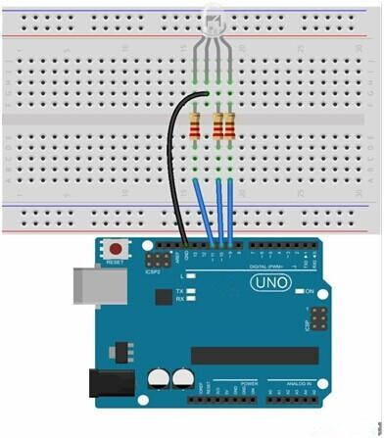

The corresponding schematic diagram is as follows:

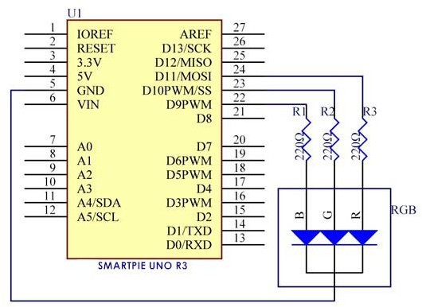

45 /136

Step 2: Program (please refer to the example code on the CD or official website)
Step 3: Compile the program
Step 4: Burn the program into RobotLinking Uno board

The RGB LED will appear red, green, and blue first, then red, orange, yellow, green, blue, indigo, and purple.
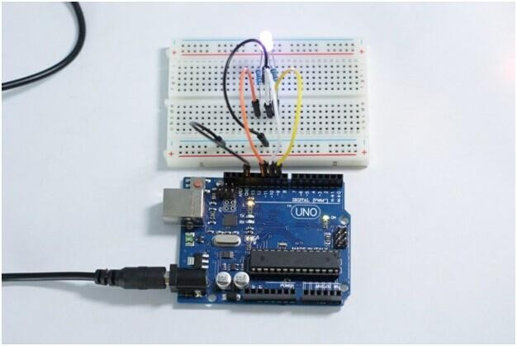

Lesson 8 Relay

Introduction
Relays are suitable for driving high power electric equipment, such as lights, electric fans and air conditioning. We can use a relay to realize low voltage to control high voltage by connecting it to MCU.

Components
- 1 * RobotLinking Uno board
- 1 * USB data cable
- 1 * Relay
- 1 * LED
- 1 * Resistor (220Ω)
- 1 * Resistor (1KΩ)
- 1 * NPN Transistor
- 1 * Diode (Rectifier)
- Several jumper wires
- 1 * Breadboard

Experimental Principle
A relay is an electronic control component with control system and controlled system. It is generally used in automatic control circuit. Actually, it is an "automatic switch" which uses low current to control high current. It plays a role of automatic regulation, security protection and circuit switch.

An electromagnetic relay is generally composed of iron core, coil and armature, contact reeds, etc. There will be electric current flowing through the coil as long as a certain voltage is supplied on both ends of the coil so as to generate electromagnetic effect. The armature will overcome spring tension to suck the iron core to drive the armature's movable contact and static contact (normally open contact) suction under electromagnetic attraction. After the coil is power off, electromagnetic suction will also disappear. The armature will return to the original position under the spring reactive force, leading to the movable contact suction with the original static contact (normally closed contact). This suction and release achieve the purpose of circuit conduction and cut off. For relay "normally open and normally closed" contacts, it can be distinguished like this: when relay coil is not energized, static contact in disconnected state is called "normally open contact"; static contact in connected state is called "normally closed contact".

In this experiment, when the relay sucks, the LED will light up; when the relay breaks, the LED will go out.

Experimental Procedures
Step 1: Connect circuit as shown in the following diagram:
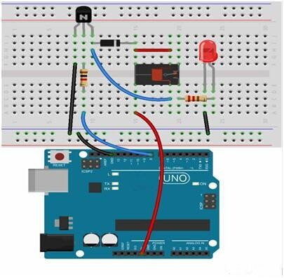

The corresponding schematic diagram is as follows:
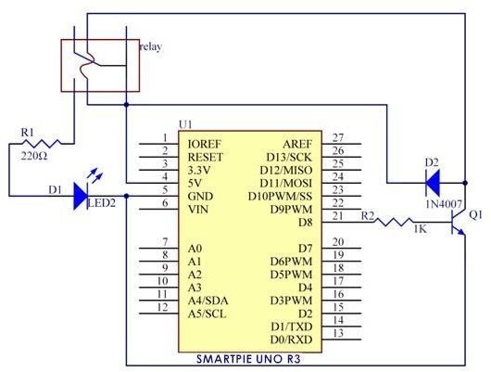

48 /136

Step 2: Program (please refer to the example code on the CD or official website)
Step 3: Compile the program
Step 4: Burn the program into ROBOTLINKING UNO board

Now, if a high voltage is supplied, the relay will suck and the LED will light up; if a low voltage is supplied, the relay will break and the LED will go out. In addition, you can hear ticktock caused by breaking normally closed contact and closing normally open contact.
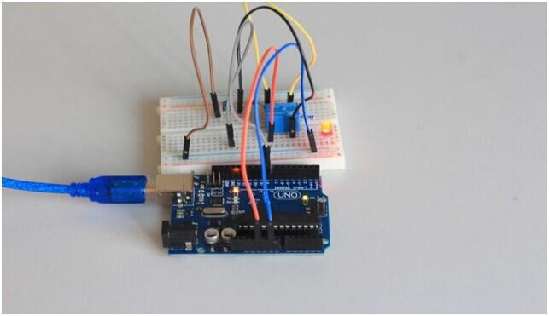

Lesson 9 Tilt-Switch

Introduction
The tilt-switch we use is a ball one with a metal ball inside. It is used to detect small angle of inclination.

Components
- 1 * RobotLinking Uno board
- 1 * USB data cable
- 1 * Tilt-switch
- Several jumper wires

Experimental Principle
The principle is very simple. It mainly uses the ball in the switch changing with different angle of inclination to achieve the purpose of triggering circuits. When the ball in tilt switch runs from one end to the other end because of external force shaking, the tilt switch will conduct, or it will break.

Experimental Procedures
Step 1: Connect circuit as shown in the following diagram:
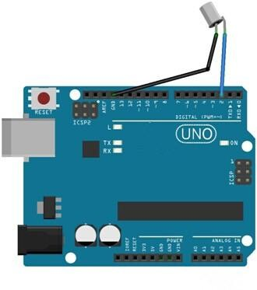
The corresponding schematic diagram is as follows:

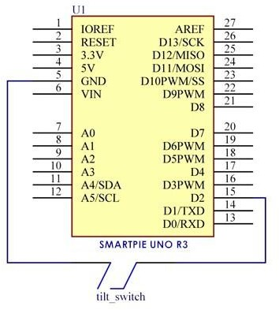
Step 2: Program (please refer to the example code on the CD or official website)
Step 3: Compile the program
Step 4: Burn the program into RobotLinking Uno board

Now, if you tilt the switch, the LED attached to pin 13 on RobotLinking Uno board will light up.
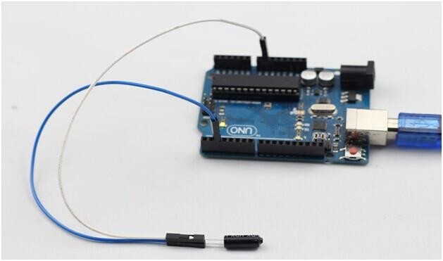

Lesson 10 Servo

Introduction
Servo is a type of geared motor that can only rotate 180 degrees. It is controlled by sending electrical pulses from your RobotLinking Uno board. These pulses tell the servo what position it should move to. A servo has three wires, the brown wire is GND, the red one is VCC, and the orange one is signal line.

Components
- 1 * RobotLinking Uno board
- 1 * USB data cable
- 1 * Servo
- Several jumper wires

Experimental Principle
Servo consists of shell, circuit board, non-core motor, gear and location detection. Its working principle is as follows: RobotLinking Uno board sends PWM signal to servo motor, and then this signal is processed by IC on circuit board to calculate rotation direction to drive the motor, and then this driving power is transferred to swing arm by reduction gear. At the same time, position detector returns location signal to judge whether set location is reached or not.

Experimental Procedures
Step 1: Connect circuit as shown in the following diagram:
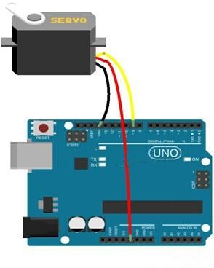

The corresponding schematic diagram is as follows:
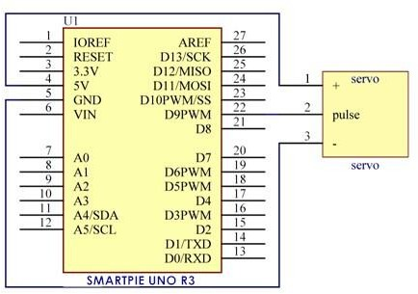
Step 2: Program (please refer to the example code on the CD or official website)
Step 3: Compile the program
Step 4: Burn the program into RobotLinking Uno board

Now, you can see the servo motor rotate 90 degrees (rotate once every 15 degrees). And then rotate in opposite direction.
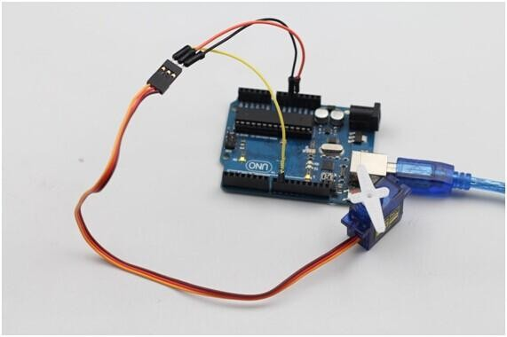

Lesson 11 LCD1602

Introduction
In this experiment, we will use the RobotLinking Uno board to directly drive LCD1602 to display characters.

Components
- 1 * RobotLinking Uno board
- 1 * Breadboard
- 1 * LCD1602
- 1 * Potentiometer (50kΩ)
- Jumper wires
- 1 * USB cable

Principle
Generally speaking, LCD1602 has parallel ports, that is, it needs to control several pins at the same time. LCD1602 can be categorized into an eight-port connection and four-port connection. If the eight-port connection is used, then the digital ports of the RobotLinking Uno board are basically completely occupied. If you want to connect more sensors, there will be no ports available. Therefore, we will use the four-port connection.

Introduction to the pins of LCD1602:
VSS: A pin that connects to ground
VDD: A pin that connects to a +5V power supply
VO: A pin that adjust the contrast of LCD1602
RS: A register select pin that controls where in the LCD‟s memory you are writing data to. You can select either the data register, which holds what goes on the screen, or an instruction register, which is where the LCD‟s controller looks for instructions on what to do next.
R/W: A Read/Write pin that selects reading mode or writing mode
E: An enabling pin that, when supplied with low-level energy, causes the LDC module to execute relevant instructions.
D0-D7：Pins that read and write data
A and K: Pins that control the LED backlight

In this experiment, we will use a 50KΩ potentiometer to adjust the contrast of LCD1602 to display characters or figures however you want. For programming, we will optimize it by calling function libraries.

Experimental Procedures
Step 1: Connect circuit as shown in the following diagram (please make sure pins are connected correctly or characters will not display properly):
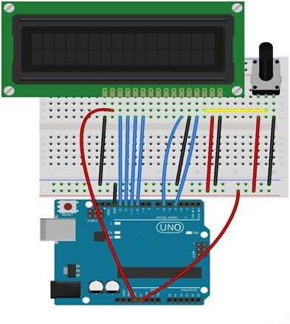
The corresponding schematic diagram is as follows:

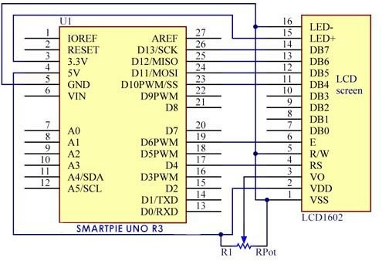

Step 2: Program (please refer to the example code on the CD or official website)
Step 3: Compile the program
Step 4: Burn the program into RobotLinking Uno board

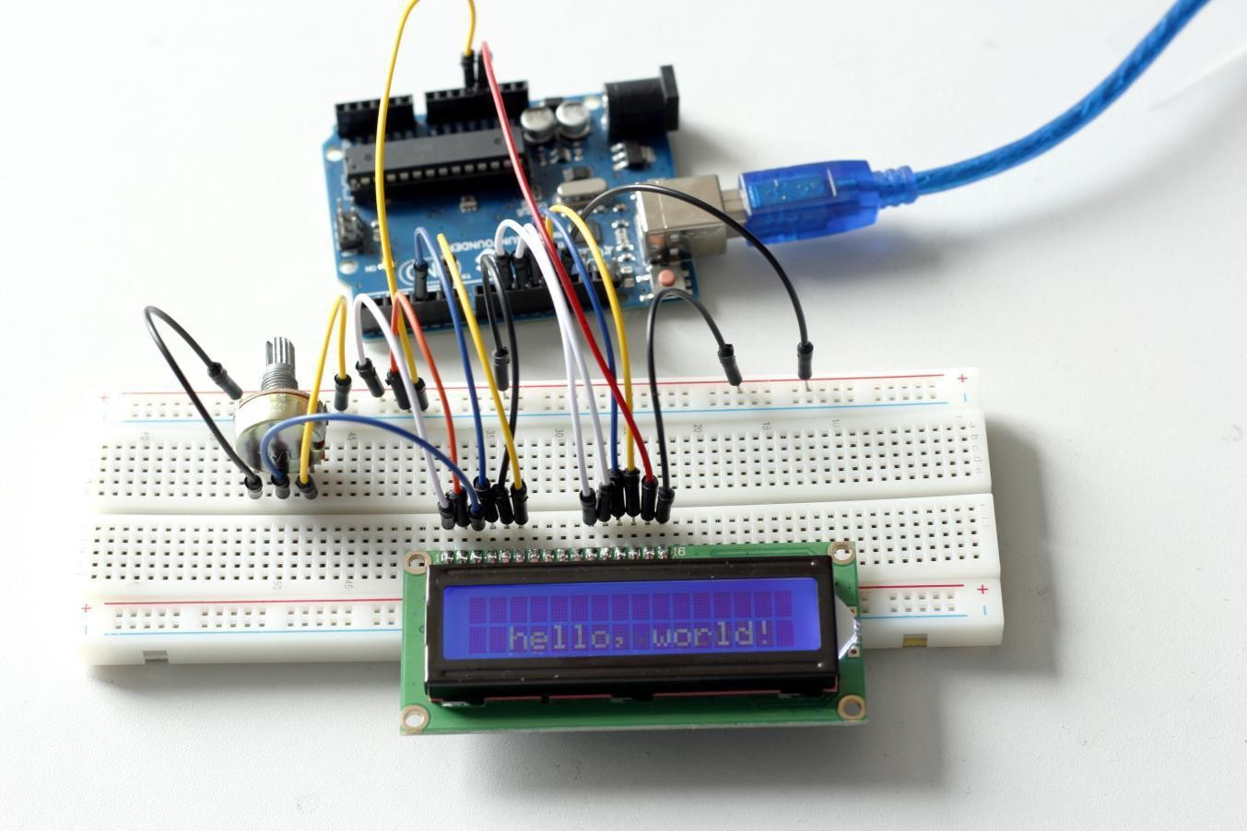
You should now see your LCD1602 display the flowing characters "ROBOTLINKING" and "hello, world! ".

Experimental Summary
Through this experiment, you've learned how to drive LCD1602. Now you can create your own messages to display! You can also try letting your LCD1602 display numbers.

Lesson 12 Thermistor

Introduction
A thermistor is a type of resistor whose resistance varies significantly with temperature.

Components
- 1 * RobotLinking Uno board
- 1 * USB data cable
-1 * Breadboard
- 1 * Thermistor
- Several jumper wires
-1 * Potentiometer (50KΩ)
-1 * Resister (10KΩ)
-1 * LCD1602

Experimental Principle
The resistance of the thermistor varies significantly with ambient temperature. It can detect surrounding temperature changes in real time. Send the temperature data to analog I/O port of RobotLinking Uno board. Next we only need to convert sensor output to Celsius temperature by simple programming and display it on the LCD1602.

Experimental Procedures
Step 1: Connect circuit as shown in the following diagram:

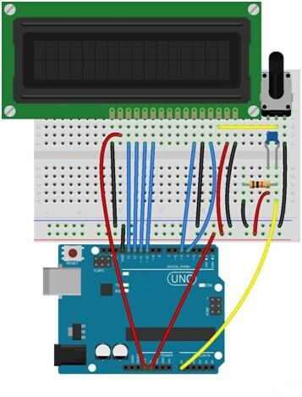

The corresponding schematic diagram is as follows:
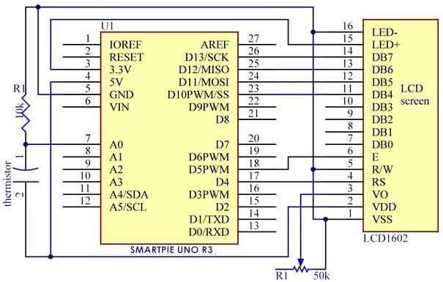

Step 2: Program (please refer to the example code on the CD or official website)
Step 3: Compile the program
Step 4: Burn the program into RobotLinking Uno board

Now, you can see current temperature displayed on LCD1602 both in Celcius and Fahrenheit degrees.
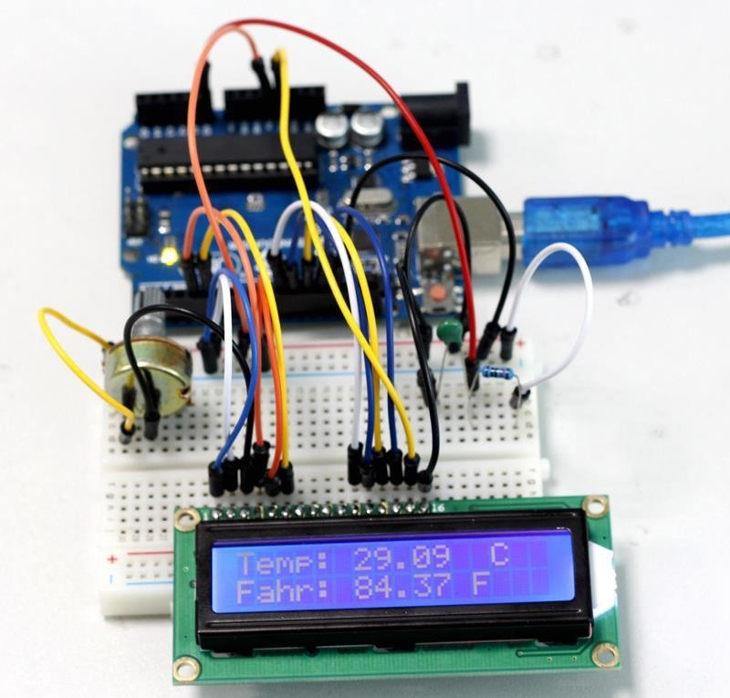

Lesson 13 Voltmeter

Introduction
In this lesson, we will use two potentiometers and a LCD1602 to make a voltmeter.

Components
- 1 * RobotLinking Uno board
- 1 * USB data cable
- 2 * Potentiometer
- 1 * LCD1602
- Several jumper wires
-1 * Breadboard

Experimental Principle
One potentiometer is used to adjust the contrast of the LCD1602. And the other is used to divide voltage.

Experimental Procedures
Step 1: Connect circuit as shown in the following diagram:
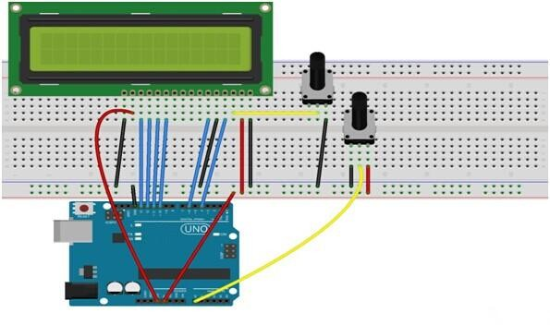

The corresponding schematic diagram is as follows:

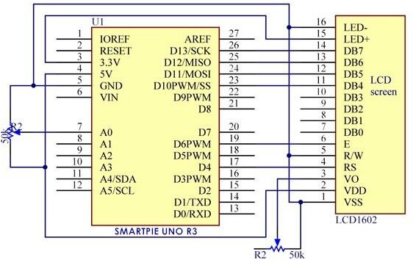
Step 2: Program (please refer to the example code on the CD or official website)
Step 3: Compile the program
Step 4: Burn the program into RobotLinking Uno board

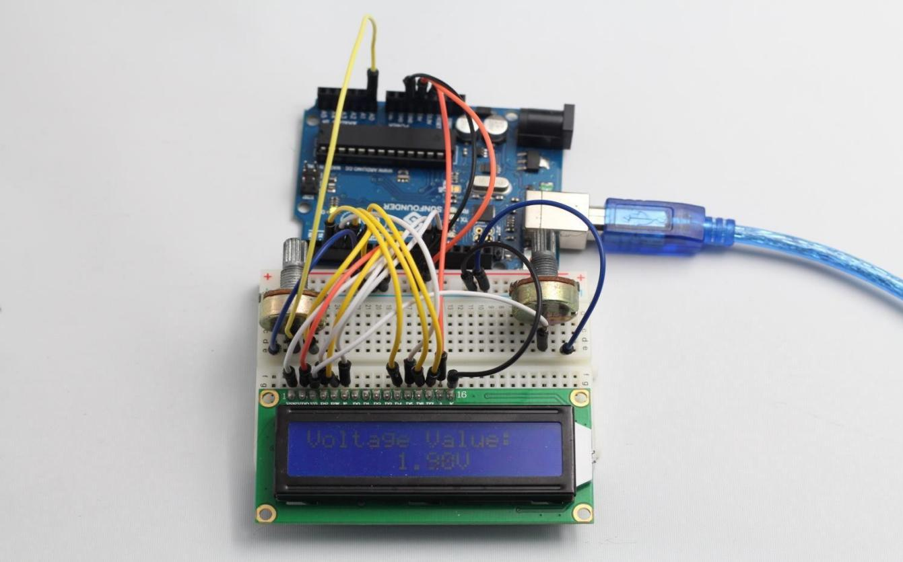
Now, if you adjust the potentiometer which is used to divide voltage, you will see the voltage value displayed on the LCD1602 varies.

Introduction

Lesson 14 Ultrasonic

The ultrasonic sensor is used to sense distance from objects.

Components
- 1 * RobotLinking Uno board
- 1 * USB data cable
- 1 * Breadboard
- 1 * Ultrasonic sensor
- 1 * LCD1602
- 1 * Potentiometer
- Several jumper wires

Experimental Principle
This sensor works by sending a sound wave out and calculating the time it takes for the sound wave to get back to the ultrasonic sensor. By doing this, it can tell us how far away objects are relative to the ultrasonic sensor.

Experimental Procedures
Step 1: Connect circuit as shown in the following diagram:

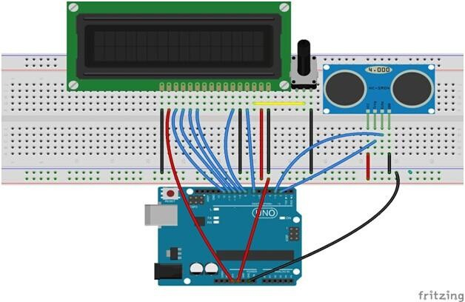

The corresponding schematic diagram is as follows:

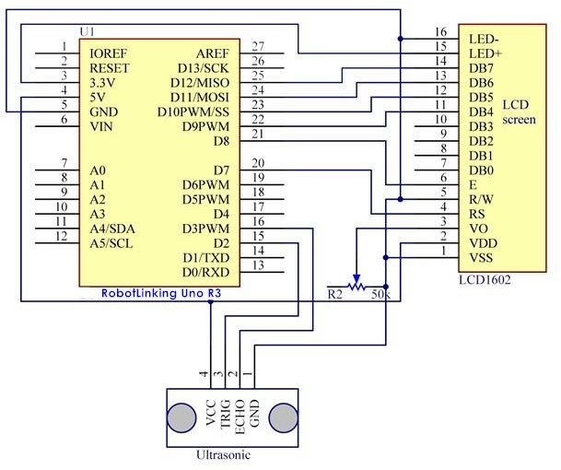

Step 2: Program (please refer to the example code on the CD or official website)
Step 3: Compile the program
Step 4: Burn the program into RobotLinking Uno board

Now, if you use a piece of paper to approach or keep it far away from the sensor. You will see the value displayed on the LCD varies, which indicates the distance between the paper and the ultrasonic sensor.

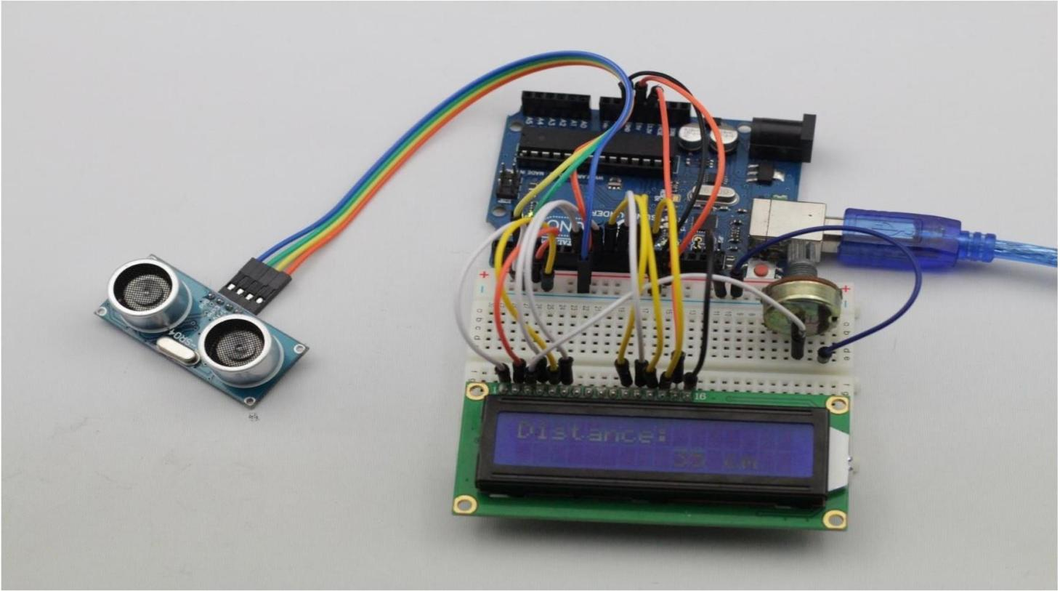

Lesson 15 Stopwatch

Introduction
In this lesson, we will use a four digit 7-segment display to make a stopwatch.

Components
- 1 * RobotLinking Uno board
- 1 * USB data cable
- 1 * Four digit 7-segment display
- Several jumper wires
- 1 * Breadboard
- 8 * Resister (220Ω)

Experimental Principle
When using one digit 7-segment display, if it is common anode, we will connect common anode pin to power source; if it is common cathode, we will connect common cathode pin to GND. When using four digit 7-segment display, the common anode or common cathode pin are used to control which digit is displayed. There is only one digit working. However, based on the principle of Persistence of Vision, we can see four 7-segment display is all displaying numbers. This is because electronic scanning speed is fast and we cannot notice it.

Experimental Procedures
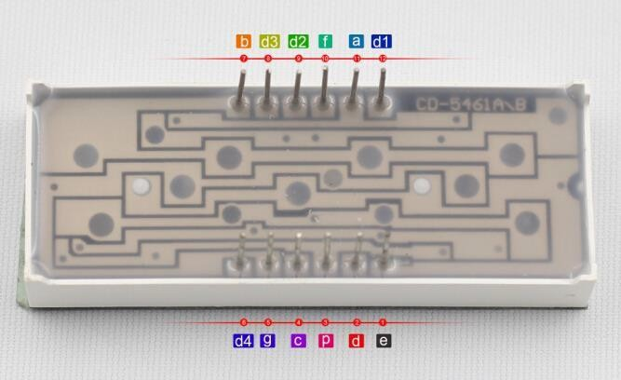
Step 1: Connect the circuit

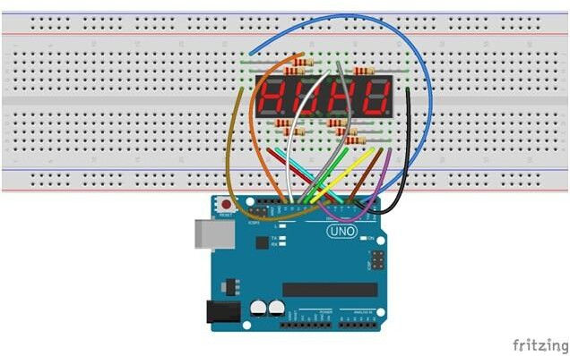

The corresponding schematic diagram is as follows:

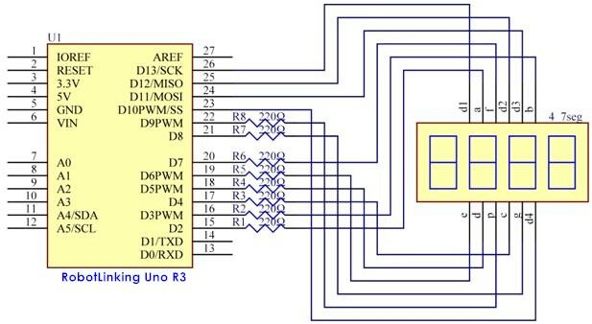

Step 2: Program (please refer to the example code on the CD or official website)
Step 3: Compile the program
Step 4: Burn the program into RobotLinking Uno board.

Now you can see number plus one per second on segment display.

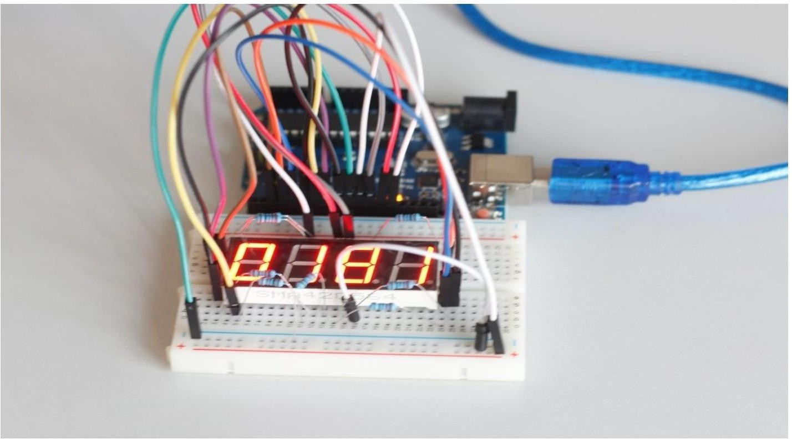

Lesson 16 74HC595 And Segment Display

Introduction
Rewrite " Lab7 make use of seven-segment display countdown function "to 74HC595 shift register control a seven-segment display sequentially displays the number from 9-0, making the effect of the digital countdown on the seven-segment display.
Note: This test assumes that you have done, " Lab7 make reciprocal use of seven-segment display function "and"Lab11 use 74HC595 and three pins to control 8 LED "principle has been known seven-segment display and a 74HC595 using separate ways.

Components
- 1 * RobotLinking Uno board
- 1 * USB data cable
- 1 * 74HC595
- 1 * 1 Segment Display
- 8 * 220R Resistors
- Several jumper wires
- 1 * Breadboard

Experimental Principle
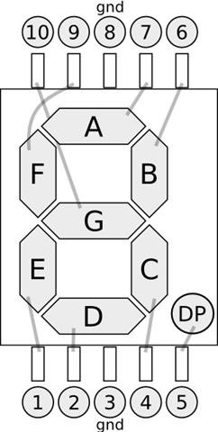
Seven segment display pin diagram below (the picture shows common cathode seven- segment display):

  - ten digits correspond with each segment are as follows (the following table applies common cathode seven segment display device, if you are using a common anode, the table should be replaced every 1 0 0 should all replaced by 1):
Display digital | dp | a | b | c | d | e | f | g
0 | 0 | 1 | 1 | 1 | 1 | 1 | 1 | 0
1 | 0 | 0 | 1 | 1 | 0 | 0 | 0 | 0
2 | 0 | 1 | 1 | 0 | 1 | 1 | 0 | 1
3 | 0 | 1 | 1 | 1 | 1 | 0 | 0 | 1
4 | 0 | 0 | 1 | 1 | 0 | 0 | 1 | 1
5 | 0 | 1 | 0 | 1 | 1 | 0 | 1 | 1
6 | 0 | 1 | 0 | 1 | 1 | 1 | 1 | 1
7 | 0 | 1 | 1 | 1 | 0 | 0 | 0 | 0
8 | 0 | 1 | 1 | 1 | 1 | 1 | 1 | 1
9 | 0 | 1 | 1 | 1 | 1 | 0 | 1 | 1
74HC595 shift register pin diagram is as follows:

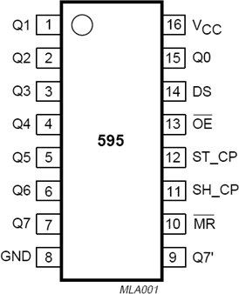

Pin Number | Name | Explanation
1-7, 15 | Q0 ~ Q7 | Output pins
8 | GND | Ground
7 | Q7 ' | Sequence output (Serial Out)
10 | MR | Master Reset, clear all data, active low (Active low)
11 | SH_CP | SHift register clock pin (Clock Pin)
12 | ST_CP | STorage register clock pin (Latch Pin)
13 | OE | Output Enable, allowing the output, active low (Active low)
14 | DS | Sequence data input (Serial data input)
16 | Vcc | Supply voltage

Experimental Procedures
Step 1: Connect circuit as shown in the following diagram:
WThe following table shows the seven-segment display 74HC595 pin correspondence table:
74HC595  pin | Seven shows remarkable control pin (stroke)
Q0 | 7 (A)
Q1 | 6 (B)
Q2 | 4 (C)
Q3 | 2 (D)
Q4 | 1 (E)
Q5 | 9 (F)
Q6 | 10 (G)
Q7 | 5 (DP)

Step one: Connect 74HC595
First, the wiring is connected to power and ground:
    - Vcc (pin 16) and MR (pin 10) connected to 5V
    - GND (pin 8) and OE (pin 13) to ground Connection DS, ST_CP and SH_CP pin:

    - DS (pin 14) connected to Arduino pin 11 (the figure below the blue line)
    - ST_CP (pin 12, latch pin) connected to Arduino pin 8 (FIG green line below)
    - SH_CP (pin 11, clock pin) connected to Arduino pin 12 (the figure below the yellow line)
Step two: Connect the seven segment display
    - The seven-segment display 3, 8 pin to GND (This example uses the common cathode, anode set if the total of 3, 8 pin to + 5V)
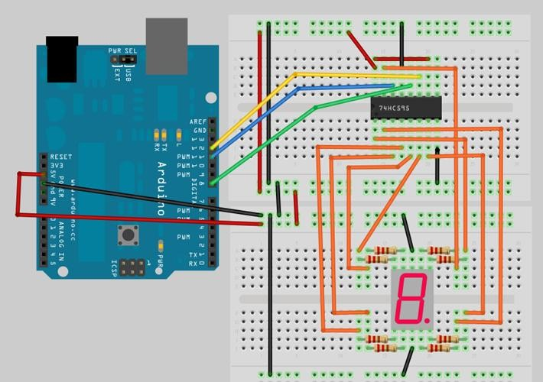
    - According to the table of the 74HC595 Q0 ~ Q7 received a seven-segment display corresponding pin (A ~ G and DP), and then each foot in a 220 ohm resistor in series

Circuit diagram
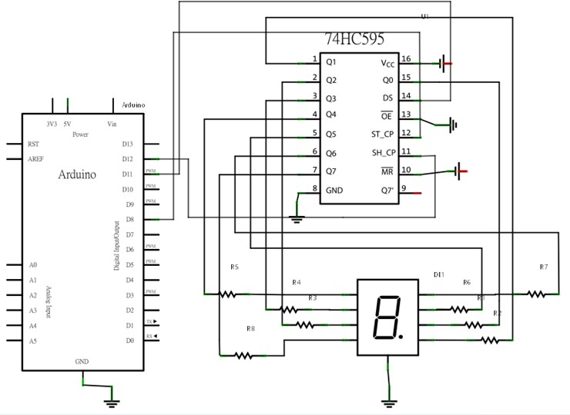

Step 2: Program (please refer to the example code on the CD or official website)
Step 3: Compile the program
Step 4: Burn the program into RobotLinking Uno board

Lesson 17 IR Remote

Introduction
In this lesson, we will learn how to use ir remote and ir receiver.

Components
- 1 * RobotLinking Uno board
- 1 * USB data cable
- 1 * IR remote
- 1 * IR receiver module
- Several jumper wires
- 1 * Breadboard

Experimental Principle
Using an IR Remote is a great way to have wireless control of your Arduino project.
Infrared remotes are simple and easy to use. In this tutorial we will be connecting the IR receiver to the UNO, and then use a Library that was designed for this particular sensor.
In our sketch we will have all the IR Hexadecimal codes that are available on this remote, we will also detect if the code was recognized and also if we are holding down a key.

Experimental Procedures
Step 1: Connect circuit as shown in the following diagram: There are 3 connections to the IR Receiver.
The connections are : Signal, Voltage and Ground.
The “-” is the Ground, “S” is signal, and middle pin is Voltage 5V.
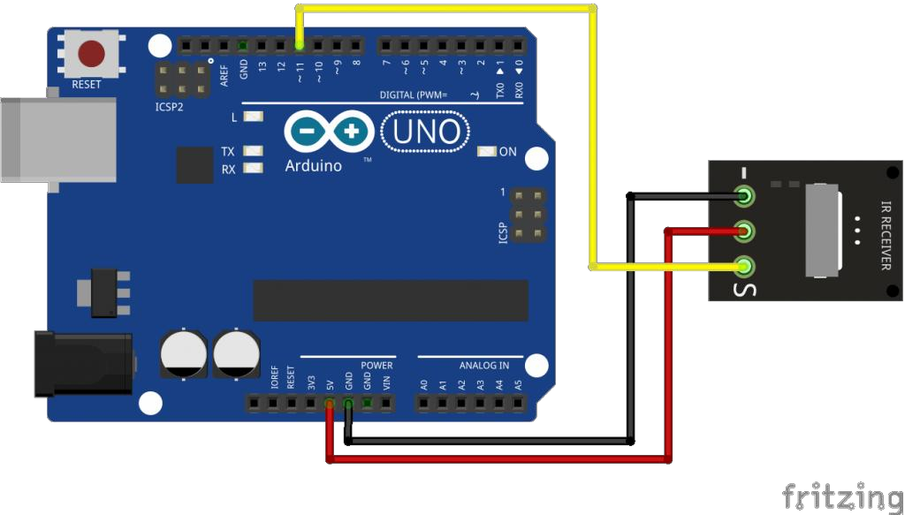

Step 2: First download the Library (link below) and extract it to your “Library” folder inside your IDE software, it should be named “IRremote”
Next we will move the “RobotIRremote” out of the Library folder, we do this because that library conflicts with the one we will be using. You can just drag it back inside the library folder once you are done programming your microcontroller.
Once you have installed the Library, just go ahead and restart your IDE Software.
Step 3: Program (please refer to the example code on the CD or official website)
Step 4: Compile the program
Step 5: Burn the program into RobotLinking Uno board
Step 6: Open Tool → Monitor to see the data.
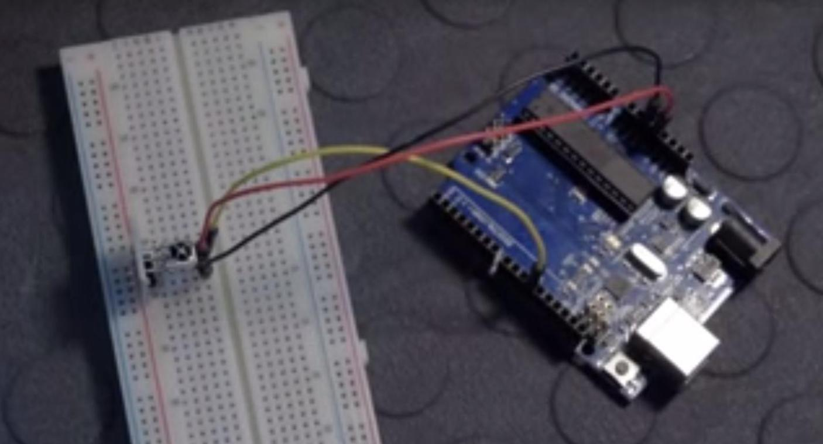

Lesson 18 MAX7219 Module

Introduction
In this lesson, we will learn how to use MAX7219 module.
In this tutorial we will connect 2 of them together and scroll the text across.
Since these modules use the MAX7219 LED driver chip, we will be able to turn on and off the 64 LEDs of each modules, using only 3 pins on our Arduino.

Components
- 1 * RobotLinking Uno board
- 1 * USB data cable
- 2 * MAX7219 Module
- Several jumper wires
- 1 * Breadboard

Experimental Principle

Experimental Procedures
Step 1: Connect circuit as shown in the following diagram:
We are using a small breadboard to put the modules side by side to give a better experience.
As you can see, even if we are using 2 Modules, the number of pins needed, does not increase.
VCC and Ground are connected to the Arduino.
Pin 8 is connected to DIN, Pin 9 is connected to CS and Pin 10 is connected to CLK. We then daisy-chain the modules together.
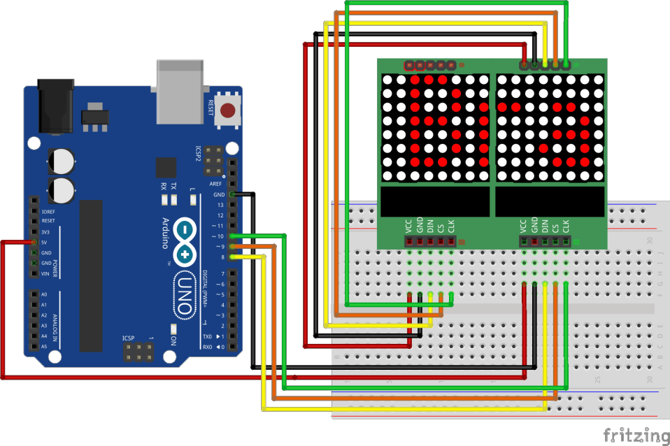

Step 2: Our Sketch will make use of the “Maxmatrix” Library to communicate with the MAX7219 modules.
Download and extract it to your Library folder, then restart your IDE software. As always you can have a look at the tutorial video for more information.
Since we are defining all the characters possible (0-9 a-z etc..), instead of using the SRAM (2048 bytes), we will put that information in Flash memory on our UNO since that information will not change and also there‟s more Flash memory available (32k).
We do this by using the “#include <avr/pgmspace.h>” and then “PROGMEM prog_uchar CH[] =” to put our array information in Flash memory.
Note: Flash (PROGMEM) memory can only be populated when we upload the code to our
UNO. You can’t change the values in the flash after the program has started running, unlike SRAM where our sketch is run.
Step 3: Program (please refer to the example code on the CD or official website)
Step 4: Compile the program
Step 5: Burn the program into RobotLinking Uno board
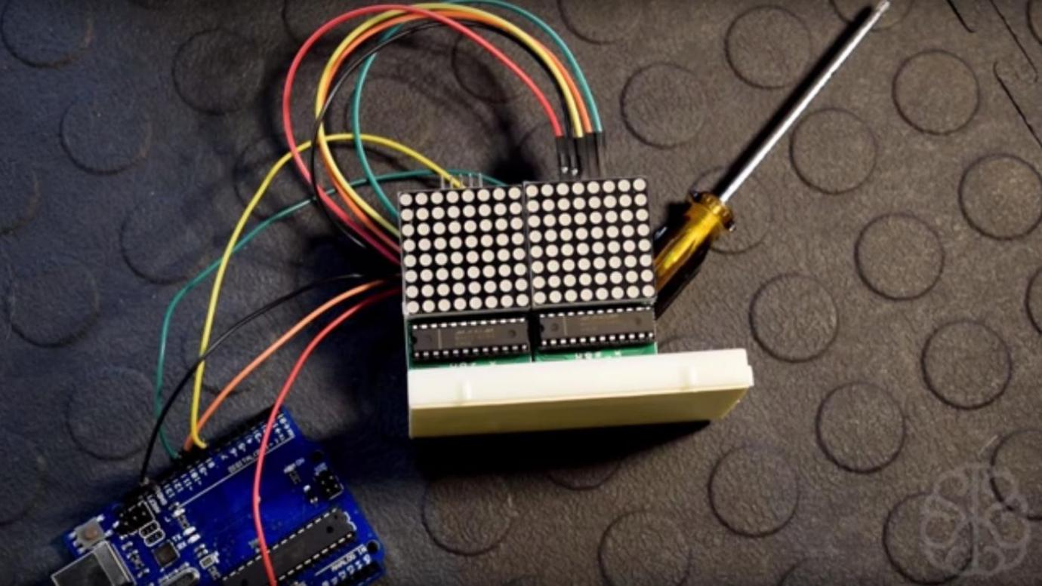

Lesson 19 JOYSTICK

Introduction
In this lesson we will learn how to use a joystick module.

Components
- 1 * RobotLinking Uno board
- 1 * Breadboard
- 1 * Joystick
- Jumper wires
- 1 * USB cable

Principle
The module has 5 pins: Vcc, Ground, X, Y, Key. Note that the labels on yours may be slightly different, depending on where you got the module from. The thumbstick is analog and should provide more accurate readings than simple „directional‟ joysticks tat use some forms of buttons, or mechanical switches. Additionally, you can press the joystick down (rather hard on mine) to activate a „press to select‟ push-button.
We have to use analog Arduino pins to read the data from the X/Y pins, and a digital pin to read the button. The Key pin is connected to ground, when the joystick is pressed down, and is floating otherwise. To get stable readings from the Key /Select pin, it needs to be connected to Vcc via a pull-up resistor. The built in resistors on the Arduino digital pins can be used.

Experimental Procedures
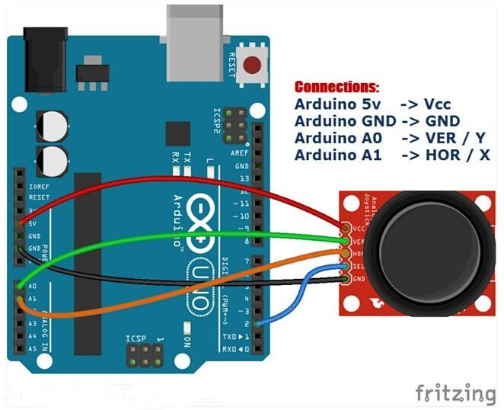
Step 1: Connect circuit as shown in the following diagram (please make sure pins are connected correctly or characters will not display properly):

Step 2: Program (please refer to the example code on the CD or official website)
Step 3: Compile the program
Step 4: Burn the program into RobotLinking Uno board
Step 5: Open "tool-monitor", to see the data.

Lesson 20 Keypad Module

Introduction
In this lesson, we will learn how to use keypad module.
Keypad or button matrices come in many different forms and sizes: 4, 12, 16 buttons…
They are great for use as input devices, but they normally require a lot of your precious Arduino pins.
A matrix needs 1 pin for each row and column, so let‟s say a Keypad as 12 buttons arranged in 4 columns and 3 rows, then it would require 7 pins to connect to an Arduino.
But there is a way to connect these keypads by using only 1 analog pin and some resistors!
Based on a voltage divider design, using two different resistor values, one for rows and one for columns, we can know which button is pressed based on the resulting voltage value on the analog pin.
In this tutorial we will connect a 4×4 or 16 buttons matrix

Components
- 1 * RobotLinking Uno board
- 1 * USB data cable
- 1 * Keypad Module
- 4 * 1K Resistors
- 3 * 4.7K Resistors
- Several jumper wires
- 1 * Breadboard

Experimental Principle

Experimental Procedures
Step 1: Connect circuit as shown in the following diagram:
As you can see in the schematic above, the Rows pins (1 to 4) of the keypad are connected using the 4.7KΩ resistors and the Columns pins (5 to 8) are using the 1KΩ.
The Arduino A0 pin is used to read the resulting voltage value.
And we are connecting the Ground and 5V from the Arduino to the breadboard rails.
Note the 1KΩ resistor that is connected to GND and the RED wire that connects to 5V on the breadboard.

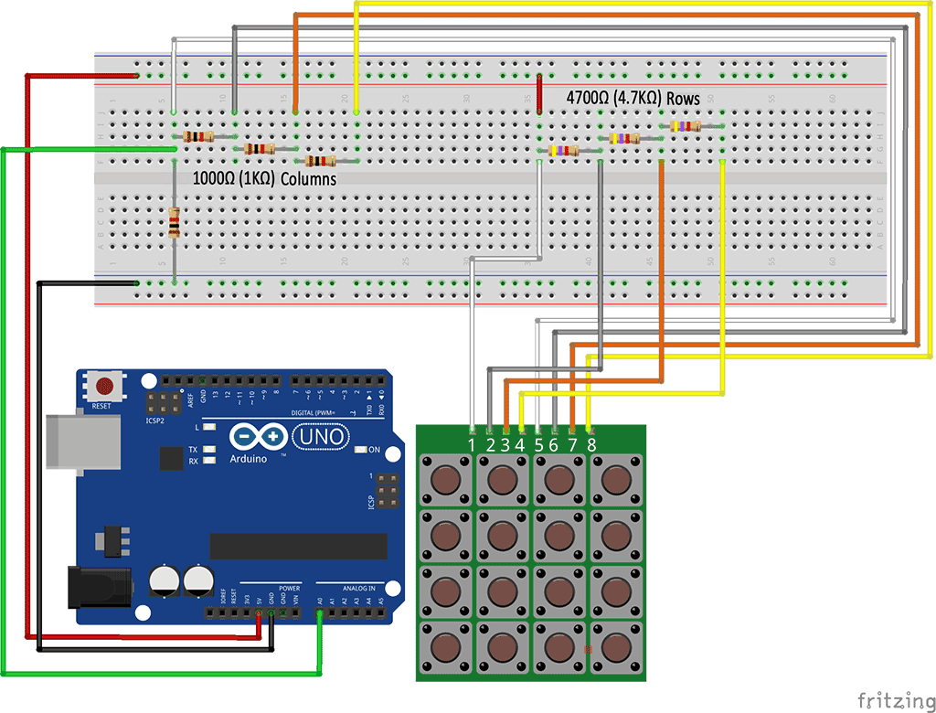
Step 2: We will be using a library called OneWireKeypad, it will take care of the calculations needed to know which keys was pressed and make our code short and easy to write.
As always please watch our tutorial video for more information and to better understand the process.
Step 3: Program (please refer to the example code on the CD or official website)
Step 4: Compile the program
Step 5: Burn the program into RobotLinking Uno board
Step 6: Open Tool → Monitor to see the data.

Lesson 21 HC-SR501 PIR Sensor Module

Introduction
Practice using infrared motion sensor (PIR Motion Sensor), the use of infrared motion sensors to control the LED switch.

Components
- 1 * RobotLinking Uno board
- 1 * USB data cable
- 1 * HC-SR501 PIR Sensor Module
- 1 * Red Led
- Several jumper wires
- 1 * Breadboard

Experimental Principle
Infrared motion sensor (PIR Motion Sensor) or said human infrared sensors, is an electronic device that can detect moving objects. Life, many things will emit infrared, such as light bulbs, candles, central air conditioning, in fact, the human body will emit infrared light, infrared motion sensors principle, that is, changes in body movement using infrared rays emitted, to sense objects.
Infrared sensor partakers active and passive two. Active infrared sensor, the sensor itself emits infrared beam, infrared beam is blocked when the objects infrared beam will be reflected by using the infrared reflection principle can do a lot of applications, such as automatic flushing toilet or urinal induction faucet, they use is active infrared sensor. Infrared motion sensor (PIR Motion Sensor) is a passive type of infrared devices, sensor itself does not emit infrared light beam. PIR is a Passive Infrared Sensor (PIR sensor) acronym.
Infrared motion sensor is generally used in security systems, such as the invasion of the house was so loud alarm infrared alarm, or automatic lighting device, such as the entrance, corridor, stairwell or garage door was rarely around, the infrared sensors and lamps installed in these places, as long as someone will automatically turn on the lights lighting, people automatically turn off the lights after leaving power.

Infrared motion sensor pin table
In general, infrared motion sensors that only three pins, which features three pins as follows:

Pin Name | Function Description
GND (-) | To ground

Power (+ or V +) | Received a + 5V power supply
OUT | Output Signal
Sensing the object moves, infrared motion sensors will be in the OUT pin outputs a signal, you can use this signal to know if anyone nearby sensors. In addition, most of the infrared motion sensor has a rotary knob that allows users to adjust the delay time of the signal output, this design is very intimate, because we can take advantage of the delay time of the time delay turn off the lights to avoid light switches too frequently .

Experimental Procedures
Step 1: Connect circuit as shown in the following diagram:
The LED connected to the Arduino board, LED long legs (anode) to the pin13, short legs (cathode) to the GND
The infrared motion sensor GND pin connected to GND, V + pin connected to + 5V, then OUT pin receiving digital input (Digital pins) pin 2
LED wiring diagram no series resistance, it is because the output current is very small Arduino will not burn LED, so dare to do so, less then a resistor to simplify. Generally speaking, LED series a resistor (220 ohms) is a good idea.
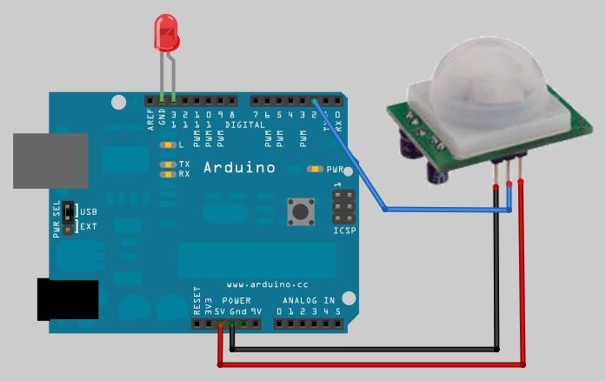

Step 2: Program (please refer to the example code on the CD or official website)
Step 3: Compile the program
Step 4: Burn the program into RobotLinking Uno board
As you can see, read infrared motion sensor signals, almost like reading the same key signal, programmable logic unimaginable simple, does not need much explanation.

Fixed brains
Please add a buzzer or horn make an infrared alarm when they detect someone entering the house sound the alarm.

Lesson 22 DHT11 TEMP AND HUMIDITY MODULE

Introduction
In this tutorial we will learn how to use a DHT11 Temperature and Humidity Sensor.
It‟s accurate enough for most projects that need to keep track of humidity and temperature readings.
Again we will be using a Library specifically designed for these sensors that will make our code short and easy to write.

Components
- 1 * RobotLinking Uno board
- 1 * USB cable
- 1 * temp and humidity module
- Dupont wires(Female to Male)

Principle
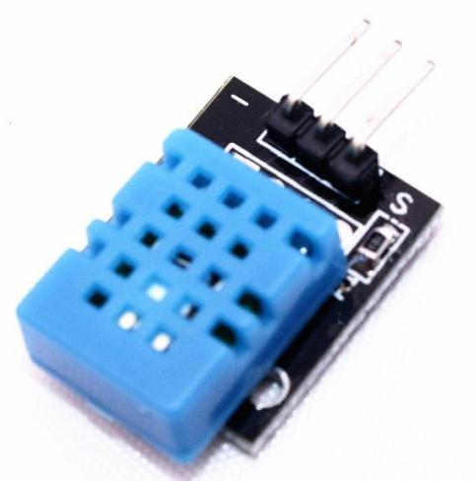

Experimental Procedures

Step 1: Connect circuit as shown in the following photo:

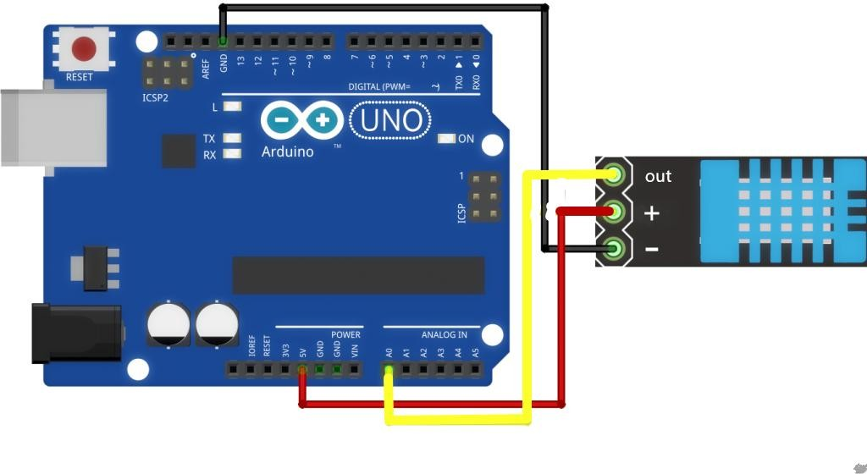

As you can see we only need 3 connections to the sensor, since one of the pin is not used.
The connection are : Voltage, Ground and Signal which can be connected to any Analog Pin on our UNO.
Step 2: Once you have the library, just go ahead and extract it to the Library folder inside your Arduino IDE software folder.

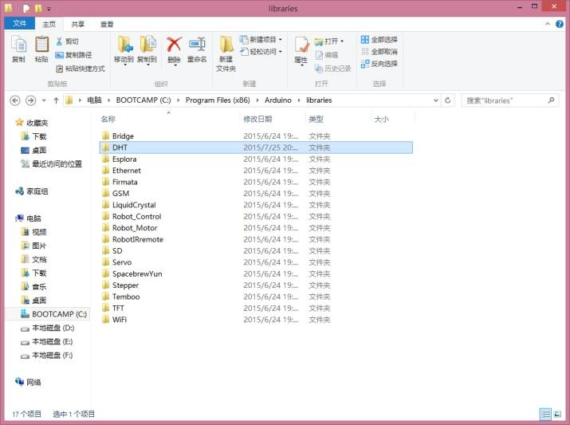

Step 3: Program (please refer to the example code on the CD or official website)

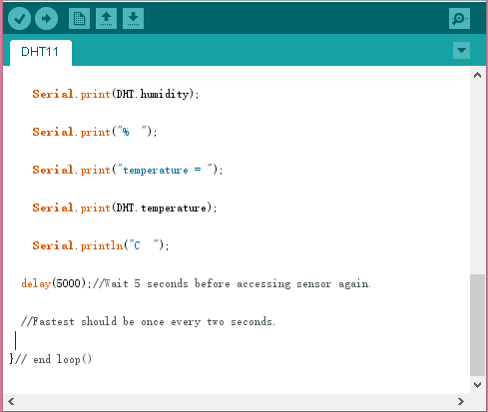

Step 3: Compile the program
Step 4: Burn the program into RobotLinking Uno board
Step 5: Open the toll → Serial Monitor, then you can see the humidity and temperature.

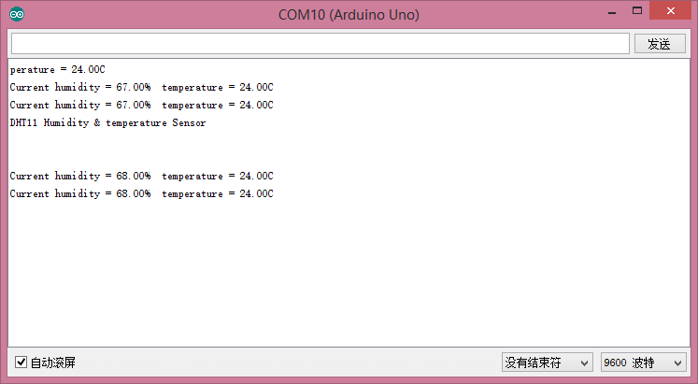

Experimental Summary
Temp and humidity module are a very simple, very practical technology that is surprisingly easy to master. If you feel as though you're struggling, check out our video tutorials on www.RobotLinking.com or ask us questions on our forum.

Lesson 23 NE555 Timer

Introduction
If you ask anyone in the know to rank the most commonly and widely applied integrated circuits, the famous 555 time base integrated circuit would certainly be at the top of the list. The 555 – a mixed circuit composed of analog and digital circuits – integrates analogue and logical
functions into an independent integrated circuit, and hence tremendously expands the
application range of analog integrated circuits. The 555 is widely used in various timers, pulse generators, and oscillators. In this experiment, we will use the RobotLinking Uno board to test the frequencies of square waves generated by the 555 oscillating circuit and show them on a
serial monitor.

Components
- 1 * RobotLinking Uno board
- 1 * USB cable
- Jumper wires
- 1 * Breadboard
- 1 * NE555
- 2 * 104 ceramic capacitor
- 1 * Potentiometer (50KΩ)
- 1 * Resistor (10KΩ)

Principle
The 555 integrated circuit was originally used as a timer, hence the name 555 time base circuit. It is now widely used in various electronic products because of its reliability, convenience, and low price. The 555 is a complex hybrid circuit with dozens of components such as a divider, comparator, basic R-S trigger, discharge tube, and buffer.

555 chip pins are introduced as follows:

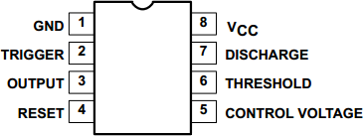

As shown in the picture, the 555 integrated circuit is dual in-line with the 8-pin package. Thus:
- Pin 1 (GND): the ground;
- Pin 2 (TRIGGER ): the input of lower comparator;
- Pin 3 (OUTPUT): having two states of 0 and 1 decided by the input electrical level;
- Pin 4 (RESET): output low level when supplied a low voltage level;
- Pin 5 (CONTROL VOLTAGE): changing the upper and lower level trigger values;
- Pin 6 (THRESHOLD): the input of upper comparator;
- Pin 7 (DISCHARGE): having two states of suspension and ground connection also decided by input, and the output of the internal discharge tube;
- Pin 8 (VCC): the power supply;

Experimental Procedures
Step 1: Connect circuit as shown in the following diagram:
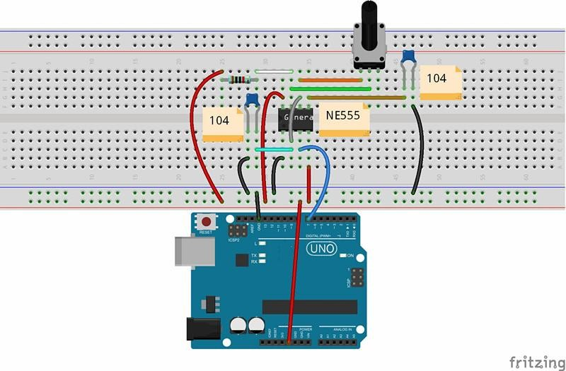

The corresponding schematic diagram is as follows:

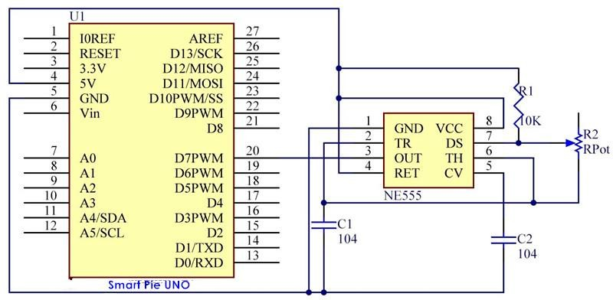

Step 2: Program (please go to our official website www.RobotLinking.com to download related code or get the code from CD.)
Step 3: Compile the program
Step 4: Burn the program into RobotLinking Uno board

After burning the program, open the serial monitor and you will see the picture shown below. If you rotate the potentiometer, the length of the pulse (in microsecond) displayed will change accordingly.

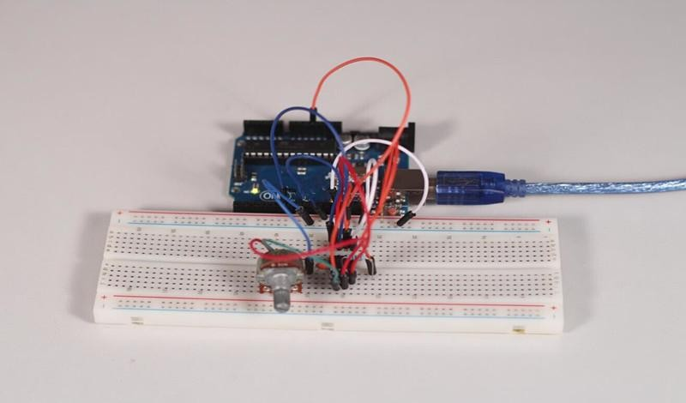

Experimental Summary
In this experiment, we learned how to use NE555. Try modifying the code and printing the frequency values measured on your LCD1602.

Lesson 24 Rotary Encoder

Introduction
In this experiment, we will learn how to use rotary encoders. A rotary encoder is an electro- mechanical device that converts the angular position or motion of a shaft or axle to an analog or digital code. Rotary encoders are usually placed at the side which is perpendicular to the shaft. Rotary encoders act as sensors for detecting angle, speed, length, position and acceleration in automation field.

Components
- 1 * RobotLinking Uno board
- 1 * USB cable
- 1 * Breadboard
- 1 * Rotary encoder module
- Jumper wires

Principle
There are two main types of rotary encoders: absolute and incremental (relative). The output of absolute encoders indicates the current position of the shaft, making them angle transducers. The output of incremental encoders provides information about the motion of the shaft, which is typically further processed elsewhere into information such as speed, distance, and position.
In this experiment, we will use the latter.

An incremental encoder is a rotary sensor intended to turn rotational displacement into a series of digital pulse signals which are then used to control the angular displacement. It generates two-phase square waves whose phase difference is 90°. Usually the two-phase square waves are called channel A and channel B as shown below:

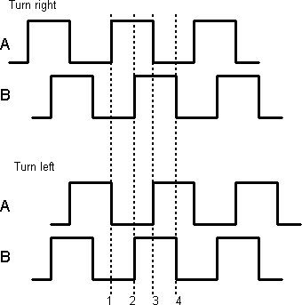

It’s difficult to distinguish left turn and right turn during SCM programming. However, when using an oscilloscope to observe the left and right turn of a switch, you will find that a phase difference exists between the signals of the two output pins. The phase difference is shown as follows:

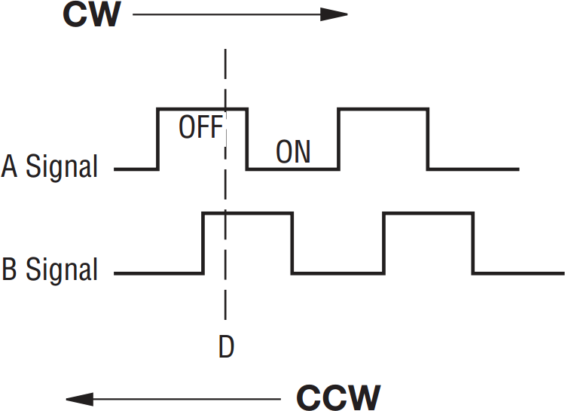

If both channel A and channel B are high, the switch rotates clockwise; if channel A is high and channel B is low, the switch rotates counterclockwise. As a result, if channel A is high, you can judge whether the rotary encoder turns left or right as long as you know the state of channel B.

Experimental Procedures
Step 1: Connect circuit as shown in the following diagram:

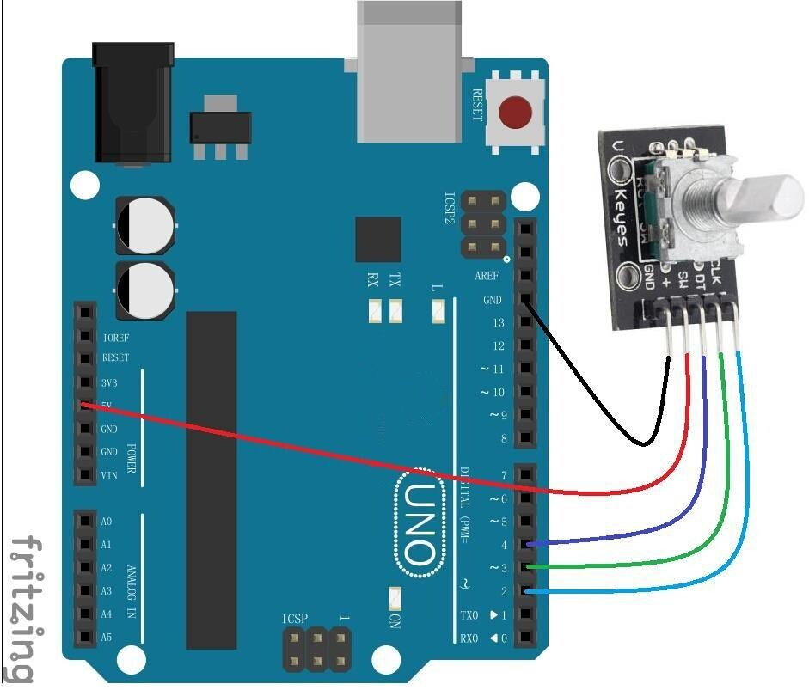

The corresponding schematic diagram is as follows:
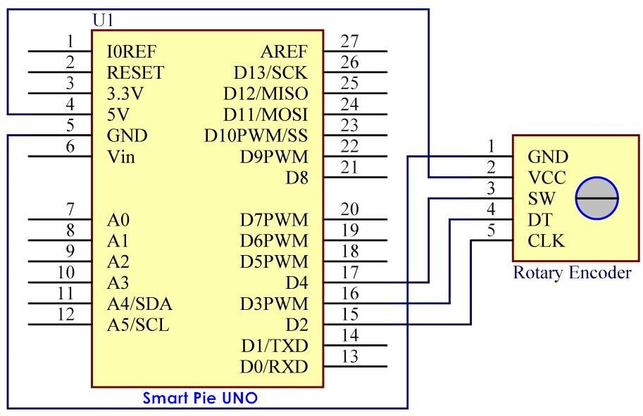

For convenience, we use a rotary encoder module. Connect pins + and GND of the rotary encoder module to pins 5V and GND of the RobotLinking Uno board, and pins CLK and DT of the module to digital pins 2 and 3 of the board

Step 2: Program (please go to our official website www.RobotLinking.com to download related code or get the code from the CD.)
Step 3: Compile the program
Step 4: Burn the program into RobotLinking Uno board

You will see the angular displacement of the rotary encoder printed on the serial monitor of the computer. When the rotary encoder turns clockwise, the angular displacement is increased; when it turns counterclockwise, it’s decreased. If you press the switch on the rotary encoder, related readings will return to zero.

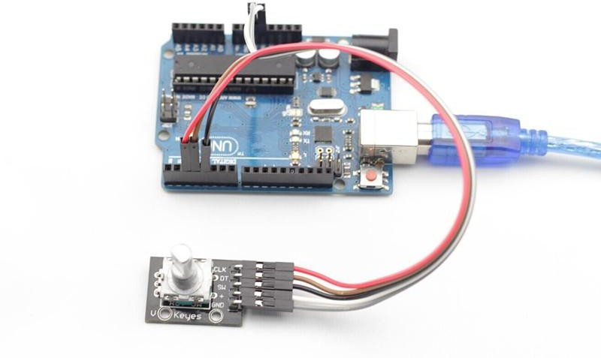

Experimental Summary
In this lesson, you have learned the basic usage of rotary encoders through the experiment. Try modifying the experiment to print the displayed data on LCD1602.

Lesson 25 ADXL335

Introduction
In this experiment, we will learn how to use the ADXL335. The ADXL335 is a small, thin, low power, complete 3-axis accelerometer with signal-conditioned voltage outputs. It measures acceleration with a minimum full-scale range of ±3g. It can measure the static acceleration of gravity in tilt-sensing applications, as well as dynamic acceleration resulting from motion, shock, or vibration.

Components
- 1 * RobotLinking Uno board
- 1 * Breadboard
- 1 * ADXL335 module
- 1 * USB cable
- Jumper wires

Principle
ADXL335
The operating voltage of ADXL335 ranges from 1.8V to 3.6V. The ADXL335 uses 5*5*2 mm LCC packaging when ambient temperature ranges from -55℃ to 125℃. This product is exceptionally light, and the size of the PCB module is only 16mm*20mm, as shown in the following picture. It’s quite convenient for embedding hardware for engineering projects. ADXL335 can obtain power from analog port A0 and A4 of the RobotLinking Uno board. However, for convenience, we directly supply 3.3V voltage from the RobotLinking Uno board to the ADXL335. Do not use the 5V voltage of the RobotLinking Uno board to supply power to the ADXL335.
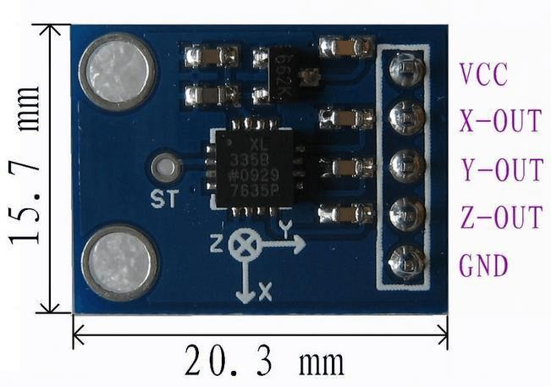

What the ADXL335 outputs are analog voltage values; therefore, what you need to do is collect output voltage values when programming. Of course you also need to perform some engineering projects. If you want to test accurate figures, you need to edit more code according
to relevant data manuals.

Experimental Procedures
Step 1: Connect circuit as shown in the following diagram:
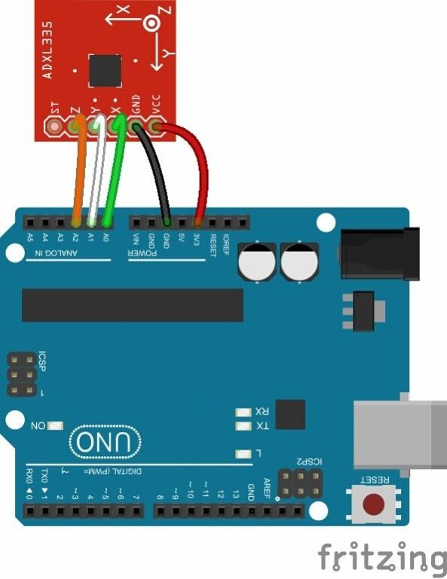
The corresponding schematic diagram is as follows:
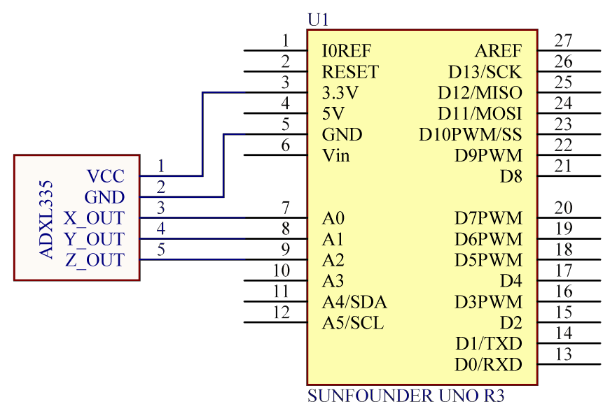

Step 2: Program (please go to our official website www.RobotLinking.com to download related code or get the code from CD.)
Step 3: Debug the program
Step 4: Burn the program into RobotLinking Uno board

After burning the program, open the serial monitor debugging window, where you can see the data detected being displayed. When the acceleration varies, the figure will vary accordingly.
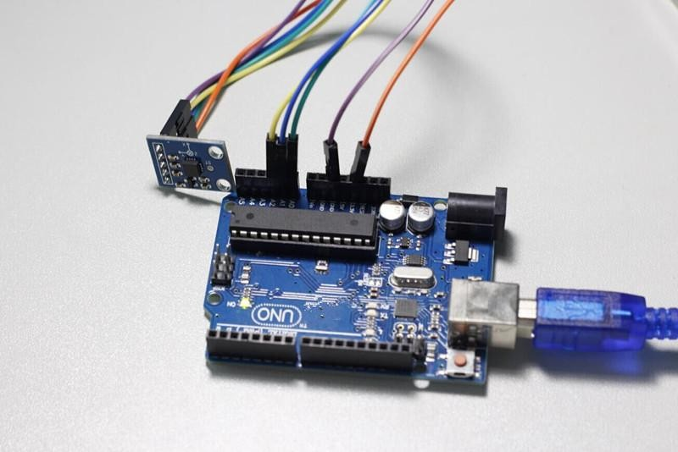

Experimental Summary
Now you have learned the basic usage of ADXL335 through this experiment. If you want your ADXL335 to become more interesting, try modifying the code.

Lesson 26 DC Motors

Introduction
In this lesson, you will learn how to control a small DC motor using an UNO R3 and a transistor.

Components
- 1 * RobotLinking Uno board
- 1 * Breadboard
- 1 * Small 6V DC Motor
- 1 * PN2222 Transistor
- 1 * 1N4007 diode
- 1 * 220 Ω Resistor
- Jumper wires
- 1 * USB cable

Principle
You will use an Arduino analog output (PWM) to control the speed of the motor by sending a number between 0 and 255 from the Serial Monitor.
When you put together the breadboard, there are two things to look out for.
Firstly, make sure that the transistor is the right way around. The flat side of the transistor should be on the right-hand side of the breadboard.
Secondly the striped end of the diode should be towards the +5V power line - see the image below!
The motor that comes with Adafruit Arduino kits does not draw more than 250mA but if you have a different motor, it could easily draw 1000mA, more than a USB port can handle! If you aren't sure of a motor's current draw, power the Arduino from a wall adapter, not just USB

Experimental Procedures
Step 1: Connect circuit as shown in the following diagram (please make sure pins are connected correctly or characters will not display properly):
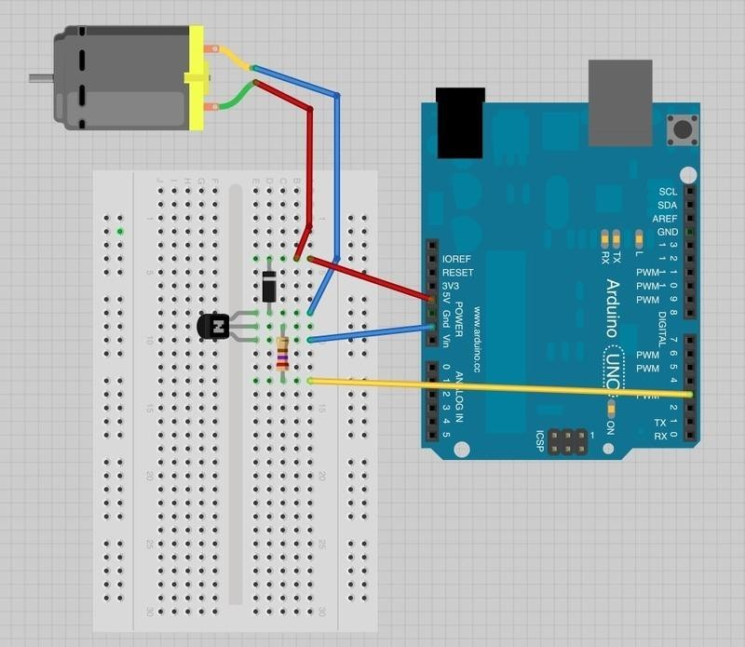
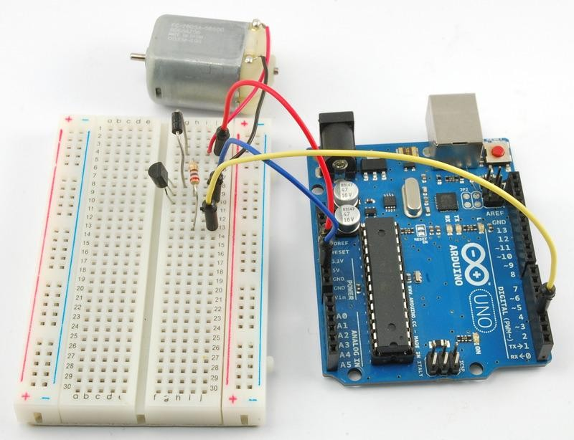

Step 2: Program (please refer to the example code on the CD or official website)
Step 3: Compile the program
Step 4: Burn the program into RobotLinking Uno board

The transistor acts like a switch, controlling the power to the motor, Arduino pin 3 is used to turn the transistor on and off and is given the name 'motorPin' in the sketch.
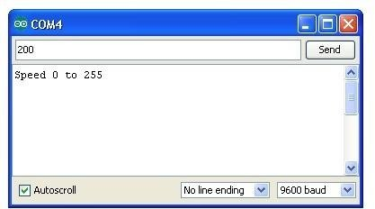
When the sketch starts, it prompts you, to remind you that to control the speed of the motor you need to enter a value between 0 and 255 in the Serial Monitor.
In the 'loop' function, the command 'Serial.parseInt' is used to read the number entered as text in the Serial Monitor and convert it into an 'int'.
You could type any number here, so the 'if' statement on the next line only does an analog write with this number if the number is between 0 and 255.

Experimental Summary A.Transistors
The small DC motor, is likely to use more power than an Arduino digital output can handle directly. If we tried to connect the motor straight to an Arduino pin, there is a good chance that it could damage the Arduino.
A small transistor like the PN2222 can be used as a switch that uses just a little current from the Arduino digital output to control the much bigger current of the motor.

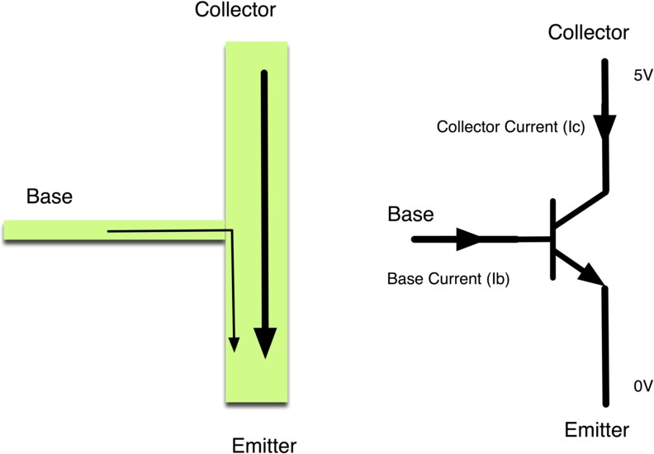
The transistor has three leads. Most of the electricity flows from the Collector to the Emitter, but this will only happen if a small amount is flowing into the Base connection. This small current is supplied by the Arduino digital output.
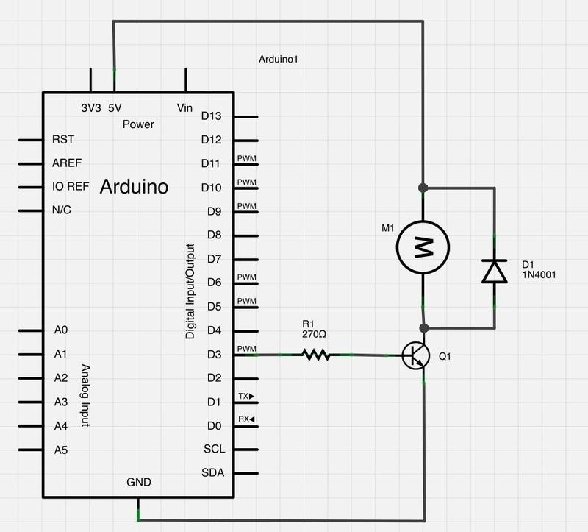
The diagram below is called a schematic diagram. Like a breadboard layout, it is a way of showing how the parts of an electronic project are connected together.

The pin D3 of the Arduino is connected to the resistor. Just like when using an LED, this limits the current flowing into the transistor through the base.
There is a diode connected across the connections of the motor. Diodes only allow electricity to flow in one direction (the direction of their arrow).
When you turn the power off to a motor, you get a negative spike of voltage, that can damage your Arduino or the transistor. The diode protects against this, by shorting out any such reverse current from the motor.
hrough this experiment, you've learned how to drive LCD1602. Now you can create your own messages to display! You can also try letting your LCD1602 display numbers.

B.Other Things to Do
Try reversing the connections to the motor. What happens?
Try entering different values (starting at 0) into the Serial Monitor and notice at what value the motor starts to actually turn. You will find that the motor starts to 'sing' as you increase the analog output.
Try pinching the drive shaft between your fingers. Don't hold it like that for too long, or you may cook the transistor, but you should find that it is fairly easy to stop the motor. It is spinning fast, but it does not have much torque.

Lesson 27 DC Motors Reversing

Introduction
In this lesson, you will learn how to control both the direction and speed of a small DC motor using an Arduino and the L293D motor driver chip.

Components
- 1 * RobotLinking Uno board
- 1 * Breadboard
- 1 * Small 6V DC Motor
- 1 * 10 kΩ variable resistor (pot)
- 1 * L293D IC
- 1 * Tactile push switch
- Jumper wires
- 1 * USB cable

Principle
Before we get the UNO R3 board to control the motor, we should experiment with the L293D motor control chip to get an idea how it works.
We can start by just using the UNO R3 to supply 5V to the motor.

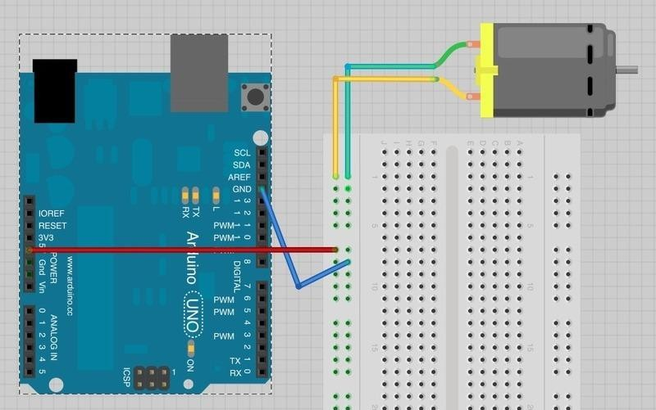

Note which way the motor is spinning. You can do this by pinching the motor shaft between

your fingers. Swap over the motor leads so that the motor lead that was going to +5V now goes to GND and vice-versa. The motor will turn in the opposite direction.
This gives us a clue as to how the L293D chip works. Its control pins allow us to do the equivalent of swapping over the motor terminals to reverse the direction of the motor.
Build up the breadboard as below. The Arduino is still just supplying power, but we can experiment manually with the control pins before we let the Arduino take over.

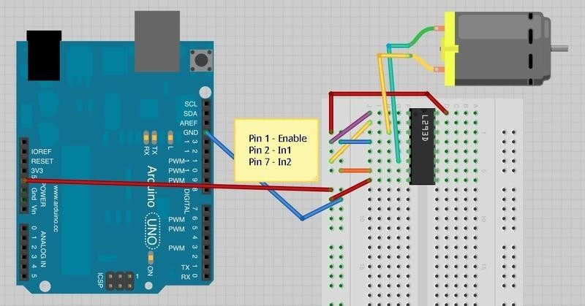

The three pins of L293D that we are interested in are Pin 1 (Enable), Pin 2 (In1) and Pin 7 (In2). These are attached to either 5V or GND using the purple, yellow and orange jumper wires.
As shown above, the motor should be turning on one direction, let's call that direction A.
If you move Pin 1 (Enable) to GND the motor will stop, no matter what you do with the control pins In1 and In2. Enable turns everything on and off. This makes it useful for using a PWM output to control the motor speed. Reconnect Pin 1 to 5V so that the motor starts again.
Now try moving In1 (pin 2, yellow) from 5V to GND. In1 and In2 are both now connected to GND, so again the motor will stop.
Moving In2 from GND to 5V will cause the motor to turn in the opposite direction (direction B).
Finally, moving In1 back to 5V so that both In1 and In2 are at 5V will again cause the motor to stop.
The effect of the pins In1 and In2 on the motor are summarized in the table below: In1

In2 Motor
GND GND
Stopped 5V GND Turns in Direction A GND 5V Turns in Direction B 5V 5V Stopped.
Now that we have got the hang of controlling the motor directly, we can let the Arduino manage the Enable, In1 and In2 pins.

Experimental Procedures
Step 1: Connect circuit as shown in the following diagram (please make sure pins are connected correctly or characters will not display properly):
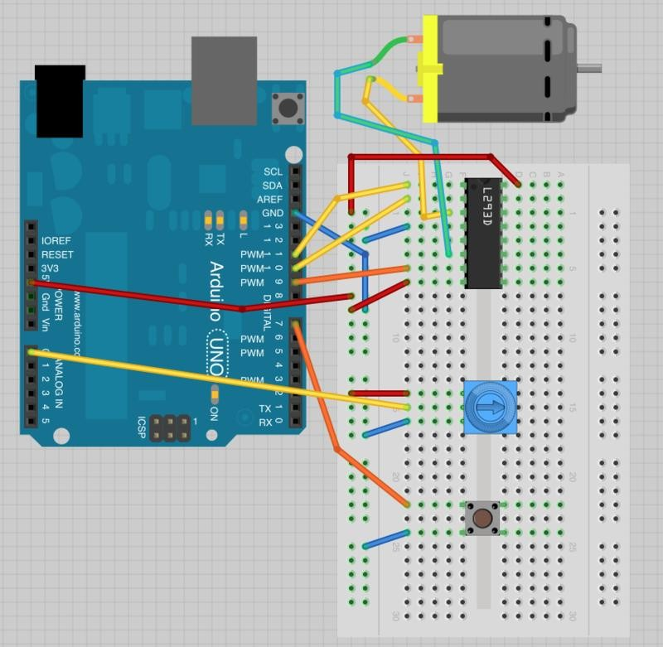

Step 2: Program (please refer to the example code on the CD or official website)
Step 3: Compile the program
Step 4: Burn the program into RobotLinking Uno board

Pins are defined and their modes set in the 'setup' function as normal.
In the loop function, a value for the motor speed is found by dividing the analog reading from the pot by 4.
The factor is 4 because the analog reading will be between 0 and 1023 and the analog output needs to be between 0 and 255.
If the button is pressed, the motor will run in forward, otherwise it will run in reverse. The value of the 'reverse' variable is just set to the value read from the switch pin. So, if the button is pressed, this will be False, otherwise it will be True.
The speed and reverse values are passed to a function called 'setMotor' that will set the appropriate pins on the driver chip to control the motor.

void setMotor(int speed, boolean reverse)
{
analogWrite(enablePin, speed); digitalWrite(in1Pin, ! reverse); digitalWrite(in2Pin, reverse);
}

Firstly, the speed is set, by using an analog Write to the enable pin. The enable pin of the L293 just turns the motor on or off irrespective of what the in1 and in2 pins of the L293 are set to.
To control the direction of the motor, the pins in1 and in2 must be set to opposite values.
If in1 is HIGH and in2 is LOW, the motor will spin one way, if on the other hand in1 is HIGH and in2 LOW then the motor will spin in the opposite direction.
The '!' command means 'not'. So the first digitalWrite command for in1 sets it to the opposite of whatever the value of 'reverse' is, so if reverse is HIGH it sets it to LOW and vice versa.
The second digitalWrite for 'in2' sets the pin to whatever the value of 'reverse' is. This means that it will always be the opposite of whatever in1 is.

Experimental Summary A.L293D
This is a very useful chip. It can actually control two motors independently. We are just using half the chip in this lesson, most of the pins on the right hand side of the chip are for controlling a second motor.

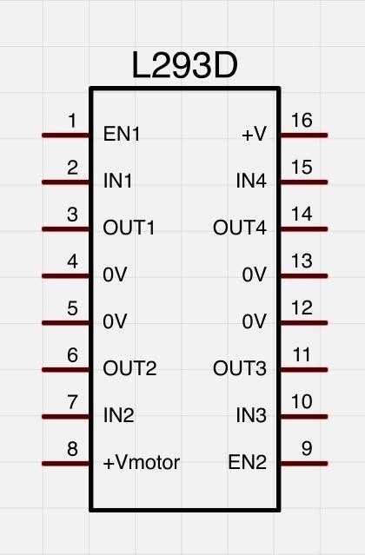

A second motor would be attached between OUT3 and OUT4. You will also need three more control pins.
EN2 is connected to a PWM enabled output pin on the Arduino IN3 and IN4 are connected to digital outputs on the Arduino
The L293D has two +V pins (8 and 16). The pin '+Vmotor (8) provides the power for the motors, and +V (16) for the chip's logic. We have connected both of these to the Arduino 5V pin.
However, if you were using a more powerful motor, or a higher voltage motor, you would provide the motor with a separate power supply using pin 8 connected to the positive power supply and the ground of the second power supply is connected to the ground of the Arduino.

B.Other Things to Do
You could try changing the sketch to control the motor without using the pot or switch. It could start slow in the forward direction, gradually get faster, slow down and then go into reverse, repeating the pattern.

Lesson 28 Steeper Motor

Introduction
Stepper motors fall somewhere in between a regular DC motor and a servo motor. They have the advantage that they can be positioned accurately, moved forward or backwards one 'step' at a time, but they can also rotate continuously.
In this lesson you will learn how to control a stepper motor using your Arduino and the same L293D motor control chip that you used with the DC motor in this lesson

Components
- 1 * RobotLinking Uno board
- 1 * Breadboard
- 1 * 5V Stepper Motor
- 1 * L293D IC
- Jumper wires
- 1 * USB cable

Principle
The stepper motor has five leads, and we will be using both halves of the L293D this time. This means that there are a lot of connections to make on the breadboard.
The motor has a 5-way socket on the end. Push jumper wires into the sockets to allow the motor to be connected to the breadboard.
The following sketch uses the Serial Monitor, so once the sketch is installed and running, open the Serial Monitor and enter a number of 'steps'. Try a value of about 500, this should cause the motor to turn through about 360 degrees. Enter -500 and it will turn back in the reverse direction.
The Stepper library is included in newer distributions of the Arduino IDE - you may need to upgrade.

Experimental Procedures
Step 1: Connect circuit as shown in the following diagram (please make sure pins are connected correctly or characters will not display properly):

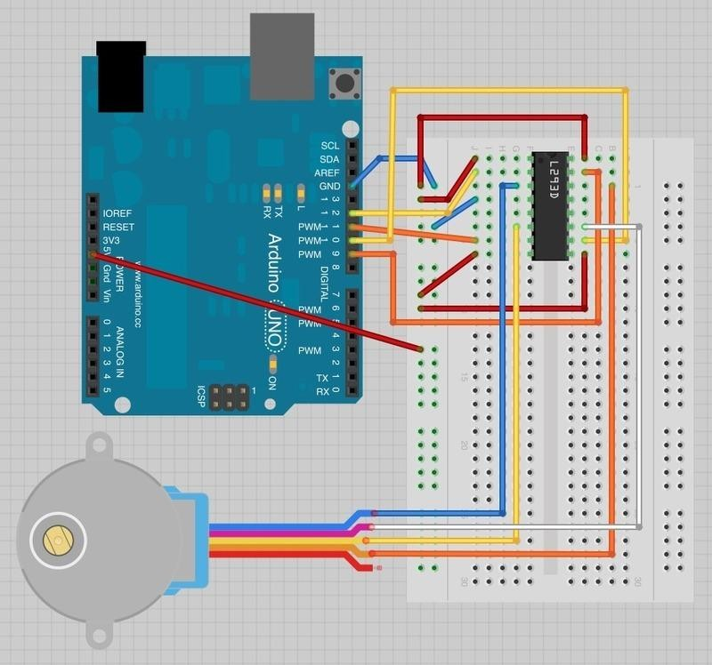
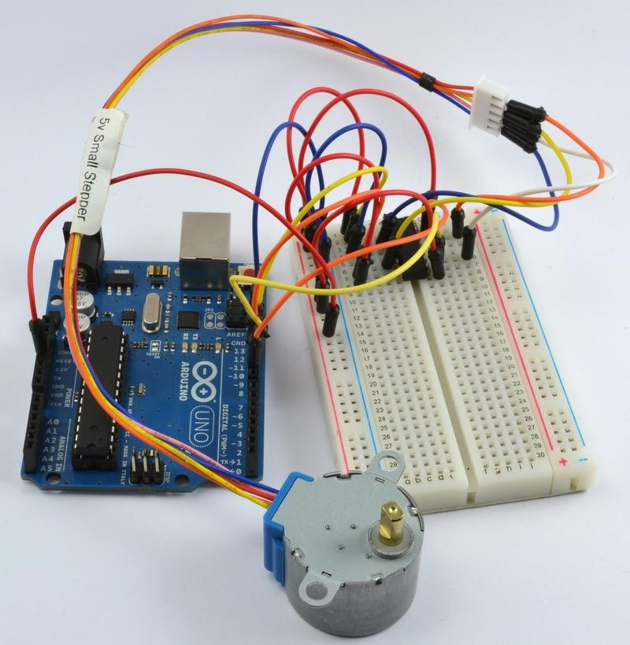

Step 2: Program (please refer to the example code on the CD or official website)
Step 3: Compile the program
Step 4: Burn the program into RobotLinking Uno board

As you might expect, there is an Arduino library to support stepper motors. This makes the process of using a motor very easy.
After including the 'Stepper' library, the four control pins 'in1' to 'in4' are defined.
To tell the Arduino Stepper library which pins are connected to the motor controller, the following command is used:

Stepper motor(768, in1Pin, in2Pin, in3Pin, in4Pin);

The first parameter is the number of 'steps' that the motor will take to complete one revolution. The motor can be moved by one step at a time, for very fine positioning.
Serial communications is then started, so that the Arduino is ready to receive commands from the Serial Monitor.
Finally the following command sets the speed that we wish the stepper motor to move, when we subsequently tell it how many steps to rotate.

motor.setSpeed(10);

The 'loop' function is very simple. It waits for a command to come in from the Serial Monitor and converts the text of the number sent into an int using 'parseInt'. It then instructs the motor to turn that number of steps.

Experimental Summary

A. Stepper Motors
Stepper motors use a cogged wheel and electro magnets to nudge the wheel round a 'step' at a time.

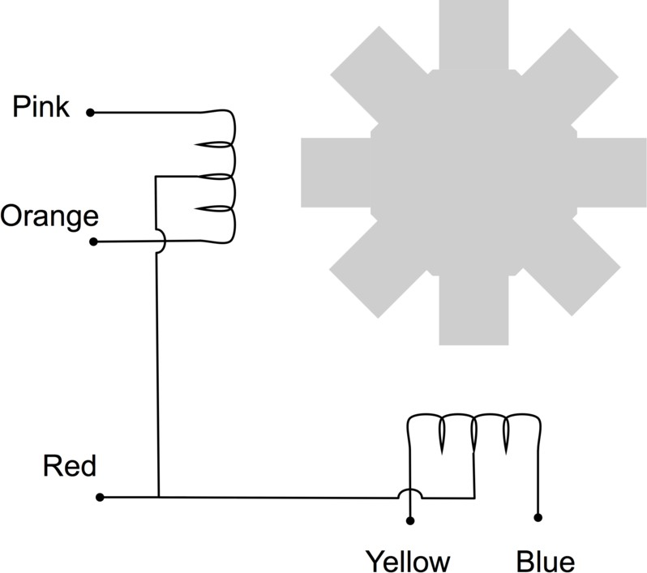

By energizing the coils in the right order, the motor is driven round. The number of steps that the stepper motor has in a 360 degree rotation is actually the number of teeth on the cog.
The motor we are using has 48 steps, but then the motor also incorporates a reduction gearbox of 1:16 that means that it needs 16 x 48 = 768 steps.
In this lesson, we do not use the common Red connection. This connection is only provided if you are using a different type of drive circuit that does not allow the current in each coil to be reversed. Having a center connection to each coil means that you can either energise the left or right side of the coil, and get the effect of reversing the current flow without having to use a circuit that can reverse the current.
Since we are using a L293D that is very good at reversing the current, we do not need this common connection, we can supply current in either direction to the whole of each of the coils.

B.Other Things to Do
Try changing the command that sets the speed of the stepper motor:

motor.setSpeed(20);

to a lower value (say 5) upload the sketch and notice that the stepper turns more slowly.
Now try and find the maximum speed for the stepper by increasing the speed above 20. After a certain point, you will find that the motor does not move at all. This is because it just cannot keep up with the stream of pulses asking it to step.
Try disconnecting the orange and pink leads of the stepper. It should still turn, but you will notice that it is weaker, as it does not have both coils working to push the motor around.

Lesson 29 Control a stepper motor using a rotary encoder

Introduction
Welcome to this multi part tutorial on how to control different stepper motors using a rotary encoder.
In this first part we will use the inexpensive and popular stepper motor that comes with it‟s own control board. The 28BYJ-48 stepper motor with the ULN2003 board.
The 28BYJ-48 motor is not very fast or very strong, but it‟s great for beginners to start experimenting with controlling a stepper motor with an Arduino.
We will write some code to have the motor move in the direction that we turn the rotary encoder, and will also keep track of how much steps we have taken, so that we can have the motor move back to the starting position by pressing down on the rotary encoder switch.

Components
- 1 * RobotLinking Uno board
- 1 * USB data cable
- 1 * 9v adapter
- 1 * Stepper Motor
- 1 * ULN2003 Module
- 1 * Rotary Encoder Module
- 1 * Breadboard Power Supply Module
- Several jumper wires
- 1 * Breadboard

Experimental Principle

Experimental Procedures
Step 1: Connect circuit as shown in the following diagram:
We are using 4 pins to control the Stepper and 3 pins for the rotary encoder module.
Pin 8-11 are controlling the Stepper motor and pin 2-4 are receiving information from the rotary encoder.
We connect the 5V and Ground from to UNO to the rotary encoder and as a precaution, use a breadboard power supply to power the Stepper motor since it can use more power that the UNO can provide.
We also connect the UNO Ground to the breadboard to serve as a reference.

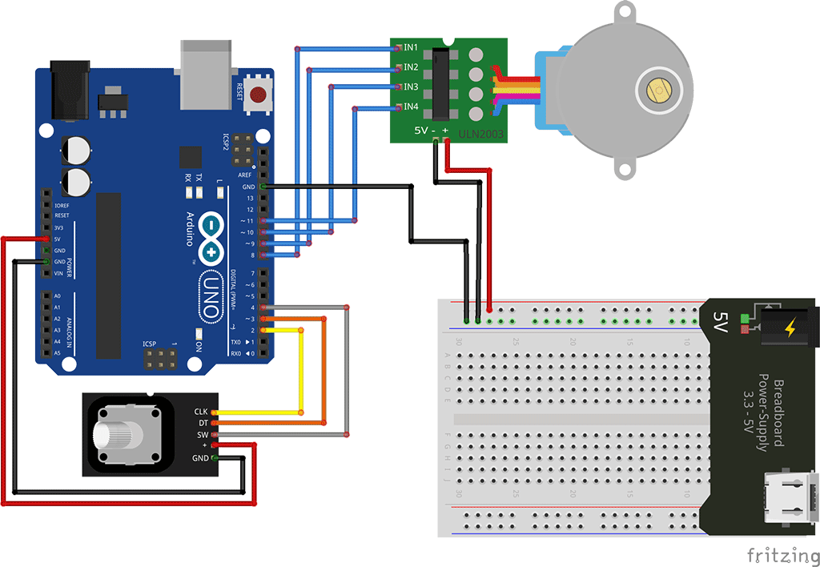
Step 2: We are using the “Stepper” library to control the stepper motor. The “Stepper” library is included by default with the Arduino Software install.
We are using some variables to store the current position, since we want to keep track of the position of the stepper motor so we can make it move back to the starting position.
We also included some error checking code to make sure that the rotary encoder is not missing steps, since that would make our motor position inaccurate.
Step 4: Compile the program
Step 5: Burn the program into RobotLinking Uno board

Lesson 30 connect and control a Stepper Motor with an IR Remote control

Introduction
Here‟s a fun and easy way to control a Stepper motor at a distance using an IR Remote control.
The stepper we are using comes with its own driver board making it easy to connect to our UNO.
Since we don‟t want to drive the motor directly from the UNO, we will be using an inexpensive little breadboard power supply that plugs right on our breadboard and power it with a 9V 1Amp power supply.
The IR sensor is connected to the UNO directly since it uses almost no power.

Components
- 1 * RobotLinking Uno board
- 1 * USB data cable
- 1 * 9v adapter
- 1 * Stepper Motor
- 1 * ULN2003 Module
- 1 * IR Receive Module
- 1 * IR Remote
- 1 * Breadboard Power Supply Module
- Several jumper wires
- 1 * Breadboard

Experimental Principle

Experimental Procedures
Step 1: Connect circuit as shown in the following diagram:
We are using 4 pins to control the Stepper and 1 pin for the IR sensor.
Pin 8-11 are controlling the Stepper motor and pin 6 in Receiving the IR information.
We connect the 5V and Ground from to UNO to the sensor and as a precaution, use a breadboard power supply to power the Stepper motor since it can use more power and we don‟t want to damage the power supply of the UNO.

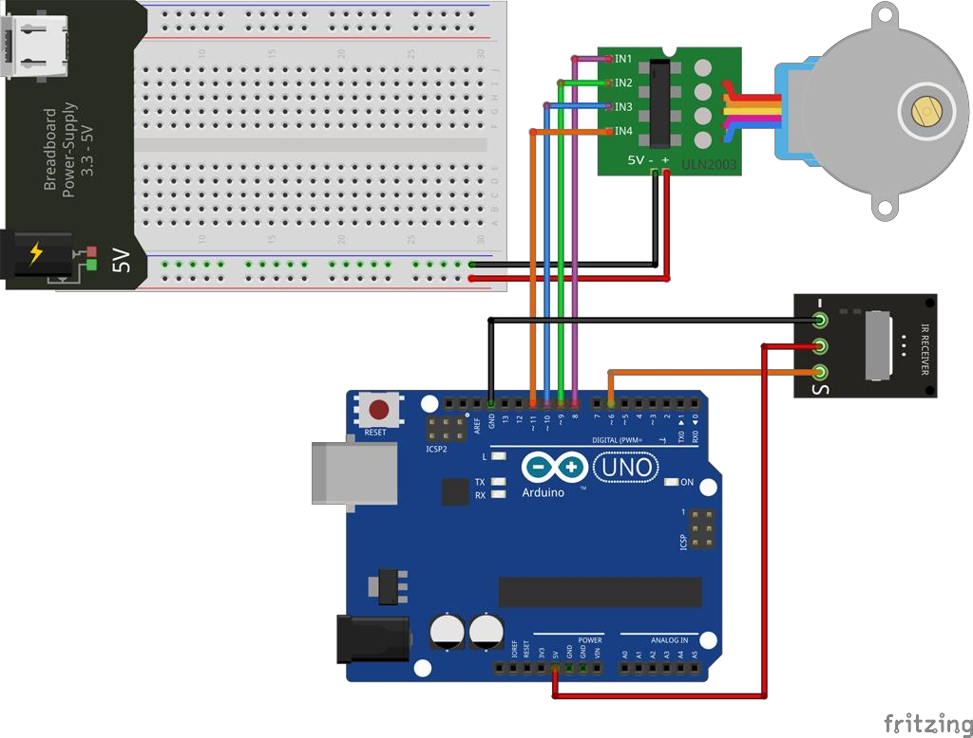
Step 2: We are using the “Stepper” library to control the stepper motor. We use 2 Libraries in our Sketch: “IRremote” and “Stepper”.
The “Stepper” library is included by default with the Arduino Software install. You will need to download the “IRremote” library and extract it to your Library folder. As always you can have a look at the tutorial video for more information.
The code below only recognize 2 values from the IR Remote control: UP and DOWN. When UP is pressed on the remote the motor will make a full rotation clockwise.
DOWN will make a full rotation counter-clockwise.
Step 4: Compile the program
Step 5: Burn the program into RobotLinking Uno board

Lesson 31 Simple Creation - Light Alarm

Introduction
This experiment is a very interesting one – a DIY photistor. DIY photistors use the principle of glow effect and the photoelectric effect of LEDs. That is, LEDs will generate weak currents when being shined on by light. We use a transistor to amplify the currents and trigger the RobotLinking Uno board to detect them.

Components
- 1 * RobotLinking Uno board
- 1 * Breadboard
- 1 * USB cable
- Jumper wires
- 1 * Passive buzzer
- 1 * Resistor (10KΩ)
- 1 * LED
- 1 * NPN Transistor S8050

Principle
LEDs not only have a glow effect, but also a photoelectric effect. They will generate weak currents when exposed to light waves.
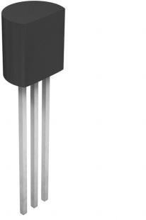
NPN Transistors are easy to use. The left pin is Emitter electrode, attached to the power source, the middle pin is Base, and the right pin is Collector. If only the middle pin has weak trigger currents, they will flow from left to right of the LED like a switch being opened.
A 10kΩ pull-down resistor is attached to the transistor output stage in order to avoid analog port suspending to interfere with signals and cause misjudgment.

Experimental Procedures
Step 1: Connect circuit as shown in the following diagram
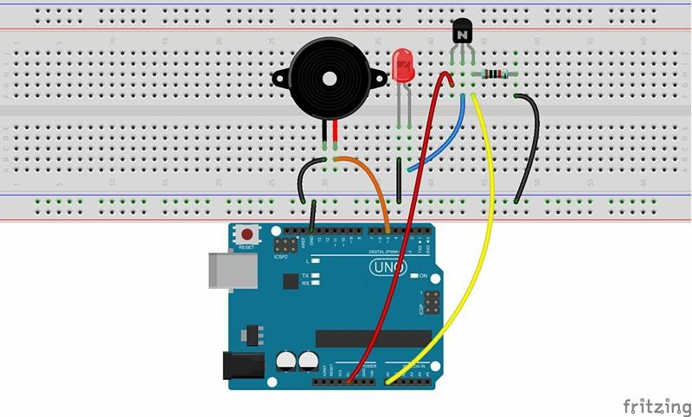
The corresponding schematic diagram is as follows:
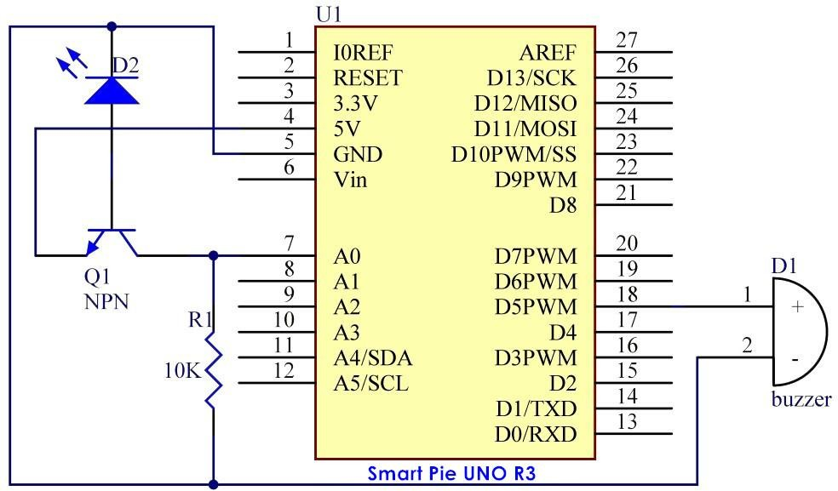

Step 2: Program (please go to our official website www.RobotLinking.com to download related code or get the code from CD.)
Step 3: Compile the program
Step 4: Burn the program into RobotLinking Uno board

Now, you can hear that the buzzer make sounds when the LED is shined.

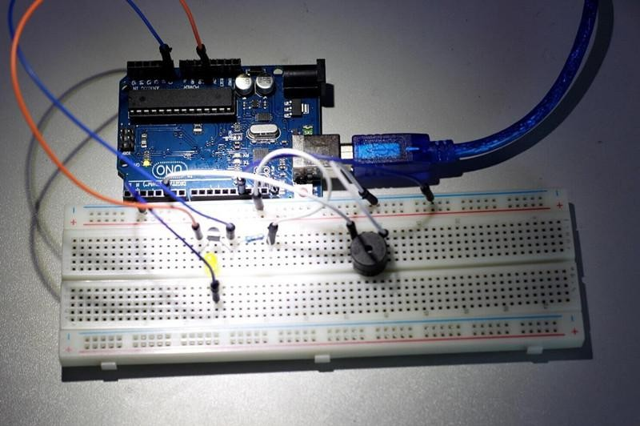

Experimental Summary
Through this experiment, you should have gained a basic understanding of analog circuits. You can also create many interesting interactive works by combining analog circuits and the RobotLinking Uno board. This is just the beginning!

Lesson 32 Simple Creation - Traffic Light

Introduction
We will conduct an experiment centered on traffic lights today. Rotating a rotary encoder will change the frequency of a traffic light being turned on sequentially.

Components
- 1 * RobotLinking Uno board
- 1 * Breadboard
- 1 * USB cable
- Jumper wires
- 1 * Rotary encoder
- 3 * LED
- 3 * Resistor (220Ω)

Principle
For a real traffic light, the time length for displaying red and green is much longer than yellow. As a result, we define two cycles with a program: a short cycle and a long cycle. In a short cycle, the traffic light changes its order at a rate of roughly once per second. On the other hand, the long cycle is changed by a rotary encoder determining the time length of red and green light.

Experimental Procedures
Step 1: Connect circuit as shown in the following diagram

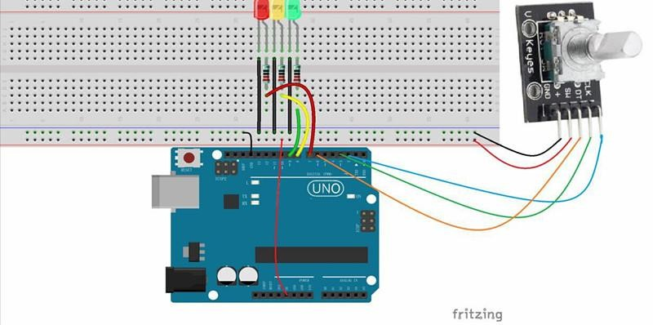

The corresponding schematic diagram is as follows:

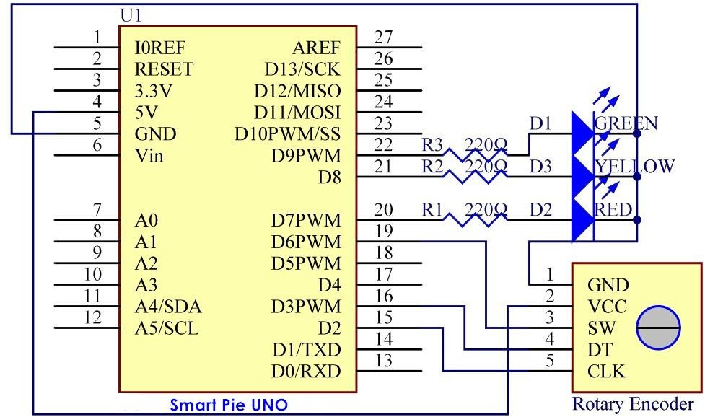
Step 2: Program (please go to our official website www.RobotLinking.com to download related code or get the code from the CD.)
Step 3: Compile the program
Step 4: Burn the program into RobotLinking Uno board

You will see the red LED light up first, then the red LED and yellow LED, followed by the green LED, and finally the yellow LED again.

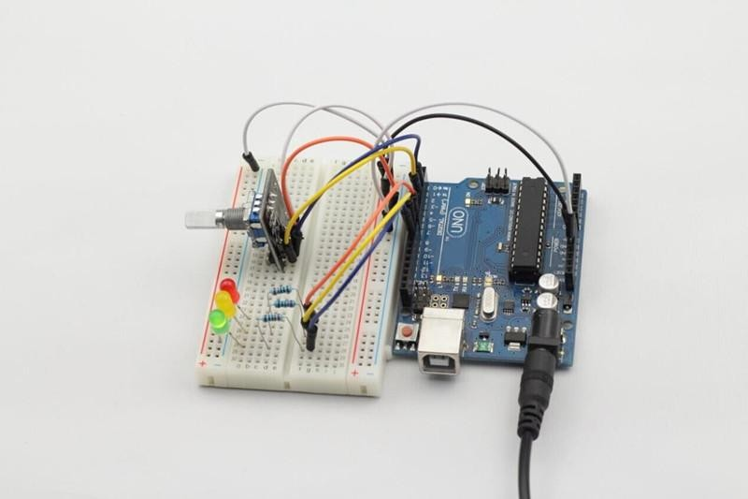

Experimental Summary
Through this experiment, you have learned the combination usage of a rotary encoder and LEDs. You should now have a deeper understanding of rotary encoders.

Lesson 33 Simple Creation - Digital Dice

Introduction
In previous experiments, we tested the single 7-segment display and controlled LEDs by pressing a button. Through them, we learned the basic usage of the two components. This time, we will combine a 7-segment display and a button together to create simple digital dice.

Components
- 1 * RobotLinking Uno board
- 1 * Breadboard
- 1 * USB cable
- Jumper wires
- 1 * Button
- 1 * Resistor (10KΩ)
- 8 * Resistor (220Ω)
- 1 * 7-segment display
- 1 * 104 ceramic capacitor
- 1 * 74HC595

Principle
The idea behind digital dice is very simple: a single 7-segment display circularly jumps from 1 to 6 rapidly. When the button is pressed, the jumping will slow down until it stops on a number three seconds later. When the button is pressed again, the process will repeat.

Experimental Procedures
Step 1: Connect circuit as shown in the following diagram:

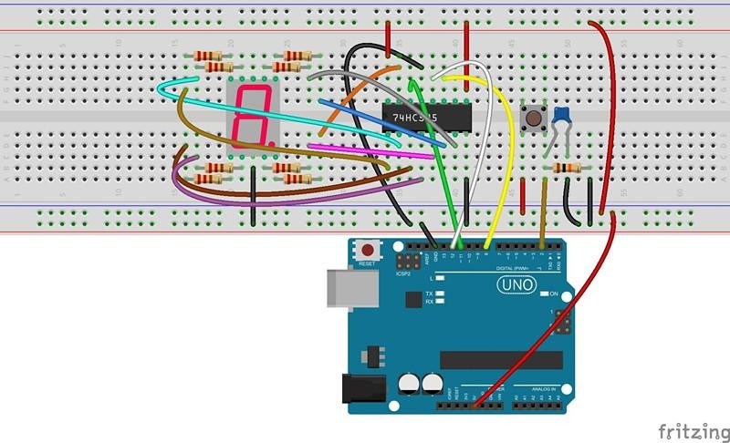

The corresponding schematic diagram is as follows:
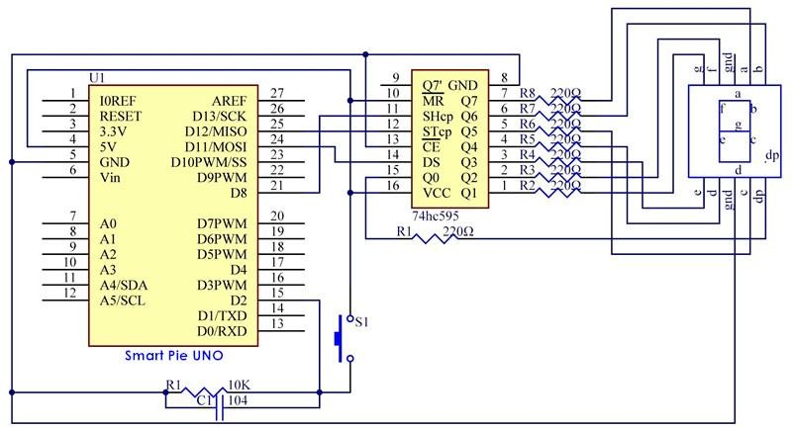
Step 2: Program (please go to our official website www.RobotLinking.com to download related code or get the code from the CD.)
Step 3: Compile the program

Step 4: Burn the program into RobotLinking Uno board

You can now see the single 7-segment display jump between numbers from 1 to 6. When the button is pressed, the jumping will slow down until it stops three seconds later. If the button is pressed again, the process will repeat.
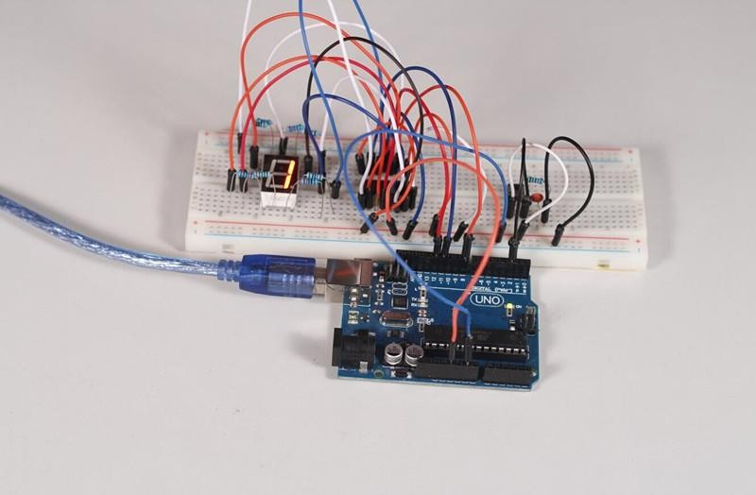

Experimental Summary
Through this experiment, you have learned the combination usage of a 7-segment display and a button. You can create many other things by using the button as an input device and the 7- segment display as a display device.

Lesson 34 Simple Creation - Small Fan

Introduction
In this experiment, we will combine a button and a motor to assemble a small simple fan. We can shift the rotational speed, or gear selection, of the fan by pressing the button.

Components
- 1 * RobotLinking Uno board
- 1 * Breadboard
- 1 * USB cable
- Jumper wires
- 1 * DC motor
- 1 * Resistor (10KΩ)
- 1 * Button
- 1 * Motor diver chip L293D
- 1 * 104 Ceramic Capacitor
- 1 * Fan

Principle
The principle of this experiment is to control the rotational speed of the motor by having it read the amount of times the button is pressed. After startup, the default gear is 0 and the fan will not rotate. If the button is pressed once, the small fan will enter gear 1 (low speed) and rotate slowly; if the button is pressed twice, it will enter gear 2 (medium speed) and rotate at a medium pace; if the button is pressed three times, it will enter gear 3 (high speed) and rotate rapidly. If the button is pressed four times, it will return to gear 0 and stop.

Experimental Procedures
Step 1: Connect circuit as shown in the following diagram:

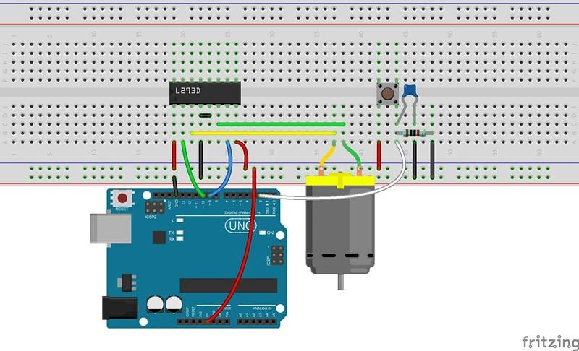

The corresponding schematic diagram is as follows:
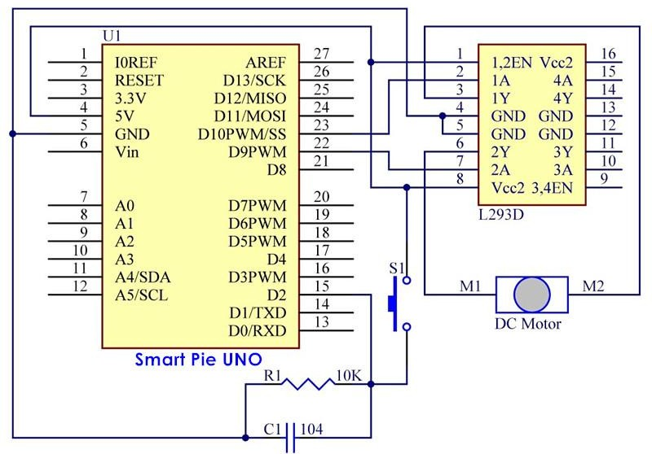

Step 2: Program (please go to our official website www.RobotLinking.com to download related or get the code from CD.)
Step 3: Compile the program
Step 4: Burn the program into RobotLinking Uno board

As explained above, the amount of times you press the button should change the rotation speed of the fan. Pressing it once will cause it to rotate slowly, while pressing it three times will cause it to rotate quickly, and pressing it four times will cause it to stop.
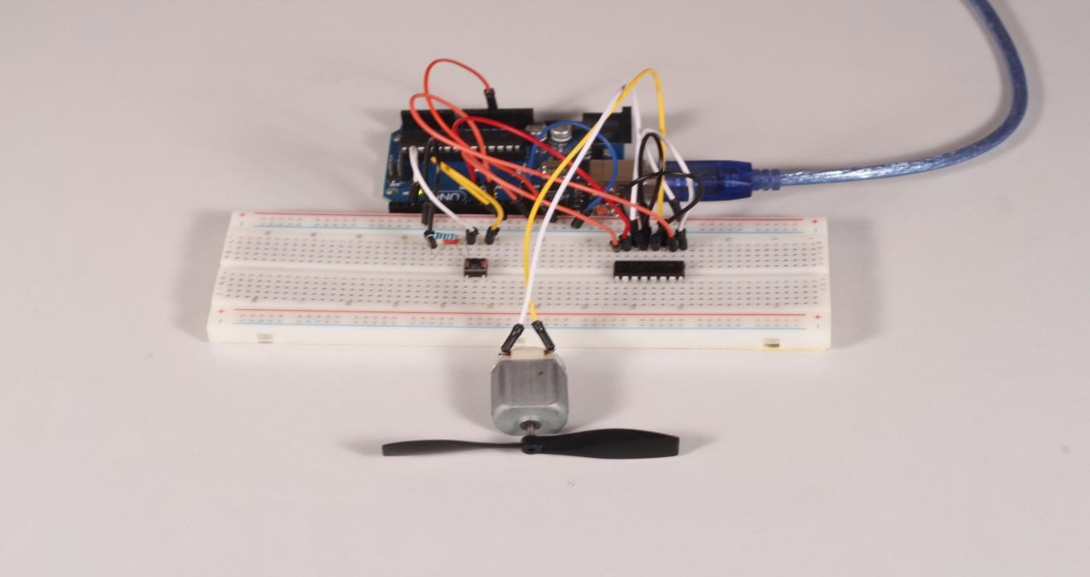

Experimental Summary
Through this experiment, we have learned the usage of motors in depth. I hope you can create more complex interactive works on your own!

Lesson 35 Simple Creation - Automatically Tracking Light Source

Introduction
In this lesson, we will use a servo motor, a photoresistor and a pull-down resistor to assemble an automatically tracking light source system.

Components
- 1 * RobotLinking Uno board
- 1 * Servo motor
- 1 * Photoresistor
- 1 * Resistor (10KΩ)
- Several jumper wires
-1 * USB data cable

Experimental Principle
The servo motor and the photoresistor scan and look for light source in 180 degree and record the location of light source. After finishing scanning, the servo motor and the photoresistor stop at the direction of light source.

Experimental Procedures
Step 1: Connect circuit as shown in the following diagram:
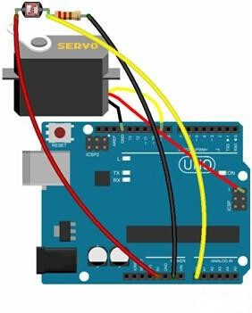
Note: you need to bind one end of the resistor and photoresistor to the wing of the servo, as

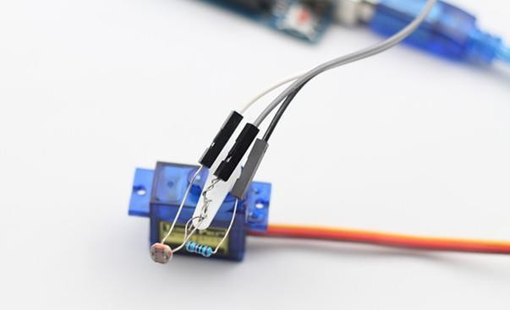
shown below:

The corresponding schematic diagram is as follows:
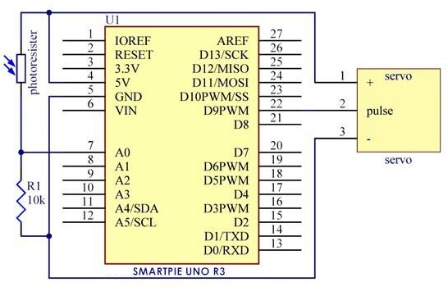

Step 2: Program (please refer to the example code on the CD or official website)
Step 3: Compile the program

Step 4: Burn the program into RobotLinking Uno board
Now, if you use a flashlight to shine the photoresistor, you will see the servo motor and the photoresistor rotate, finally stop at the direction of light source.
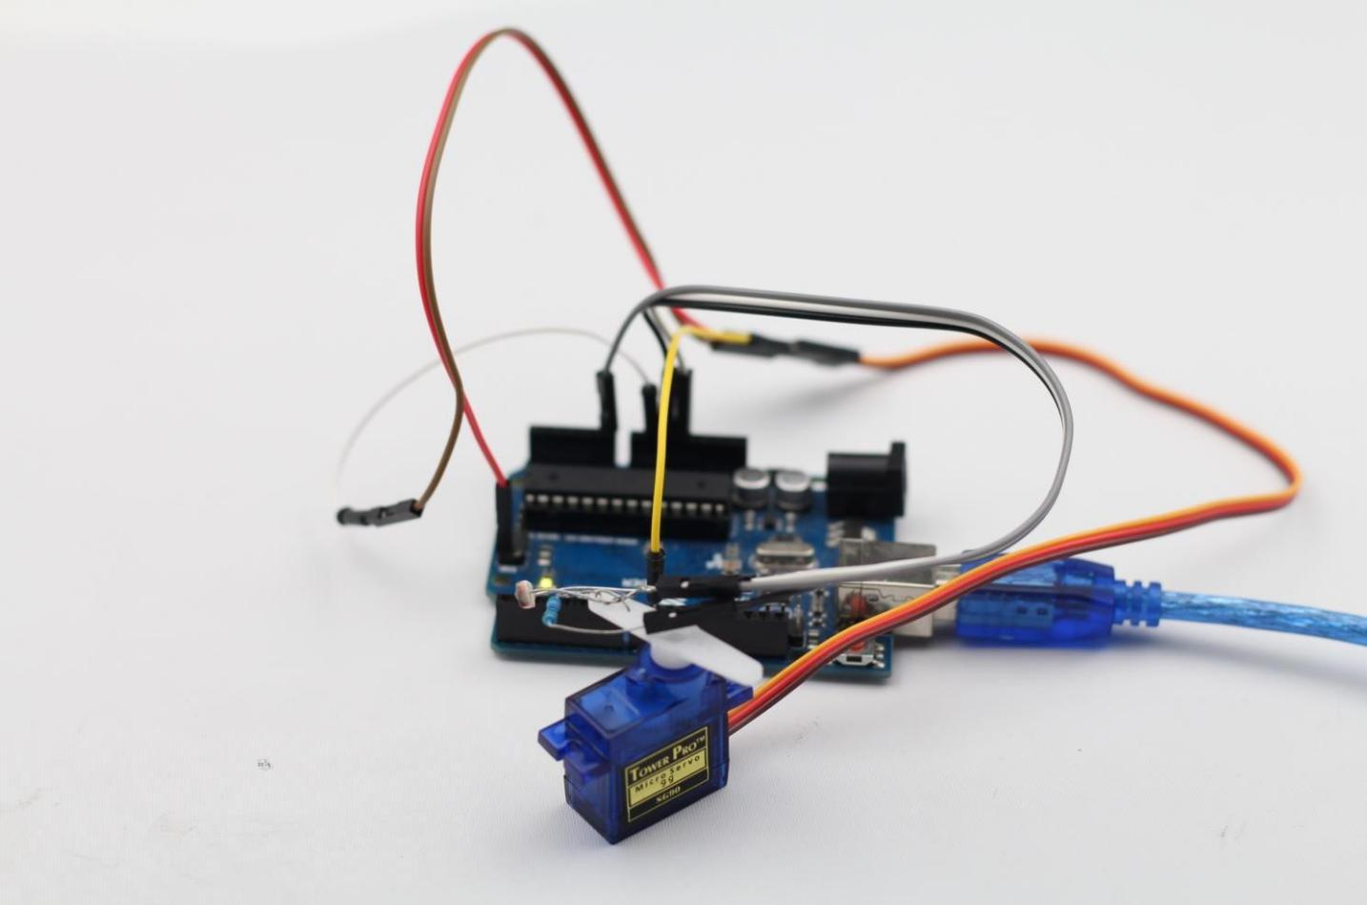

Lesson 36 Simple Creation - Packing

Introduction
In this lesson, we will use an ultrasonic sensor and some other components to simulate how to back a car.

Components
- 1 * RobotLinking Uno board
- 1 * USB data cable
- 1 * Ultrasonic sensor
- 1 * Buzzer
- 1 * LCD1602
- Several jumper wires
- 1 * Breadboard
- 1 * Potentiometer

Experimental Principle
When the distance between the ultrasonic and the obstacle is greater than 5cm and less than 15cm, the buzzer will make sounds in a low frequency, which means backing a car is in progress. When the distance is less than 5cm, the buzzer will alarm and make sounds in a high frequency.

Experimental Procedures
Step 1: Connect circuit as shown in the following diagram:

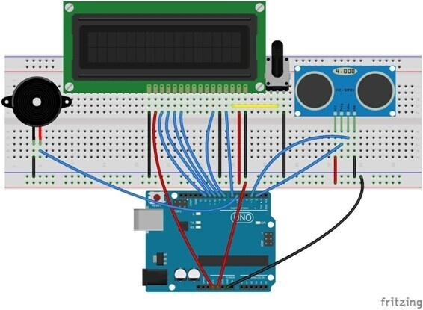

The corresponding schematic diagram is as follows:

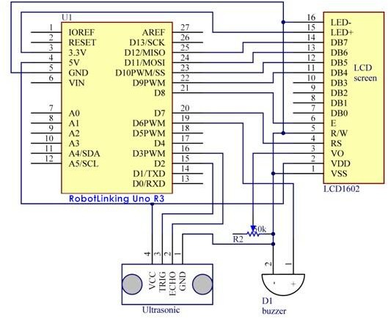

Step 2: Program (please refer to the example code on the CD or official website)
Step 3: Compile the program
Step 4: Burn the program into RobotLinking Uno board

Now, if the distance between the ultrasonic and the obstacle is greater than 5cm and less than 15cm, the buzzer will make sounds in a low frequency; if the distance is less than 5cm, the buzzer will alarm and make sounds in a high frequency. At the same time, the current distance between the ultrasonic and the obstacle will display on LCD1602.
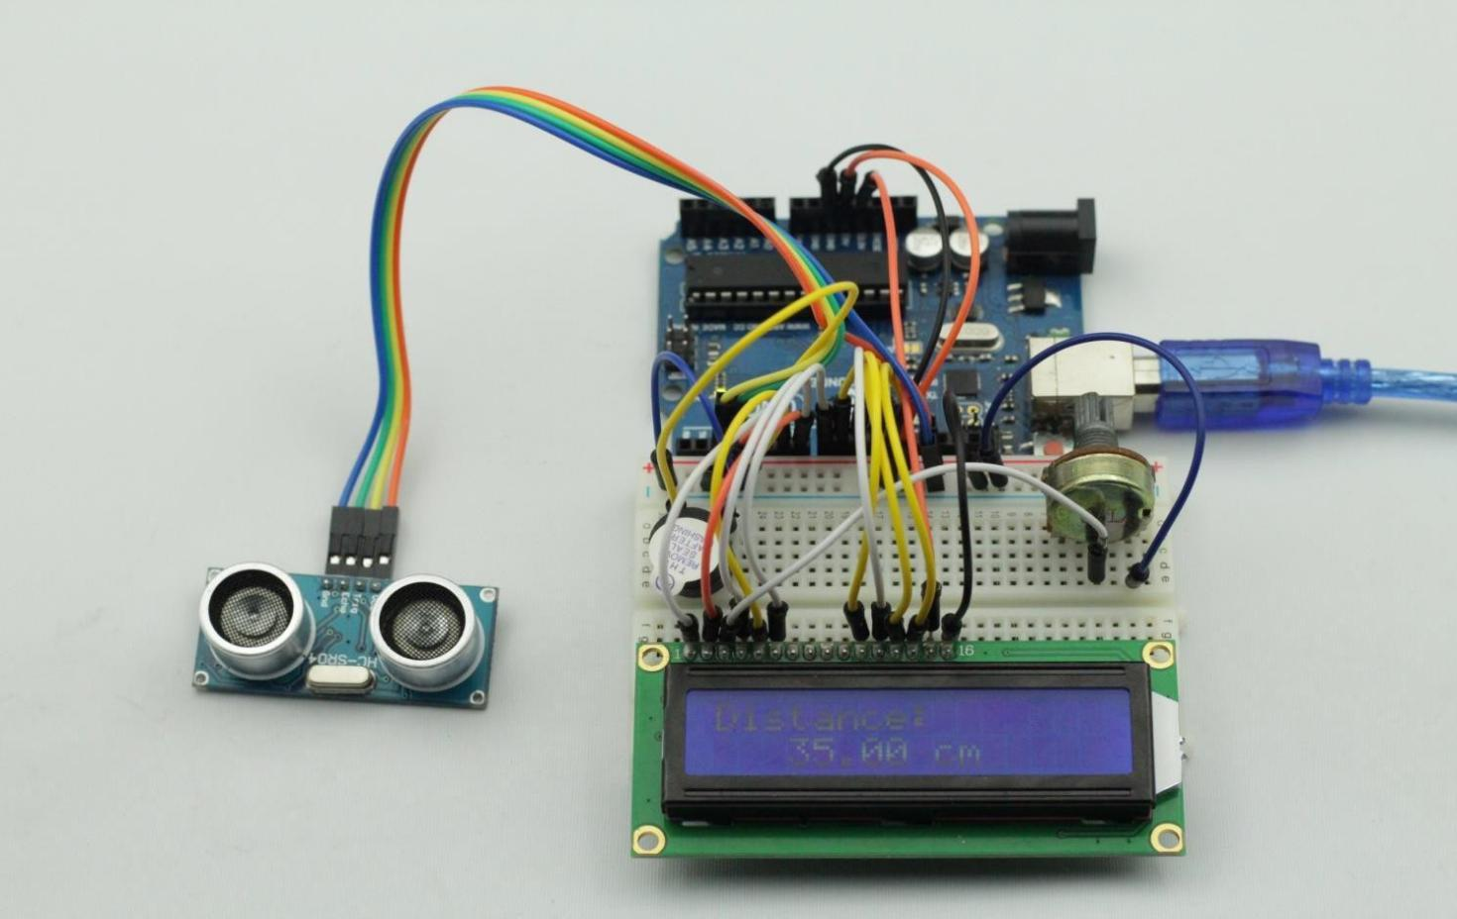

135 /136

