使用说明书
打猎相机
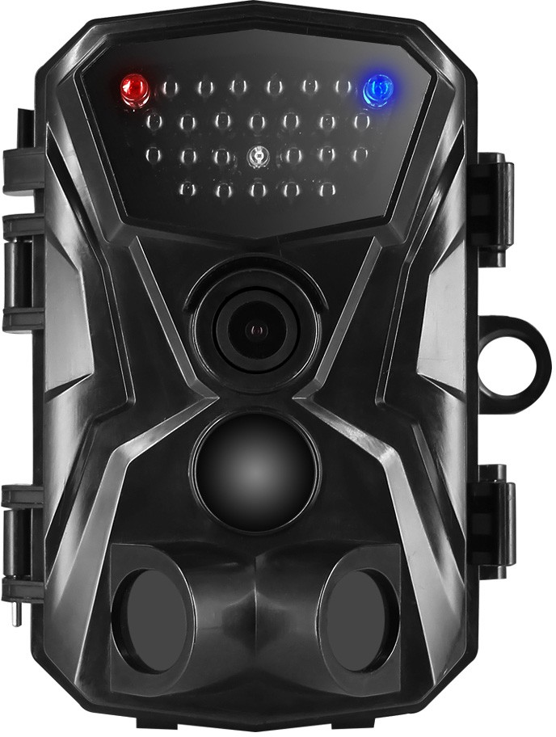

目录
简体中文 2-15

English 16-30

前言
感谢您购买此款打猎机，本产品是一款专门用于记录和观察野生动物的数码相机。为了使您能尽快轻松自如地操作本机，我们配备了内容详尽的使用手册，本手册为您系统地介绍了打猎机的使用说明等。请在使用前仔细阅读本手册，以便您快速正确地掌握使用方法。
在编写本手册时我们非常认真和严谨，希望能给您提供完备可靠的信息，然而难免有错误和疏漏之处，请您给予谅解。
本公司对于因软件、硬件的错误操作、产品自行拆卸维修或其他意外情况所引起的内部资料的丢失和损坏不负任何责任，也不对由此造成的其他间接损失负责。
本手册的信息如有变更，怒不另行通知。
本手册信息受到版权保护，其他任何部分未经本公司事先书面许可，不准以任何方式影印和复制。
本公司保留对本手册、三包凭证及其相关资料的最终解释权。

安全
在使用本产品前，请认真阅读并了解以下安全措施。
- 请勿试图打开本产品外壳，只有授权维修人员才能进行维修。
- 长时间使用本产品后，机身温度会升高，并非故障。
- 使用本厂商提供的附件。

外形结构
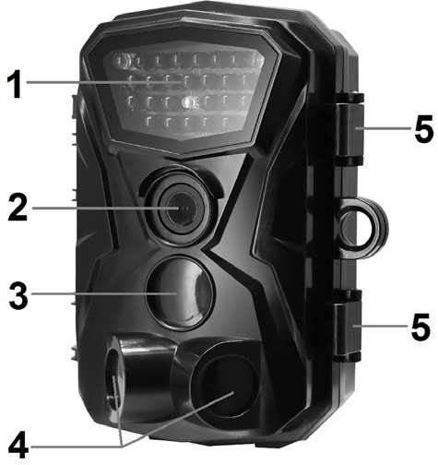
- 红外灯区
- 镜头
- 主传感器
- 辅传感器
- 锁扣
- LCD 显示屏
- 录像/向上按键
- 拍摄按键
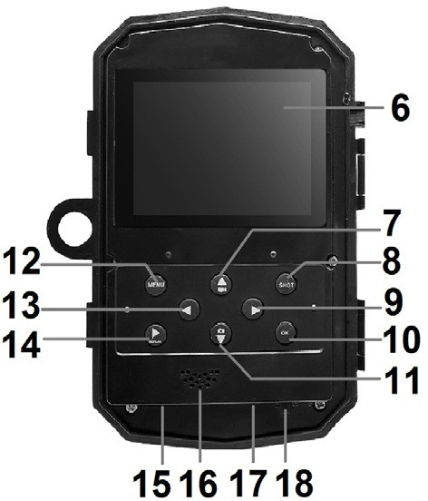
- 向右按键
- 确认按键
- 拍照/向下按键
- 菜单按键
- 向左按键
- 回放按键
- TF 卡槽
- 喇叭
- USB 接口
- OFF-TEST-ON 开关

电池充电
使用本产品前，请先插入电池。
- 打开打猎机，找到电池盖并打开，插入 6 节 1.5 V AA 电池，同时确保电池极性的正确。
- 当使用电源适配器(不提供)充电时，在相机的底部找到橡胶密封圈并打开，用电源适配器的一端连接打猎机， 另一端接入电源，进行供电。

插入内存卡
本产品没有内置内存, 请在使用前，先插入一张 TF 卡。如果不插入存储卡，相机将不能保存任何数据。拍摄前， 请先将 TF 卡格式化，可提高电池寿命和快门速度。
- 支持 Micro SD 卡，最大容量为 32 GB。建议用户使用 6 级或以上的高速卡。
- 为了避免故障，储存卡应远离水源，避免强烈振动、粉尘、热源和阳光直射。
- 不要强行插入存储卡，按照产品上标识的方向插入。
- 第一次使用时，应该待存储卡温度达到环境温度后再进行拍摄。打猎机可能会受到环境温湿度的影响而导致短路，所以在室外使用时应注意对产品的保护。

- 当存储卡空间已满，摄像机将会自动停止拍照、录像以及关闭 LED 灯。
- 拔出 TF 卡时，轻轻按下卡的突出边缘，弹出存储卡。

基本操作

开关机
插入电池后，将模式开关拨到“测试”/“开机” 档位，摄像机开机。
将模式开关拨到“关闭”档位，摄像机关机。
系统设置
将模式开关拨到“测试”档位，可对摄像机进行设置操作。
- 按录像/拍照按键在拍照和录像模式之间切换。
- 按菜单键打开设置菜单。
- 按上/下键浏览菜单。按确认键打开选项界面。
- 按上/下键浏览选项。按确认键确认设置。
- 再次按菜单键返回上一级或退出设置。

设置菜单及功能如下：
模式
设置摄像机工作时的模式。拍照模式下摄像机只拍摄图片。录像模式下摄像机录制视频。拍照& 录像模式下, 相机会先拍摄一张图片，然后开始录像。
选项：【拍照】/【录像】/【拍照&录像】。
照片像素
设置静止图片的分辨率。
选项：【1800 万像素】/【1200 万像素】/【800 万像素】
/【500 万像素】。
录像分辨率
设置视频分辨率。分辨率越高，能够存储的视频时长越短，反之越长。
选项：【1080P】/【720P】/【WVGA】/【VGA】。
拍照张数
设置相机连续拍照数量。拍照模式下，相机会连续自动拍摄相应张数的照片。
选项：【1 张】/【2 张】/【3 张】。

录像长度
设置录制一段视频的时间长度。
选项：【1 秒~60 秒】/【3 分钟】/【5 分钟】。
拍摄间隔
可设置相机的定时拍照间隔时间。例如，设置间隔时间为 30 分钟，机器就会在每 30 分钟拍摄一张照片。若想观察植物的开花过程，将机器放置 24 小时，就会有 48 张照片，开花的全过程即可记录下来。
选项：【2 秒】/【5 秒】/【10 秒】/【15 秒】
/【30 秒】/【1 分钟】/【3 分钟】/【5 分钟】/
【10 分钟】/【15 分钟】/【30 分钟】。
PIR 灵敏度
设置传感器的灵敏度。在室内所受到的环境影响很小，应选择”低灵敏度“，在室外时，环境正常情况下选择“中灵敏度”，当外界环境对拍摄有很大影响时选择”高灵敏度“。温度也会影响到灵敏度。“高灵敏度”设置适用于温和环境， “低灵敏度”试用于寒冷的环境中。

选项：【低】/【中】/【高】。
时间水印
拍摄照片时，在照片上添加拍摄的日期和时间。选项：【关闭】/【开启】。
定时器
设置相机的监控时间，可设置相机录制的具体时间段。如图所示，可以设置相机录制的起始时间和结束时间。设置完成后，每天相机只会在设定的时间段内录制，其他时间处于待机状态。
选项：【关闭】/【开启】。
设置定时时间
开始:时-分 结束:时-分
00 ：00 23：59
MENU 退回 OK 确 认

密码设置
设置相机的开机密码，密码为 4 位数，每个数字在 0-9，A-Z 之间选择。
如果忘记开机密码，可对相机进行复位操作，恢复到出厂默认设置。选项：【关闭】/【开启】。

序列号设置
为相机设置一个唯一的序列号，序列号为 4 位数，每个数字在 0-9，A-Z 之间选择。
选项：【关闭】/【开启】。
定时拍摄设置
可设置定时拍摄间隔时间。例如，设定时间为
30 分钟，机器每隔 30 分钟定时拍一张照片。如放置 24 小时，即 1*48=48 张照片，最后机器会将这些照片自动合成一个录像文件。
选项：【关闭】/【15 秒】/【30 秒】/【1 分钟】
/【3 分钟】/【5 分钟】/【10 分钟】/【15 分钟】
/【30 分钟】。
侧 PIR
打开或关闭侧边移动感应即辅助传感器。选项：【关闭】/【开启】。
闪光灯
设置闪光灯亮度。
选项：【自动】/【高亮】/【经济】。

语言
设置屏幕显示语言。
选项：【英语】/【法语】/【德语】/【西班牙语】
/【意大利语】/【中文】/【葡萄牙语】/【丹麦语】/【荷兰语】/【瑞典语】/【日语】。
格式化
格式化存储卡将永久删除存储卡内的所有数据。当你使用一个新的存储卡或使用的存储卡曾被用于另一个设备时，应先将存储卡格式化。
选项：【否】/【是】。
系统时间设置
设置相机的日期和时间。
恢复出厂设置
将相机所有的设置都恢复到出厂时的默认设置。包括设置的密码、序列号等。
选项：【否】/【是】。
自动关机
设置机器自动关机时间。

选项：【3 分钟】/【5 分钟】/【10 分钟】/【关闭】。
系统
查看软件升级以及软件版本信息。
选项：【软件升级】/【软件版本】。
拍照、录影、回放
将模式开关拨到“测试”档位。可手动进行拍照、录影以及回放录制的文件。
- 拍照：按拍照键切换至拍照模式。按快门键拍摄一张照片。
- 录像：按录像键切换至摄像模式。按快门键开始录像，再次按快门键停止录像。
- 回放：按回放键进入回放界面，按左/右键浏览已保存的照片和视频。回放视频时，按 OK 键播放，再次按 OK 键暂停，按菜单键停止播放。视频播放过程中，按左键快退播放，按右键快进

播放，同时屏幕上显示 2/4/8 倍速率。再次按下回放键退出回放模式。
回放下菜单：文件删除：删除当前或所有的照片或视频文件。选项：【删除单张】/【删除所有】。

工作模式
将模式开关拨到“开机”档位。机器开机后，屏幕上显示倒计时 5 秒后，LED 灯以及屏幕将会熄灭，摄像机开始独立运作并进入待机模式。
此时若有动物进入了传感器的检测范围，摄像机将被激活并检测运动轨迹如果物体继续向传感器检测的区域移动，摄像机将自动进行拍照或摄像。如果物体离开了传感器检测的区域，摄像机回到待机模式。

夜间模式
在夜间，红外 LED 等会自动打开，为拍照提供必要的光照。LED 灯照射的范围可以使摄像机拍

摄大约 3 米到 20 米外的物体。如果碰到物体的反射时可能会造成曝光过度。
在夜间模式下，所拍摄的画面只能显示黑色或白色。当长时间记录视频时，低电压可能对机器的稳定性有很大的影响。所以在夜间低电压情况下, 不要录制视频。
下载文件到电脑
有两种方法可以将图像从摄像机的存储卡下载
到计算机中：
- 将 SD 卡插入闪存读卡器中
- 用附带的 USB 线将摄像机和电脑相连。
使用读卡器
- 从摄像机中弹出存储卡然后将其插入到电脑的读卡器中。
- 打开[我的电脑]或 windows 资源管理器，然

后双击代表存储卡的可移动图标。
- 将图像从存储卡上复制到计算机中你选择的目录下。

通过 USB 线将摄像机连接到计算机
- 通过 USB 线将摄像机连接到计算机，开启摄像机。液晶屏上显示 ”MSDC“。
- 打开[我的电脑]或 windows 资源管理器，然后双击代表存储卡的可移动图标。所有文件存储在一个名为 “DCIM”的文件夹中。
- 将图像从“DCIM”文件夹中复制到计算机中你选择的目录下。

User Manual
Hunting Camera

Introduction
Congratulations on the purchase of your new device. You have selected a high-quality product. The operating instruction is one constituent of this product. It contains important information about safety, use and disposal.
Before using the product, familiarise yourself with all operating and safety instructions. Use this product only as described and only for the specified areas of application.

Safety
Please read below safety precautions carefully before using the camera.
- Do not try to disassemble the product case.Only
authorized technician can repair the product.
- The camera will be hot after using for too long time.This is normal.
- Please use the accessory provided by our factory.

Parts Of The Camera
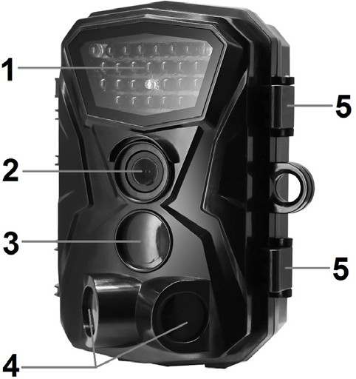
1.Infrared LEDs 2.Lens
3.Front Motion Sensor 4.Side Motion Sensor 5.Lock
6.LCD Display Screen 7.Video/Up Button 8.Shot Button
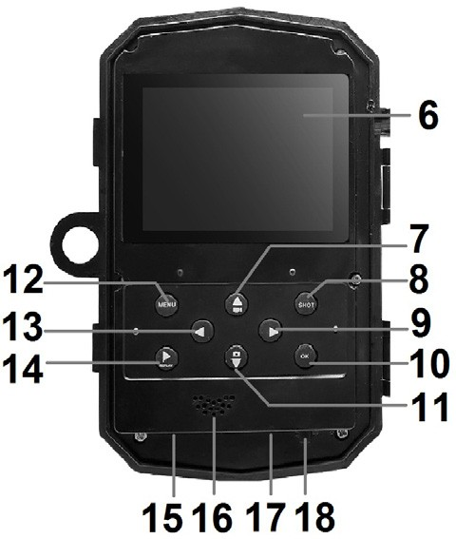
9.Right Button 10.OK Button
11.Capture/Down Button 12.Menu Button
13.Left Button 14.Playback Button 15.Micro SD card Slot
16. Speaker 17.USB Jack
18.OFF-TEST-ON Mode
Button

Power Supply
Please install batteries before using the camera.
- Open the camera case and remove the battery cover. Install 6 pieces of 1.5V AA batteries. Please make sure the electrode is correct.
- If the camera is in low power, please connect the camera to a power adapter(not provide) for power supply.

Inserting Storage Media
Please prepare a Micro SD card and insert it into the camera for saving more files. Before recording, please format the memory card first.
- Support Micro SD card,up to 32GB. Suggest to use class 6 or above high speed card.
- To avoid malfunction, the memory card should be far away water, strong vibration,dust, hot source and direct sunlight.
- Do not insert the memory card forcibly. Please refer to the marking on the camera.

- For the first time use, please wait for the memory card temperature reach the ambient temperature.The camera will be short-circuit influenced by environment temperature and humidity. Please notice protection for the camera when using it outdoor.
- If the capacity of memory card is full,the camera will stop recording automatically and the LEDs will go out.
- Press the edge of the card gently to pop-up the TF card.

Basic Operation

Turn On And Off The Camera
Switch the Mode Button to“Test/On”to turn on the camera.
Switch the Mode Button to “Off” to turn off the camera.

System Setup
Switch Mode Button to “Test”, then you can set the system parameters.

- Press Video/Capture button to switch between these two modes.
- Press Menu button to open the setup menu.
- Press Up/Down button to scan all menu. Then press OK button to enter the options interface.
- Press Up/Down button to scan all options. And press OK button to confirm options.
- Press Menu button again to turn back to last menu or exit the setup menu.
Setup menu and functions are as below:

Mode
Set the working mode. In Camera mode,the camera just take pictures. In Video mode,the camera just record video. In Camera+Video mode,the camera will take a photo first,then start to record video.
Options：【Camera】/【Video】/【Camera+Video】.

Photo Size
Set the still image size.
Options：【18M】/【12M】/【8M】/【5M】.

Video Size
Set the video size. The bigger the size is ,the longer the video time can be stored.
Options：【1080P】/【720P】/【WVGA】/【VGA】.

Picture No.
Set the photo number of continuous shooting. In camera mode, the camera will take photos continuously.
Options：【1 Photo】/【2 Photo in】/【3 Photo】.

Video Length
Set the duration of recording a video clip. Options：【1 Sec~60 Sec】/【3 Min】/【5 Min】.

Interval
The camera will take pictures automatically as per the time interval. For example,set the interval time to 30 minutes, the camera will take two photos each hour. If you want to observe that a plant blooms, the camera will take 48 photos in 24 hours to record the whole process of blooming.

Options：【2 Sec】/【5 Sec】/【10 Sec】/【15 Sec】
/【30 Sec】/【1 Min】/【3 Min】/【5 Min】/【10 Min】
/【15 Min】/【30 Min】.

PIR Sensitivity
Set the sensitivity of the sensors. Environmental impact is small indoors, you can choose “Low”. In
outdoor, choose “Middle”in normal condition. Choose
“High”if the environment impact is huge outdoors.
The temperature can also influence the sensor
sensitivity. “High Sensitivity”applies to mild environment. ”Low Sensitivity ”applies to cold
environment.
Options：【Low】/【Middle】/【High】.

Time Stamp
Stamp the date&time on the photos or not.
Options：【Off】/【On】.

Timer Set
Set the target recording time. As shown in below picture, you can set the start and end time. The camera

will work just in the stated time slot. In other time, the camera will keep in standby state.
Options：【Off】/【On】.
Timer Set
Start:h-m End:h-m
00 ：00 23：59

MENU Exit OK Enter

Pass Word Set
Set the power-on password of the camera. The password is four digits, each digit ranges from 0 to 9 or A to Z. If you forget the password, please reset the camera. Then all parameters will reset to the factory settings.
Options：【Off】/【On】.

Serial No. Set
Set the unique serial number for the camera. The number is four digits，each digit ranges from 0 to 9 or A to Z.

Options：【Off】/【On】.

Time Lapse
You can set the interval time. For example, set the interval to 30 minutes, the camera will take two photos each hour. If the camera works for 24 hours,there will be 48 photos. These photos will be converted into a video.
Options：【Off】/【15 Sec】/【30 Sec】/【1 Min】/
【3 Min】/【5 Min】/【10 Min】/【15 Min】/【30 Min】.

Side PIR
Open/close the side motion sensors.
Options:【Off】/【On】.

Flash Light
Set the brightness of the flash light.
Options:【Auto】/【High】/【Low】.

Language
Set the language display on screen.

Options：【English】/【French】/【German】/【Spanish】
/【Italian】/【Chinese】/【Portuguese】/【Danish】/
【Dutch】/【Swedish】/【Japanese】.

Format
Formatting the memory card will delete all data permanently. Before using a new memory card or a card that has been used in another device previously, please format the memory card.
Options：【No】/【Yes】.

Set Clock
Set the date and time of camera.

Default Set
Restore the camera to factory default settings including password,serial number and so on.
Options：【No】/【Yes】.

Auto Power Off
Set the auto power off time for the camera. Options：【3 Min】/【5 Min】/【10 Min】/【Off】.

System
Look up the Firmware update and version information of the camera.

Take Photos,Record Video,Playback
Switch the Mode Button to “Test”. In this mode,you can take photos, record video and playback files manually.
- Take Photos：Press Capture button to switch to photo
mode. Press Shot button to take a picture.
- Record Video：Press Video button to switch to video mode.Press Shot button to start to record a video clip.
Press Shot button again to stop recording.
- Playback：Press Playback button to enter the playback interface. Press Left/Right button to scan
photos or video. When playback video, press OK button to play the video. Press OK button again to have a pause. Press Menu button to stop playback.During playing the video, press left button to fast backward the video, press right button to fast forward the video.

At same time, the screen display 2/4/8 rate to play the video. Press Playback button again to exit the playback mode.
Playback Menu：Delete：Delete current one file or
delete all files. Options:【One】/【All】.

Working Mode
Switch the Mode Button to “On”. After turn on the camera,the screen will display 5 seconds countdown. Then the LEDs and screen will go out. The camera begins to operate independently and enter standby mode.
If the wild animals enter the detection range of the motion sensors , the camera will be activated and detect the motion trail.
If the wild animals continue to move to the detection zone of the sensor, the camera will take photos or record video automatically.
When the wild animals leave the detection zone of the sensors , the camera will be deactivated and turn back to standby mode.

Night Mode
During the night，the infrared LEDs will turn on
automatically to provide necessary light for taking pictures. This makes it is possible to taking picture at a distance about 3m to 20m without overexposing the at night. However, reflective objects such as traffic signs can cause overexposure if they are located within the recording range.
In night mode,the pictures just can display white and black.
When record a video for long time in the evening, the low voltage may have a great influence on the stability of the machine. Do not record video with low voltage in the evening.

Download Files To The Computer
There are two ways to download files from the memory card to a computer:
- By inserting the memory card into a card reader
- By connecting the camera to a computer using the supplied USB cable.

Using a Card Reader
- Pop-up the memory card from the camera and insert it into a card reader.Then connect the card reader to a computer.
- Open [My Computer] or [Windows Explorer] and double-click the removable disk icon that represents the memory card.
- Copy image or video files from the memory card to your computer.

Connecting the Camcorder to a PC by the USB Cable
- Connect the camera to the computer via USB cable.Turn on the camera,the screen will display”MSDC“.
- Open [My Computer] or [Windows Explorer]. A"Removable Disk" appears in the drive list. Double-click the "Removable Disk" icon to view its contents. All files are stored in the folder
named ”DCIM”.
- Copy the photos or files to your computer.

