QUICK TOUR
AccurateTracking | Easy Installation

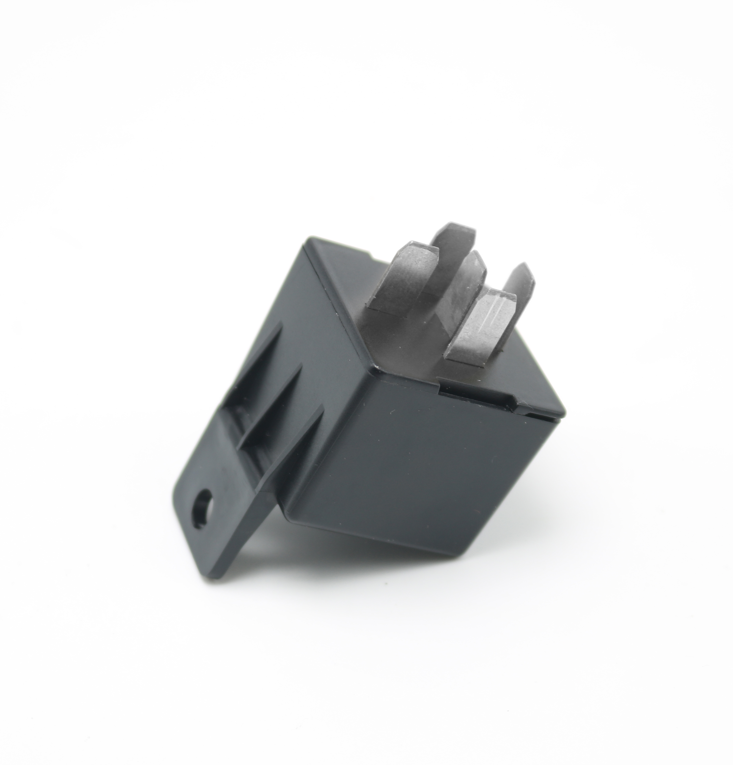
Version：V1.0

Please read the guide carefully before you use it, so that you can use it correctly and quickly. Product appearance, color and accessories are subject to change without prior notice.

①Functions and Product parameters
◆ Real-time Tracking ◆ Historical Route
◆ Geo-fence ◆ Arm/disarm
◆Cut and resume fuel remotely
◆Vibration/overspeed alarm

Bands | GSM 850/900/1800/1900MHz
Network | GSM/GPRS
Working Voltage | 10-50V
Locating Time | Cold start 35s-80s
Locating Time | Warm start 1s
Location accuracy | 5 meters (3D positioning mode)
Operating temperature | -20℃~+55℃
Dimension | 31*31*57mm
Weight | 29.3 g

②Device Activation and Connection Diagram

1, Open the top cover and insert the SIM card (support NANO card), the gap down

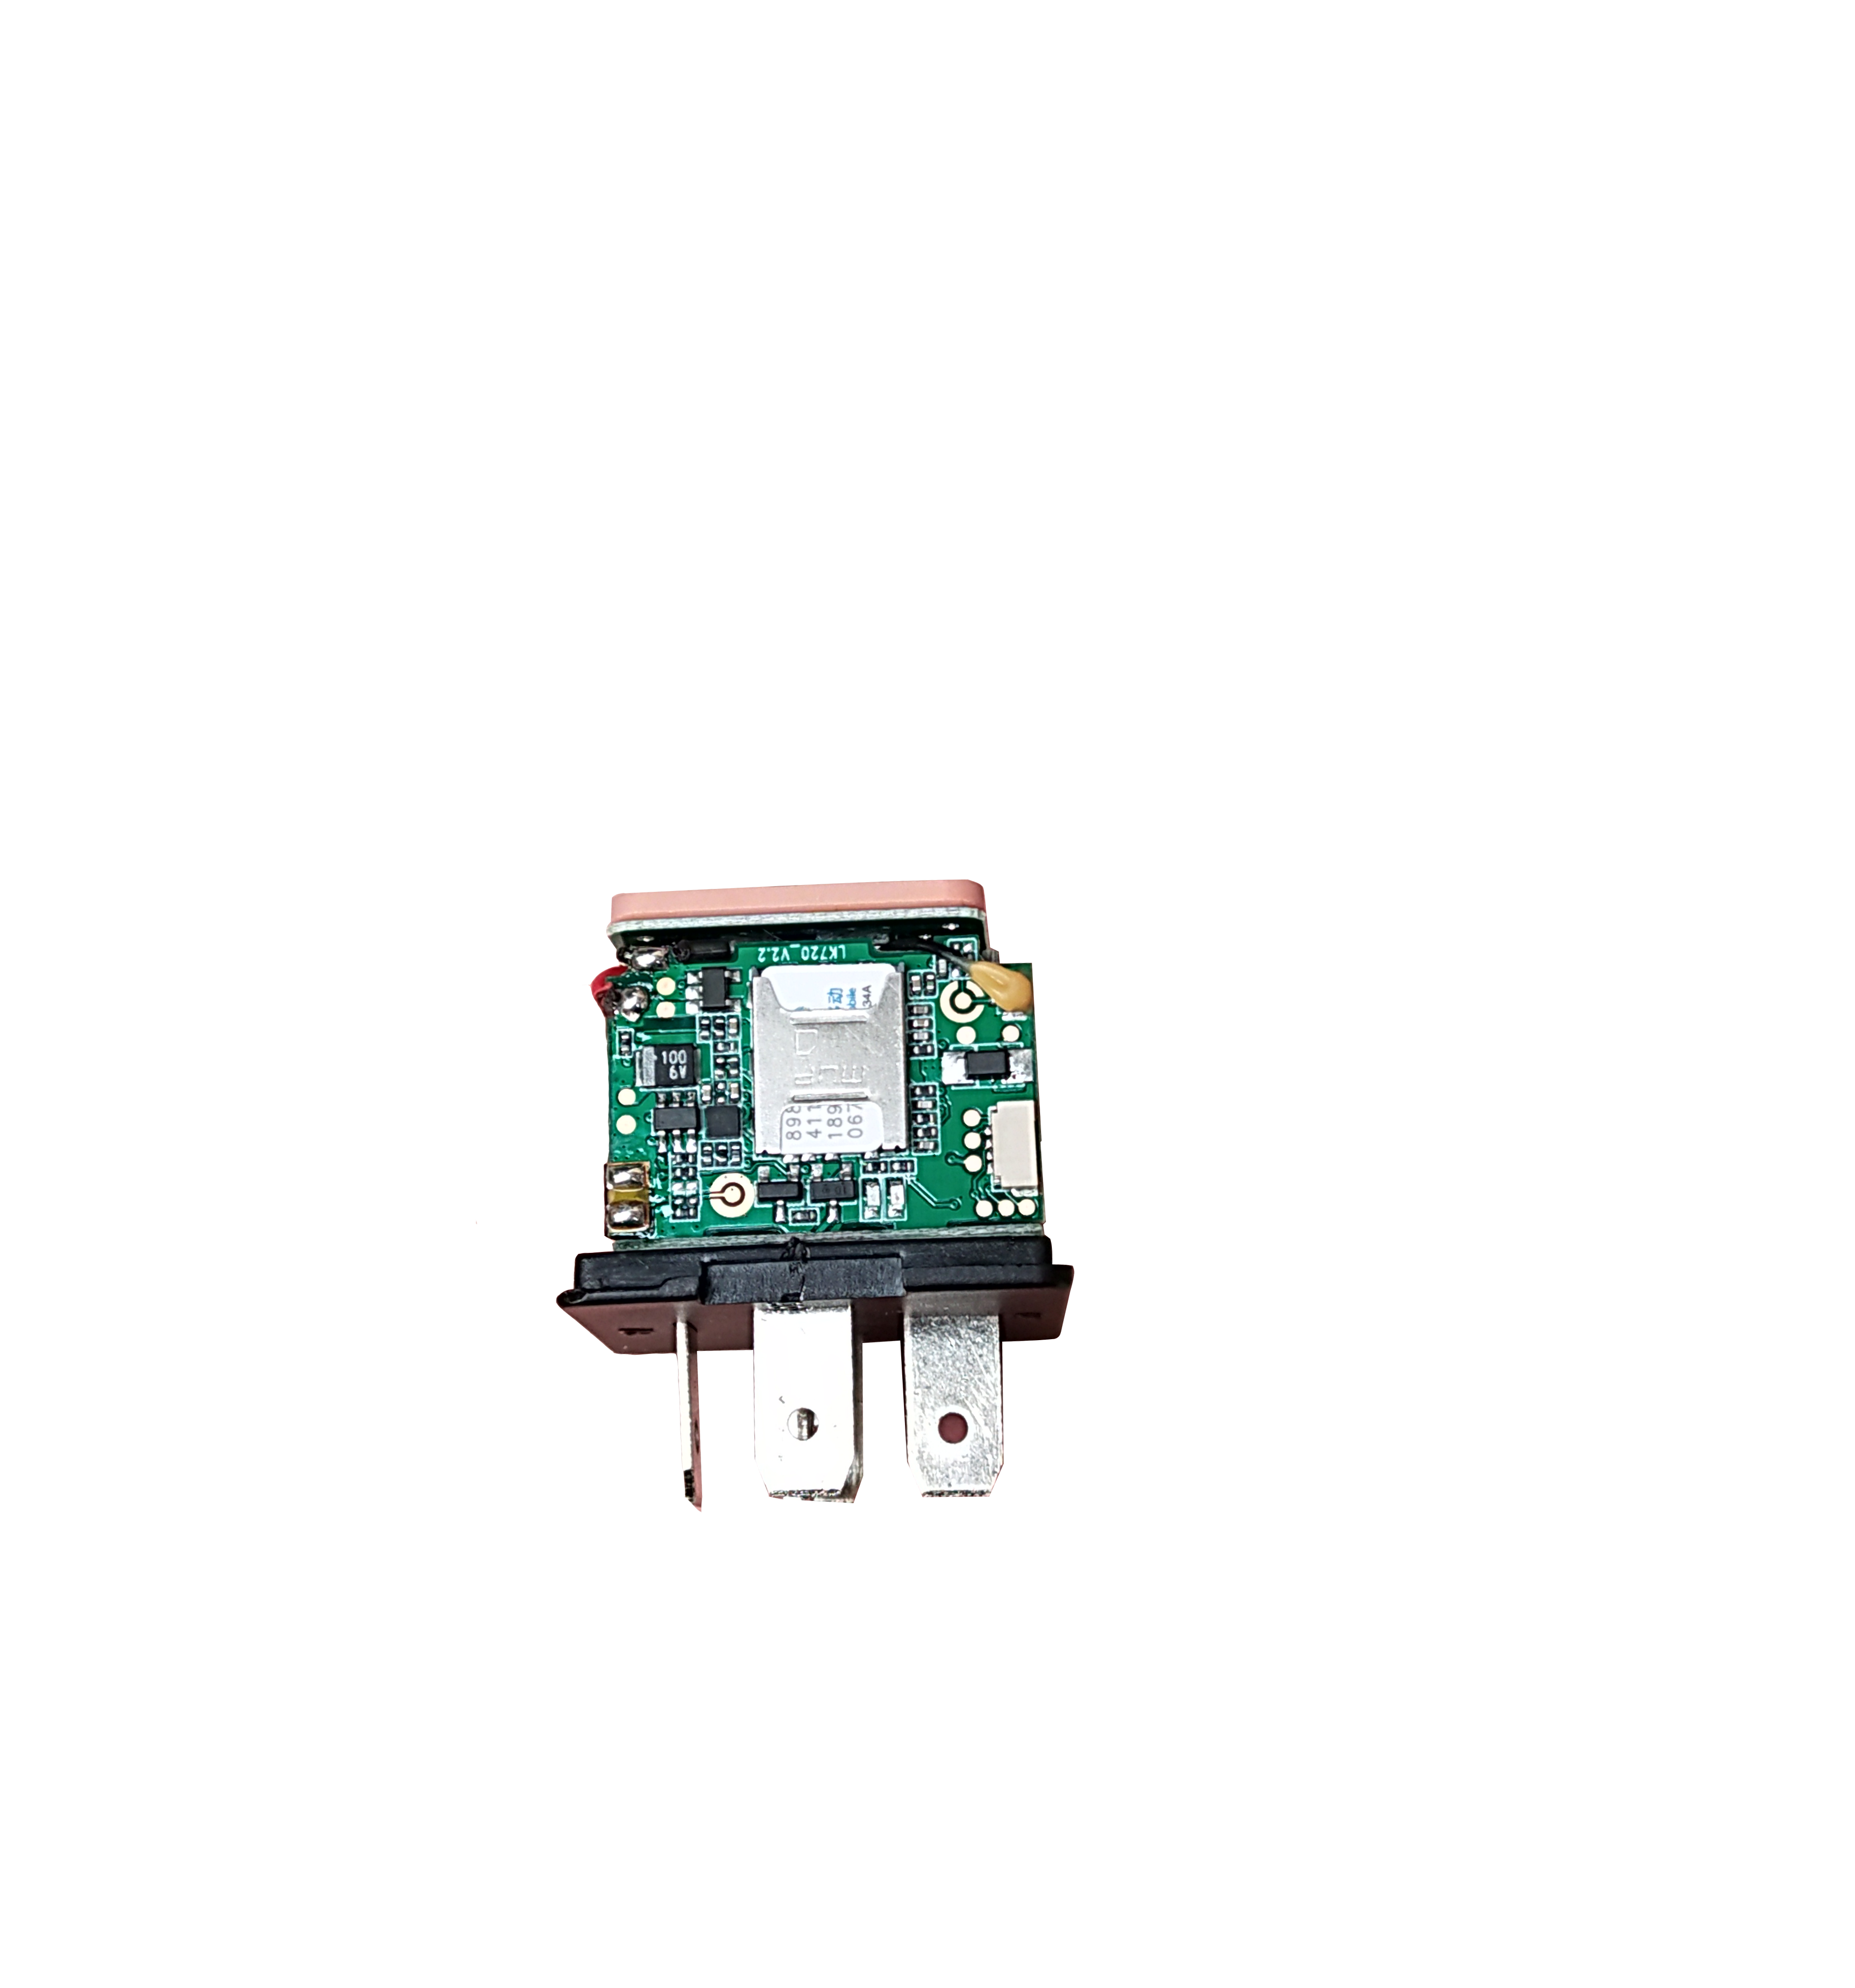

2. Close the cap and insert it with the fuel cut line (please see the right picture for cable-connecting, be careful not to insert the wrong way)
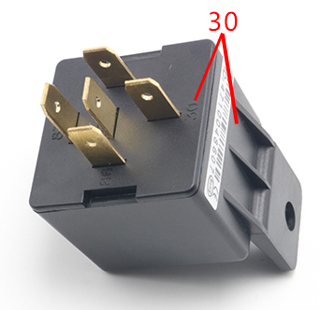
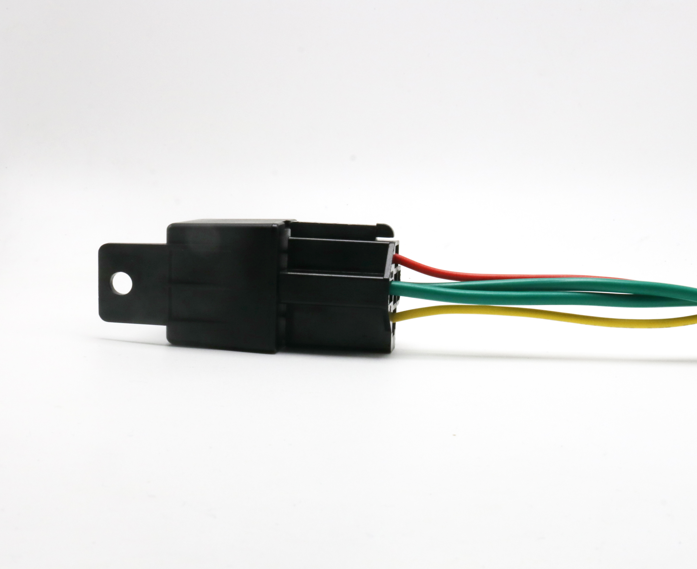

Wiring diagram for cars：
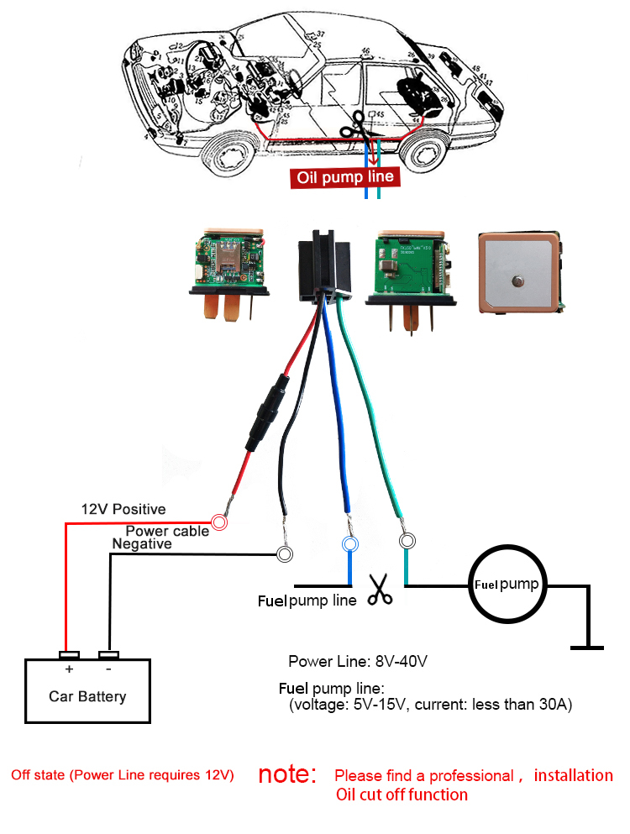
③ Download phone APP


Method 1：Scan the QR code to download the phone APP；

④ Login the website and phone APP
Log in by Website:
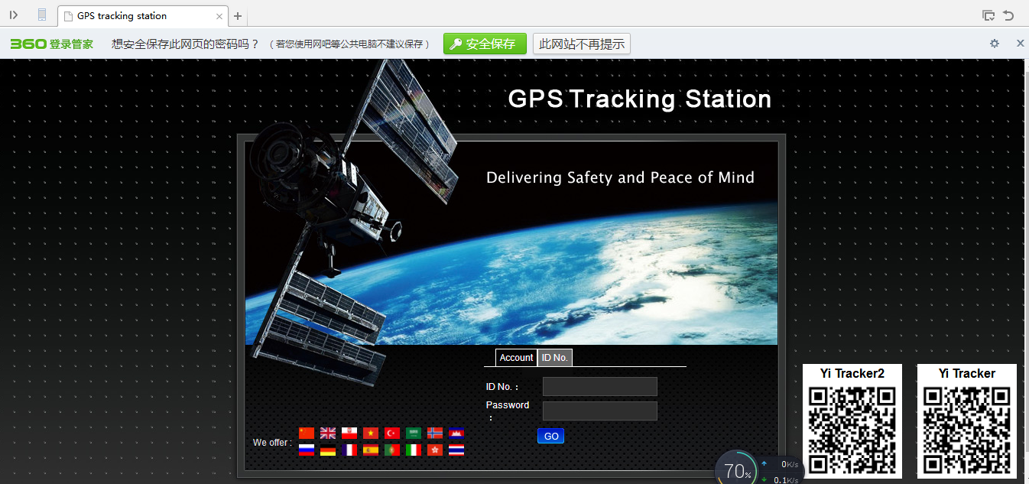

Open the website www.gpscj.net, choose IMEI, enter the 10-digit bar code of the device, the default password is 123456, click “GO” to log in into the platform.

Log in by Phone APP
Please see the following photo 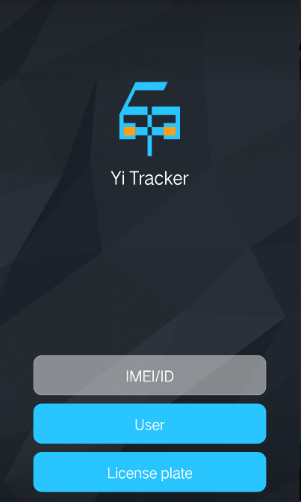 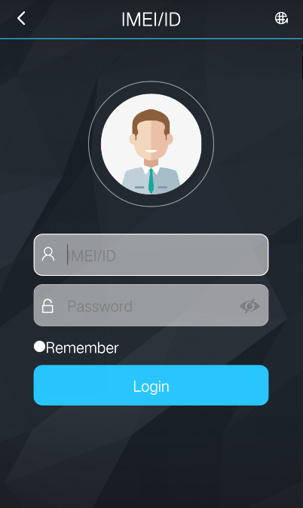

⑤More Commands
Function | Command Format | Reply | Delete | for example
admin number | admin123456+space+ admin phone number | admin ok | noadmin123456 | admin123456 186********
shock sleep(default) | sleep123456 shock | sleep shock ok
no sleep | sleep123456 off | sleep off ok
upload frequency（10-180s） | upload123456+space+time | upload ok |  | upload123456 10
Cut and resume fuel | 555 | resume fuel OK | 666
Arm | 111 | Arm delay in 0s | 000
Position | G123456# or where | google map
Restart | rst | restart ok
Back to factory | format | No reply

⑥Faults & The solutions
Q：Start up Fail?
A：Check the cable connect right or not.
Q：The device can not obtain location information?
A：Place the unit at the open area to test.
Q：How to choose SIM card?
A: the SIM card must support GSM&GPRS，and ensure that the card has enough currency and credit.
Q: How to use in the foreign countries?
A：please set the APN before use，please edit the text “APN123456 CMNET “ and send it to the SIM card of the device，CMNET is Chinese operator’s APN, Replace the corresponding APN when use in other countries, APN details, please consult your local SIM card carrier.

⑦Cautions：
Please comply with the instructions to extend the unit life:
1. Keep the unit dry. Any liquid, i.e. rain, moisture, may destroy or damage the inside circuitry.
2. Don’t put the unit in overheated or over cooled places.
3. Handle carefully. Don’t vibrate or shake it violently.
4. Clear the unit with a piece of dry cloth. Don’t clean in chemicals, detergent.
5. Don’t paint the unit, this may cause some foreign materials left in between the parts.
6. Don’t disassemble or refit the unit.

