Ferris wheel soldering tutorial

Tool:
1, 35W power soldering iron
2, solder
3, electronic pliers
4, scorpion

Precautions:
1. Adjust the temperature of the soldering iron to about 300 degrees Celsius, and the speed should be as fast as possible to prevent the temperature from burning out the components, especially the led light.
2. Each pin of the component is soldered as much as possible, and the soldering is not repeated. The pins between each pin of the same component and between the component and the component must be soldered together.
3, Led, resistors, capacitors and other components use tweezers to clamp the welding
4, the chip is soldered using drag welding, the pins can not be shorted together
- After the plug-in components are soldered, be sure to use pliers to cut off the corresponding pins.

Component soldering sequence (soldering short components first)
1, soldering led
2, soldering resistance
3, soldering capacitor
4, soldering button
5, soldering chip

Parameter | Position | Package | Quantity
SMD colorful LED |  | 0805 | 100
56R resistor | R2-R13 | 0805 | 13
100K resistor | R1 | 0805 | 2
47pF capacitor | C1 | 0805 | 2
SMD Tact switch | S1 |  | 1
STC15W408AS | U1 | SOP-28 | 1
5mm Color LED |  | DIP | 15
T-type plug connector |  |  | 1
Rotary bearing |  |  | 1
One minute two audio power cord |  |  | 1
One minute two audio socket |  |  | 1
M3*6mm screw |  |  | 3
M3*10mm screw |  |  | 2
M3 Nut |  |  | 5
Ferris wheel PCB |  |  | 1
Power board PCB |  |  | 1
Shell |  |  | 1

Start soldering
- Solder led, led has positive and negative poles, and there is a vertical pin on the reverse side of the LED as the positive pole (or a triangular pattern, which corresponds to the triangle of the printed circuit board), and the printed circuit board has a vertical triangle with a vertical.
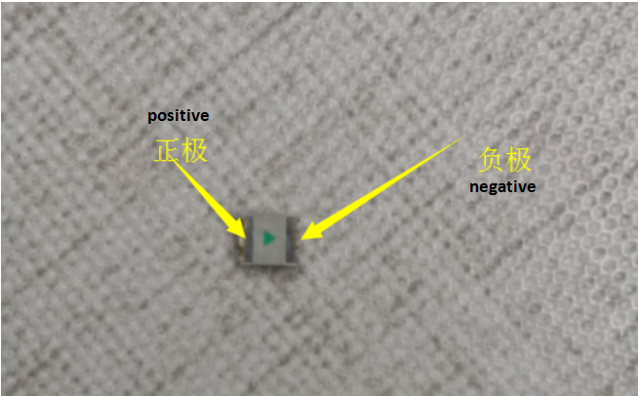
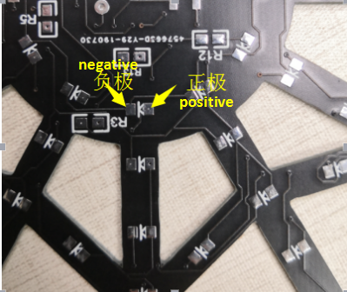
2. LED soldering, first add solder to one of the two solder pads, as shown in the figure

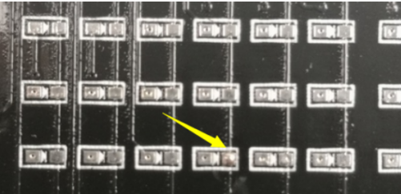
- Hold the led with the tweezers and place it on the soldering pad.
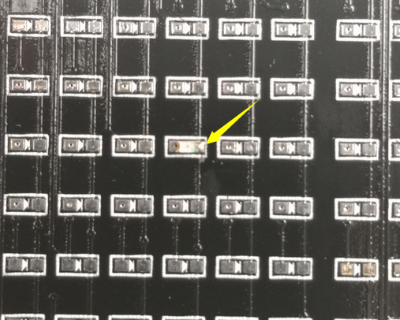

4, in the other side of the led pin plus solder
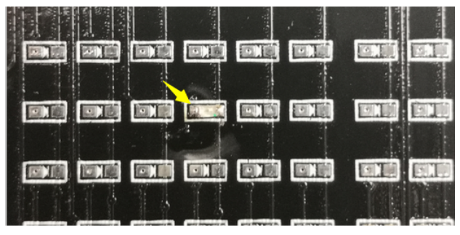
5, the soldering method of resistor and capacitor is the same as led.
6, the SMD chip soldering, first clear the direction of the chip and the direction of the board, the chip has a little circular recess, corresponding to the printed circuit board recess.
Add solder on one side of the printed circuit board
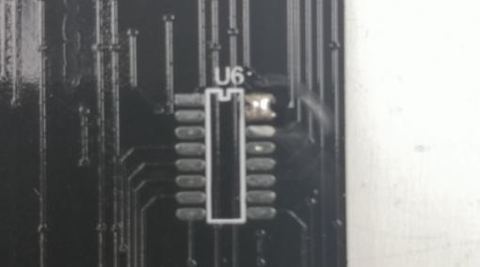
Align the chip with the silkscreen pins and fix
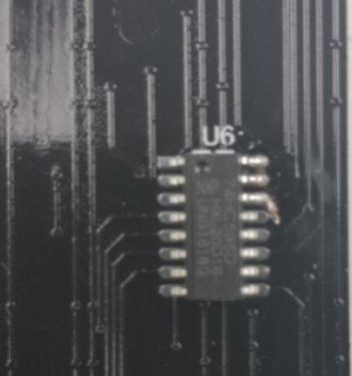
Fill both sides of the chip with solder, first add the side of the pin without solder
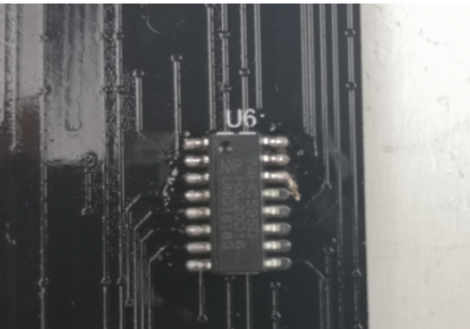

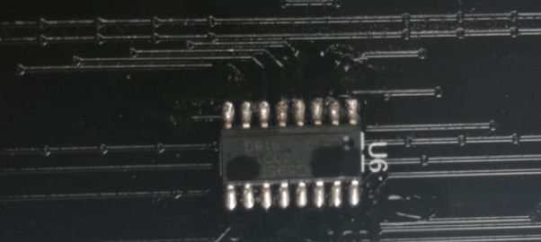
7. button switch soldering can be placed on the printed wire pattern by soldering the pins.
8. Plug-in led soldering, led long leg is positive, inserted into the circuit board, there is a + pad soldering on the printed wire.
9. Finished product.
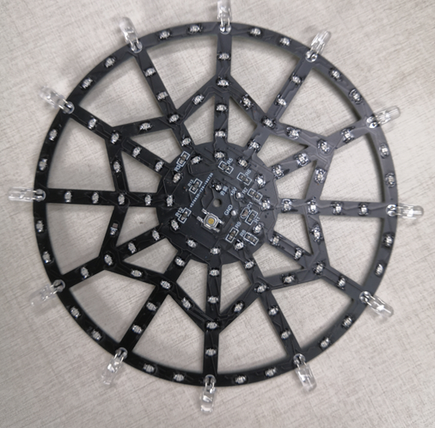
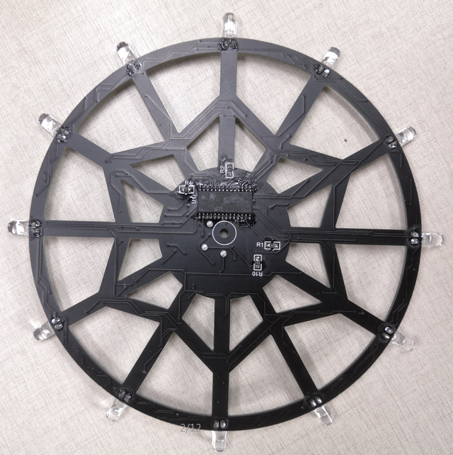

The power supply board is relatively simple to solder. There is only one component. The components can be soldered according to the pattern of the printed silk. Note that each pin of the component needs to be separately and cannot be soldered together.
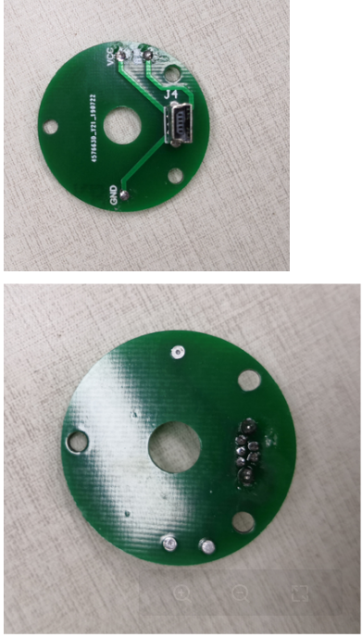

Ferris wheel assembly

- First tear off the yellow protective paper on two acrylic.
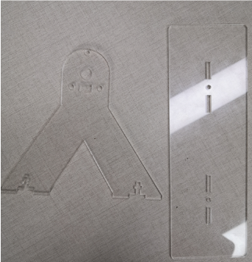
- Fix the power supply board with short screws and nuts.
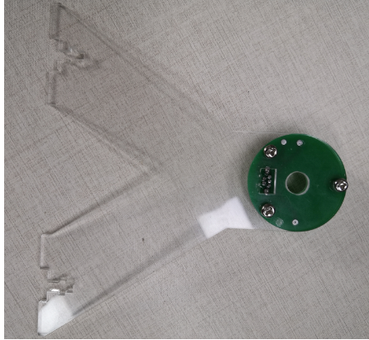
- Fix the two shells with long screws.
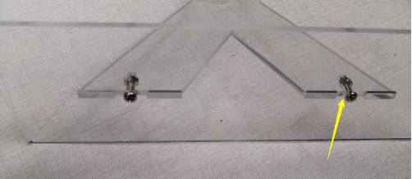
- Insert the rotary bearing on the main board of the Ferris wheel, and keep the same three color lines on the two sides of the rotary bearing (that is, one end retains the black line, the yellow line, the red line, and the other end also retains the black line, yellow line, red line ), the remaining three are cut off
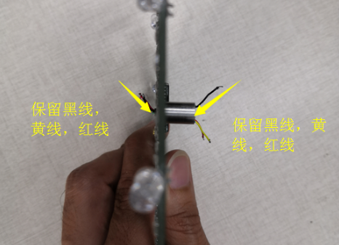
Retains black line,yellow line,red line
- Cut the corresponding line a little shorter (be careful not to cut too short, otherwise the soldering is not long enough), then solder the three wires to the "+5V, GND, audio" on the board of the Ferris wheel. On the top, the color is not fixed, but if the black wire is soldered at +5V, the other end of the rotary bearing needs to be soldered to the pad of the power supply board VCC.
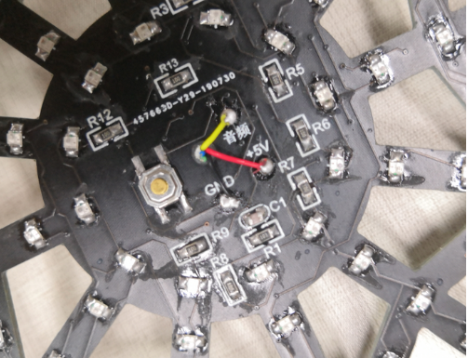
- Insert the soldered Ferris wheel into the housing.
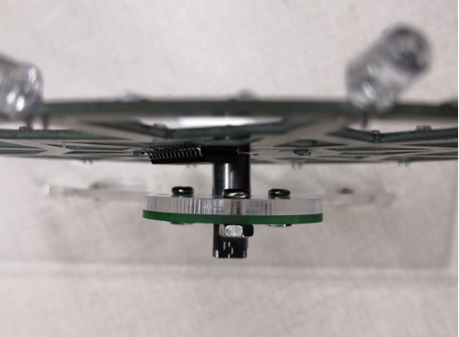
- According to the soldering position of the color line on the Ferris wheel, solder the wire at the other end of the rotating bearing to the corresponding pad of the power supply board.


