DIY Electronic Watch Kit Manual

1.First fold the first piece and the second piece of the case, and put the nut into the hole.
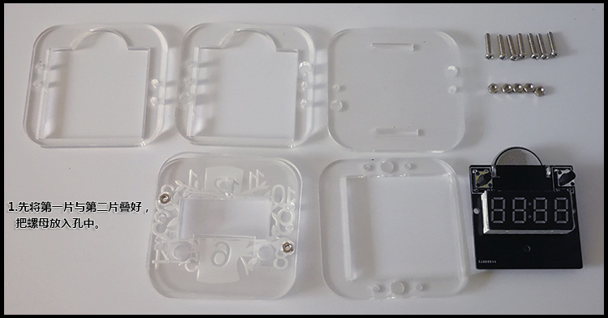
2.Stack the third piece of the case and place the nut into the hole.
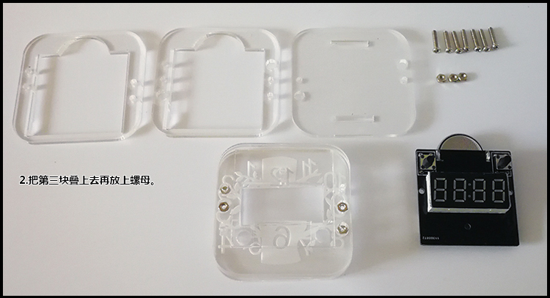

3.Stack the fourth piece of the case and put the nut into the hole. Then stack the fifth piece of the case and prepare the screws.
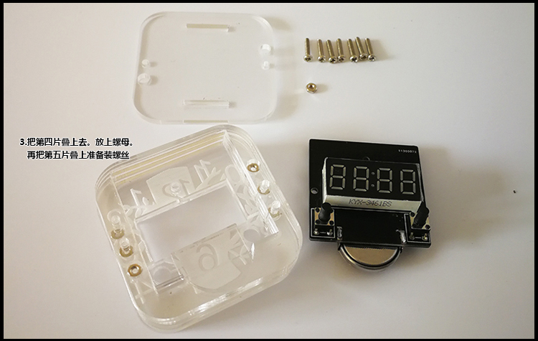

4.Insert the screws as shown below and put the watch into the case.
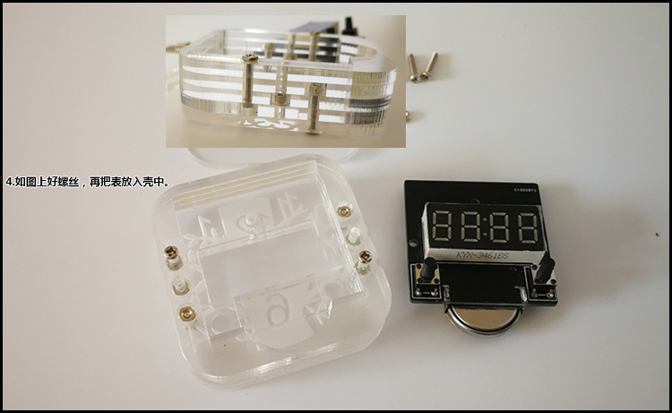

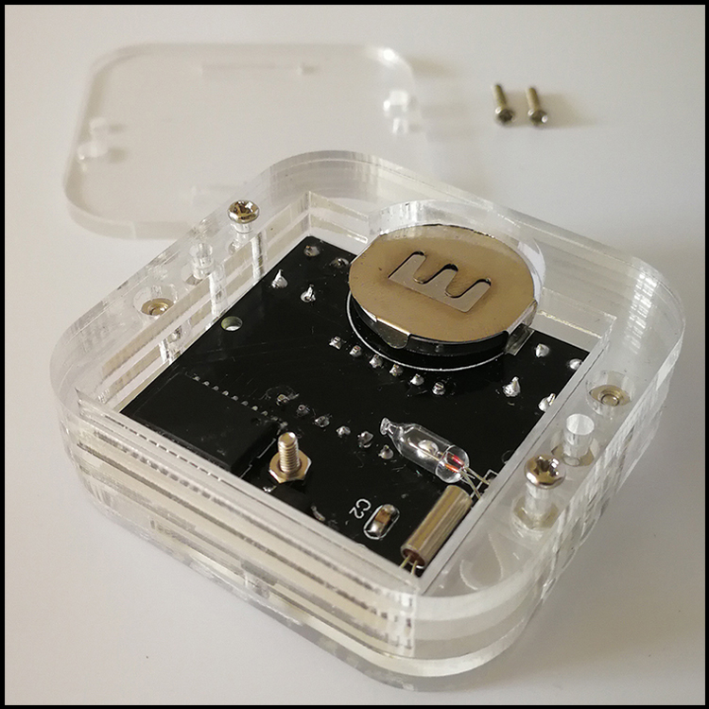

- Put the strap on the sixth plate, install it to the case, and then screw it up, it is done.
