USB Desktop Tool
POWER/VA-Meter/PWM
Applicable model: XY-DUT
USB Desktop Tool
Applicable Model: XY-KZ25/XY-KZ35

Dear users, thank you for purchasing USB desktop tools. In order to let you know all the functions of this product more quickly, get a better experience and avoid misoperation, please read and keep the instructions carefully before using them for future reference. 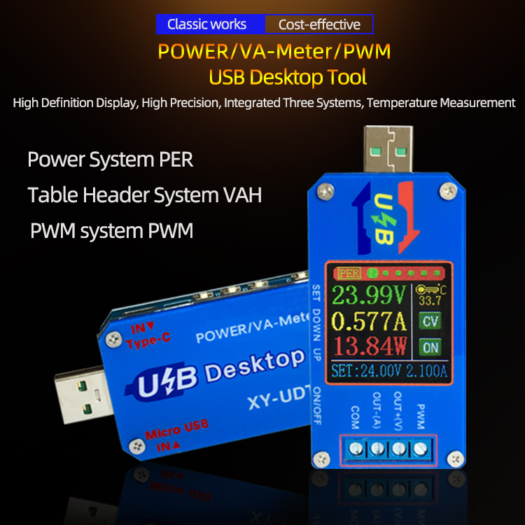

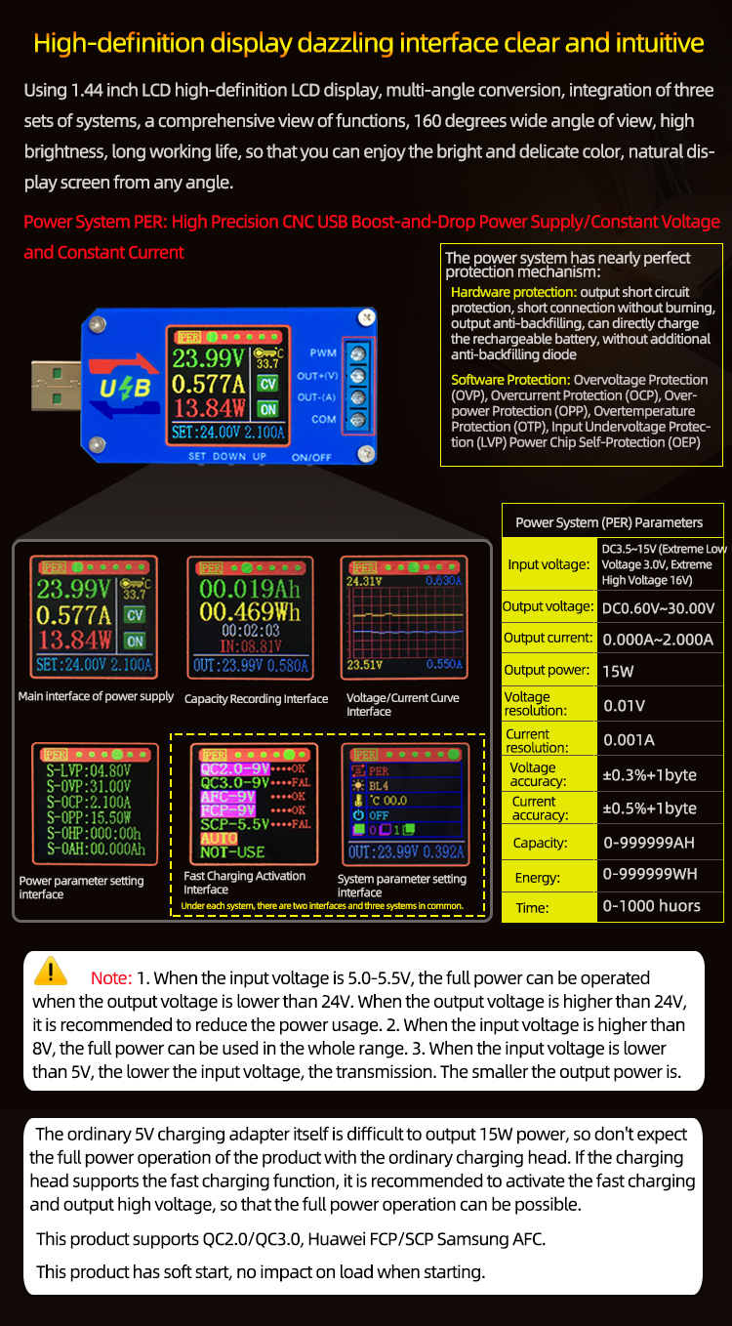
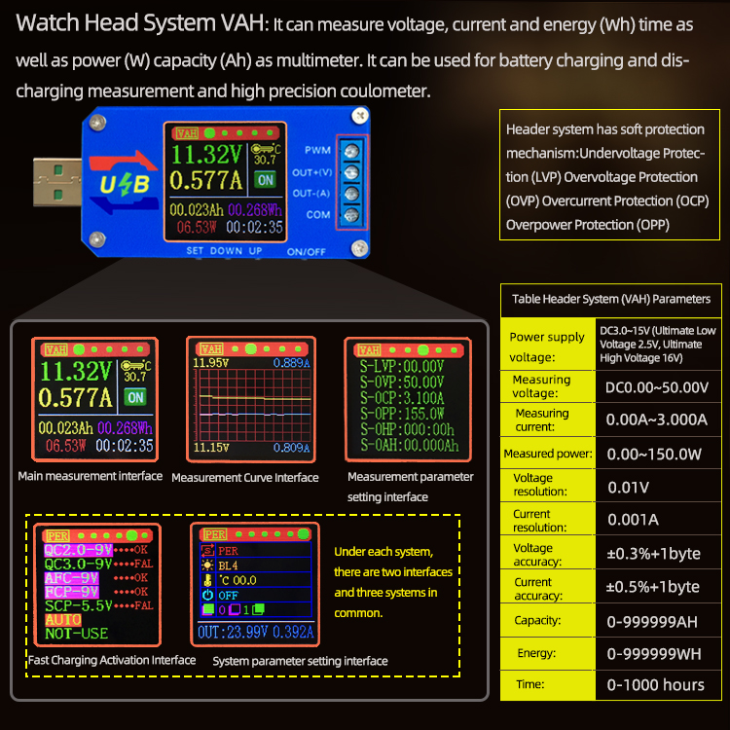

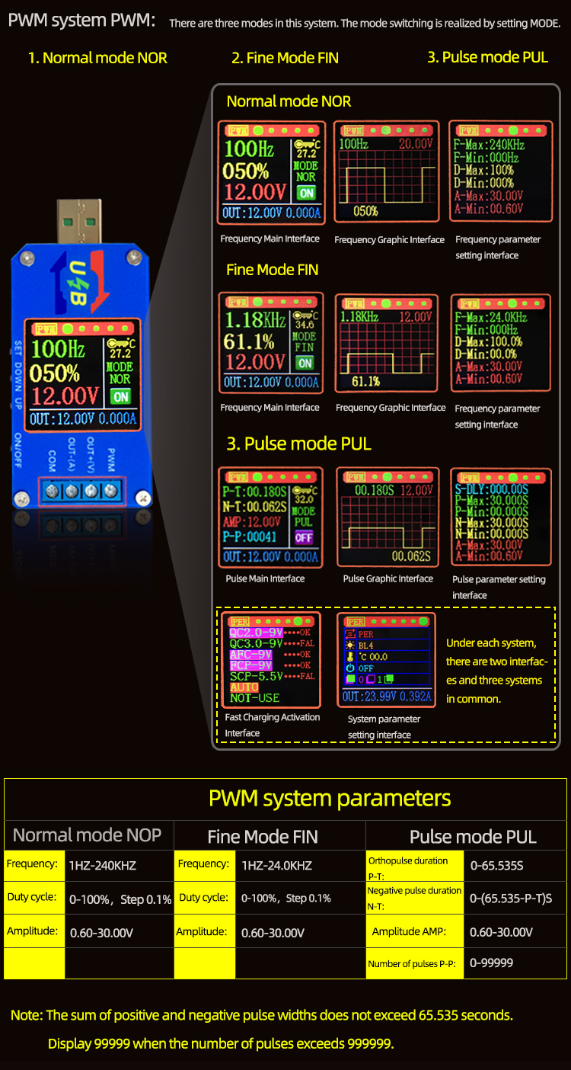
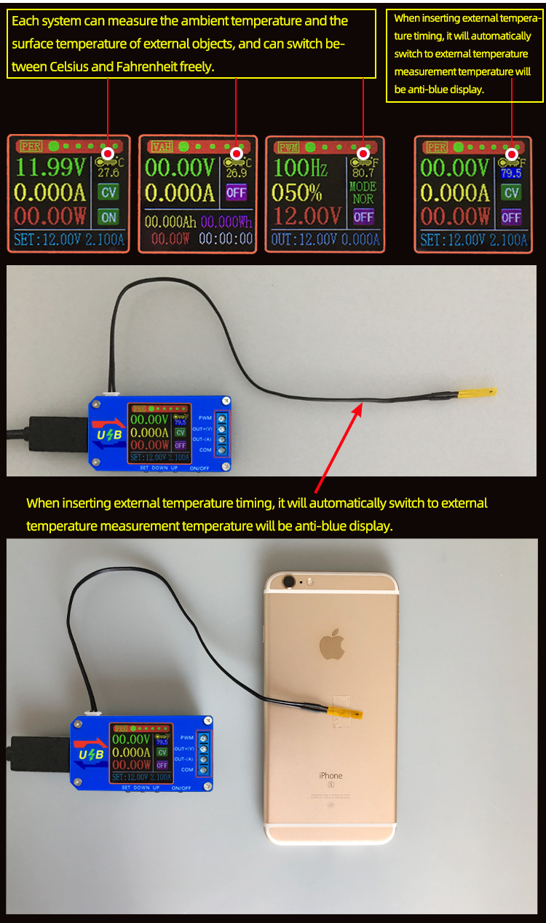
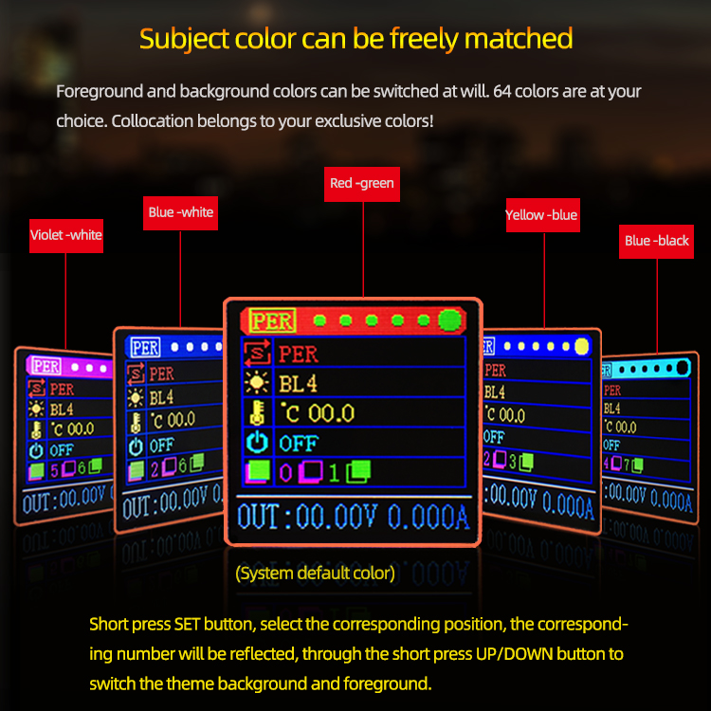
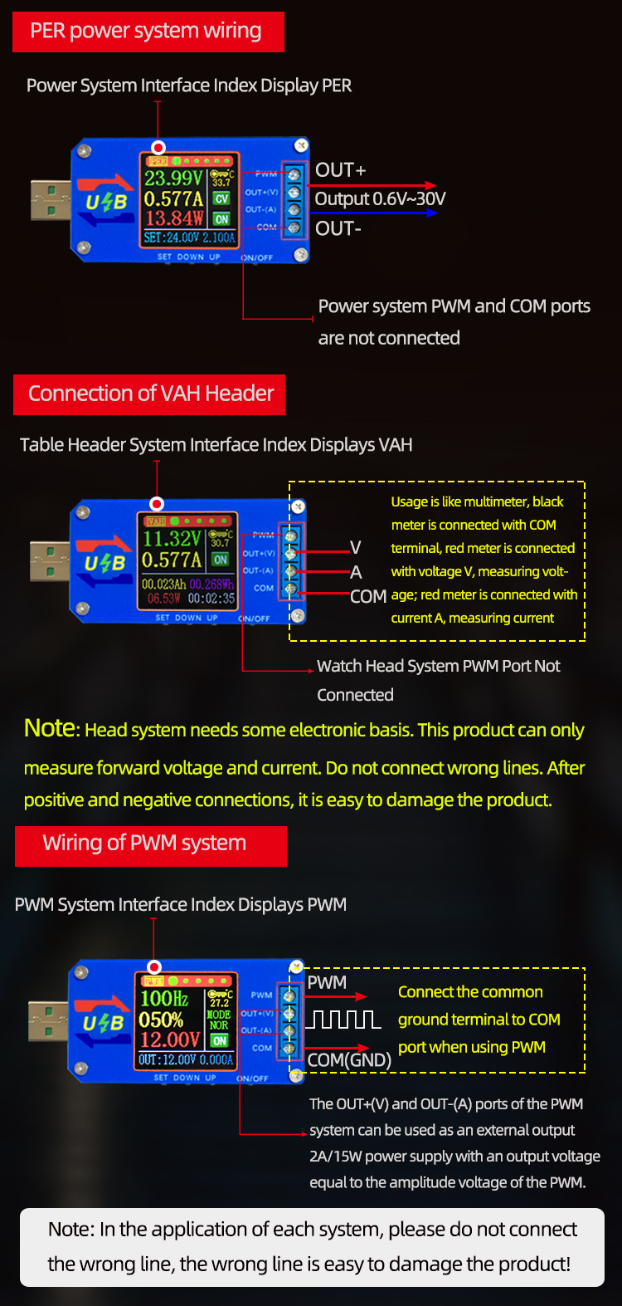

Application:

Power System (PER):
1. As a common boost-and-drop power supply with over-voltage/over-current/over-power/over-temperature/under-voltage protection;
2. The product has constant current function and can charge all kinds of small rechargeable batteries within 0.6V-30V within 15W.
Charging step:
(1) Determine the floating charge voltage and current of your rechargeable battery; (If the lithium battery parameter is 3.7V/2200mAh, the floating charge voltage is 4.2V, if it is 12V rechargeable battery, the floating charge voltage is generally set to about 14V)
(2) Under no-load condition, set the output voltage to reach floating charge voltage; (If charging 3.7V lithium battery, adjust the output voltage to 4.2V only)
(3) Set charging current (constant current value) and set current directly. Note: When setting the current, the power should be calculated, charged within the power range, and the product will enter a protective state if it is used with super power.
(4) Connect the battery to charge.

Application:

Power System (PER):
1. As a common boost-and-drop power supply with over-voltage/over-current/over-power/over-temperature/under-voltage protection;
2. The product has constant current function and can charge all kinds of small rechargeable batteries within 0.6V-30V within 15W.
Charging step:
(1) Determine the floating charge voltage and current of your rechargeable battery; (If the lithium battery parameter is 3.7V/2200mAh, the floating charge voltage is 4.2V, if it is 12V rechargeable battery, the floating charge voltage is generally set to about 14V)
(2) Under no-load condition, set the output voltage to reach floating charge voltage; (If charging 3.7V lithium battery, adjust the output voltage to 4.2V only)
(3) Set charging current (constant current value) and set current directly. Note: When setting the current, the power should be calculated, charged within the power range, and the product will enter a protective state if it is used with super power.
(4) Connect the battery to charge. 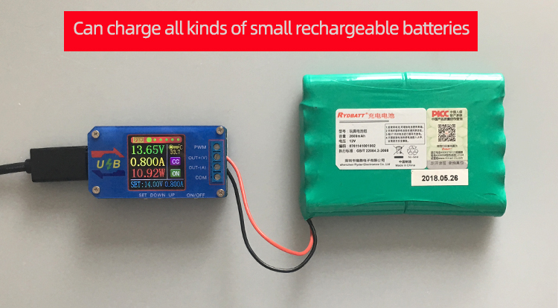
3. This product has constant current function, can directly drive 0.6-30V, 0-15W LED lamp;
Step of driving LED lamp:
(1) Determine the working current and maximum operating voltage of the LED you need to drive.
(2) Under no-load condition, set the voltage and current values to make the output voltage reach the maximum working voltage and working current of the LED.
(3) Connect the LED and test it.
This product can adjust the constant current value (between 0 and working current) to achieve LED polar dimming, no stroboscopic!! 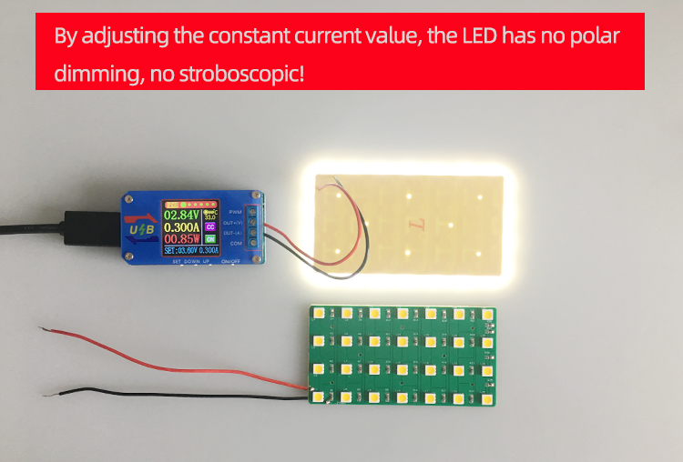

Table Header System (VAH):
1. Like multimeter, it can measure forward voltage and current. It can measure power, capacity, energy and time. It can be used for battery charging and discharging measurement and high precision Coulometer. 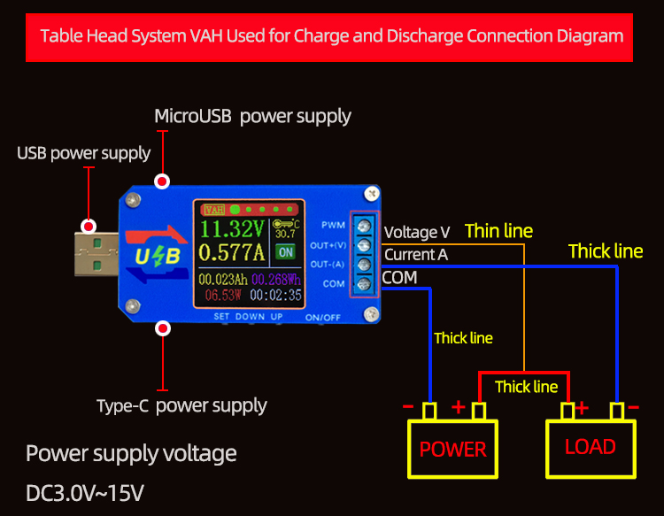 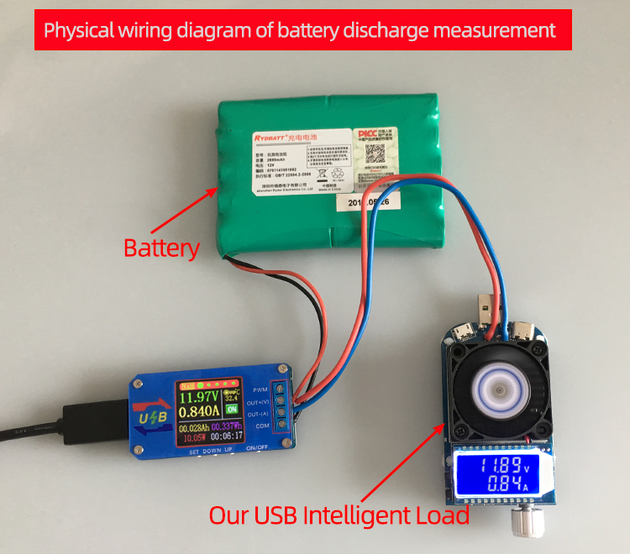
PWM system (PWM):
1. Used as square wave signal generator and pulse signal generator to generate square wave pulse signal for experimental development and debugging.
2. Square wave signal used to control DC motor or stepper motor driver; Servo motor, stepper motor, electric clamp, instead of PLC pulse, etc.
3. Generating adjustable pulse, matching driver to realize dimming, speed regulating, controlling solenoid valve, etc.
Note: PWM system is only the output signal, and can not directly drive power loads such as electric lamps, motors, solenoid valves.

Detailed Explanation of Interface and Key Function

Power System PER

Shortly press the ON/OFF button, turn on and off the power output, and long press the ON/OFF button for 2 seconds. The screen can rotate 360 degrees in four directions.
Short press the `UP/DOWN'button to turn the page.

Main interface of power supply: 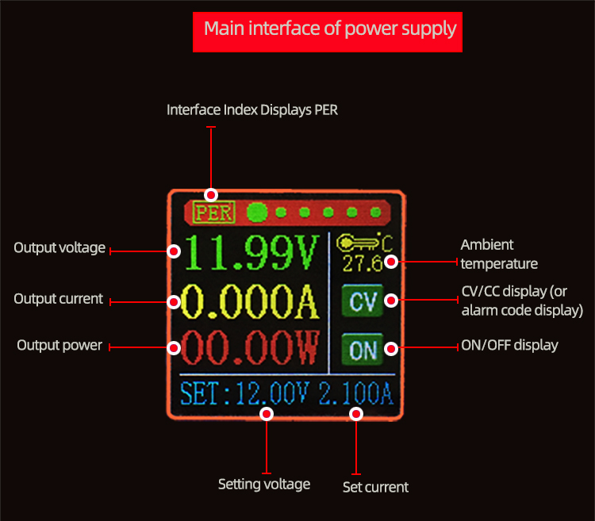
Press the'SET'button to activate the parameters (voltage/current) to be set.
The switch between full selection and bit selection is realized by pressing the'SET'button.
After full selection, all anti-blue display will be displayed, and the setting voltage/setting current will be switched by the'UP/DOWN'button.
After bit selection, the corresponding bit will be displayed in reverse blue. The parameters are set by the'UP/DOWN'button. The'UP/DOWN' button supports long press, and the long press increases/decreases the parameters rapidly.
When the settings are completed, press the'SET'button for 2 seconds or no key operation for more than 6 seconds will automatically exit the settings.
All parameters are saved automatically after exit.

Capacity Recording Interface: 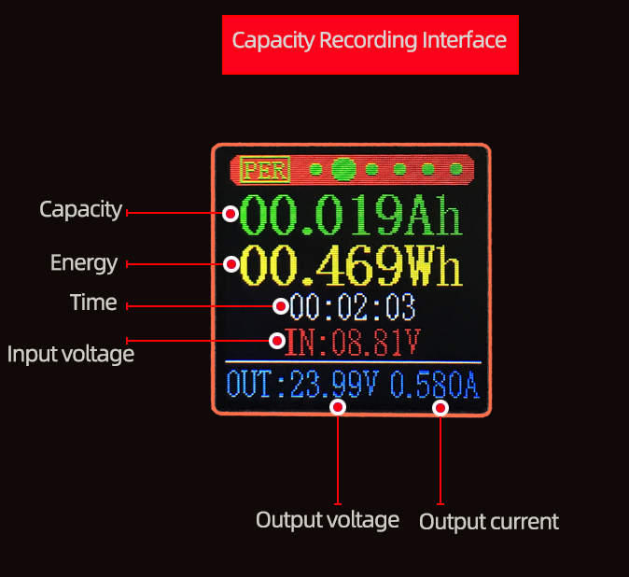
Shortly press the'SET'button, select the'capacity/energy/time', the corresponding anti-blue display after the full selection, switch the parameters to be cleared by the'UP/DOWN' button, and then press the'SET'button to clear the corresponding parameters; after the selection, press the'SET' button for 2 seconds or no key operation for more than 6 seconds will automatically exit. 。

Voltage and Current Curve Interface: 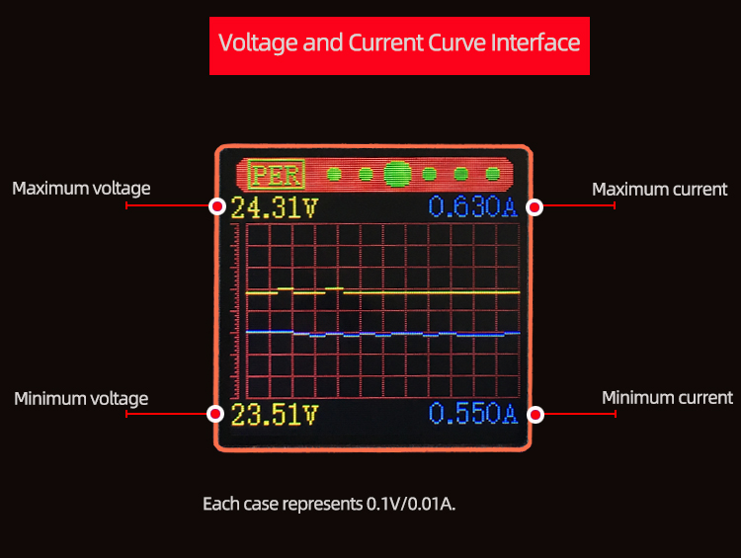

"SET" button has no function

Power parameter setting interface: 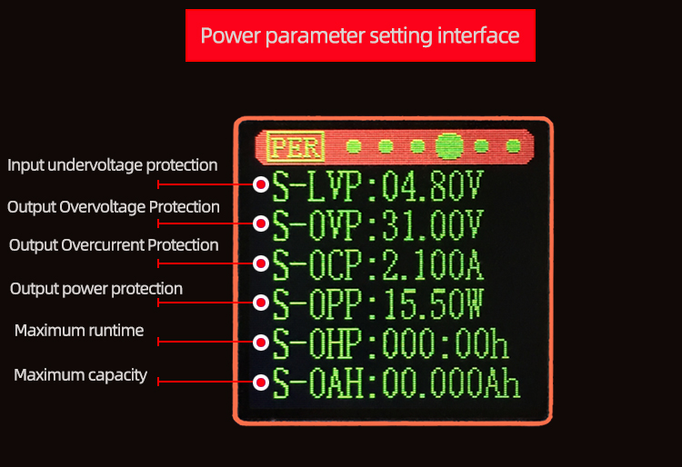
Press the'SET'button to activate the parameters to be set.
The switch between parameter name and bit selection is realized by pressing the'SET'button.
When the parameter name is selected, the parameter name will be displayed in reverse blue, and the parameters to be set will be switched by the ‘UP/DOWN'button.
After bit selection, the corresponding bit will be displayed in reverse blue. The parameters are set by the'UP/DOWN'button. The'UP/DOWN' button supports long press, and the long press increases/decreases the parameters rapidly.
When the settings are completed, press the'SET'button for 2 seconds or no key operation for more than 6 seconds will automatically exit the settings.
All parameters are saved automatically after exit.

Fast Charging Activation Interface: 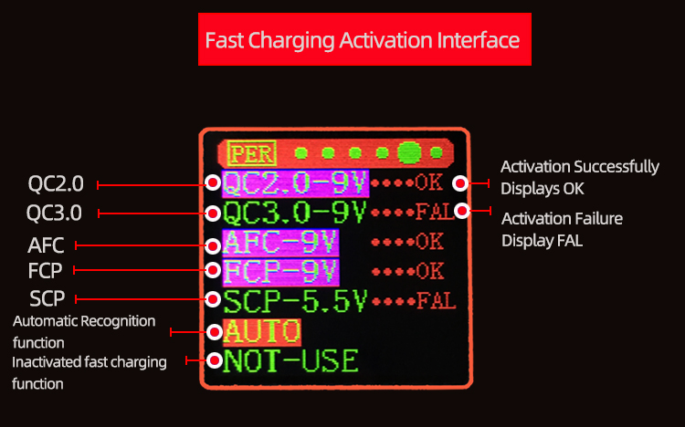

Shortly press the'SET'button, select the fast charging mode to activate, switch the fast charging mode to activate through the'UP/DOWN' button, the corresponding mode will be anti-blue display after selection; after selection, just press the'SET'button to activate the fast charging protocol; long press the'SET' button for 2 seconds or no button operation for more than 6 seconds will automatically exit the selection mode. After exit, it will save automatically and trigger the currently selected mode again.
AUTO function: Automatically detect the fast charging protocol supported by the current charging head, and the fast charging protocol will be marked with purple background color after detection.

System parameter setting interface: 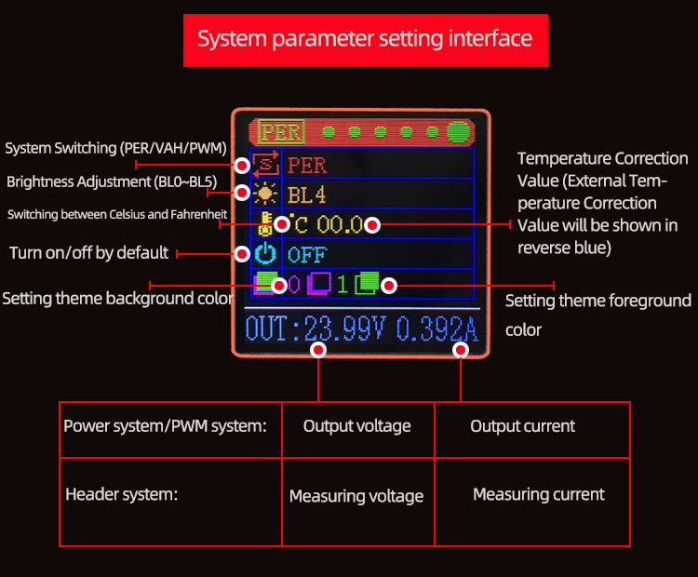
Shortly press the'SET'button and select/switch the parameters to be set. After selection, the parameters will be displayed in reverse green. The parameters will be set by the'UP/DOWN' button.
When the settings are completed, press the'SET'button for 2 seconds or no key operation for more than 6 seconds will automatically exit the settings.
All parameters are saved automatically after exit.

Table Header System VAH:

Shortly press the ON/OFF button, open and close the measurement, and long press the ON/OFF button for 2 seconds. The screen can rotate 360 degrees in four directions.
Short press the `UP/DOWN'button to turn the page.

Main measurement interface:

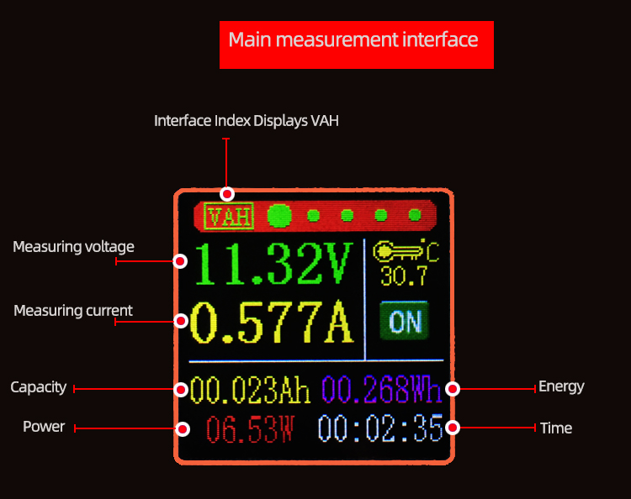
Keyboard operation is the same as PER'capacity recording interface'of power supply system.

Shortly press the'SET'button, select the'capacity/energy/time', the corresponding anti-blue display after the full selection, switch the parameters to be cleared by the'UP/DOWN' button, and then press the'SET'button to clear the corresponding parameters; after the selection, press the'SET' button for 2 seconds or no key operation for more than 6 seconds will automatically exit.

Measuring Curve Interface: 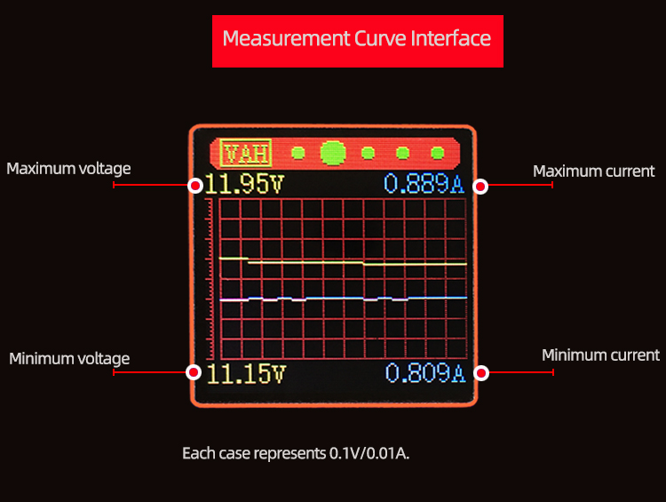
"SET" button has no function

Measurement parameter setting interface: 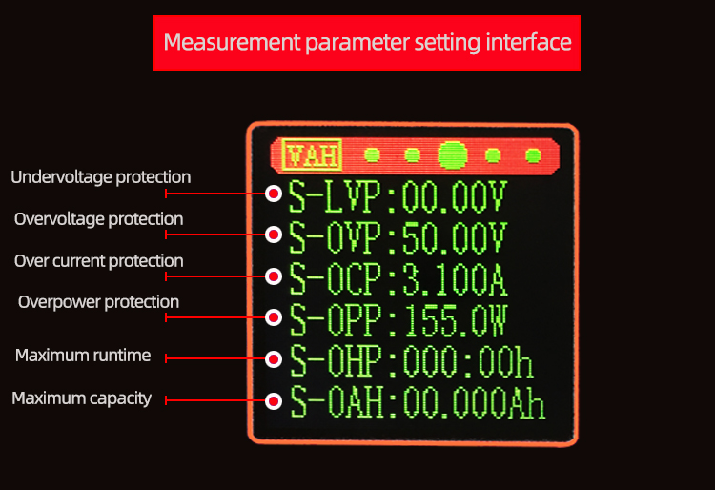

The key operation is the same as PER's power parameter setting interface'.

Press the'SET'button to activate the parameters to be set.
The switch between parameter name and bit selection is realized by pressing the'SET'button.
When the parameter name is selected, the parameter name will be displayed in reverse blue, and the parameters to be set will be switched by the `UP/DOWN'button.
After bit selection, the corresponding bit will be displayed in reverse blue. The parameters are set by the'UP/DOWN'button. The'UP/DOWN' button supports long press, and the long press increases/decreases the parameters rapidly.
When the settings are completed, press the'SET'button for 2 seconds or no key operation for more than 6 seconds will automatically exit the settings.
All parameters are saved automatically after exit.

PWM system PWM:

Shortly press the ON/OFF button, turn on and off the PWM output, and long press the ON/OFF button for 2 seconds. The screen can rotate 360 degrees in four directions.
Short press the `UP/DOWN'button to turn the page.

Frequency Main Interface: 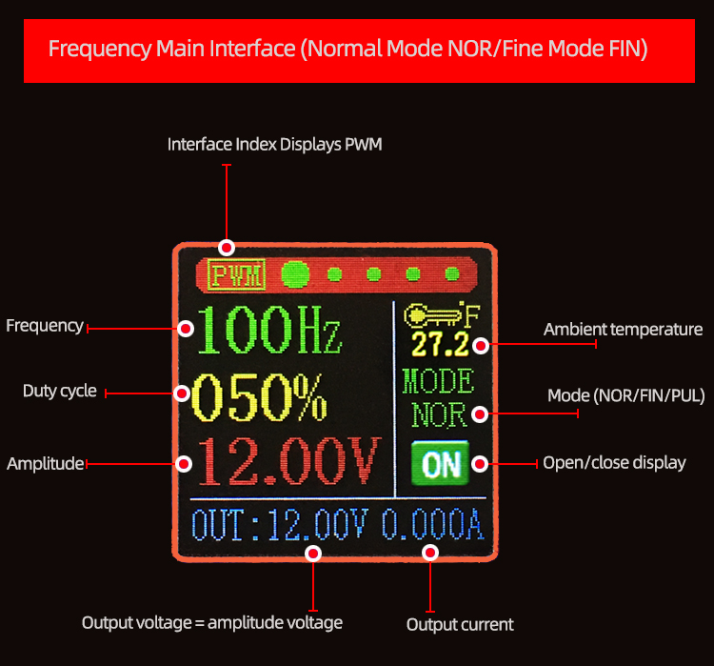

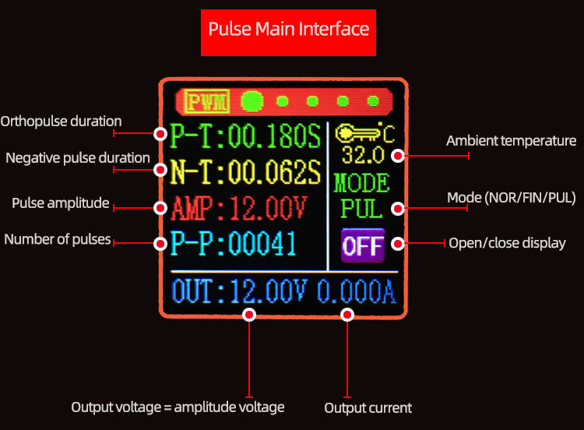
The operation of key press is the same as that of PER's main interface of power supply system.

Press the'SET'button to activate the parameters (frequency/duty cycle/amplitude/mode) to be set.
The switch between full selection and bit selection is realized by pressing the'SET'button.
After full selection, all anti-blue display will be displayed, and the parameters to be set will be switched by the'UP/DOWN'button.
After bit selection, the corresponding bit will be displayed in reverse blue. The parameters are set by the'UP/DOWN'button. The'UP/DOWN' button supports long press, and the long press increases/decreases the parameters rapidly.
When the settings are completed, press the'SET'button for 2 seconds or no key operation for more than 6 seconds will automatically exit the settings.
All parameters are saved automatically after exit.

Frequency parameter setting interface: 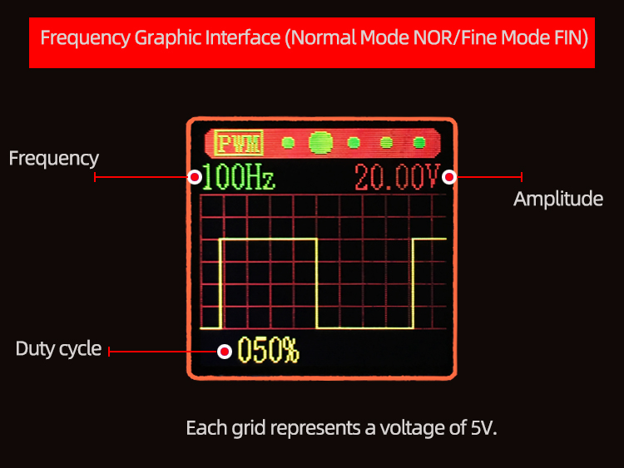

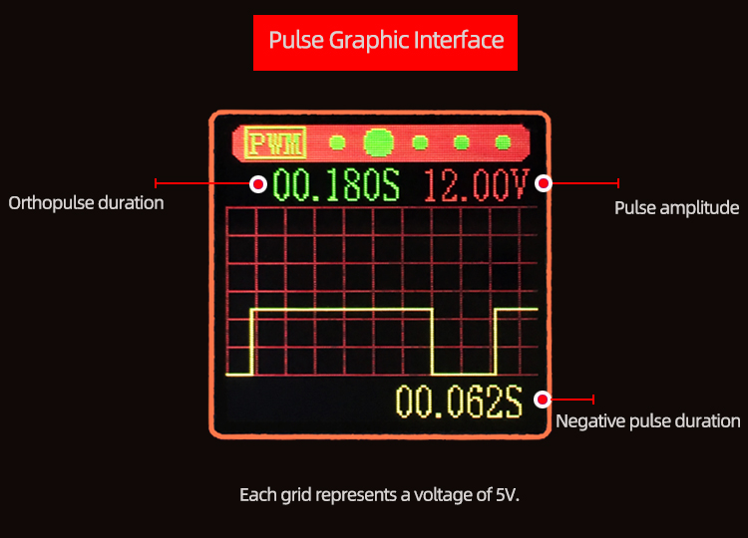
The operation of key press is the same as that of PER's main interface of power supply system.
Frequency parameter setting interface: 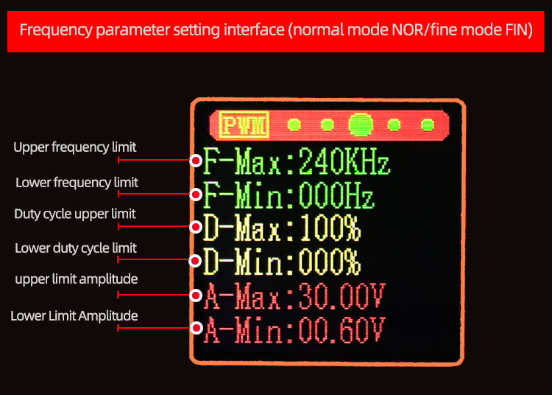
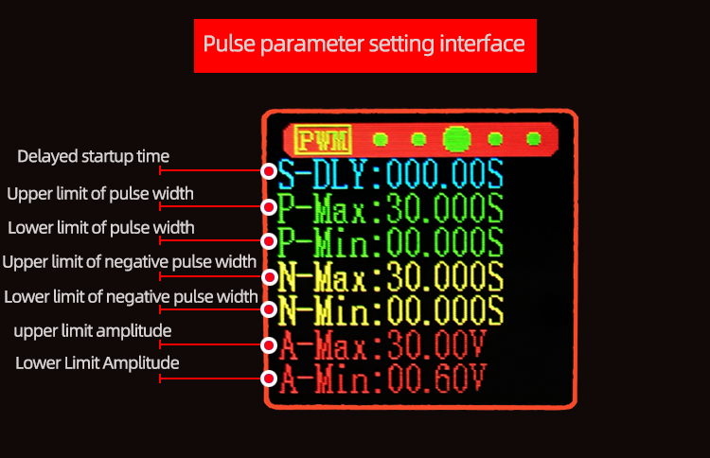
The key operation is the same as PER's power parameter setting interface'.

Press the'SET'button to activate the parameters to be set.
The switch between parameter name and bit selection is realized by pressing the'SET'button.
When the parameter name is selected, the parameter name will be displayed in reverse blue, and the parameters to be set will be switched by the `UP/DOWN'button.
After bit selection, the corresponding bit will be displayed in reverse blue. The parameters are set by the'UP/DOWN'button. The'UP/DOWN' button supports long press, and the long press increases/decreases the parameters rapidly.
When the settings are completed, press the'SET'button for 2 seconds or no key operation for more than 6 seconds will automatically exit the settings.
All parameters are saved automatically after exit.

Fine mode FIN and pulse mode PUL button operation are the same as normal mode NOR button operation.
