Please note: This kit is available in 4 colors. If you buy a color model, please solder the LED according to the correct position, Y for yellow LED, G for green LED, R for red LED, if you are buying monochrome , LED welding can be free
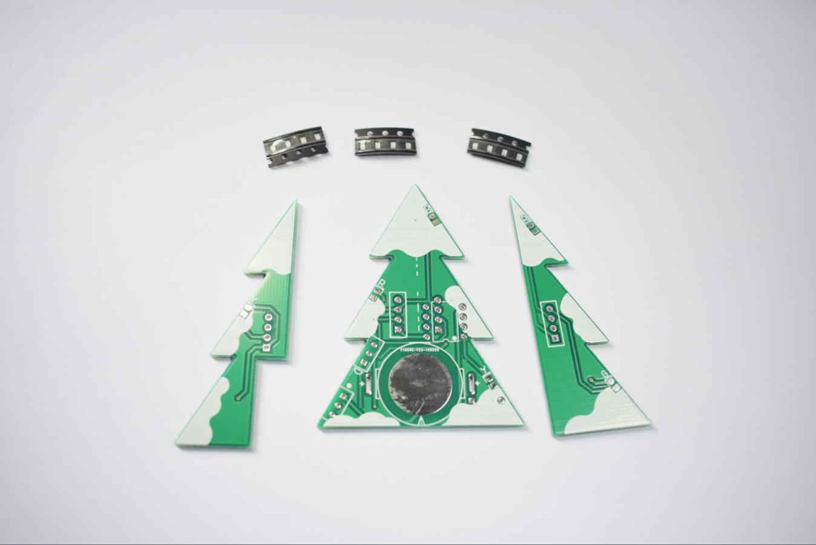
1. Solder the LED, please pay attention to the welding direction of the LED. The green dot on the LED corresponds to the end of the letter package.


1. LED soldering as shown below


- Soldering resistors and triodes, R1-R4: 470Ω (471), R5: 4.7K (472), Q1: 9012 (2T1)
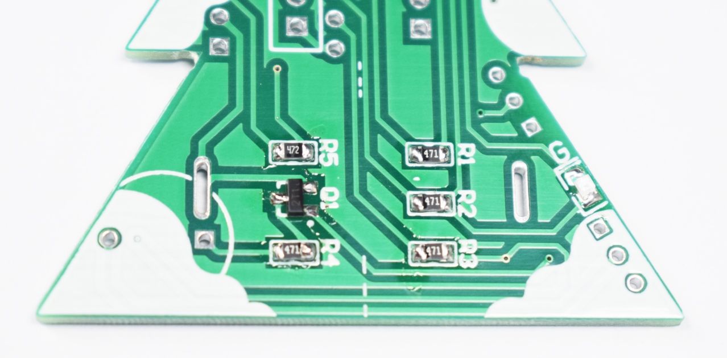

- Soldering IC and toggle switch
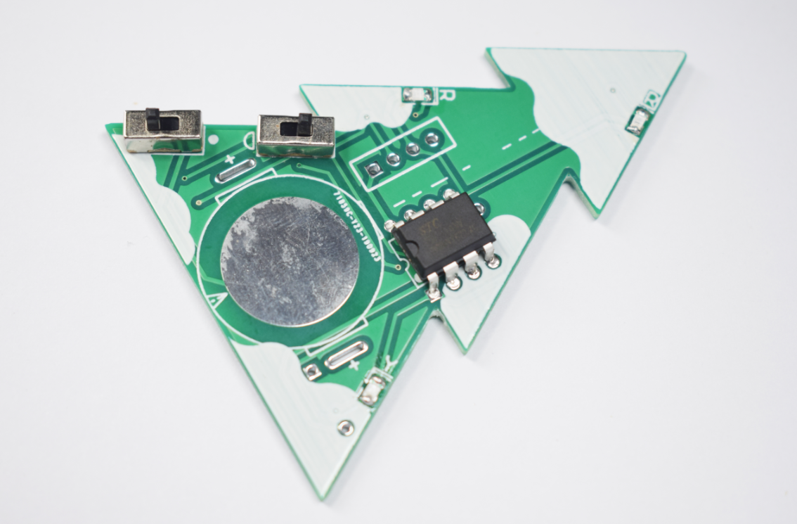
Power switch
Buzzer switch

3. Solder the battery holder, please pay attention to the direction of the battery holder, insert the welding as shown below
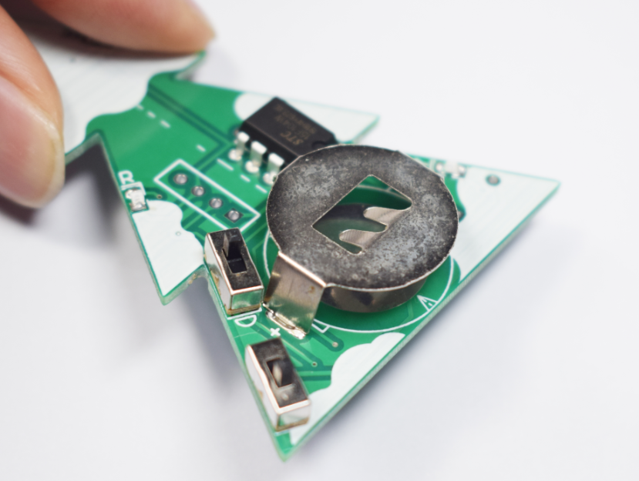

4. Solder the buzzer, the positive side of the buzzer corresponds to the square pad
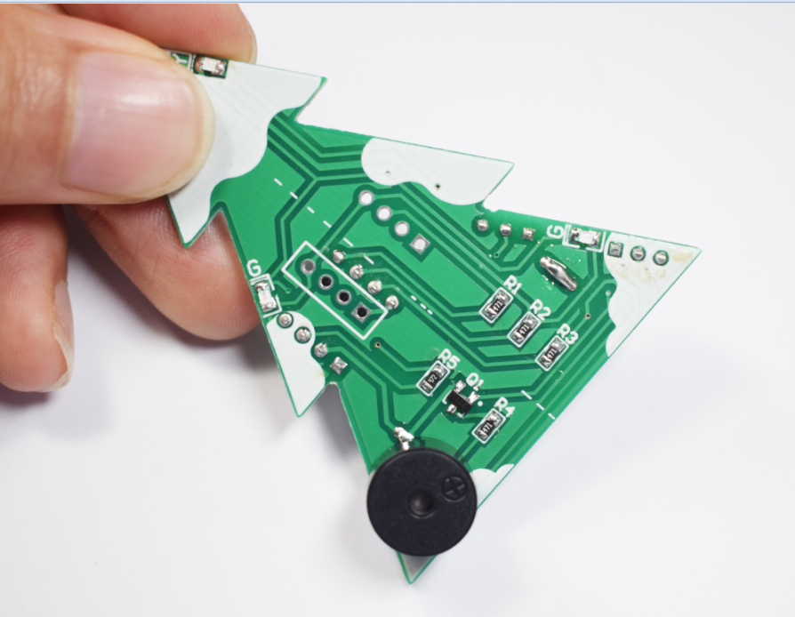
5. Solder pin headers, please note that the pin headers are soldered to the patterned side of the PCB.
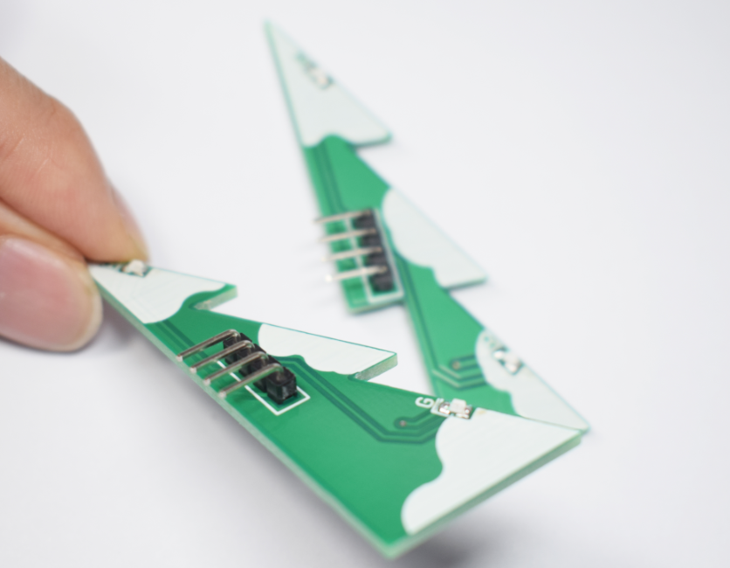
6.The three boards are combined as shown below
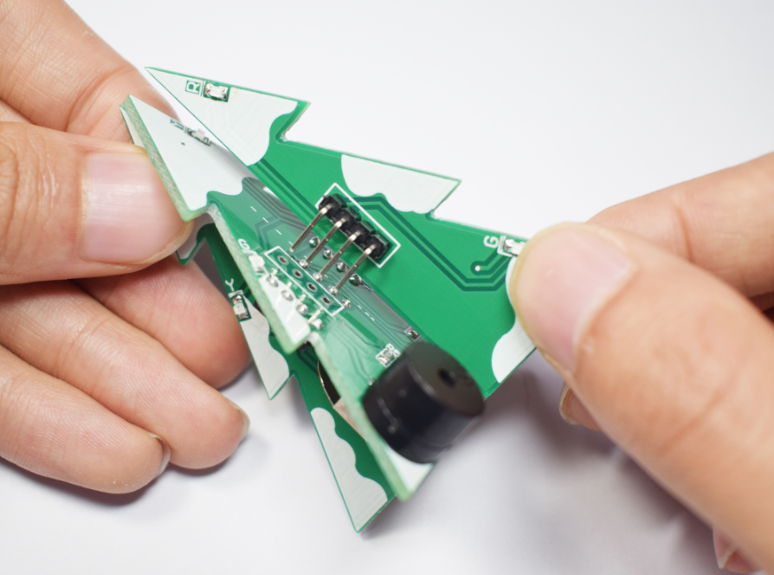

7.After installation, as shown below


Load 2 CR2032 button batteries to work


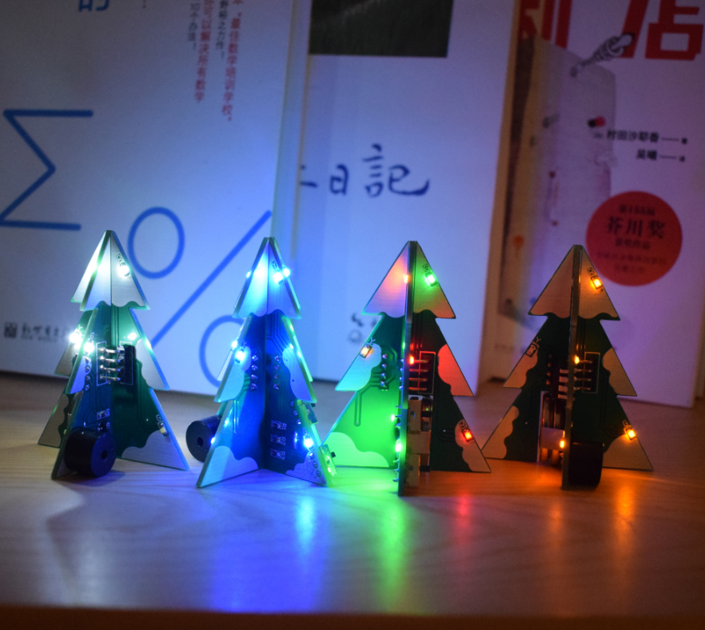
Features:
Mini stereo PCB Christmas tree design;
3 different PCB combinations with snowflake patterns;
7 different Christmas songs (see the list of songs for details);
7 kinds of LED gradient effects;
The switch powers up automatically to switch between different LED blink modes and different Christmas melody;
Can be set to turn music on or off;
Powered by two CR2032 coin cell batteries;
Available in a variety of colors: color, white, blue, yellow;
PCB size: 49mm x 63mm;
(Note: The production process is in the description!)
Song list:
1, I wish you a merry Christmas;
2. Santa Claus Is Coming To Town;
3. When a child is born;
4, O Christmas Tree;
5. It Came Upon A Midnight Clear;
6, Joy To The World;
7, Jingle Bells;
Function:
1. Load two CR2032 button batteries to supply power;
2. Toggle the power switch to switch to the next mode and the next song;
3. Turn the music switch to turn off or turn on the Christmas music melody;

