Application:
1. As a common boost-and-drop power supply with
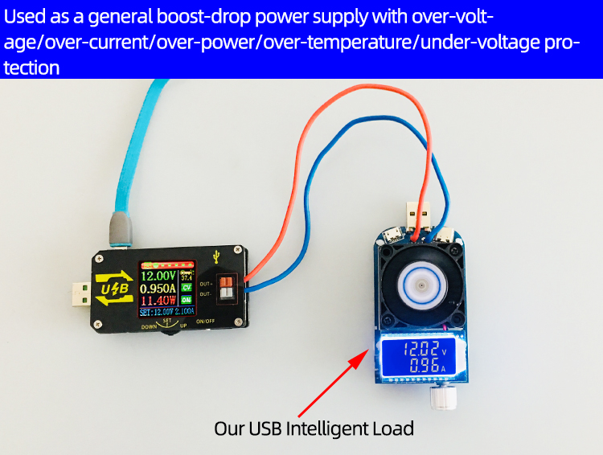
over-voltage/over-current/over-power/over-temperature/under-voltage protection;
2. The product has constant current function and can charge all kinds of small rechargeable batteries within 0.6V-30V within 15W.
Charging step:
(1) Determine the floating charge voltage and current of your rechargeable battery; (If the lithium battery parameter is 3.7V/2200mAh, the floating charge voltage is 4.2V, if it is 12V rechargeable battery, the floating charge voltage is generally set to about 14V)
(2) Under no-load condition, set the output voltage to reach floating charge voltage; (If charging 3.7V lithium battery, adjust the output voltage to 4.2V only)
(3) Set charging current (constant current value) and set current directly. Note: When setting the current, the power should be calculated, charged within the power range, and the product will enter a protective state if it is used with super power.
(4) Connect the battery to charge.
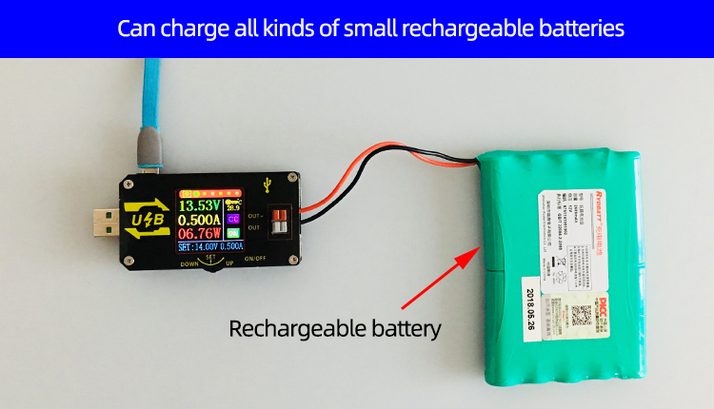
3. This product has constant current function, can directly drive 0.6-30V, 0-15W LED lamp;
Step of driving LED lamp:
(1) Determine the working current and maximum operating voltage of the LED you need to drive.
(2) Under no-load condition, set the voltage and current values to make the output voltage reach the maximum working voltage and working current of the LED.
(3) Connect the LED and test it.
This product can adjust the constant current value (between 0 and working current) to achieve LED polar dimming, no stroboscopic!!
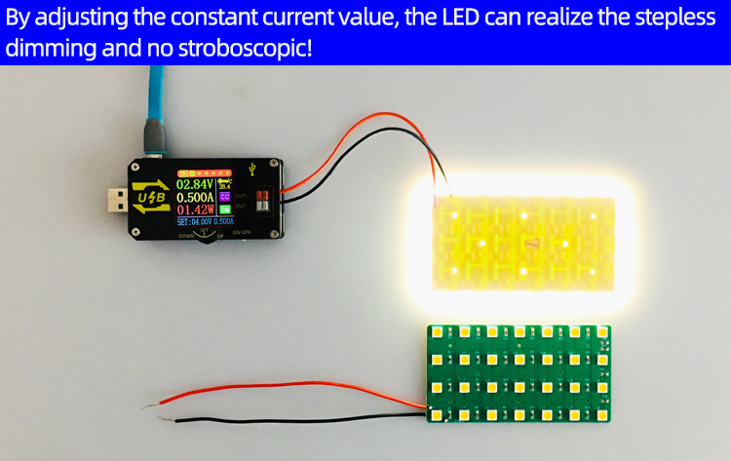

Main interface of power supply:
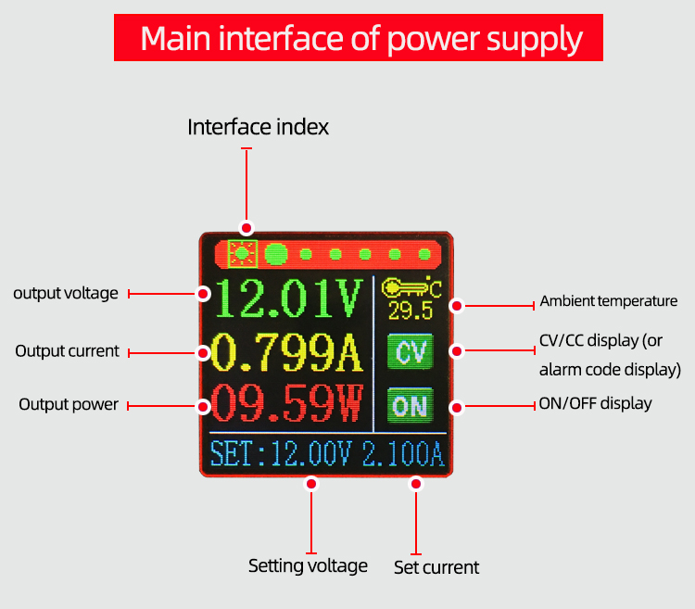
Press the'SET'button to activate the parameters (voltage/current) to be set.
The switch between full selection and bit selection is realized by pressing the'SET'button.
After full selection, all anti-blue display will be displayed, and the setting voltage/setting current will be switched by the'UP/DOWN'button.
After bit selection, the corresponding bit will be displayed in reverse blue. The parameters are set by the'UP/DOWN'button. The'UP/DOWN' button supports long press, and the long press increases/decreases the parameters rapidly.
When the settings are completed, press the'SET'button for 2 seconds or no key operation for more than 6 seconds will automatically exit the settings.
All parameters are saved automatically after exit.

Capacity Recording Interface:
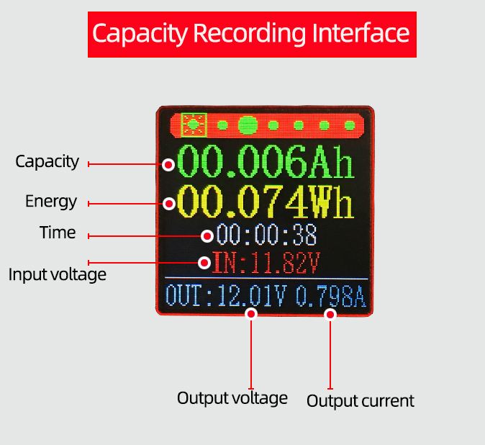
Shortly press the'SET'button, select the'capacity/energy/time', the corresponding anti-blue display after the full selection, switch the parameters to be cleared by the'UP/DOWN' button, and then press the'SET'button to clear the corresponding parameters; after the selection, press the'SET' button for 2 seconds or no key operation for more than 6 seconds will automatically exit. 。

Voltage and Current Curve Interface:
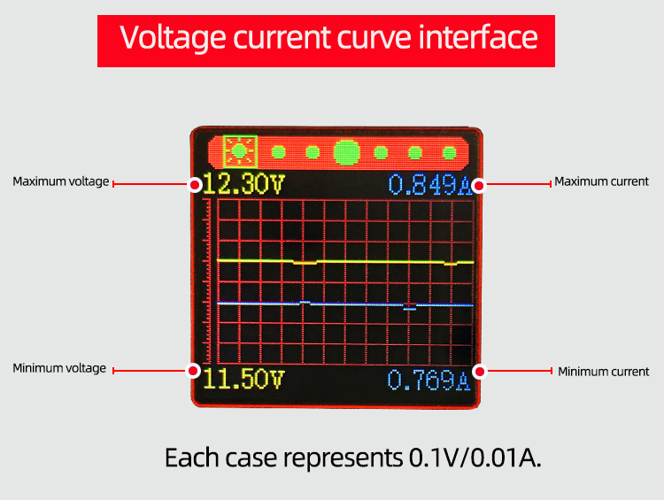

"SET" button has no function

Power parameter setting interface:
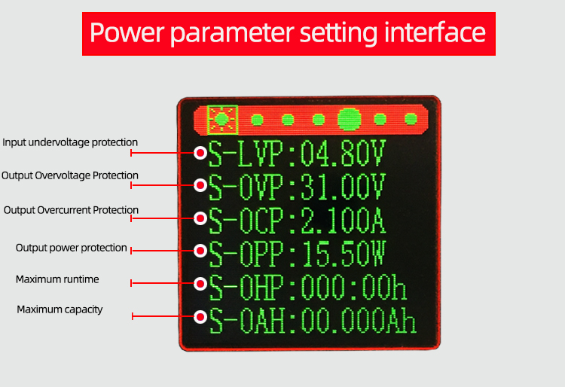
Press the'SET'button to activate the parameters to be set.
The switch between parameter name and bit selection is realized by pressing the'SET'button.
When the parameter name is selected, the parameter name will be displayed in reverse blue, and the parameters to be set will be switched by the ‘UP/DOWN'button.
After bit selection, the corresponding bit will be displayed in reverse blue. The parameters are set by the'UP/DOWN'button. The'UP/DOWN' button supports long press, and the long press increases/decreases the parameters rapidly.
When the settings are completed, press the'SET'button for 2 seconds or no key operation for more than 6 seconds will automatically exit the settings.
All parameters are saved automatically after exit.

Fast Charging Activation Interface:
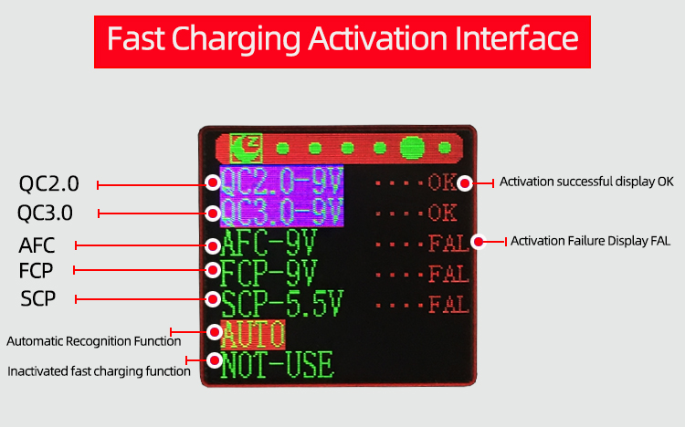

Shortly press the'SET'button, select the fast charging mode to activate, switch the fast charging mode to activate through the'UP/DOWN' button, the corresponding mode will be anti-blue display after selection; after selection, just press the'SET'button to activate the fast charging protocol; long press the'SET' button for 2 seconds or no button operation for more than 6 seconds will automatically exit the selection mode. After exit, it will save automatically and trigger the currently selected mode again.
AUTO function: Automatically detect the fast charging protocol supported by the current charging head, and the fast charging protocol will be marked with purple background color after detection.

System parameter setting interface:
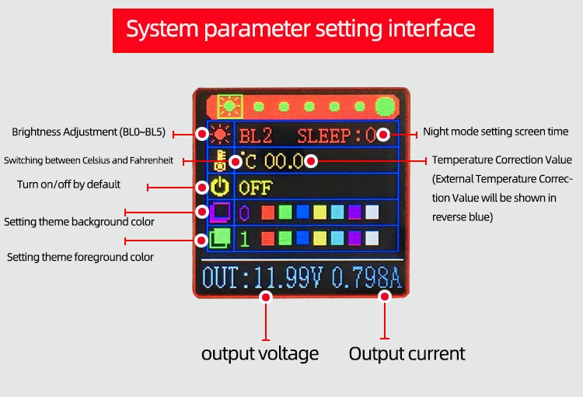
Shortly press the'SET'button and select/switch the parameters to be set. After selection, the parameters will be displayed in reverse green. The parameters will be set by the'UP/DOWN' button.
When the settings are completed, press the'SET'button for 2 seconds or no key operation for more than 6 seconds will automatically exit the settings.
All parameters are saved automatically after exit.

