Quick installation guide
WIFI Camera

General：
Thank you for purchasing our products.WiFi camera is the product that use industry-leading low power solutions.It supports two way audio,high resolution,night vision,control remotely.Welcome to use
Smart phone system requirements：Android 4.0 version and above, IOS10.0 version and above

Descriptions of device’s button:
Power on: （Reset to default）press”power”button for 2s.
Power off : (Reset to default)press”power”button for 2s.
Reset to default:press”reset”button for 6s.
Use the reset pin in the kit when operating
Device charging power: 5V2A

APP Installation
1
Android phone download method
Google play download Mycam


2
IOS APP download method
Visit Apple Store download Mycam



Please follow the above operation to obtain and install the mobile client APP.
APP Operation Display
Take android system for example, ios system is the same
After installing the APP, please register and log in to the account, the phone registration must select the correct area to receive the verification code.
1 Login Account: Register an account, login into the registration interface
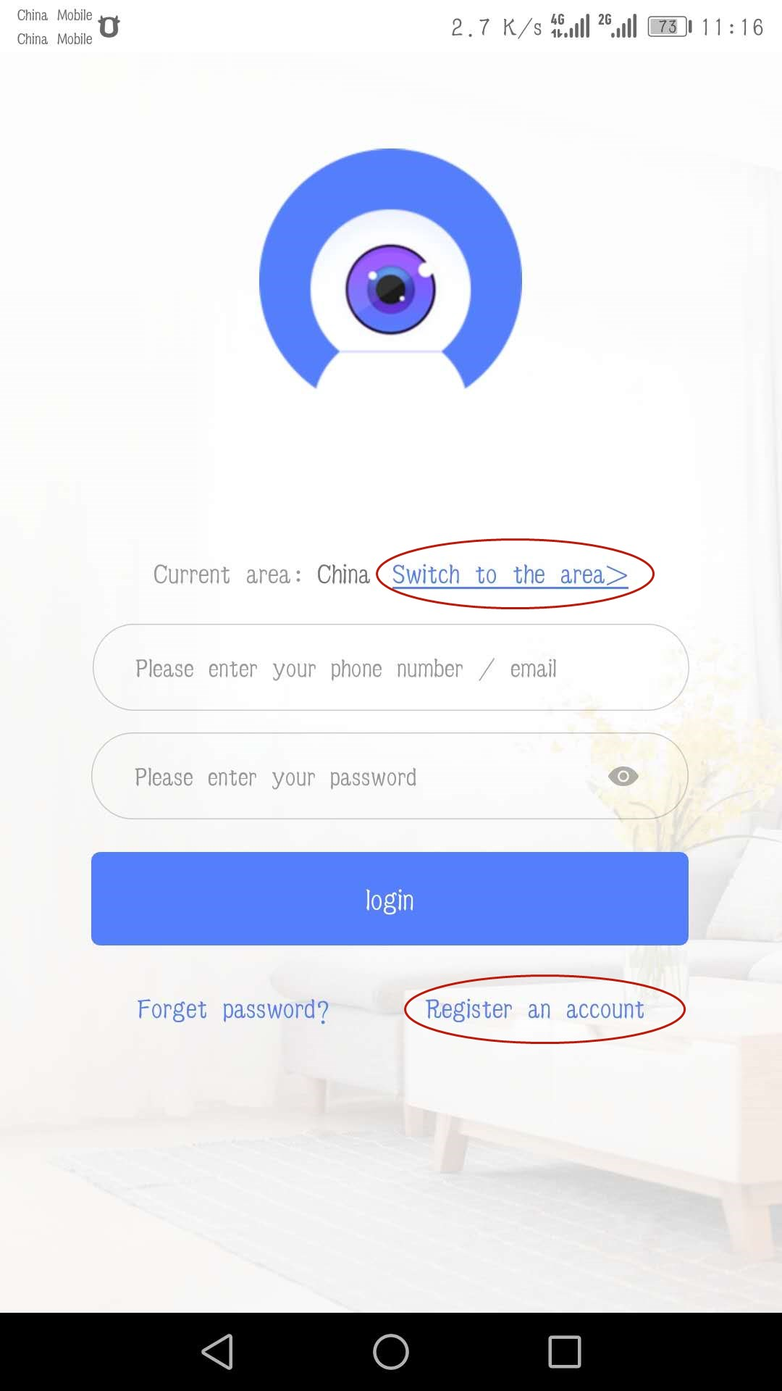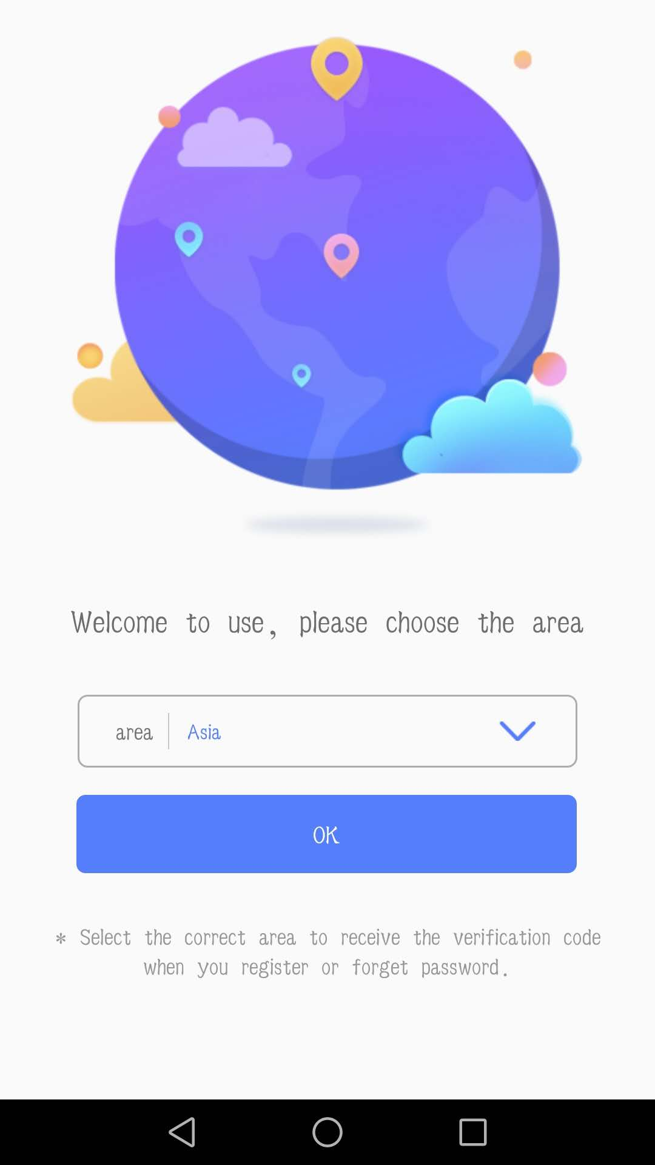

2 Register an account: Select the phone number or email to register
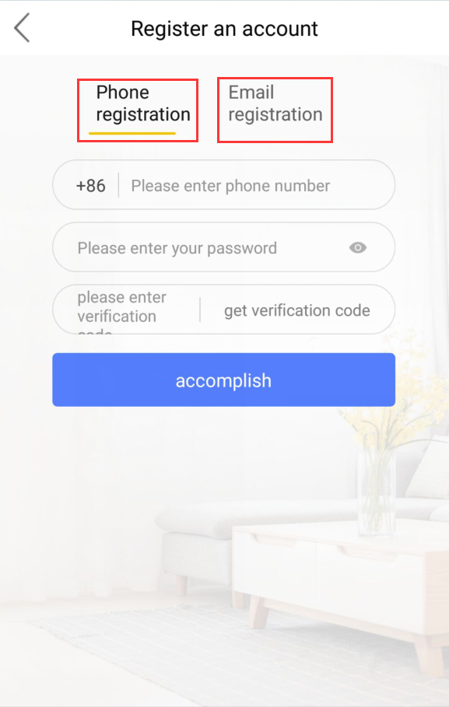
3 Login interface: input the account and the password, select login
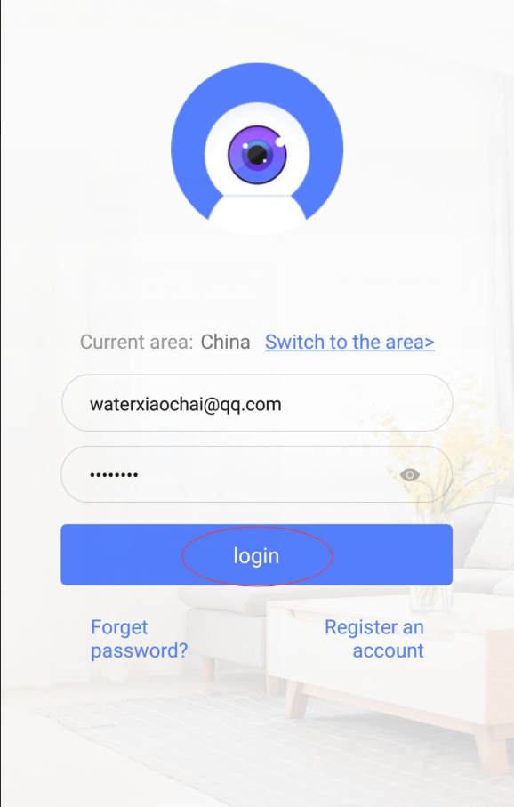
4 Device main interface: Click “+” to add a device in the right- upper cornerr

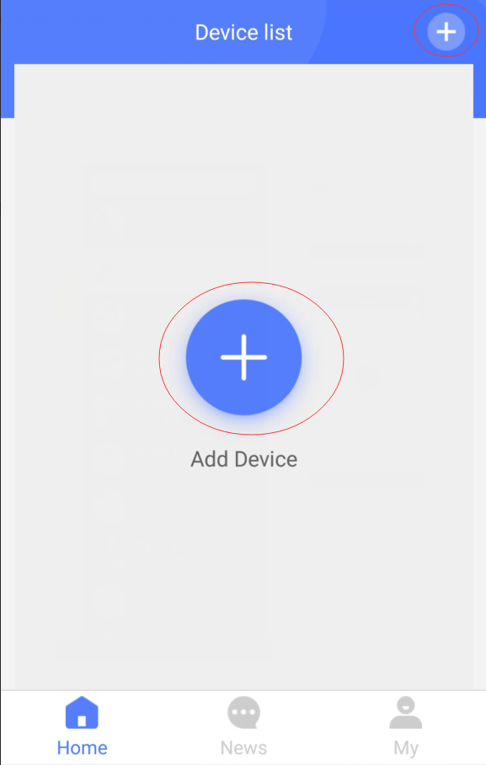

5 Add device: Select the"Wi-Fi Camera" type
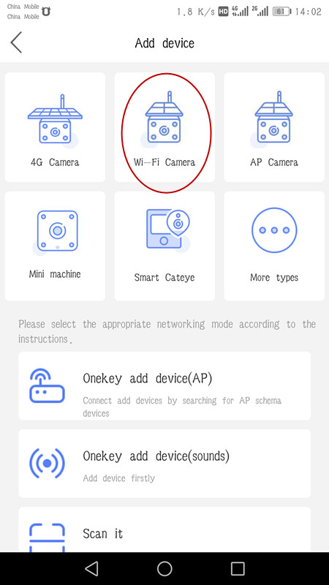
6 Press the reset button for 5 seconds according to the prompt, click "WIFI configurage"
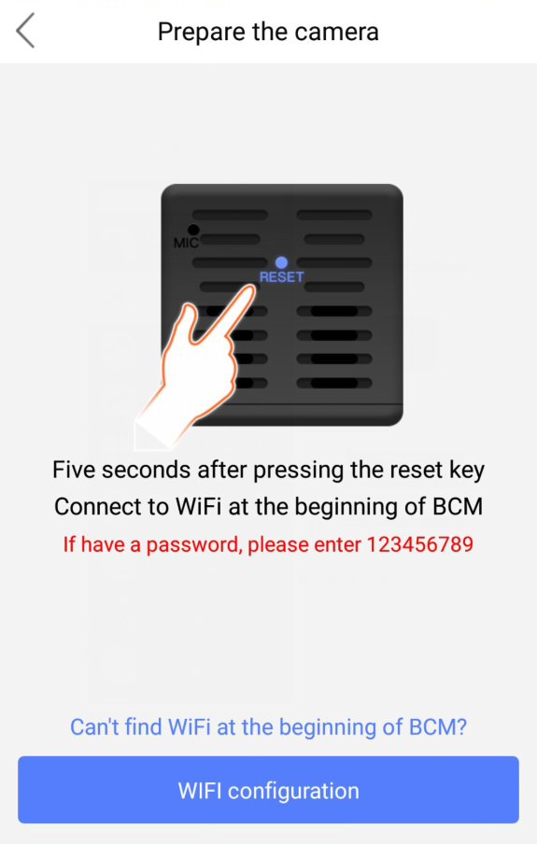
7 Select the network starting with "BCM"or"Mycam", then connection
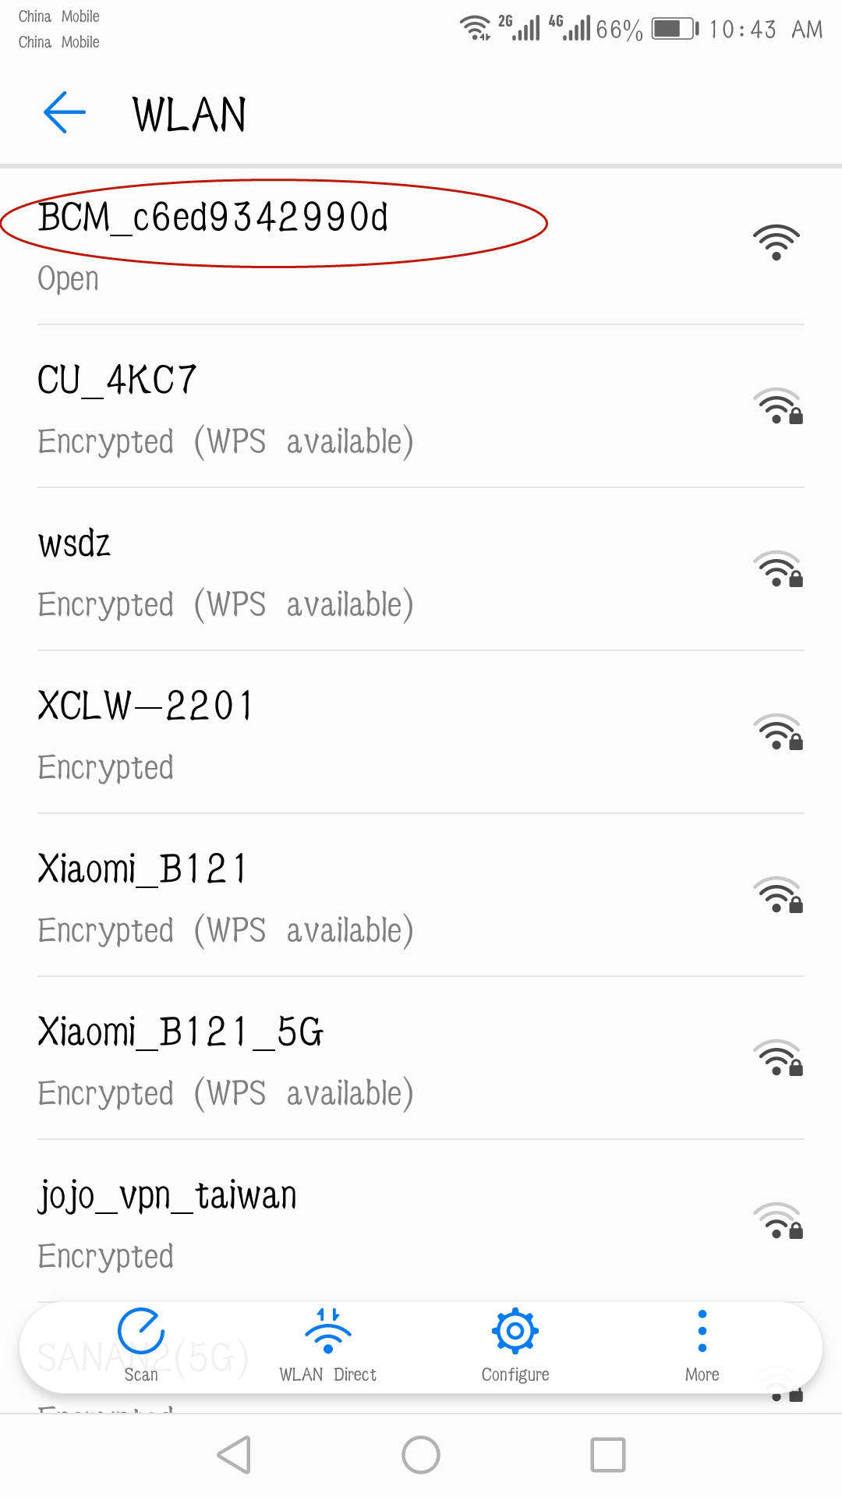

8 Return to the main APP page and Enter AP mode to watch the video page
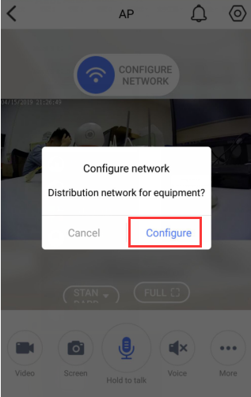
9 WIFI configure interface : choose the router which you want to connect and enter the name and the password
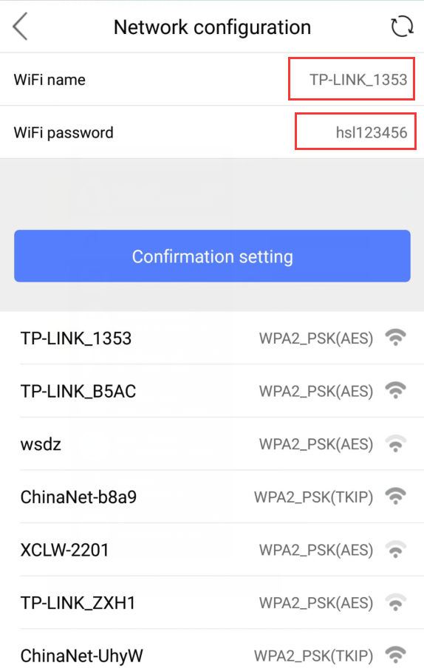

10 Jump to the network configuration page, After successful, it will automatically jump to the add success page.

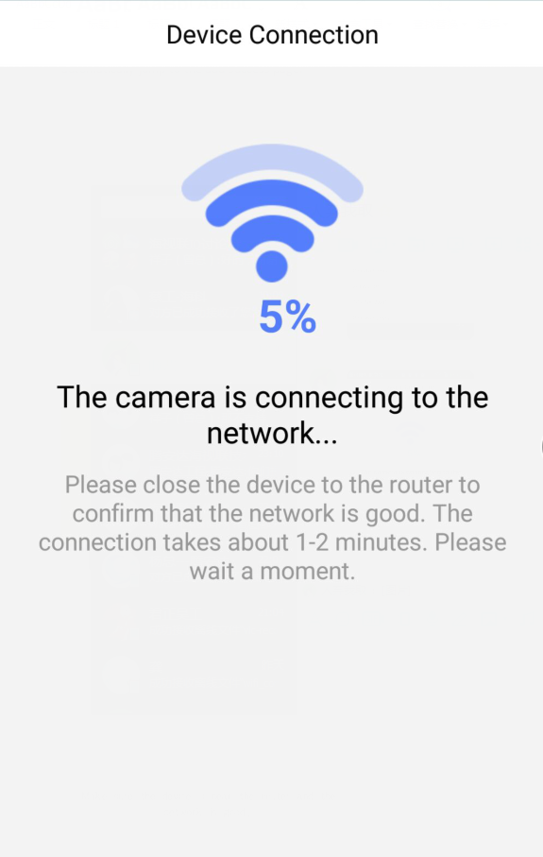
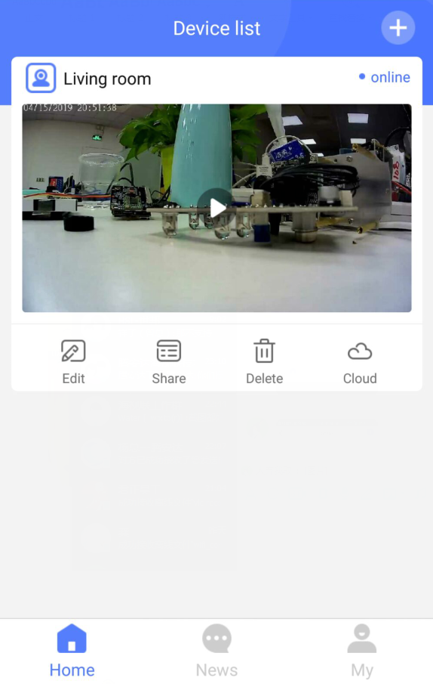
11 Edit the device’s name interface
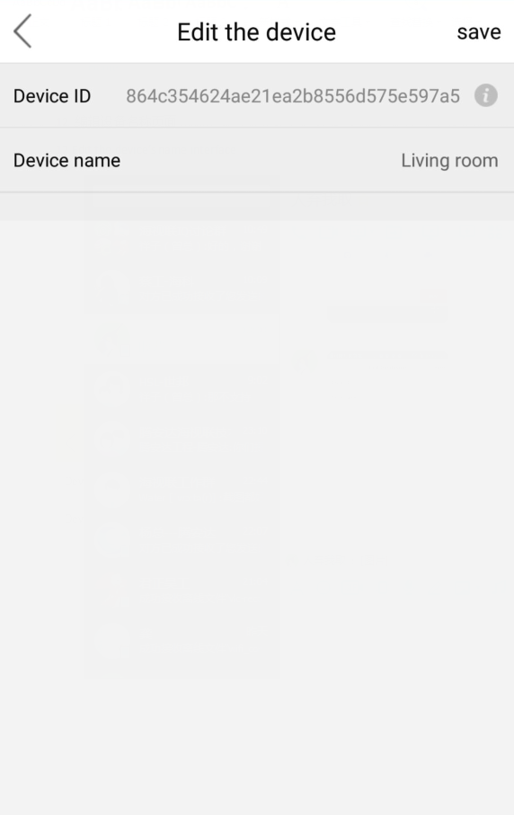
12 Share device interface
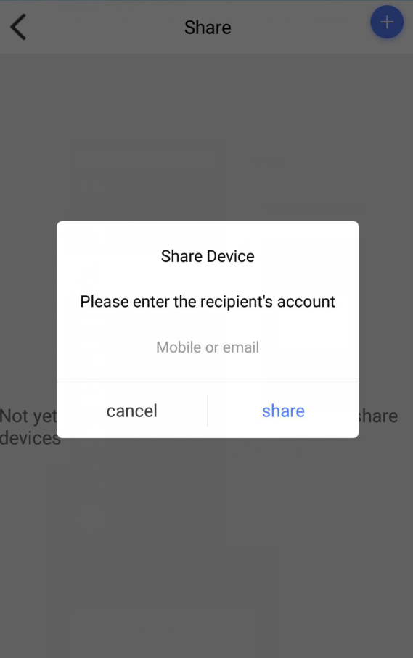
After sharing, the other person can click the “news” in the APP home page ，enter the system message, click the "agree", the device will appear in the other page list,Shared by users can only view video rights, can not set device parameters
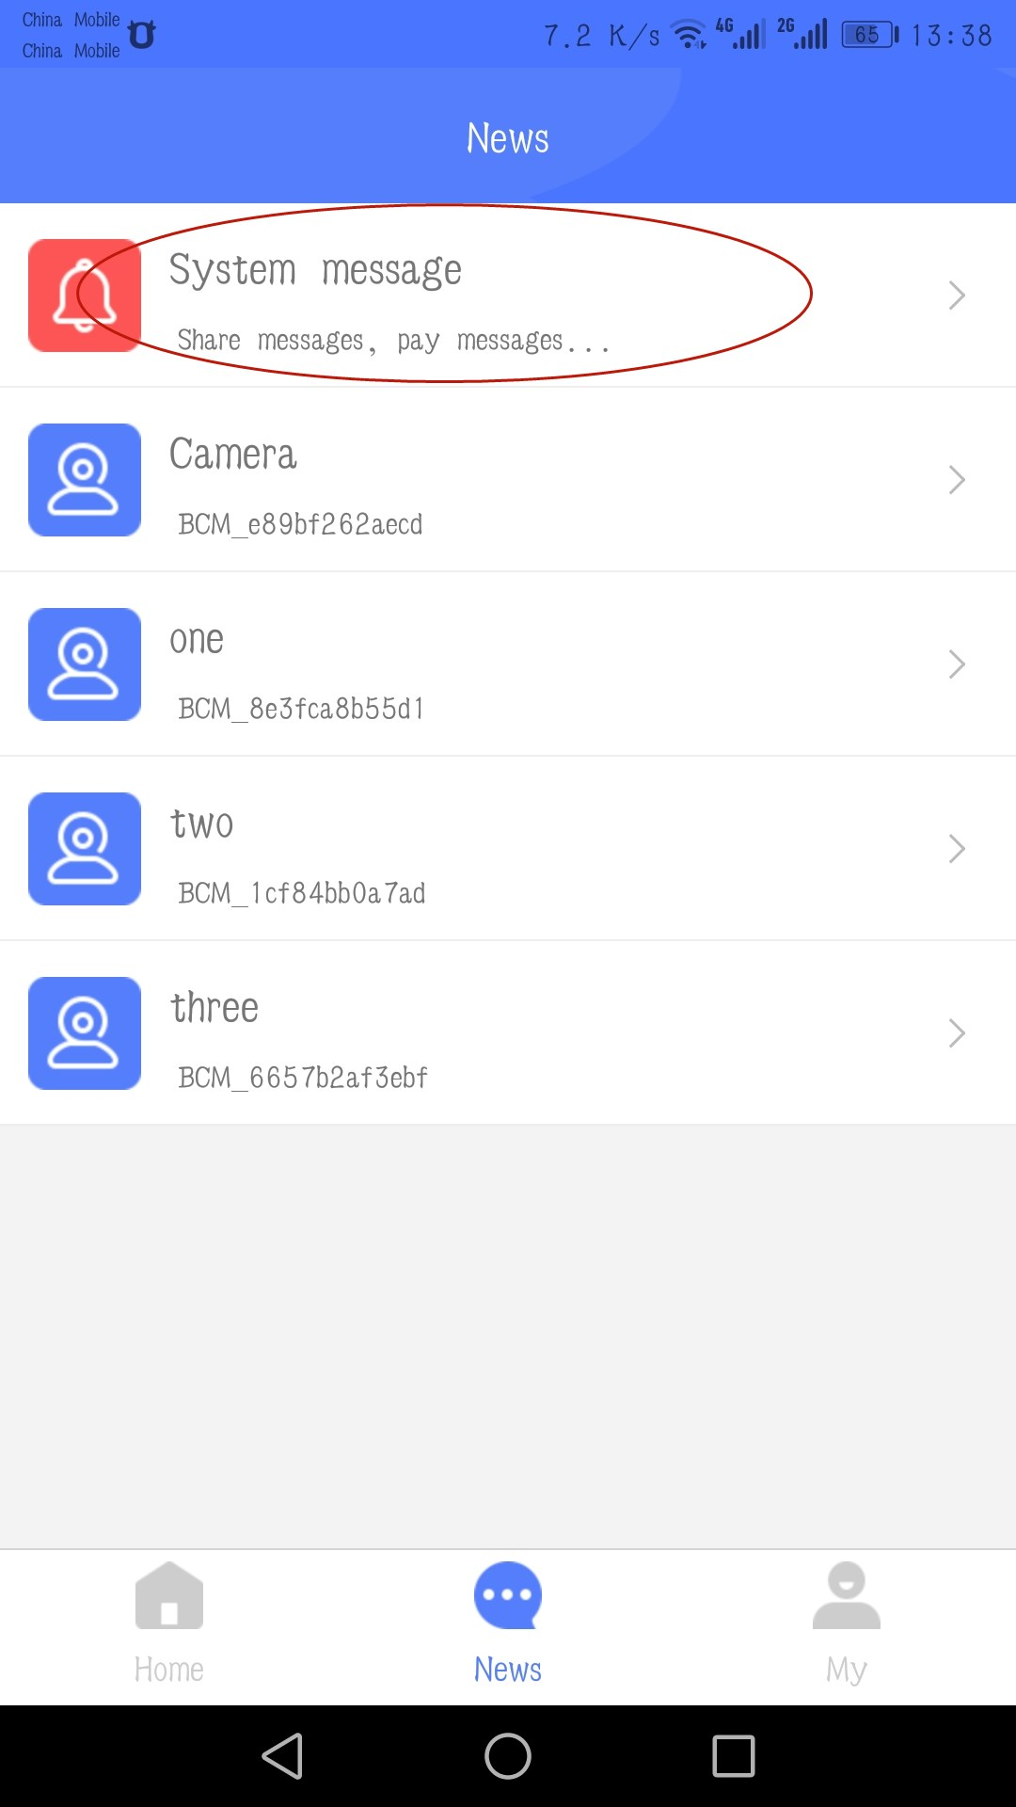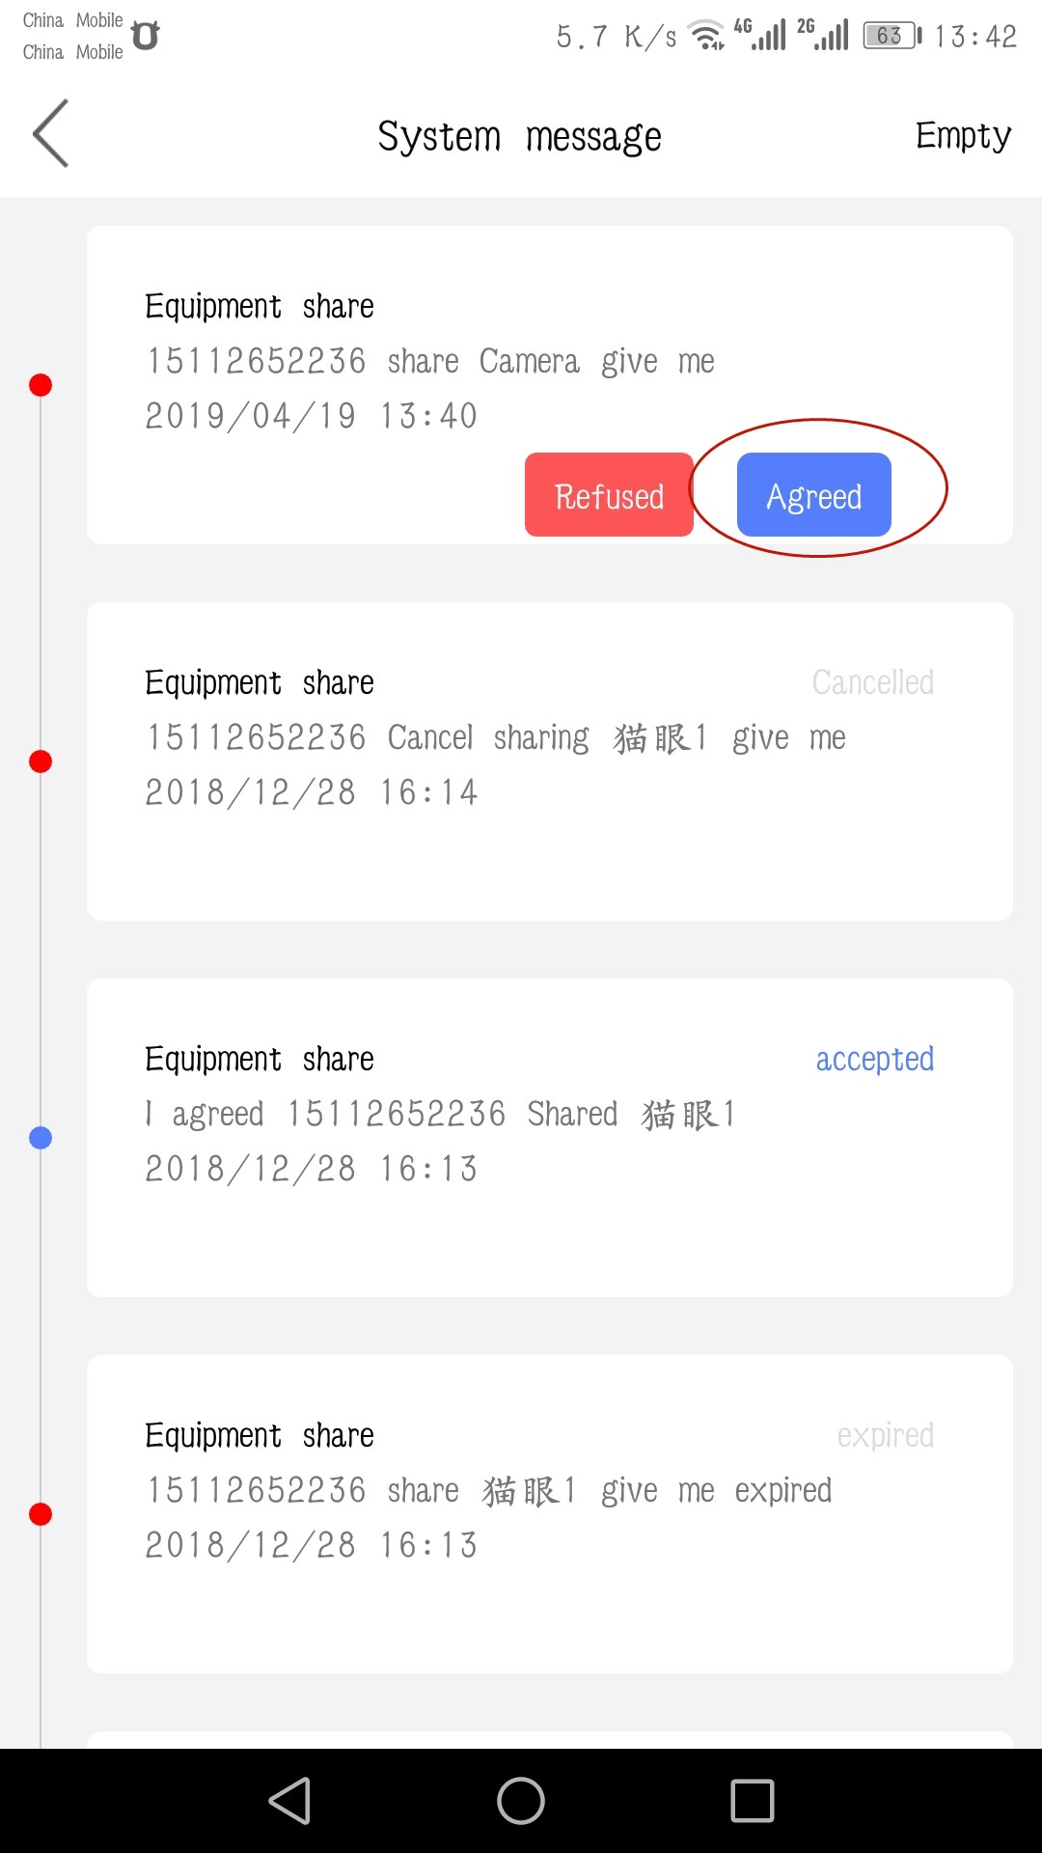

13 Cloud storage: Click to go to the cloud storage page and users can choose from a variety of packages for cloud storage
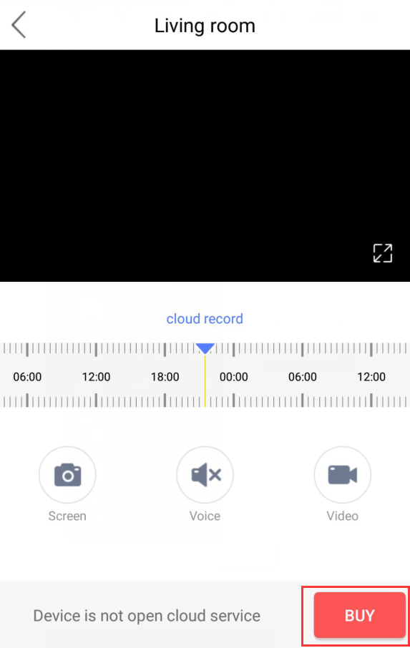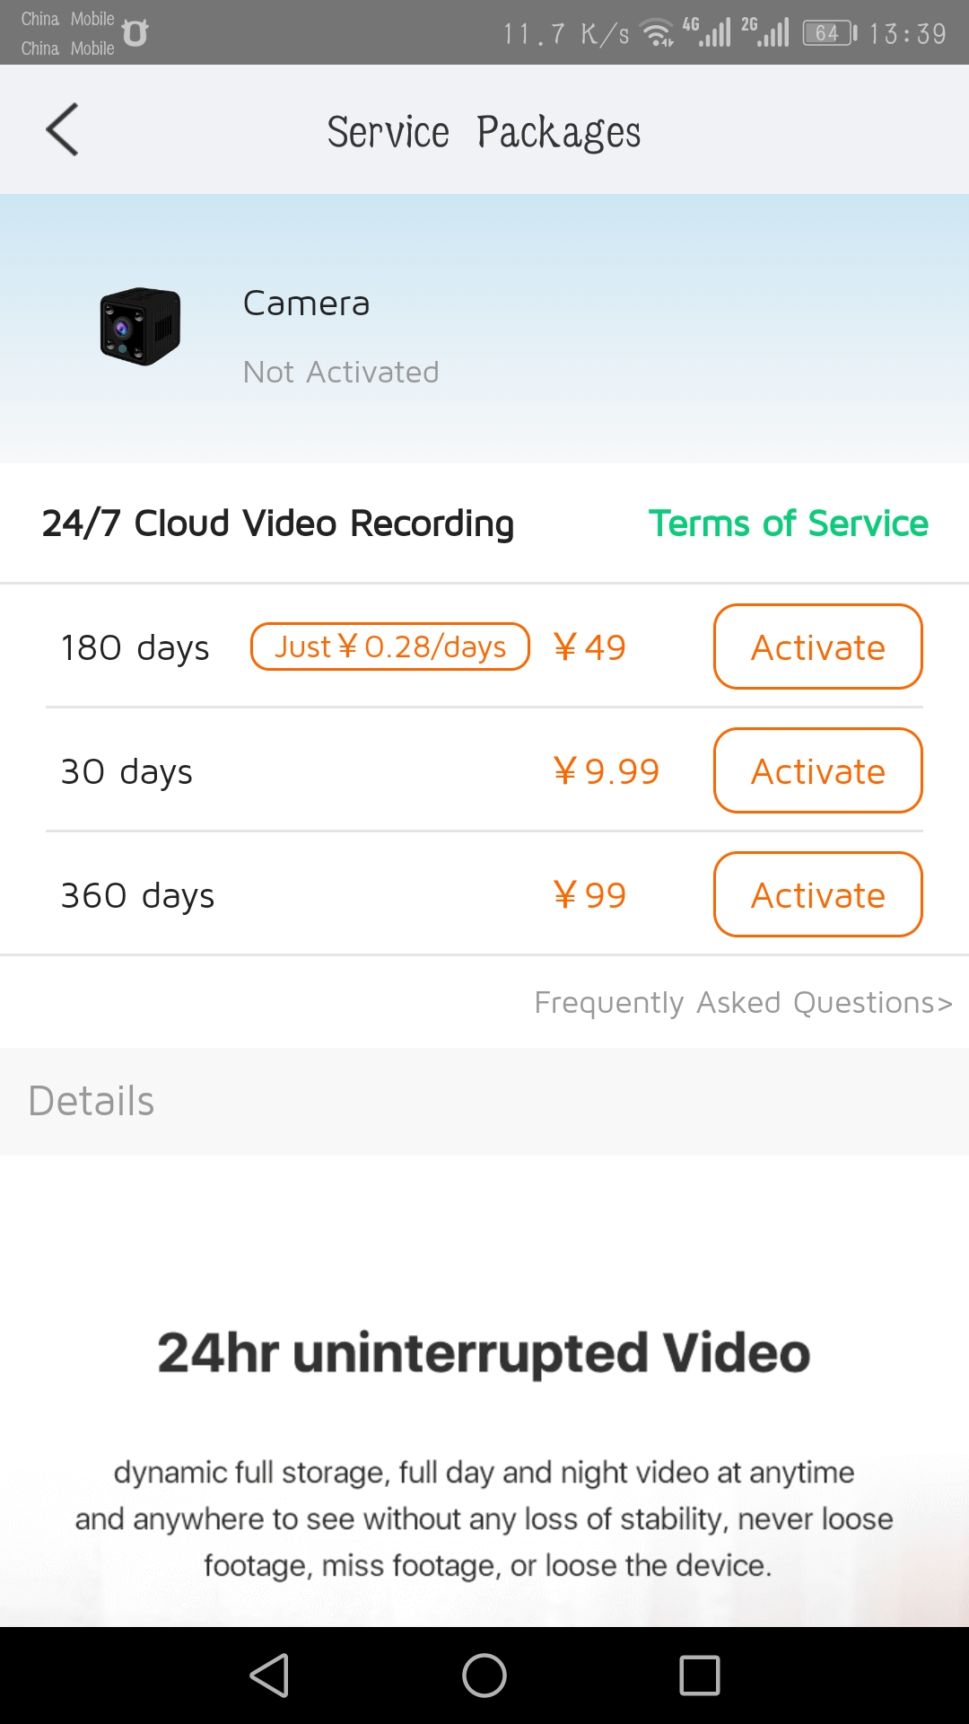
14. User Information list: Click on “my file”, you can go in to see the local video and photos, click on the “Help Center” can enter to view the simple use of guidelines
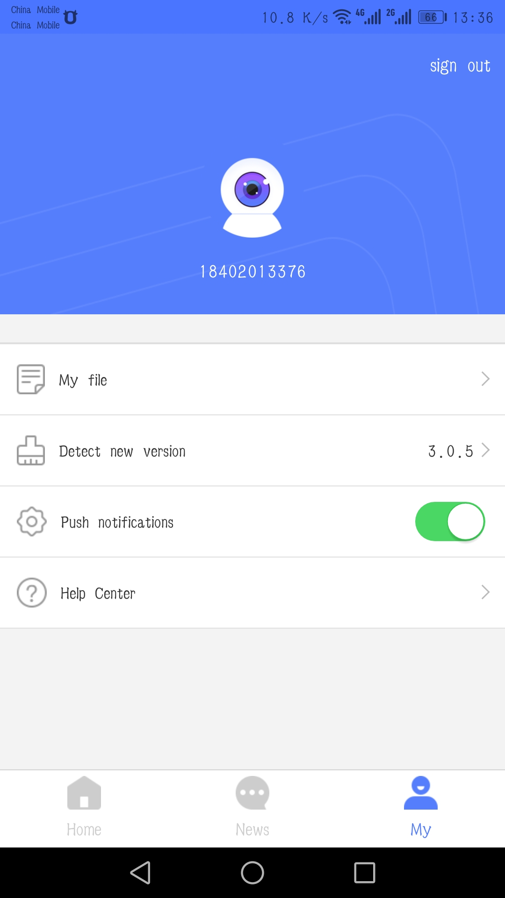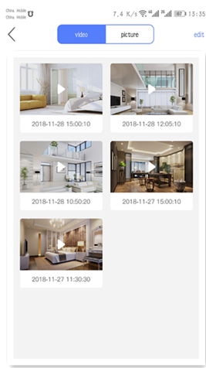
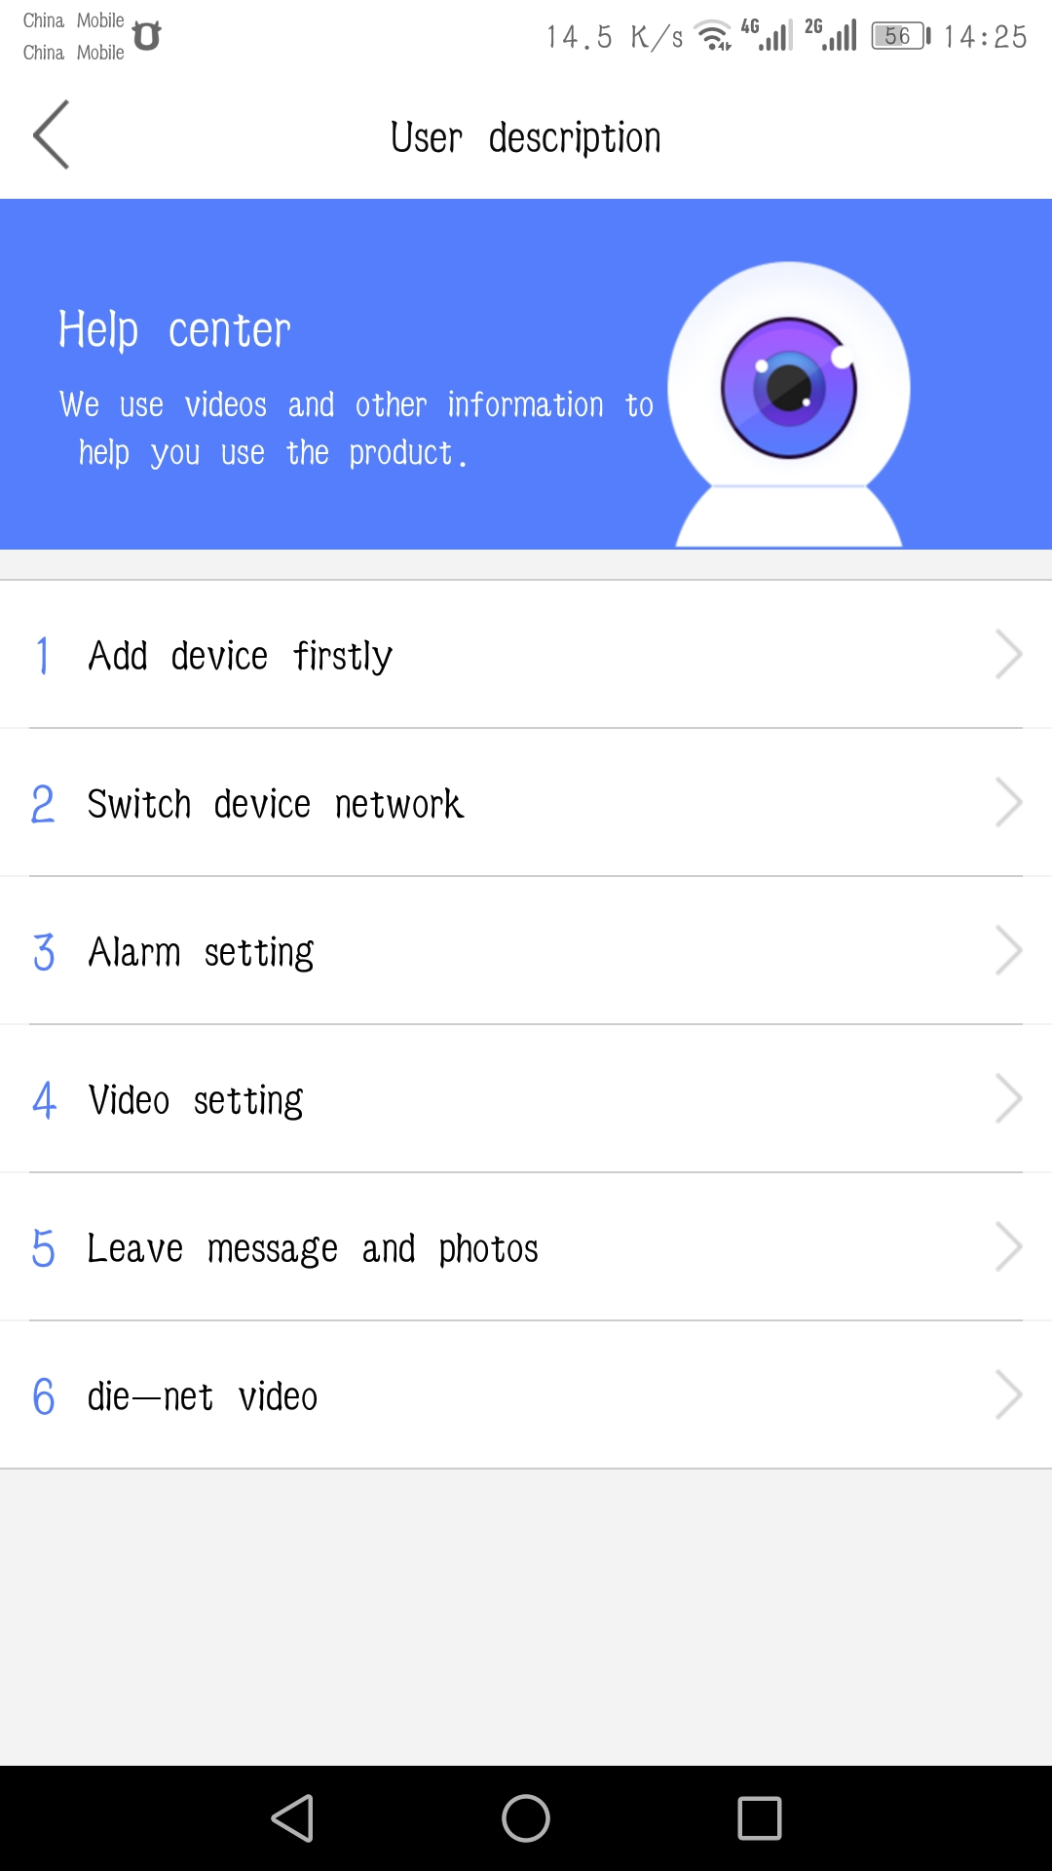
15 Video viewing interface
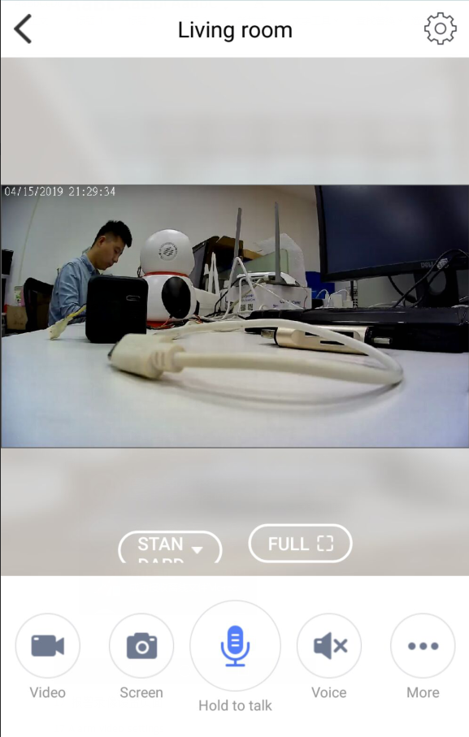

15 Parameter settings: Click the parameter Settings key to enter the parameter Settings page
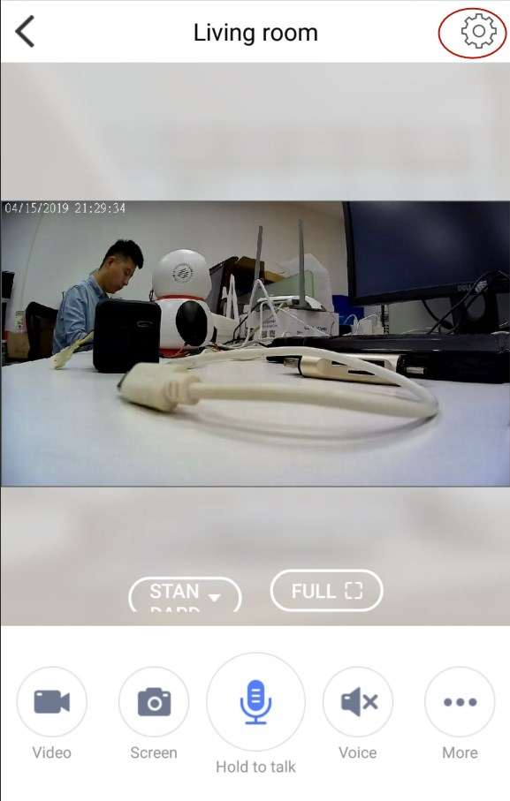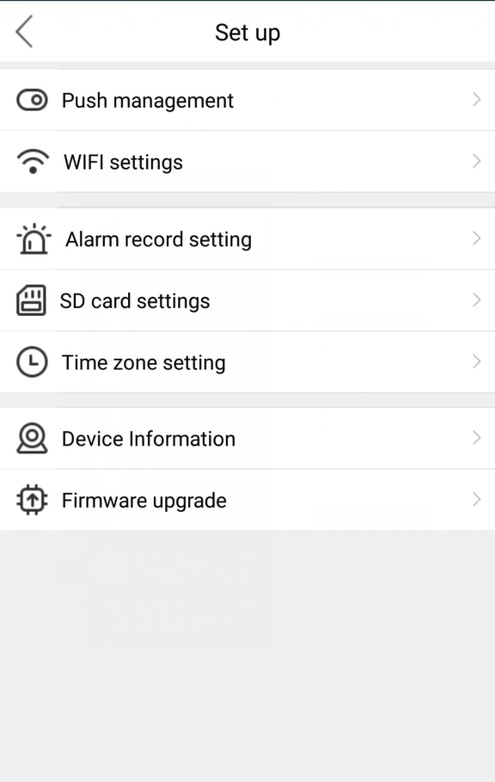
16. WIFI settings: Display the currently connected WiFi and can switch wifi, switch wifi steps as shown below, select the WiFi input password to switch to determine the connection will automatically switch
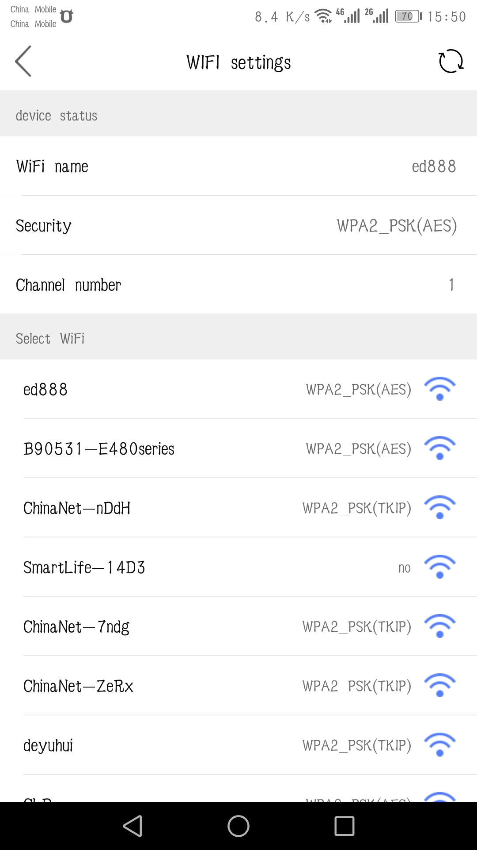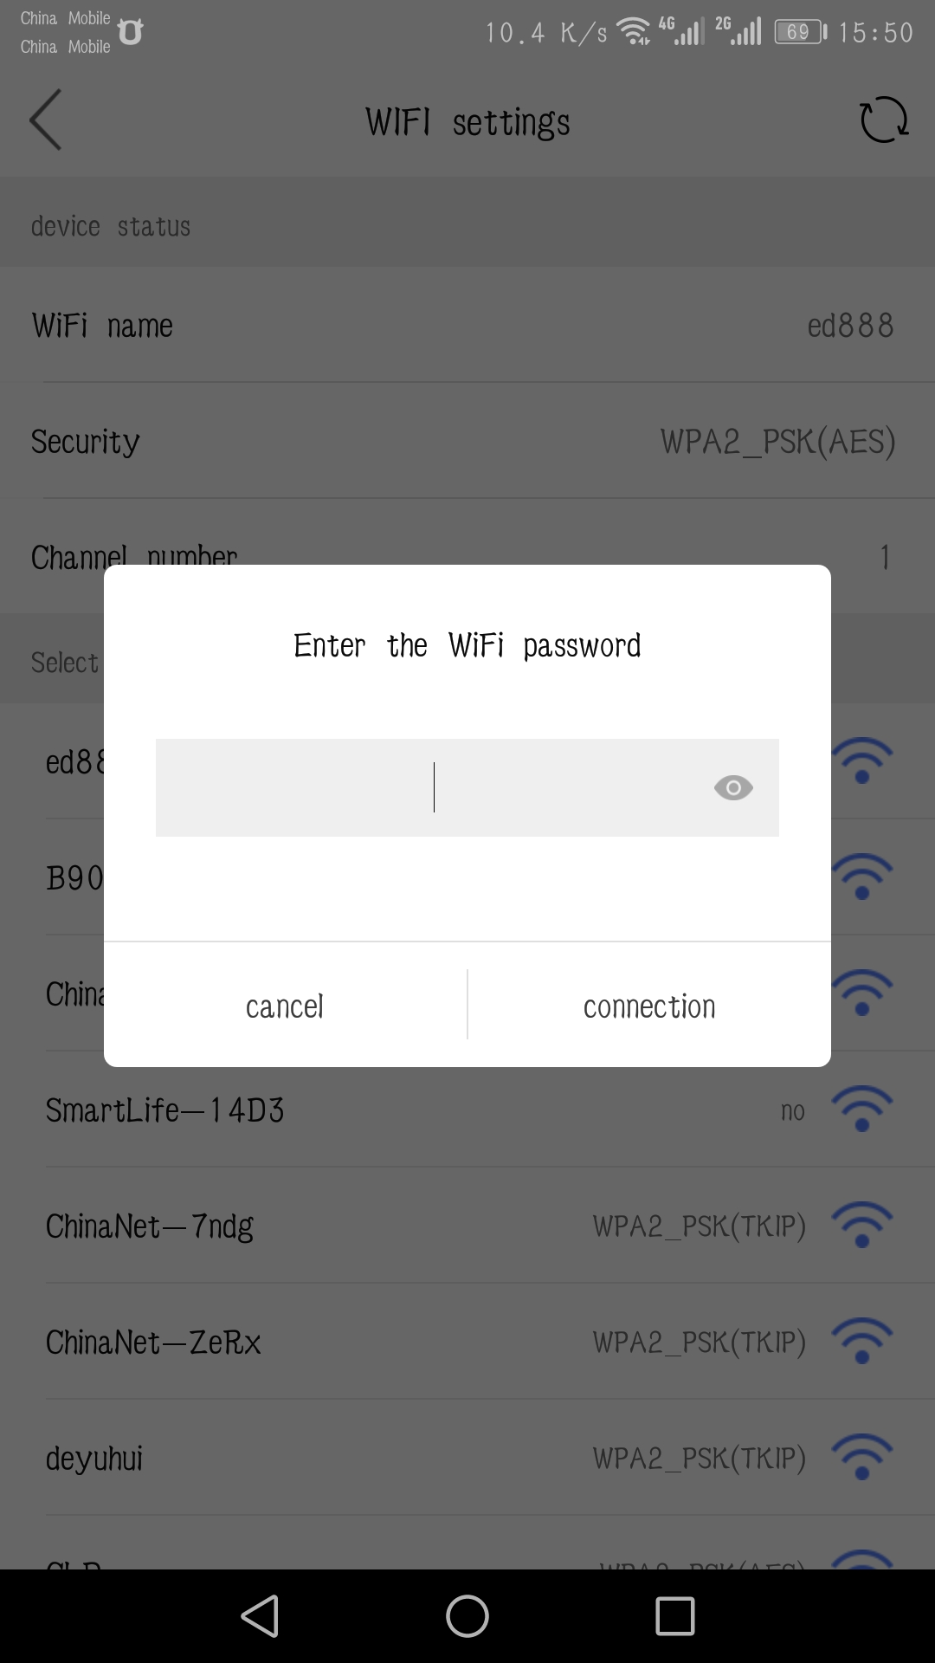
17 Alarm settings: set PIR alarm, you can set the PIR sensitivity level and recording time.
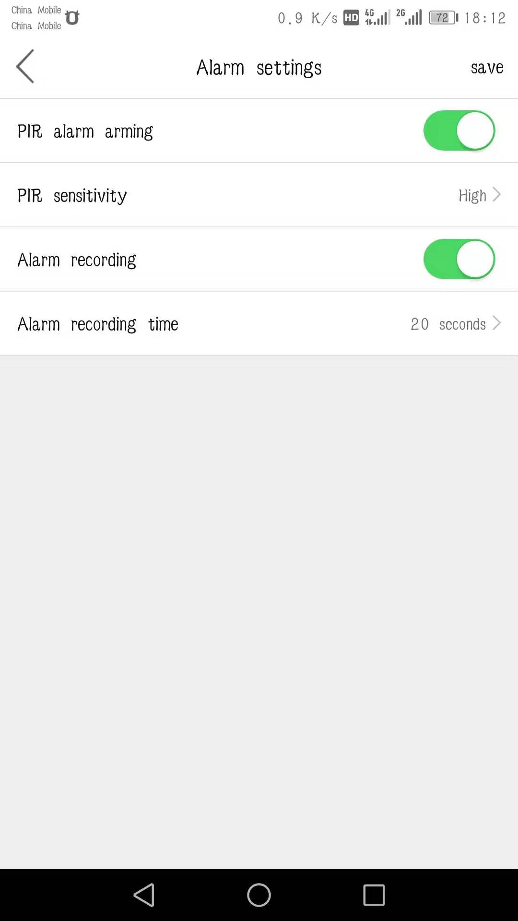

18 SD card set
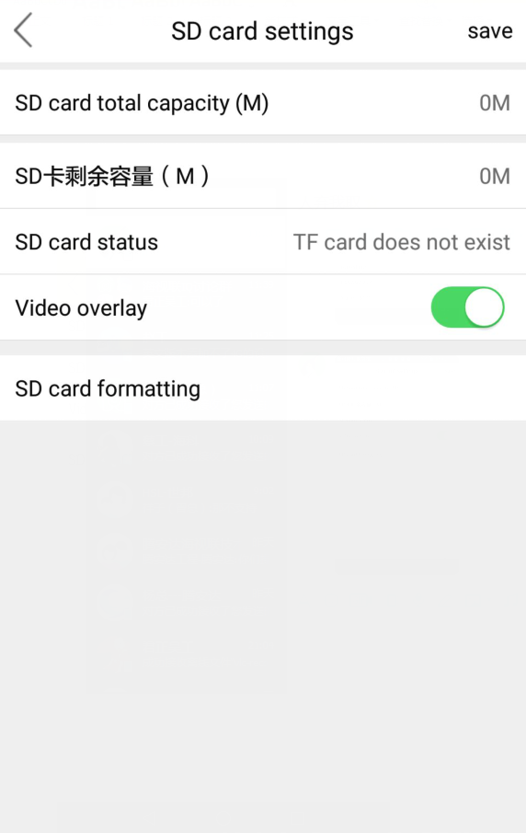
19．Time zone settings: You can select time in different regions
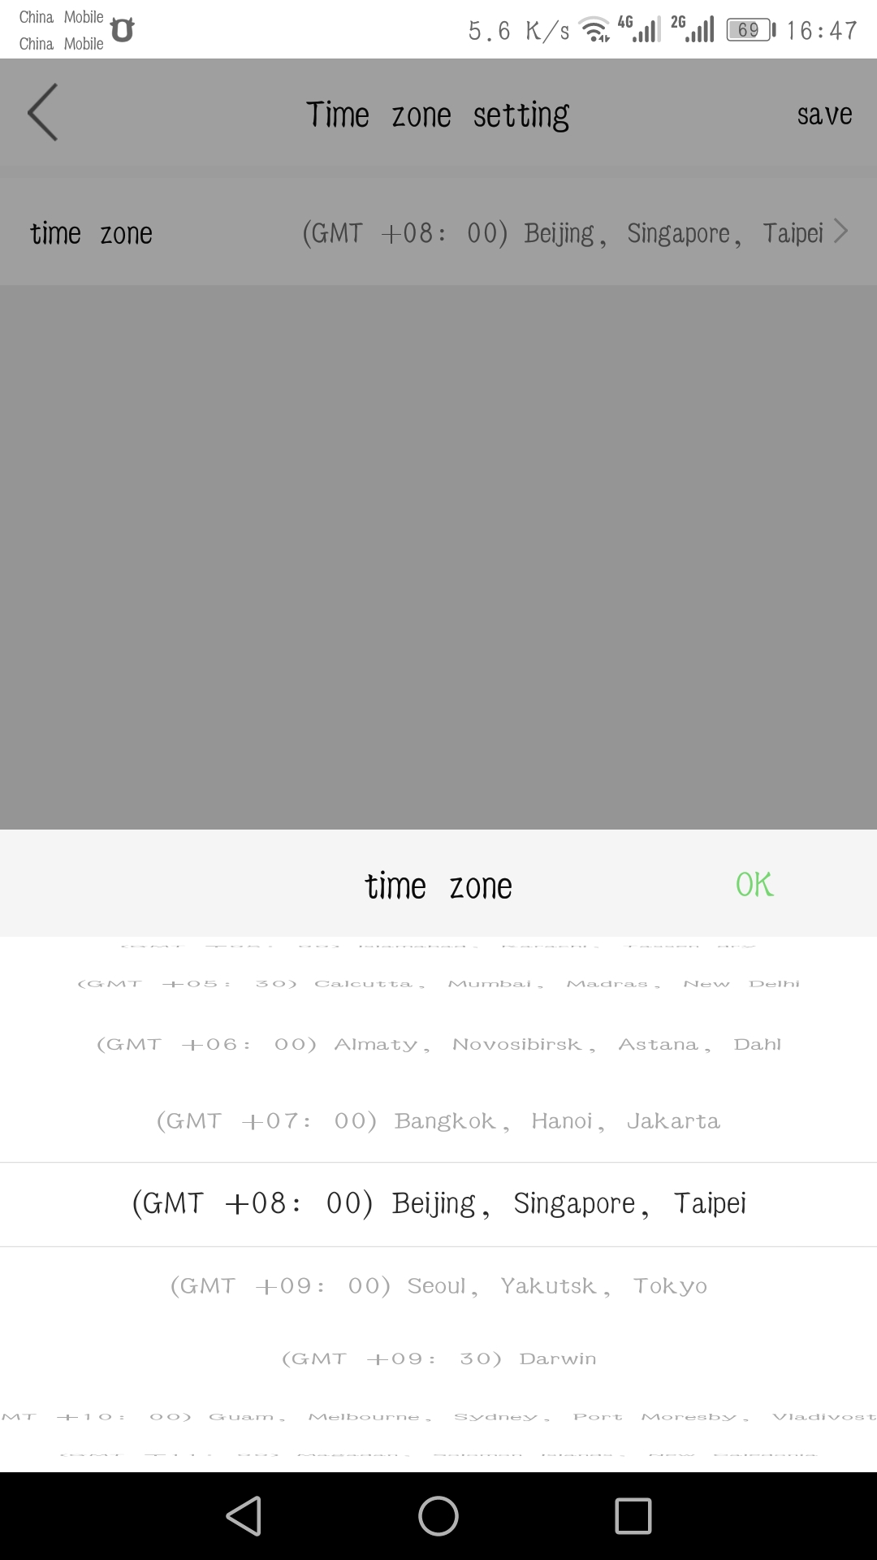
20 Device information: You can get information such as System firmware version
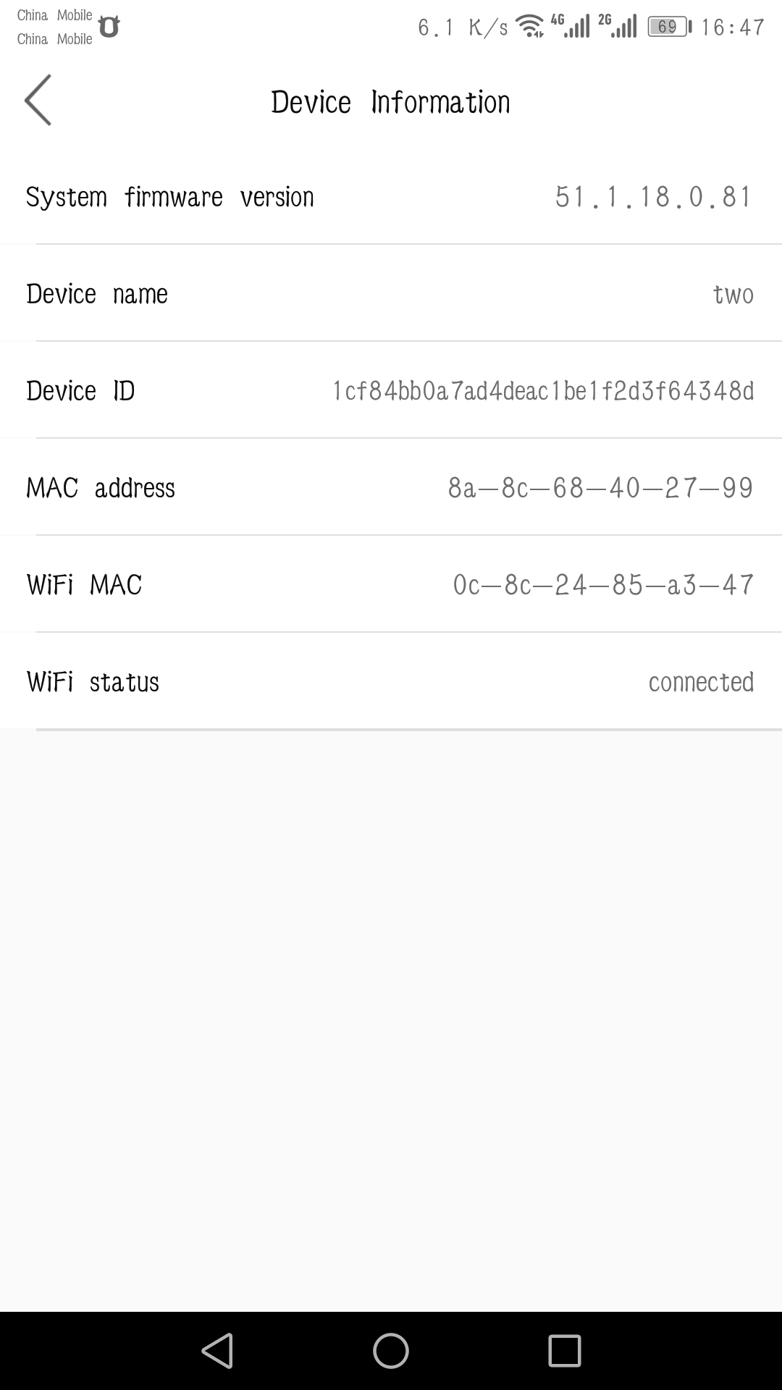
21 Warning message: When the device moves the alarm to trigger. There's going to be a record of the alarm in the message
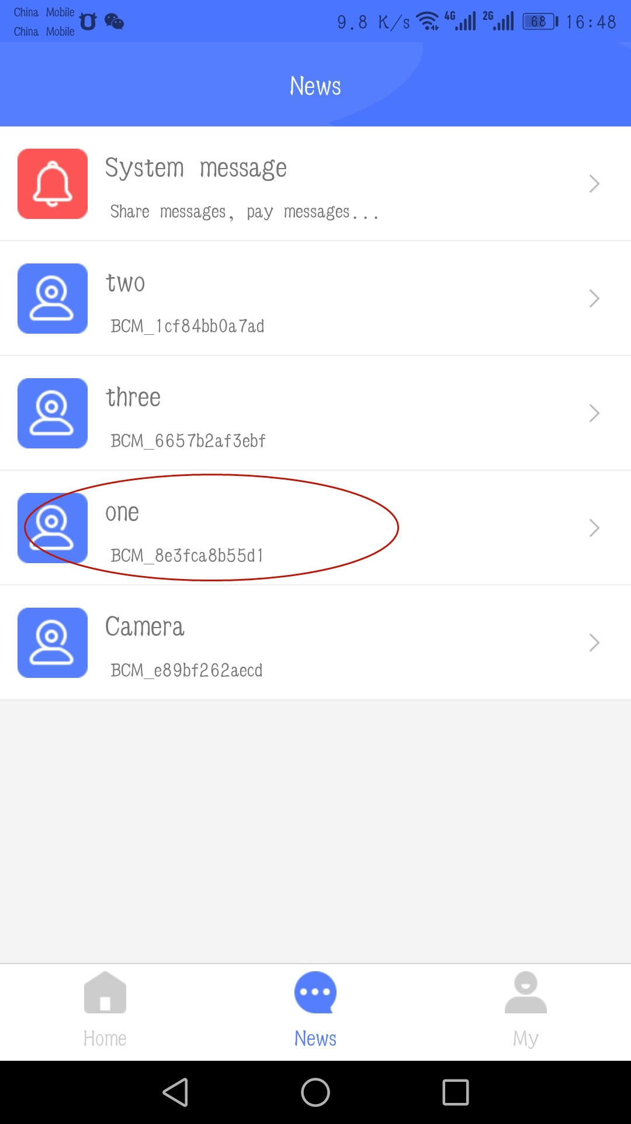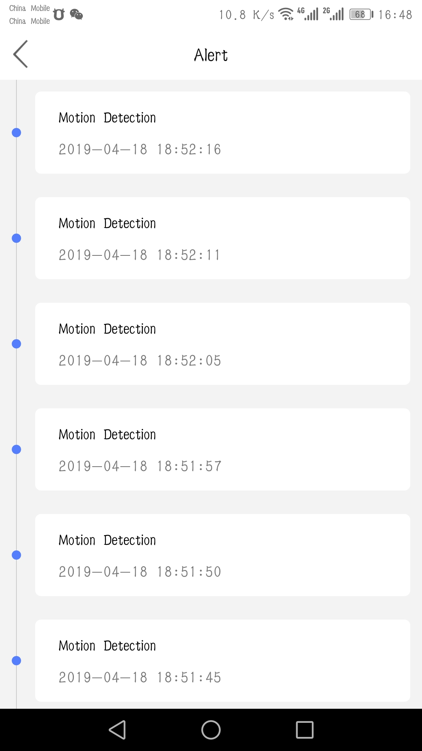
22. Video storage: When device has moves detection, a video is stored inside the SD card
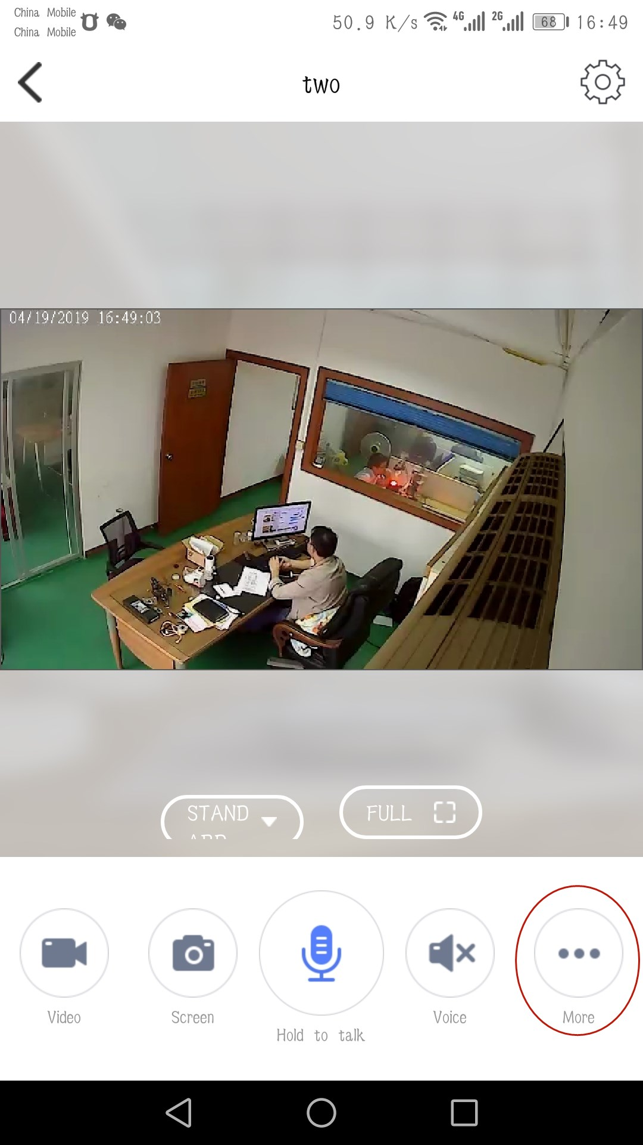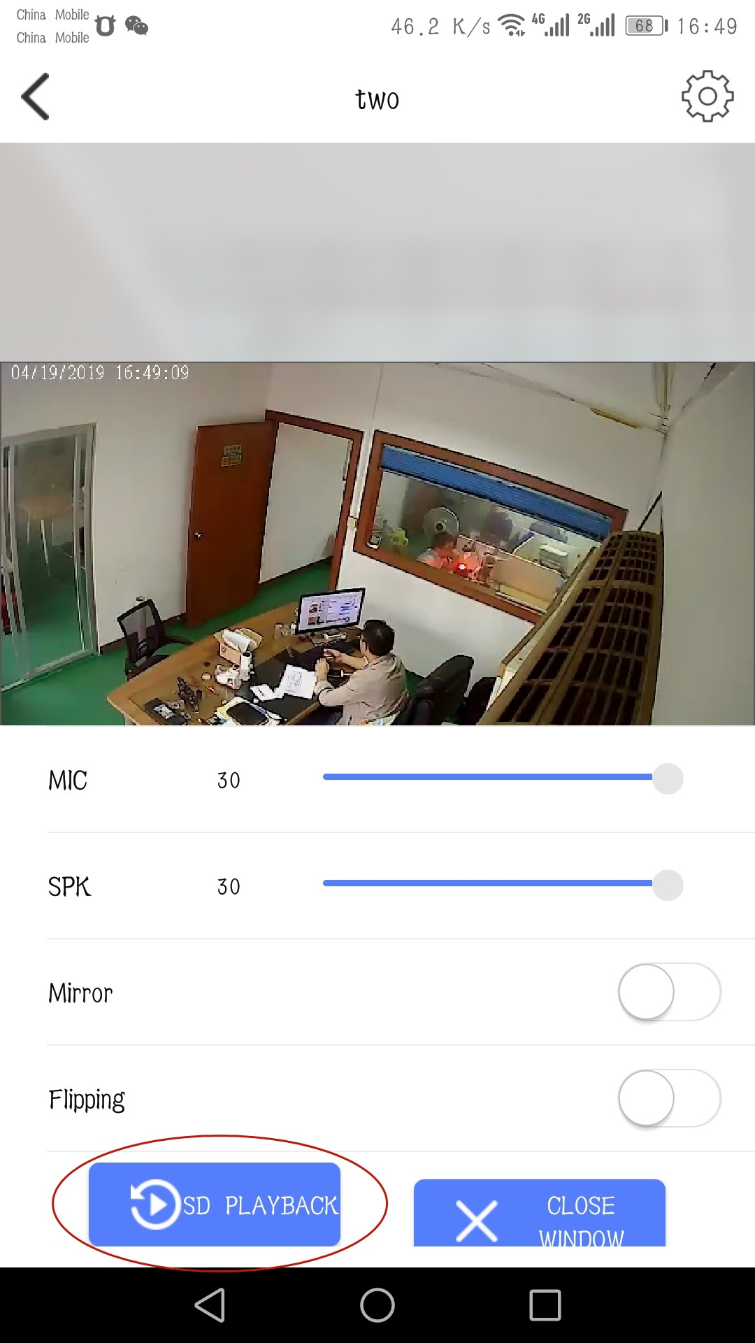
23. Video Search: Access page you can search videos by Time date
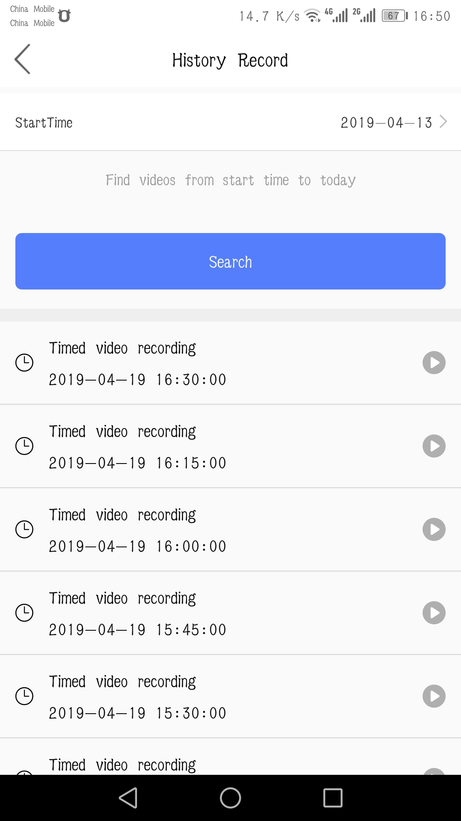
24．Message push :when the mobile detection trigger, there will be information directly pushed to the phone side, the app will receive the push information in Figure 1 , Click to enter the Answer page as shown in Figure 2
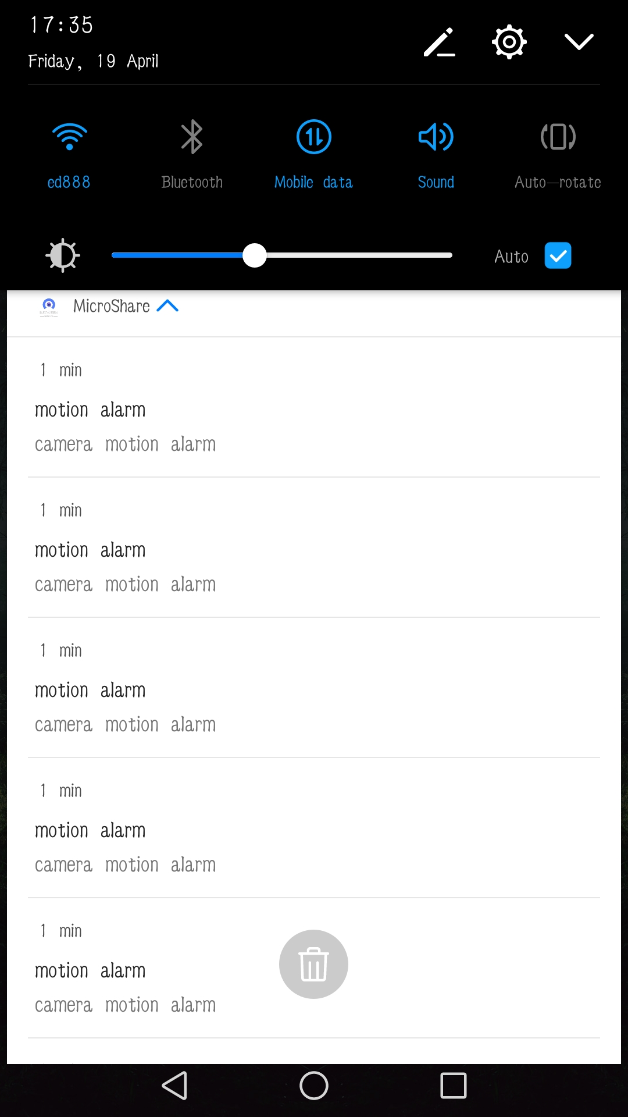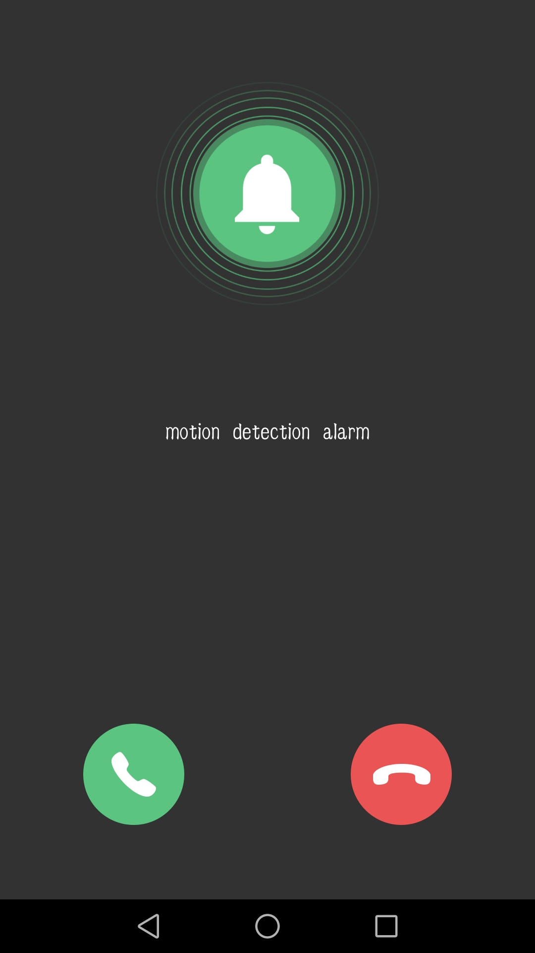
Figure 1 Figure 2
About account binding:①A device can only be bound to one primary account. For other accounts to monitor the device, must the primary account share the device to the sub-account②If the device is to be bound to a sub-account, the primary account must be deleted before the device can be bound.

Function Setting
- Switch device network
1. It needs to reset the device when there is something wrong with wifi network or you move device into a new environment, you need reset the network, at first long press" RESET" button in the back of the camera, recover factory reset, repeat the network step, add the new WiFi network
Alarm recording setting
- choose alarm recording setting in the setting menu
- Set PIR sensitivity and recording time

C VIdeo setting
- Put SD card to device card slot,64G is largest support
- In setting interface, choose “SD card set”

3. Ensure SD card be inserted to camera,please format SD card for the first tme use on the mobile phone, then select”video cover” according to demand. Click”save”setting to complete

Video cover: once the SD card is full, the old video will be covered by new video antomatically.
Device functions introduction
1
Motion dection alarm : if the fuction on,device will record automaticly and send alarm to call phone when people or animals move into the area covering by camera .
2 Wake-up remotely: The device is in sleeping status, and you can open app of phone,then press the main screen to wake-up the device remotely. Open the monitoring screen, you can watch the scene of the real-time scene,image capture, local video and other operations, and you can choose a different image quality.
FAQ
①Camera is unable to connect to WIFI network.
1： Camera is only available to 2.4G router instead of 5G router.
2：
Please do not set hide functionality on your wifi router, or the device will notsuccessfully configure home wifi
3： Please check whether the wifi router runs normally or not, then confirm the DHCP router
4：
Please try to reset the wifi router before configuring the device to get a better network environment.
5： Please follow the instructions carefully, configure your home wireless network, and don’t skip any one of these steps. or it may cause the device connection failure.
②The device has inserted SD card,and record video function is turn on, why still can not find video file after
In the first time use SD card, you need format the SD card before the normal reading and writing
③what’s the temperature can ber normal use ofthe device?
Suggest temperature is -10－50℃

