BabyHawk R Pro 4 Inch

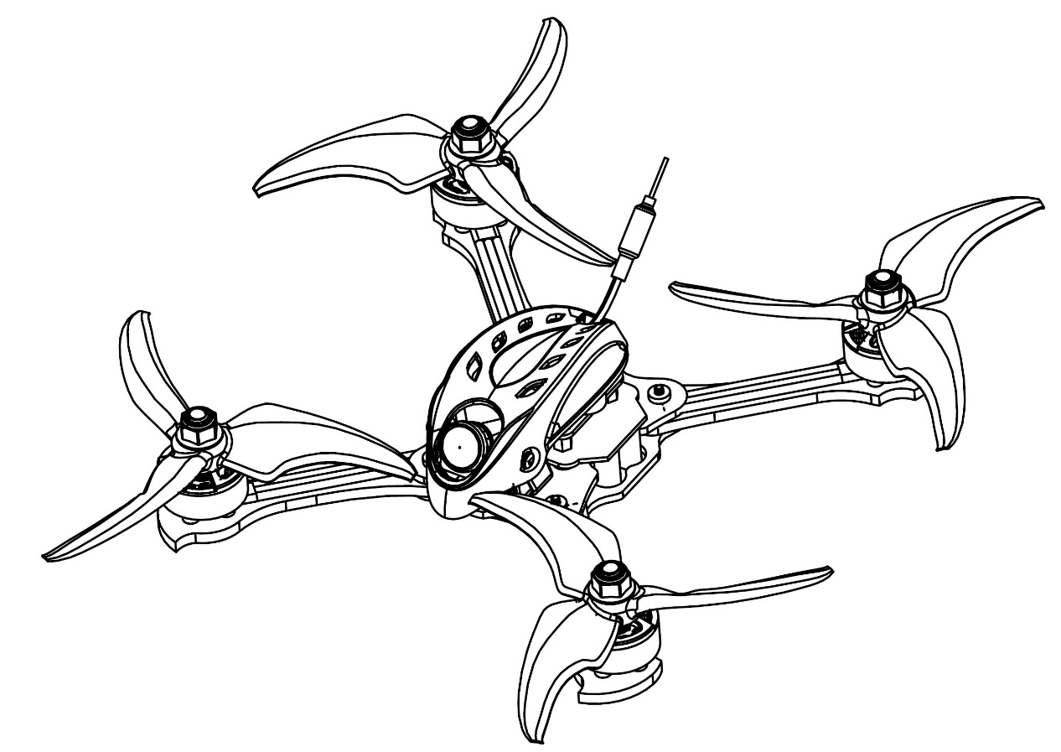

Thanks for purchasing the Babyhawk Race Pro 4 inch. Designed in California, assembled in China.

Disclaimer

Please read the disclaimer carefully before using this product. By using this product, you hereby agree to this disclaimer and signify that you have read them carefully and completely. This product is not suitable for people under the age of 18. Adult supervision is highly recommended for kids under the age of 18.
Our Babyhawk Race Pro 4 inch features open-source flight controller and Electronic Speed Controllers to meet the FPV enthusiasts' need to upgrade their quad.
Please read the instruction manual and warnings carefully. Before every flight, make sure the battery is fully charged and power connections are secure. DO NOT fly around crowds, children, animals or objects. EMAX ACCEPTS NO LIABILITY FOR DAMAGE(S) OR INJURIES INCURRED DIRECTLY OR INDIRECTLY FROM THE USE OF THIS PRODUCT.

Precautions
Please follow the instructions to assemble and to operate this product in a proper way.
Pilots do not use this product if you have physical or mental illness, dizziness, fatigued, or use while under the influence of alcohol or drugs.
Please fly in a safe area away from people
Do not modify or use other parts and accessories not approved for the use of EMAX.
Do not use this product in harsh environments (such as winds, rain, lightning, snow, etc.).
Do not use this product in a strong electromagnetic environment.

Support
Please visit emax-usa.com or emaxmodel.com for any updates or support needs.

Table of Contents
BabyHawk R Pro 4 Inch 0
0
Disclaimer 1
Precautions 1
Support 1
Product specification 1
Babyhawk Race Pro 4 inch 1
Parameter 1
Product list 1
Babyhawk Race Pro 4 inch 2
Propeller Direction and Mounting 2
Babyhawk Race Pro 4 inch VTX Settings 3
VTX Channel Settings with the Button 3
CE and FCC unlicensed user chart 4
Unlocked FCC HAM licensed user chart 4
Changing VTX setting via Betaflight OSD 4
Babyhawk Race Pro 4 inch Electronic Stack 6
6
Emax Tiny Receiver 6
Binding Procedure 6
Emax Babyhawk Race Pro 4 inch Flight Controller (FC) 7
Stock Flight Controller Settings 7
Adjusting Software Settings (Betaflight Configurator) 7
Reprogramming Babyhawk Race Pro 4 inch Flight Controller 7
8
Set the Correct Settings 8

Product specification
Babyhawk Race Pro 4 inch | Parameter
Diagonal wheelbase (without propellers) | 160mm
Aircraft weight (without battery) | 150g
Motor | RS 1606 3300kv
Propeller | Avan Scimitar 4x2.8x3
Electronics | F4（MATEKF405 firmware）  4 in one 3-6s 35A 32 bit ESC  EMAX Tiny Receiver
FPV Camera | Caddx Micro S1 CCD
Transmitter | 25-200mW Adjustable frequency 37CH
Battery | Emax 4 Cell 850 mAh lipo battery

Product list
- Babyhawk Race Pro 4 inch × 1
- Instruction manual × 1
- Emax 1s HV 450 mAh × 1
- Avan Scimitar 4x2.8x3 (3 CW, 3 CCW)
- Avan Scimitar 4x2.4x3 (3 CW, 3 CCW)
- Extra Hardware Set x 1

Babyhawk Race Pro 4 inch

Propeller Direction and Mounting
There are 2 spinning directions for Babyhawk Race Pro 4 inch propellers, Clockwise (CW) and Counter-Clockwise (CCW). When Buying a set of propellers, 2 CW and 2 CCW will be given. The blunt leading edge indicates the direction the propeller is suppose to rotate as compared to the sharp trailing edge. When mounting propellers please make sure the correct orientation shown in the diagram below.
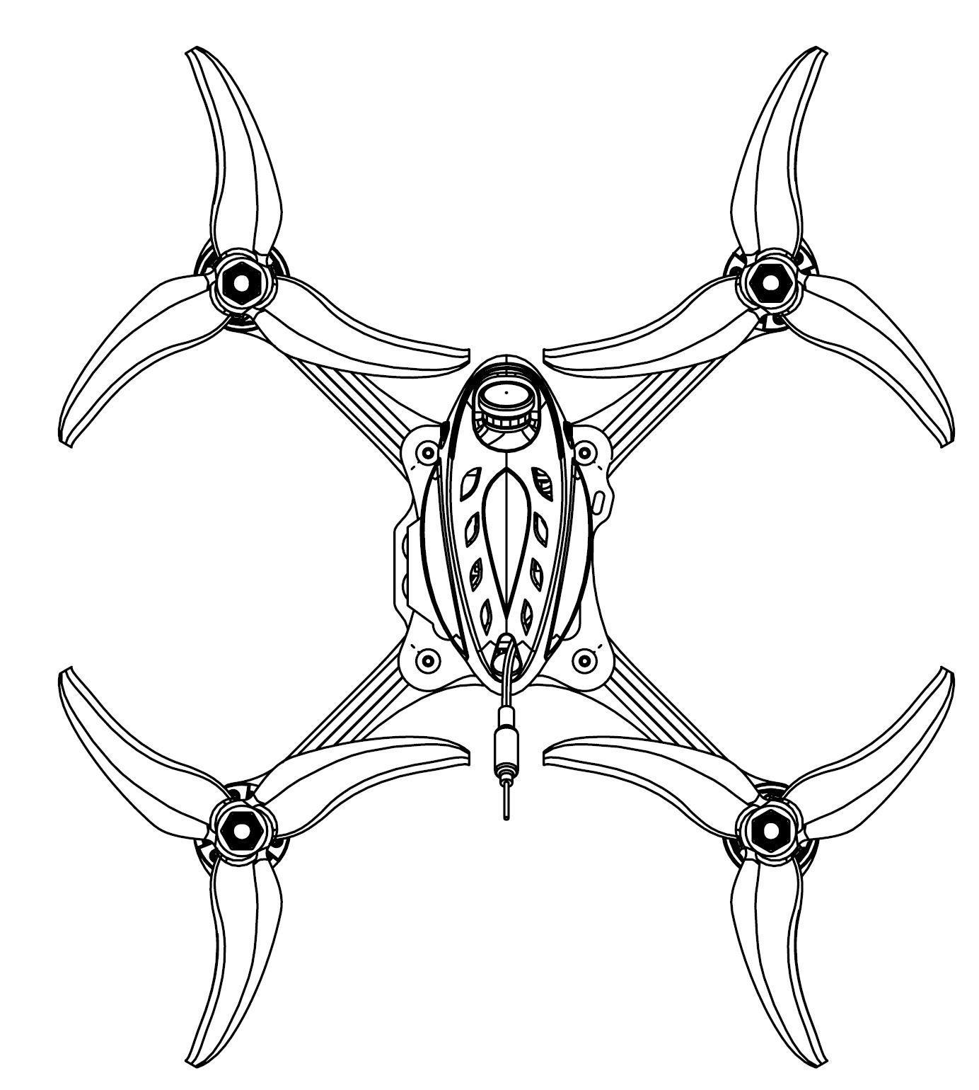
CCW
CW
CCW
CW
Caution: Failure to mount the propellers in the correct orientation will cause Babyhawk Race Pro 4 inch to not fly correctly and with no control. Please double check for the correct orientation.
- Place the propeller onto the M5 shaft of the motor
- Tighten the M5 nut tightly onto the propeller

Babyhawk Race Pro 4 inch VTX Settings
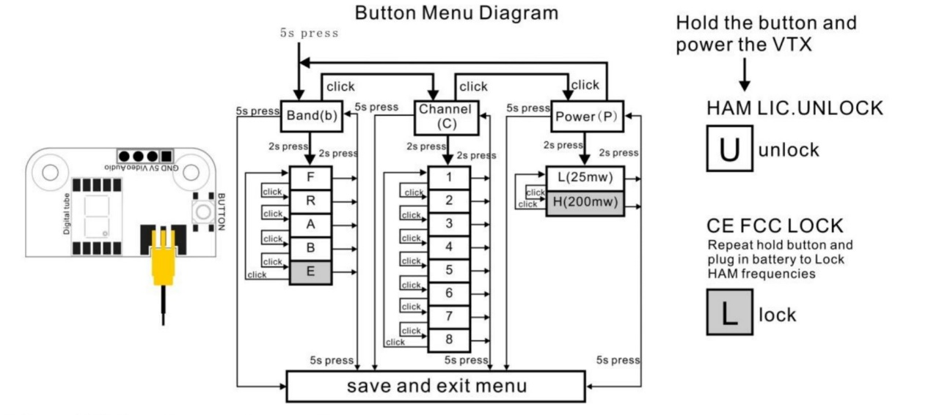
Vtx Schematic and Button Diagram

VTX Channel Settings with the Button
1. Normal display
The display will cycle between showing band and channel. If the red dot is on in the lower right corner, that means the vtx is in high power mode (200 mW). Otherwise it is in low power mode (25 mW).
2. Menu Entry / Exit
(1)Press the button and hold for 5s to enter the top level menu.
(2) Press the button and hold for 5s again to save changed parameters.
3. Band, Channel, and Power parameter change
(1) Once entered top level menu, press the button to cycle through the 3 menu options: band “b” , channel “c”, and power “p”.
(2) Press the button for 2s for one of the 3 top level menu selections to enter sub menu.
(3) Once in the sub menu, press the button to cycle through the options.
(4) Set the selected option by holding the button again for 2s and will exit to top menu
(5) Continue cycling through other parameters if desired and press the button for 5s to save and exit.
Notice: If you change to an illegal channel using SmartAudio, there will be no image transmitting from Babyhawk Race Pro 4 inch. To switch back to a legal channel, press the button on the vtx and follow the vtx menu guide shown below.

CE and FCC unlicensed user chart
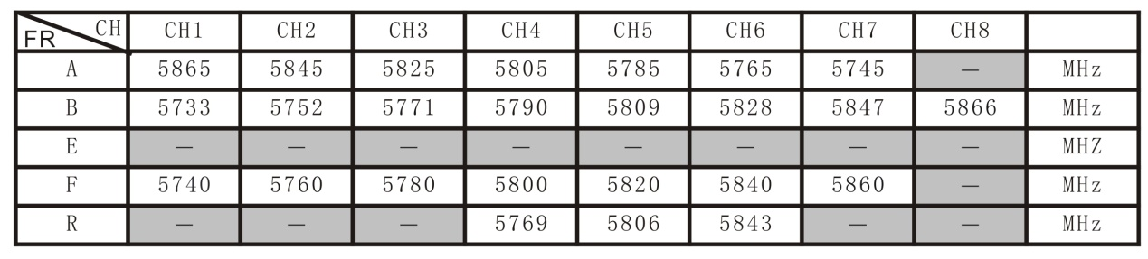

Unlocked FCC HAM licensed user chart
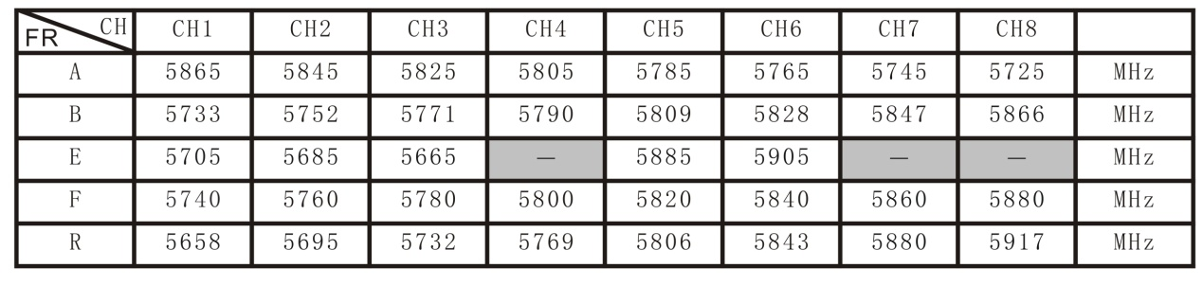
* From the factory this video transmitter is designed to operate within CE and FCC unlicensed users specifications. To use the unlocked features of this VTX the user is required to have a HAM radio license or prior consent from the FCC. By purchasing this equipment, the user is agreeing that they understand these responsibilities and will operate the equipment legally. Emax cannot be held responsible for your actions if you purchase and/or use this product in violation of your government's regulations.

Changing VTX setting via Betaflight OSD
Babyhawk Race Pro 4 inch is equipped with SmartAudio and is already configured with stock settings. The SmartAudio line is operated on UART 6 TX.
1. Power on Babyhawk Race Pro 4 inch, goggles, and controller.
2. Follow the tips on screen to enter the main settings menu: THROTTLE MID+ YAW LEFT+ PITCH UP to enter OSD parameter adjustment menu. as shown in Figure 2.
3. In the menu interface, switching PITCH up/down to choose menu option. Move the cursor to “FEATURES” and stir Roll stick right to enter next menu. Using PITCH stick to move cursor to “VTX SA”, as shown in Figure 3.Then pull ROLL stick right to enter VTX configuration menu, as shown in Figure 4.

Figure 1
Figure 1

Figure 3
Figure 5

4. In the menu of VTX SA, we can configure the BAND, CHAN and POWER. Pulling the PITCH stick to move cursor up and down to choose VTX options that need setting. While pulling ROLL stick left and right to change the corresponding parameters.Once the parameters is set, moving the cursor to “SET”, then turn ROLL stick right to enter “SET” and choose “YES” and turn ROLL stick right to save setting parameters, as shown in Figure 5.
Figure 6

Babyhawk Race Pro 4 inch Electronic Stack
Flight Controller

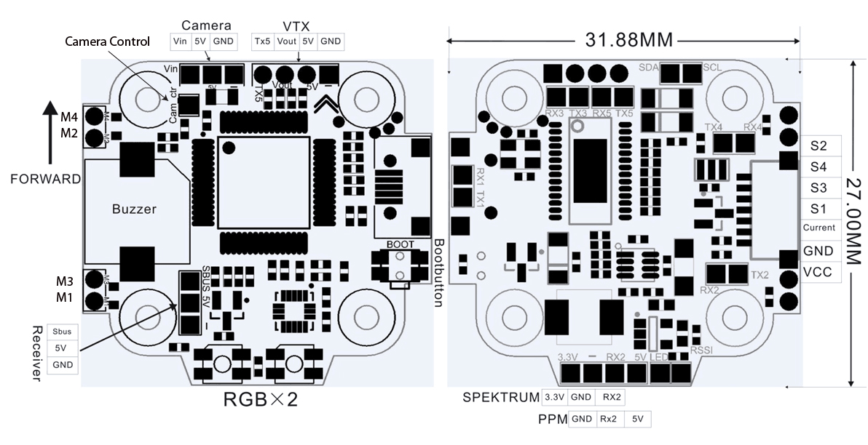
ESC
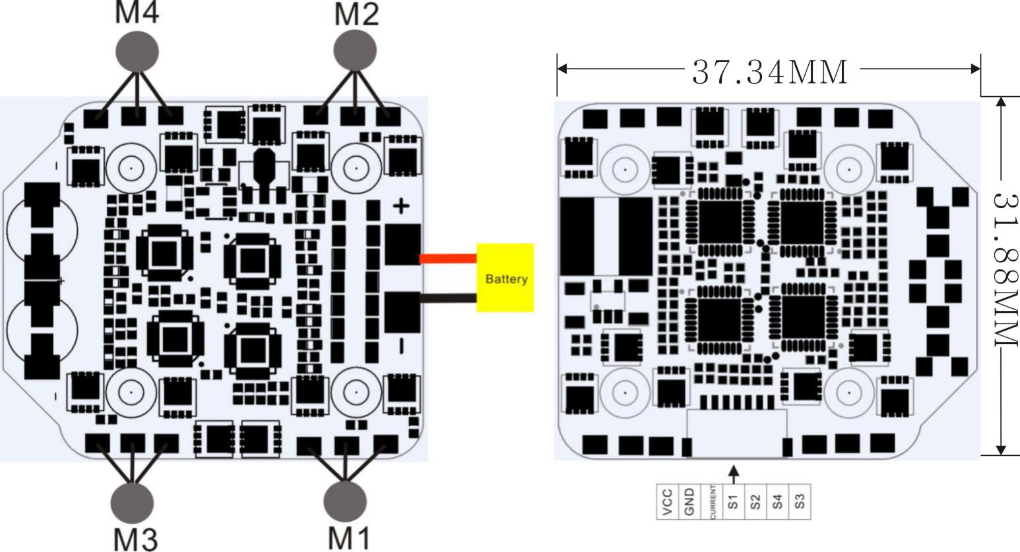

Emax Tiny Receiver
Number of Channels: Up to 8CH using SBUS
Compatibility: FrSky D8 mode

Binding Procedure
Binding is the process of uniquely associating a receiver to a transmitter module. A transmitter module can be bound to multiple receivers (not to be used simultaneously). A receiver can only be bound to one transmitter module.
1.Hold the bind button while powering on the receiver. When the GREEN LED is on, it means the receiver is in BIND MODE
2.Turn on the transmitter, make sure it is set to D8 mode, and then set it into bind status. When the RED LED of the receiver starts flashing, it means bind successful.
3.Turn on the transmitter again, the GREEN LED receiver will be on, it means the receiver is receiving data from transmitter. Transmitter bind with receiver no need repetitive operation, unless you change either receiver or transmitter.

Emax Babyhawk Race Pro 4 inch Flight Controller (FC)
This flight controller has a F4 MCU with a MPU6000 gyro. Babyhawk Race Pro 4 inch flight controller comes pre-programmed and properly tuned for optimal flight. The flight controller is programmed with Betaflight 4.0.2. For a full tune and configuration setting file (CLI dump file) please visit https://emax-usa.com/ for the CLI dump file.

Stock Flight Controller Settings
Babyhawk Race Pro 4 inch is configured to take a channel map of the TAER1234 convention. That is the channel map is in the respective order: throttle, aileron, elevator, rudder, AUX 1, AUX 2, AUX 3, and AUX 4. The arm switch on Babyhawk Race Pro 4 inch is set on AUX 1 and armed with the highest value. AUX 3 is configured for the beeper in a high state. AUX 4 is set to Flip Over After Crash mode (often referred to as turtle mode). Turtle mode is set when AUX 4 is in a high state. Please configure your radio as described above or change these settings in Betaflight Configurator.
PID profiles:
PID profile 1 is tuned and optimized for Babyhawk Race Pro 4 inch with the provided Emax 4s 850 mAh battery for ultimate control.
Please do not change these values.
Rate Profiles:
Profile 1 is set to our determined rates

Adjusting Software Settings (Betaflight Configurator)
Betaflight Configurator can be used to changed programmed settings on Babyhawk Race Pro 4 inch and to flash new firmware if desired. Betaflight Configurator and flight controller firmware can be downloaded at https://github.com/betaflight/. The hardware target for Babyhawk Race Pro 4 inch Flight Controller is MatekF411RX.
DISCLAIMER: We do not suggest changing any PID settings on Babyhawk Race Pro 4 inch or upgrading the firmware to new versions. Babyhawk Race Pro 4 inch comes stock with an optimal tune for superior flight performance. Changing this can affect flight time, overall speed, control of the aircraft, and excessive heat within the motors.

Reprogramming Babyhawk Race Pro 4 inch Flight Controller
- Put the Flight Controller in DFU mode by pressing the BOOT button while plugging in the micro USB cable to a computer.
- Select MATEKF405 as the target and then select the firmware (4.0.2) or download the hex file from https://emax-usa.com/ . Select Manual Baud Rate with 256000 in the drop down menu
- Select Load Firmware(Online) to download the firmware or Load Firmware (Local) if already downloaded the hex file.
- Select Flash Firmware to program the flight controller

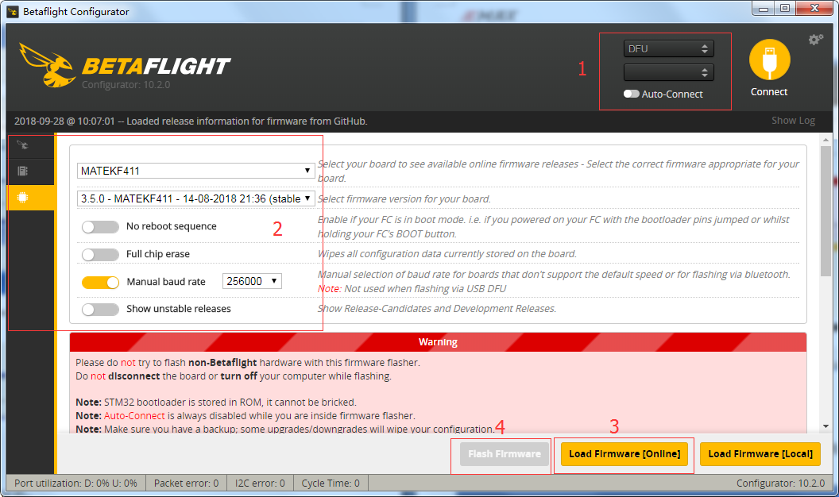

Set the Correct Settings
- Download the latest CLI Dump File from https://emax-usa.com/
- Connect Babyhawk Race Pro 4 inch to Betaflight configurator and select the CLI tab
- Open the CLI Dump File in a text editor and copy all the text.
- Paste the settings into the command bar and press enter
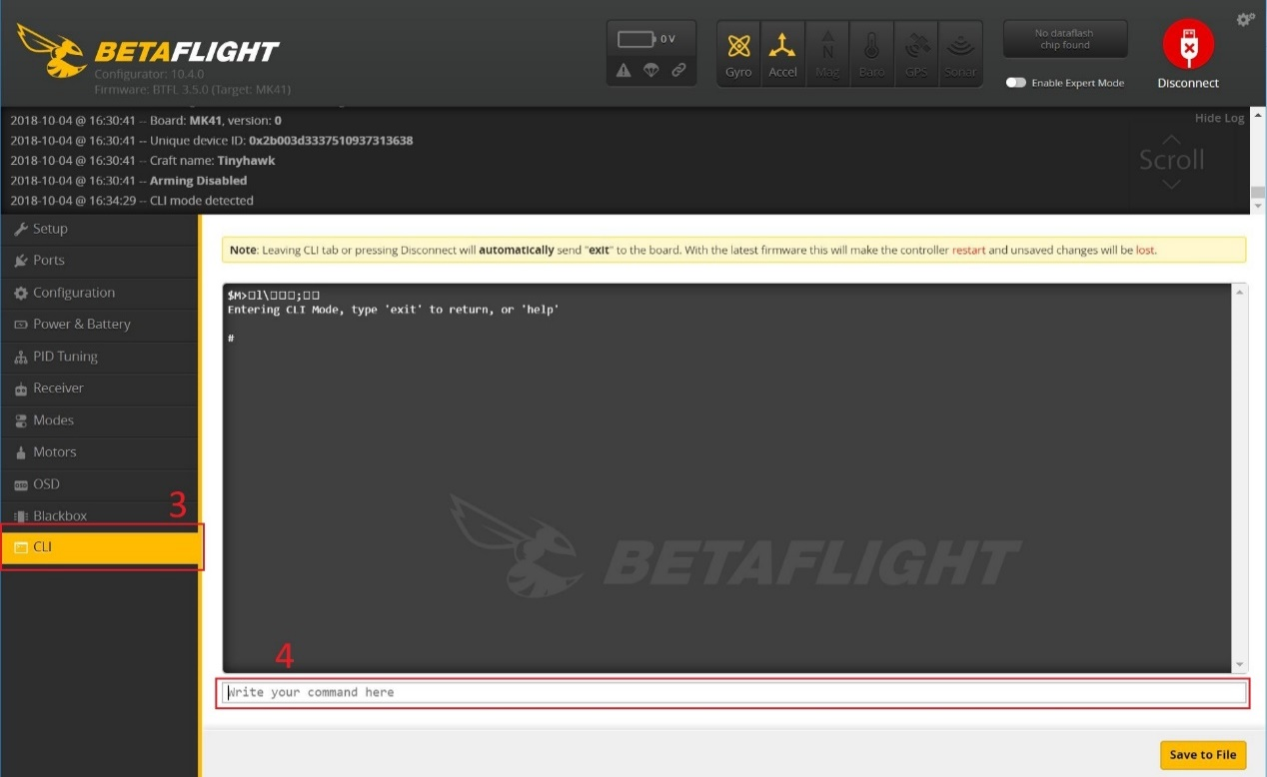
- Babyhawk Race Pro 4 inch will reconnect to Betaflight when completed

