Please carefully read the entire production process and then do it better!
First talk about the issues that need attention before welding
1. The soldering temperature should not be too high below 320°C
2. We recommend that the soldering iron be grounded and that it is best to wear an electrostatic wrist strap grounding solder. The welding speed should be as fast as possible.

This kit is very simple to weld, let's get started
- Solder the microcontroller, pay attention to the direction of the IC when soldering (see the figure below). If you are a beginner, it is recommended to solder on each pad, and then heat the solder to fix the pins.
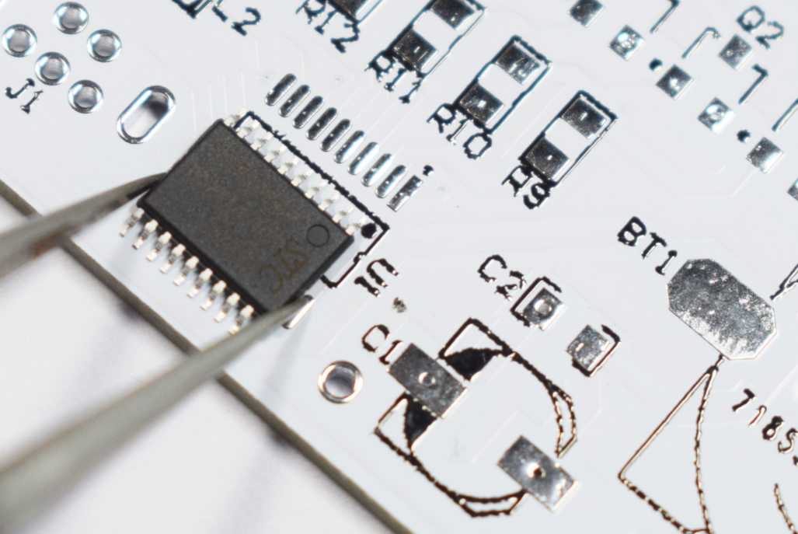
2. Solder DS1307 chip, IC direction is as shown below
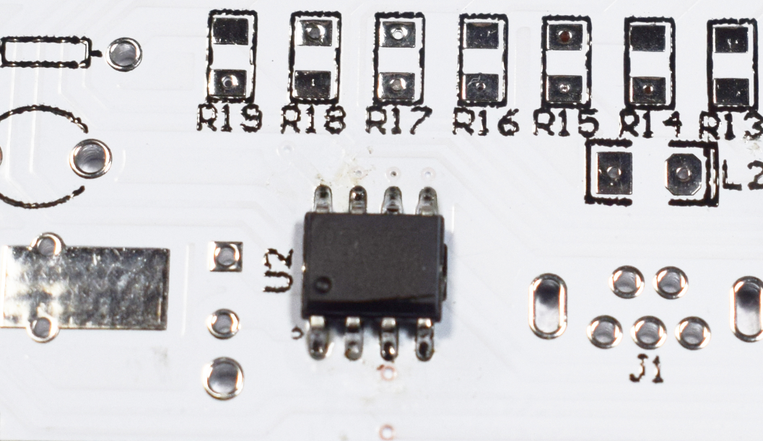
3. Solder the chip components, solder on one end of the pad, heat the solder after fixing the components, and then solder the other end
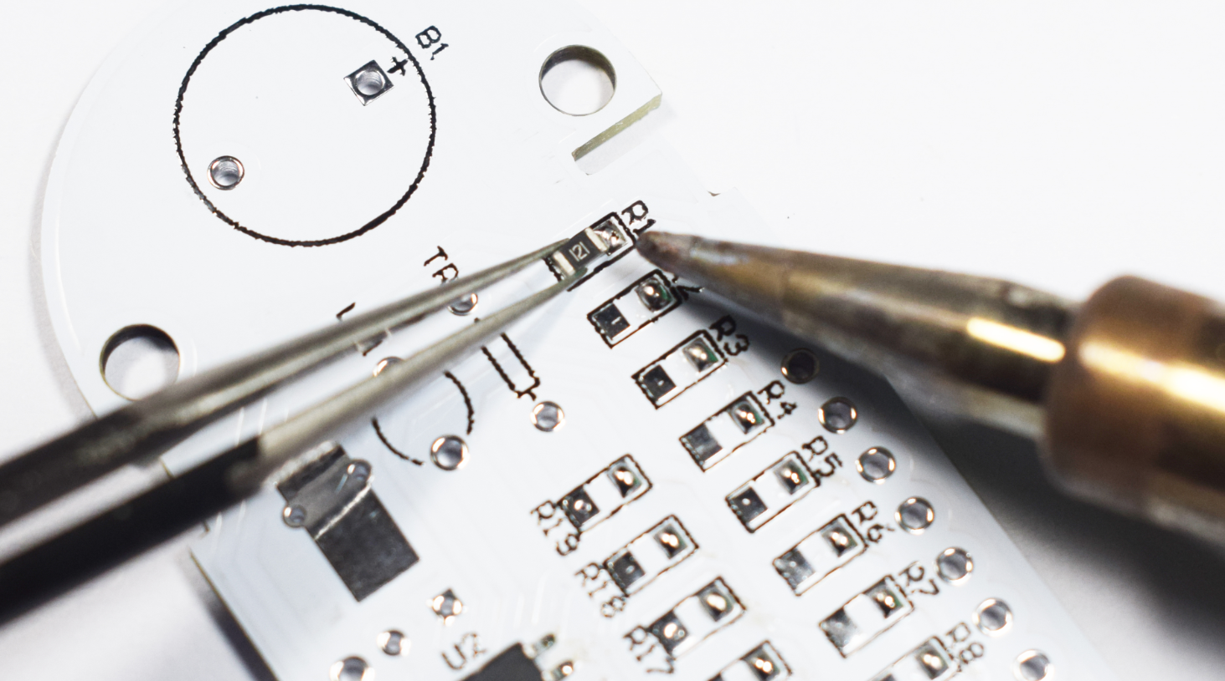

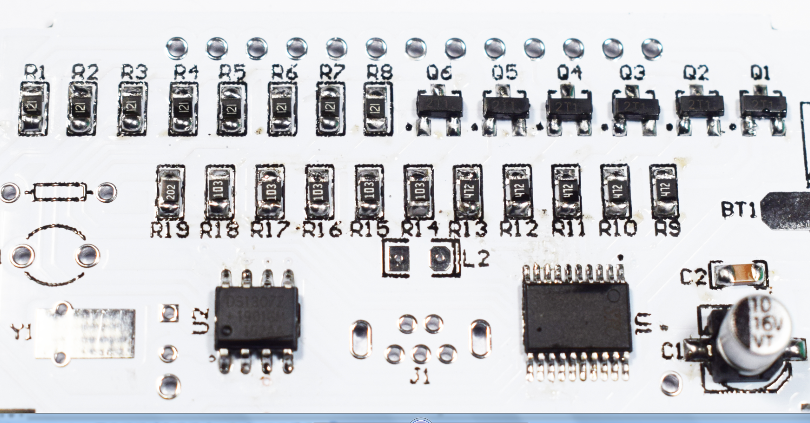
R1-R8:120（121）
Q1-Q6:9012(2T1)
R14-R18:10K（103）
R9-R13:4.7K（472）
C2:100nF(104)
C1:10uF
R19:2k(202)

4. Note the direction of the soldering LED, the green dot points to the direction of the letter
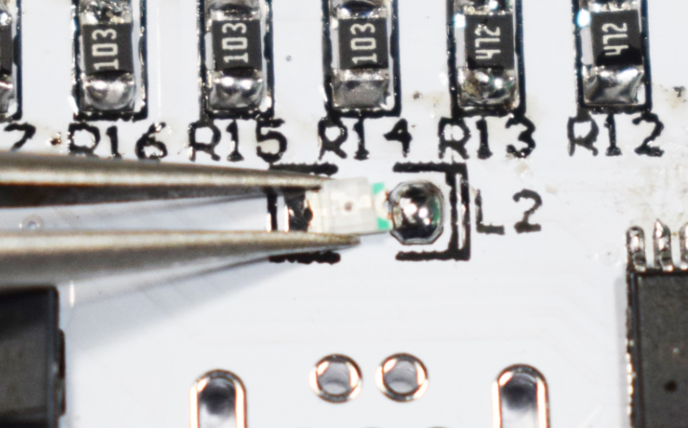

5. Welded battery holder
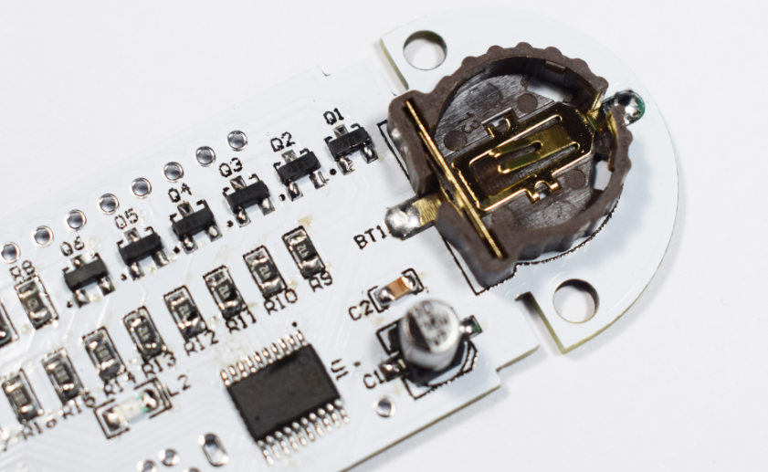

6. Welding thermistors, photoresistors and crystals
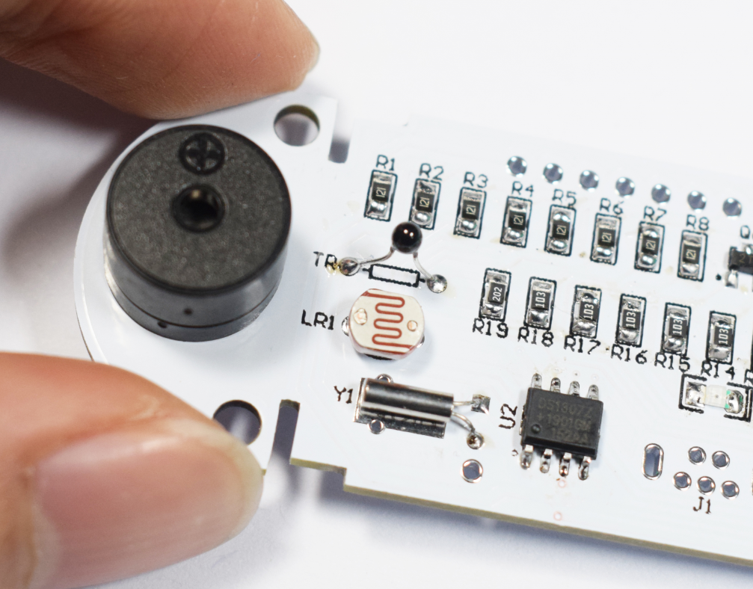

7. Cut off the pins
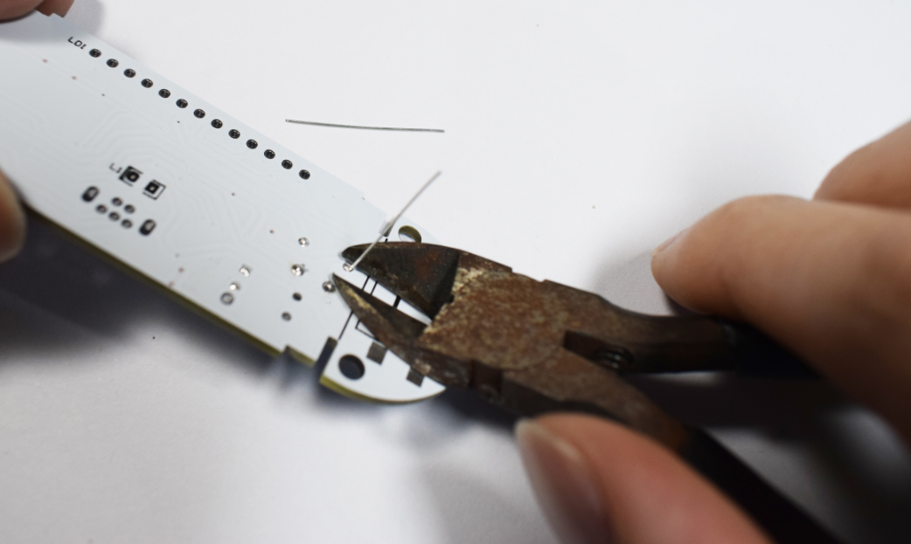

8. Fixing the crystal with obsolete pins
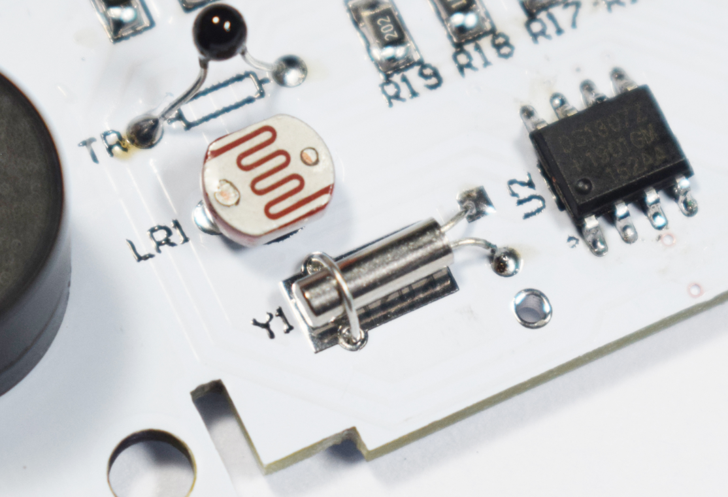
9. Weld the keys, as shown in the figure below, cut off the bent pins of the keys before welding
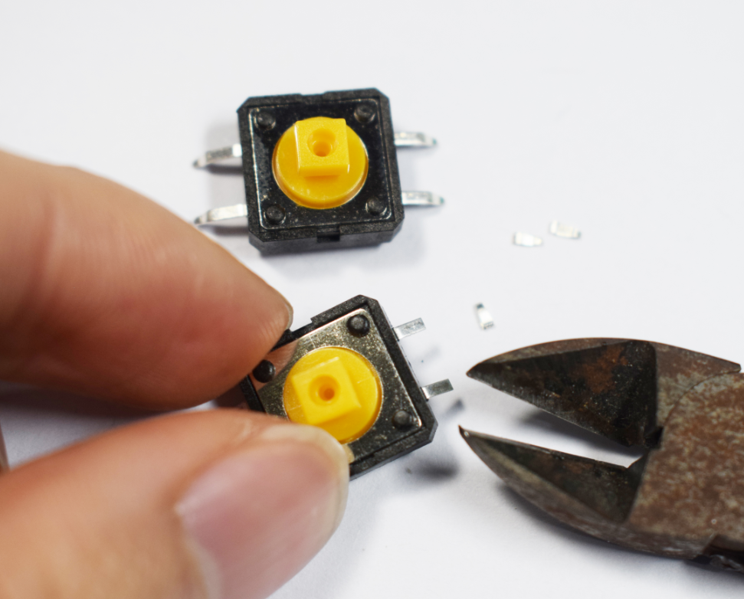

10. Welded as shown below
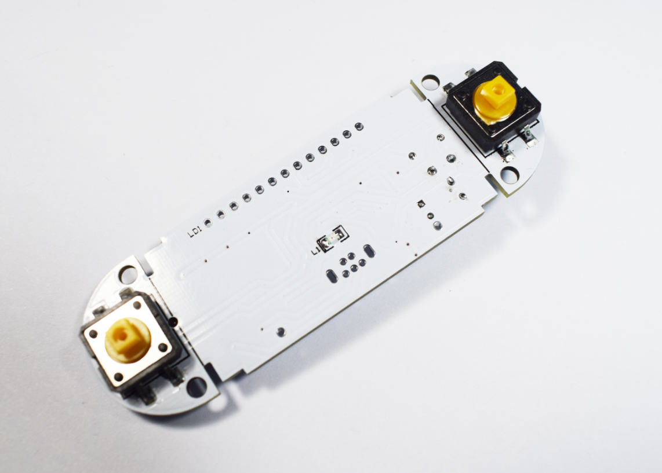

11. Soldering USB socket
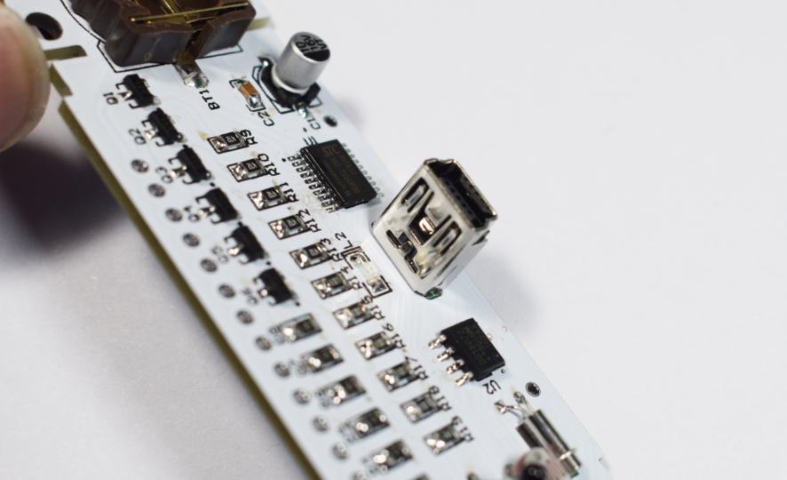

12. Weld the nixie tube, the nixie tube is pressed down and stuck, as shown below
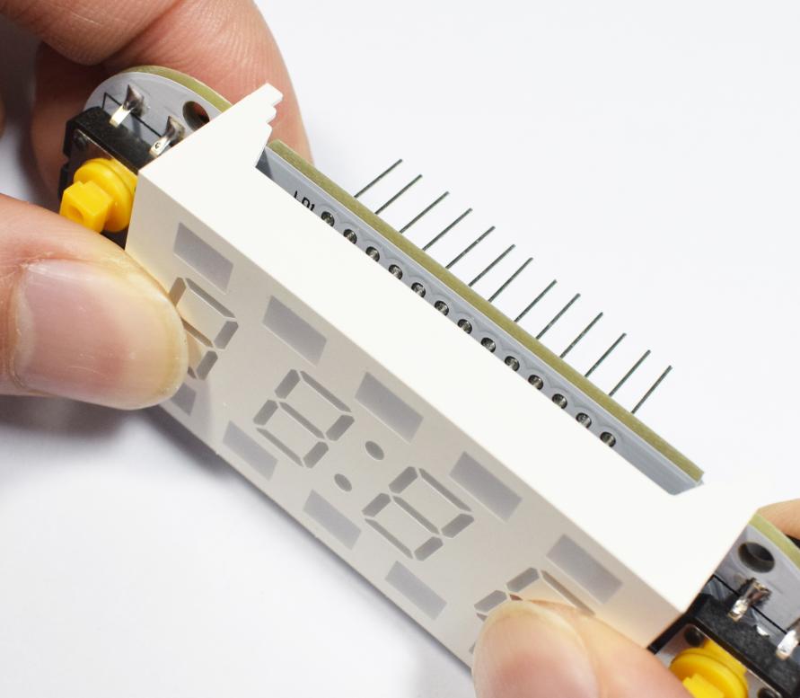
13. Cut the pins after soldering
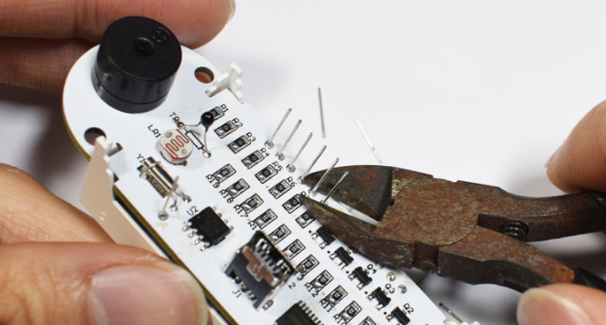

14. Please install the coin cell battery (model CR1220) before power on, otherwise the clock may display errors
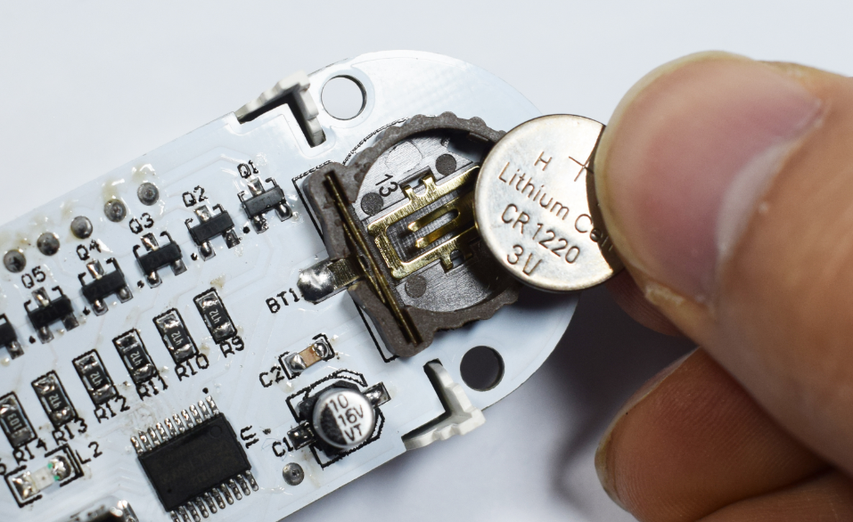
15. Install acrylic panels
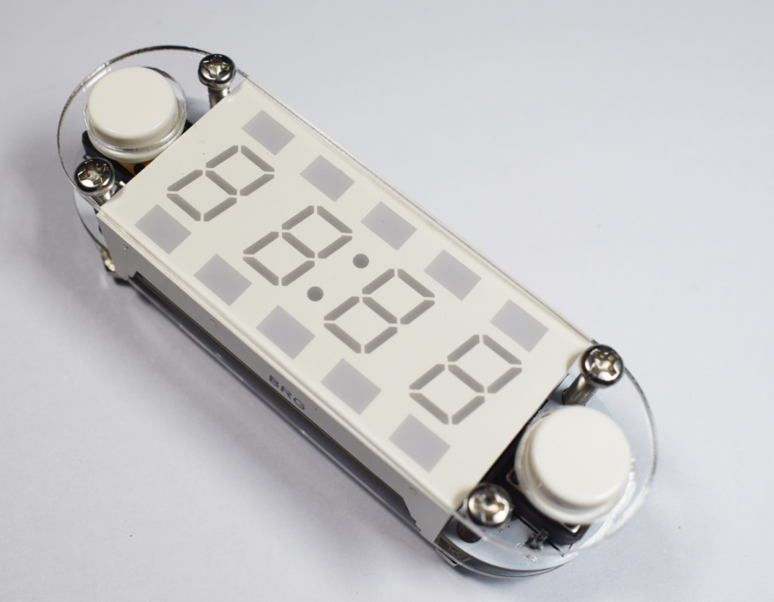

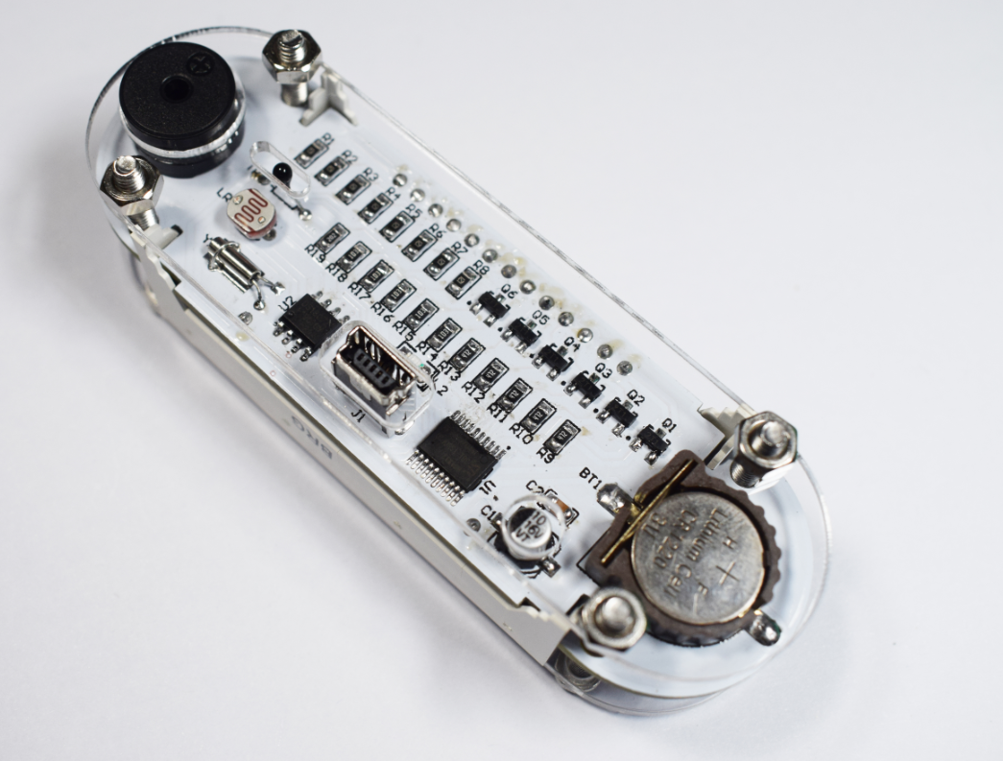
16. Plug in the USB power cable (voltage: 5V)
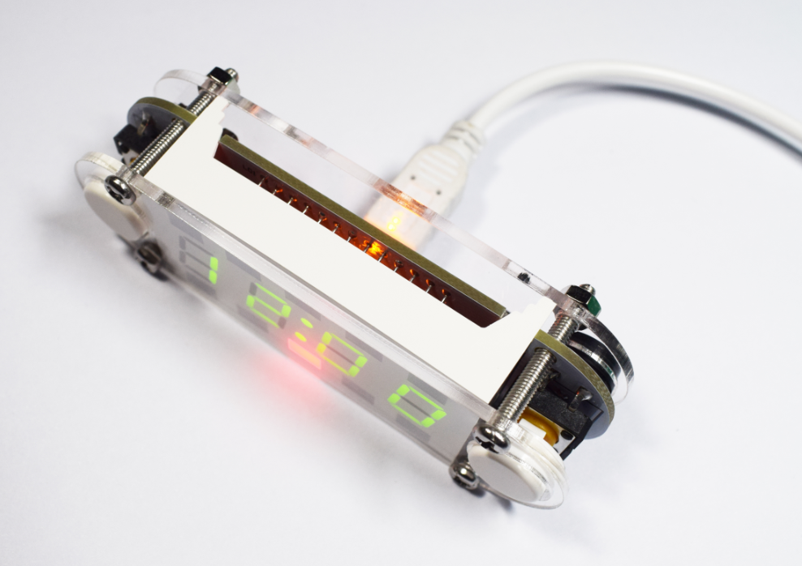

Amazing！
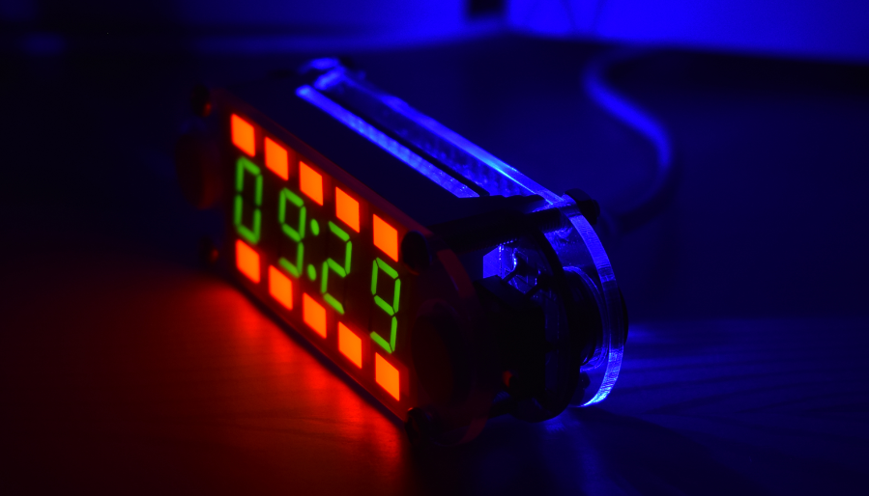

Function：
1. Press and hold the setting button (Left) for about 1.5 seconds to enter or exit the menu;
2. Short press the switch key (Right) to switch between: (Set Time)-(Set Date)-(Set Alarm)-(Set LED Mode)-(Set Brightness)- (Set Information Switching Duration)-(Set Format)-(Set Led Cube Move)-(Set Time Signal)-(Set Time Digital Transition Effect)-(Set Information Display Switching Animation Animation)-(Set Countdown)-(Enable Key Wakeup)-(Set Mid-point "Colon" Effect)-(Turn on the seconds display)- (Stopwatch Function)

Parameter Settings:
1. Time (Set Time): change the flashing parameter value by the switch key (Right), and confirm the change by setting key (Left);
2. Date (Set Date): The modification sequence is: year-month-day;
3. Set Alarm: ON- Turn on the alarm and enter the alarm time setting; OFF- Turn off the alarm
4. LED effect (Set LED-Mode): 0-turn off the backlight; 1-always on; 2-key light; 3-breathing mode; 4-candle light mode;
5. Brightness (Set Brightness): level: 1-16- (1-16 brightness); Auto- automatically adjusts the brightness according to the environment;
6. Set Switching Duration: 0-only time display; 1-switch once in 10 seconds; 2-switch once in 30 seconds;3-switch once in one minute; 4-switch once in 2 minutes; 5-switch once in 10 minutes;
7. Display Format (Set Format): The switch (Right) switches the three format settings [Time Format-Date Format-Temp Format].
Time Format: 24-Hour (24-hour mode); 12-Hour (12-hour mode).
Date Format: Month.Date: month-day mode; Date.Month: day-month mode.
Temp Format: Centigrade / .C-Celsius; Fahrenheit / .F-Fahrenheit;
8. LED Cube Move mode: 0-turn off the LED square; 1-LED square are all light up; 2-second moves one square; 3-6 seconds moves one square; 4- reverse color one Grid; 5-one circle per second;
9. Set Time Signal: Set key (Right) to switch the built-in option settings [Remind Range-Remind Way-Remind Interval].
Remind Range: Enter the reminder start time (inclusive) and reminder end time (not included). [Note] 00-00 (never remind); 00-24 (24-hour remind).
Remind Way: Both- (LED flashing + buzzer); LED- (LED only); Sound- (buzzer only).
Remind Interval: Every 15 Minutes (reminded every 15 minutes); Every 30 Minutes (reminded every 30 minutes); Every Hour (reminded every one hour); Every 2 Hours (every two Remind every hour).
10. Time Digital Transition Effect: OFF- no transition effect; 1M- transition effect every minute; 5M- transition effect every 5 minutes; 10M- transition effect every 10 minutes; 15M- every 15 minutes One conversion effect; 30M- one conversion effect every 30 minutes; 1h- one hour conversion effect;
11. Set Information Display Switching Animation: 0-Direct change; 1-Rotate animation; 2-Up and down switching animation; 3-Left and right page turning animation; 4-Up and down closing animation; 5-Blinking;
12. Set Countdown: Enter the minutes and seconds, press the set button (Left) to start the countdown, the end of the countdown LED flashes and the buzzer beep remind, press any button to exit the countdown; 99 minutes and 59 seconds)
13. Enable Key Wakeup: OFF-Off; ON-On; (Any message is displayed once after any key is turned on)
14. Set Mid-point "Colon" Effect: 0-no "colon"; 1-always on; 2-one-second flashing; 3-up-down flashing;
15. Turn on the seconds display: OFF-turn off the seconds display; ON-turn on the seconds display;
16. Stopwatch function-(Stop Watch): Press the set key (Left) to exit the stopwatch function; each press of the switch key (Right) functions as: Start-Stop-Clear; (Note: Lights up an Red LED Square after every minute, stopwatch maximum time: 10 minutes and 59.99 seconds)

