Fingerprint Lock User Manual

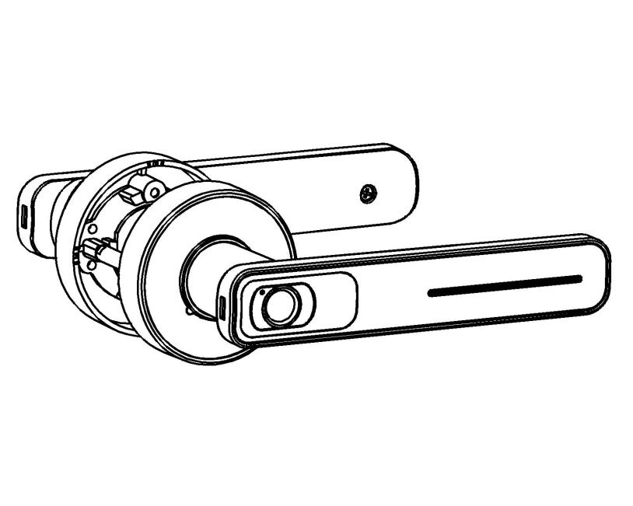

I、Product Features
- Unlocking method: By fingerprint or by key.
- Dual modes: Always unlocked/always locked. Switch as you like.
- Frontier algorithm: adopts a new fingerprint algorithm, which is mature and stable.
- User-friendly design: low voltage alarm function and emergency power interface
- Easily unlock with just one touch: The design is simple and generous. Feel the infinite charm of technology through one touch.
- Applicable places: residential areas, star hotels, commercial office buildings, villas, etc.
- Applicable doors: wooden doors, steel doors and various composite security doors with a thickness of 35-55mm.
- Suitable lock case: as shown below.
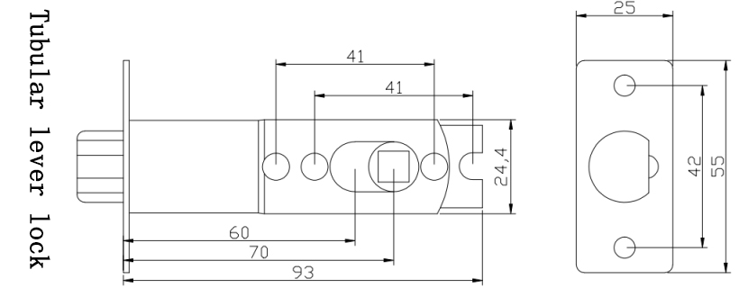
Ⅱ、Product Functions

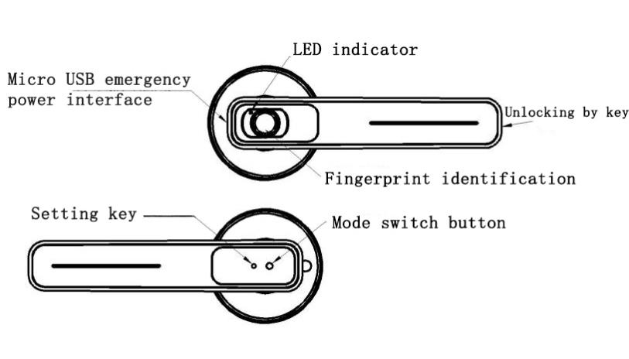

- USB Emergency power interface：When the product is out of power, the charging cable can be temporarily used for emergency unlocking.
- LED Indicator: indicates signals.
- Unlock with key: when product is dead or the battery malfunctions.
- Unlock with fingerprints: unlock with pre-set fingerprints to unlock the door.
- Mode switching button: switch between channel mode and locking mode.
- Setting button: for function settings.

Ⅲ、Installation Instructions
Warm tip: please connect the power cord to test whether it is powered on before installation

① Alternative adjustment of latch length (60mm or 70mm)，Install the lock body as shown (note inclined tongue direction and door opening direction)

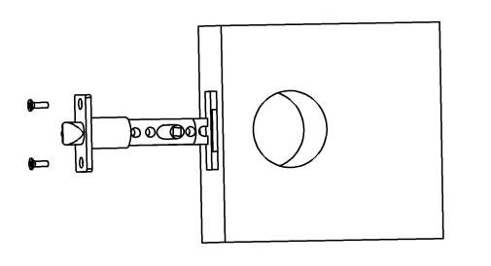
② Install the outer handle (with fingerprint head), insert the outer handle square rod and data line interface into the square hole of the lock body.
③ Install the internal handle, one hand to grasp the power cord on the four-square pole of the outer handle, the other hand to hold the internal holding hand and hold the power cord of the internal handle with two fingers. Insert the power cord with internal handle into the corresponding power cord interface on the square rod (as shown in ①), Press the fingerprint to test the power,plug the square rod and the power cord on the square rod into the corresponding hole of handle after confirming the power supply.
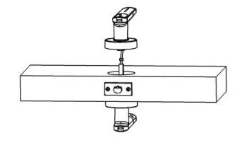
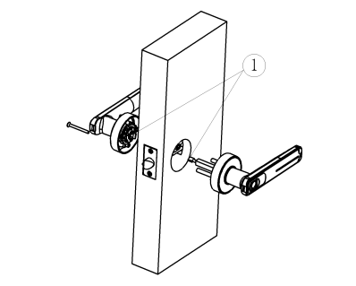
④ First install the outer screw of internal, then install the inner screw(Please note that at this time,the handle should be pressed down slightly or lifted up slightly before fixing the screw. After the screw is installed, press down or lift up to test the flexibility of the lower hand, and check whether the emergency key unlocks properly)，the installation is complete.

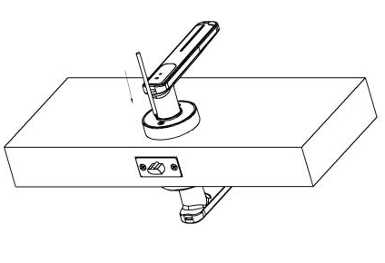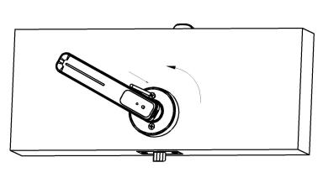

⑤ The acceptance method：
A、It’s normal not to unlock when press down the front handle without fingerprint
B、It’s normal to lock when press down the front handle with fingerprint
C、It’s normal to lock when press down or lift up back handle.
D、Press the switch button of back handle, hearing the motor turn, and no fingerprint putting on，the front handle is able to unlock, at this time it turns to channel state, the lock is normal；Press again the switch button of back handle, hearing the motor turns, no fingerprint putting on,the back handle is able to unlock, at this time it turns to locking state, the lock is normal.

Ⅳ、Operation Instructions
1) Add user fingerprints through the setting button (Registration Method 1)
To add user fingerprints, you’ll need to approve the fingerprint of the administrator. The first 2 fingerprints inputted in initial mode are the administrator’s fingerprints.
Press the setting button shortly(the color indicator flashes once) → Verify the administrator’s fingerprint(the color indicator flashes once) → input the user fingerprint(Press the fingerprint 6 times in sequence) → registration completed (blue indicator shines for 2 seconds).

- Register fingerprints through the fingerprint recognizer (Registration Method 2)
Input the administrator’s fingerprint for 10 seconds (The first 2 fingerprints inputted in initial mode are the administrator’s fingerprints.) → the blue light flashes 3 times slowly→ release the administrator’s fingerprint → put in the to-be registered fingerprint → Press the fingerprint 6 times in sequence → registration completed

Note:
①By abnormality flashes the red indicator once. After 3 consecutive abnormalities, you should start the registration all over again.
②By one whole operation only one user fingerprint can be added.

3) Delete Fingerprints:
Press the fingerprint recognizer for 2-3 seconds → till the red indicator flashes 2 times → lift the finger → Administrator presses twice → delete all fingerprints → complete (blue indicator flashes 2s with a long beeping sound)

4) Channel Mode or Locking Mode
Method 1: press the mode switching button to switch between channel mode and locking mode.
Method 2:administrator presses the fingerprint recognizer for 17s → the color indicator flashes 3 times → lift the finger to switch between channel mode and locking mode.

Note: In channel mode, press down the handle to unlock the door. The handle is in unlock status and any one can enter; in locking mode, the visitor should be verified to unlock the door. The blue indicator flashes twice, indicates successful verification.

- Reset:
Press for 5 Secs to reset the system. In this process, the administrator verification is not needed. (all registered fingerprints will be deleted after reset).

- Other Details:
① Fingerprints verification failed – the indicator flashes red for 4 seconds;
② Operation timed out or abnormal - the red light shines for 2 seconds.
③ Please do not place the stand by keys inside the house.
④ The fingerprint recognizer is precision mechanism. Wet fingers or sweat stains can cause abnormalities to the lock. Please wipe the recognizer and finger then try again.

Ⅴ、Technical Parameters
Name | Description
Battery Type | 3.7V 800mah Lithium Battery
Charging Interface Type | Micro USB
Motor Rotating Time | 500ms
Charger Power | 5V, ≤1A
Number of fingerprints | 20 includes 2 for admin.
Fingerprint resolution | 508dpi
Identification speed | 0.25s
False rate | <0.001%
Rejection rate | <1%
Working temperature | -20～+55℃
Working humidity | 40%～85%（No condensation）
Warning: DO NOT charge with rapid-charging cable!!！
Be sure to leave at least 1 mechanical key outside!！！

Ⅵ、Package Contents
Door fingerprint lock body, 2 keys, pull screw ×2, short screw ×4, instruction manual, pin, data line, three-bar ball lock body, pinch plate

Ⅶ、Opening Diagram
