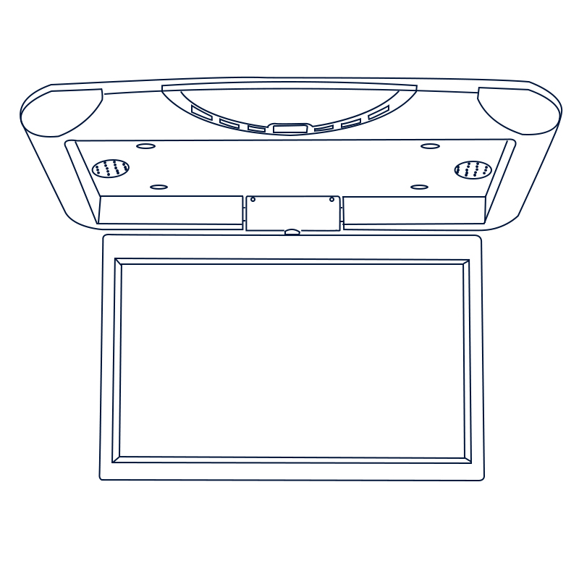

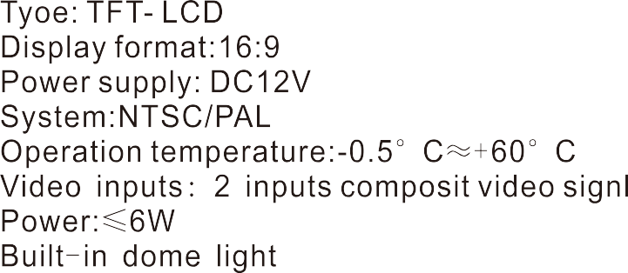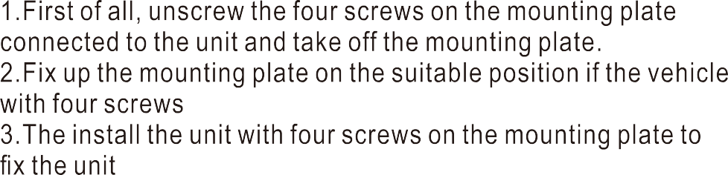

9/10.1 Inch Car Mounted Top Mounted MP5 Display
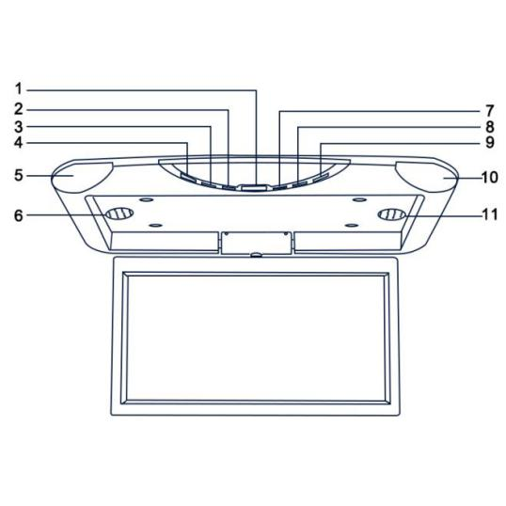
1、Screen switch
2、VOL-
3、Menu
4、Power switch
5、LED lights
6、Horn
7、VOL +
8、Screen interface
rotation key
9、Screen interface
proportional key
10、LED lights
11、Horn

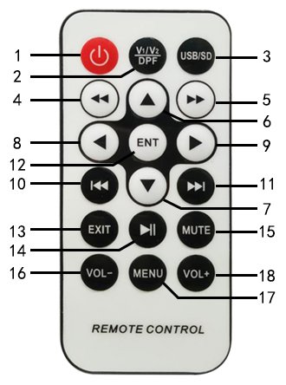
- Stand by to turn on / off
2. MP5/AV mode switch
3. USB / SD card mode selection
4. Retreat
5. Come in
6. Choose Up
7. Choose Down
8. Choose Left
9. Choose Right
10. The last song
11. Next
12. Confirmation
13. Exit / Return
14. Play / pause
15. Silence
16. Simulations reduced
17. Set Menu
18. Simulated increase

