I. Instrument Diagram and Introduction
1.1 Diagram
The diagram is only for your reference. If any discrepancy found between the diagram and actual product, the actual product shall prevail.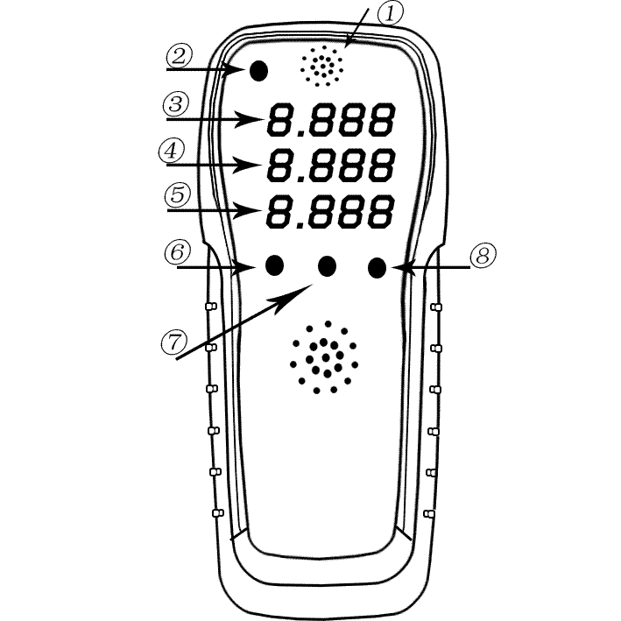

1.2 Function Button
SET ............ If you long press it for three seconds, the detection data is cleared.
PM ............When the countdown is 200 after starting, press the button for three seconds long to turn on/off the pm2.5 detection; After the countdown of 200, long press three seconds to turn off the pm2.5 detection. After opening the test for 5 minutes, close the test. The screen flashes the last test value.
ON/OFF............ Power master switch

1.3 Product Introduction
Product name: Formaldehyde detector
Product Model:GT58A
Display method: Digital display
Measurement method: Sensor sensing technology
Monitoring method: Automatic
Power supply: The 5th battery

1.4 Measurement Range and Index
Formaldehyde measurement index
Measuring range: 0.001-3.888
Volatile organic compound (VOC) measurement index
Measuring range: 0.001-9.999
Humidity range:15-90%RH
Scope of PM:0-900

II. Safety and Maintenance
1. Do not conduct measurement when the product is in a highly contaminated chemical environment, because the environment can damage the product.
2. Do not use the product when the product is in an environment that exceeds the normal temperature and humidity, because the environment will affect the measurement accuracy.
3. Do not disassemble the internal device and shell.
4. Only use a dry cloth to clean the surface of the shell softly, and do not use a damp cloth.
5. Do not let the product encounter strong shocks and vibrations (for example, falling to the ground).
6. Do not directly inflate the pressure-vent hole or block the detection hole, because this will interfere with the normal operation of the product.
7. Do not let foreign matter or moisture into the interior of the machine.
8. Do not use cloth to cover the machine.

III. Usage and Operation
3.1 Notice to Users
1. If the instrument is used for the first time or stored for a long time, please boot it outdoor or near window, and after half an hour (it is recommended that the temperature difference between indoor and outdoor can not be too high) when the value is returned to zero, use it (if the value cannot be returned to zero, please press the “SET” key for calibration zero.
2. When you use the instrument again, you can use it immediately after it has been placed outdoors or in a ventilated area for 7-10 minutes. (If you don’t want to get the test results immediately, we don’t recommend that you use the relative tests often. If you use this function, please leave it outdoors for more than 30 minutes, otherwise it may affect the accuracy of the next measurement.)
3. You start the detection: Doors and windows shall be closed before and during the detection; the detection location can be the bedroom, living room, cabinets, cloakrooms and other places. Do not block the detection port of the machine during or after the detection; you read the inspection results directly.
4. When you detect the second place, you just take the detector to the second place; after it is placed for three minutes or so, you read the values directly; it is the same to detect the third and fourth place. If there is air flow, or if the change in temperature and humidity is large, it will affect the monitoring accuracy.
3.2 Operation Instructions
①. Put the battery into the battery box on the back and install it according to the positive and negative poles
②. Test of formaldehyde and TVOC can be conducted after preheating whose countdown is from 200 to 0.
③. If Formaldehyde exceeds standard (execute according to national standard; When formaldehyde concentration exceeds 0.1mg/m3, TVOC concentration exceeds 0.6mg/m3 or pm2.5 exceeds 120ug/m3, the alarm light changes from green to red. When formaldehyde and PM2.5 seriously exceed the standard (formaldehyde exceeds 0.3mg/m3 and PM2.5 exceeds 300ug/m3), the buzzer will alarm.
3.3 Power alarm
When the battery is low, the display displays lo, which is then automatically shut down. Please properly handle the used batteries, and do not reuse them, so as not to cause the instrument to be unable to work properly.

IV. Precautions
1. Any sensor will be interfered with by certain external substances in working, so, when you use this product for detection, please avoid contact with alcohols, perfumes and other terpinoid alcohols, other chemical volatile gases, smoke and other gases.
2. The indoor air is in circulation at all times, so the air entering the sensor vents at different time points is different, and the formaldehyde content in the air may also be different. Therefore, a small amount of fluctuations in the detection values ​​is a normal phenomenon.
3. When you use the instrument, please avoid that the strong wind from electric fans and heaters blown directly to the pressure-vent hole, because it affect the accuracy of the test results. The product should be placed in an area with relatively stable air flow, so that the detection results are accurate.
4. Prior to the detection of formaldehyde and TVOC in bedrooms, living rooms, cloakrooms, etc., the windows and doors should be sealed for 24 hours, and the detection results are better. If you detect multiple points in a room, the average of readings at multiple points is the average air content in the room.

V. Use Environment
Humidity range: 15-90% RH
Pressure range: One atmosphere

VI. Common Problems and Solutions
1. Q: I am lazy and I don’t want to think hard. Is there an easiest way to use it?
A: Yes, there is. You boot the instrument in the ventilated area outside the window; after about 10 minutes, you keep in boot state; you just take it directly into the room for detection; you can get the test results 3-5 minutes after the indoor test. Except that you boot the instrument, you do not need to press any button until all measurements are completed; then you just turn it off. (If you first use the instrument, you turn it off outdoor, and the ventilation is for 24h; if you turn it on outdoor, the ventilation is 1h.)

2. Q: Why do I need to calibrate the detector when using it for the first time?
A: The necessary function of professional detecting instruments is that it shall be calibrated before detection so as to ensure the validity of the detection results. The instrument is applied to civil use from industry with more accurate and more sensitive. Please ensure that the calibration environment is outdoor pure air; the normal calibration time is more than 10 minutes; it is recommended that the calibration time of the new machine can be longer, and the calibration quality is higher, and the detection speed and detection accuracy is also higher.

3. Q: Why is it difficult to calibrate outside? Why outdoor values are high? Why these values are difficult to return to zero?
A: You need to manually calibrate it: Place the instrument outdoor and boot it; the screen will show the countdown from 200 to 0; you keep the current boot state; 3 minutes after the countdown is finished, you long press the SET key for 3 seconds, and the values are all returned to zero; you keep the current boot state; the time of outdoor ventilation is 30 minutes; you just wait for the instrument to conduct recalibration. You avoid contaminated sites in calibration; the gases emitted by outdoor vehicles or from drainage and septic tank and direct sunlight will interfere the instrument.

4. Q: The detection values are sometimes high or low, or unqualified, or unstable with low values. Why?
A: ①. The instrument calibration is unqualified. You recalibrate it by the calibration procedure, and this problem can be solved. ②. The instrument conducts detection in real time, while the air is flowing irregularly; the instrument is sensitive and immediately displays the content of formaldehyde that is exposed. It is recommended that you close the doors and windows; you keep the airflow as stable as possible in detection.

5. Q: Why does the detector always show 0.000 during indoor detection?
A: The sensitivity and accuracy of the instrument are closely related to the calibration quality and calibration time. Please relocate the instrument to the place with outdoor ventilation and recalibrate it for more than 10 minutes. The problem will be solved. The instrument can display the correct detection results after it is static for 3-5 minutes in the detection environment during detection. If the instrument still displayes “0.000”, it proves that the formaldehyde content in the air is so low that the instrument cannot sense it.

- Q: Why does the battery run out of power quickly after a new one, or even automatically shut down immediately?
A: Fake battery has almost flooded the market, general stores are easy to buy fakes, please go to the mall to buy authentic battery, formal choice, comparing the different brands and different malls such as the new battery can only use in low electric remote control use, not in the raider buggies and higher products of formaldehyde detector such as electricity use, basic judged to be fake battery or for a long time.

- Q: Why does it shut down automatically?
A: Because the battery power is too low, please replace the normal no.5 dry battery or the no.5 rechargeable battery.

8. Q: How long can the new dry battery last?
A: The normal working time of normal dry battery is about 8 hours. If it is measured every 3 to 5 days, please remember to turn off the battery when not in use. For daily use, it can be used for about 3 months. For special cases, it needs to be used for a long time.

9. Q: What are the correct calibration ways?
A: ①. Auto calibration: You place the instrument outdoors or in a ventilated area; the instrument will automatically conduct calibration more than 15 minutes (30 minutes for the first time) after boot; you can take it into the room for detection after calibration without repeated calibration and shutdown. ②. Manual calibration: If the instrument can not be automatically calibrated, or if the instrument is not used for a long time, you can manually calibrate the instrument. You place the instrument outdoors or in a ventilated area; when it displays 4-digit values after boot, you long press the SET key for 3 seconds, and place it for over 10 minutes (30 minutes for the first time); you can take it into the room for detection after calibration without repeated calibration and shutdown.

10. Q: What are the standard values of formaldehyde and TVOC?
A: The testing standards for our products are as follows:
①. Formaldehyde (HCHO) standard ≤ 0.10 mg/m³
(GB/T 18883-2002 Indoor Air Quality Standard).
②. TVOC standard ≤0.6 mg/m3
(GB/T 18883-2002 & GB/50325-2001 Class II Civil Construction Projects).
③.PM2.5 concentration standard: Qualified: ≤120ug/m³; unqualified: >120ug/m³.

Shanghai Aike Biology&Technology Company Limited

After-sales tel.: 021-60522688.

