Tutorial
MCU-PRO Library: Download
DESCRIPTION
This library is the extension of Arduino IDE for MCU-PRO Mega 2560 with additional pins. It includes several pins:
Board Pin | MCU Port | MCU #Pin
D70 | PJ7 | 79
D71 | PJ6 | 69
D72 | PJ5 | 68
D73 | PJ4 | 67
D74 | PJ3 | 66
D75 | PJ2 | 65
D76 | PD6 | 49
D77 | PD5 | 48
D78 | PD4 | 47
D79 | PG4 | 29
D80 | PG3 | 28
D81 | PH7 | 27
D82 | PH2 | 14
D83 | PE7 | 9
D84 | PE6 | 8
D85 | PE2 | 4
Note: D85 have addition function for Analog IN
- HOW TO INSTALL

For successful programming MCU-PRO in “Arduino IDE”
- Download and open zip-archive “MCU-PRO Lib.zip”;
- Open folder “MCU-PRO Lib” in archive;
- Copy folder “mcupro” from archive into “Arduino IDE” path:
“C:\Program Files\Arduino\hardware\arduino\avr\variants” – 32-bit Windows;
“C:\Program Files (x86)\Arduino\hardware\arduino\avr\variants” – 64-bit Windows;
- Find a file boards.txt in “\hardware\arduino\avr\”, add to end of file this code:
##############################################################

mcupro.name=RobotDyn MCU-PRO

mcupro.vid.0=0x2341
mcupro.pid.0=0x0010
mcupro.vid.1=0x2341
mcupro.pid.1=0x0042
mcupro.vid.2=0x2A03
mcupro.pid.2=0x0010
mcupro.vid.3=0x2A03
mcupro.pid.3=0x0042
mcupro.vid.4=0x2341
mcupro.pid.4=0x0210
mcupro.vid.5=0x2341
mcupro.pid.5=0x0242

mcupro.upload.tool=avrdude
mcupro.upload.maximum_data_size=8192

mcupro.bootloader.tool=avrdude
mcupro.bootloader.low_fuses=0xFF
mcupro.bootloader.unlock_bits=0x3F
mcupro.bootloader.lock_bits=0x0F

mcupro.build.f_cpu=16000000L
mcupro.build.core=arduino
mcupro.build.variant=mcu_pro
# default board may be overridden by the cpu menu
mcupro.build.board=AVR_MEGA2560

## RobotDyn Mega CPU w/ ATmega2560
## -------------------------
mcupro.menu.cpu.atmega2560=ATmega2560

mcupro.menu.cpu.atmega2560.upload.protocol=wiring
mcupro.menu.cpu.atmega2560.upload.maximum_size=253952
mcupro.menu.cpu.atmega2560.upload.speed=115200

mcupro.menu.cpu.atmega2560.bootloader.high_fuses=0xD8
mcupro.menu.cpu.atmega2560.bootloader.extended_fuses=0xFD
mcupro.menu.cpu.atmega2560.bootloader.file=stk500v2/stk500boot_v2_mega2560.hex

mcupro.menu.cpu.atmega2560.build.mcu=atmega2560
mcupro.menu.cpu.atmega2560.build.board=AVR_MEGA2560

- Restart “Arduino IDE”;
- Choose menu “Tools->Board->RobotDyn MCU-PRO”.
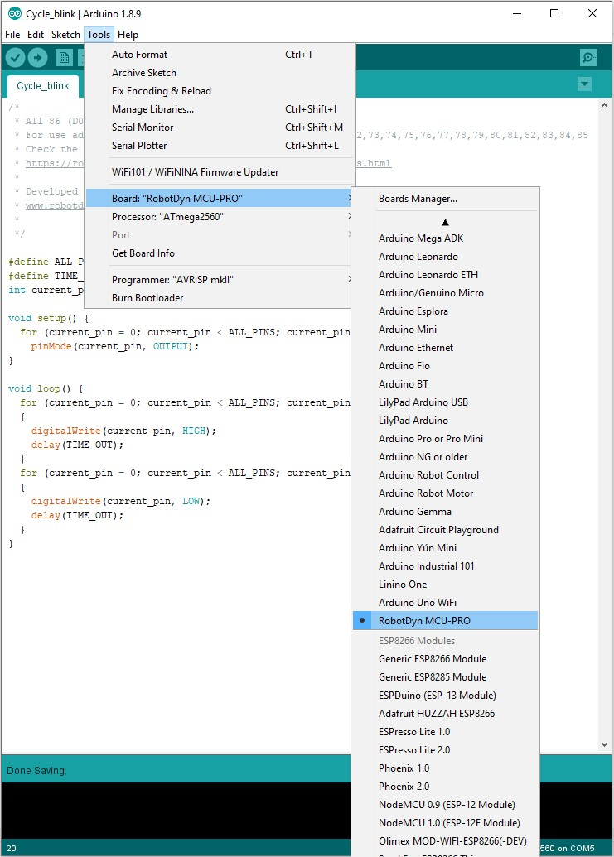
- Test & Example
For testing all MCU-PRO board pins
- Find folder “Cycle_blink” zip-archive “MCU-PRO Lib.zip” and extract it;
- Open sketch “Cycle_blink.ino” and start it.
All the pins will serially raise its state to HIGH and LOW.

