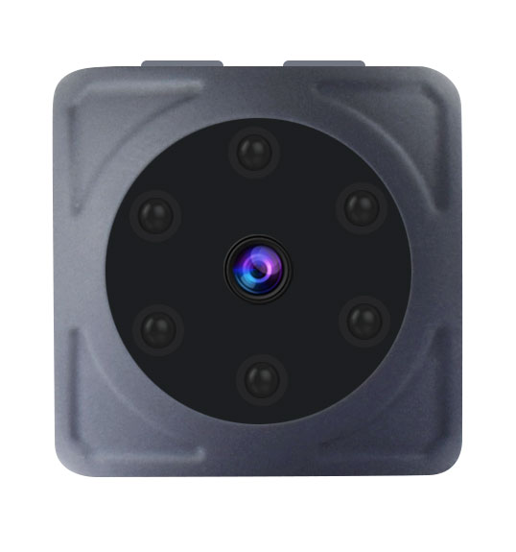

Multi-functional Camera
Operating Instructions V20.0

Note: please read this instruction carefully before operating the device,thank you!
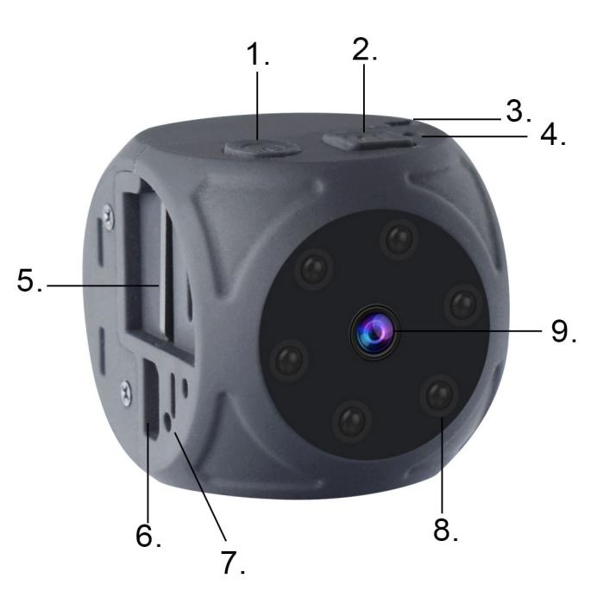
1.Power Button； 2.M-Mode Button； 3.rope hole； 4.LED； 5.TF；
6.USB； 7.Reset； 8.IR-Infrared night vision light; 9.Lens

Note:
1). insert correct memory card (TF Card) before using the device. No memory card is inserted, the red light will automatically turn off after 5 seconds.
2). no operation after boot, automatic shutdown at 1 minutes.

One. Product parameters:
Video format: AVI
Video encoding: M-JPEG
Video resolution: 1920*1080 1280*720
Video frame rate: 30fps
Photo resolution: 4032*3024
Image format: JPG
Battery capacity: about 170mah
Recording time: about 60 minutes
Charging voltage: DC-5V 1A
Storage support: 8GB-32GB
Transmission speed: USB 2.0
Interface type: Mini 8PIN USB

Two:Product Operation Guide:
The following operation is based on inserting the TF card correctly.
1).Charging:
The device is equipped with rechargeable lithium battery. When the power is weak, please charge it by below method:
1. Connect 5V charger;
2. Connect the mobile power;
3. Connect the computer USB port.
Note: the red light flashes when charging and the red light is bright when full.
2).Power on&Power off.
On: long press the power key for 2 seconds.
Off: long press the power key for 5 seconds to turn off the device.

Long press the power button for 2 seconds to boot, and the blue light is on, it enters into the standby mode.
3).720P video mode:
In standby mode, click the power button once, the blue light flashes 3 times to enter the video mode, and there is no indicator light during the recording; while recording, click the power button once to stop recording and save file, the blue light will be on, and the device is back into standby mode.
One paragraph,5 minutes, support loop recording.
4).1080P video mode:
In standby mode, click the mode button once, the red and blue lights are on. Then click the power button,the red light flashes 3 times,and all lights go off to begin recording; while recording, click the power button once to stop recording and save file. Red and blue lights will be on at the same time, and the device is back into standby mode.
One paragraph,5 minutes, support loop recording.
5).Photo:
In standby mode, click the mode button 2 times, the red light is on, and the blue light is off. In this mode, click the power button, the red light flashes once, a picture is generated and saved. To continue taking photos, click the power button again.
6).Infrared night vision lights switch:
Open: In standby mode, press the power button for 2 seconds and release,the red light flashes 2 times, the infrared night vision light is on, it can be viewed at night.
Close: In any mode, press the power button for 2 seconds and release,the red light flashes 3 times, and turn off the infrared night vision.
7).Motion detection mode (720p-1080p) :
720P motion detection: After boot, the blue light is always on, press the mode button for 3 seconds and release, the red light flashes 3 times and goes off, the blue light is on,it enters into the motion detection mode.Once detect the moving object within the range, the blue light goes off and it begins recording; after 5 minutes, the recording is automatically saved. If there is no moving object, the blue light is on and the device is in detecting state; when there is a moving object, the blue light is off and enters into the recording again.
1080P motion detection: After boot, the blue light is always on, click the mode button once, the red and blue lights are on, the device is in 1080P recording mode.Press the mode button for 3 seconds and release, the red light flashes 3 times, red and blue lights are on and the device enters into the motion detection mode.Once detecting the moving object within the range, the red and blue lights go off and it begins recording. After 5 minutes, the recording is automatically saved. If there is no moving object, the red and blue lights are on, and the device is in the detecting state; when there is a moving object, the red and blue lights are off and enters into the recording again.
Note:Press any button once to exit motion detection mode.
8).Reset:
The device is dead, the key is invalid, or don’t be used normally, and you can insert by the pointed object to the reset hole button to reset the device.
9).Recording with charging:
Connect the charger or the mobile power supply to record with charging, or you can stop recording to switch to any mode.
10) .Time Setting:
1.）Upon power on, the device will generate a time file named “TIMEREST.TXT” in the system.
2.）TURN OFF the device and connect it to a computer.
3.）Locate the “TIMEREST.TXT” file, set the desired time using format “20180101192526 Y” and save the file.
4.）Disconnect the device from the computer then turn on the device. The time set is then complete.

* Modify “Y” in “TIMEREST.TXT” file to “N” to disable the time display.The reference format is as follows:
1: 20180101192526 Y (with time watermark display)
2: 20180101192526 N (no time watermark display)

Disclaimer
- The usage of this device is subject to the relevant national laws and regulations, DO NOT use this product for any illegal activities.
- DO NOT point the camera lens to the direct sun light or permanent damage may occur.
- Keep away from fire. Never expose the device to any fire source.
- DO NOT disassemble and modify. Doing so causes the risk of electric shock, burn injury and other health related hazard.
- DO NOT let water, liquids, or foreign matter get inside the device. Extra precaution is advised where it is raining, snowing, near the ocean or other form of water. In case any of the symptoms are present, turn off the device immediately and contact us for further support.
- DO NOT drop the device or permanent damage may occur.

