F6F Assembly Manual 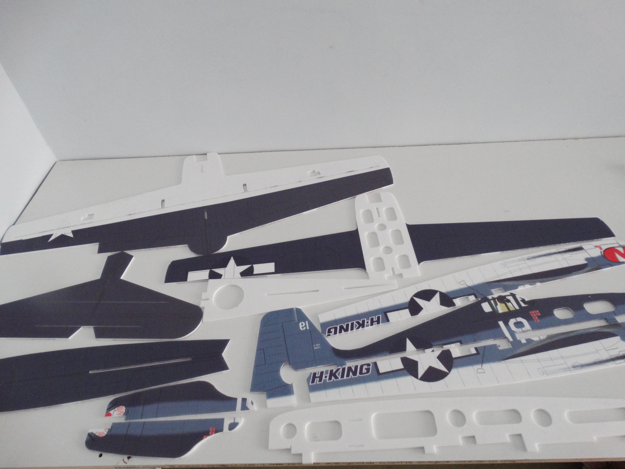

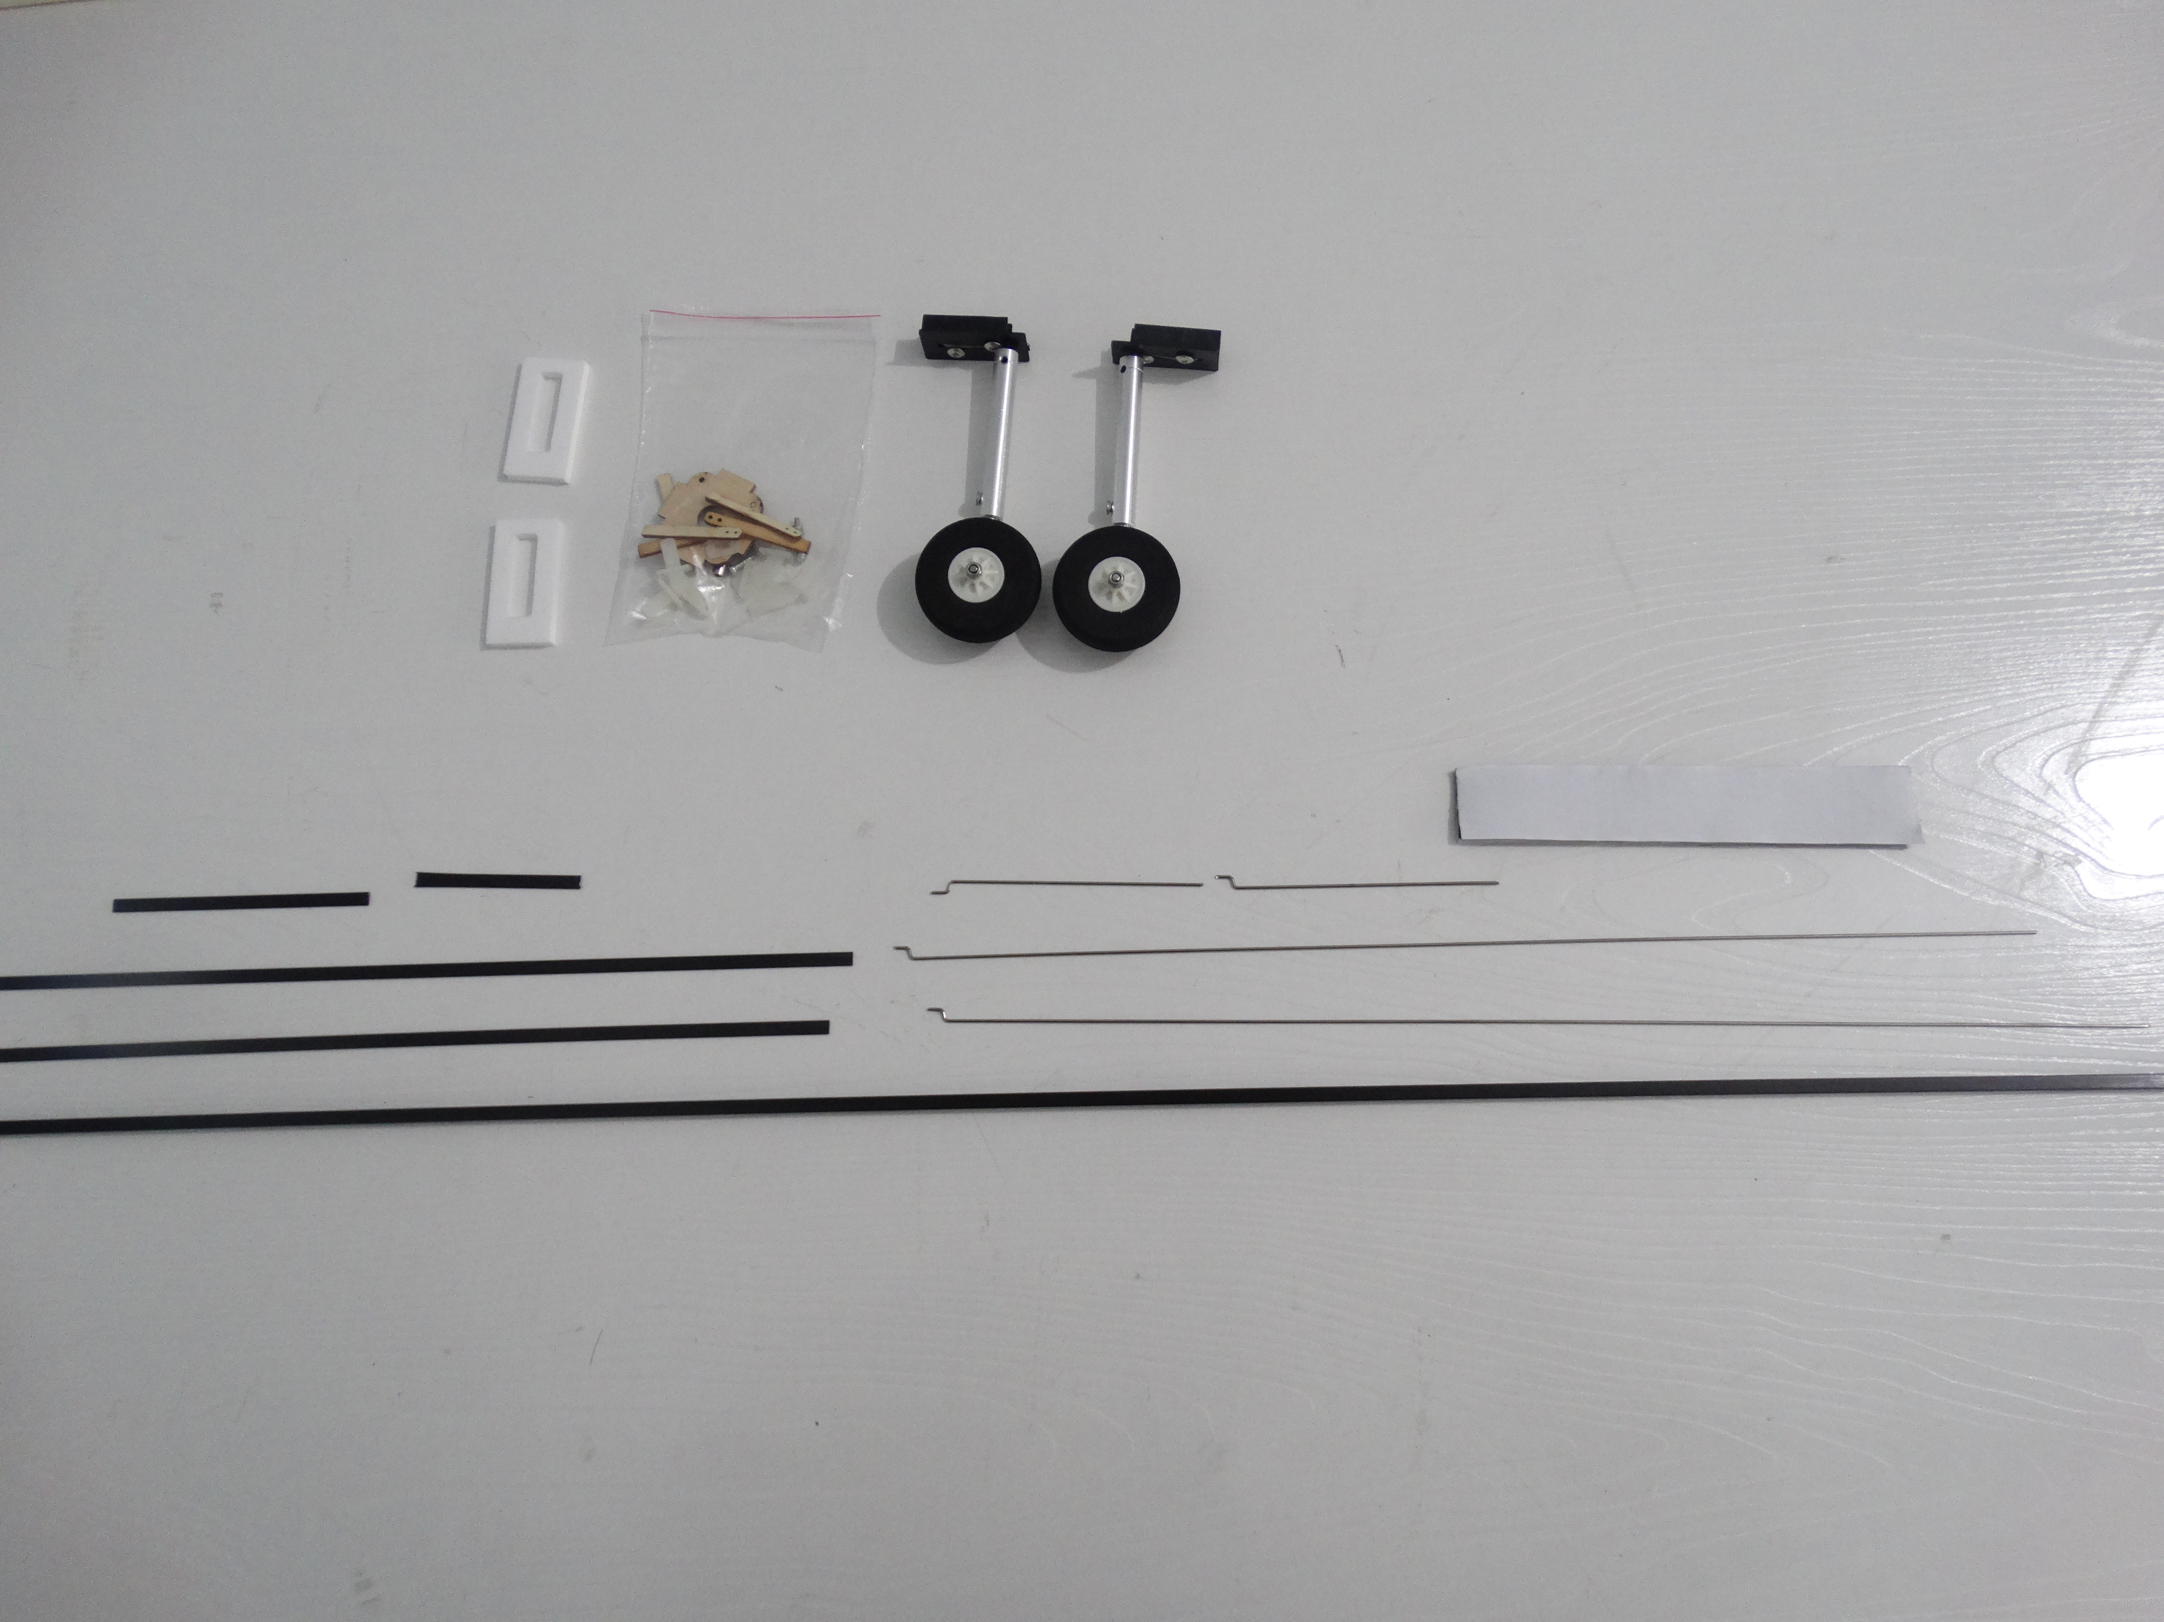

Packing list：
1: PP F6F fuselage *1
2: Carbon tube 5*5*940mm*1
3: Pull rod *4
4: Motor mount *1
5: Quick rod adjuster *4
6: Hinge*4
7: M3 screws*4
8: Hook and loop tape*1
9: Wood strip*4
10: Carbon strip *4
11: Landing gear *2
12: PP sheets *2
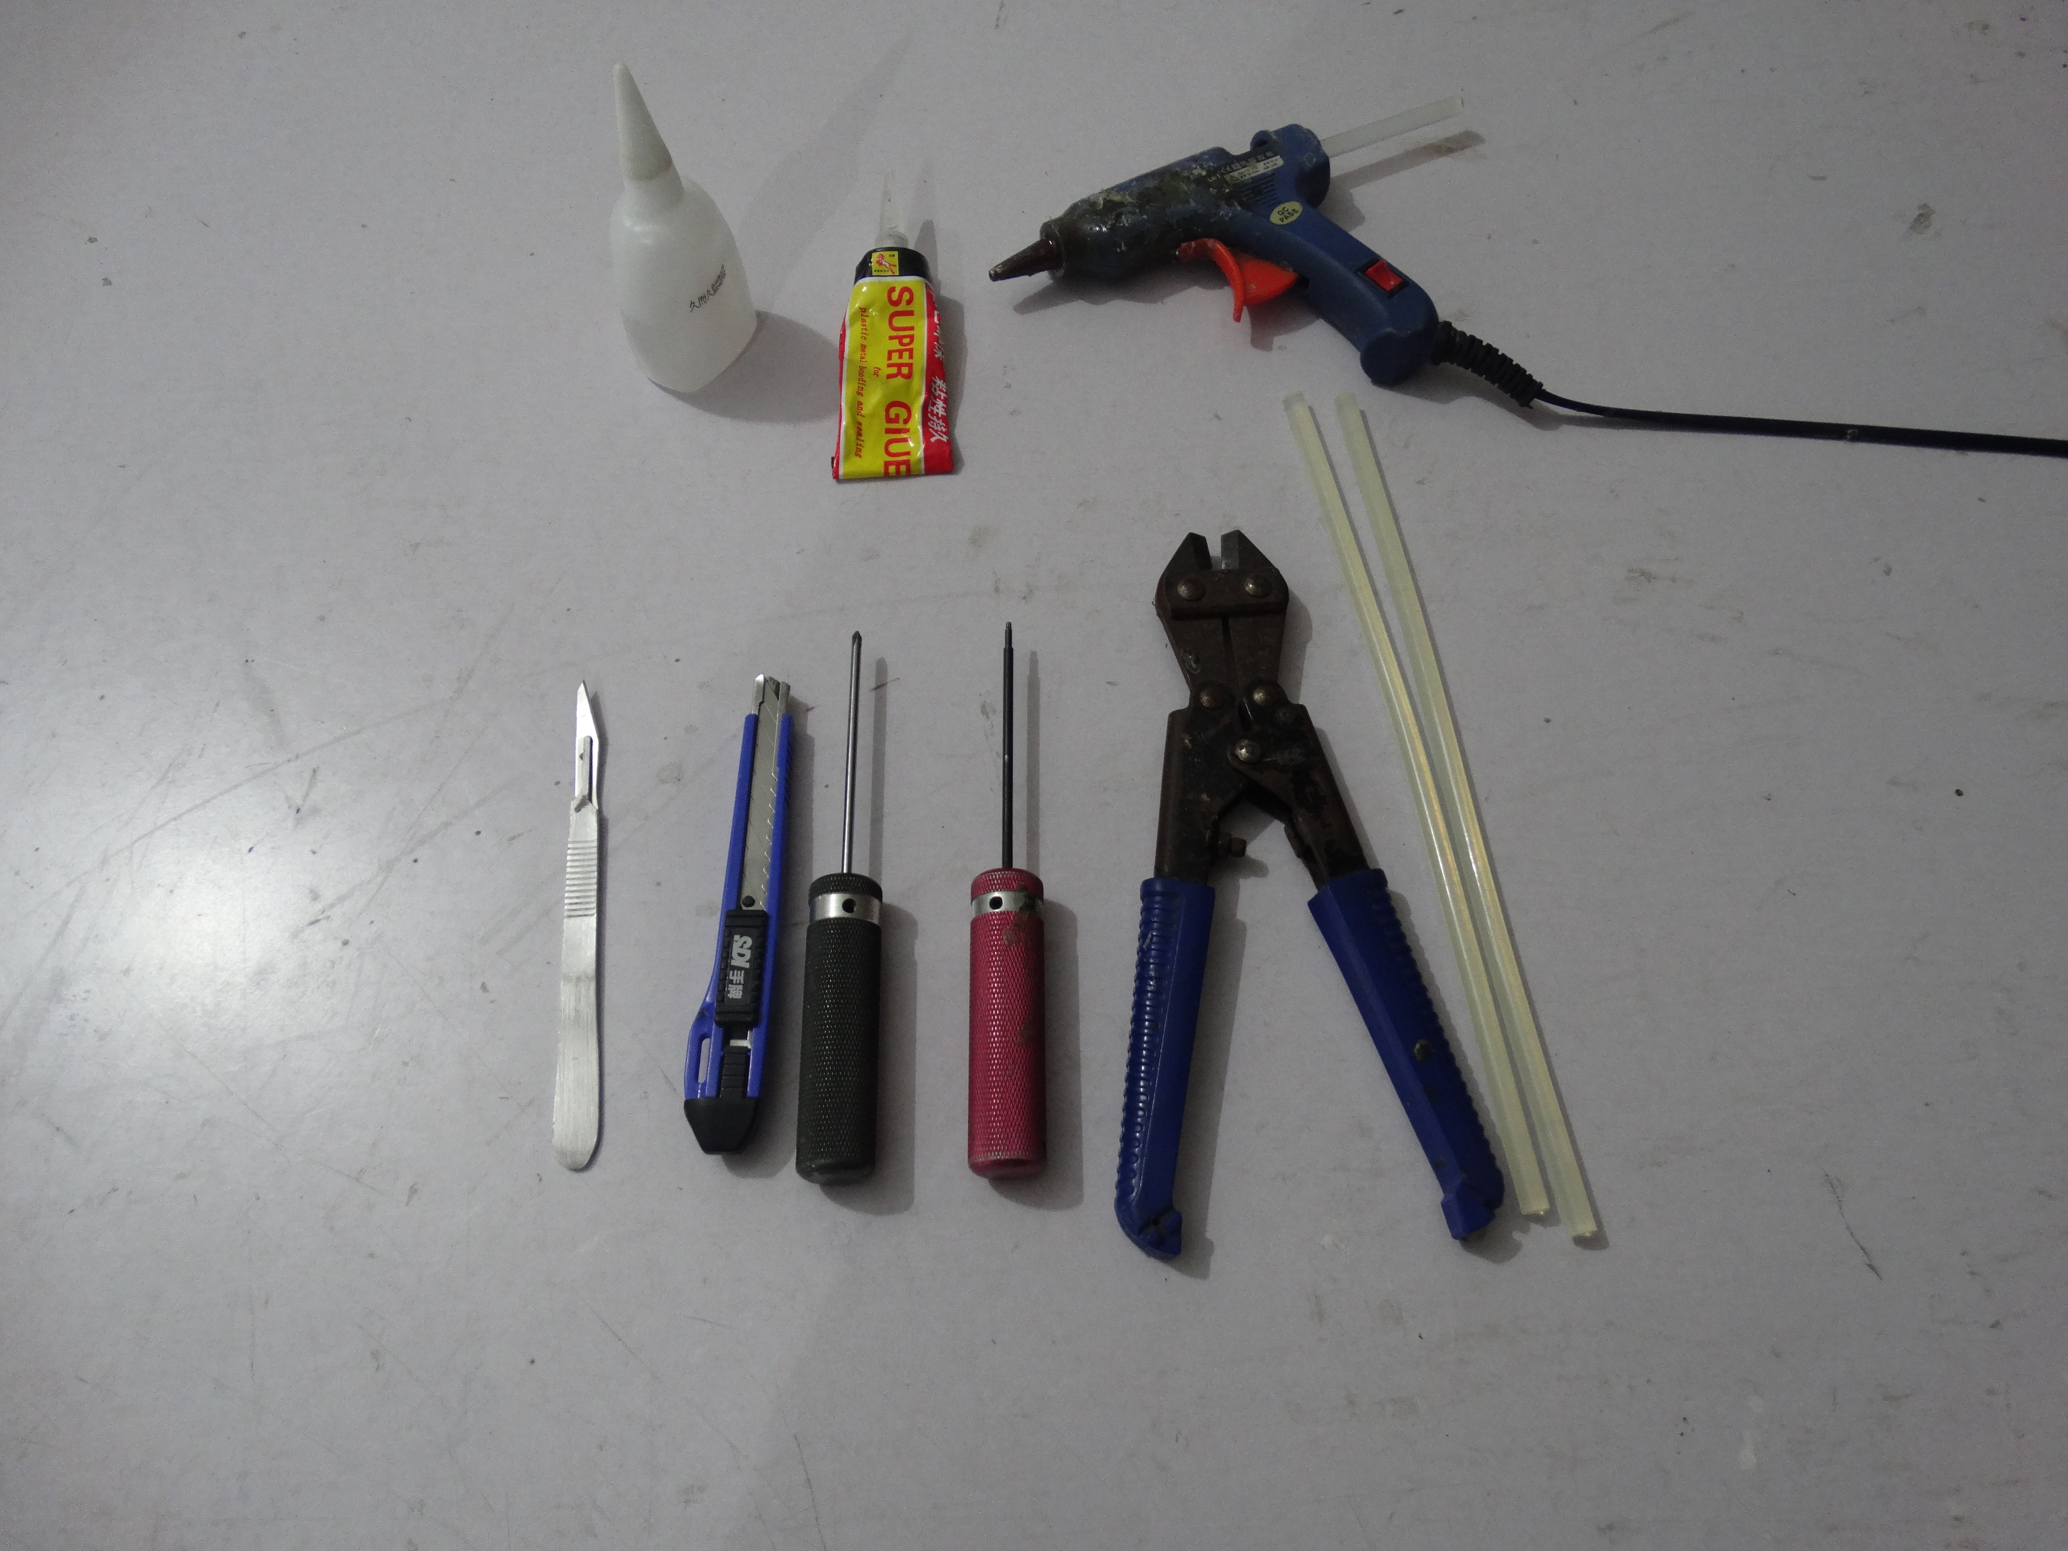
Tools：
1: 1.5mm allen wrench
2: Phillips screwdriver
3: Modelling knife
4: Wire cutters
5: Hot melt glue gun and glue sticks
6: Foam Glue
7: No.502 glue

Electronic equipment：
Motor：2208-2212-2216 1400kv *1
Prop：8 inch *1
ESC：20-40A*1
Servo：8/9g *4
Battery：1300-2200mah 3S *1

Assemble the 3 pcs bottom fuselages using foam glue.
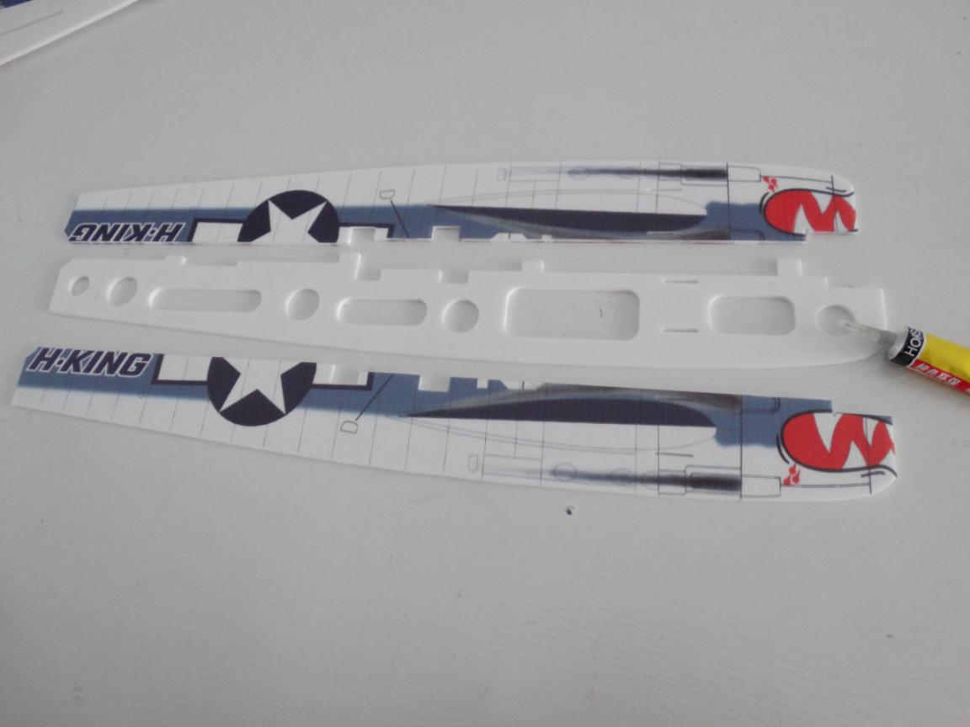

Press it after assembly.
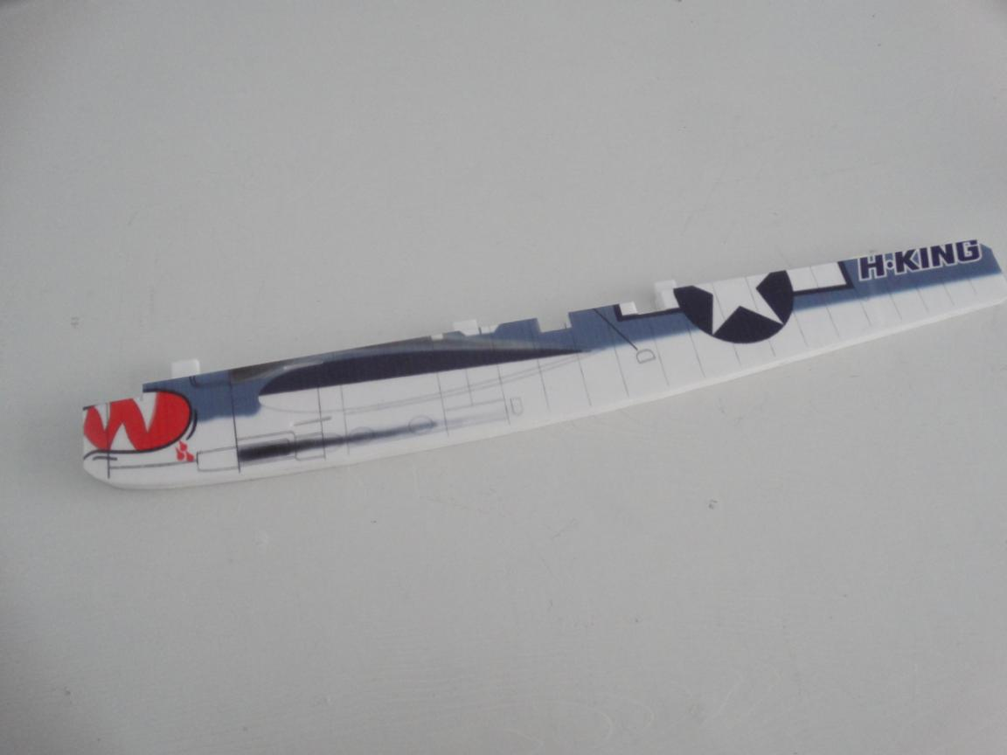

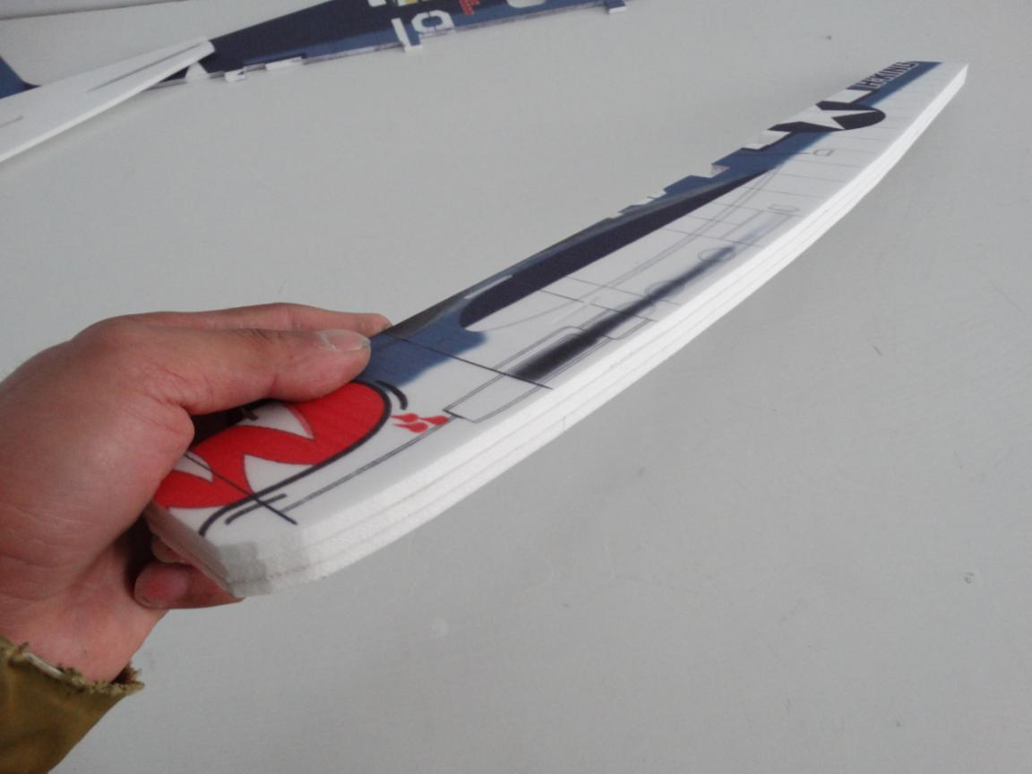

Assemble the 3 pcs top fuselages using foam glue.
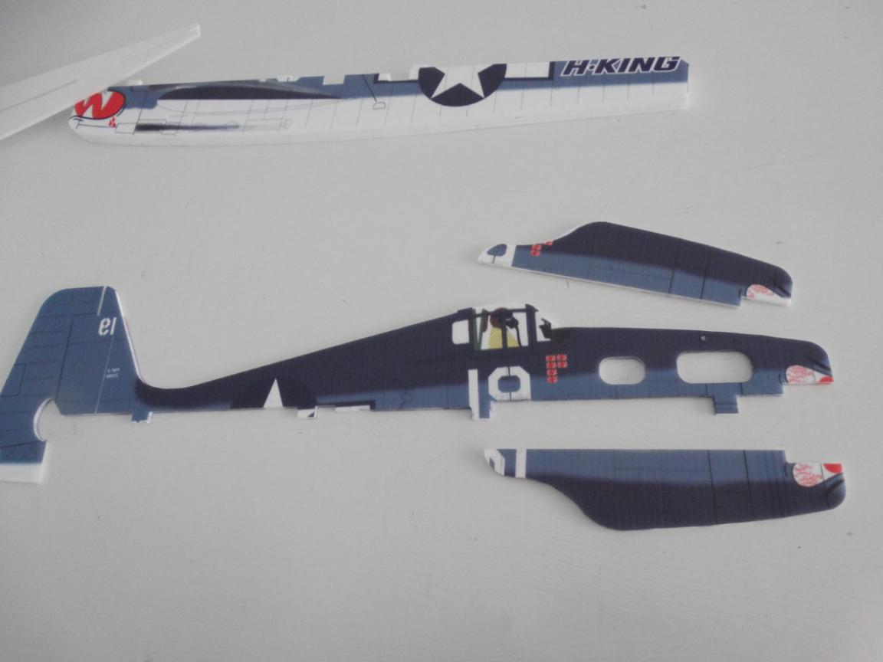
Press it after assembly.
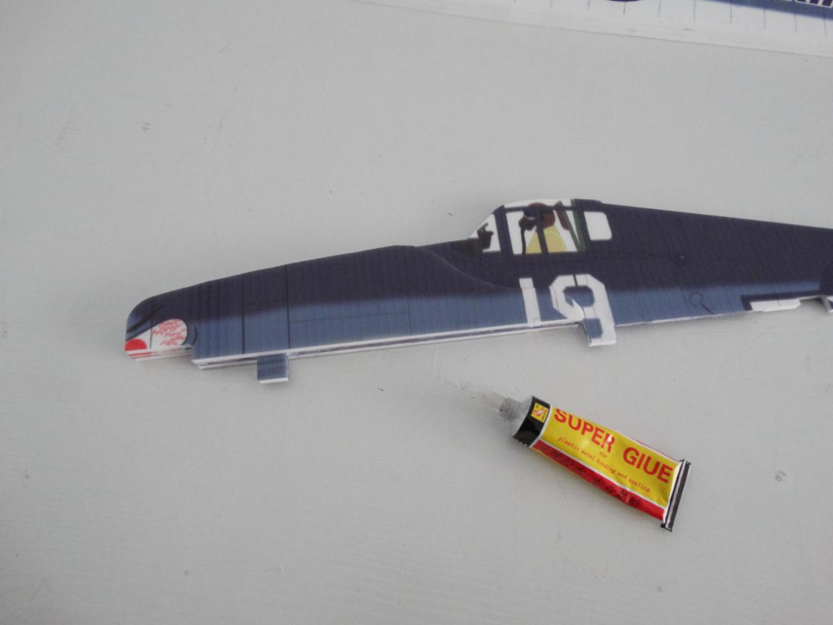

Install the carbon tube into the wing. Important: don’t glue the carbon tube now!
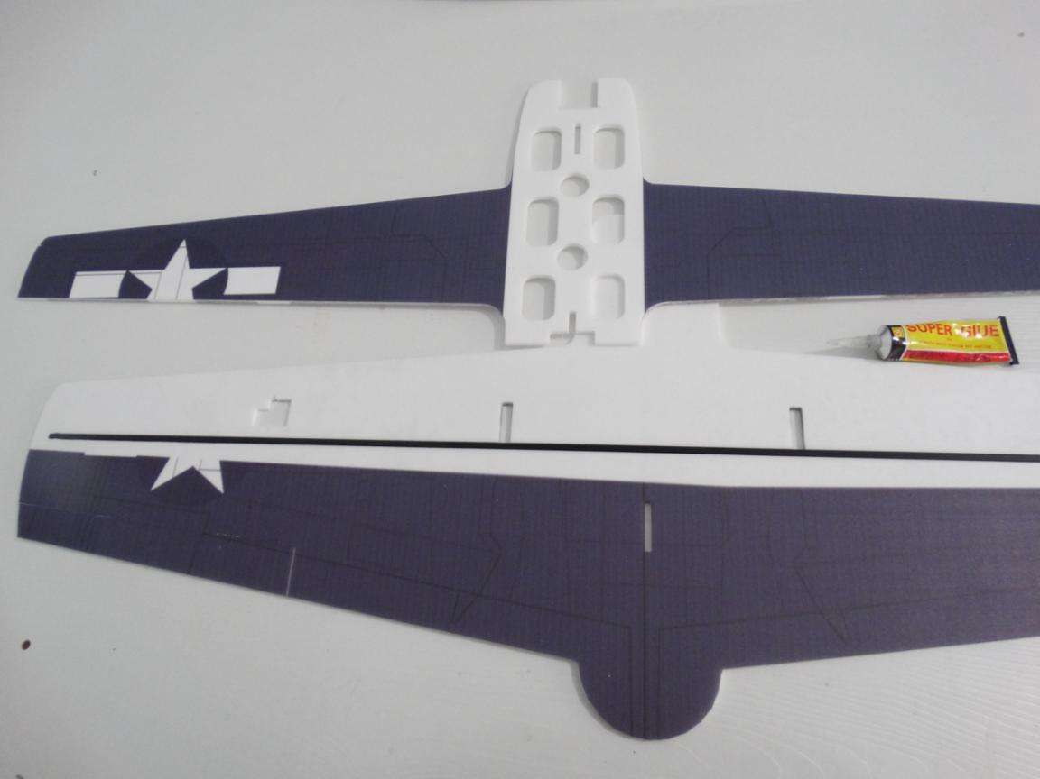
Assemble the 2 pcs wings using foam glue. Make sure 2 pcs wings trim.

Assemble the mid horizontal fuselage on wings using foam glue. Make sure all parts trim.
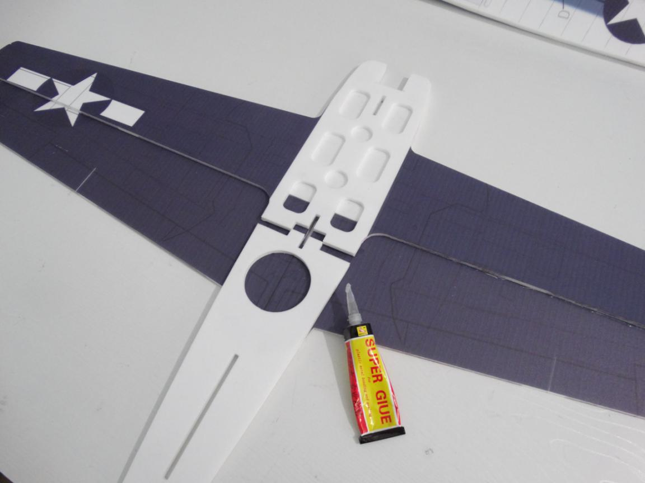
Assemble the horizontal tail and fuselage using hot glue sticks.
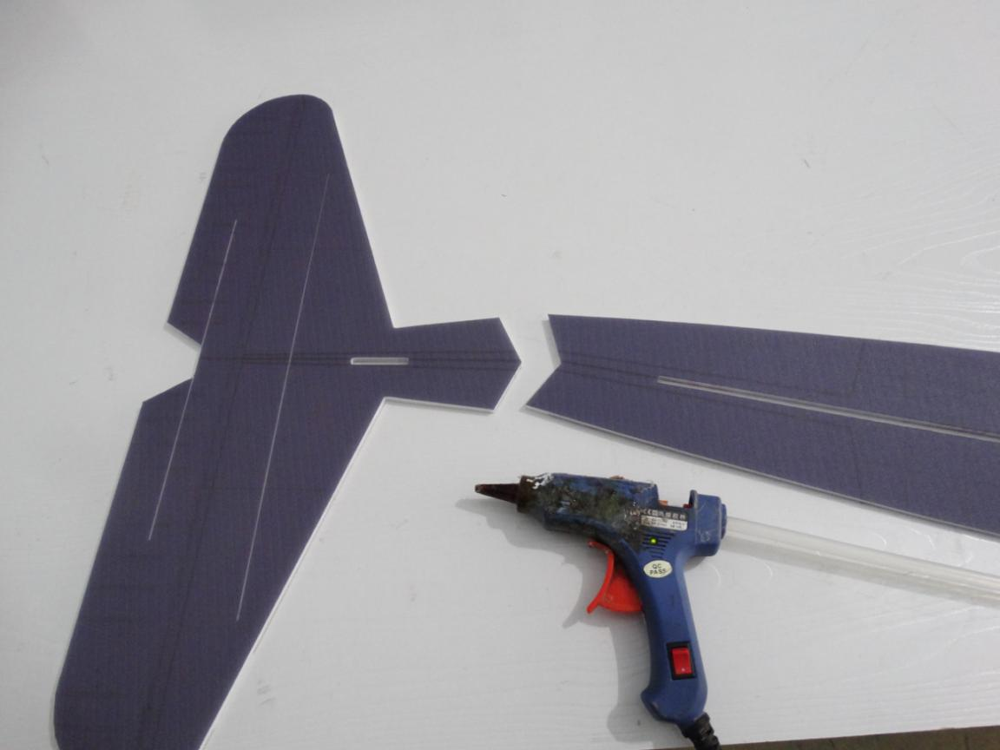

Wait glue dried.
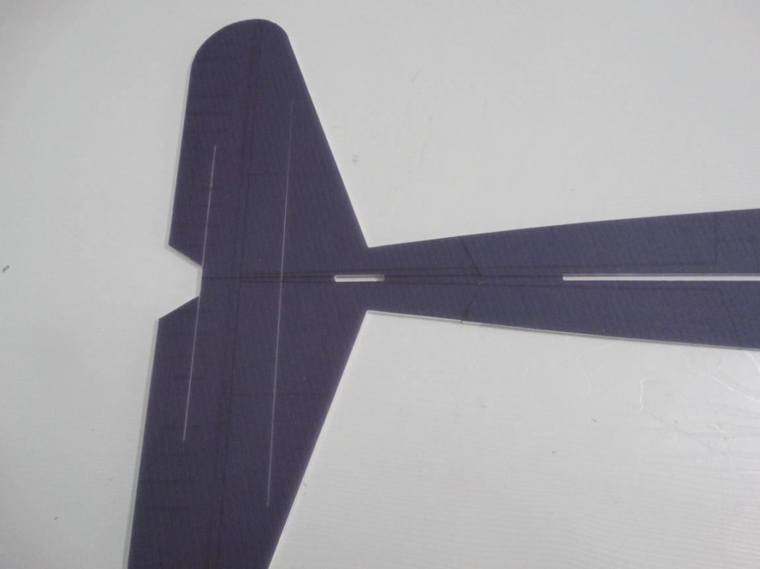
Install the 2 pcs carbon strip into the horizontal tail and glue them using No.502 glue.
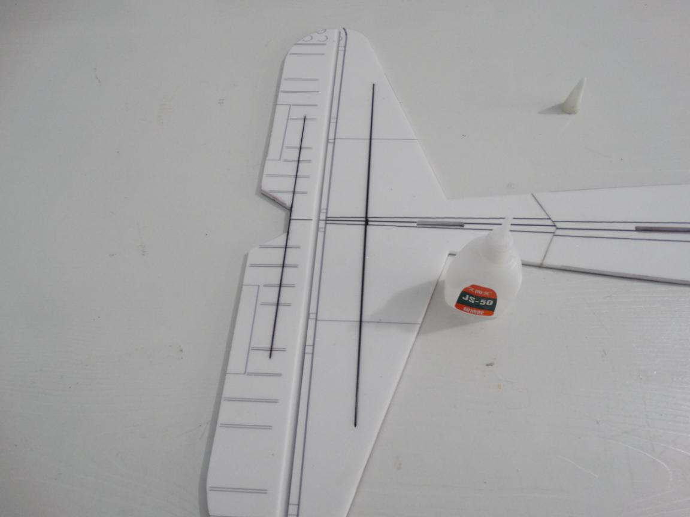

Assemble the bottom horizontal fuselage on fuselage using foam glue.
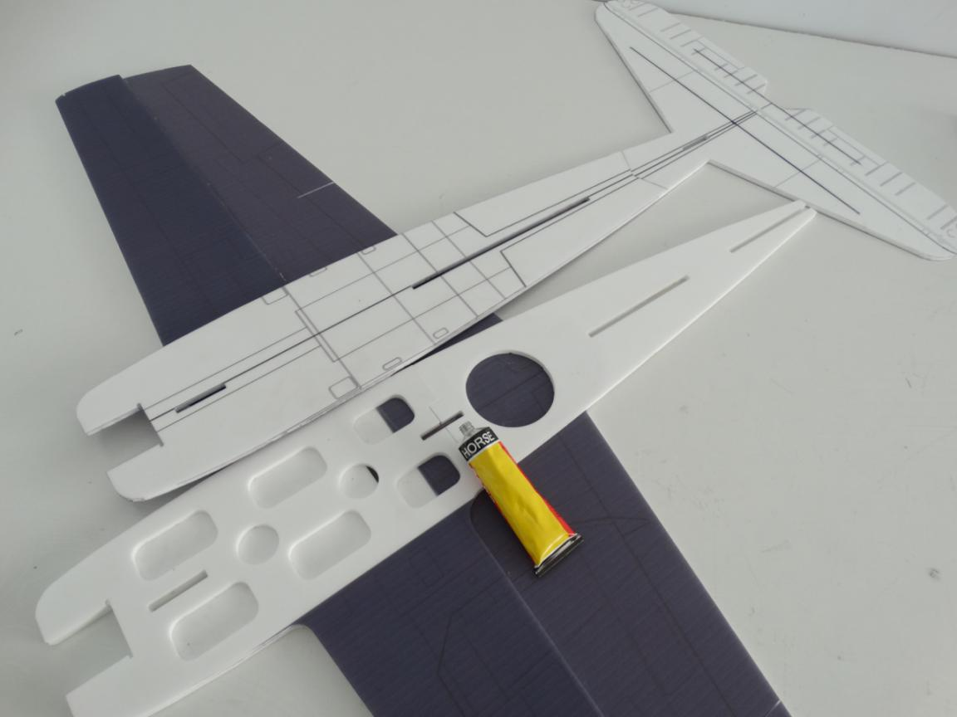
Make sure all parts trim. Especially the hole.
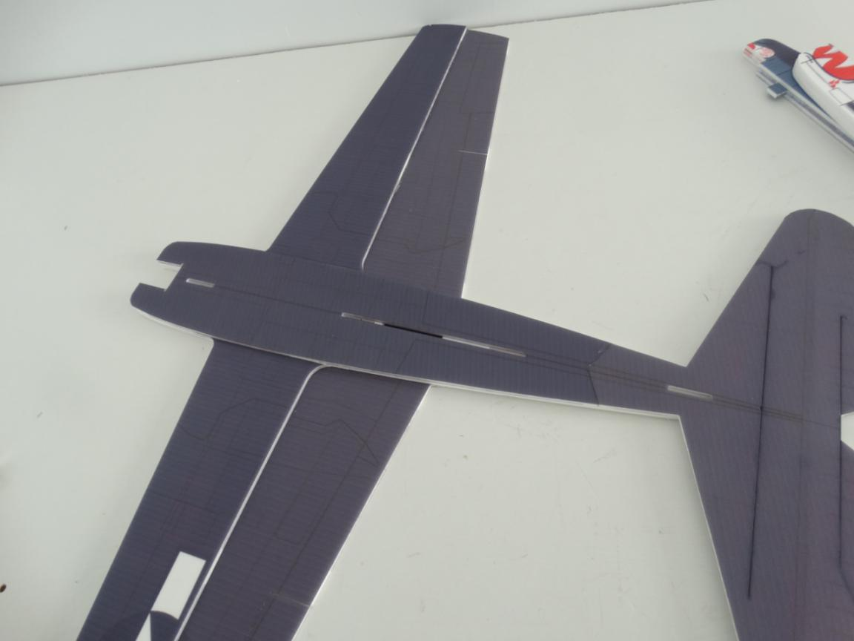

Turn over fuselage after assembly. Reinforce wing and horizontal tail using foam glue. Then glue the carbon tube using foam glue or No.502 glue.
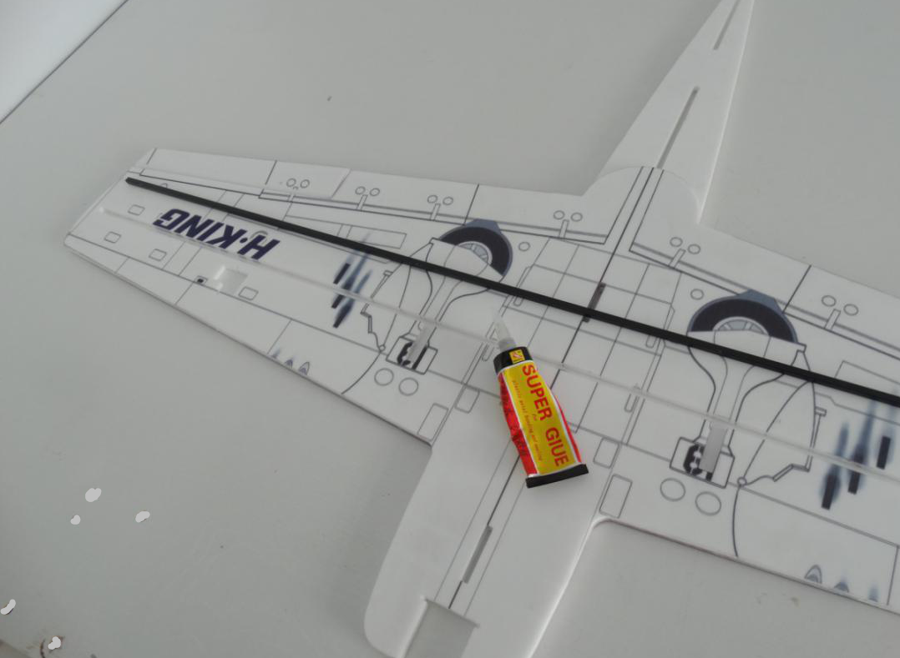
Install the carbon strip into the vertical tail and glue it using No.502 glue.
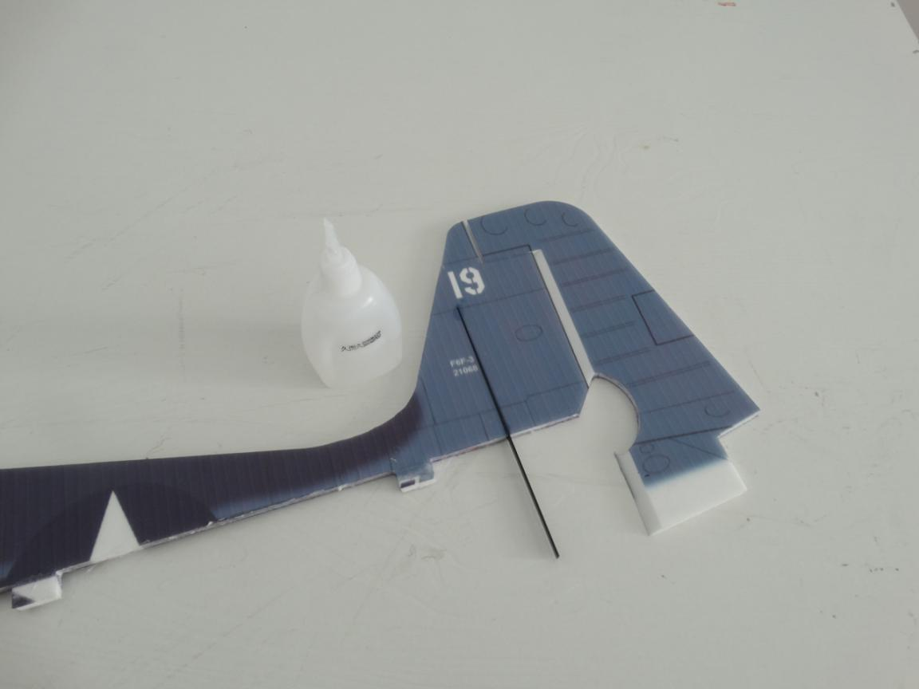

Wait glue dried. Then assemble bottom fuselage into the horizontal fuselage using foam glue.
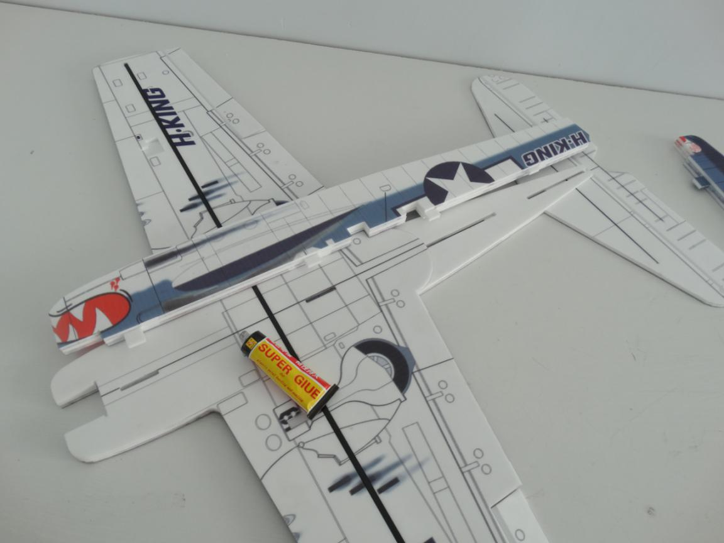
Install motor mount on fuselage after assembly using foam glue.
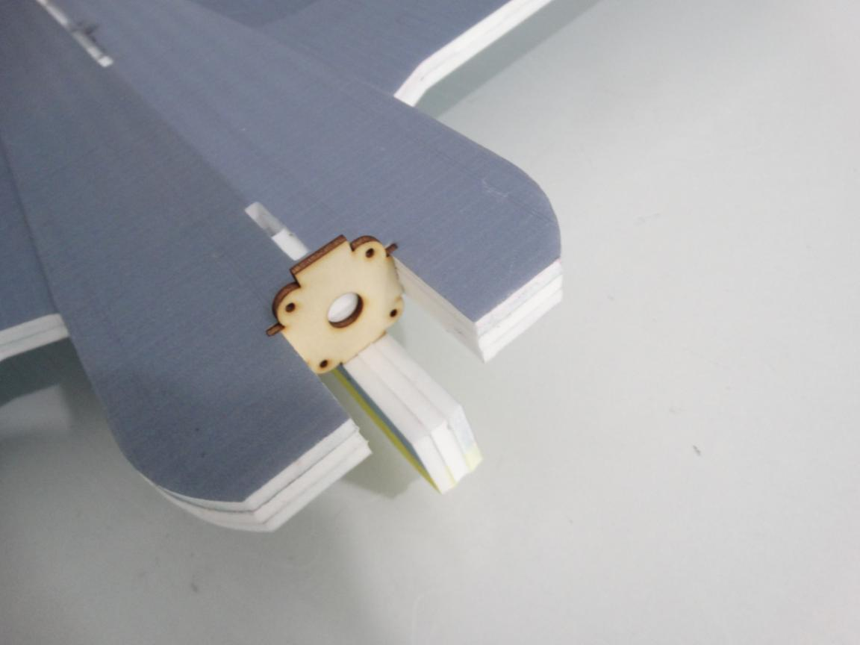

Applying foam glue on top vertical fuselage and horizontal fuselage.
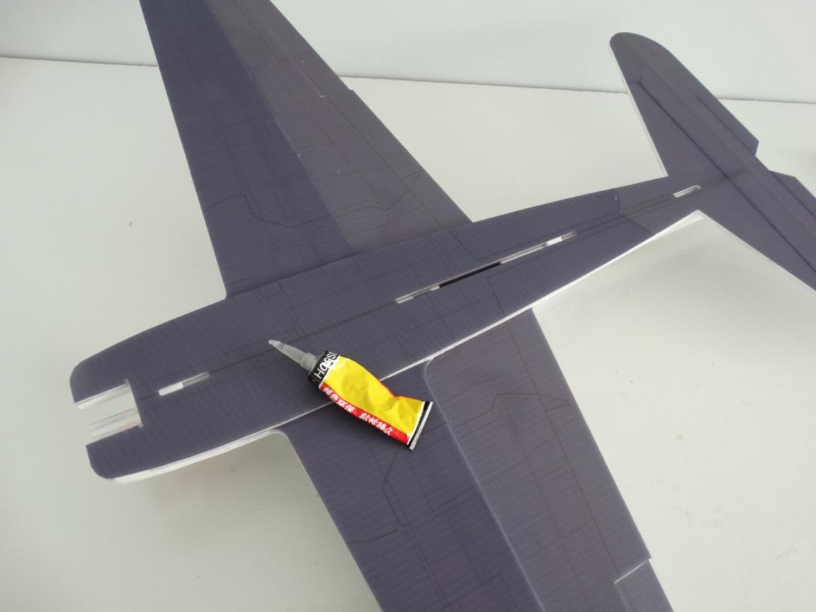
Press the carbon strip into the horizontal fuselage’s hole first. Then press the top vertical fuselage into horizontal fuselage.
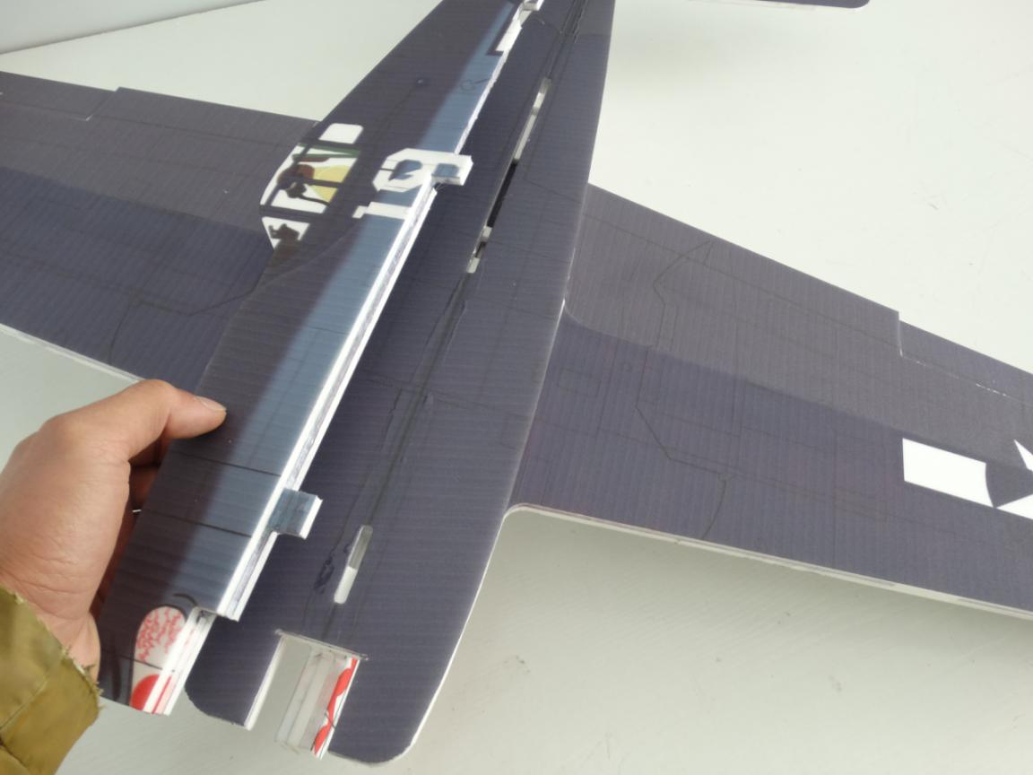
Reinforce all bonding parts using hot glue sticks. Especially for weakness point as shown picture below.
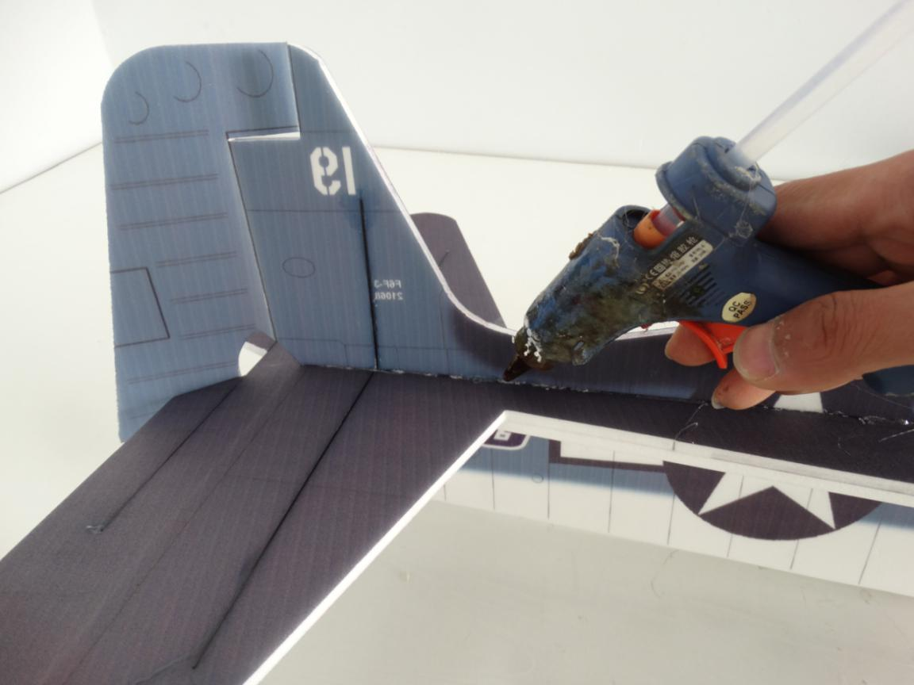
Assemble 2 pcs PP sheets on wing using hot glue sticks. Make sure the hole trim.
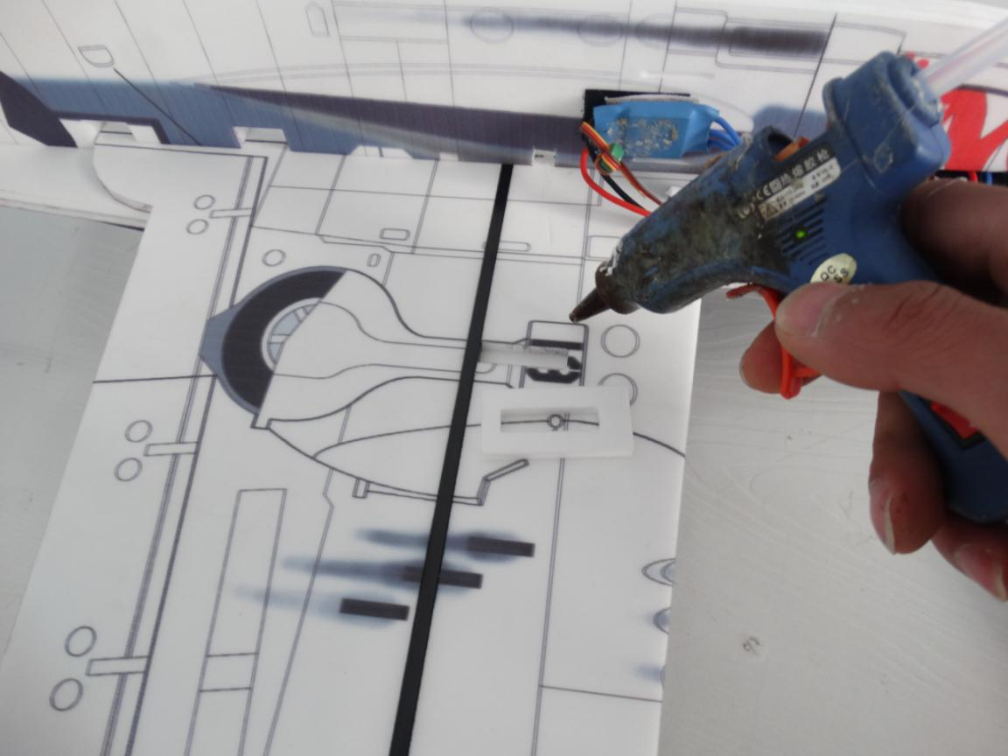

Install the landing gear on the PP sheets using hot glue sticks as shown picture below.
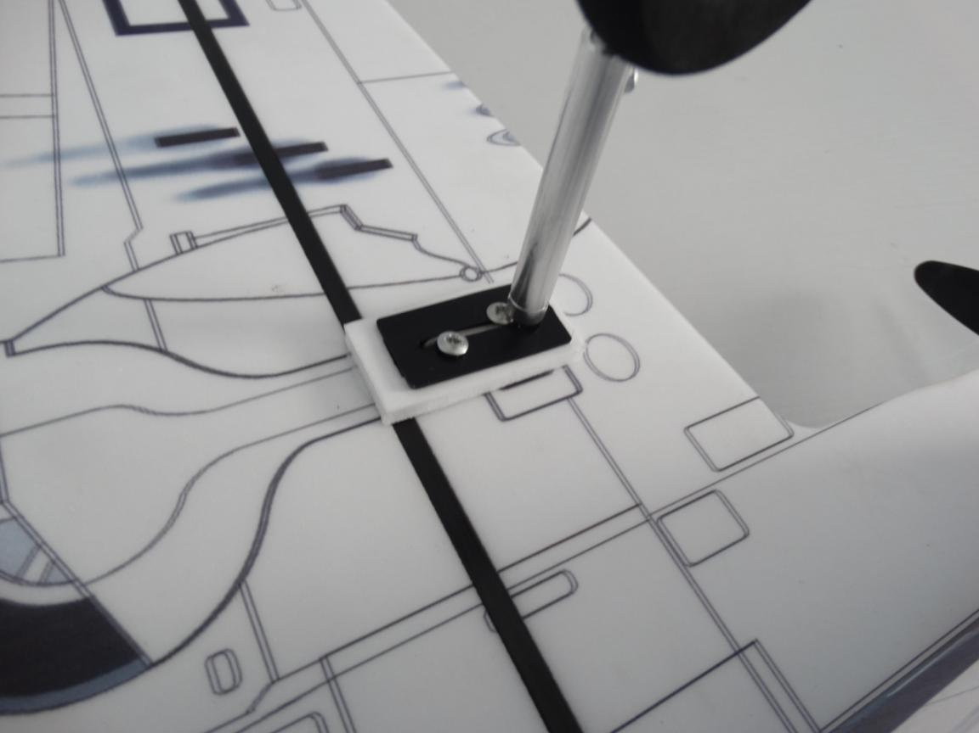
Install the shortest carbon strip into the hole using No.502 glue.
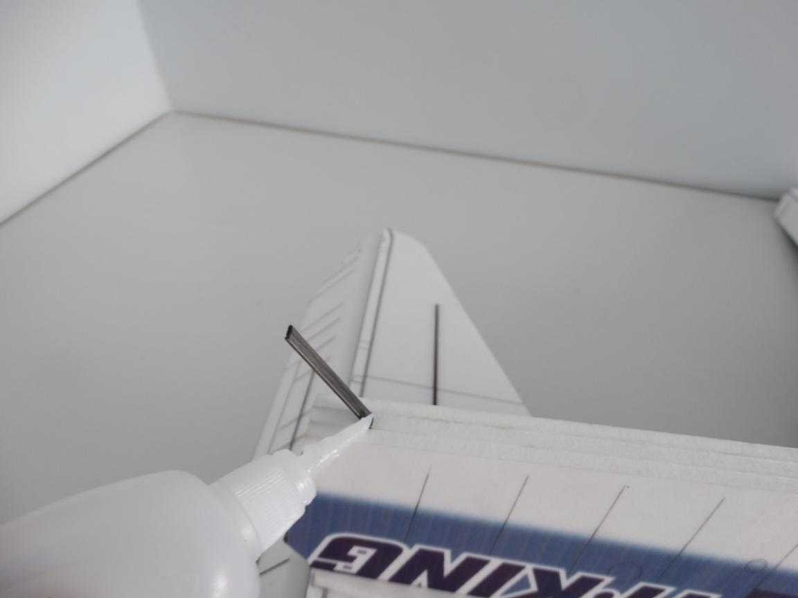

Glue the rudder on vertical tail using foam glue. Important: must applying foam glue even the rudder don’t fall off!!!
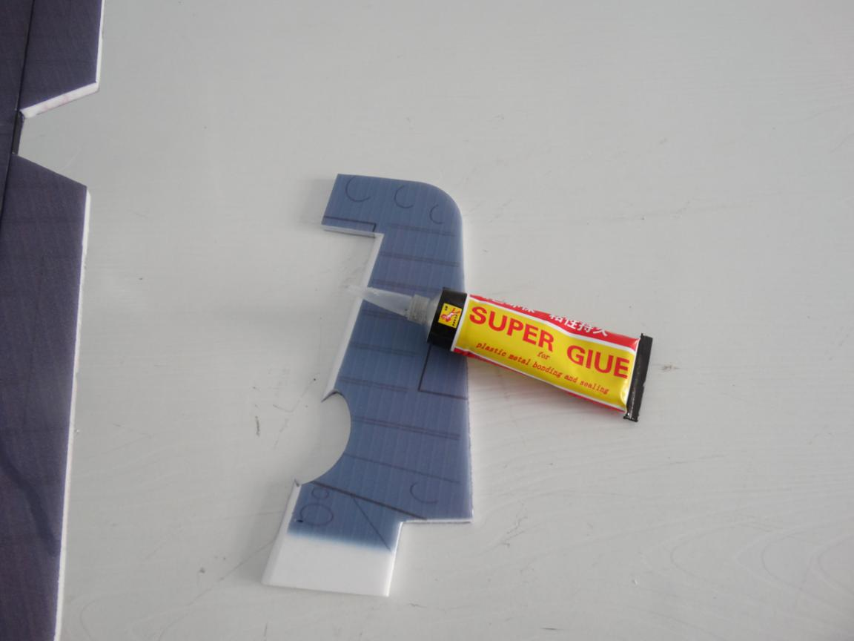
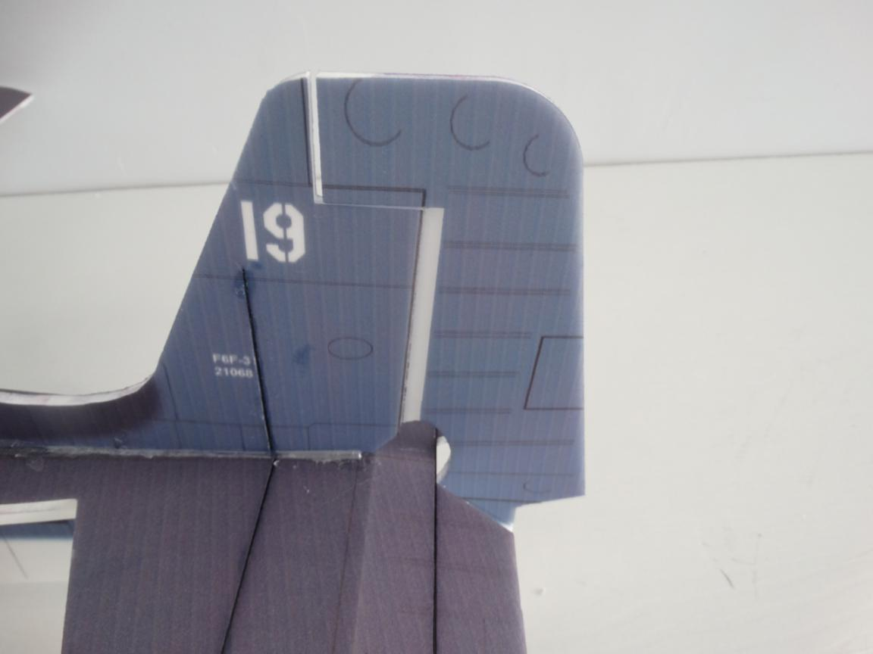

Assemble motor on the metal cross using screws.
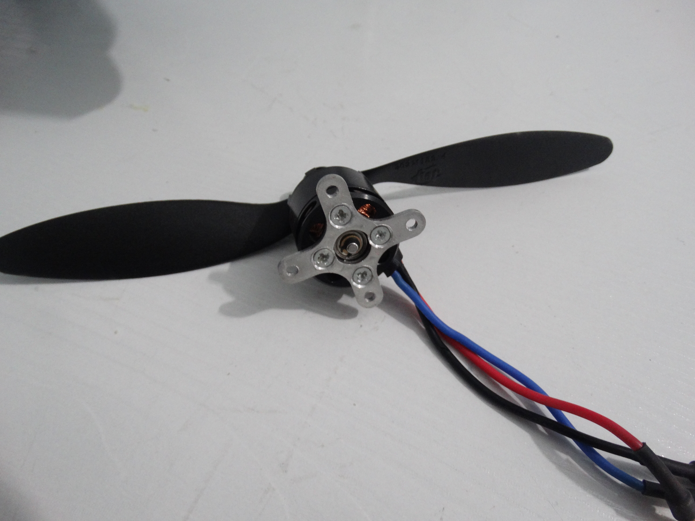
Assemble the metal cross with motor on the wood motor mount using the 4 pcs M3 screws. We can choose 1.75 inch Cowling on motor to make it more beautiful.
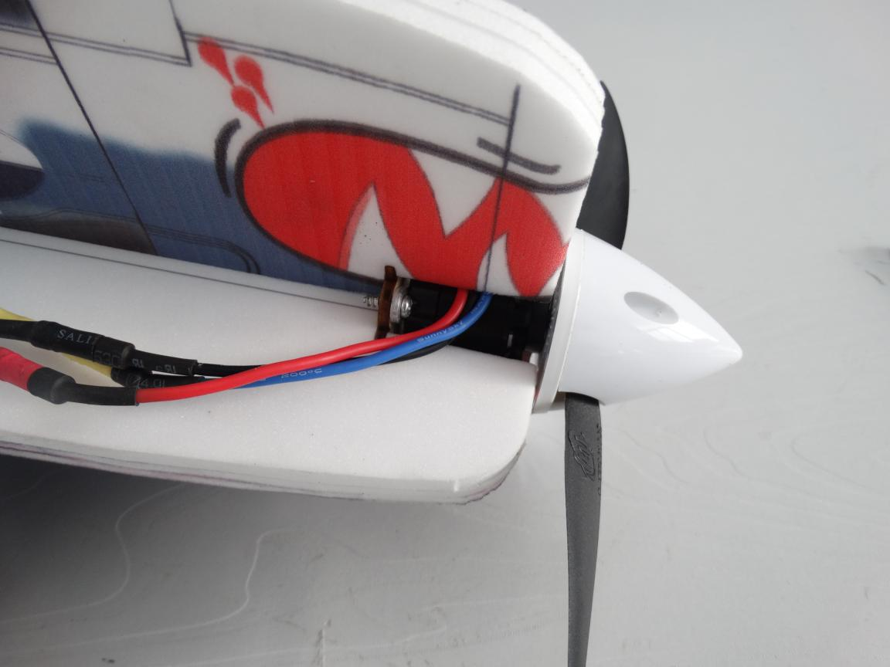
Install arm on servo and electrify all servos to make sure the arm perpendicular to servo. Then install arm screws.
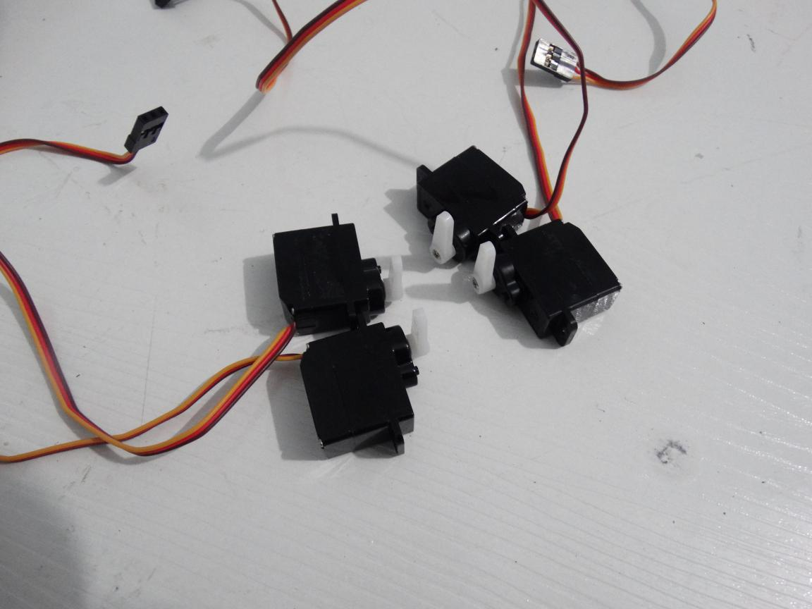
Assemble Quick rod adjuster and install it in hinge, apply a little No.502 to the nuts.
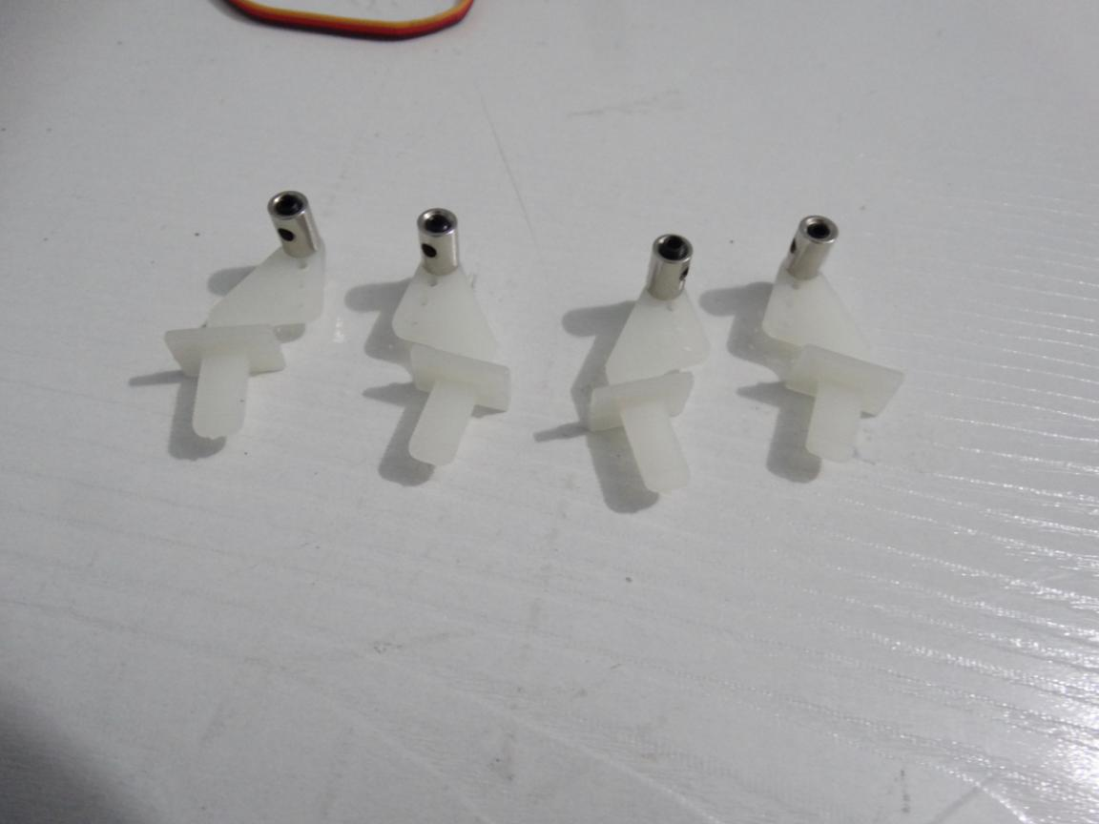

Install hinge into the hole on wing using foam glue.
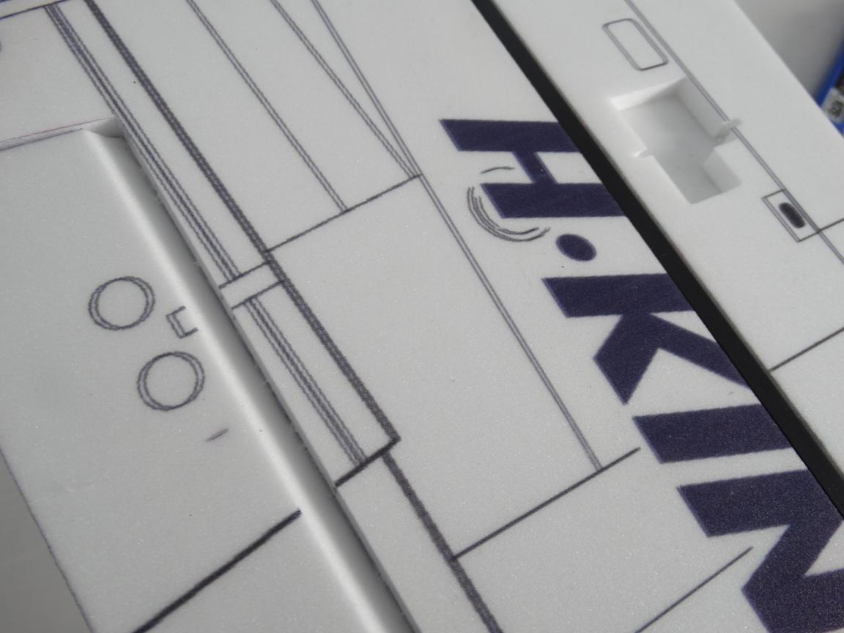
Applying glue into the servo ‘s hole on the wing using hot glue sticks. Then put servo into the hole.
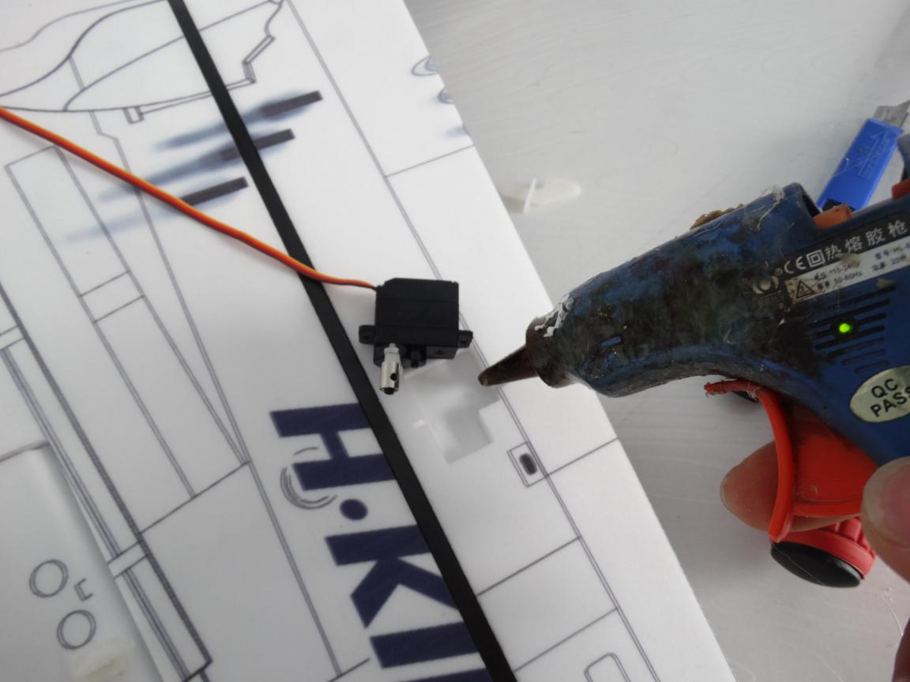

Glue the servo’s wire on wing using hot glue sticks and use Y cord connect the 2 servos on wing.
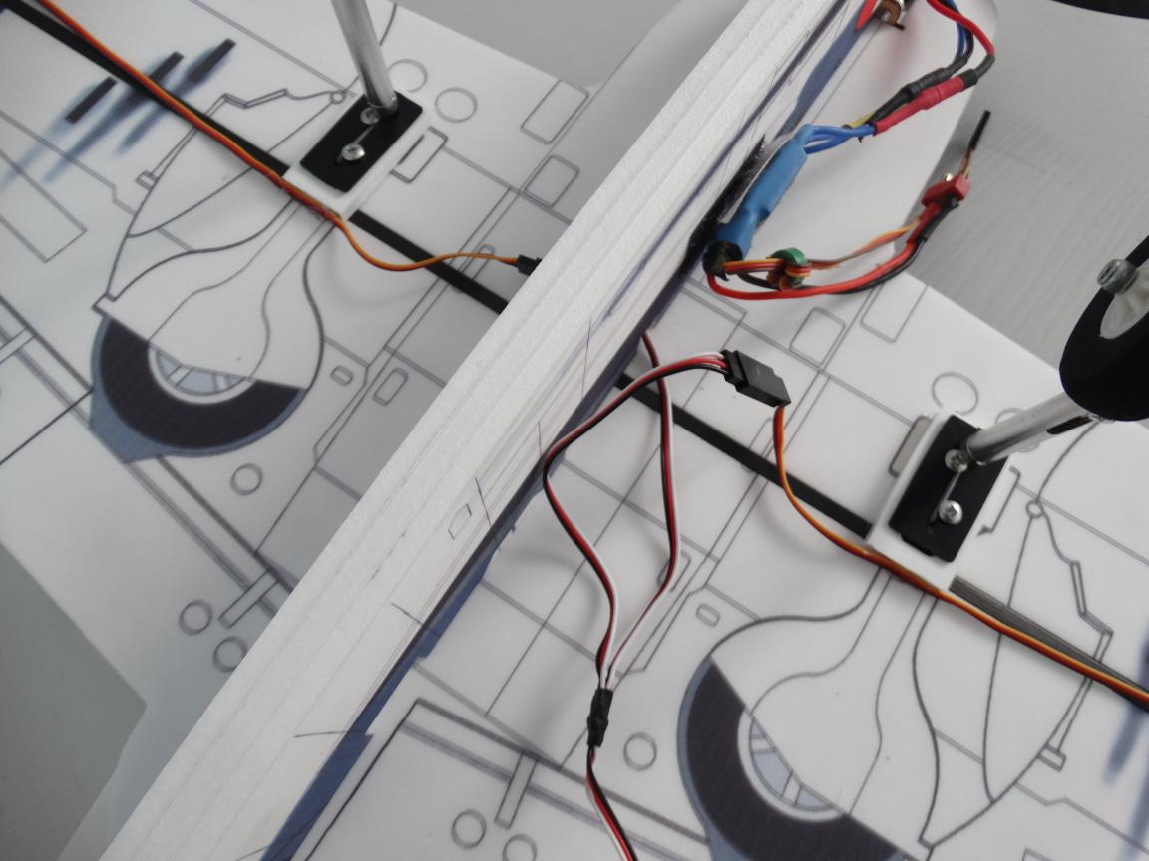
Install hinge into the hole on wing using foam glue.
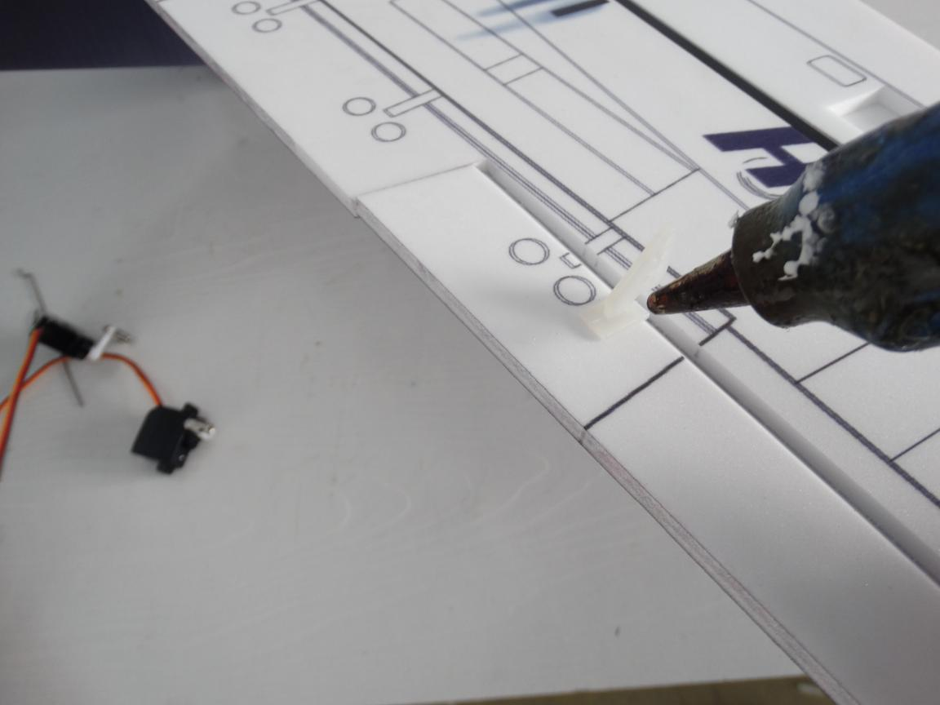

Don’t forget block the hinge with cover and apply glue to reinforce.
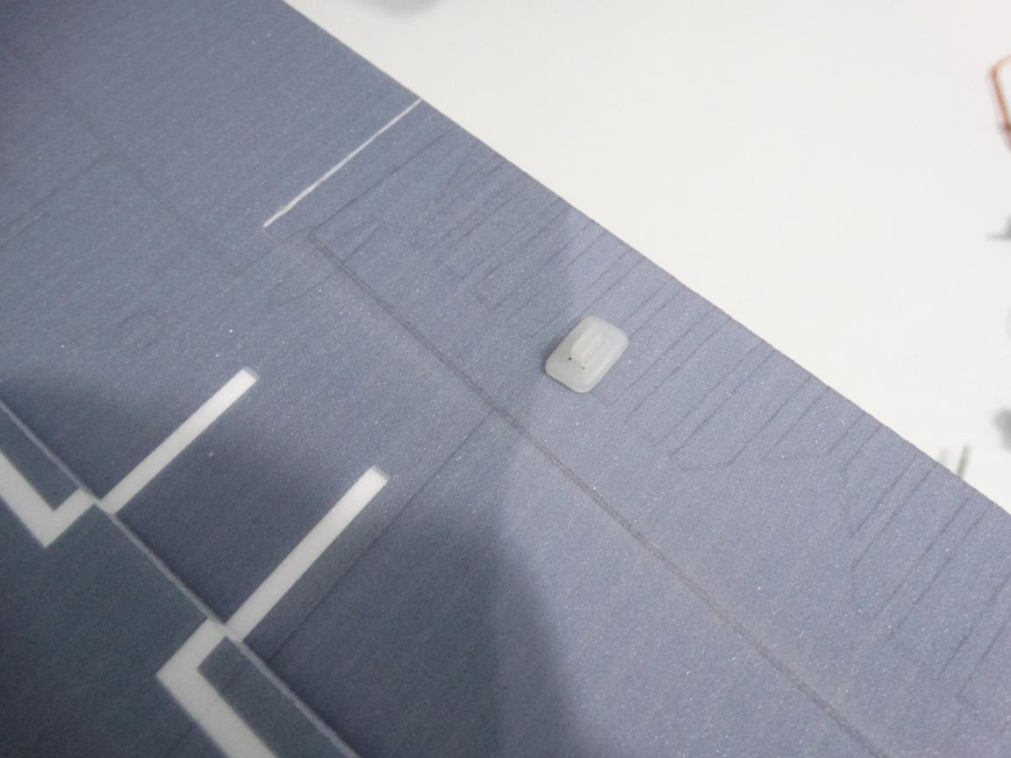
Install the 2 pcs shorter rods into arm and Quick rod adjuster. Then adjust the pull rod and tighten the screws.
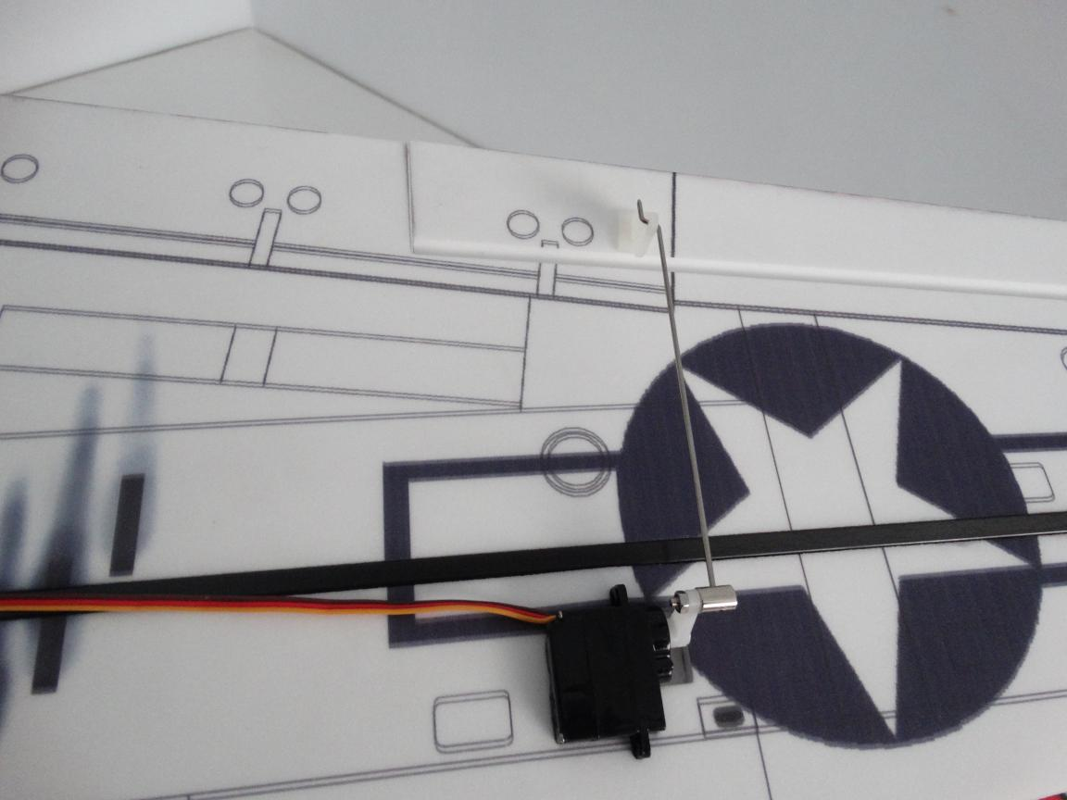

Same way to install the front fuselage’s servo.
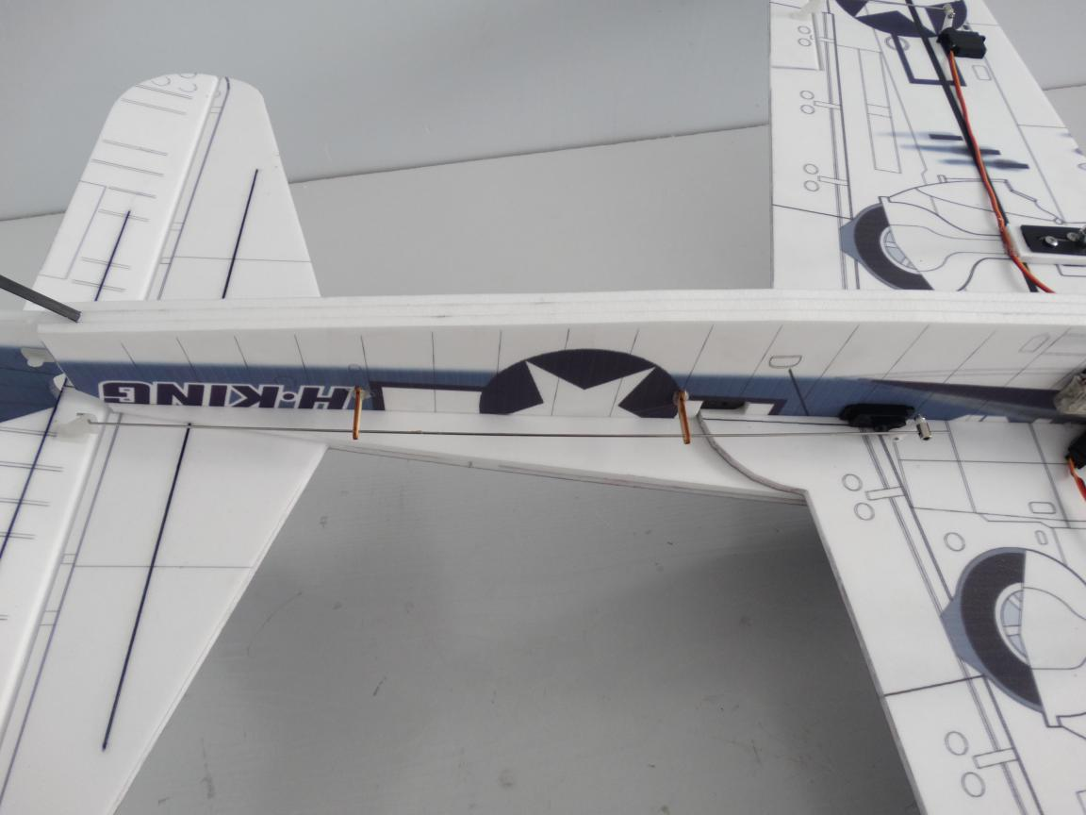
Install wood strip in the hole using No.502 glue or hot glue sticks. Notice must let pull rod through the hole on wood strip.
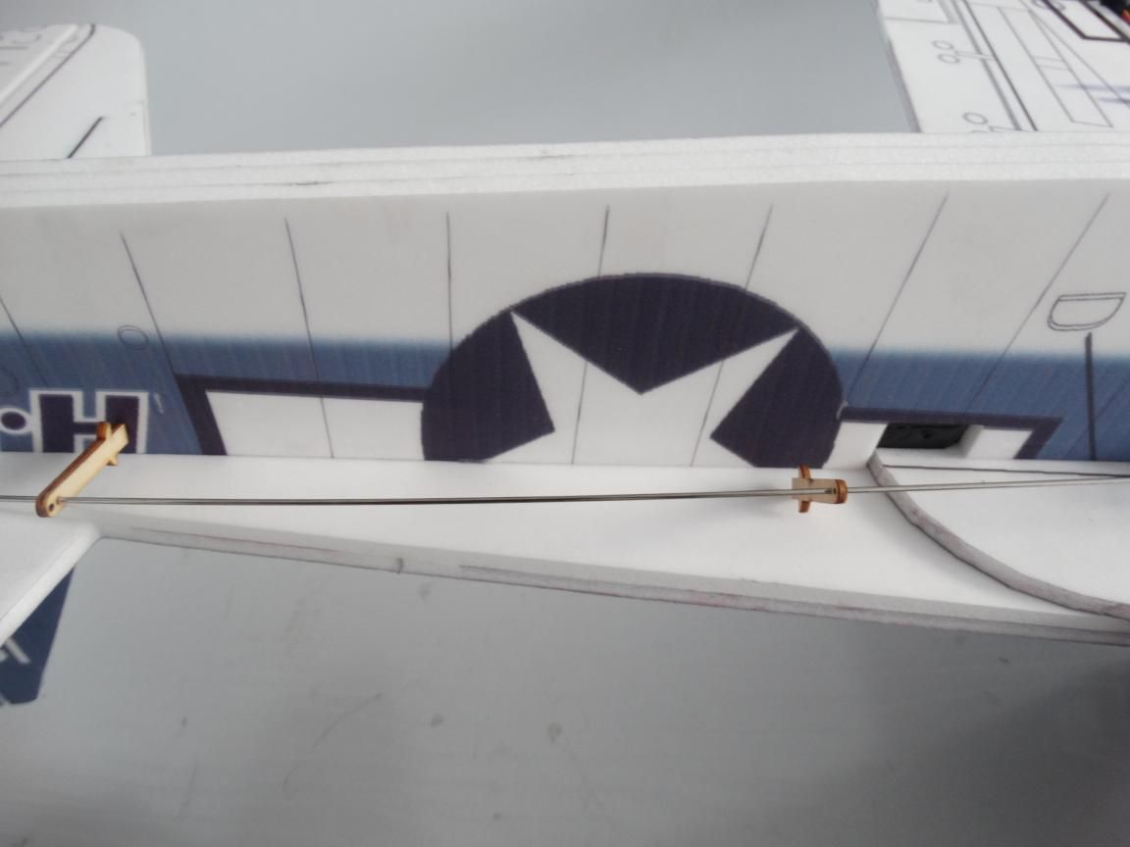

Same way to install the middle fuselage’s servo.
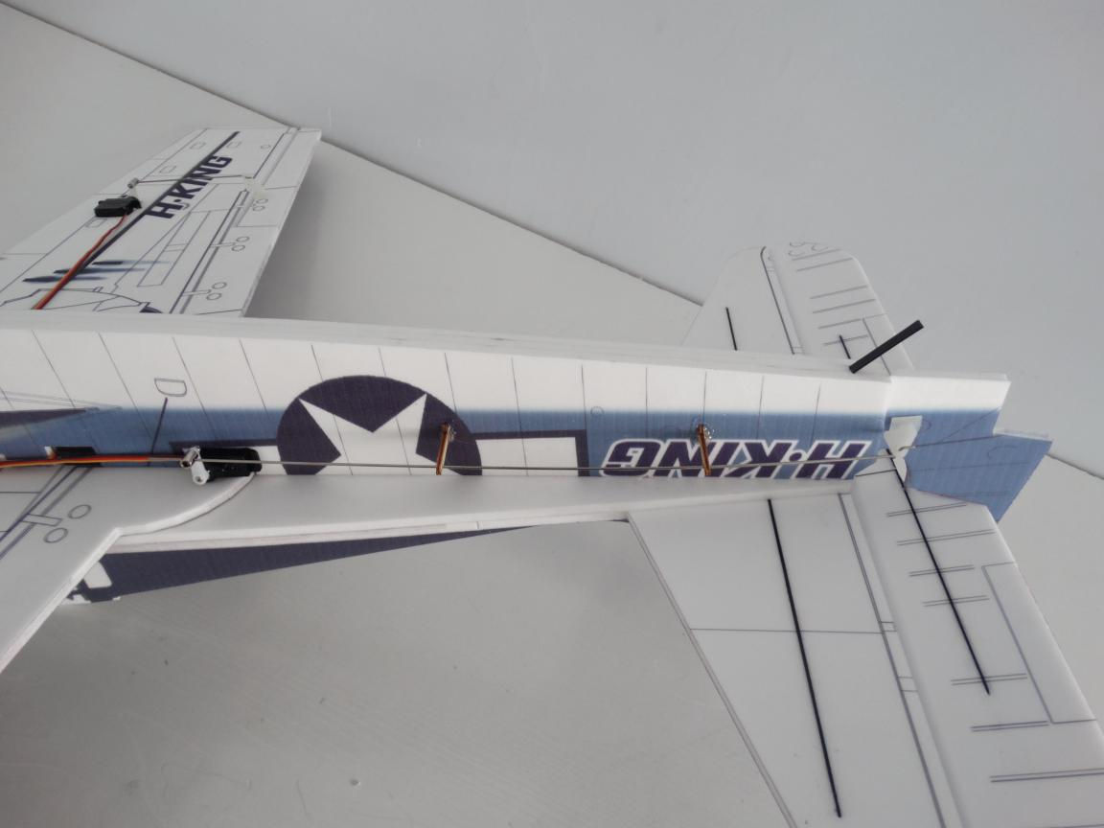
Install hinge into the hole on vertical tail using foam glue.Don’t forget block the hinge with cover and apply glue to reinforce.
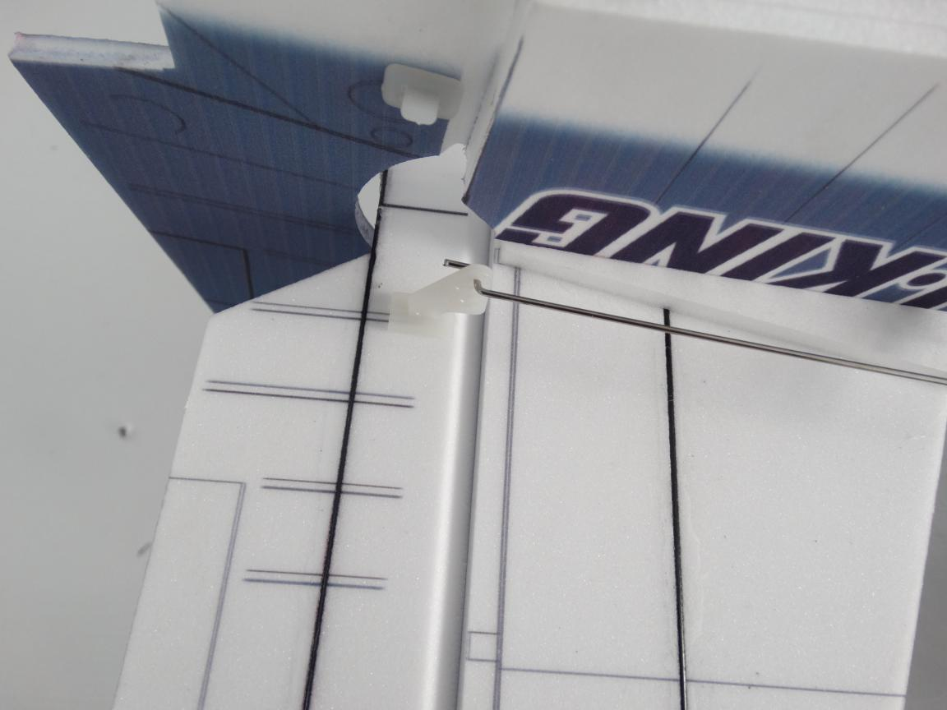
Connect servo, ESC with receiver. Glue hook and loop tape on fuselage using foam glue. Then put receiver on tape.
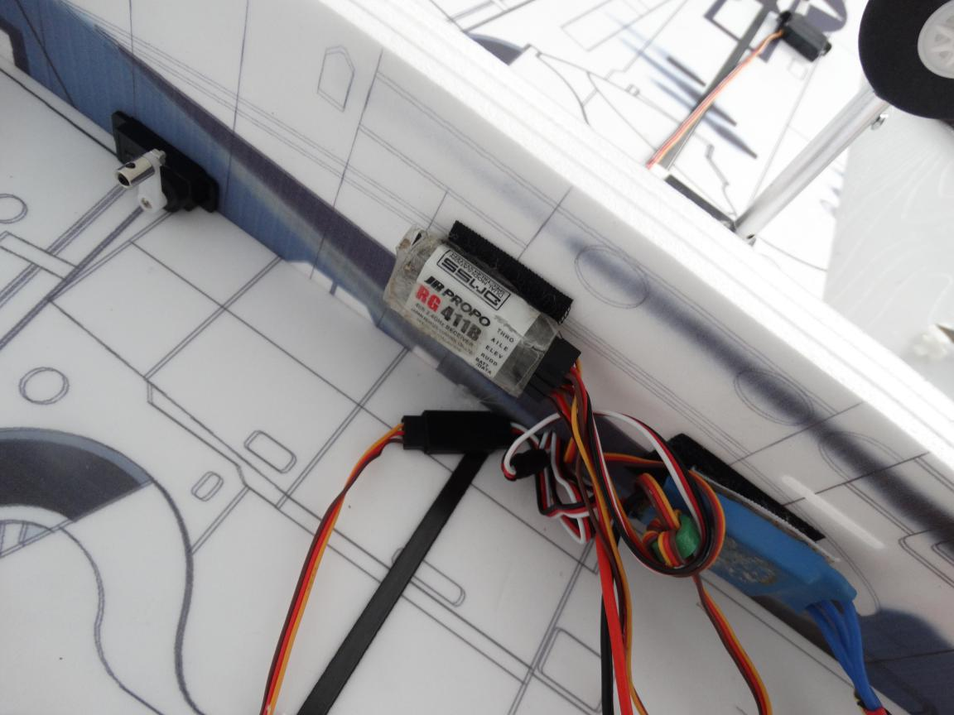
Use battery hook and loop tape through the hole to fix battery. Don’t forget glue another hook and loop tape after install battery hook and loop tape.
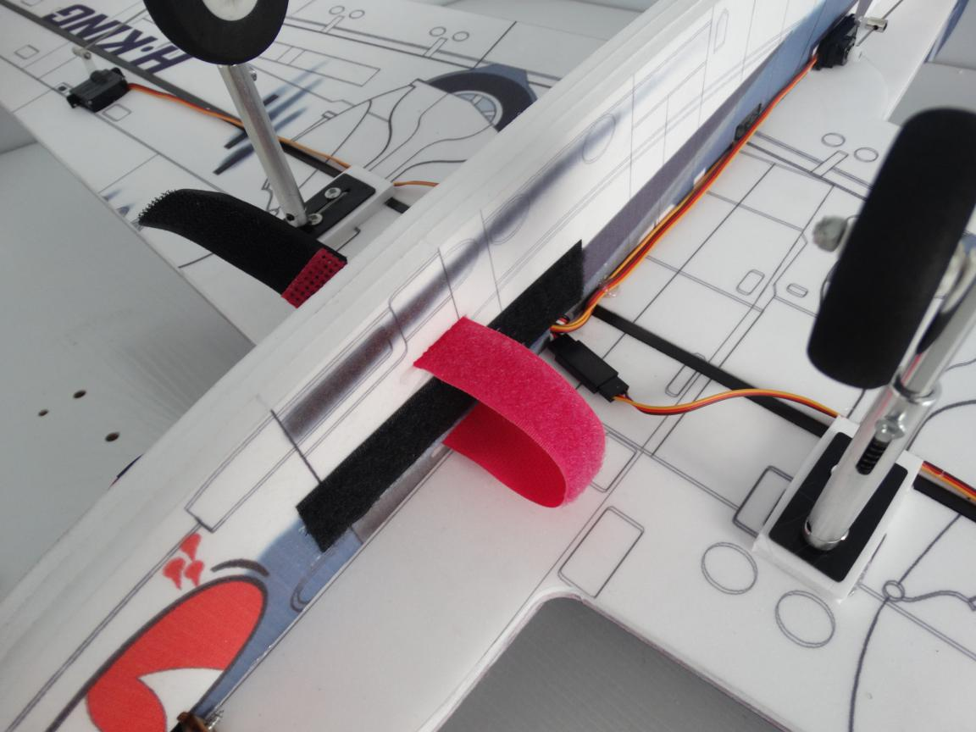
C of G is at the cross point of carbon tube with the vertical fuselage.
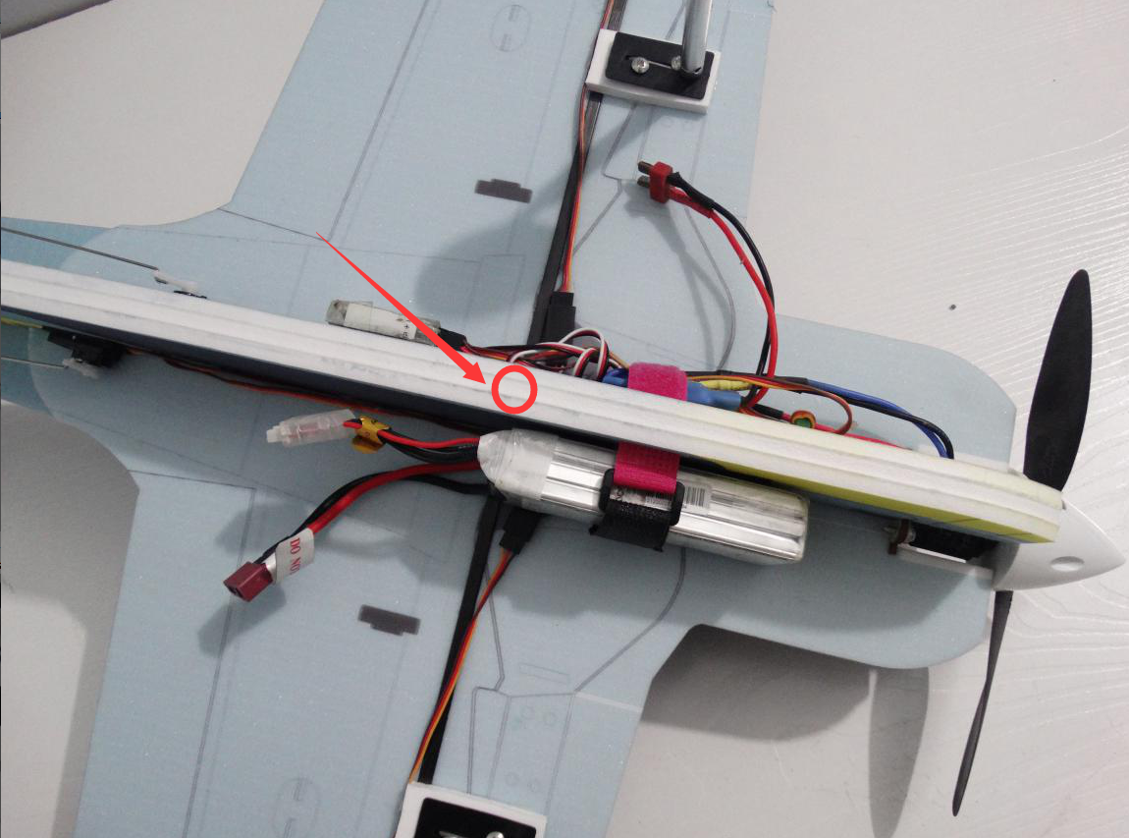
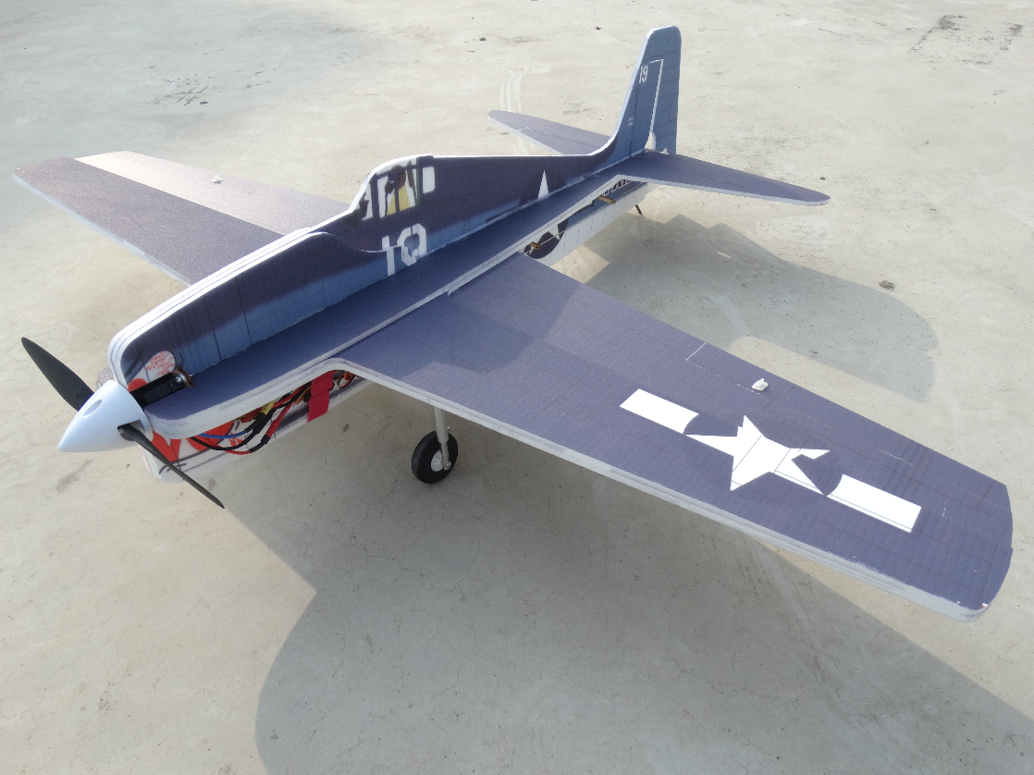
F6F is made by new way, it flying very stable. We can choose 1.75 inch cowling on motor to make it more beautiful.

