FW190 Assembly Manual 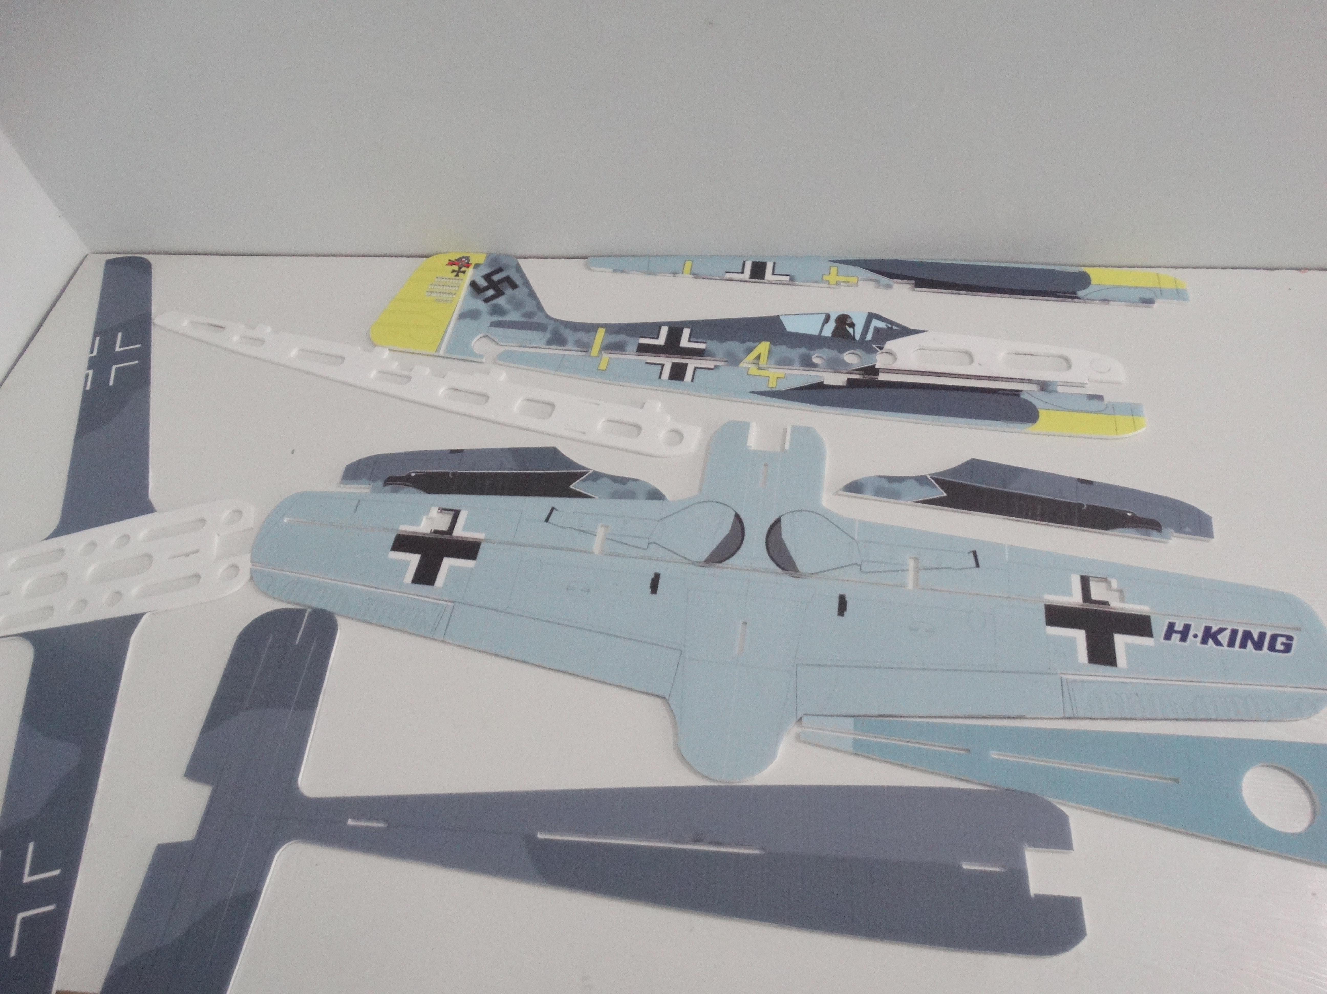

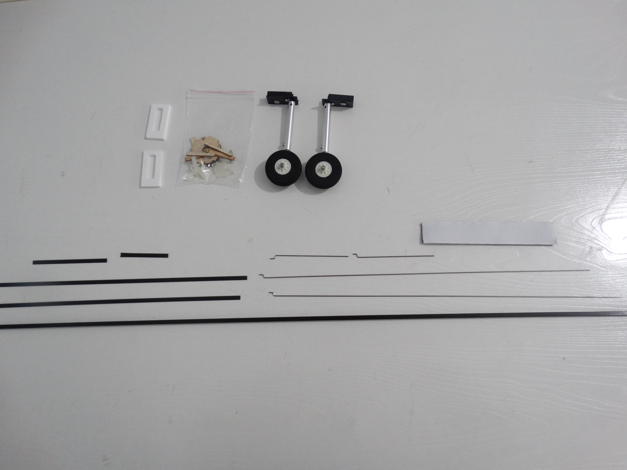

Packing list：
1: PP FW190 fuselage *1
2: Carbon tube 5*5*940mm*1
3: Pull rod *4
4: Motor mount *1
5: Quick rod adjuster *4
6: Hinge*4
7: M3 screws*4
8: Hook and loop tape*1
9: Wood strip*4
10: Carbon strip *4
11: Landing gear *2
12: PP sheets *2

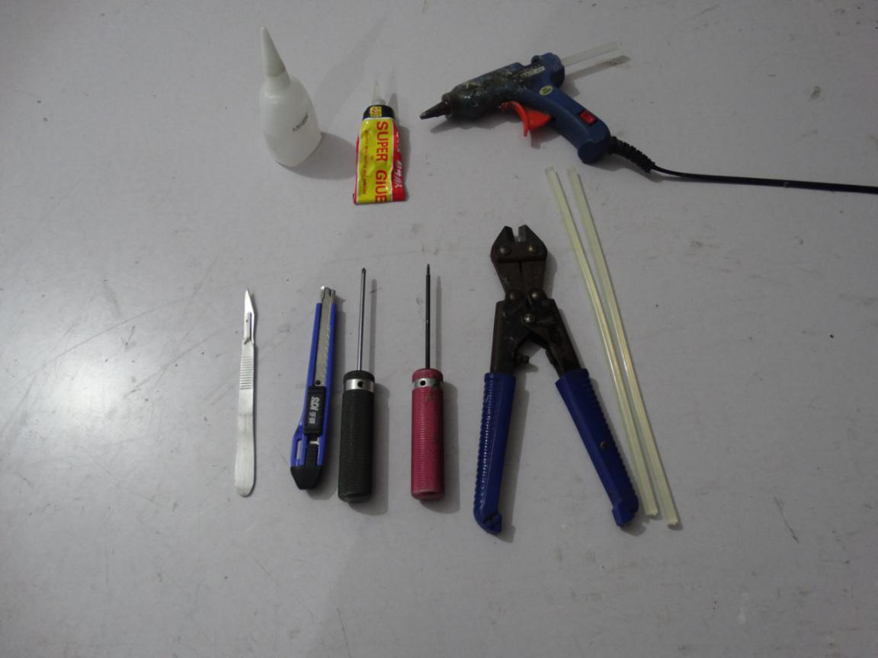
Tools：
1: 1.5mm allen wrench
2: Phillips screwdriver
3: Modelling knife
4: Wire cutters
5: Hot melt glue gun and glue sticks
6: Foam Glue
7: No.502 glue

Electronic equipment：
Motor：2208-2212-2216 1400kv *1
Prop：8 inch *1
ESC：20-40A*1
Servo：8/9g *4
Battery：1300-2200mah 3S *1

Assemble the 3 pcs bottom fuselages using foam glue.
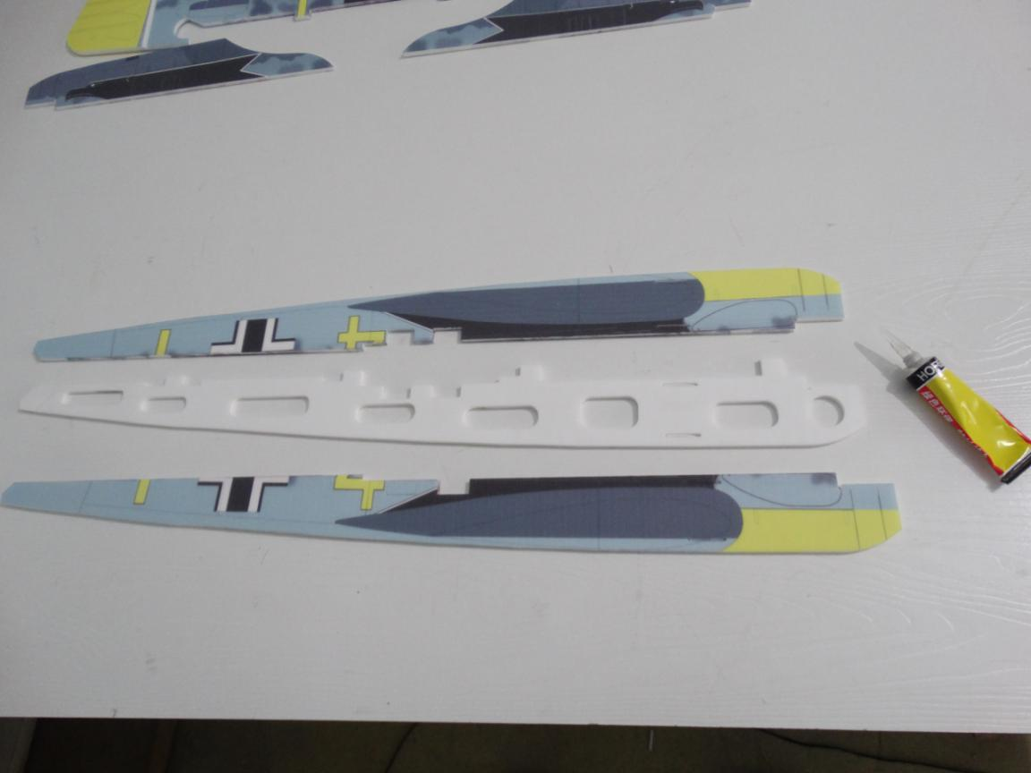

Press it after assembly.
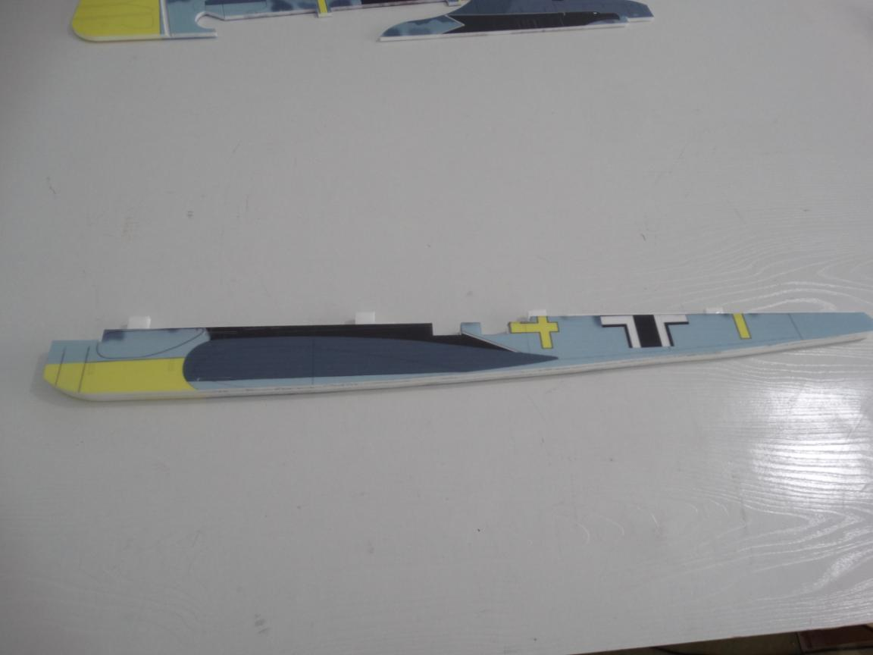
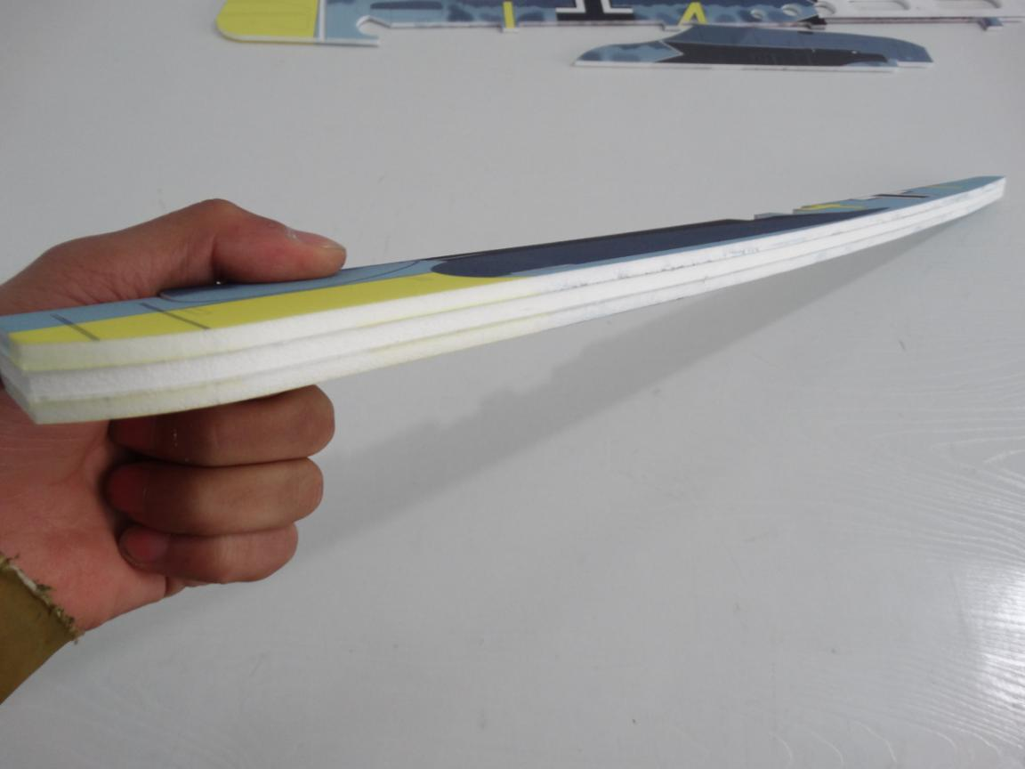

Assemble the 3 pcs top fuselages using foam glue.
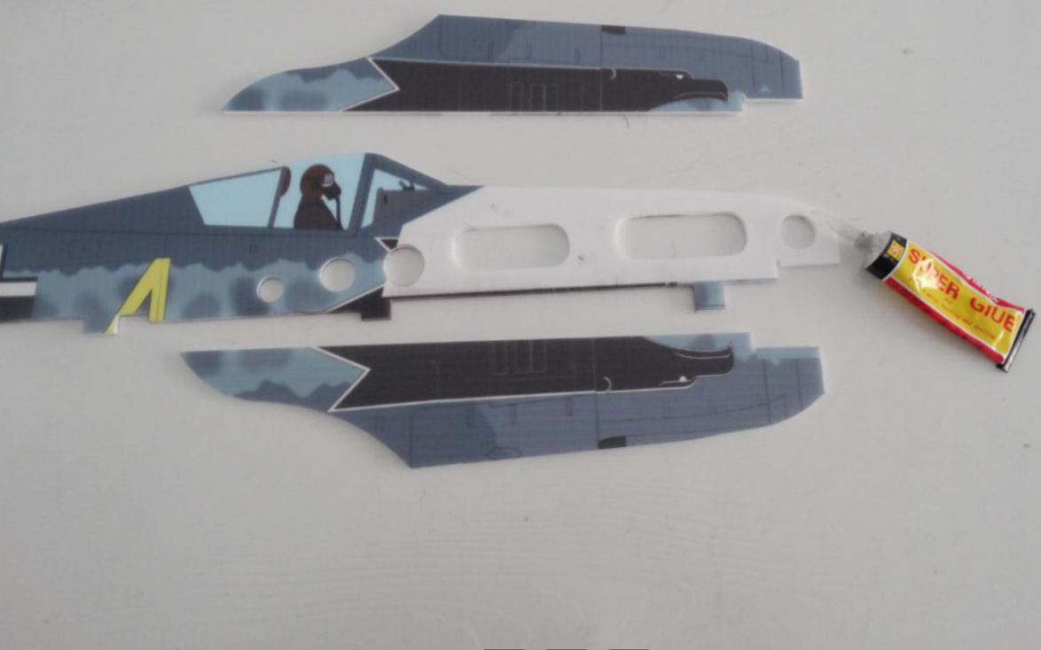
Press it after assembly.
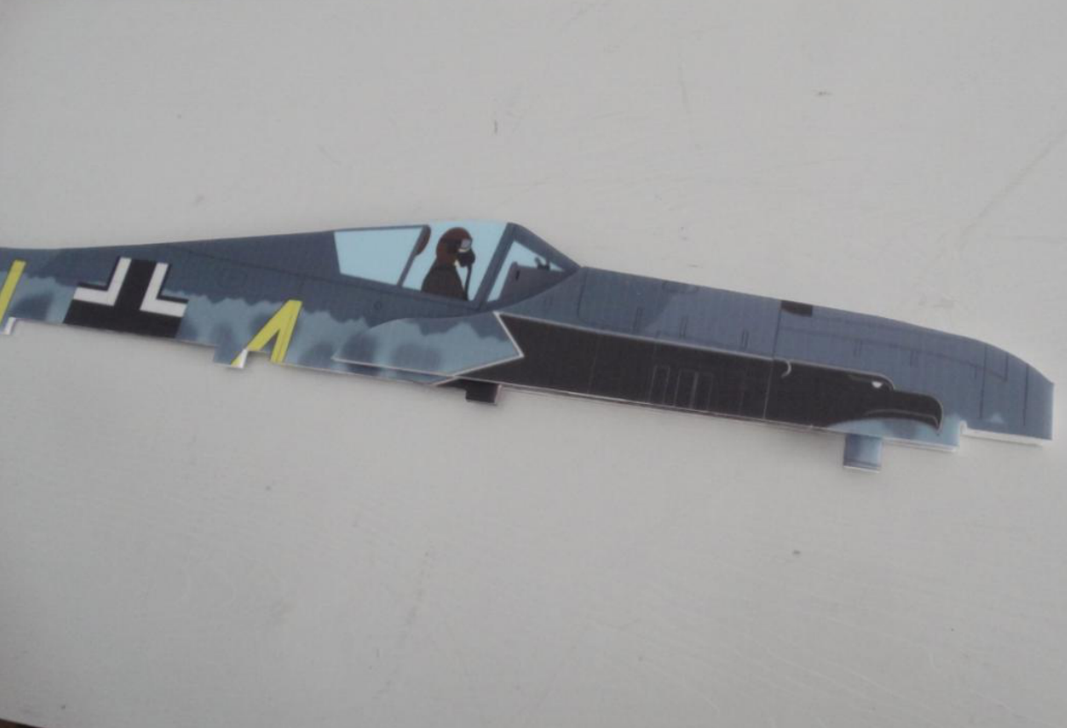

Install the carbon tube into the wing. Important: don’t glue the carbon tube now!
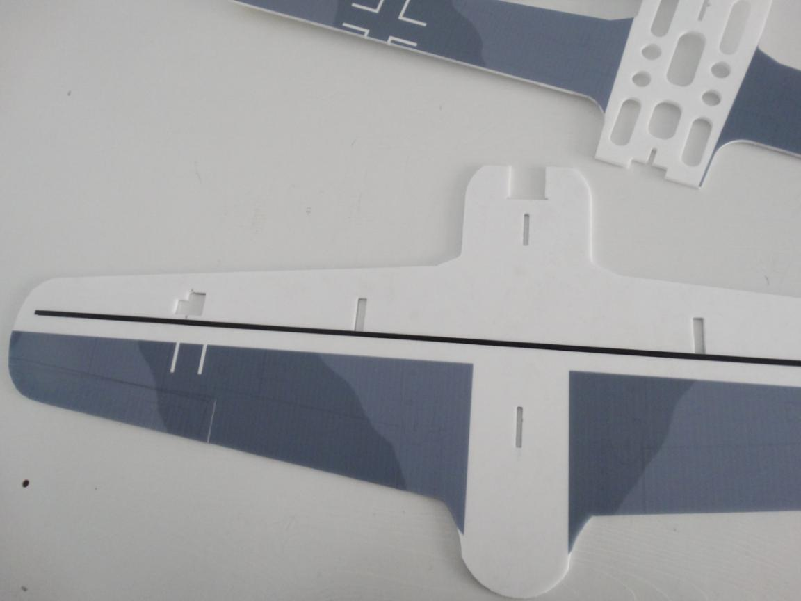
Assemble the 2 pcs wings using foam glue. Make sure 2 pcs wings trim.
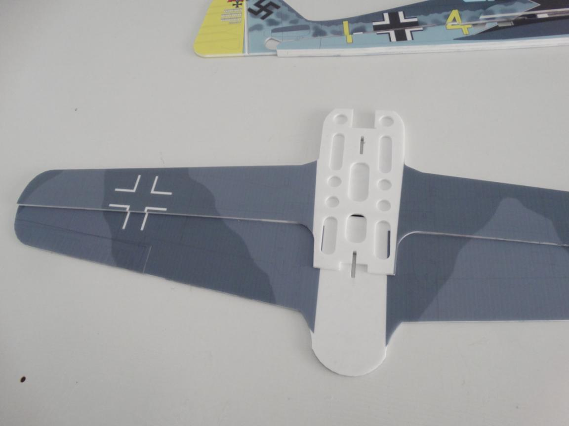

Assemble the mid horizontal fuselage on wings using foam glue. Make sure all parts trim.
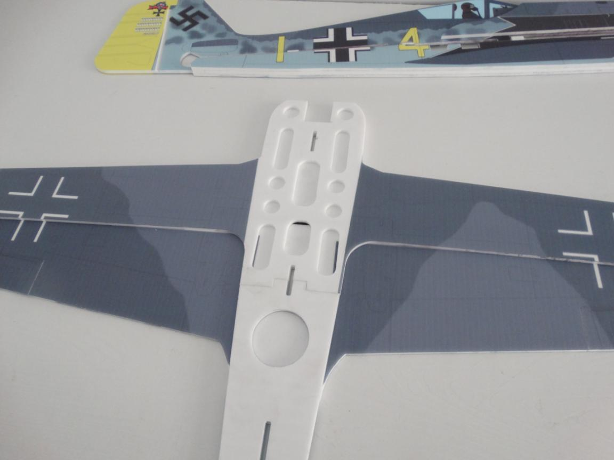
Assemble the bottom horizontal fuselage on wings using foam glue. 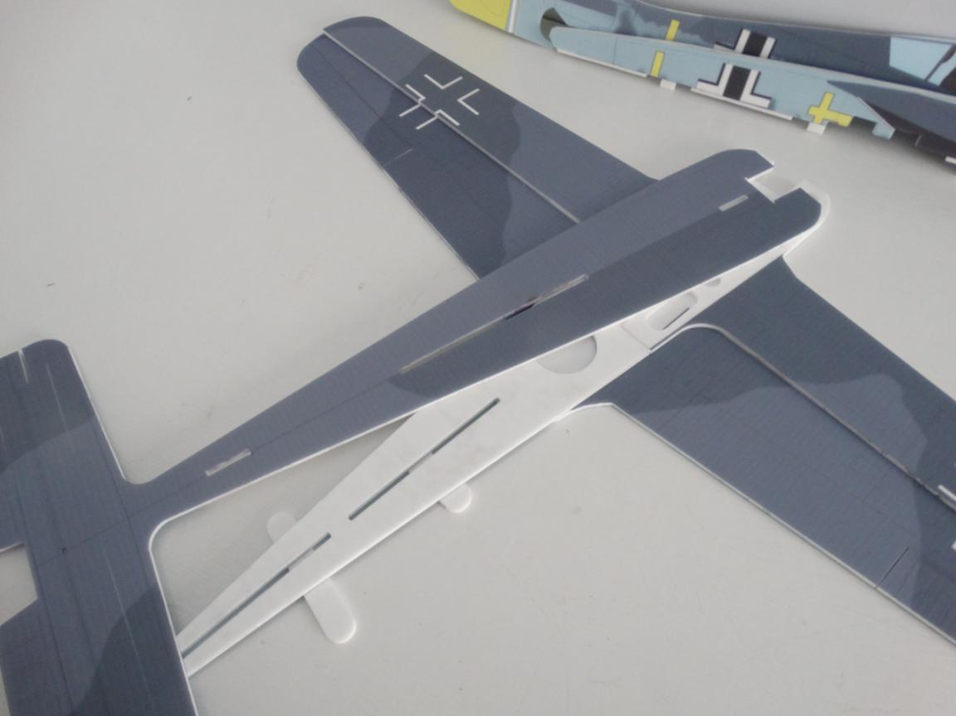

Make sure all parts trim. Especially the hole.
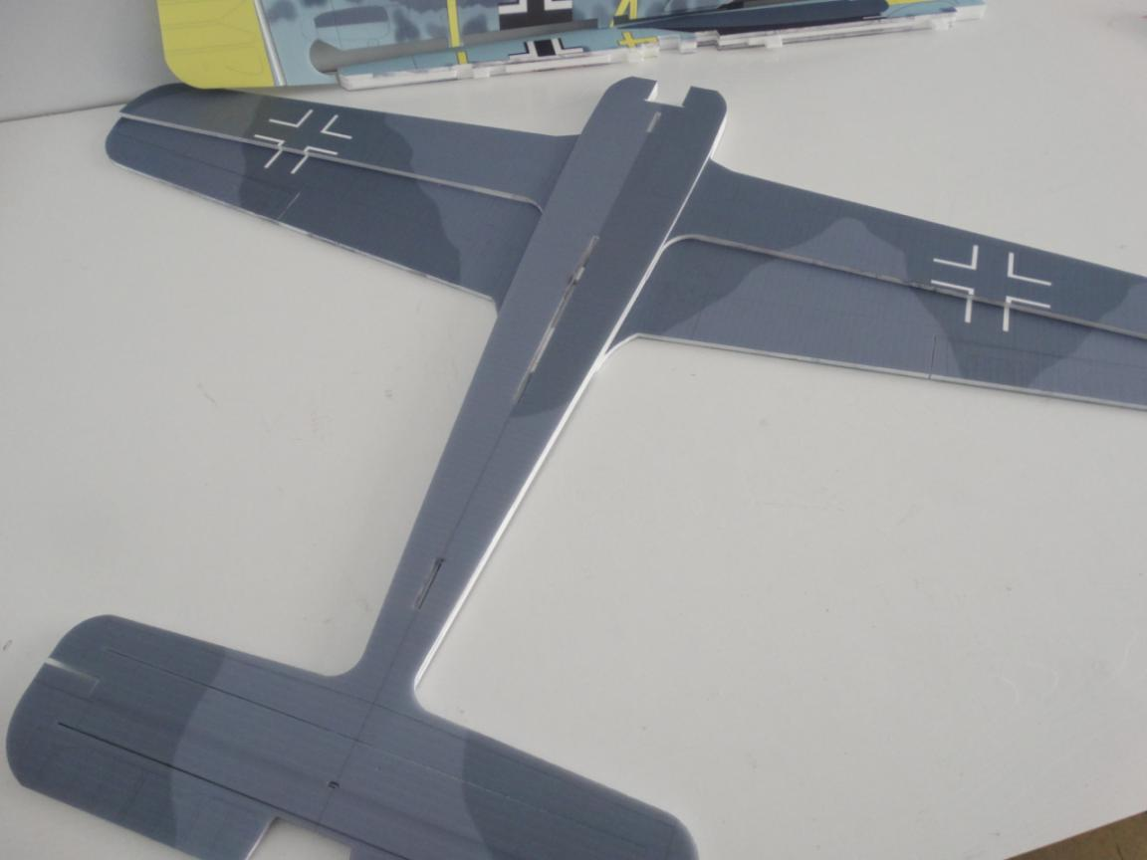
Turn over fuselage after assembly, Reinforce wing and horizontal tail using foam glue. Then glue the carbon tube using foam glue or No.502 glue.
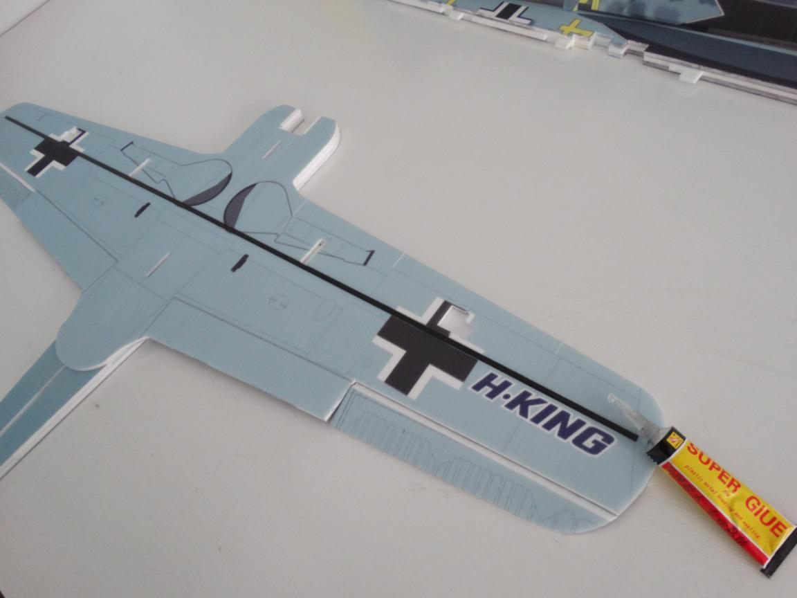

Install the 2 pcs carbon strip into the horizontal tail and glue them using No.502 glue.
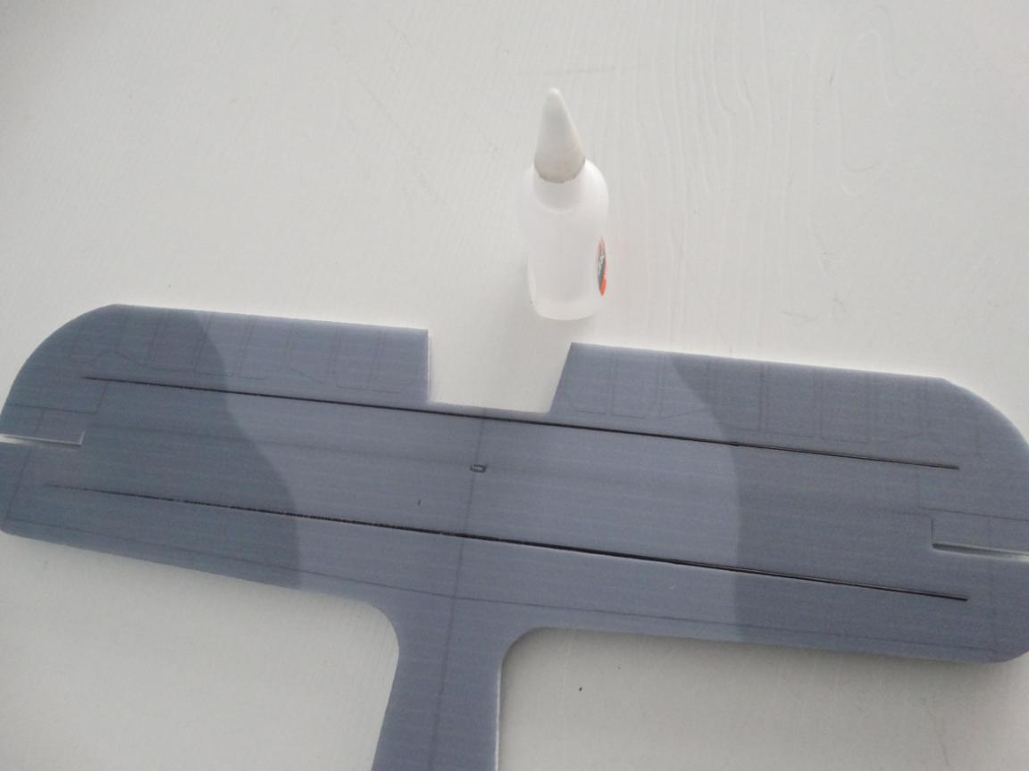
Install the carbon strip into the vertical tail and glue it using No.502 glue.
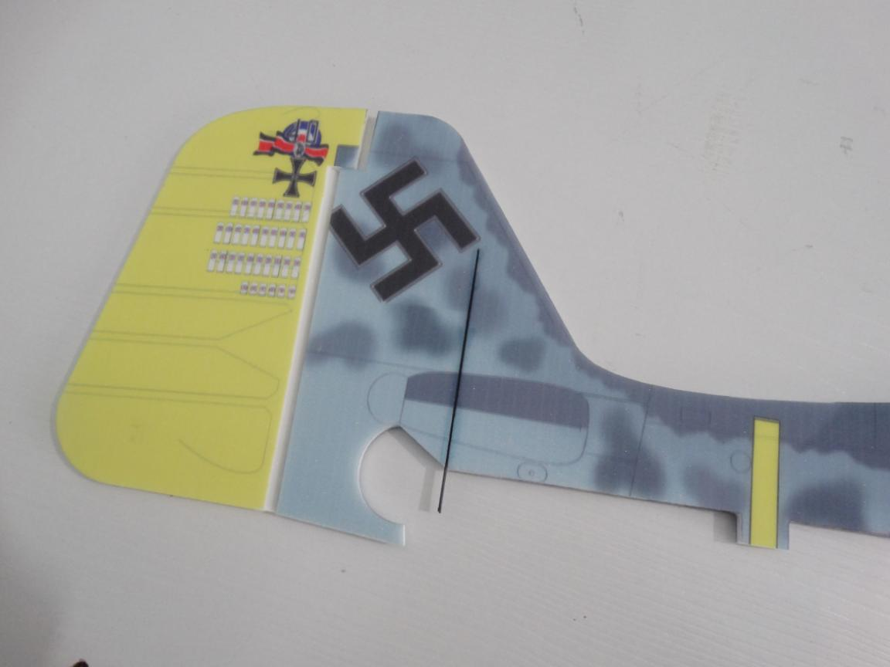

Wait glue dried. Then assemble bottom fuselage into the horizontal fuselage using foam glue.
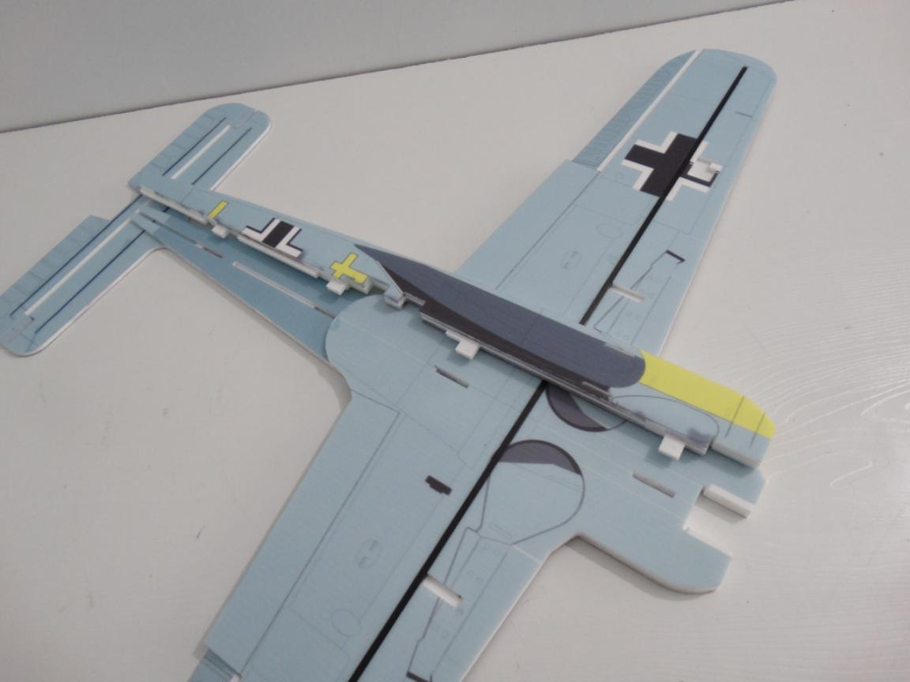
Install motor mount on fuselage after assembly using foam glue.
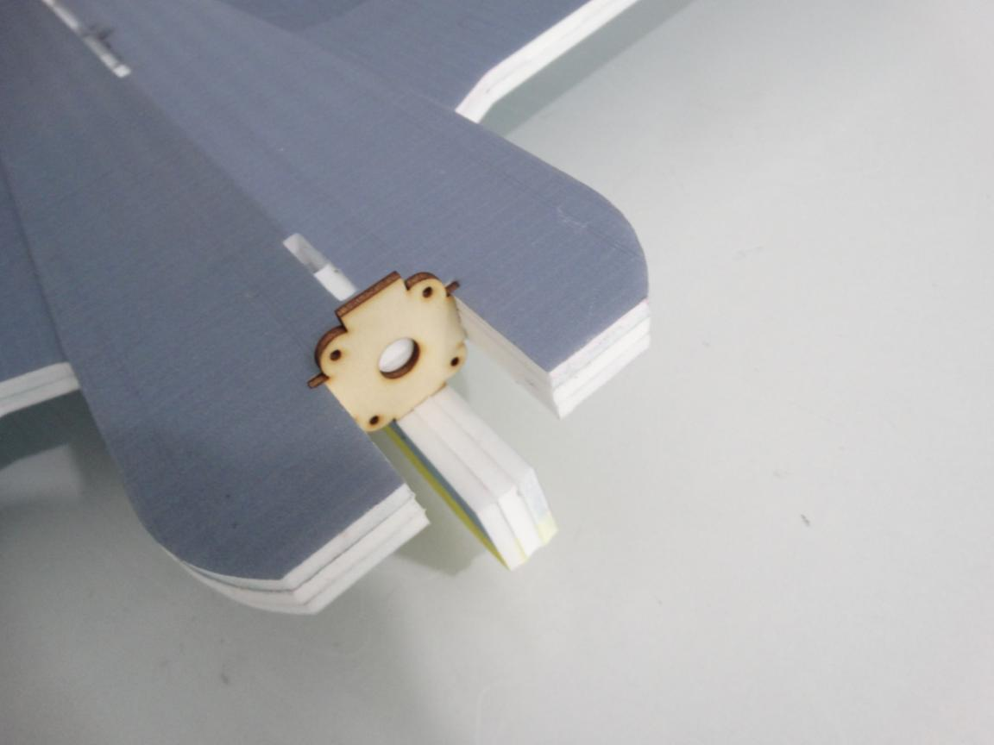

Applying foam glue on top vertical fuselage and horizontal fuselage.
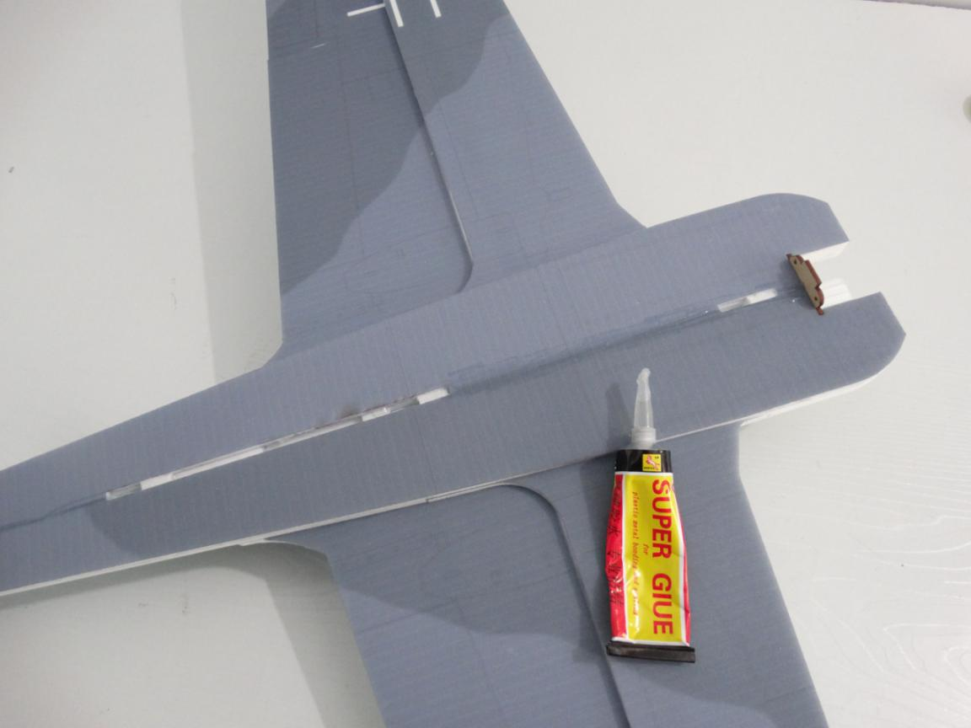
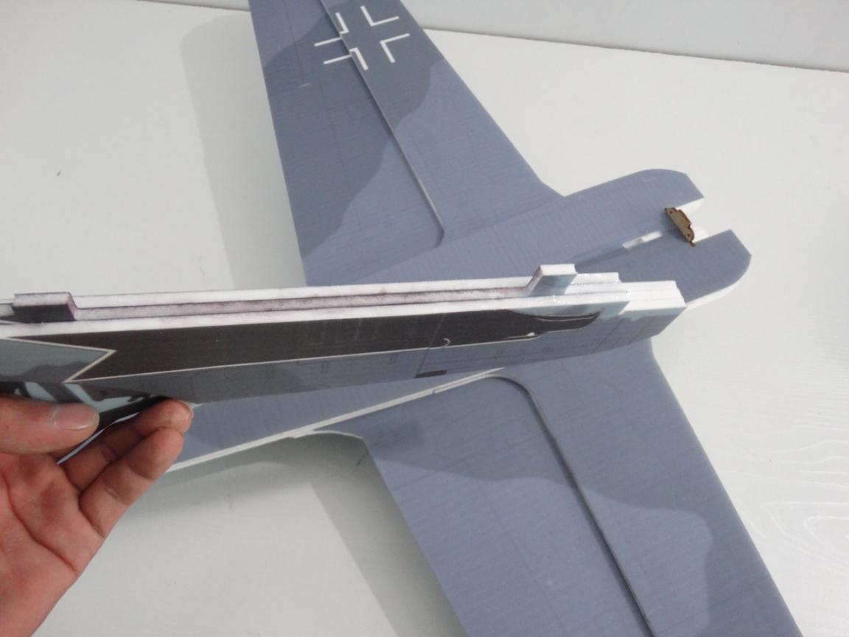

Press the carbon strip into the horizontal fuselage’s hole first.
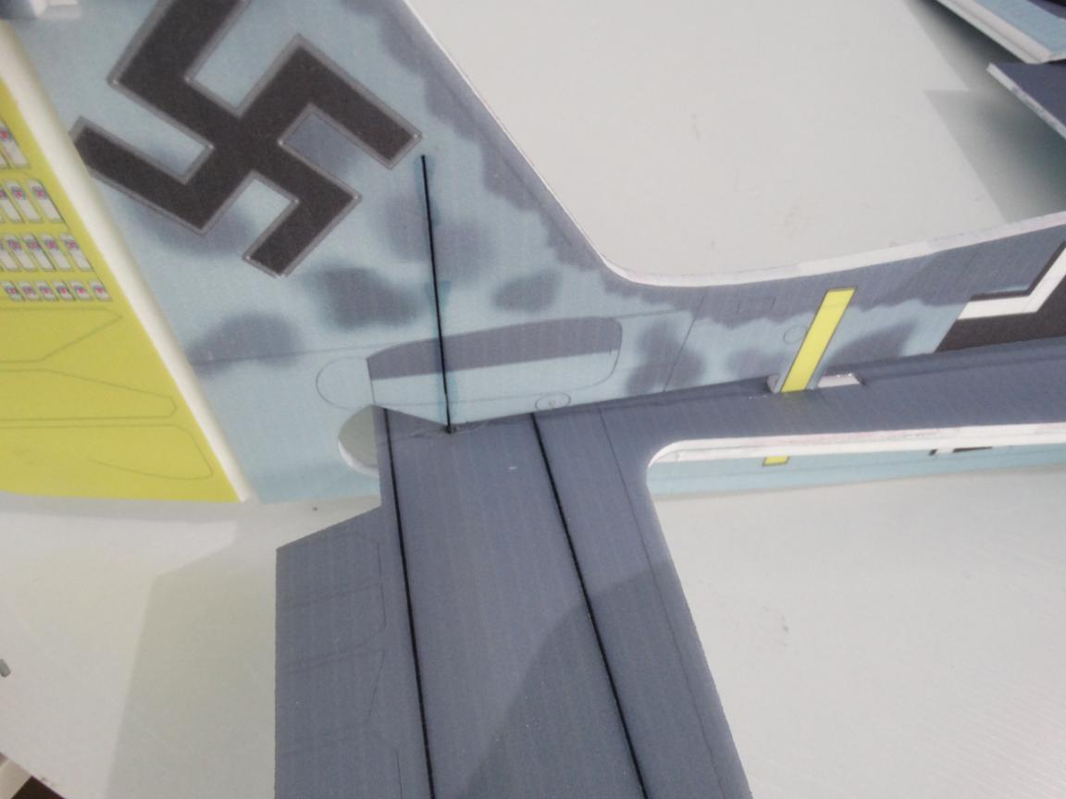
Then press the top vertical fuselage into horizontal fuselage.
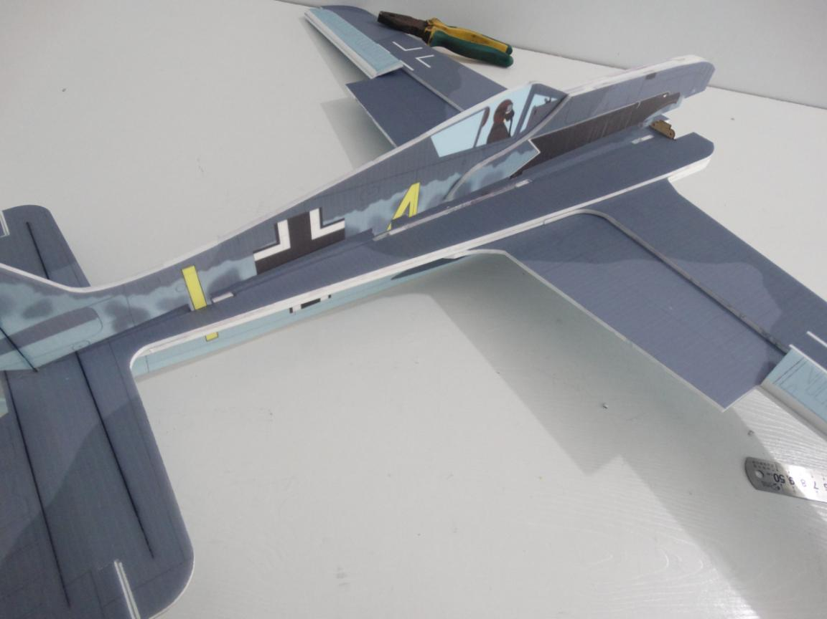

Glue the vertical tail using hot glue sticks.
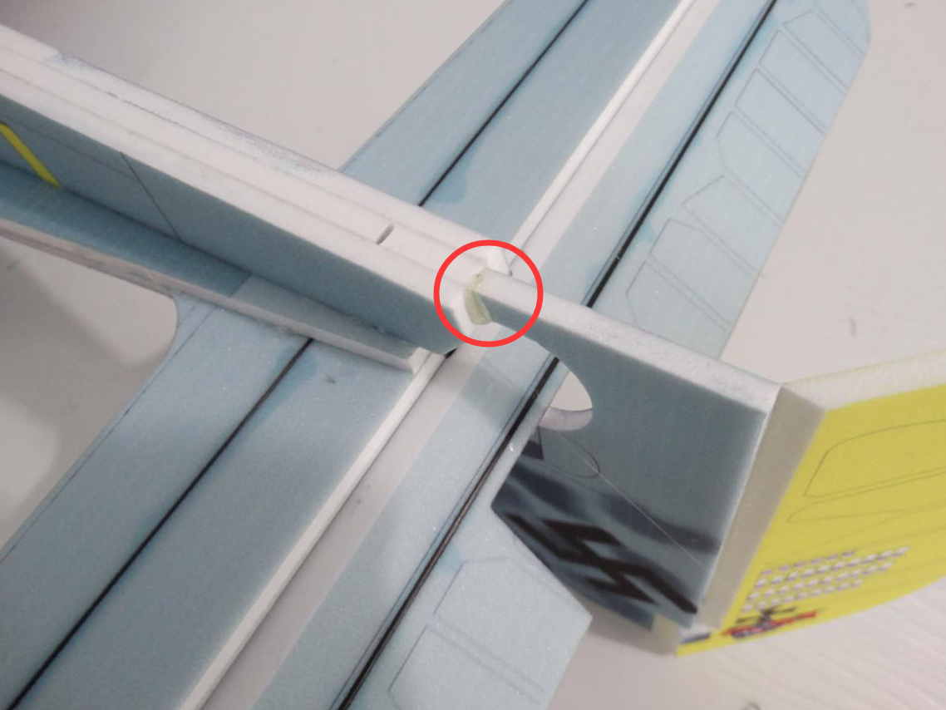
Reinforce all bonding parts using hot glue sticks. Especially for weakness point as shown picture below.
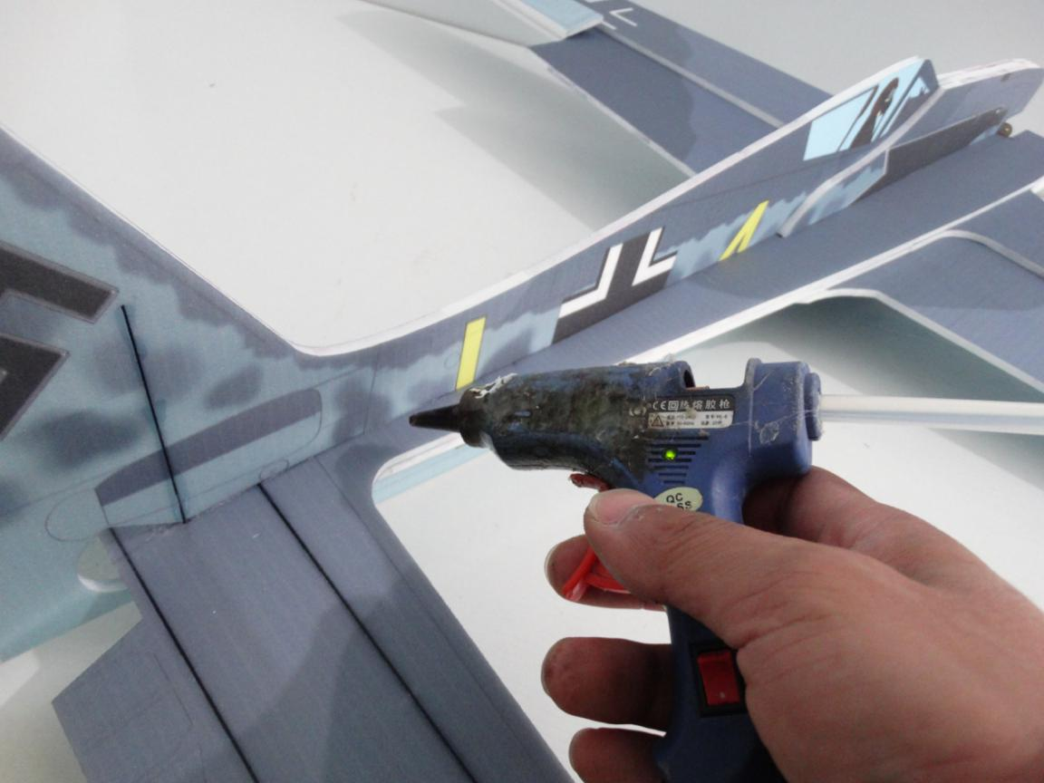

Assemble 2 pcs PP sheets on wing using hot glue sticks. Make sure the hole trim.
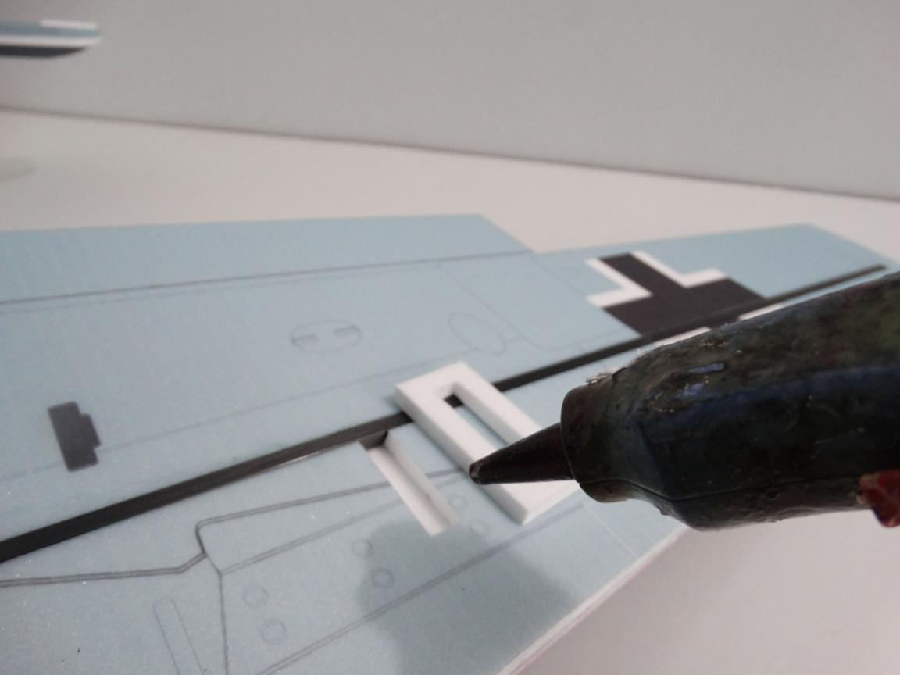
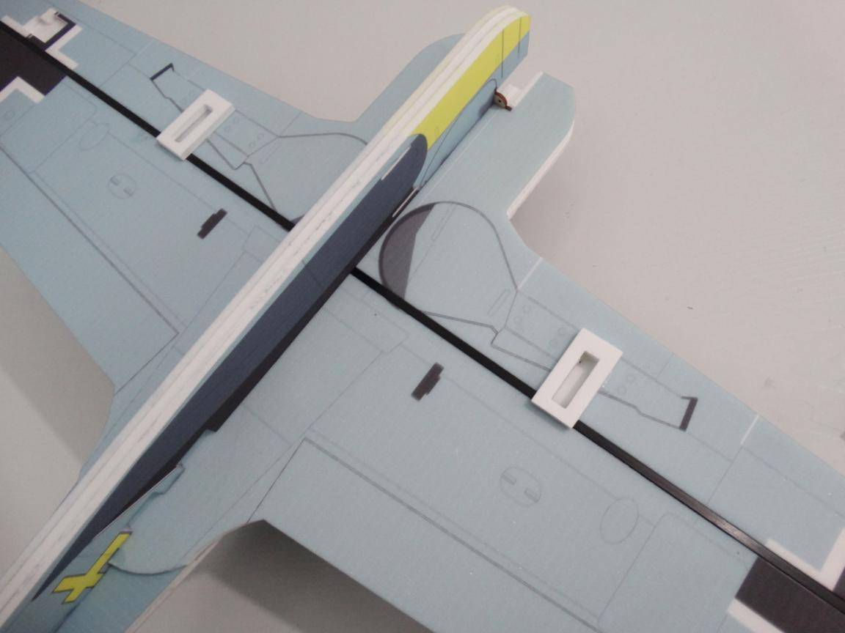

Install the landing gear on the PP sheets using hot glue sticks as shown picture below.
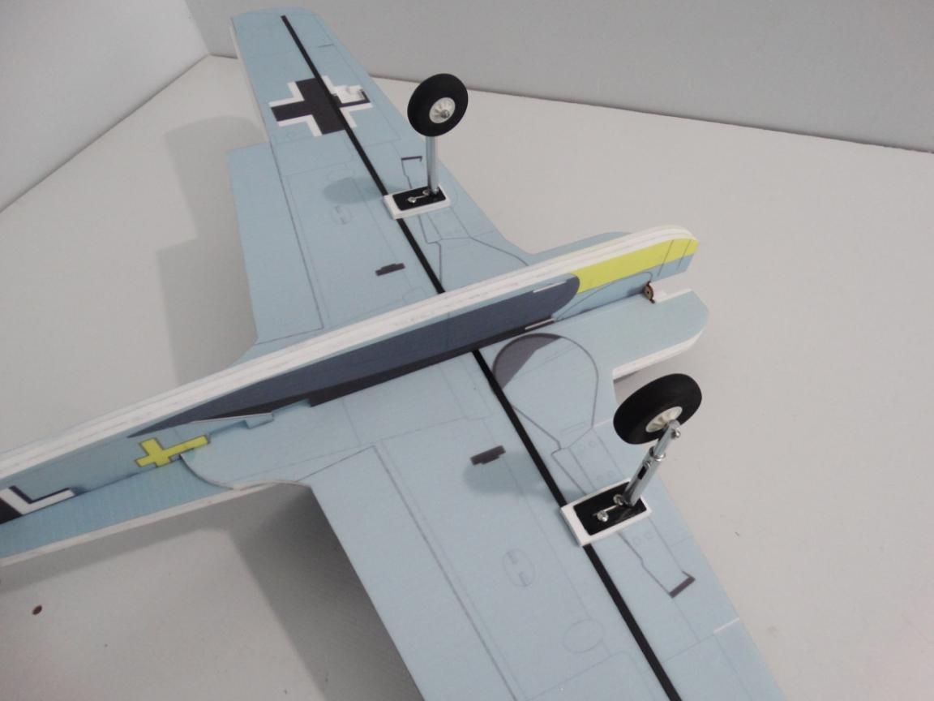
Install the shortest carbon strip into the hole using No.502 glue.
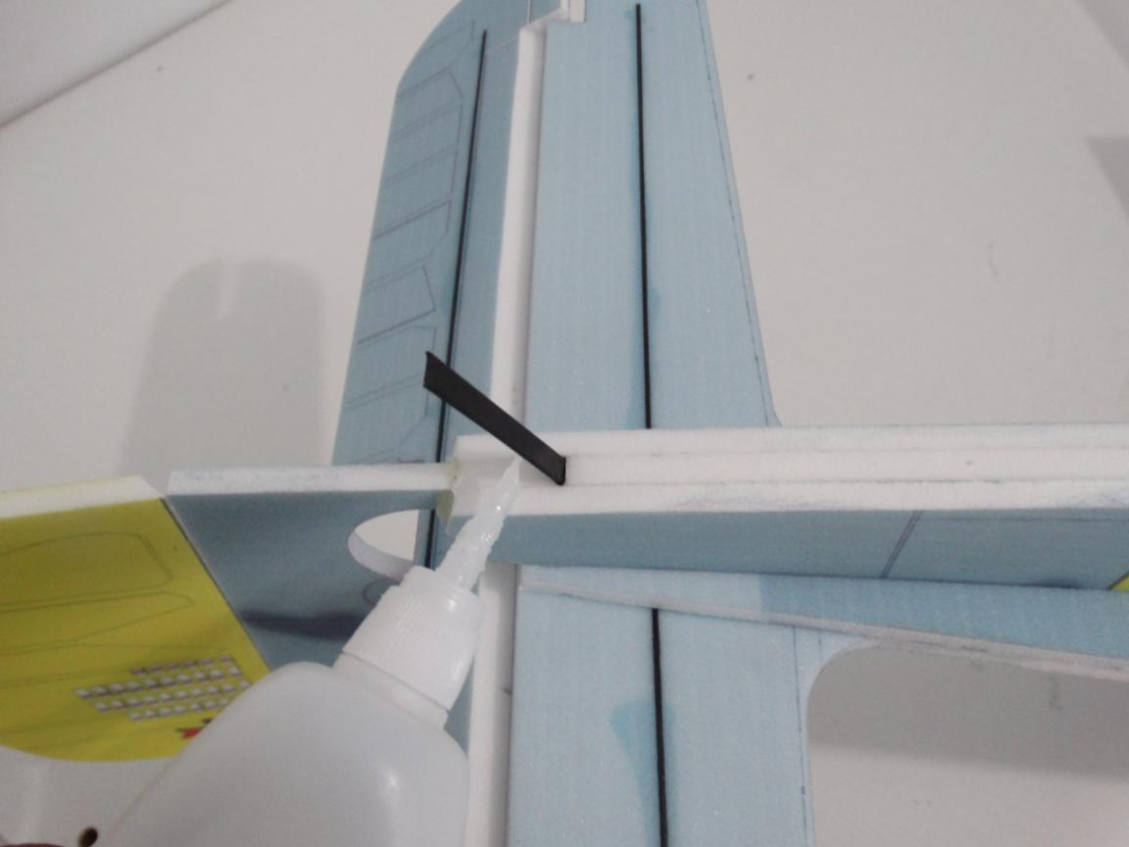

Assemble motor on the metal cross using screws.
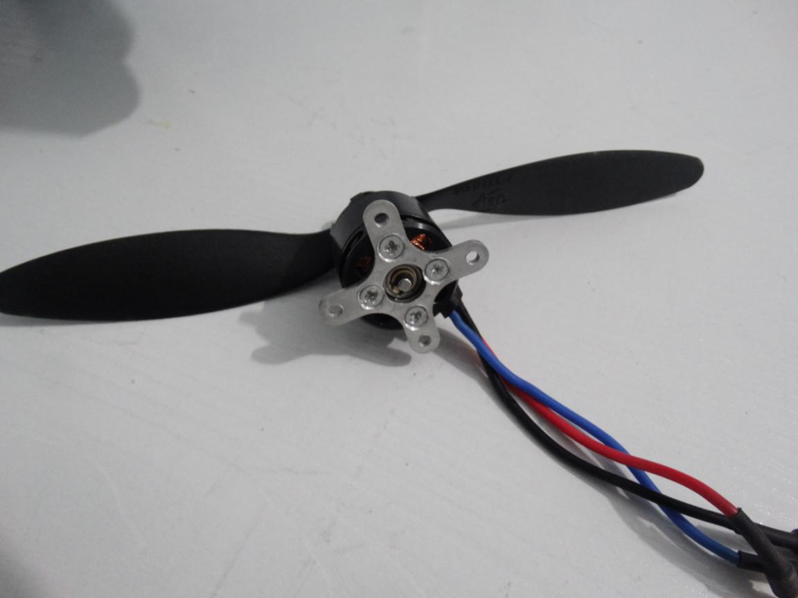
Assemble the metal cross with motor on the wood motor mount using the 4 pcs M3 screws.
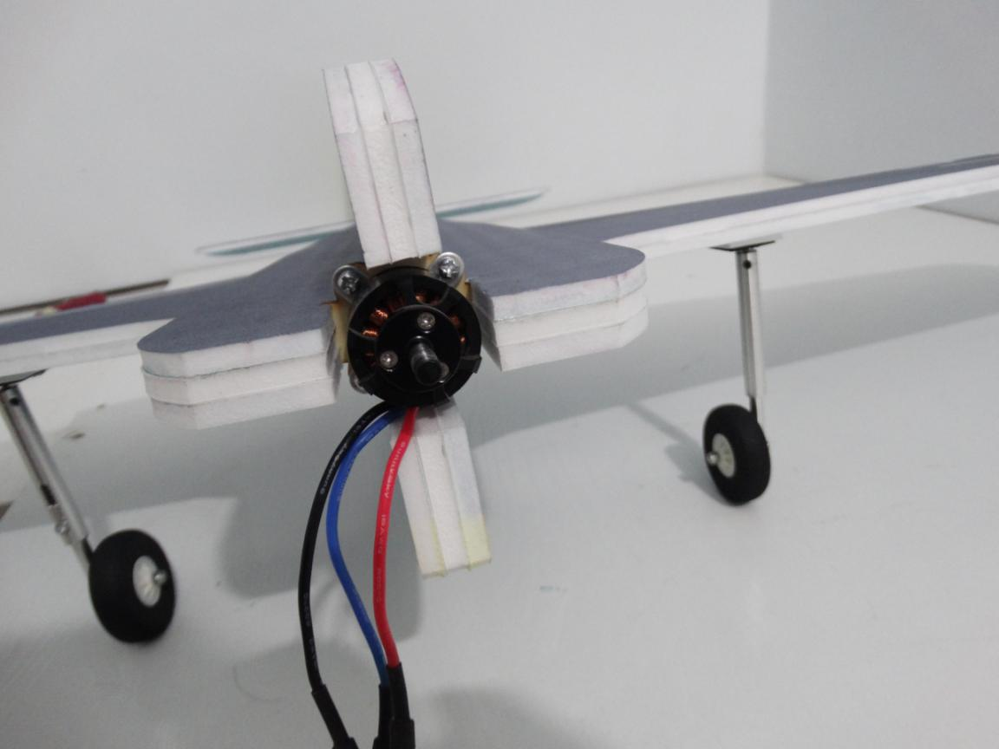
Assemble Quick rod adjuster and install it in hinge, apply a little No.502 to the nuts.
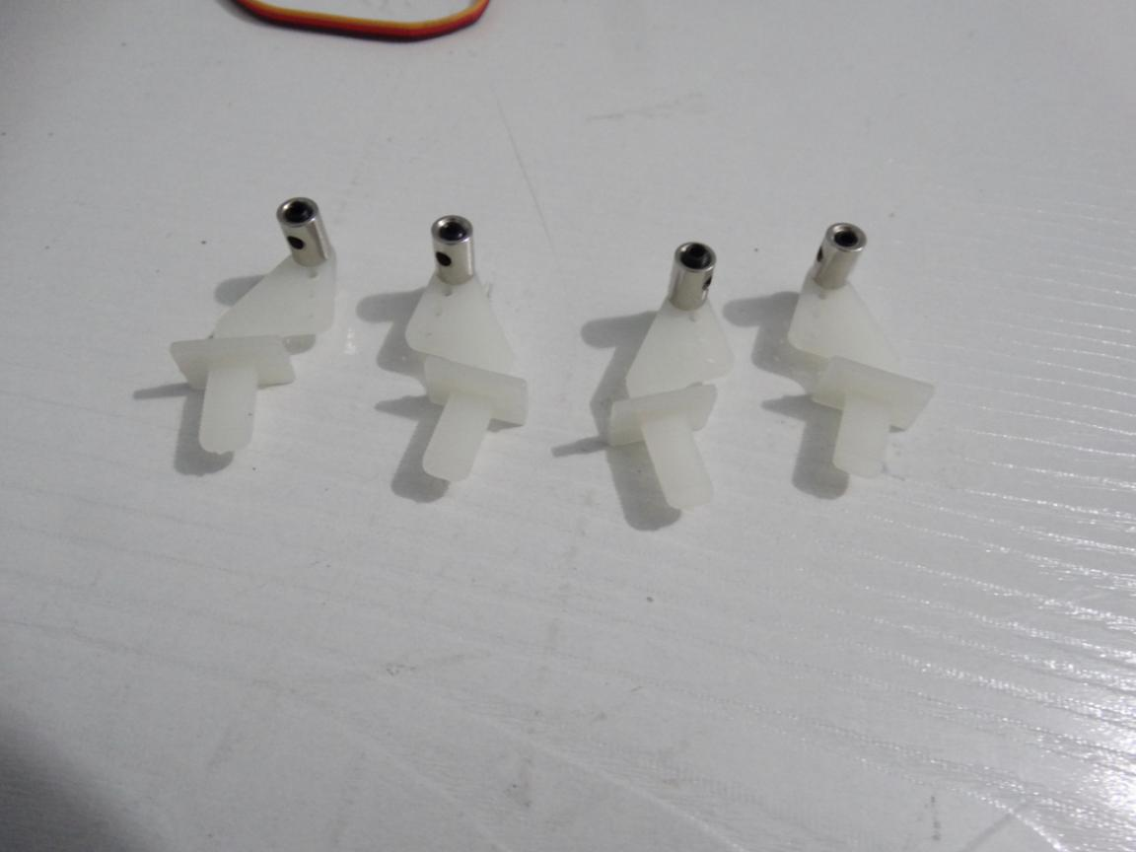
Install arm on servo and electrify all servos to make sure the arm perpendicular to servo. Then install arm screws.
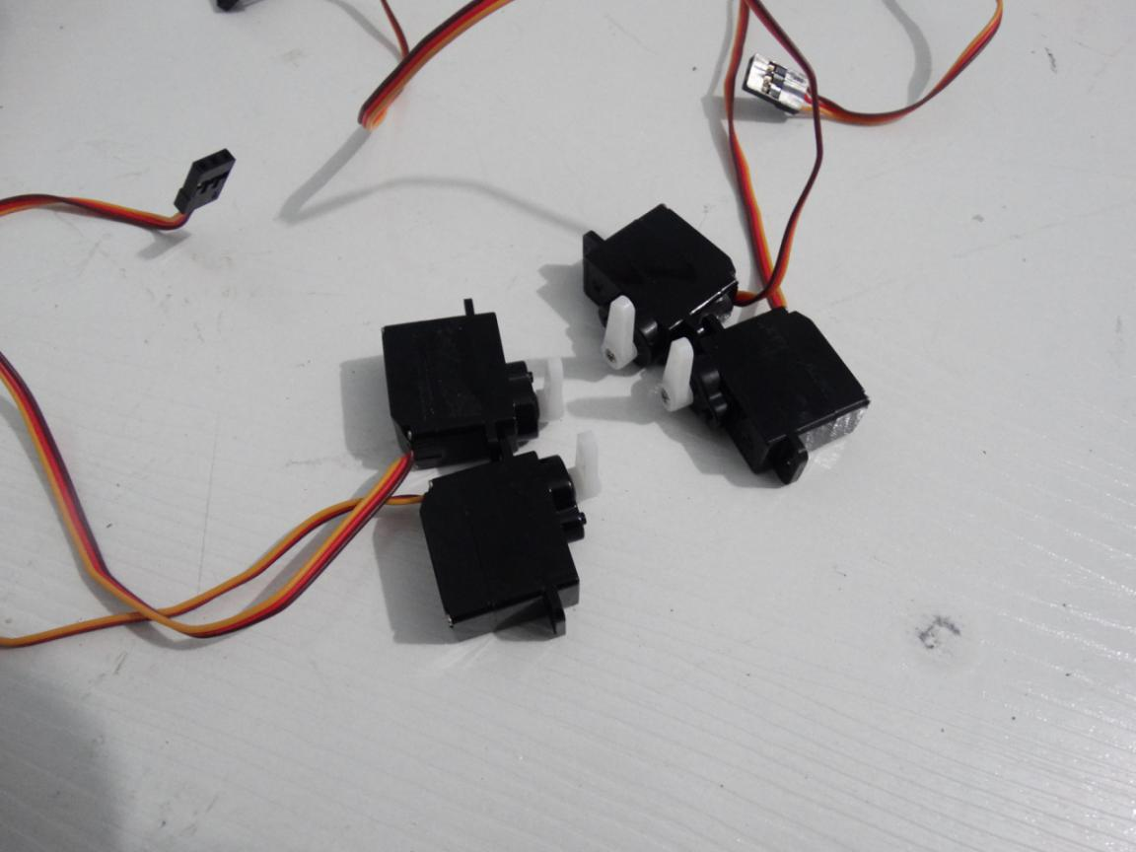
Applying glue into the servo ‘s hole on the wing using hot glue sticks. Then put servo into the hole.
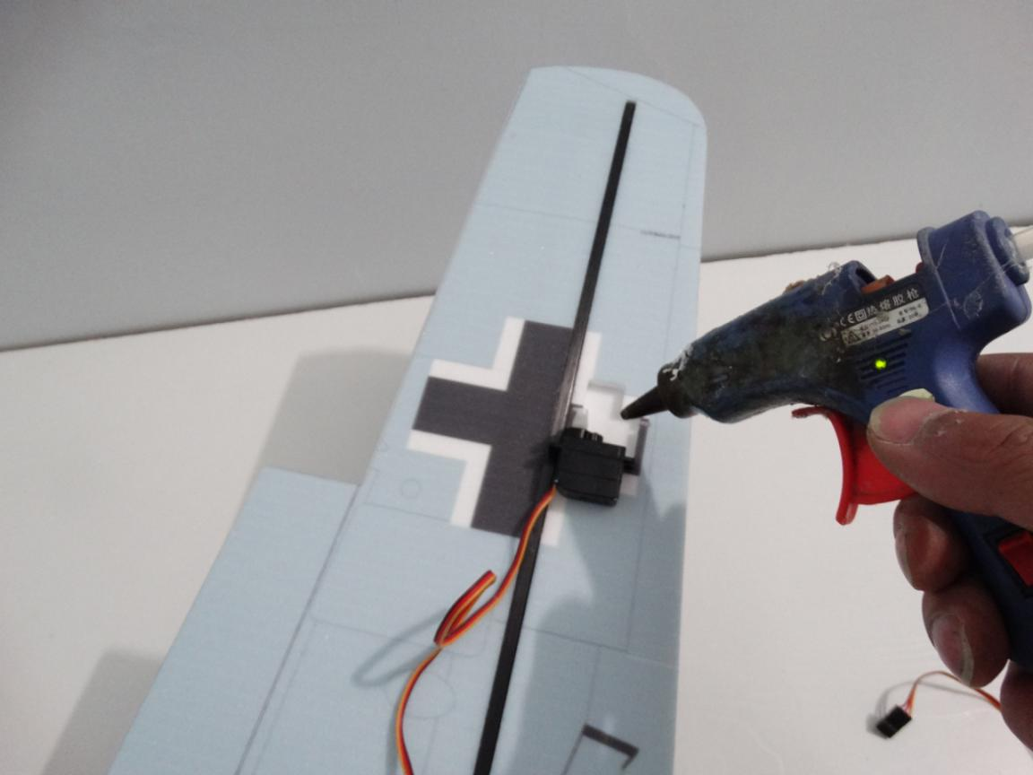
Glue the servo’s wire on wing using hot glue sticks and use Y cord connect the 2 servos on wing.
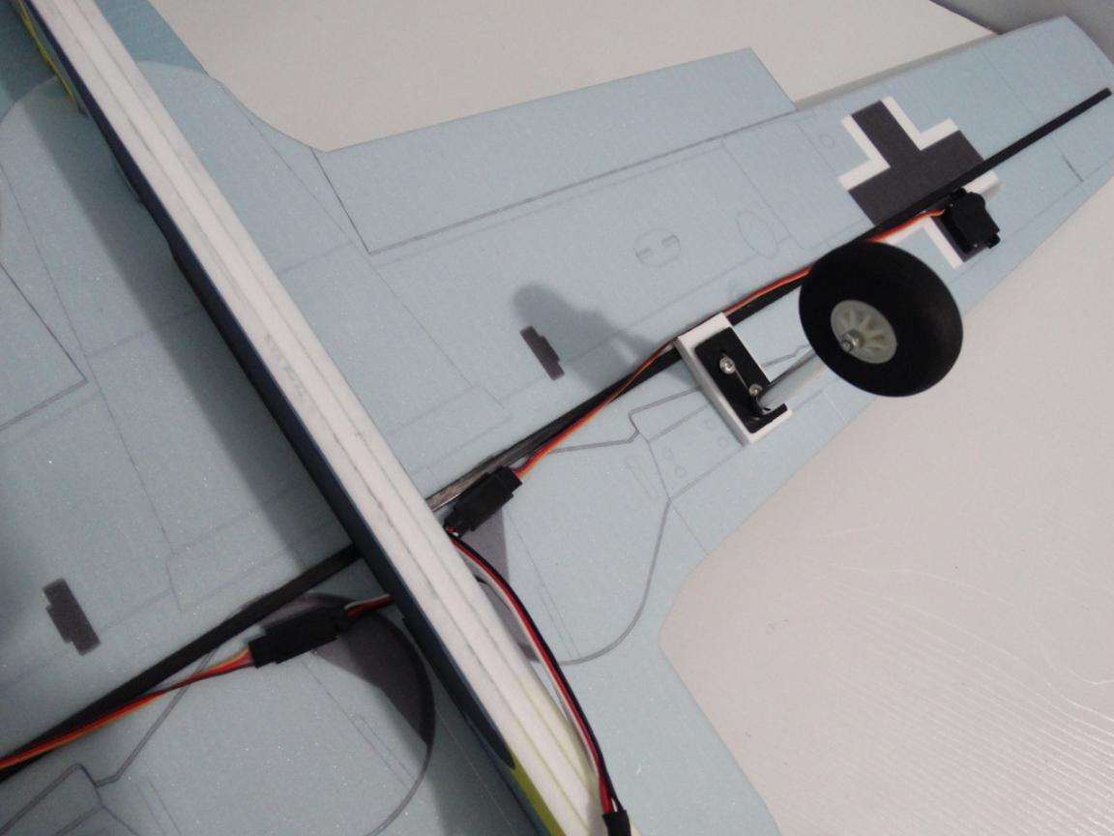

Install hinge into the hole on wing using foam glue.
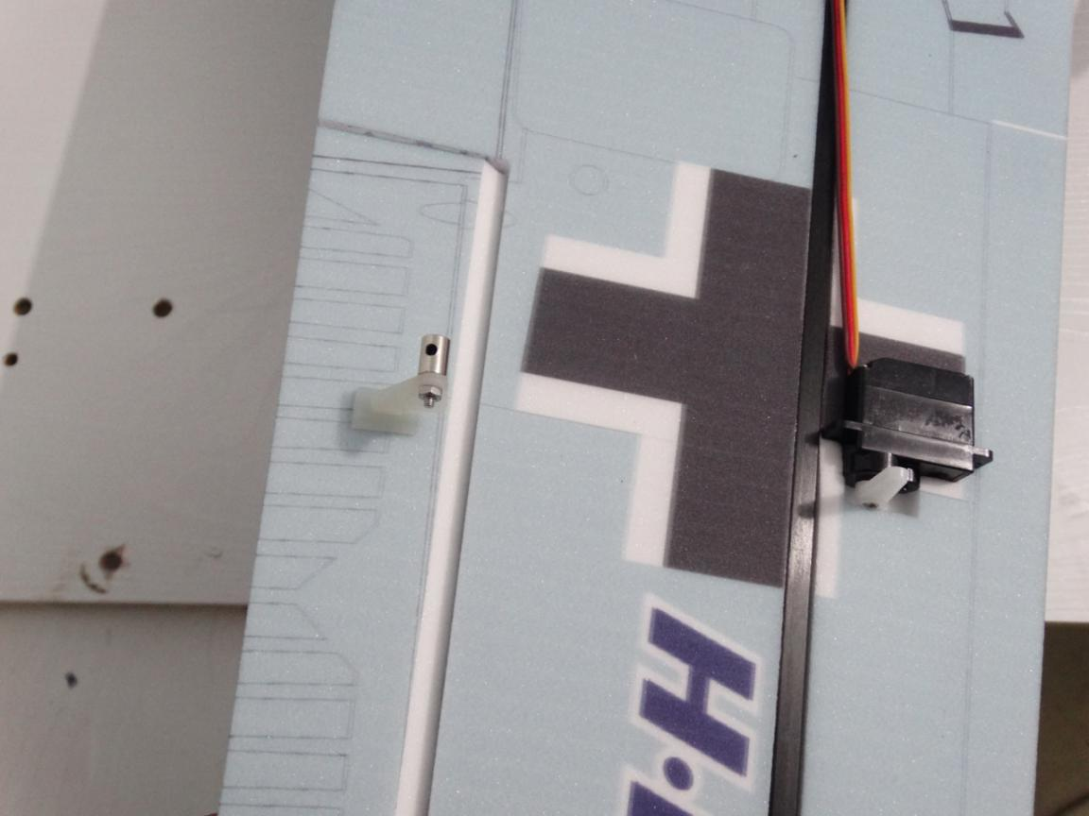
Don’t forget block the hinge with cover and apply glue to reinforce.
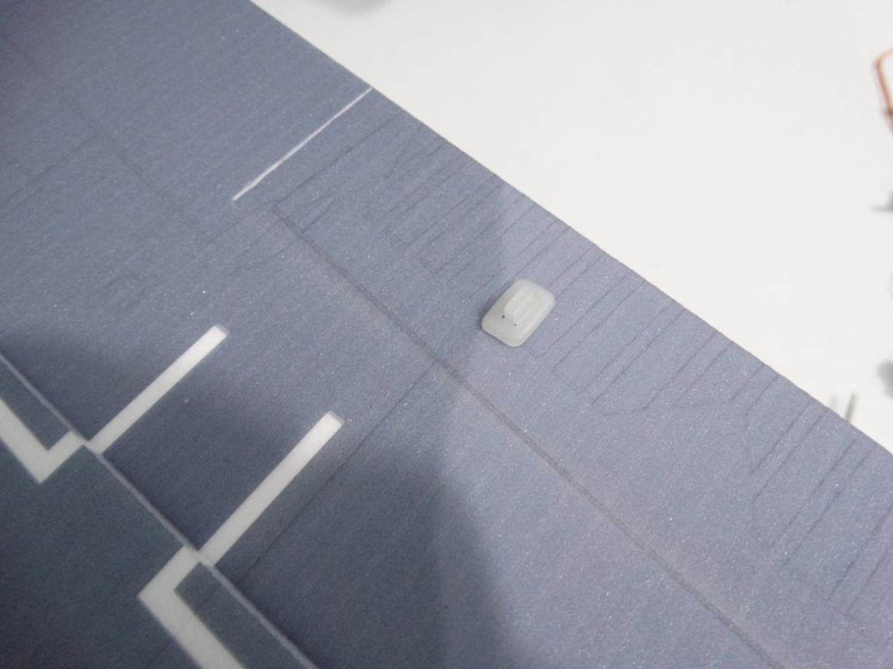

Install the 2 pcs shorter rods into arm and Quick rod adjuster. Then adjust the pull rod and tighten the screws.
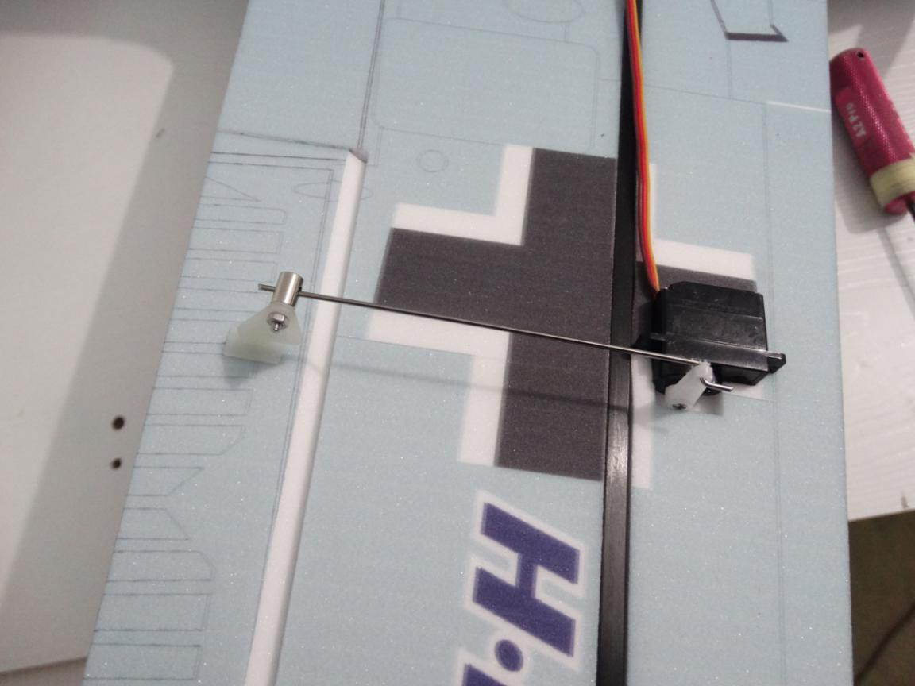
Same way to install the front fuselage’s servo.
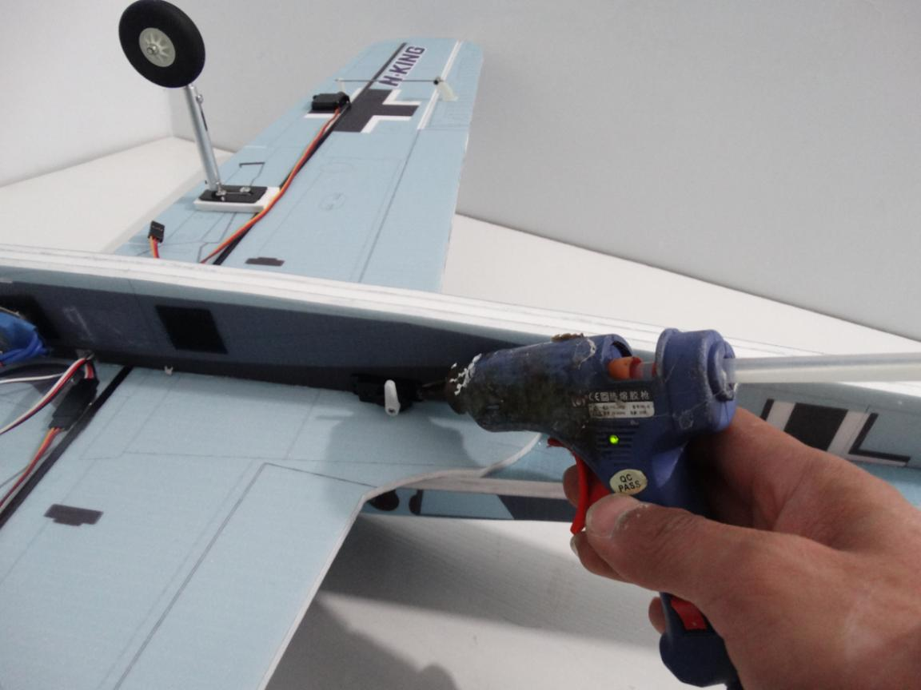

Use the shorter pull rod for the front fuselage’s servo.
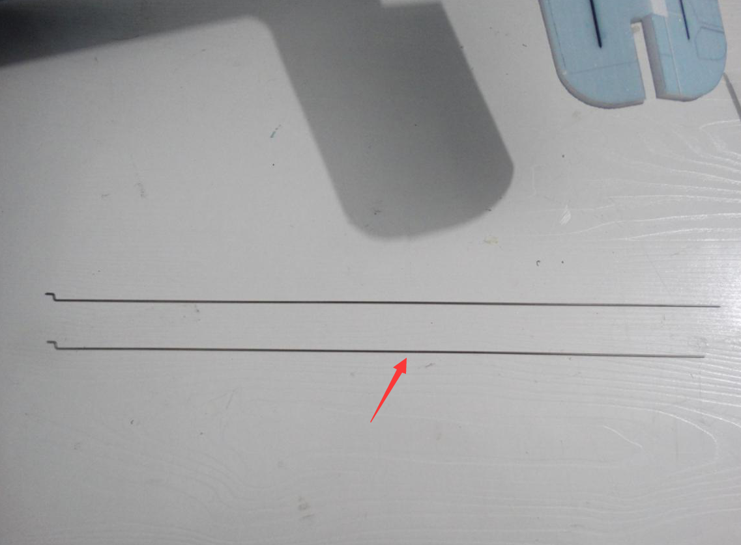
Install wood strip in the hole using No.502 glue or hot glue sticks. Notice must let pull rod through the hole on wood strip.
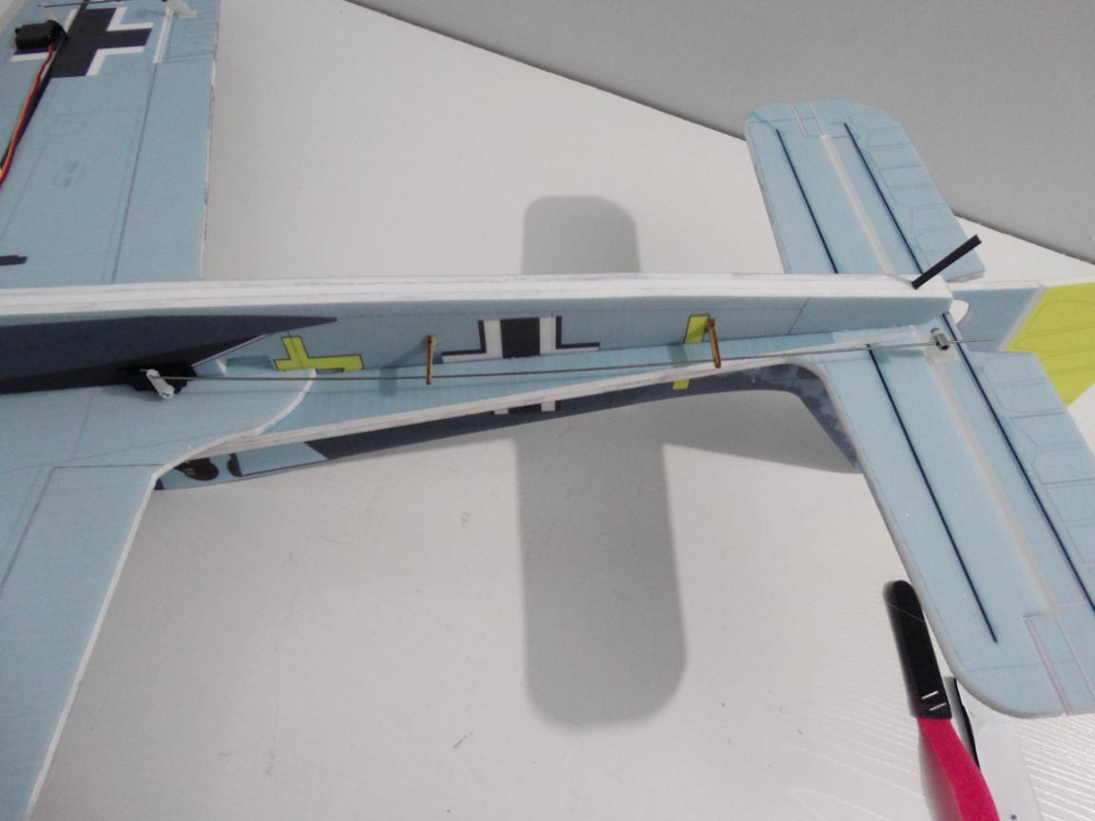

Same way to install the middle fuselage’s servo.
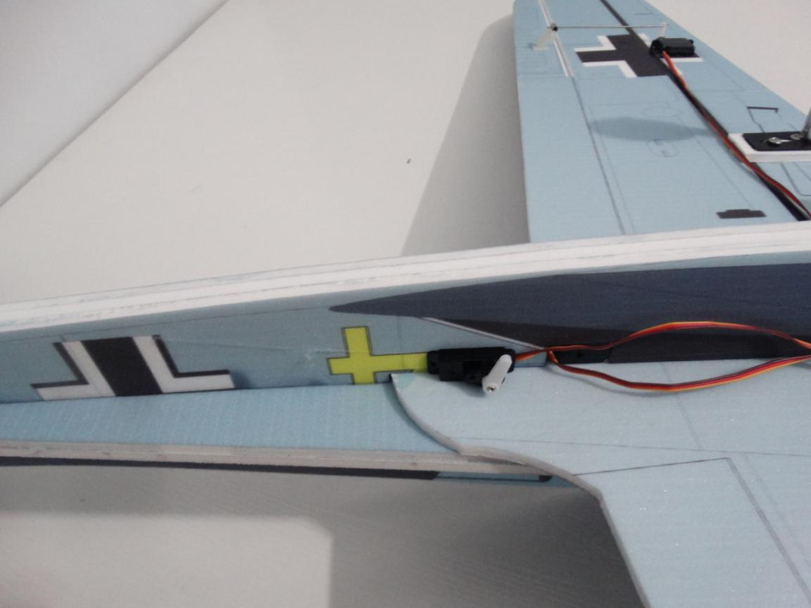
Install hinge into the hole on vertical tail using foam glue.Don’t forget block the hinge with cover and apply glue to reinforce.
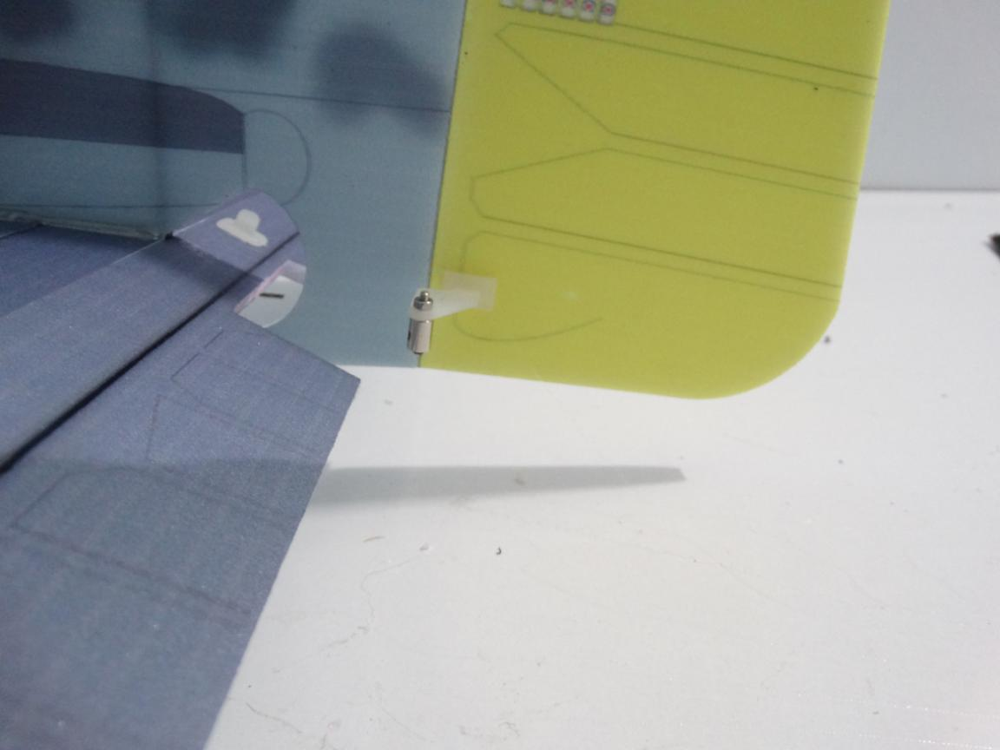

Also need install 2 pcs wood strips using No.502 or hot glue sticks. Notice must let pull rod through the hole on wood strip.
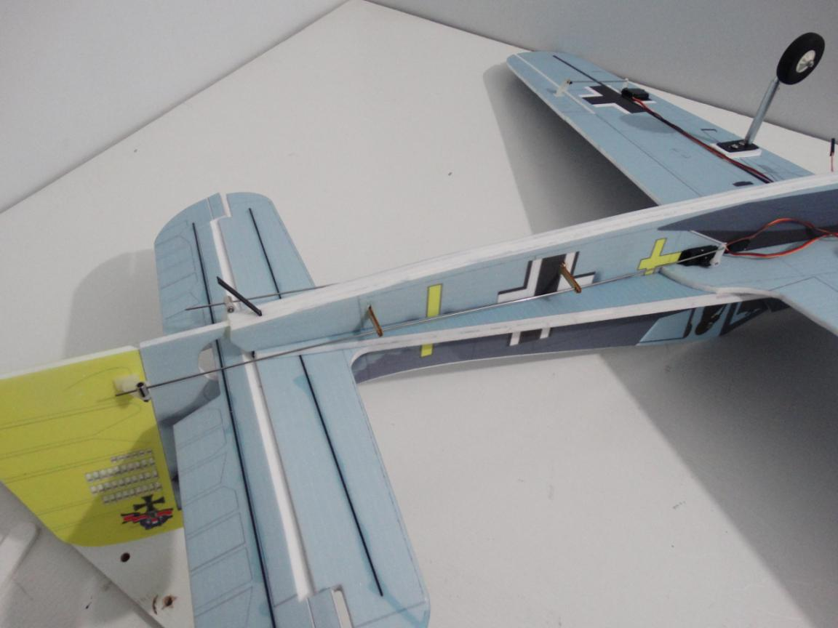
Glue the servo’s wire on wing using hot glue sticks
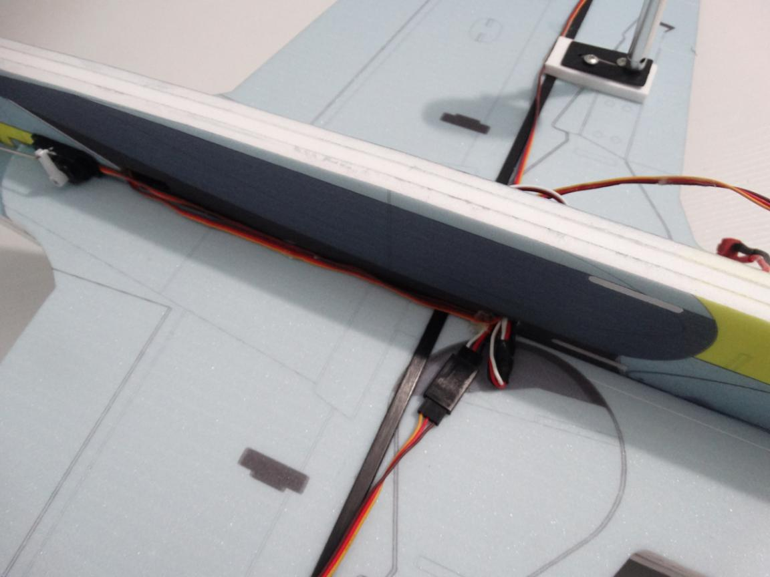
Connect servo, ESC with receiver. Glue hook and loop tape on fuselage using foam glue. Then put receiver on tape.
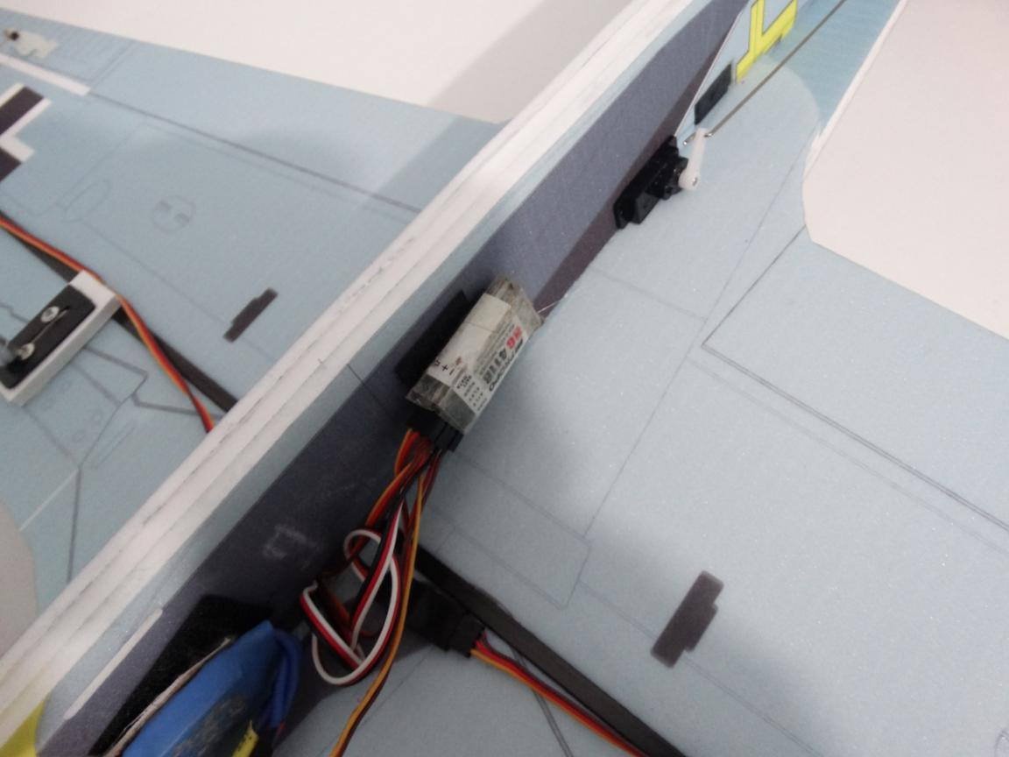
Use battery hook and loop tape through the hole to fix battery. Don’t forget glue another hook and loop tape after install battery hook and loop tape.
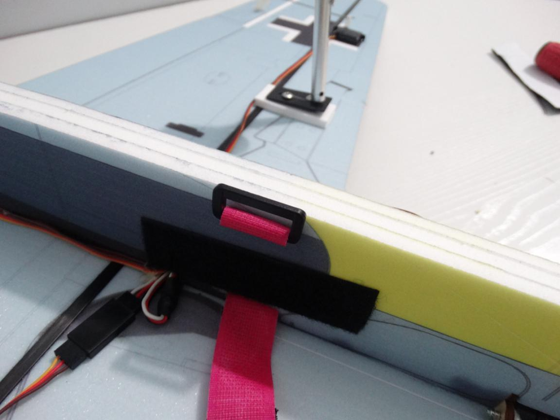
C of G is at the cross point of carbon tube with the vertical fuselage.
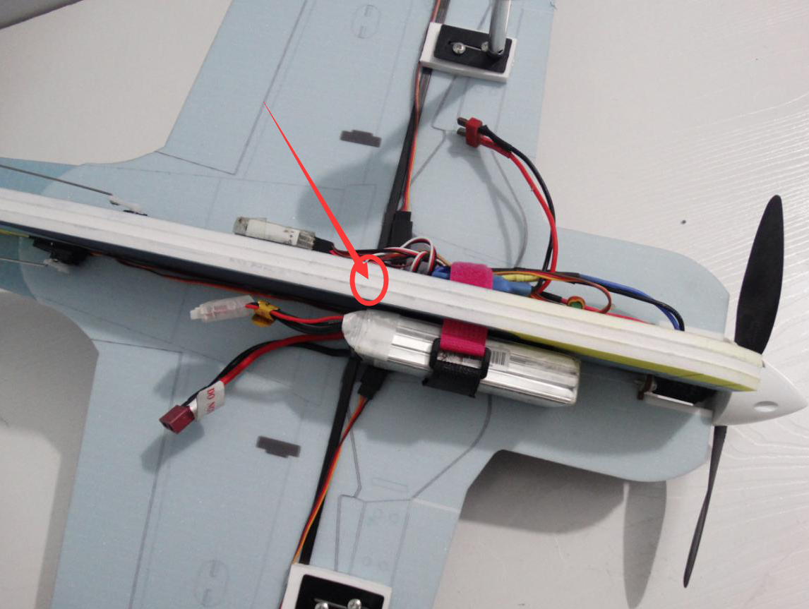
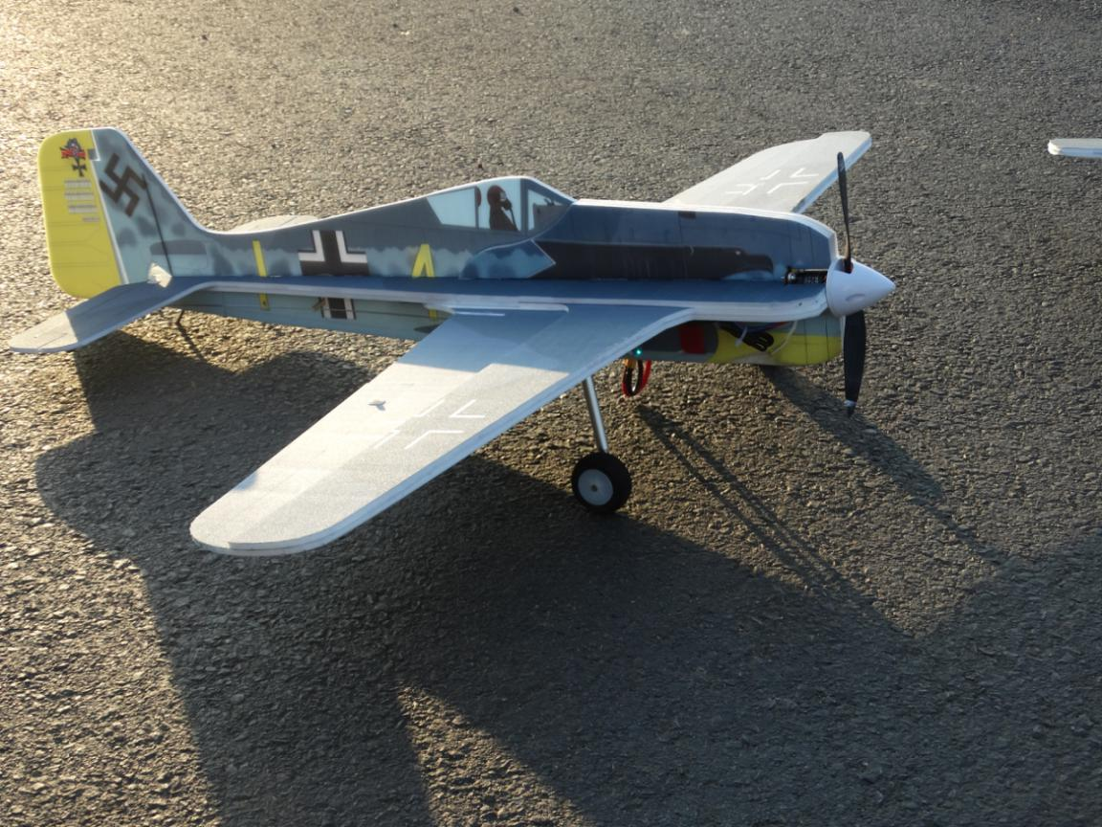
FW190 is made by new way, it flying very stable. We can choose 1.75 inch Cowling on motor to make it more beautiful.

