Aviation band receiver Suite manual V3.1

A simple introduction
This suite is dedicated to receive calls between aircraft and tower, cooperate with the good performance of the antenna (VHF yagi antenna), open within about 190 km in the biggest can receive calls between various types of aircraft with the control tower.
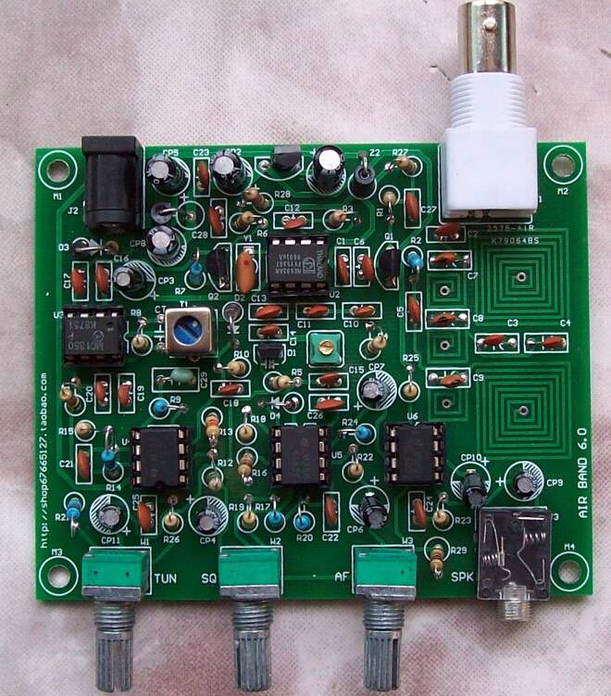

Main indicators
Power supply: 12 v
Antenna: 50 ohms, is not balanced Typical receiving current: 30 ma
Receive frequency: 118 MHZ to 136 MHZ Working pattern: AM

Circuit principle
Antenna to receive signals first enter a band-pass filter, the band-pass filter function is to ensure that the 118 MHZ to 136 MHZ signal can be put into
2 sc3355 high, other signal is maximum attenuation. After filtering, the signal amplified by the 25th sc3355 (2), and then enter the NE602 mixing, at the same time NE602 inside a voltage-controlled oscillator, the frequency changes because of the D1 junction capacitance, design covers about 120 MHZ to 150 MHZ.
Native intermediate frequency is 10.7 MHz, after NE602 mixing signal to 10.7 MHz ceramic filter, its function is to filter out irrelevant signals generated by mixing, and then the signal to do into Q2, finally gave MC1350 further intermediate frequency amplifier. MC1350 amplified signal, in the weeks after the T1 frequency selective, D2 for amplitude modulation signal envelope detection.
Check out the audio signal after U4A and U5B, LM386 amplification for headphone output again.
Among them, the AGC function performed by U4A and U4B, mute function by U5A, U5B to cooperate to complete.

Component selection
All less than 1000 pf the capacitors for high frequency of ceramics, greater than 1 uf capacitance for aluminum electrolytic capacitors, all resistance is a quarter w 5% fixed resistance.

Production debugging
Control circuit diagram and the identity of the PCB mounting of all components. General compliance installation sequence of low to high. Checked everything is in order, after turn on the juice and the power of positive and negative polarity must not be wrong. Insert the walkman headphones headphone socket, should be white noise could be heard. Touch one end of the detector diode, audio headphones get bigger noise description function is normal. To the antenna connected to a soft line of 60 cm, will hear a noise significantly larger, mean channel essentially normal.
Because of all the inductance walked straight line on the PCB, and high precision, no need to be adjusted. Such as near no carrier signal, advice from C5 to 60 centimeters or so at the end of the software, then short circuit R21, so the vibration of the coverage has reached around 100-150 MHZ, judge machine can listen to the local FM signal.
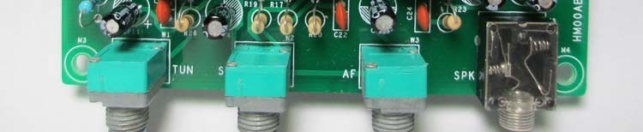
Native function knob from left to right are: frequency control, noise threshold adjustment, volume adjustment, clockwise. Headphone socket on the right.

Method of use

For VHF are close to a straight line transmission, therefore VHF communication cannot be obscured, listening to the tower signal more need to pay attention to it, close to the airport in a plane is apart from the ground height when there are several hundred to several thousand meters high, so the signal can cover a distance. In order to better effect, it is recommended to use external high antenna, such as a quarter wavelength (60 cm) of GP antenna, yagi antenna or using better VHF paragraph. In a word, need according to the practical environment, appropriate cooperates antenna, can obtain good result!

For primary fans, it is recommended to use GP antenna or yagi antenna.
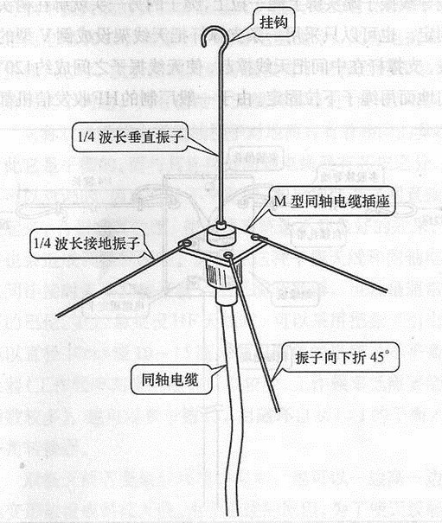
Below is GP antenna, GPS antenna is short for flat ground antenna, the antenna, also known as vertical ground antenna is a kind of common vertical polarization omnidirectional antennas. It consists of a vertical level of radiation oscillator and 3-4 root extension of the oscillator. A few metal rod with a M, made simple.

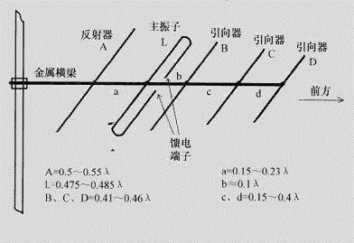
Below as the yagi antenna, has the very good directivity and high gain.
Also can use insulators metal bar! Diagram for wavelength lambda, director, reflector are calculated respectively and the main oscillator length and a, b, c, d spacing after assembled.

Chassis to install
This circuit board can be easily in the size of 40 mm * 97 mm * 75 mm standard aluminum chassis (this case is not included in this kit, such as the need to please buy).

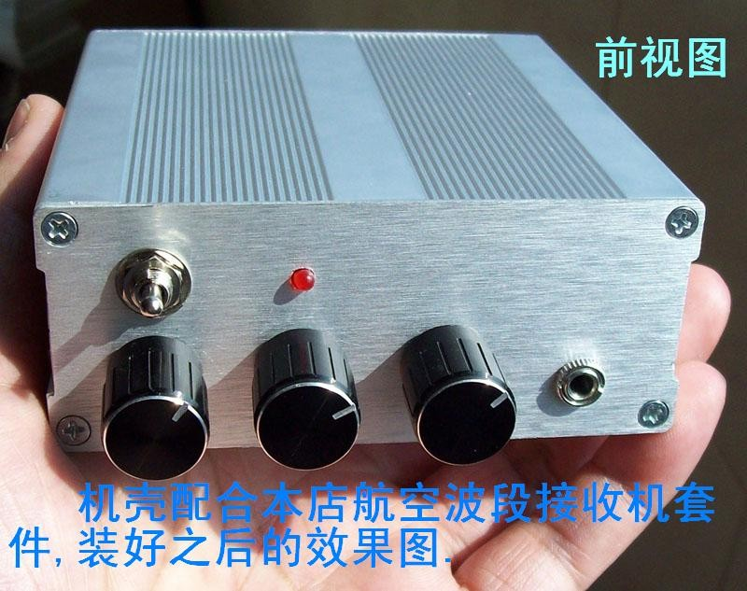

元件清单

1/4W 固定电阻
R1,R6,R11,R16,R29 | 1K
R2,R7,R9,R14,R17, R20, R2 | 4 47K
R3,R27,R28 | 270
R4,R8,R10,R15,R22 | 10K
R5,R18 | 100K
R12 | 1M
R13 | 33K
R19 | 4.7K
R23,R25,R26,R21 | 10
W1,W2,W3 | 10K | 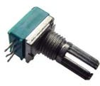
磁珠、电感、变压器
T1 | 7X7-10.7MHz | 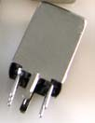
Z1,Z2 | 直插磁珠
瓷片电容
C1,C16,C21,C22,C23,C24,  C25,C26,C27,C28 | 0.1uF(104)
C2,C5,C6,C13,C17 | 1000pF(102)
C3,C4 | 2pF
C7,C8,C9 | 43p
C10,C14 | 27pF
C11 | 10pF
C12,C15,C18,C19,C20 | 0.01uF(103)
C29 | 0.47uF(474)
电解电容
CP1,CP2,CP5,CP8 | 100uF /25V
CP3,CP4,CP7,CP9,CP10,CP1 | 1 10uF /25V

CP6 | 10uF
晶体管
D1 | BB910 | 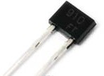  插入板子请按丝印方向
D2 | 检波二极管2AP9
D4 | 1N4148
D3 | 1N4001
Q1,Q2 | 2SC3355
集成电路
U1 | 78L08（TO92）
U2 | NE602（DIP8） | 配 IC 插座
U3 | MC1350（DIP8） | 配 IC 插座
U4,U5 | LM358（DIP8） | 配 IC 插座
U6 | LM386（DIP8） | 配 IC 插座
陶瓷滤波器
Y1 | 10.7MHz | 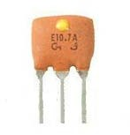  请注意管脚方向：器件表面印刷字面对读者，1 脚在右边
其他元件
J1 | BNC（Q9）插座
J2 | 电源插座
J3 | 3.5mm 立体声插座 | SPK（插入耳机）
PCB 电路板×1 片

R29 / 1K
R29 in LM386 3 between foot and ground, Can improve the response speed of noise, Please welding on the back of the PCB.

CT has been welded in T1 weeks inside, no need to install.

电路板装配

Please note that Y1 1 foot, can not install error!
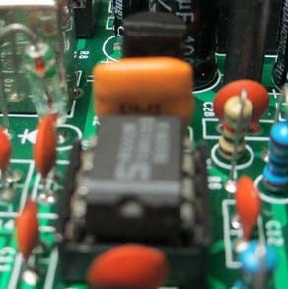

5 4 3 2 1

航空波段接收机电路图（V3.0） 淘宝店：
D
论 坛：

R1

C27 0.1u

R27

270

C1 0.1u

AVCC_8V Z2 FB

VCC_8V

+
CP1

U1

78L08 /TO92
1 3
VOUT VIN
GND

VCC_12V D

+ CP2

ANT
J1
C2 1000p

1

2
4
3

C3

2p

C7
43p

C4

2p

C8
43p

C5

1000p

C9
43p
1K

R2

47K

1

C6

1000p

R3 270
3

Q1

U2

- INA
- INB
- GND
- OUTA

VCC 8
OSCE 7
OSCB 6
OUTB 5

R4 10K

C10 27p

C11
100u /25V
100u /25V

VCC_8V
2

R26 10

78L08 2SC3355
AS119

1N4001

2SC3355

C12 0.01u
2
NE602

10p

C13

C14 R5
W1

1000p

27p

100K
2

10K

C C28

0.1u

R28
R6 270
1K C17
1
AVCC_8V
C16

Y1

+
CP3

LT10.7
3

1

C25
2

VCC_8V

CP4

D1 BB910

C15 0.01u

CP11
+

10u /25V

R21
3.3K

为PCB电感 C

R7 0.1u 10u /25V
+

47K

1000p U3
T1 D2
1 6
4
IN-

VCC
2

1
OUT-

3 +
LM358_1
R9
8

0.1u

10u /25V
8

3
3
1
Q2 7
2
NK
GND
6
IN+

AGC
R8 2
10K 3
OUT+

AS119
4
R10
8
7

C18
0.01u
1
2 -
4
U4A

47K

C29
5 +
7
6 -
4
U4B
AGC

2SC3355
5

8
10K
0.47u
LM358_1

MC1350

C19
B 0.01u

C20 0.01u

R11 1K

AGC

7X7-10.7MHz

C26

VCC_8V

R13 33K

R17

R12 1M

R20

10K W3

R15 10K

R14 47K

C21 0.1u

R16 1K
R18

VCC_8V

B

12V电源输入

CP9
J3
2
3
4

LM386

5
+

CP7
U6
7
1
8
10u /25V

+ 3
+
- 2
4

6

0.1u

7

U5B

47K

+ 5
8
- 6
4

47K C22

0.1u

R22

CP6

10u /25V

U5A

1

100K

+ 3
8
- 2
4

R19 4.7K

W2 10K

J2 Z1
3
2 FB
1
D3
+ CP5

VCC_12V

+

SPK

A
5 10u /25V
1
R23
10

C24 0.1u

R25 10
+
CP10 10u /25V

VCC_12V

LM358_2

R24

47K

470K

D4 AS119
LM358_2
POWER

1N4001
CP8 100u /25V 100u /25V
C23 0.1u

A

M1 HOLD_0

M2 HOLD_0

M3 HOLD_0

M4 HOLD_0

1 1 1 1

Title

01.MAIN

Size Document Number Rev

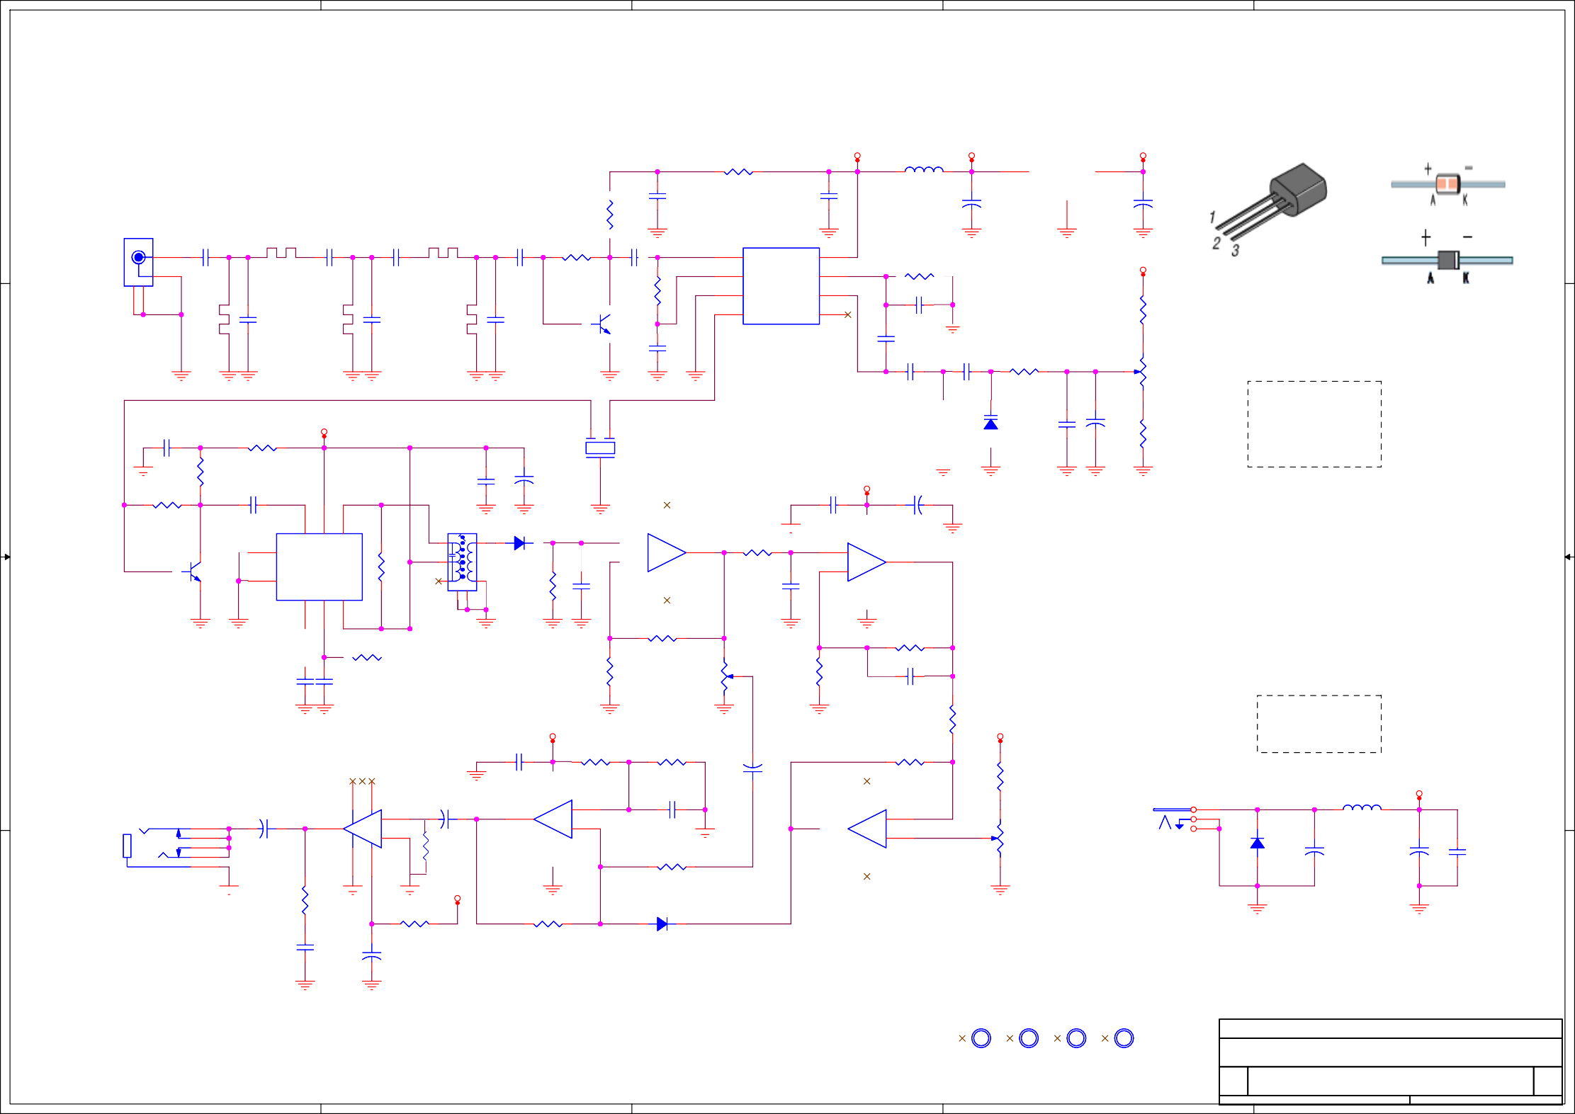

5 4 3
A3

Date:
2
HM00ABRA_3
Tuesday, June 25, 2013

Sheet
1
1 of 1
3.0

