Jinhan car special induction probe（JH-02 AIP）
### This device is an Android USB slave device, please confirm that your Android device supports or has OTG mode turned on, some old phones may not support OTG mode, and some brand phones need to manually turn on OTG mode(Such as OPPO VIVO OnePlus)###
### Android version 7 and above is recommended###
### This device is a non-broken line induction device, different test positions may affect the amplitude of the waveform.###

Appearance:
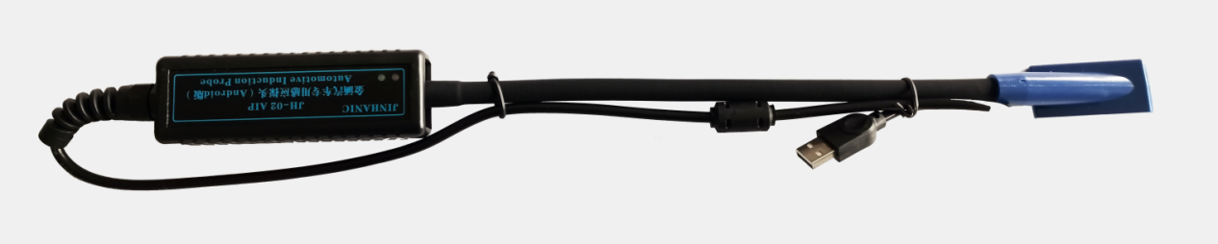

1.Product function description
Jinhan Automotive Special Induction Probe (JH-02 AIP) is a type of sensor that is compatible with Android phones for automotive ignition systems (including independent ignition systems), fuel injection nozzles (including direct injection in cylinders), solenoid valves (VVT), etc. Special instrument for measuring auto repair.

2.Features
Support Android system (does not support IOS system);
The mobile phone is directly powered, and the software is automatically upgraded online;
No broken skin measurement, no harm to the wiring harness;
Pre-set test menu, built-in reference waveform;
One-click screenshot can be quickly compared with the last test result;
Plug and play, quickly determine the lack of cylinder, fire, fuel injector vvt solenoid valve failure and other phenomena
Ergonomic design, comfortable and durable, easy to carry.

3.Hardware parameters:
Connection method: usb
Measurement method: non-broken line contact induction
Time base range: 50ms-50us
Magnification range: x1-x200

4.Instructions:
The software can be obtained by scanning the attached QR code.
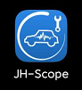
Access the device through the patch cord:
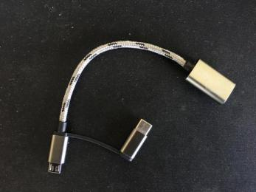
Some mobile phone models need to open the OTG option manually (OTG option can be found in the settings), take one plus, VIVO mobile phone as an example:
OnePlus mobile phone:
Open the settings and type OTG in the search box
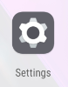
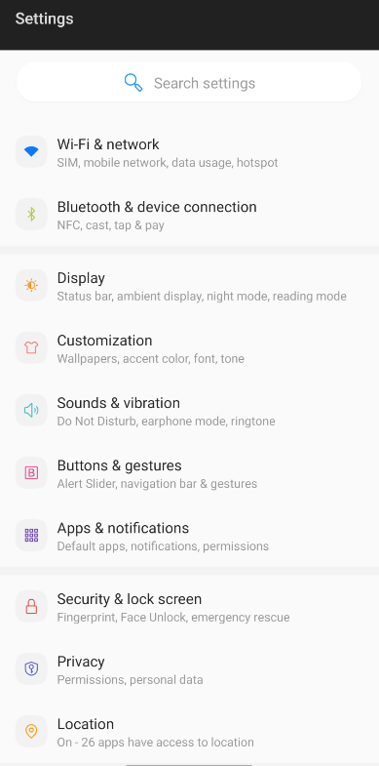

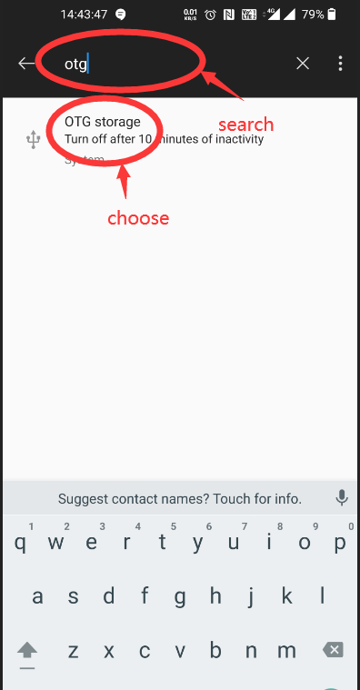
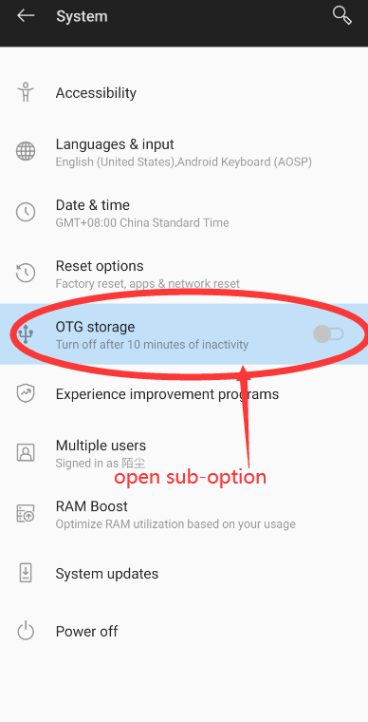
VIVO mobile phone (system requires Android 7 and above):
Open the settings and type OTG in the search box
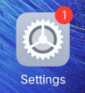
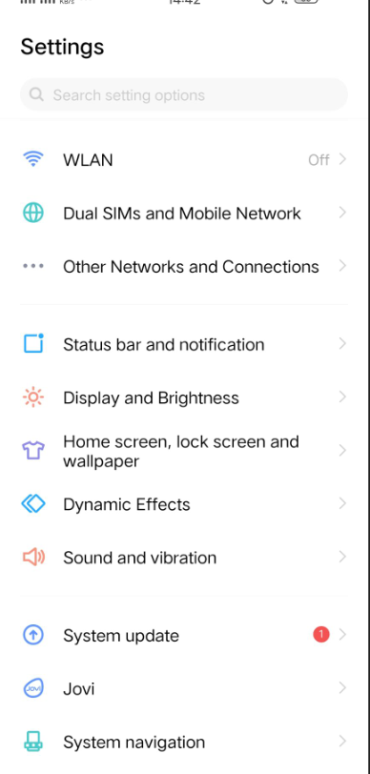

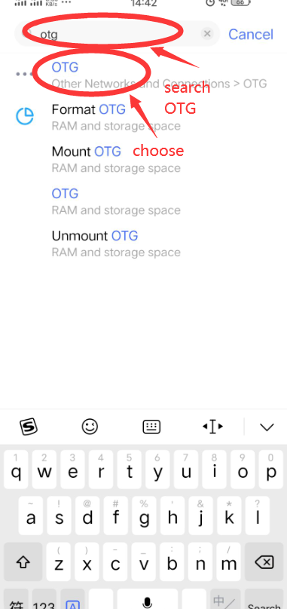
After the device is inserted, the software will automatically start.
The first time the device is inserted, the USB authorization will pop up, please click to confirm:
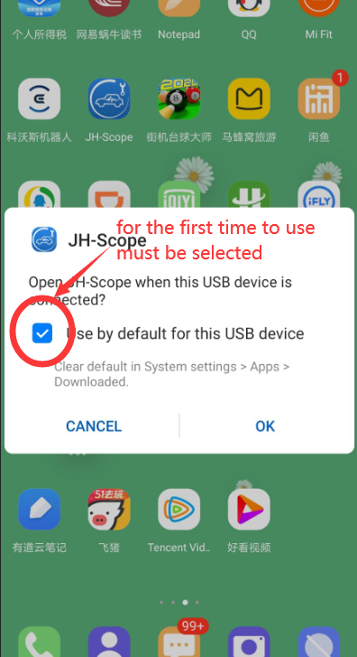
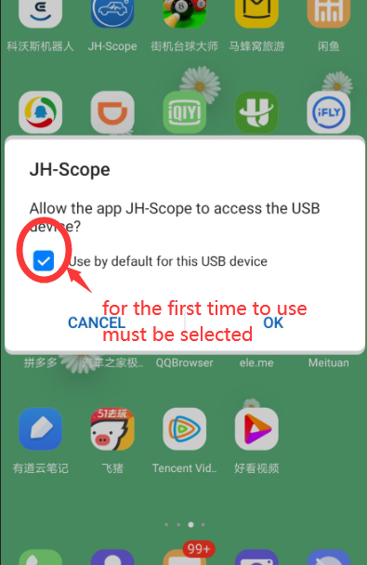

After the device is connected, enter the main menu.
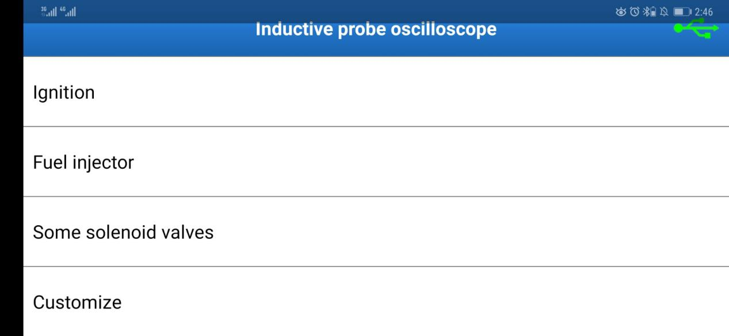
Whether the device link is successful can be judged by the link status indicator in the upper right corner.
connection
not connected
After the device is connected, you can start the test:
The software itself is preset with ignition, fuel injection and some solenoid valve options, and may need to be fine-tuned after entering options according to different vehicle models.
5.Basic use of software
Software interface introduction:
The parameters section includes Frequency
Duty cycle A
Duty cycle B
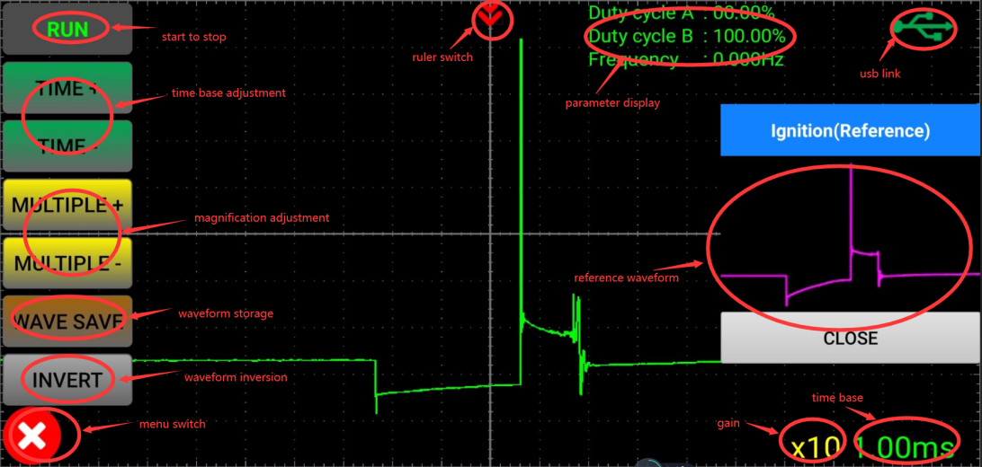
Open button for control menu:
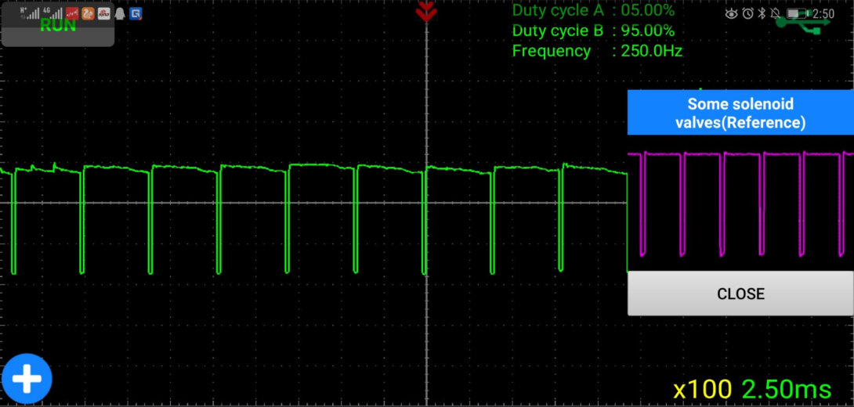
The ruler's open and close buttons (the ruler can be dragged freely after opening)
The scale can measure the injection time (injection pulse width), ignition time, etc.
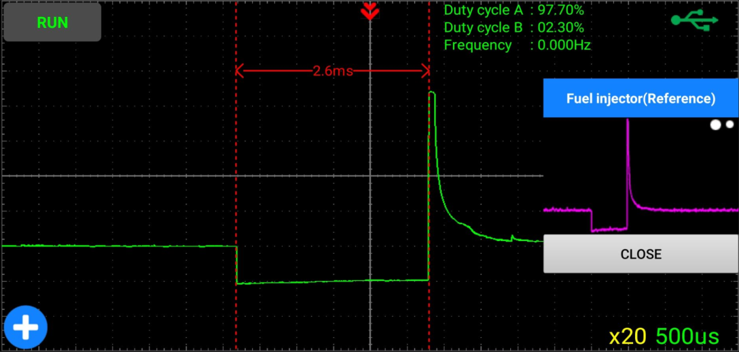
The software supports a temporary line to save a set of comparison waveforms:
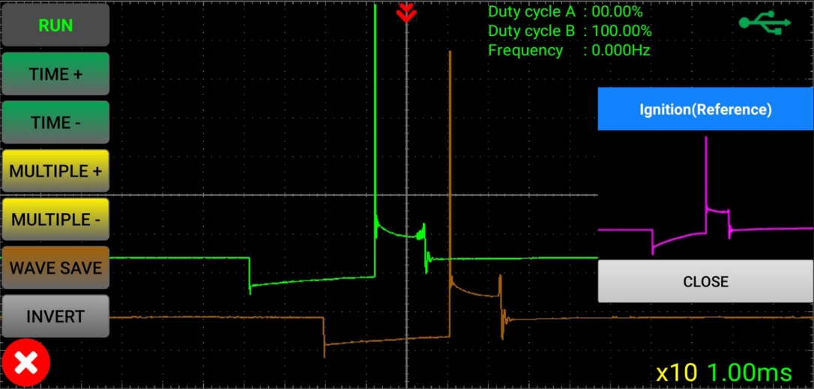
The software supports the invert function of the waveform:
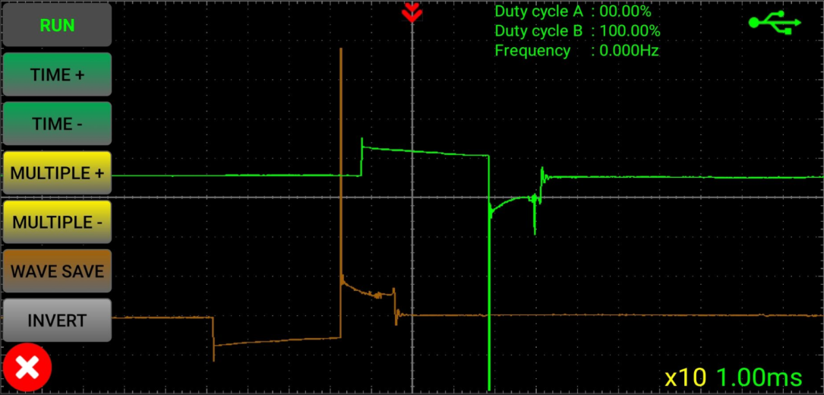

6.Actual example:
The following is an example of actual measurement:
Ignition (the device can be placed at the joint):

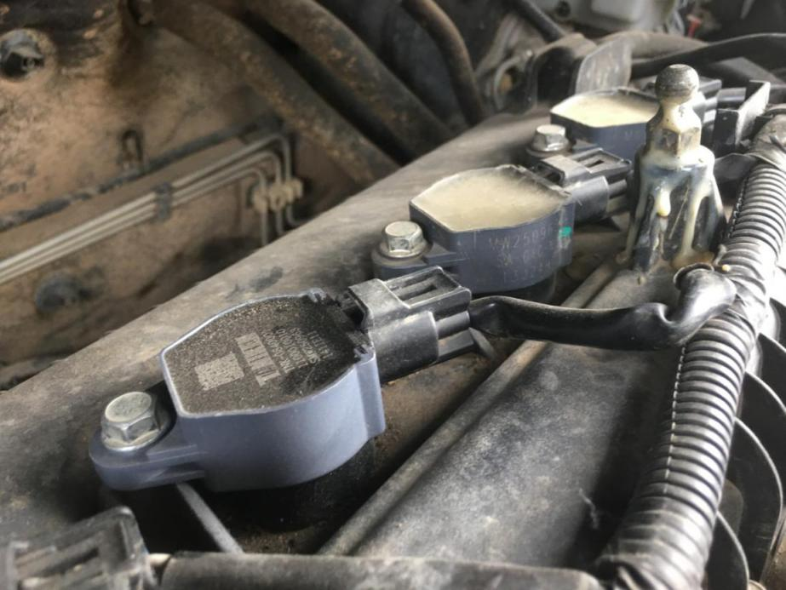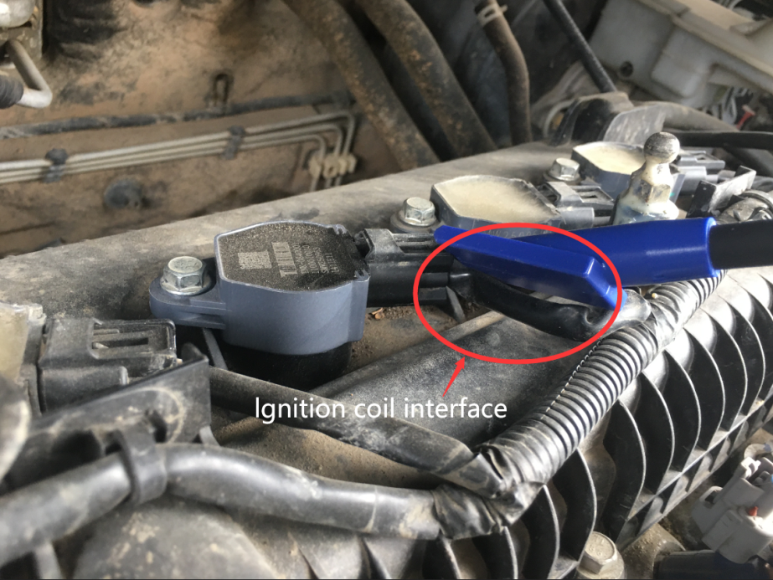

Waveform display:
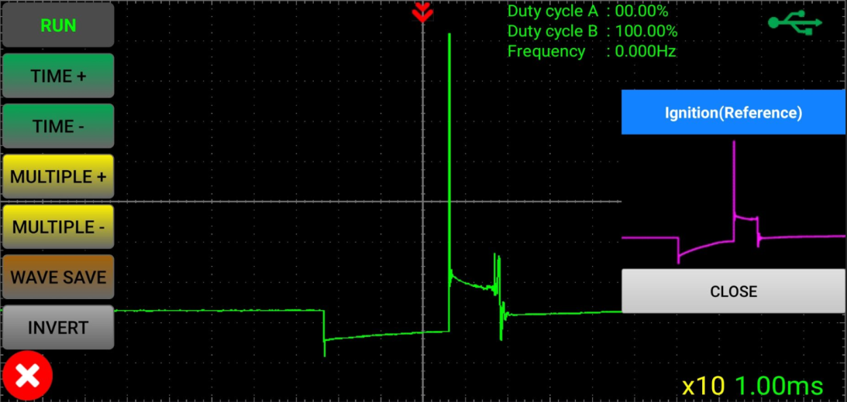
Fuel injection (the equipment can be placed at the joint):
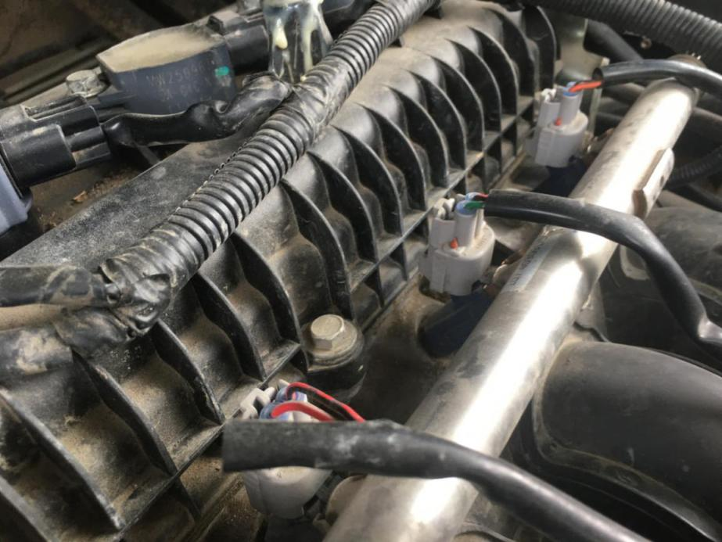
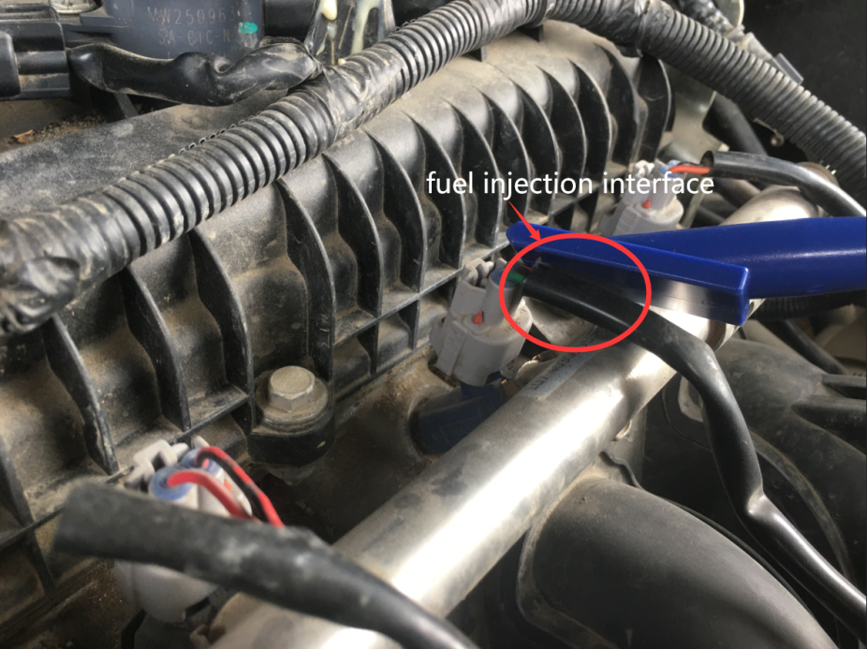

Waveform display:
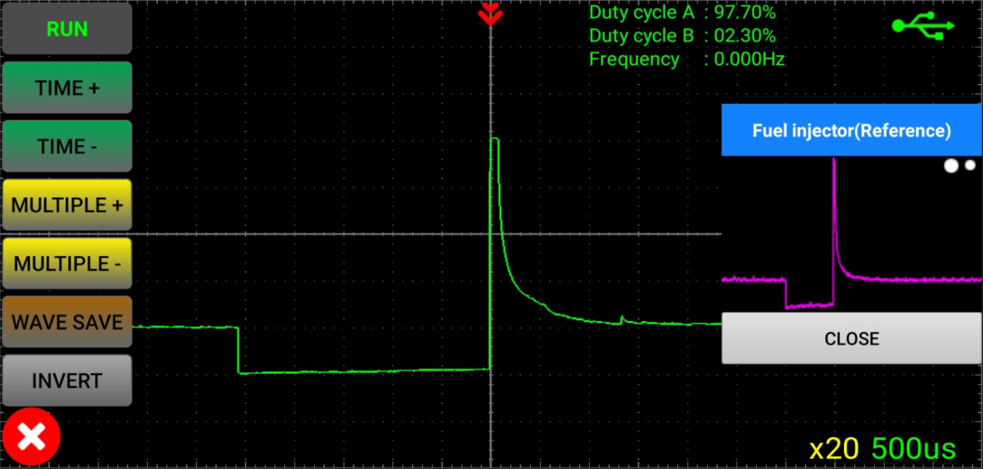
Solenoid valve (the equipment can be placed at the joint):

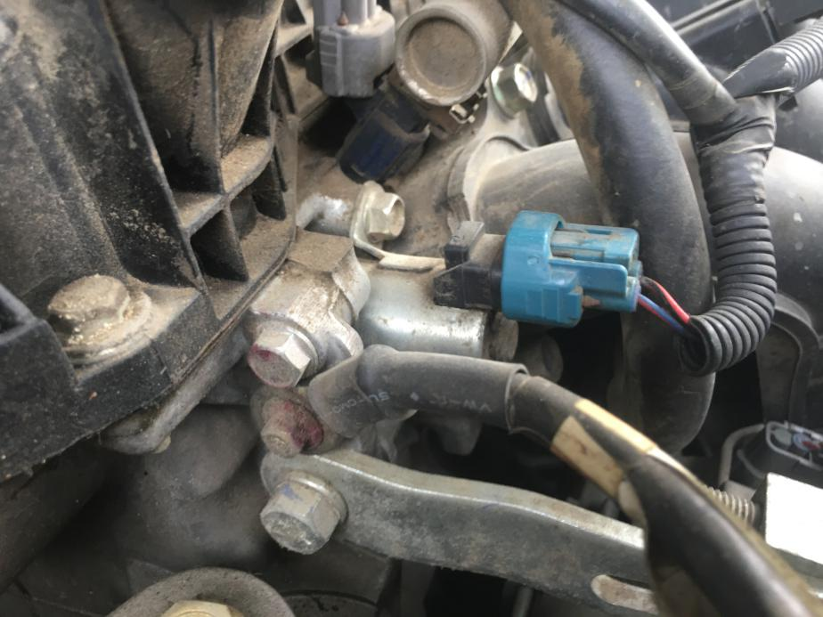
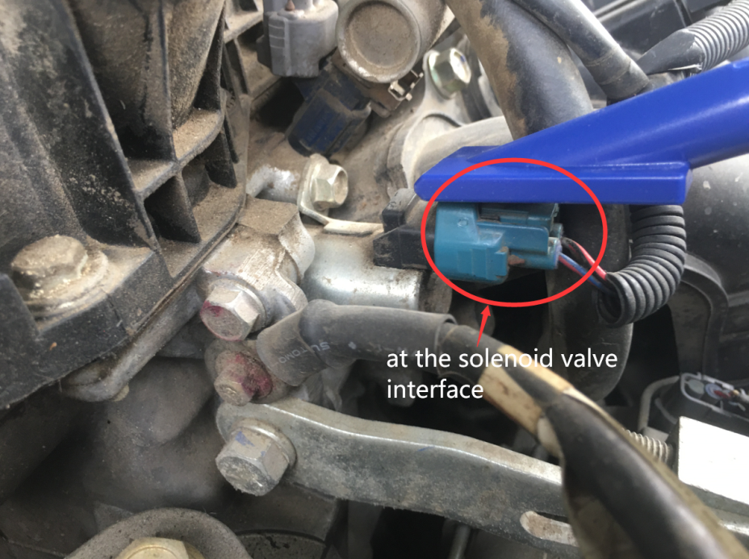
Waveform display:
Note: The duty cycle and frequency at idle speed are displayed at the same time.
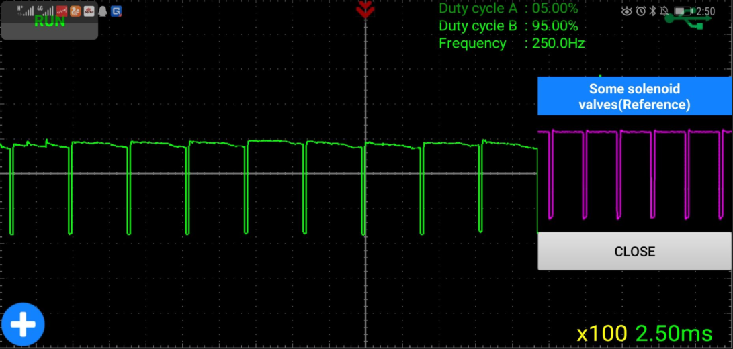

The following is a comparison between the oscilloscope broken line measurement and this device:

