The wall wangzi shell
temperature and humidity
transmitter
operation instruction
（Analog Quantity Type）

Document version：V1.2

Context
1. Product Introduction 3
1.1 Product summary 3
1.2. Function feature 3
1.3. Main technology indexes 3
2. Product Selection 4
2.1 86LCD Shell 4
3. Device Installation Instruction 5
3.1. Check before device installation 5
3.2. Wiring 5
3.2.1: Power supply wiring 5
3.2.2: Output interface and wiring 5
3.3 Specific model wiring 5
3.3.1: Wall wangzi shell wiring 5
3.4 Wiring example 6
4. Common Problem and Solution 6
5. Contact Information 7
6. Document History 7
7. Shell Size 7
Wall wangzi shell ：110×85×44mm 7

1. Product Introduction

1.1 Product summary
This product is widely applied in communication engine room、automation、automatic control where needs the temperature and humidity monitor .The three parts about input power supply, temperature measurement unit and signal output of sensor are completely isolated. Safe and reliable, beautiful appearance, easy installation.

1.2. Function feature
●Imported Swiss measure unit，accurately measure.
●Using special analog circuit ，widely applying range.
●10~30V DC wide voltage supply.
●Be applied in three wire and four wire system simultaneously.

1.3. Main technology indexes
DC powered（default） | 10~30V DC
Maximum power dissipation | Current output | 1.2W
 | Voltage output | 1.2W
Degree of accuracy;（default） | Humidity | ±3%RH(5%RH~95%RH,25℃)
 | Temperature | ±0.5℃（25℃）
Temperature of transmitter electric circuit operation | -20℃~+60℃，0%RH~80%RH
Temperature of probe operation | -40℃~+120℃，default -40℃~+80℃
Humidity of probe operation | 0%RH-100%RH
Long-term stability | Humidity | ≤1%RH/y
 | Temperature | ≤0.1℃/y
Reaction time | Humidity | ≤8s(1m/s wind speed )
 | Temperature | ≤25s(1m/s wind speed )
Output signal | Current output | 4~20mA
 | Voltage output | 0~5V/0~10V
Load capacity | Voltage output | Electric resistance output≤250Ω
 | Current output | ≤600Ω
Note: The maximum current with display products increased by 5mA

2. Product Selection

2.1 86LCD Shell
RS- |  |  |  |  | Code of Ren Shuo corporate
 | WS- |  |  |  | Humiture variable and sensor
 |  | I20- |  |  | 4～20 mA current output
 |  | V05- |  |  | 0～5V voltage output
 |  | V10- |  |  | 0～10V voltage output
 |  |  | 1 |  | 86LCD Shell
 |  |  |  | 6 | External waterproof probe
 |  |  |  | 7 | External high-sensitivity probe
 |  |  |  | 8 | External common probe
 |  |  |  | 9 | External metal waterproof probe
 |  |  |  | A | External long metal probe
 |  |  |  | B | External wide temperature probe
2.2 Probe Selection Table
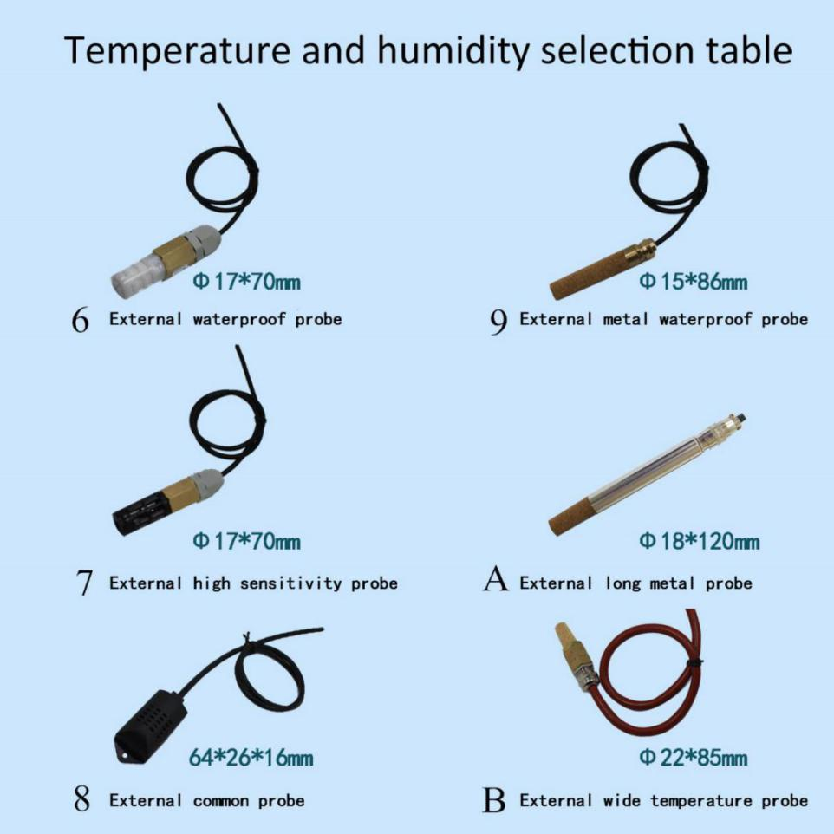

Device Installation Instruction

3.1. Check before device installation
■One transmitter device
■One 12V/2A power（selection）
■Certificate, warranty card, after sales service card and so on

3.2. Wiring

3.2.1: Power supply wiring
DC power input by wide voltage 10-30V. Only 24V power supply applied in 0-10V output type device.

3.2.2: Output interface and wiring
The standard setting of the device is the one which owns two independent analog quantity output and adopts the three wires and four wires system simultaneously.

3.3 Specific model wiring

3.3.1: Wall wangzi shell wiring
 | Line color | Description
Power | brown | Power supply
 | black | Power supply negative
Output | blue | The temperature signal is positive
 | green | The temperature signal is negative
 | yellow | Humidity signal positive
 | white | Humidity signal negative

3.4 Wiring example
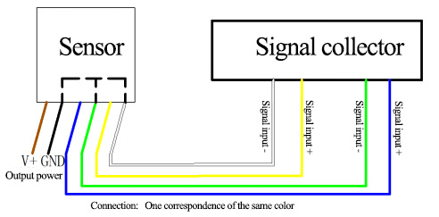Four-wire connection diagram
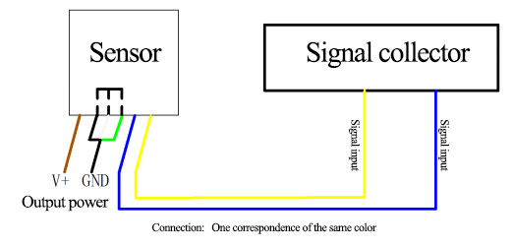
Three-wire connection diagram

4. Common Problem and Solution
Fault situation：no output or wrong output
Reasons possible:
(1) The wrong measure range leads to PLC calculation wrong, the measure range please refer to the technology in the first part.
(2) Wrong connection mode or wrong connection order.
(3) Wrong power voltage (the type 0-10V is all power supplied in 24V).
(4) Over distance between transducer and collector leads to signal disorder.
(5) PLC collection point is damage.。
(6) Device is broken

5. Contact Information
Shandong Renke Control Technology Co., Ltd.
Post code：250101
Tel：+86-531-58720832
Fax：+86-531-67805165
Website address: www.temperaturehumiditysensor.com

6. Document History
V1.0 Document building.
V1.1 Add a variety of different shell.
V1.2 To increase the wiring and solutions to common problems.

7. Shell Size

Wall wangzi shell ：110×85×44mm

