DC-580 Digital Controlled Buck-Boost
Adjustable Power Supply
DC-580 NC step-up and step-down adjustable power supply is small in size, powerful in function, stable in performance, high in precision, and has various humanized system settings. Adopt 1.44 inch LCD high-definition display screen, display a variety of data on one screen, the page is concise and rich.
● Color screen display；● Minimal operation；●Software
Protection；●Intelligent temperature control

Parameter Description
1, The parameters of DC-580 numerically controlled buck-boost adjustable power supply are as follows:
Description | Parameter
Input voltage | 8V-32V (Note: the lower the input voltage, the smaller the output power)
The output voltage | 1.8-32V
Output current | Up to 5A
Output Power | 80W (Note: It is necessary to ensure that the input source voltage is greater than 15V and  the power is greater than 100W when running at full load)
Voltage resolution | 0.01V
Electric current Resolution | 0.001A
- The protection mechanism parameters are described in the following table：
Input anti-reverse connection, output anti-backflow, can charge the rechargeable battery directly, no need to add anti-backflow diode

Desription | Parameter
Input anti-reverse | Have
Output anti-backflow | Have
Output overvoltage protection (OVP) | 1.8V-32V custom adjustment, default 35V
Output overcurrent protection (OCP) | 0-5A custom adjustment, default 5A
Output over power protection  (OPP) | 0-80W custom adjustment, default 80W
Output over temperature  protection (OTP) | 45-120 ℃ custom adjustment, closed by default
Output timeout protection  (OHP) | 0-100h custom adjustment, closed by default
Power on default (ACQ) | Off by default

Interface instructions
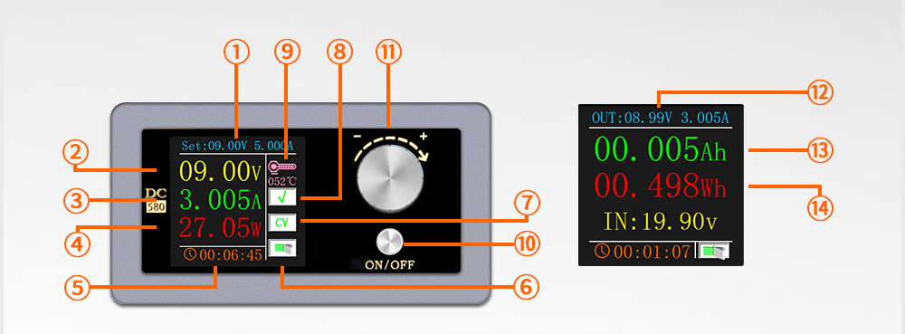

Features：
- Digitally set voltage and current; ② Output voltage;③ Output current; ④Output power; ⑤ Running time; ⑥ Switch indicator;⑦ CC / CV constant current and constant voltage display;⑧ √: Normal output status. If software protection is triggered, Display protection type OVP / OCP / OPP / OTP / OHP;⑨Temperature display; ⑩ Switch button; ⑪ Coding keys
⑫ Output parameters: voltage, current; ⑬ Output power; ⑭ Output energy

Instructions:
Switch button:
On any page, short press the power switch, and long press to enter the waveform page (in the software protection alarm state, short press reset);
Coding button: rotate left or right to realize page turning or adjustment function;
Main page：short press the timer to clear it, long press to enter the state of setting output voltage and current (in this state, short press to adjust the output voltage
and current by bit);
Battery display page: Long press to switch to the value of clear 0, the corresponding font color will turn white (power, energy, timing), short press to clear 0;
Settings page: short press to enter the setting options, and adjust the specified setting item by rotating the button (the corresponding option will turn yellow at this time), long press to enter the specific setting of this option, and long press again to exit the specific setting (when exiting, it will Automatically save the set values) Short press again to exit the setting options;
Waveform interface: Press and hold to switch the output voltage and current waveform interface.

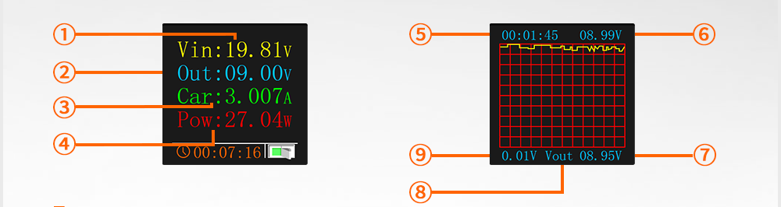

Features：
① Input voltage value; ② Output voltage value; ③ Output current value; ④Output power value; ⑤ Operating time; ⑥ Waveform maximum voltage; ⑦Waveform minimum voltage; ⑧ Grid voltage of each pixel;⑨ Output voltage waveform.
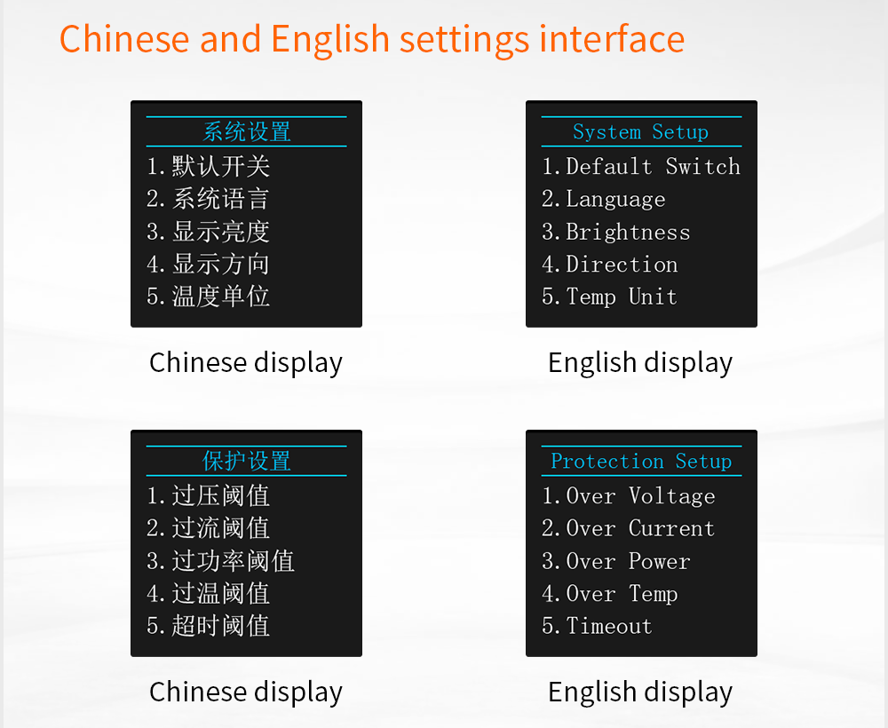
Chinese and English settings interface
- Chinese display; ② English display; ③ Chinese display; ④ English display;

Intelligent temperature control system:
When the product temperature is greater than 45 ° C or the output current is greater than 1A, the fan will automatically start. The fan will automatically turn off when the conditions are not met.
Software protection system:
When the parameter exceeds the software protection set value, the product will automatically stop working, and the working status indicator box on the main interface will show a code that stops working due to the corresponding software protection (OVP: overvoltage protection; OCP: overcurrent protection; OPP: over Power protection, OTP: Over-temperature protection, OHP: Obsolete protection) After the startup state is met, just press the key to reset and restart.

Screen supports four-way rotation
Meet the slotted installation in different orientations, you can get the ideal viewing angle
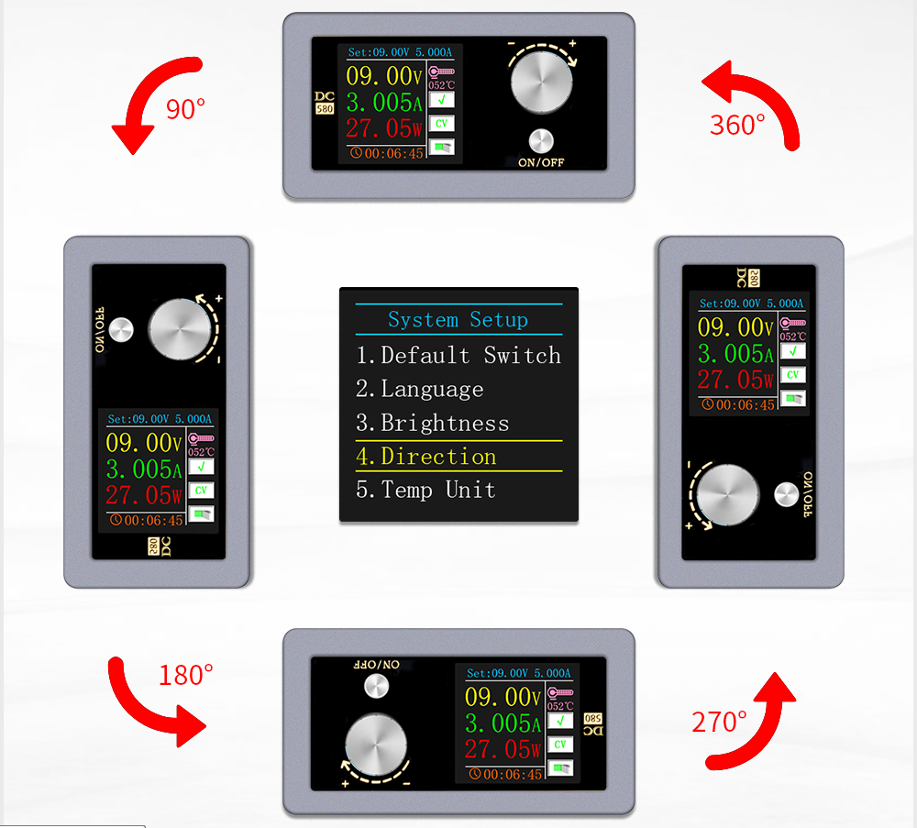

Product measured map:
- 08.99V : 8.992V, output current and load display contrast；
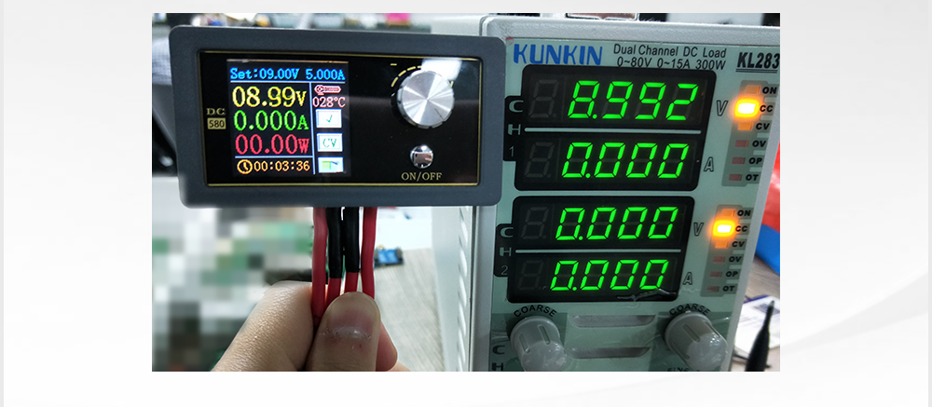
② 3.137A : 3.139A, Comparison of output current and
load display.
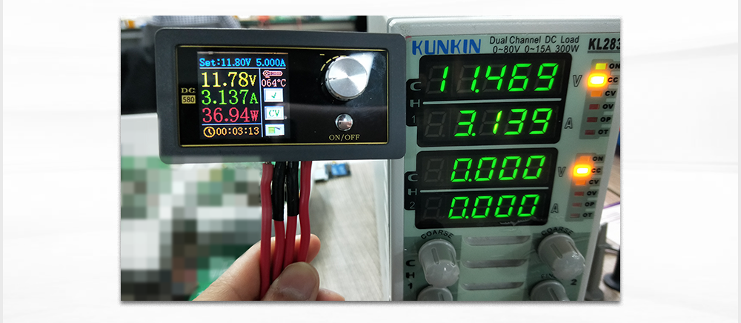
Note: The voltage display error is a normal phenomenon due to the voltage drop caused by the internal resistance of the wire.

Product Size
