F LYWOO Vampire V2-HD 5inch FPV Freestyle Drone BNF MANUAL
Instructions:
- Default UARTS port Settings
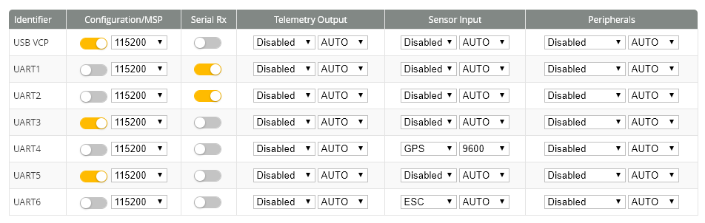
2. Setting motor direction, connect usb, use BLHeliSuite software to set direction and calibrates the throttle.
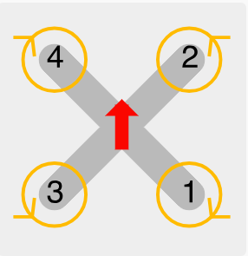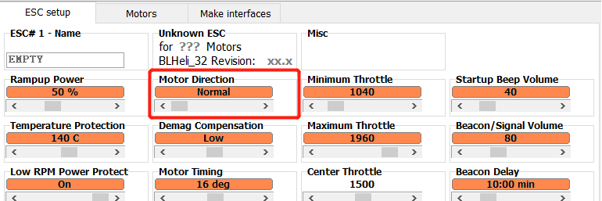
3. Wiring diagram

Betaflight APP
WWW.FLYWOO.NET
Warning : that the propeller must be removed to connect the computer Settings

