Introduction
Action Camera is a high-definition digital motion video recording device, created to reach market demand. It has a wide variety of the leading features for digital video recording, photo shooting, audio recording with screen display and detachable battery. Best suitable for vehicle recording, outdoor sports, home security, diving and more related activities. Allowing you to enjoy the moments while capturing every scene anytime, anywhere.
Warning
- Keep it safe from falling and dropping .
- Keep it distance from any strong magnetic interference objects like electrical machine to avoid strong radio waves that might be damaging the product and affect the sound or image quality.
- Don’t expose the product directly to high temperatures and strong sunlight .
- We recommend using high quality Micro SD Card for the best results.
- Don’t place your Micro SD card near strong magnetic objects to avoid data error.
- In case of overheating, unwanted smoke or unpleasant smell from the device, unplug it immediately from the power outlet to prevent hazardous fire.
- Keep it safety from children while on charging.
- Stored the device in a cool, dry and dust free local.
Product Features
- With a water proof casing, allowing you to film 30 meters under water scene.
- 1.8 inch HD screen display for convenient videos and image playback .
- 900MAH removable battery, easy to replace the battery, safe and durable, longer life.
- 4glass A+ 140° high precision lens.
- HDMI Output.
- support the highest 64G storage card.
- kinds of video recording format 4K 2K 1080P 720P WVGA .
- AVI format video recording, M-JPEG compression format.
- super WIFI, APP Internet, can share the wonderful picture in real time.
- Super mini Iook is a variety of coIors
- Webcam function

Camera Illustration
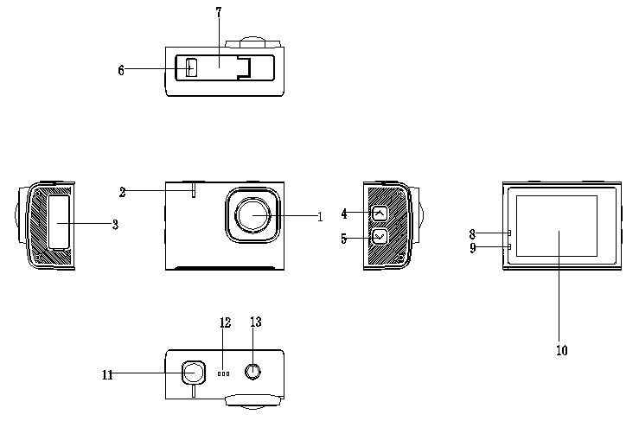

- Camera 2. wifi Indicator 3. USB case 4. UP 5.DOWN
6. Battery switch 7. The battery door 8.Work Indicator 9.Charging indicator light 10. Screen 11. The video button
12. Decorative 13. The switch machine key

Waterproof case
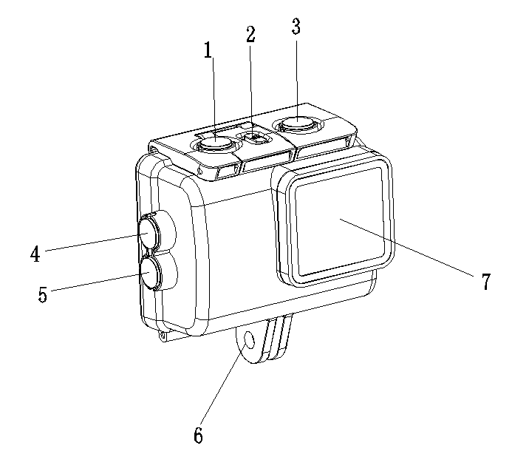

1、The video button 2、 Case security lock 3、The switch machine key
4、UP 5、DOWN 6，Bracket buckle
7， Camera

Operation
- Installing and removing the batteries
A. Press the switch of the battery, and the battery cover in the direction of the arrow, slide
the battery cover, a battery cover can be opened up.
B. the battery is installed and removed in accordance with the positive and negative signs
and arrows indicated on the battery.

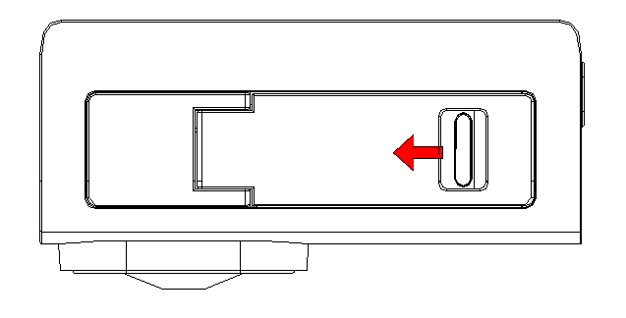

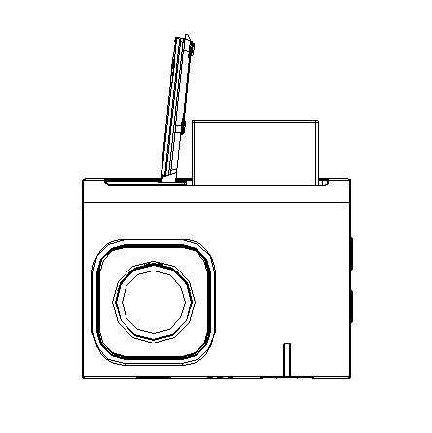

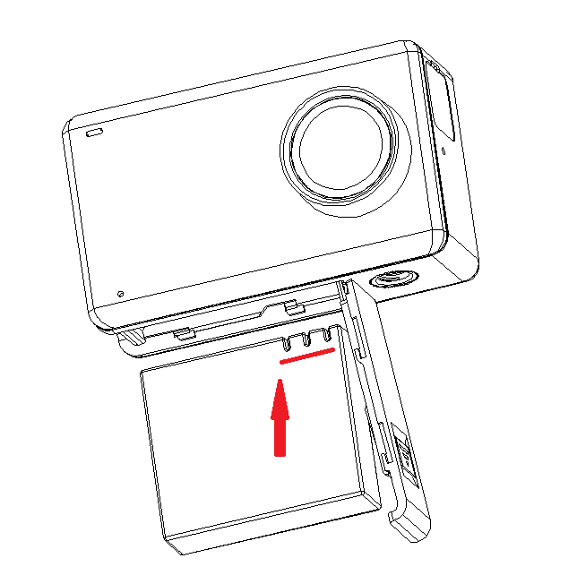
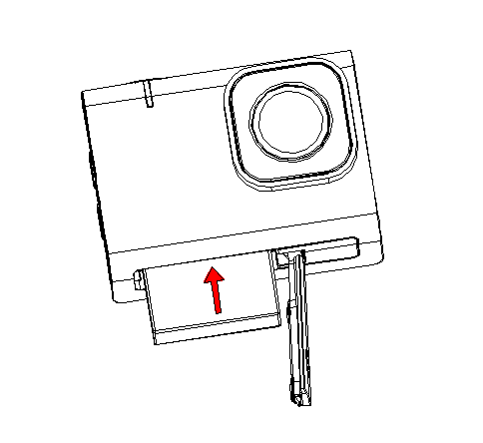

- Charging
- You can recharge this Action Camera by connecting it directly to the computer or with the power adapter.
- Action Camera can record the video while charging ( Switch to Vehicle-mounted Mode in the “Menu”).
- The camera can be charge even the power is switch off.
- When charging, the device 9 indicator light will be bright, and the indicator light will
off
- Switching the camera on and off
- Press the ON/OFF switch for 1 seconds to turn it on
- Press and hold the ON/OFF switch for 3 seconds to turn it off
4. Mode Change
A. boot, touch the bottom of the screen, there will be 6 shooting mode, shooting mode can be Selected
5. Menu setting
- select the shooting mode, click on the lower right corner of the screen settings
Icon , you can enter the menu settings.
- in the menu settings can be set on the shooting mode, in different modes, menu
options will be different.
- shooting mode menu: resolution, color, white balance, exposure settings.
- system menu: time settings, language, screen protection, formatting, etc..
6. Photo shooting mode
A.in the shooting mode, select the photo mode, press the shutter button to take pictures.
7. Video recording mode
A. Choose the video mode in shooting mode, press the shutter button for recording, press the shutter button again, can stop the video.
B. video indicator 8,will be flash.
8. Playback
A.In the bottom left corner of the screen, click on the replay icon , you can enter the
impact playback mode.
9. Date storage
A. using Micro USB data cable, the date files will be copied to the computer to play, or
you Can also take the Micro SD out,and use the card reader to read the image data .
10. shortcut key mode
A. boot, slide down from the screen, there will be a shortcut menu, you can quickly
operate.
- WIFI connection
- A. installed on the phone or tablet computer GoPlus Cam software (Android system can be
searched on the Google Play and download, Apple's system can be downloaded from the
APP Store , the china mainland market, Android users can search in the application
treasure Load).
B. open the camera, open the WIFI, the camera screen will display the WIFI logo, and
then appear 01s DV........C. on the phone or tablet PC to open the WIFI function, in the settings, search and
connect 01s DV........,The initial password is: 12345678; after the connection is
successful, the camera screen will display WIFI connection ready.
D. After the success of the connection, can be on the phone or tablet PC, open the APP
"GoPlus Cam" for the corresponding operation or image sharing.
E.WIFI indicator light

Specifications
CPU | ICT4248
Sensor | GC1064
Lens | 170°A+High resolution wide angle
Screen | 1.8 inch LCD touch screen
Video/Compression format | AVI/M-JPEG
Video resolution | 4K 30pfs 2K 30pfs 1080P(1920*1080) 30FPS  720P(1280*720 )30FPS  VGA(640*480)30FPS
Picture format | JPG
Picture resolution | 16M/12M/10M/8M/5M/3M/2M
Storage format | Micro SD card, maximum support 32G
USB | Micro 5pin 2.0USB
Waterproof depth | 30M
Audio frequency | Microphone
Battery | 3.7V/900mAh
Battery autonomy | 80Min
Measurement | 61.6*45.7*25.5MM
Video mode | Video/Time-lapse/Slow motion
Photo mode | Photo/ Photo lapse
Operating system | Windows XP /Mac OS
Language | English/French/German/Spanish/Italian/Portuguese/Simple Chinese/Japanese/Traditional Chinese/ Russian

Note: specifications may be upgraded, updated and other reasons to make changes in order to prevail in kind.

