Start-up
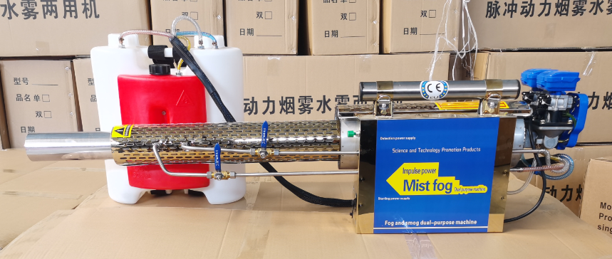
- Check the status: the medicine valve is closed, the carburetor is open, and the shoulder strap is tight;
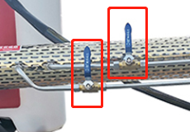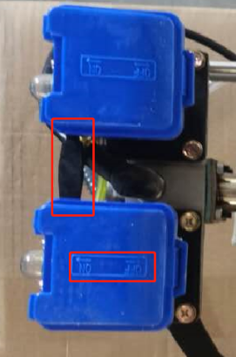
- The red barrel is filled with gasoline 92/95/98, and the white barrel is filled with disinfectant.
**Note: If need water mist, filled disinfectant in both white barrel;
If need smoke mist, one filled with gasoline 92, the other with disinfectant.
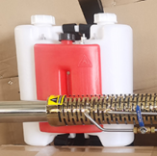
 | tablet | Water mist Spray range | Smoke mist Spray range
1L water | 1pc | 60 square meters | 180 square meters
15L water (1 full barrel) | 15pc | 1000 square meters | 3000 square meters
After adding disinfectant, tighten the two lids of the medicine barrel to avoid air leakage; if not tighten, the machine won’t be able to work.
- Press the two oil bubbles of the carburetor at the same time for ten times, to let the carburetor fully absorb the gasoline;
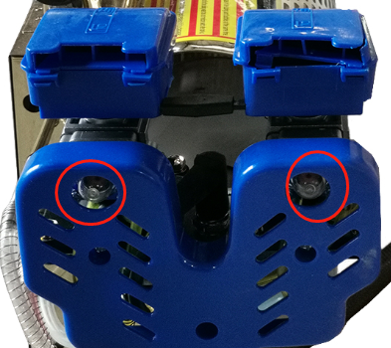
- Carry the barrel, carry the machine with your right hand, and tilt the head of the machine down towards the ground. Hold still the green or red ignition key with the other hand for 10 to 30 seconds until the machine starts (when you hear stable buzzing start sound);
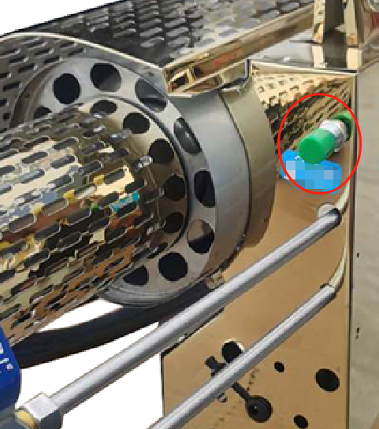
- Open two blue valves and start spraying water mist for disinfection;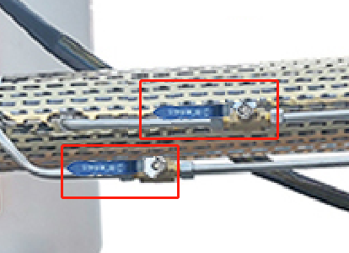
- Flameout: Close the blue medicine valve first, then push the carburetor switch forward to flameout.
