Foreword, thank you for choosing a single police law enforcement audio and video recorder, I hope that our products can do your part for your hard work.

- product description
The single police law enforcement audio and video recorder developed by our company contains night vision and video and audio processing technology, with comprehensive functions and reliable performance. Law enforcement officers use the equipment to perform law enforcement tasks, can record in a timely manner, collect evidence, standardize law enforcement, and truly record the law enforcement process to ensure more accurate and fair law enforcement.

two. Product parameters
Product function introduction
display screen | 2.0 inch 16:9 TFT LCD
Lens angle | Built-in camera 170 degrees
Storage capacity | Supports up to 128GB TF
Photo format | JPG file format highest output pixel; 45 million pixels
Video camera | H.264/H.265 compression format 1728*1296 1920*1080 1280*720 640*480
Infrared night vision | Infrared fill light, distinguishes the faces of the characters within 6 meters, and sees the human silhouette at 15 meters
Audio | Built-in microphone
battery capacity | 3.7V, 3500mAh continuous recording for more than 14 hours
Watermark | Device ID Police Officer ID Date and Date
Language | Chinese / English
PTT | stand by
waterproof level | IP68
Operating temperature | Negative 10 to positive 55 degrees Celsius
Storage temperature | Negative 20 to plus 60 degrees Celsius

three. Quick instructions
Press the [Power On/Off] button and press and holdPower on, after entering the standby screen;
Press the [Camera] button to press the video or one-touch recording function.
Press the [Photo] button to take a photo after pressing
Press the [Record] button to press the recording or one-touch recording function.
Press the [Up] key to press the infrared night vision light when recording at night. The arrow symbol is the up selection key.
Press the [Down] button to turn on the laser light positioning, and the arrow symbol is the down selection button.
Press [OK/Fill Light] button. When pressed, short press is the fill light, long press white light flash, and the confirmation button function is in the menu or playback interface.
Press the [Back] key. When the machine is pressed, the machine will start flashing red and blue when it is turned off or turned on. When entering the menu, tap to return to the previous screen. Long press to enter the playback menu, short press to return to the previous level.
Press the [Menu] button. When you press to stop recording, press to enter the menu to set various functions, and short press to exit the menu.
Press the [Reset] button to press and then press to restart the machine to support the machine restart.

four. Appearance and button description
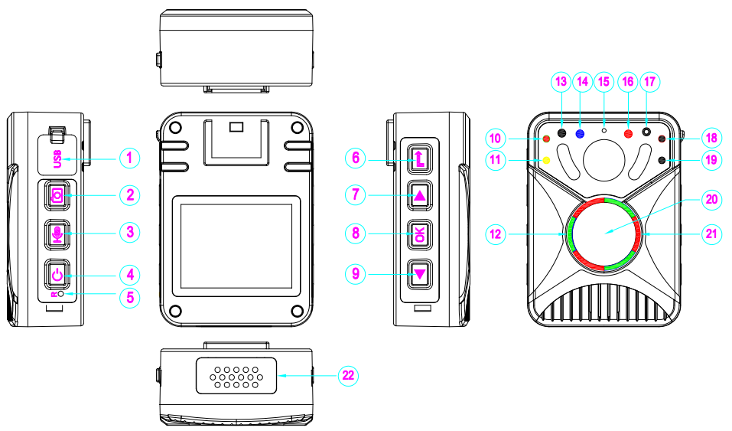

1. USB interface 2. Photo / WiFi button 3. Recording / one-click recording button
4. Power switch machine / menu button 5. Reset button 6. Red and blue flash / return button / long press play button
7. Infrared/Up button 8. White flash/confirm button 9. Laser/down button
10. Red charging indicator 11. Yellow GPS indicator 12. Green: Long light means standby, flashing means recording
13. White light 14. Blue strobe light 15. Microphone hole 16. Red strobe light
17. Laser light 18. White WIFI indicator 19. Tri-color lamp shows battery power
20. Recording/One-touch recording button 21. Red recording indicator 22. Multi-function interface

Fives. Screen interface introduction
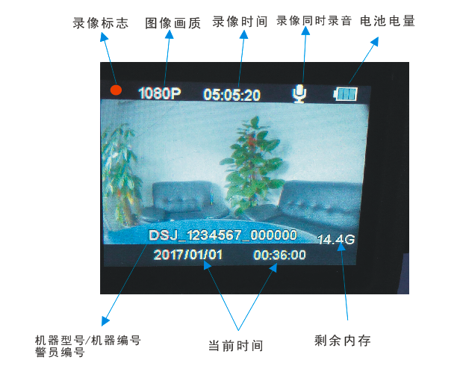

six. Basic operating instructions
1.Power switch / menu button
Press and hold the [Switch] button for 2 seconds, the sound is prompted, the green standby indicator lights up, the screen enters the live preview standby state, short press the open menu option,Stop recording, real-time screenPreviewIn the state, tap the [Power] button to prompt for the password.Please enter the set password to enter the menu settings [default secretThe code is 6 0, that is, press 6 continuously.Press OK button],Machine functions and parameters can be set.
2. Video / One-touch video button
In the case of real-time preview of the screen, press the [Camera] button to shock the body.Action, voice prompt "recording start", video key weekThe red video indicator light starts to flash and the recording starts. Press the [Camera] button again to stop recording, the body vibrates, the red video indicator is off, the recording ends and the video file has been saved. Press and hold the recording function in the off state, directly turn on the recording, and the red light flashes around the recording button.
3. Photo / WiFi button
In the case of real-time preview of the screen, press the [Photo] buttonThat is, take and save the photo, long press the [Photo] button to open WIFI, use the mobile phone-specific APP to connect to the machine WIFI to view the video.
4. Recording / One-touch recording button
inIn the case of real-time preview of the screen, press the [Record] buttonThe body vibrates, the voice prompts “recording starts”, and the yellow recording indicator flashes, that is, the recording starts. Press the [Record] button again to vibrate the body, the yellow indicator light is off, and the recording has been saved.
In the off state, long press the [Record] button for 3 seconds, you can directly enter the recording work state.
5.Infrared/up arrow
inWhen the screen is in real-time preview standby or recording status, tap the [Up] key.That is, the infrared night vision light function is turned on, and the infrared night vision light is turned off by tapping again. When entering menu or video, photo, and recording file playback, tap the [Up] key to select the function.
6.Laser/down button
inWhen the screen monitors the standby or recording status in real time, tap the [Down] button.That is to turn on laser-assisted positioning, assist in correcting the shooting target, tap again, and laser-assisted positioning is turned off. When entering the menu or video, photo, and recording file playback, tap the [IR/DOWN] button to select the function down.
7．Blue light flash / playback / back button
When entering the menu setting function or playback, when entering the submenu in the menu, tap [Blue light flash / playback / back button】The key returns to the previous interface, and in the preview state of the live screen, long pressBlue light flash / playback / back button, enter playback mode, you can choose to play back video, photo, and recording files.
In the live preview mode, short pressBlue light flashing / playback / back button to turn red and blue alternate flash
8.OK / white light button
When you stop recording, tap [OK / white light button】The white light of the button flashes. When you stop recording, when you enter the menu setting function, tap [OK / white light button】 key means confirmation.
9.USB interface / multi-function interface
This interface is connected to a computer (collection station) to read data and charge functions.
19. Reset function key
When the machine is interrupted frequently due to occasional operation or continuous use of button commands, causing the machine to temporarily stop working, press the [Reset] button for about 2 seconds, the machine is turned off, and then manually restarted.
21. Charging
This machine uses a lithium ion battery.
In the case of using the standard charger, the machine is fully charged for about 3.5 hours of charging, and the red LED of the body will light up when charging, and the red LED will go out after charging is completed.
When charging on the standard collection station, if the data is not read, please turn it off manually and charge it for about 3.5 hours. The red LED of the body will light up when charging, and the red LED will go out when charging is completed.
22. Connect to the computer
When the machine is connected to the computer via the standard USB cable,Prompt to enter the password, please enter the set password to enter the machine to read data [default passwordFor even 6 zerosPress and hold the 6 button. After entering the password, you can view the video, photo or recording in the machine through the computer.

User needs to know
The single police law enforcement audio and video recorder products are produced by our company, and our company is responsible for the after-sales maintenance service of the products. In order to better protect the interests of users to avoid unnecessary problems, please read the following points in detail:
1. When purchasing the machine, please ask the sales unit to fill in the relevant contents of the [warranty card] and add the official seal of the sales unit.
2. For faulty machines with human damage [such as water ingress, damp, improper use, etc.], damage caused by private modification or repairs that are not authorized by the company, and law enforcement recorder products that exceed the warranty period, the company will provide For paid services, users are required to pay a certain fee.
3. Seriously man-made faulty machines [such as liquids or broken machines, etc.], please sign a [maintenance agreement] with the maintenance unit during maintenance to decide whether to agree to pay for repairs.
4. For dampness. Into the water. damaged severely. The illegally modified law enforcement recorders, after being processed by an authorized maintenance organization, do not rule out other new problems. The company does not promise to be able to completely repair, this is the irreparable damage caused by the fault.
5. If only the host is faulty and meets the changing conditions, only the host part will be replaced and other accessories will not be replaced.

Warranty Card
year month day
User profile
username |  | contact number
company name
Unit address

Law enforcement recorder product information
Host model |  | Product number
Dealer [stamp]

Maintenance information
Repair date | Maintenance records | Maintenance unit | Repair date | Maintenance records | Maintenance unit

