COATING THICKNESS GAUGE
USER GUIDE
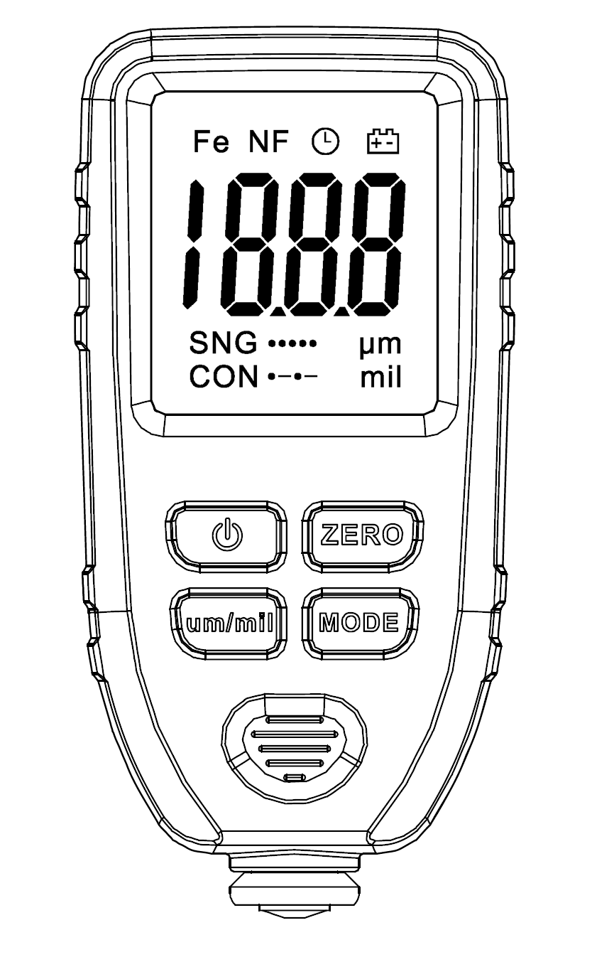

Introductions:
The thickness gauge is used to measure the thickness of the plated and coated sheet on metal, e.g. paint/enamel/ chrome on steel, paint and anodizing coating on aluminum/copper.
The gauge takes the precision integrated probe, and uses principles of electro-magnetic induction and the eddy current effect, which automatically detects the attribute of substrates.

Application Field:
The Gauge is designed for non-destructively measuring the thickness of coating and painting. It is essential for material surface treatment and widely used in manufacturing industry, metal-processing industry, chemical industry, commodity inspection area, and also able to work steadily in the laboratory, workshop and outdoor.

Operating Principle:
The gauge adopts the principle of electromagnetic induction and eddy current effect. It has F probe and N probe.
F probe works on the magnetic induction principle and should be used for detecting the non-magnetic coating’s thickness such as chrome/copper/zinc/varnish/rubber on the iron/steel substrate.
N probe works on the eddy current principle and should be used for detecting the insulating coating’s thickness such as paint/anodizing/ceramics on the aluminum/copper/brass substrate.

Supply Information:
The package list:
- Coating Thickness Gauge
- Substrates
- Five Standard foils
- User Guide
- Protective Case

Description：
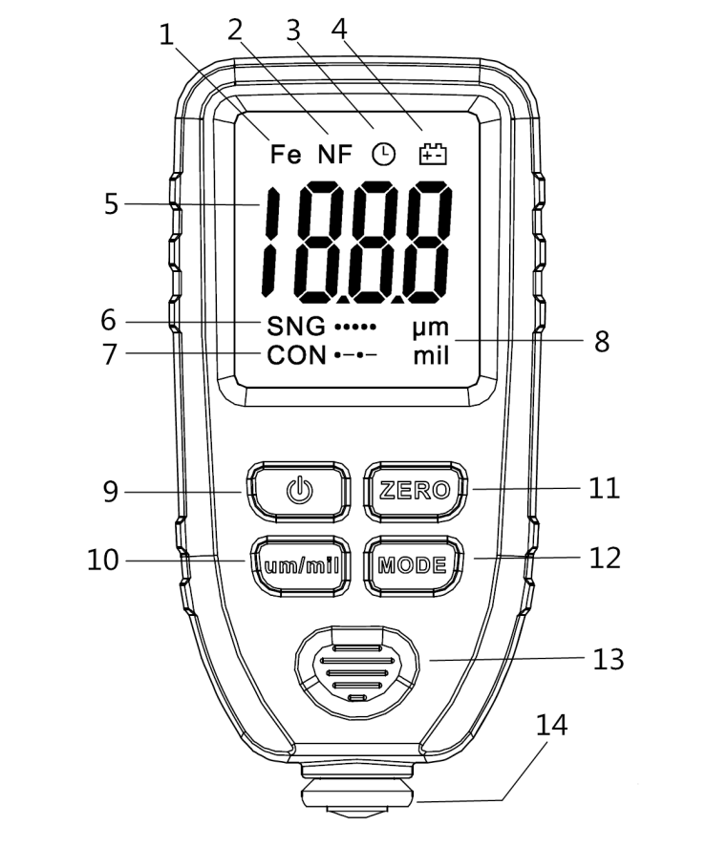

1. Fe--Magnetic substrate indicator: Steel/Iron
2. NF--Non-magnetic substrate indicator: Copper/Aluminum
3. Auto power off flag, auto power-off in 15 minutes with no-operation
4. Low battery indicator
5. Measured Reading Display
6. SNG: Single Measurement Mode
7. CON: Continuous Measurement Mode
8. Unit: um, mil
9. ON/OFF
10. um/mil: Unit Switch Key, System Resetting Key( Press and Hold More than 3s )
11. ZERO: Clearing Display when SNG shows;
Using for calibration when CON shows.
12. MODE: Switch SNG/CON; SNG shows, Single-point Mode; CON shows, Continuous Mode
13. Anti-Skid Slot
14. Probe
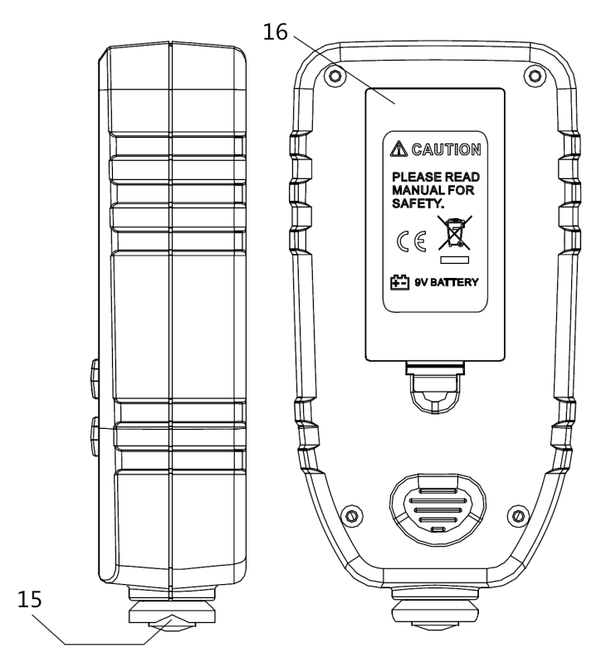
15.V-Groove
16. Battery Compartment

Technical specifications
 | Probe F | Probe N
Principle | Magnetic Induction | Eddy Current
Range | 0~1300um  0~51.2mil | 0~1300um  0~51.2mil
Accuracy | ±(3%+2um)  ±(3%+0.08mil) | ±(3%+2um)  ±(3%+0.08mil)
Resolution | 0.1um/0.01mil | 0.1um/0.01mil
Calibration | Points: ZERO/50/100/250/500/1000um
Units | um, mil
minimum curvature radius convex: 1.5mm
minimum curvature radius concave: 25mm
minimum measuring area: Diameter 6mm
minimum thickness of substrate | 0.5mm(0.02”) | 0.3mm(0.012”)
Power | One 9V battery
Operation Environment | Temperature:0~40℃(32~104℉) Humidity:20%~90%RH
Size | 130mm x 62mm x 32mm  (4.88” x 2.44” x 1.26”)
Weight | 100g(3.53oz)
Note: The final specifications may be upgraded without notifying. for more details, Please consult with your supplier.

Factors of Affecting Accuracy
User needs to know the factors of affecting measurement accuracy before using the gauge. The factors are listed as below:
- Curvature radius convex <1.5mm
- Curvature radius concave <25mm
- Diameter of measuring area <6mm
- Thickness of substrate <0.5mm
- Surface roughness
- Adhesive substances: clean the probe and coating surface
- Strong magnetic field around
- Out of Operation Temperature and Humidity
- Low Battery

Use the Gauge
Please refer to the factors of affecting measuring accuracy before using.
1. Placing the Battery: Open the battery compartment and insert a new 9V battery, Close the lip
2. Prepare the target samples for measuring.
3. Placing the gauge in the air, at least 5cm away from any mental, then power on.
Note: The battery has to be replaced, if the LCD shows low battery which will lead to the measurement unreliable.
4. Press the um/mil key for unit choosing (um, mils); Press the MODE key for selecting SNG/CON; SNG means single measurement one time; CON means continuous measurement.
5. Measuring start. SNG (single point measurement mode), vertically and rapidly placing the probe on the sample, the readings display on LCD, when one beep alerting. CON( rapidly continuous measurement mode) Vertically placing the probe on the sample, Keeping the probe on the sample, changing the measurement point at random to do the next measuring.
6.Power Off. The gauge is built-in APO, auto power off with no operations in 15min.

Measurement Modes
“SNG”: the Single Mode (Default), Press "MODE" key to display SNG, Vertically and rapidly placing the probe on the sample. The readings display on LCD with one beeping. Press the "ZERO" key to clear the statistics showing on LCD. Hand up the probe more than 5cm away from the mental, then do the next measuring, as showing below:
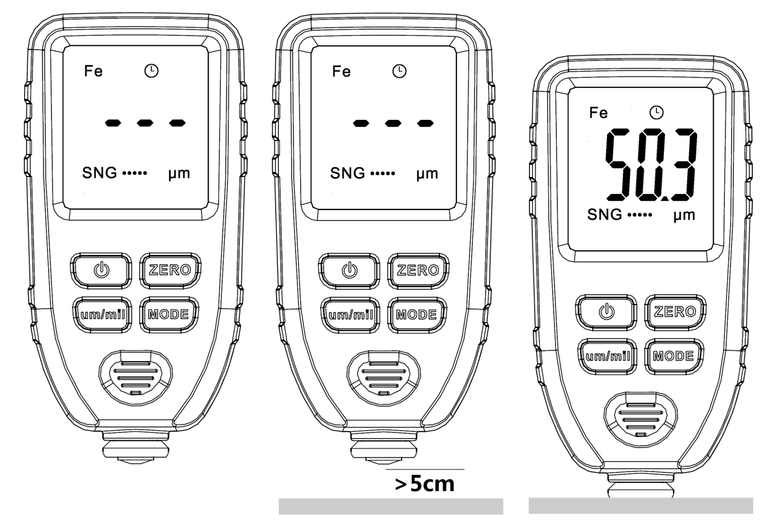

“CON”: the Continuous Measurement Mode, Pressing "MODE" key to display CON, vertically and directly placing the probe on the sample. The readings will continuously upgrade following with the probe moving, as showing below: (Note: ZERO key in CON mode is used for calibration, please do not press it except calibration. Please read the below calibration chapter for more info.)
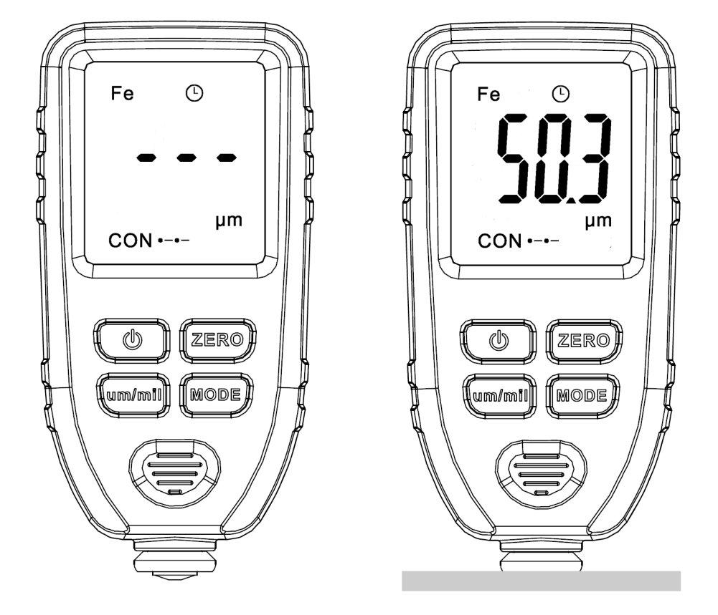
Description of “Fe” and “NF”
“Fe” in LCD means: Target substrate is ferrous material such as iron/steel.
“NF” in LCD means: Target substrate is non-ferrous material such as aluminum/copper.

Unit Switching
Press “um/mil” key to switch unit “um” or “mil”

Auto Power Off
Automatically power off without any operations within 15min.

System Reset:
Press and hold "un/mil" key until the full screen displays with two beeping, the system resetting is finished.
Note: system resetting is mainly used for the return of error operation and error calibration.

Calibration:
Calibration adjustment is the process of setting the gauge to be more accurate. There are factors to affect accuracy such as the probe slight wear, long time no use, hostile environment, or special substrate. How to calibrate the gauge, steps as follows:
Firstly take out the two pieces of substrates (ferrous substrate/ aluminum substrate) and the five standard foils (50um /100um/250um/500um/1000um). Place them horizontally on the table. You also could use your target bare metal substrate instead of our attached substrates.
Note: The gauge just supports total 6 Points (0/50/100/250/500/1000um) calibration. The other points (e.g. 750um) are not allowed. Please seriously note this. Once you did a misoperation, please press and hold “um/mil” 3 seconds for resetting the factory default.

Zero Calibration: Press "MODE" to the Continuous Measurement Mode(CON in LCD), Placing the probe on the substrates: if Reading in LCD is not Zero, please hold and keep the gauge, go on pressing "ZERO" key, then 00.0 on screen, at the meanwhile, the zero calibration has been finished. Now you could do a test for checking, showing as follows:
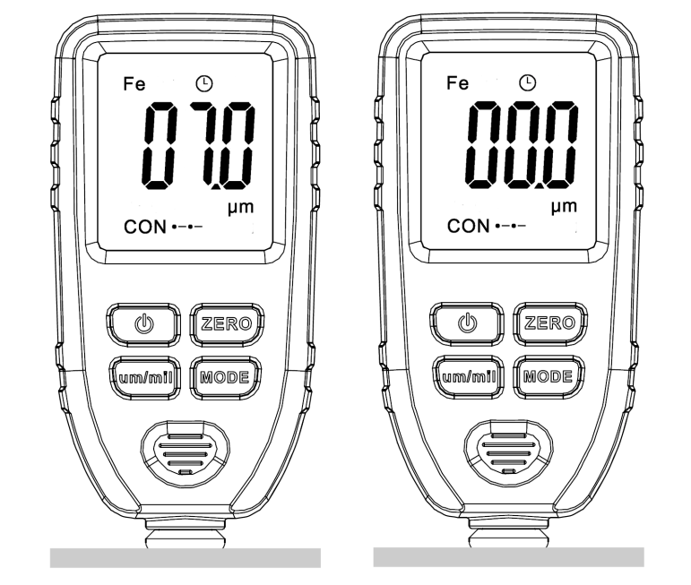

Calibration with 50um film: The process is same to zero calibration, of course, the 50um film should be placed on the substrate; showing as follow:
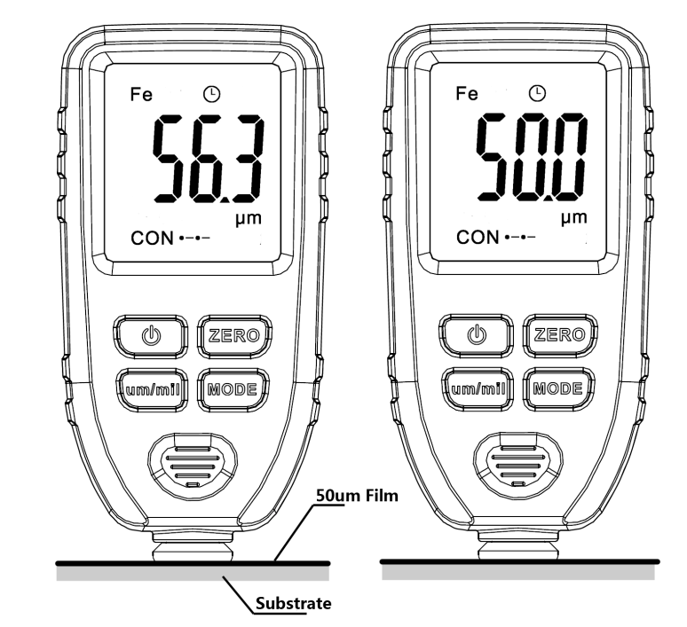
100/250/500/1000um calibration are same to the 50um calibration, just need to switch the correspond film on the substrate.

Maintenance:
The gauge has to be avoided working under hostile environment, such as collision avoidance, dust, hyperthermia, humidity, strong magnetic field. If the gauge is no response and can’t be power on, please remove the battery, and wait for minutes, then reinstall the battery for try again. If the error still persists, please contact with your supplier for help.

