User Manual Download links: http://68.168.132.244/PSG9080_EN_manual.pdf
PC Software Download links: http://68.168.132.244/PSG9080_EN_Setup.rar

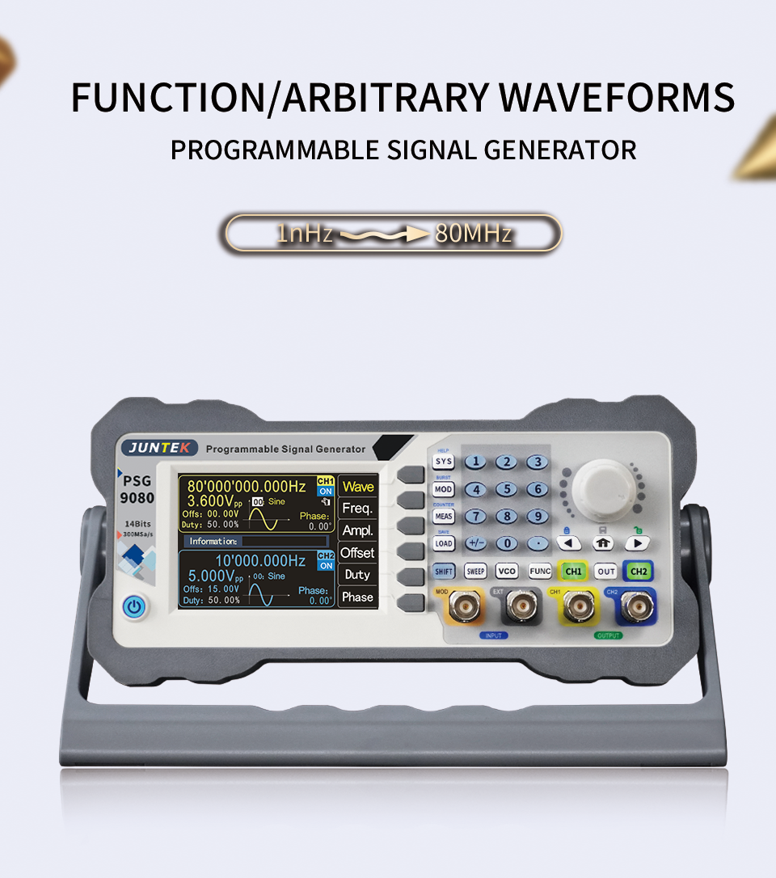

PSG9080 is the programmable function/arbitrary wave signal generator. It can output sine wave, square wave, triangle wave, pulse wave, and arbitrary wave, etc. The frequency range of the instrument is up to 80MHz, with modulation, frequency sweep, measurement signal frequency and programming functions, etc. It can simultaneously display the output signals, amplitude, phase, duty cycle and frequency. This series has excellent amplitude - frequency characteristics, multifunctional, high performance, cost effective, portable and other characteristics provide new options for education, research and development, production, testing and other industries.
The instrument is exquisite in appearance and equipped with a 3.5-inch high-resolution color LCD screen to bring a new visual experience.
Programmable output：The type of waveform output (such as sine wave, square wave, triangle wave, arbitrary wave, etc.), output time, and output sequence can be freely formulated to realize automatic work.

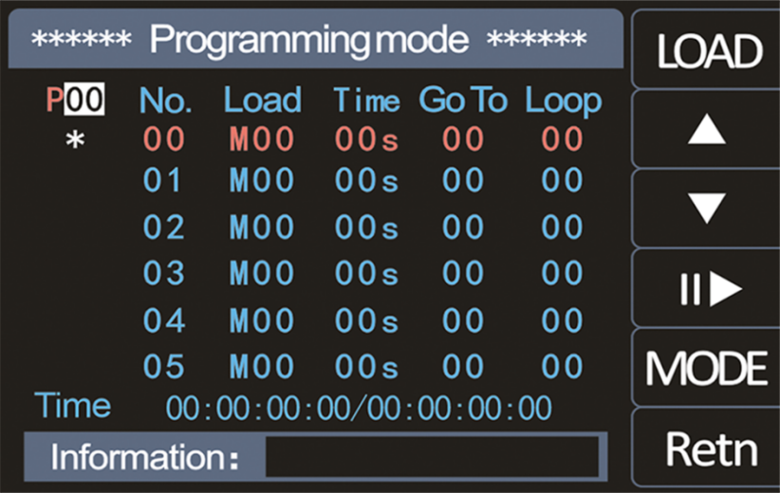

Firmware update in real time：Firmware upgrade can be updated at any time to fix bugs, or used for your special customization needs. Press the corresponding soft key to confirm entering the update mode, and perform a one-key firmware upgrade by connecting with the PC software.
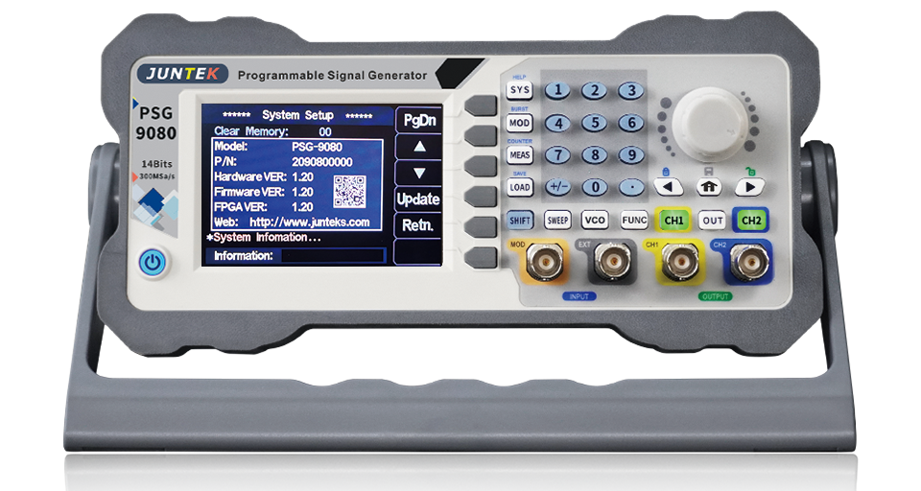
Voltage-controlled adjustment：The frequency, amplitude and duty cycle of the output can be controlled by an external analog voltage signal to achieve voltage-controlled sweeping frequency, sweeping amplitude and sweeping duty cycle, which are widely used in industrial debugging.
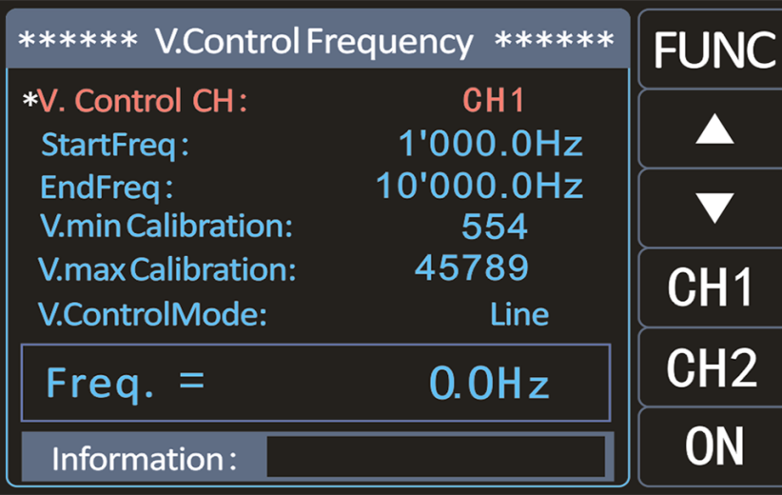
Modulation function：The modulated waveforms can be output in single channel or dual channel. Modulation: The process of adding information from a signal source to the carrier to make it suitable for channel transmission. It is the technology that makes the carrier wave change with the signal.
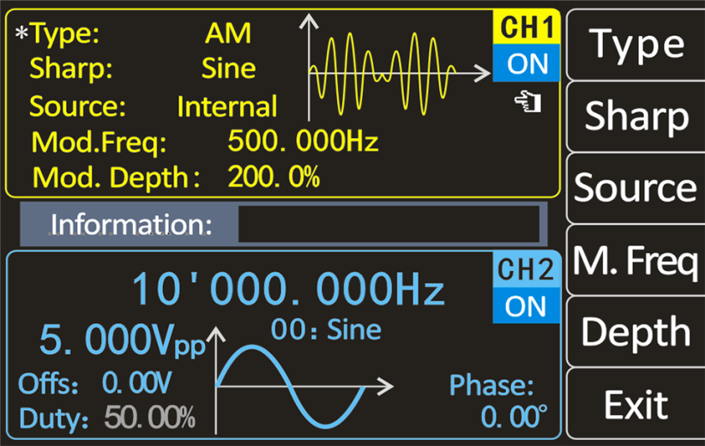

High sampling rate ：The sampling rate of up to 400MSa/s can obtain more waveform data per unit time, thus making the displayed waveform more accurate.
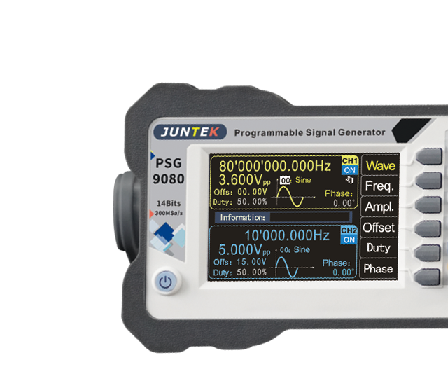
Personal color：In order to meet the personalized needs of customers, four color schemes for the system are provided. You can use the numeric keys and knob to select the desired system color, press the soft key save to save the selected color

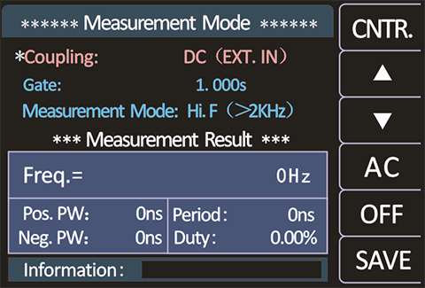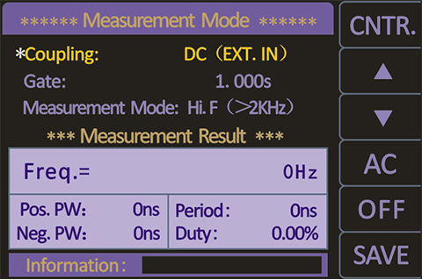
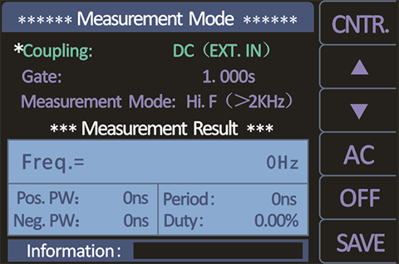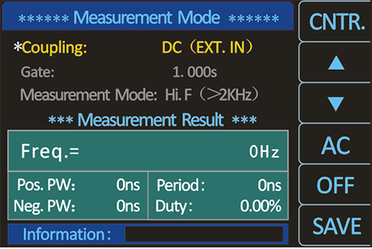

Equivalent performance dual channel output：The same or different function signals or arbitrary waveform signals can be output simultaneously; all parameters can be adjusted independently, the phase difference between the two channels is continuously adjustable from 0 to 359.9 degrees; the signal frequency can be up to 80MHz, and the output signal can be within 1MHz Up to 25Vpp.
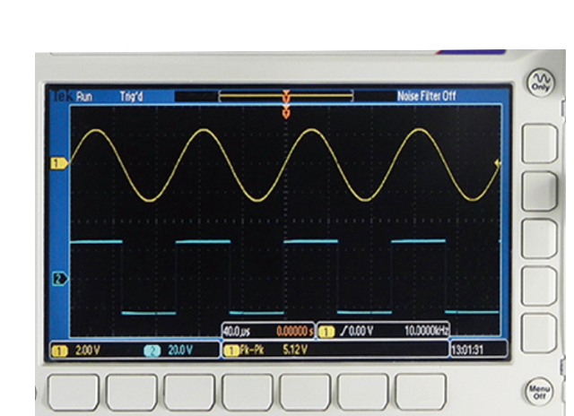

Burst function：Sine wave, square wave, saw tooth wave, or arbitrary wave can be used to generate burst signals, the number of periods is continuously adjustable between 1-1,000,000,000
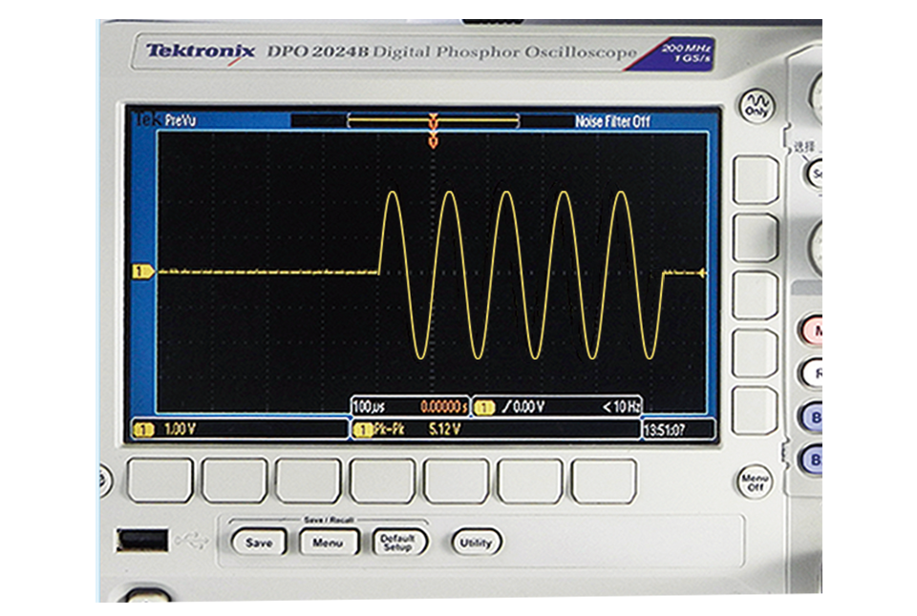

The pulse width can be adjusted accurately：The pulse width and the pulse period time of the pulse wave are digitally and accurately adjustable, enabling a wide range of pulse waveforms to be accurately set without jitter output.
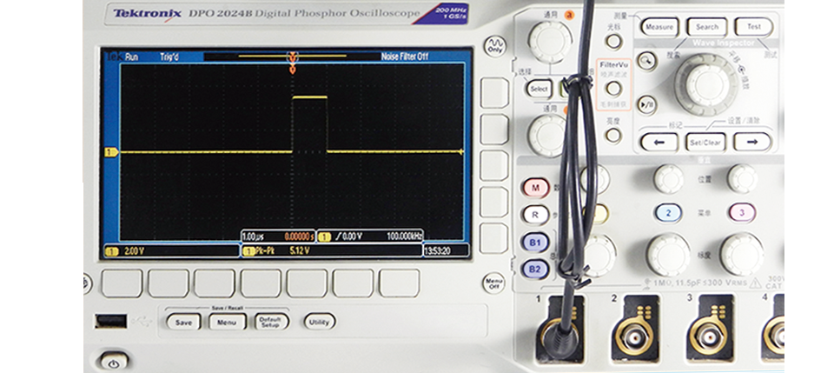

Can draw arbitrary waveform：PC software and communication protocol are provided for free, arbitrary waveforms can be drawn using the PC software; using the communication protocol can be secondary development programming; all functions of the instrument can be controlled by the PC software (The instrument can be also finished all operations without connecting to the computer.)
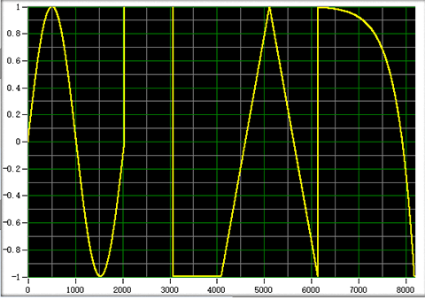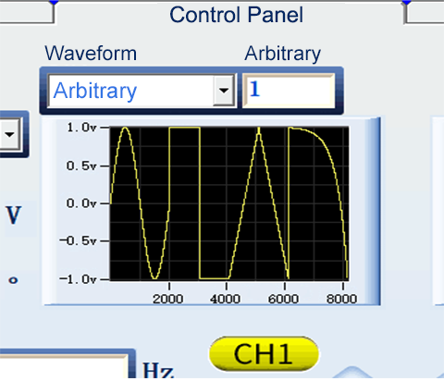

<The PC software draws arbitrary waves> <The PC computer controls the output of arbitrary wave>
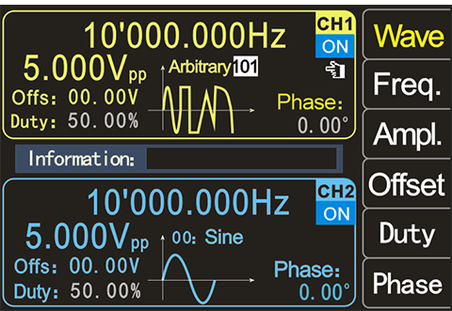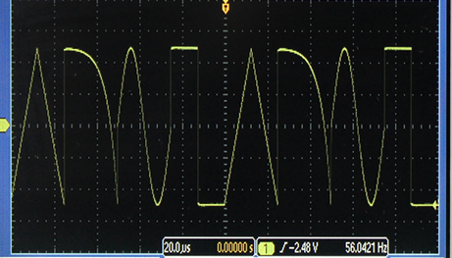
<The signal generator displays the drawn pattern> <An oscilloscope displays an arbitrary wave pattern>

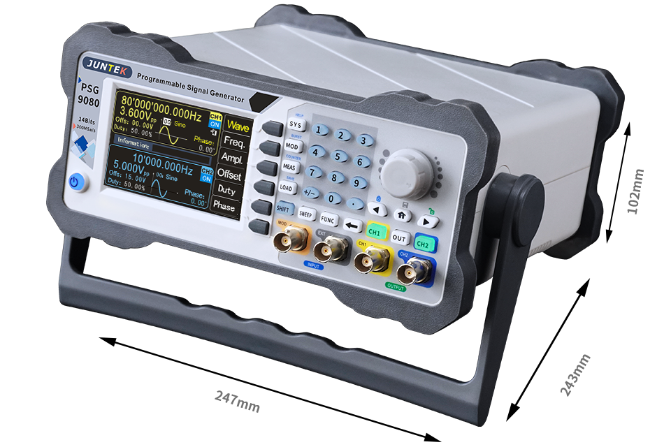

Model：PSG9080
Channel：2
Maximum frequency of sine wave：80MHz
Sampling Rate：300MSA/S

Waveform characteristics
Wave length ：8192 points/channel
Waveform vertical resolution：14 bits
Waveform type：Sine wave, square wave, pulse wave (duty cycle, pulse width and cycle time can be accurately set), triangle wave, rising saw-tooth wave, falling saw-tooth wave, CMOS wave, DC level, half wave, full wave, positive step wave, inverse step wave, exponential rise, exponential fall, Lorentz pulse wave, muti-sound wave, random noise wave, trapezoidal pulse wave, sink pulse wave, amplitude modulation waveform, frequency modulation waveform and 99 groups of user-defined wave-forms.

Frequency characteristics
Sine wave frequency range：1nHz-80MHz
Square wave frequency range：1nHz-30MHz
Triangle wave frequency range：1nHz-50MHz
Pulse wave frequency range：1nHz-30MHz
TTL digital wave frequency range：1nHz-20MHz
Arbitrary wave frequency range ：1nHz-50MHz
Pulse width adjustment range：5nS~4S
Pulse period adjustment range：10nS~40S
Frequency minimum resolution：1nHz
Frequency accuracy：±5ppm 0 to 50℃
Frequency stability：±3ppm per 1 year

Sine wave spectral purity
Total harmonic distortion：≤0.5%（@1kHz,5Vpp）

Signal characteristics
Square wave
Rising/falling edge time：≤10nS
Overshoot：≤10%
Asymmetry：≤0.1%

Ramp and triangle wave
Linearity ：≤1%(less than 1MHz)
Asymmetry：≤1%(less than 1MHz)

Pulse wave
Pulse Width：5nS~4S
Pulse period：10nS~40S
Duty cycle：0.01%-99.99%
Rising/falling edge：≤10nS
Overshoot：≤10%

Arbitrary wave
Wave length：8192 points（8K points）
Vertical resolution：14 bits
Minimum rise/fall time ：≤10nS
Overshoot：≤10%
Arbitrary waveform non-volatile storage number：99

Output characteristics
Amplitude
Amplitude range：Frequency≤1MHz------2mVpp~25Vpp
1MHz≤Frequency＜11MHz ------2mVpp~10Vpp
11MHz≤Frequency＜60MHz------2mVpp~5Vpp
60MHz≤Frequency＜80MHz------2mVpp~3.6Vpp
Amplitude resolution：1mVpp
Amplitude stability：± 1% ±1 mVpp (@ 1 kHz, >10 mVpp)
Amplitude flatness：±1%(0.1dB)<10MHz
±2%(0.2dB)<10MHz~50MHz
±10%(0.9dB)<50MHz~70MHz
±20%(1.9dB)<70MHz~80MHz

DC bias
Offset adjustment range：-9.99V-15.00V
Offset resolution：0.01V

Phase characteristics
Phase adjustment range 0°-359.9°
Phase resolution 0.1°

Waveform output
Output impedance：50Ω (nominal)
Protection：Short circuit protection

Modulation characteristics
Modulation type：AM、FM、PM、ASK、FSK、PSK、PWM

AM
Carrier wave：Sine wave, square wave, saw-tooth wave, arbitrary wave (except DC)
Modulation source：Internal/external
Modulated wave：Sine wave, square wave, saw-tooth wave, noise wave, arbitrary wave
Modulation depth：0% to 200%
Modulation frequency：1mHz to 1MHz

FM
Carrier wave ：Sine wave, square wave, saw-tooth wave, arbitrary wave (except DC)
Modulation source：Internal/External
Modulated wave：Sine wave, square wave, saw-tooth wave, noise wave, arbitrary wave
Modulation frequency：1mHz to 1MHz
Frequency deviation：0.1Hz to 10kHz

PM
Carrier wave：Sine wave, square wave, saw-tooth wave, arbitrary wave (except DC)
Modulation source：Internal/External
Modulated wave：Sine wave, square wave, saw-tooth wave, noise wave, arbitrary wave
Phase deviation：0° to 360°
Modulation frequency：1mHz to 1MHz

ASK
Carrier wave：Sine wave, square wave, saw-tooth wave, arbitrary wave (except DC)
Modulation source：Internal/External
Polarity：Positive and negative
Rate：1mHz to 1MHz
ASK amplitude：0% to 200%

FSK
Carrier wave：Sine wave, square wave, saw tooth wave, arbitrary wave (except DC)
Modulation source：Internal/External
Modulated wave：50% duty cycle pulse wave
Polarity：Positive and negative
Rate：1mHz to 1MHz
Frequency hopping：0.1Hz to 80MHz

PSK
Carrier wave：Sine wave, square wave, saw tooth wave, arbitrary wave (except DC)
Modulation source：Internal/External
Polarity：Positive and negative
Rate：1mHz to 1MHz
PSK phase：0° to 360°

PWM
Carrier wave：Pulse wave
Wave inversion：Regular and reverse
Pulse period：0.01uS to 40S
Pulse Width：0.001uS to 4S

Burst
Idle：Zero position, positive maximum, negative maximum
Mode：Single, automatic
Trigger source:Manual burst, CH2 burst, external burst (AC), external burst (DC)
Pulse number:1-1000000000

Measurement and counting function

Measurement mode
Measurement function：Frequency, positive and negative pulse width, period, duty cycle
Coupling method：DC, AC
Gate time：0.001S-10.000S
Measurement mode：Low frequency, high frequency
Frequency measurement range ：1Hz~100MHz
Input signal amplitude range：2Vpp~20Vpp
Period measurement：10nS~4S
Pulse Width：4S
Duty cycle measurement range ：0.01%~99.99%

Counter mode
Counter range：0-4294967295
Coupling method：DC and AC coupling
Counting method：Manual

External modulation input characteristics
Input signal amplitude range 0~3Vpp
Input signal frequency range DC~200kHz

Scanning characteristics
Sweep channel：CH1 or CH2
Carrier wave：Sine wave, square wave, saw-tooth wave, arbitrary wave (except DC)
Sweep function：Sweep frequency, sweep amplitude, sweep duty
Sweep mode：Linear, logarithmic
Sweep direction：Increment, decrement, round trip
Start/end frequency：Consistent with the upper and lower limits of the corresponding carrier frequency
Start/end amplitude：Consistent with the upper and lower limits of the corresponding carrier amplitude
Start/end duty cycle：Consistent with the upper and lower limits of the corresponding carrier duty cycle
Sweep time：0.01S-640S

Voltage control characteristics
Voltage control channel: CH1 or CH2
Carrier wave: Sine wave, square wave, saw-tooth wave, arbitrary wave (except DC)
Voltage-control function: Frequency control, amplitude control, and duty cycle control
Sweep mode: Linear, logarithmic
Start/end frequency: Consistent with the upper and lower limits of the corresponding carrier frequency
Start/end amplitude: Consistent with the upper and lower limits of the corresponding carrier amplitude
Start/end duty cycle: Consistent with the upper and lower limits of the corresponding carrier duty cycle
Voltage-control voltage range: 0V-5V, starting point and end point can be set arbitrarily

Programming features
Running mode: Debugging、normal
Storage: P00-P19
Programming number: 00-99
Programming time: Single serial number programming time 0-99S

General specifications
Display
Screen: 3.5 inch TFT color LCD display
Resolution: 320*480
Color: 64K true color

Store and load
Quantity: 100 groups
Location: 00 to 99 (The data of 00 storage location is loaded by default)

Interface
Interface method: USB to serial interface
Extension interface: Serial port with TTL level mode, convenient for secondary development
Communication rate: Standard 115200BPS
Protocol: Using the command line, the protocol is open

Power
AC power: Supply voltage:85V-264V，47-63Hz
Power consumption: Less than 30W
Fuse: 250VAC,T3.15A
DC power: Supply voltage/current: DC5V±0.5V 3A

Environment
Temperature : 0~40℃
Humidity: Humidity<80%

