Product User Manual

Digital Double Pulse Gas-shielded Welding Machine
>
MIG-200

Model: Model code:

..........................................................................................................................................................................................
Product User Manual

As the user's manual of digital MIG series inverter welding machine, this Manual is only for the MIG series welder. No prior notice will be given in case of any change.

In the benefit of you and others, we recommend you to read and fully understand this Manual before installation and operation.

Safety instructions

Note | Please install and use strictly according to the Manual!  Electrical connection can be done only after the power of the distribution box is turned off. The operation process shall conform to relevant safety operation rules.
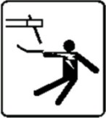 | Warning | An electric shock may hurt or even kill people. | 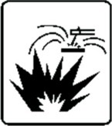 | Welding operation may cause fire or explosion!  Welding spatter may ignite combustibles nearby.  Combustibles shall be placed at least 10m from the welding site. Prevent the spatter from falling  on clothes or body.
Please turn off the power of the distribution box before wiring.
Do not touch exposed conductive parts.
 | The welding fume is harmful to health.  Do not inhale the fume produced during welding. Clean up the greasy dirt on work piece. Keep the welding site in ventilation. Smoke and dust exhausting facility shall be arranged at the welding station. |  | 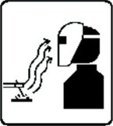 | The arc light may hurt the eyes and the skin.  Strong arc light may hurt the eyes.  The ultraviolet rays produced by the electric arc may hurt the skin and the eyes, and please wear labor protection clothes properly during welding.
 | Inert gases are harmful to the human body  Inert gases are harmful to the human body and even cause suffocation, so please choose a well-ventilated environment for welding. If not, please close the gas cylinder valve. |  | 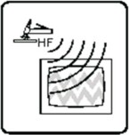 | High-frequency arc ignition may cause electromagnetic radiation Radiation may interfere with other devices! Contact arc ignition can be  used to avoid interference.
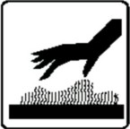 | The overheated part may burn the skin, and do not touch the overheated welding part.  The overheated part may burn the skin, and do not touch the overheated welding part. |  |  | High-speed moving objects may cause hurt.  and do not put your hands or a thin objects into the fan hood.  Please cover the open shell during welding.
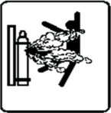 | The gas cylinder may explode. so do not to heat it.  It is preferred to keep the gas cylinder away from the welding site and fix it well. |  | 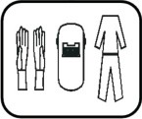 | Personal protection.  To prevent eye and skin injury, please comply with the rules of labor safety and health and wear necessary protective clothing!

Product User Manual
Contents

1 Characteristics of digital pulse gas-shielded welding machine P₀₁
Overview
01

Precautions for electromagnetic compatibility

Installation of welding machine
  - Overvie P₀₃
  - Environmental assessment and recommendations
02
---------------------------------------------------P₀₃
  - Method to reduce emission P₀₃
  - Installation environment P₀₅
03
  - Quality of power supply voltage P₀₅
  - Basic parameters P05

Control and connection
  - Control and interface P₀₇
  - Guidance for device connection P09
04

5-1 Operation panel description P₀₉
Control panel of welding machine
05
06
  - Wire feeder mechanism P16
  - Specification and installation of wire feeding
wheel P₁₆
  - Braking and Adjustment of Wire Reel P17
Wire feeder
7-1 Installation of Gas Shielded Arc Welding Torch
--------------------------------------------------------P₁₈
Installation of Welding Torch
07
Maintenance of welding machine
  - Precautions for use P₁₉
  - Regular inspection and maintenance of welding machine P19
  - Welding machine troubles and trouble-shooting
-------------------------------------- P₁₉
08

9-1 Schematic diagram of main circuit P₂₀
Technical data
09

..........................................................................................................................................................................................
Product User Manual

Overview
01
1 Characteristics of digital double pulse gas-shielded welding machine

Thank you for buying the digital inverter welding machine . Please read the Manual carefully before use. This Manual is applicable to the following welding machine: MIG-200

Mig-200 digital double pulse welding machines apply to welding methods including MMA, MIG/MIX, PULSE AlMg, PULSE AlSi and DOUBLE PULSE. MASTER-MIG DPP
series welding machines are suitable for welding materials including carbon steel, stainless steel, aluminum-magnesium, aluminum-silicon and flux-cored wire. Its characteristics include no-spatter, uniform weld pool, etc.

The performance features are as follows:

Use full-digital control system to realize precise control and stable arc length during welding. Use full-digital wire feeding control system to realize precise and stable wire feeding.
With built-in welding expert database, the system can be used to realize automatic intelligent
parameter combination.
Friendly operation interface, unified regulating mode, easy to master.

Perfect single pulse and double pulse functions, minimum welding spatter and good-looking appearance of weld.
The special four-step function is suitable for welding metals with good thermal conductivity, and the welding quality is perfect during the arc initiating and extinguishing.

The manufacturing of this series welding machines conforms to the GB15579.1-2004 Arc Welding Equipment - Part 1: Welding Power Source

Product User Manual
02

Precautions for electromagnetic compatibility
2-1 Overview

Welding may cause electromagnetic interference.
The interference emission of the arc welding equipment can be minimized by proper installation and proper use.
The product described in this Manual is a Class A equipment (applicable to all occasions other than residential areas powered by public low voltage power systems).
Warning: Class A equipment are not applicable to residential buildings powered by public low voltage power systems. Due to conduction and radiation disturbance, it is difficult to guarantee electromagnetic compatibility in these places.
2-2 Environmental assessment and recommendations
Before installing the arc welding equipment, the user shall evaluate the potential electromagnetic disturbance within the surrounding environment. Considerations are as follows:
If there are any power cables, control cables, signal and telephone line on or under or around the arc welding equipment;
If there are radio and television transmitting and receiving equipment; If there are computers and other control equipment;
If there are equipment of high-level of security, such as industrial protective equipment;
It needs to consider the health of the staff working around, to see if there are individuals wearing hearing
-aid and using cardiac pacemaker;
If there are equipment for calibration or testing;
Pay attention to the interference immunity of other surrounding equipment. The user shall ensure that other devices used around are compatible, and this may need additional protective measures;
The time for welding or other activities.
The scope of environment to be considered depends on the structure of the building and other possible activities. This scope may exceed the boundary of the building itself.
2-3 Method to reduce emission

Public power supply system
The arc welding equipment shall be connected to the public power supply system in the manner recommended by the manufacturer. If interference occurs, additional preventive measures shall be taken, for example, to add a filter in the public power supply system. For stationary-mounted arc welding equipment, it is necessary to consider the shielding problem of its power supply cable (metal tubes or other equivalent methods can be used for shielding). The shielding shall guarantee electrical continuity. The shielding layer shall also be connected to the housing of welding power toguarantee good electrical contact between them.
Maintenance of arc welding equipment
Routine maintenance of the arc welding equipment shall be done in the manner recommended by the manufacturer. When the welding equipment is running, all the inlets, auxiliary openings and cover plates on the equipment shall be closed and properly tightened. The arc welding equipment shall not be modified in any form unless the corresponding changes and adjustments are allowed in the Manual. Especially, the spark gap of the arc-initiating device and arc stabilizer shall be adjusted
Welding cable
The welding cable shall be as short as possible and close to each other, close to or close to the floor line.
Equipotential overlap
It is necessary to pay attention to the overlapping of all metal objects in the surrounding environment. Overlap of metal object with work piece will increase the risk of work. When operators touch metal object and electrodes at the same time, they may be struck by electric shocks. Operators shall be insulated from all these metal objects.

..........................................................................................................................................................................................
Product User Manual

Ground of workpiece
Considering the electrical safety or the position and size of workpiece, the workpiece, such as the hull or the building steel frame, may not be grounded. The connection between the workpiece and the ground may, but not always, reduce the emission. Therefore, it is necessary to prevent the increase of electrical shock or damage of other electrical equipment caused by the grounding of the workpiece. When necessary, the workpiece shall be connected to the ground directly. However, in some countries, direct grounding is not allowed, it can only be realized with appropriate capacitance according to the provisions of the country.

Shielding
To shield the surrounding equipment and other cables selectively can reduce the electromagnetic interference. For special applications, it can be considered to shield the whole welding area.

Product User Manual
03

Installation of welding machine
3-1 Installation environment
It shall be placed in indoor environment with no direct sunlight, no rain, low humidity, less dust and ambient air temperature varying from -10°C to +40°C.
The ground inclination shall not exceed 15°.
No wind is allowed at the welding station, if any, shield is needed.
It shall be confirmed that a space at least 20cm shall be kept in front of and behind the welding machine to guarantee good air cooling circulation, and there shall be a space at least 10cm at the right and left side of the welding machine.
When using water-cooled welding torch, inject pure water into the water-cooling machine and pay attention to freeze protection.
3-2 Quality of power supply voltage
The waveform shall be standard sine wave, the effective value is 220V±10% and the frequ-
ency is 50Hz/60Hz.
The unbalance degree of three-phase voltage =5% Technical parameter of power supply
3-3 Basic parameters

Specification of welding machine | MIG-200 | MIG-185
Rated input voltage | 220V±10% | 220V±10%
Rated input current (A) | 35A | 31A
Rated output capacity | 7.7KV.A | 6.8KV.A
Output no-load voltage (V) | 69V | 69V
Rated load succession rate | 30% | 35%
Power factor COSφ | 0.73 | 0.73
Efficiency η | 85% | 85%
Outline dimension (mm) | 490*220*375 | 490*220*375
Net weight (kg) | 15 | 15

..........................................................................................................................................................................................
Product User Manual

Coating manual welding parameters(MMA Mode)

Specification of welding machine | MIG-200 | MIG-185
Rated input current (A) | 20～180A | 20～160A
Arc-initiating time (HOTT) | 0～205 | 0～160
Arc-initiating time (HOTI) | 0～160A
Arc-initiating time (HOTT) | 0～99ms
Arc characteristics (SLOP) | Cc constant current mode
 | Cp constant power mode
 | 1~20A slow-decrease characteristic
VRD | ON/OFF

Unitary gas shielded arc welding parameters(SYNC MIG)

Specification of welding machine | MIG-200 | MIG-185
Rated input current (A) | 60～200A | 60～185A
Material selection | AlSi5 Ar，E308 Ar98 | AlSi5 Ar，AlMg5 Ar
Welding wire diameter (DIAM) | 0.8，1.0 ,1.2
Operation mode (TRIG) | 2T，4T，S2T，S4T，Spot，Cpot
Inductance (Forc) | -90%～50%
Burn-back time (Burn) | -90%～90%
Time for spot welding (Sptt) | 0.1～9.9s
Soft Starting Speed (StFd) | 1～13m
Spot welding stop time (Stop) | 0.1～25.5s
Preflow time of gas (Freg) | 0～10s
Postflow time of gas (Post) | 0.1～50s

Product User Manual

Double pulse gas shielded arc welding(Twin Pulse)

Specification of welding machine | MIG-200
Rated current (A) | 20～170A
Material selection | AlSi5 Ar，AlMg5 Ar | Fe Co2，Fe Ar82，  E308 Ar98
Welding wire diameter (DIAM) | 1.0，1.2 | 0.8，1.0
Operation mode (TRIG) | 2T，4T，S2T，S4T，Spot，Cpot
Inductance (Forc) | -90%～50%
Burn-back time (Burn) | -90%～90%
Time for spot welding (Sptt) | 0.1～9.9s
Pulse frequency (Freq) | 0.5～5.0H
Duty ratio (Duty) | 20%～80%
Pulse amplitude (Ip-p) | 5%～50%
Basic arc length (PU) | -50%～50%
Peak arc length (BU) | -50%～50%
Soft starting speed (StFd) | 1～13m
Spot welding stop time (Stop) | 0.1～25.5s
Preflow time of gas (Freg) | 0～10s
Postflow time of gas (Post) | 0.1～50s

Single pulse gas shielded arc welding(Pulse MIG)

Specification of welding machine | MIG-200 |  | MIG-185
Rated current (A) | 20～170A |  | 20～160A
Material selection | AlSi5 Ar AlMg5 Ar | E308 Ar98 | AlSi5 Ar  AlMg5 Ar | Fe CO2  Fe Ar82
Welding wire diameter(DIAM) | 1.0，1.2 | 0.8，1.0 | 1.0，1.2 | 0.8，1.0
Operation mode（TRIG） | 2T，4T，S2T，S4T，Spot，Cpot
Peak current amplitude (Forc) | -99%～50%
Burn-back time (Burn) | -90%～90%
Time for spot welding (Sptt) | 0.1～9.9s
Soft starting speed (StFd) | 1～13m
Spot welding stop time (Stop) | 0.1～25.5s
Preflow time of gas (Freg) | 0～10s
Postflow time of gas (Post) | 0.1～50s
Note: Some of the parameters in the table above can only be used in specific functions.

..................
........................................................................................................................................................................
Product User Manual

04

Control and interface
4-1 Control and interface
The controls and interfaces on front and rear panels of welding machine are shown in Fig. 1.
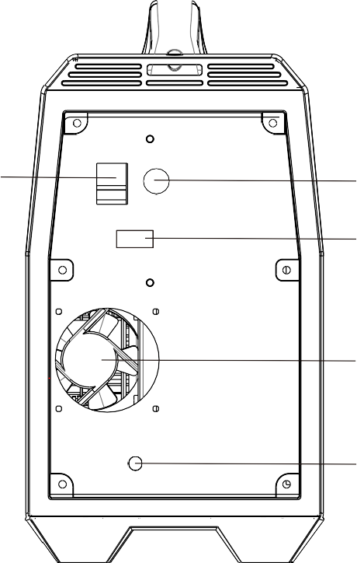
3
4
5

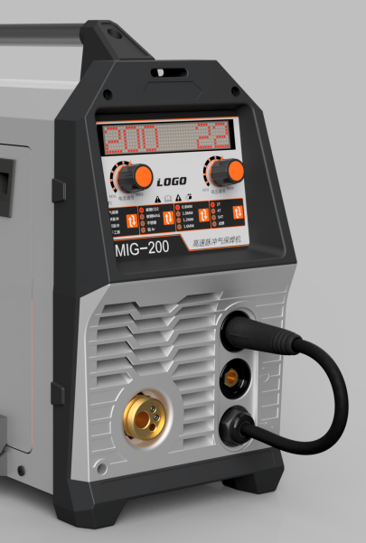
7
6
2
1

8

Fig. 1

    - Rocker switch
    - Power cord
    - Gas cylinder heating interface
    - Fan
    - Gas interface
    - Output socket of welding machine (-)
    - Output socket of welding machine (+)

Product User Manual

4-2 Guidance for device connection

Use grounding cable to connect the to-be-weld workpiece to the output socket (I) of welding machine.
Use positive welding cable to connect welding cable socket of wire feeder to the output socket (+) of welding machine.
Use control cable to connect control socket on rear panel of wire feeder to the feeding control socket on rear panel of welding machine.
Use gas pipe to connect wire feeder to gas regulator or proportioner.
The heating cable of CO2 regulator shall be connected to the heating power socket on the rear panel of welding machine.
Connect the input three-phase cable to the distribution board and the ground wire shall be grounded reliably.
Close the automatic air switch on the distribution box.
After the completion of the above work, install the accessories of the supporting wire feeding system and load the wire. Select corresponding weir diameter and material on the control panel of the welding machine and switch in the specified protective gas for the wire material. Turn the voltage knob to the standard position, turn the current knob to obtain the required current, and
then you can get the appropriate welding specification and start welding.
For detailed functions and operations, please see relevant sections of this Manual.

05
..........................................................................................................................................................................................
Product User Manual

Description of Operation Panels
5-1 Description of Operation Panel Functions

This welding machine has two kinds of operation interfaces: current setting and parameter setting. Current setting interface
The welding machine will automatically enter the current setting interface after starting up, and will also
automatically enter the current setting interface during welding.
- Current and voltage adjustment
Knob A is used to adjust current, and Knob B is used to adjust voltage. There are two modes to display the set voltage: percentage and voltage value. Press Knob B to switch the two display modes. 100% re- presents the difference from the standard voltage; 0% represents the standard voltage; 10 % means that the voltage is 10 % higher than the standard voltage, and so on.
- Wire inspection
Press Knob A to start wire inspection, and gradually increase the speed to the set value.
- Gas detection
Press the Knob B to start gas detection, and loose to stop.

Amps
Inch
Voltage
Gas
MIG
PULS
DOUBLE PULSE
ARC

STEEL CO2
STEELMAG
ATAINLESS
ALU。
Ø0.8 Ø1.0 Ø1.2
2T
4T S4T
Spot
MIG-200

A B

MIG-200 Operation Panel

Product User Manual

Parameter setting interface
Press and hold Knob A and Knob B simultaneously in the current setting interface to enter the parame- ter setting interface. Press any button in this interface to return to the current setting interface. Other pa
-rameters can also be adjusted in this interface: press Knob A to select parameters, and Knob B to adjust parameter values.

（1）Select welding mode
As soon as you enter the parameter setting interface, the current welding mode will be displayed. Use Key E to adjust the welding mode. See Table-1 for various welding modes. This welding machine supports up to 14 welding modes, depending on the specifications of the product ordered by the user. Users can also purchase passwords later to add welding modes.

Amps
Inch
Voltage
Gas
MIG
PULS
DOUBLEPULSE
ARC

STEEL CO2
STEELMAG
ATAINLESS
ALU。
Ø0.8 Ø1.0 Ø1.2
2T
4T S4T
Spot
MIG-200

A

B

MIG-200 Operation Panel

Table-1
Code | Abbreviation | Name of welding mode
FastPulse | FMIG | High-speed pulse gas shielded arc welding
PulseMIG | PMIG | Pulse gas shielded arc welding
FastTwin | Ftwi | High-speed dual-pulse gas shielded arc welding
TwinPulse | Twin | Dual-pulse gas shielded arc welding
FastArc | Farc | High-speed gas shielded arc welding
MIG/MAG | YMIG | Gas shielded arc welding
FastUp | F-UP | High-speed internal welding
MMA Mode | MMA | Coating manual welding
FastRoot | Root | High-speed root welding
TIG Mode | TIG | DC argon arc welding (pulling and striking arc)
FastCold | Cold | High-speed cold welding
PulseTIG | PTIG | Pulsed argon arc welding
SYNC MIG | MIG | Unitary gas shielded arc welding
CarbonArc | Carc | Carbon arc air gouging

..........................................................................................................................................................................................
Product User Manual

Select welding materials
When the welding mode is displayed, adjust the left knob clockwise to display the current weld
-ing material, and press Key D to adjust the welding material. See Table-2 for various welding materials. This welding machine supports up to 19 welding modes, depending on the specifi- cations of the product ordered by the user. Users can purchase passwords to add welding ma- terials.
Select wire diameter
When the welding material is displayed, adjust Knob A clockwise to display the current wire dia- meter, e.g. "SIZE 1.0"; press Key C to adjust the wire diameter.

Amps
Inch
Voltage
Gas
MIG
PULSDOUBLEE PULSE
ARC

STEEL CO2
STEELMAG
ATAINLESS
ALU。
Ø0.8 Ø1.0 Ø1.2
2T
4T S4T
Spot
MIG-200

MIG-200 Operation Panel

Table-2
Code | Abbreviation | Name of welding mode
Fe CO₂ | FeCO | Carbon steel Co₂
Fe Ar82 | FeA8 | Carbon steel Ar 82%+CO₂ 18%
Fe Ar92 | FeA9 | Carbon steel Ar 92%+CO₂ 8%
Al Ar | Al | Pure aluminium Ar
AlMg4.5Ar | AlM4 | Aluminum-magnesium welding wire ( ER 5183) Ar
AlMg5 Ar | AlMg | Aluminum-magnesium welding wire ( ER 5356) Ar
AlSi5 Ar | AlSi | Aluminium-silicon welding wire (ER 4043) Ar
CuSi3 Ar | CuSi | Silicon-bronze welding wire Ar
CuAl8 Ar | CuAl | Aluminum-bronze welding wire Ar
CuSiAr98 | CuS9 | Silicon-bronze welding wire Ar 98%+CO₂ 2%
CuAlAr98 | CuA9 | Aluminum-bronze welding wire Ar 98%+CO₂ 2%
E308Ar98 | E308 | Stainless steel welding wire (ER 308) Ar 98%+CO₂ 2%
E316Ar98 | E316 | Stainless steel welding wire (ER 316) Ar 98%+CO₂ 2%
RutilFlux | Ruti | Acid flux-cored wire Ar 82%+CO₂ 18%
BasicFlux | Basi | Basic flux-cored wire Ar 82%+CO₂ 18%
MetalFlux | Meta | Iron dust flux-cored wire Ar 82%+CO₂ 18%
CrNiFlux | CrNi | Stainless steel welding wire Ar 82%+CO₂ 18%
ER2319Ar | 2319 | Aluminum-copper welding wire Ar
FeCO₂ 09 | Fe09 | Carbon steel0.9mm CO₂

Product User Manual

Adjust other parameters
Other parameters can also be adjusted in this way: press Knob A to select parameters, and Knob B to adjust parameter values. See parameter codes in Table 3.

Table-3
Code | Abbreviation | Name of welding mode
Size | Welding wire diameter | Support 3 wire diameters: 0.8, 1.0, and 1.2
Mode | Operation Mode | Support 6 gun switch modes: 2T, 4T, S4T, S2T, spot welding and continuous spot welding
EndI | Extinguishing arc current | The function is to fill the arc crater, for S4Tand S2T
HotI | Initial current | The function is to increase the heat input at the beginning of welding, for S4T and S2T
Burn | Burn-back time | It is used to adjust the effect of small ball cutting at the end of welding.
Hott | Initial time | The initial current duration is only for S2T.
Endt | Extinguishing time | Extinguishing arc current duration is only for S2T.
Slop | Transition time | The time for switching of the two currents (e.g. the initial current and the welding current); characteristic selection for manual welding: CC constant current, CP constant power ( for cellulose ), 1 - 20 slow descent
Sptt | Time for spot welding | Duration of spot welding
Freq | Pulse frequency | Frequency of dual-pulse gas shielded, high-speed dual-pulse gas shielded and high-speed vertical position welding
Freq | Pulse frequency | Frequency of dual-pulse gas shielded, high-speed dual-pulse gas shielded and high-speed vertical position welding
Duty | Duty ratio | Duty ratio of dual-pulse gas shielded, high-speed dual-pulse gas shielded and high-speed vertical position welding
Ip-p | Pulse amplitude | Peak current amplitude of dual-pulse gas shielded and high- speed dual-pulse gas shielded welding
HotU | Initial arc length | Initial current length
PU | Peak arc length | Peak current arc length
BU | Basic arc length | Background current arc length
StFd | soft starting | Soft start feeding rate
VRD | Low/no-load | Manual welding VRD switch
Stop | Stop time | Time interval to stop welding during continuous spot welding
Preg | Preflow of gas | Gas Preflow Time
Post | Postflow of gas | Gas Postflow Time
EndU | Extinguishing arc length | Extinguishing arc length
FORC | Arc force | Gas shielded welding refers to inductance; pulse gas shielded arc  welding refers to the peak current amplitude; manual welding refers to arc force

..........................................................................................................................................................................................
Product User Manual

Operation Mode
2T operating instructions: Press the gun switch to start gas supply, wait for the gas preflow time before arcing to the set current, release the gun switch for arc extinguishing and gas postflow.
t
GPO
I
GPR
I
+

2TOperation Mode

4T operating instructions: Press (and release) the gun switch to start gas supply, wait for the gas preflow time before arcing to the set current. Press the gun switch once again for arc extingui- shing and gas postflow.

GPR | I | GPO | t

4TOperation Mode
+
+
I

HotI
Welding current
Product User Manual

S2T operating instructions: Press the gun switch to start gas supply, wait for the gas preflow time before arcing to the initial current, wait for the initial time before increasing to the set currentgradually and the time for gradual increase is SLOP; release the gun switch and the set currentwill change to the extingui
-shing arc gradually, wait for the arc extinguishing time before arc extinguishing and gas postflow.

S2TOperation Mode
t
ARC off
ARC on
0
1
Robot signal
I-E
t
EndI
DWSL
I-S DWSL
Endt
SLOP
SLOP
Hott

S4T operating instructions: Press the gun switch to start gas supply, wait for the gas preflow time before arcing to the initial current, wait for the initial time before increasing to the set current gradually and the time for gradual increase is SLOP; release the gun switch and the set current will change to the extingui
-shing arc gradually, wait for the arc extinguishing time before arc extinguishing and gas postflow.
t
GPO
I-E
DWSL
I
DWSL
I-S
GPR
I
+
+
S4TOperation Mode

..........................................................................................................................................................................................
Product User Manual

SPOT (spot welding) operating instructions: Press the gun switch to start gas preflow to arc striking to the set current, wait for the spot welding time for arc extinguishing and gas postflow. If you release the gun switch before the spot welding time, the arc will be extinguished immediately and gas will post flow.

PreG | Sptt | PosG | t

Spot Welding Operation Mode
+
+
I

Preg in the figure is the gas preflow time, Posg is the gas postflow time, HotI is the initial current,EndI is the extinguishing current, WeldI is the setting current, Hott is the initial time, Endt is the extinguishing time, SLOP is the gradual change time, and Sptt is the spot welding time.

CPOT (continuous spot welding) operating instructions: press the gun switch and the welding machine will start intermittent spot welding. The spot welding time is Sptt and the intermediatebstop time is STOP. Release the gun switch to stop welding.

Error display
Characters will be displayed directly in case of errors. There are only two kinds of displays: 1 overheating: Over Temp; and 2 over time: Over Time

Product User Manual
06

Wire feeder
6-1 Wire feeder mechanism
The wire feeder mechanism is single -drive, as shown in the figure below.

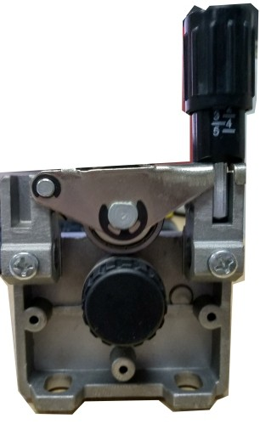
1

- (1) Pressure handle
(2) Wire pressing wheel
- (3) Wire feeding wheel

Fig-6-1
6-2 Specification and installation of wire feeding wheel

The wire feeding pressure scale is located on the pressure handle, and the pressure relations are different for welding wires made of different materials and with different diameters, as shown in the Table 6-2 and Figure 6-2. The values in the table are for reference only, and the actual pressure adjustment specifications must be adjusted according to the welding torch cable length, welding torch type, wire feeding condition and welding wire type.

Type 1 is suitable for the hard welding wire, such as those made of solid cored carbon steel and stainless steel.
Type 2 is suitable for the hard welding wire, such as those made of solid cored carbon steel and stainless steel.
Type 3 is suitable for the flux cored welding wire.
Use the pressure handle to adjust the wire feeding wheel pressure, so as to feed the welding wire into the conduit and to allow the welding wire with a little braking force while coming out of the contact tube, which will avoid slipping on the wire feeding wheel.
Note: The excessive pressure will make the welding wire flattened and the coating damaged, and will result in the rapid wear of wire feeding wheel and the increased resistance of wire feeding.
Table 6-2

Welding wire  diameter  Wire feeding Pressure  wheel type scale | φ 0.8 | φ 1.0 | φ 1.2
1 | 3 | 3 | 2.5
2 | 1. 5 | 1. 5 | 1. 5
3 |  |  | 2

..........................................................................................................................................................................................
Product User Manual

1
2

3

4
Pressure handle scale

Flat wheel

V-shaped wheel
U-shaped wheel
U-shaped wheel

Flat wheel

U-shaped wheel

Type 1 Type 2 Type 3

Fig6-2
6-3 Braking and Adjustment of Wire Reel

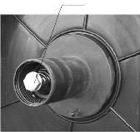
Use the screw wrench to turn the braking force control screw (1) to adjust the braking force (as shown in Fig. 6-3); the braking force should be moderate. Adjust the braking force to an appro
（1）
-priate level so that the welding wire on the wire reel is not too loose, thus preventing the weld- ing wire from scattering when the wire reel stops; the braking force cannot be too large, otherwise the motor load will be increased.
Fig6-3

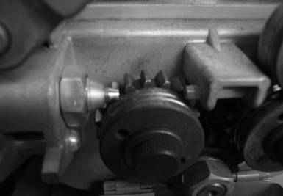
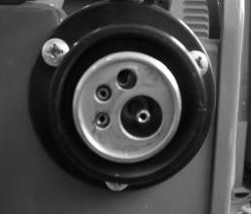
Product User Manual
For Al welding, remove the steel wire guide
steel wire feeding conduit
07

Installation of Welding Torch
7-1 Installation of Gas Shielded Arc Welding Torch
In order to ensure the smooth welding progress, please make sure that the wire feeding conduit and contact tube agree with the model of the welding torch. The wire feeding conduit is compatible with the diameter of all welding wires used and the type of welding wire. The wired hose is suitable for the hard welding wire, such as those made of solid cored carbon steel and stainless steel. The Teflon hose is suitable for the soft wire, such as those made of aluminum and its alloys and those made of copper and its alloys. When the wire feeding conduit is too tight or too loose, the resistance of wire feeding will be increased and thus the wire feeding will be unstable. Tighten the torch's quick connector to ensure there is no voltage drop on the contact surface. The pressure drop caused by loose contact will make the torch and the wire feeder heated.

The wire feeding hose made of steel wire and its installation are shown in the figure below:
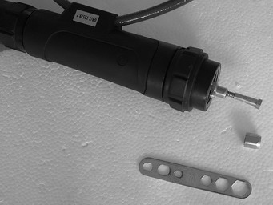
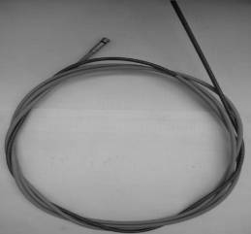
Wire hose
Wire hose

08
..........................................................................................................................................................................................
Product User Manual

Maintenance of welding machine
In principle, the maintenance of welding machine should be the responsibility of the company; the user can solve various problems encountered in use under the guidance of the company.
8-1 Precautions for use

The enclosure upper cover shall be riveted with the equipment number plate, otherwise the internal components may be damaged.
The welding cable and the output socket of welding machine shall be connected closely and reliably. Otherwise, the socket may be burned and the instability may be caused in the welding process.
Avoid that the welding cable is contacted with the metal object on the ground to prevent the output short circuit of welding machine.
Avoid damage and break of the welding cable and the control cable.
Avoid that the welding machine is deformed due to impact, and never stack the heavy object on the welding machine.
Ensure smooth ventilation.
8-2 Regular inspection and maintenance of welding machine

Ask the professional maintenance personnel to deduct the welding source with the compressed air every 3-6 months, and pay attention to inspect whether the fastener inside the machine is loose.
Frequently inspect whether the cable is damaged, whether the adjusting knob is loose and whether the component on the panel is damaged.
Timely replace the contact tube and the wire feeding wheel, and frequently clean the wire feeding hose.
8-3 Welding machine troubles and trouble-shooting
Before repair of the welding machine, inspect the followings:
Whether the front panel state and the welding condition display of welding machine are correct, and whether the key and the knob function normally.
Whether the line voltage of three-phase source is in the range of 220V-380V; whether the phase is deficient.
Whether the input cable of welding machine power supply is connected correctly and reliably. Whether the grounding wire of welding machine is connected correctly and reliably.
Whether the welding cable is connected correctly and is in good contact.
Whether the gas circuit is in good condition, and whether the gas regulator or the proportioner functions normally.

Notes: The maximum voltage inside the machine is up to 600V, so to ensure safety, never open the enclosure without permission. In maintenance, take proper safety protection measures like electric shock prevention. In installation of welding cable and replacement of welding torch accessories, turn off the power.

Product User Manual
09

Technical data
9 Schematic diagram of main circuit

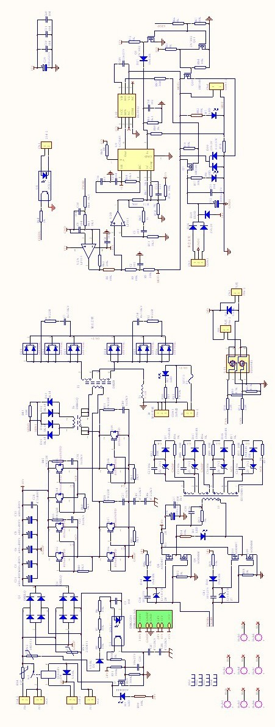
Schematic diagrams of MASTER-MIG DPP series main circuit and wirin
Annex 1: The latest software upgrade has added the function of restoring factory settings. There are two cases of restoring factory settings. The first kind of software finds that the settings are lost or chaotic and will automatically restore factory settings. The other is that the user will manually restore factory settings. The method is: hold down the two encoders to boot, enter the settings and adjust set1 to 66, then select Init, press the left encoder, and then display InitData, indicating that the factory settings have been restored and reboot.

