XY3605 manual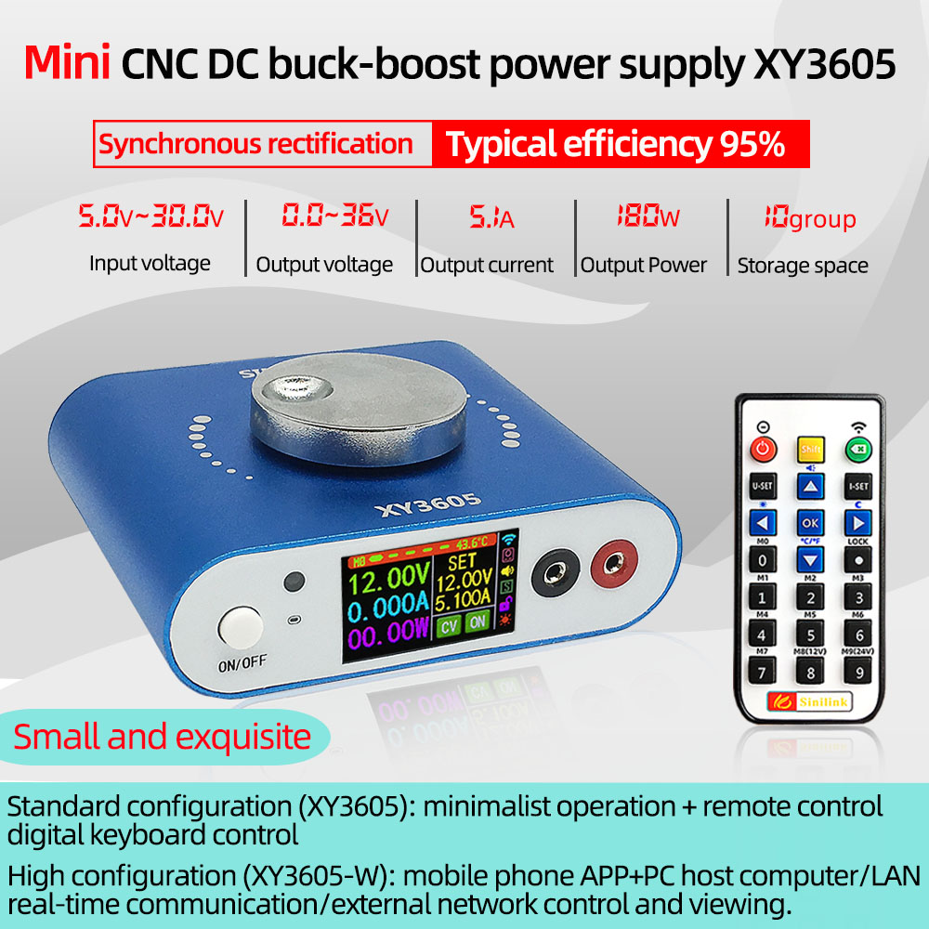
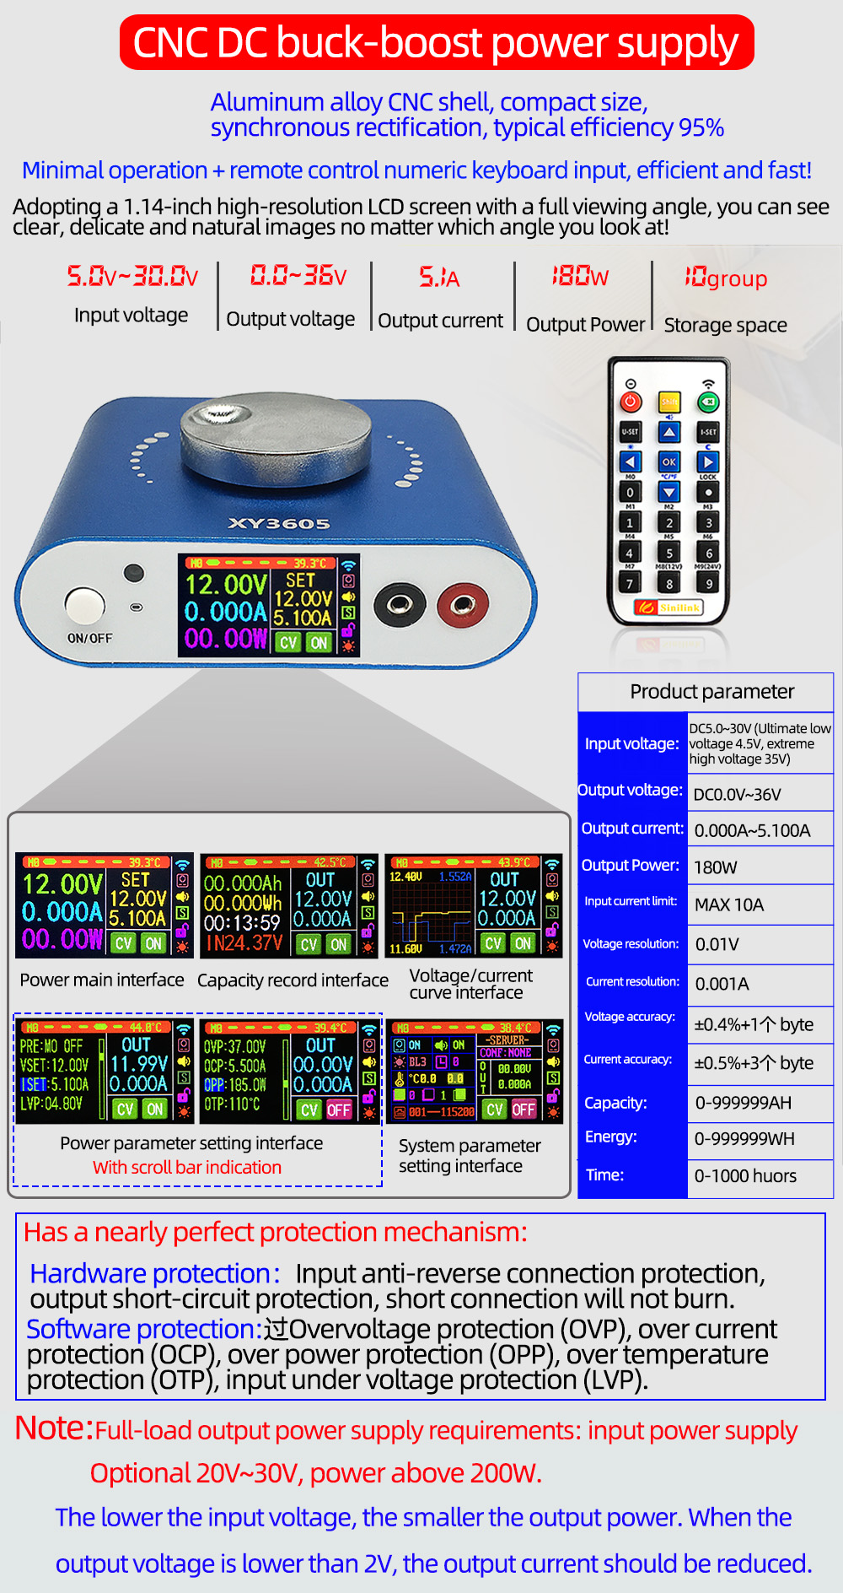
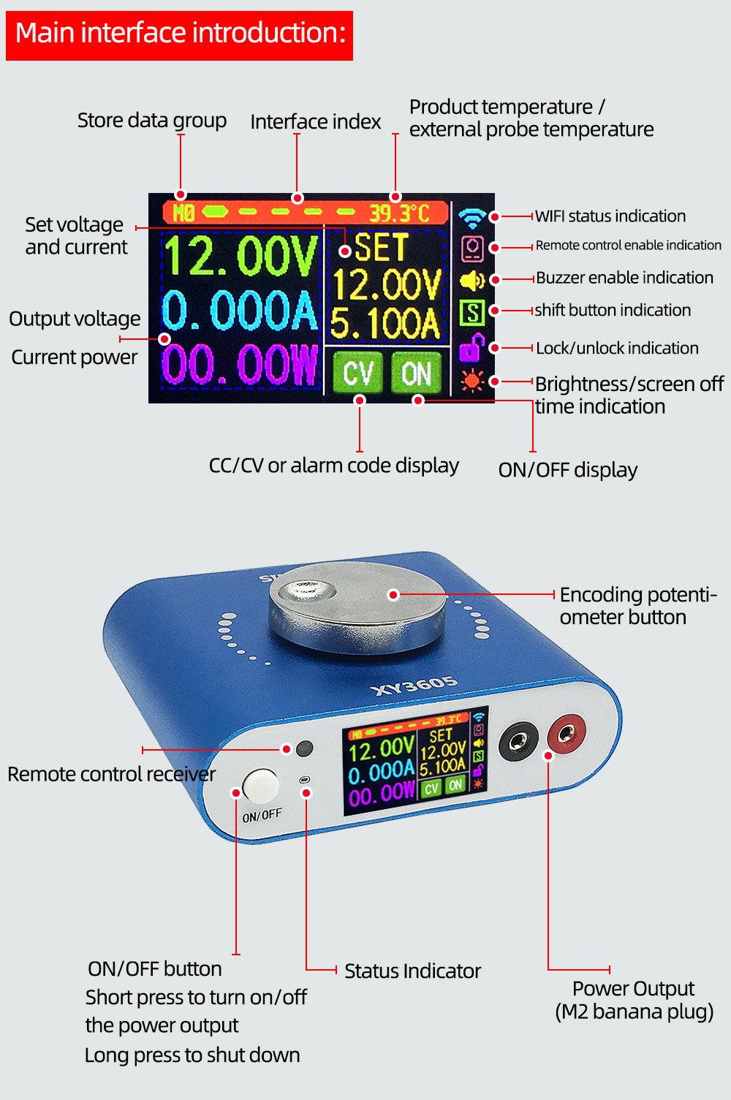
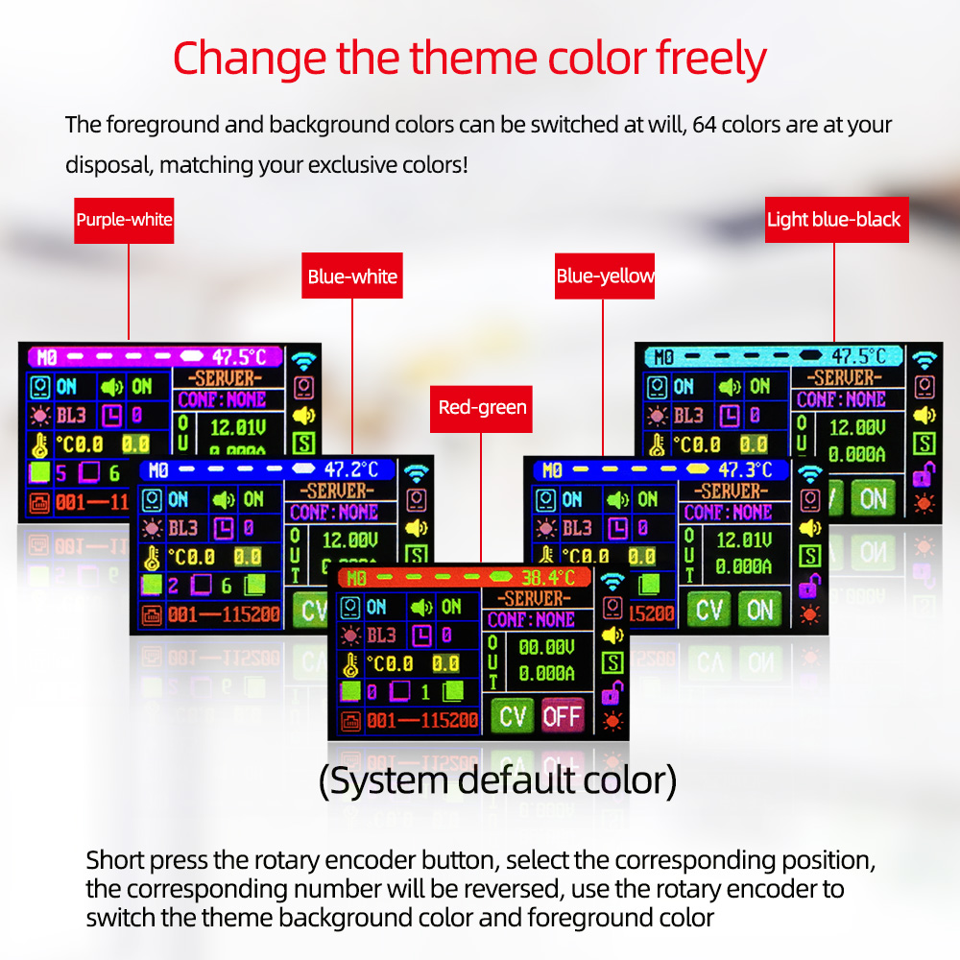
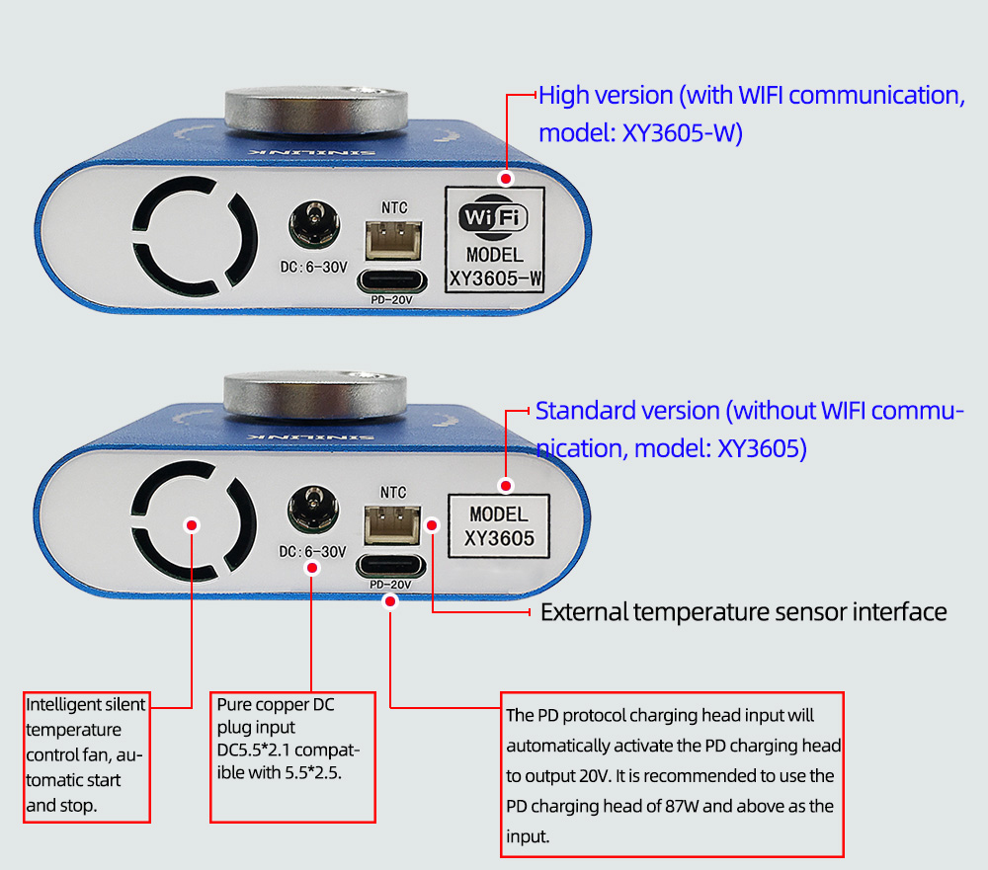
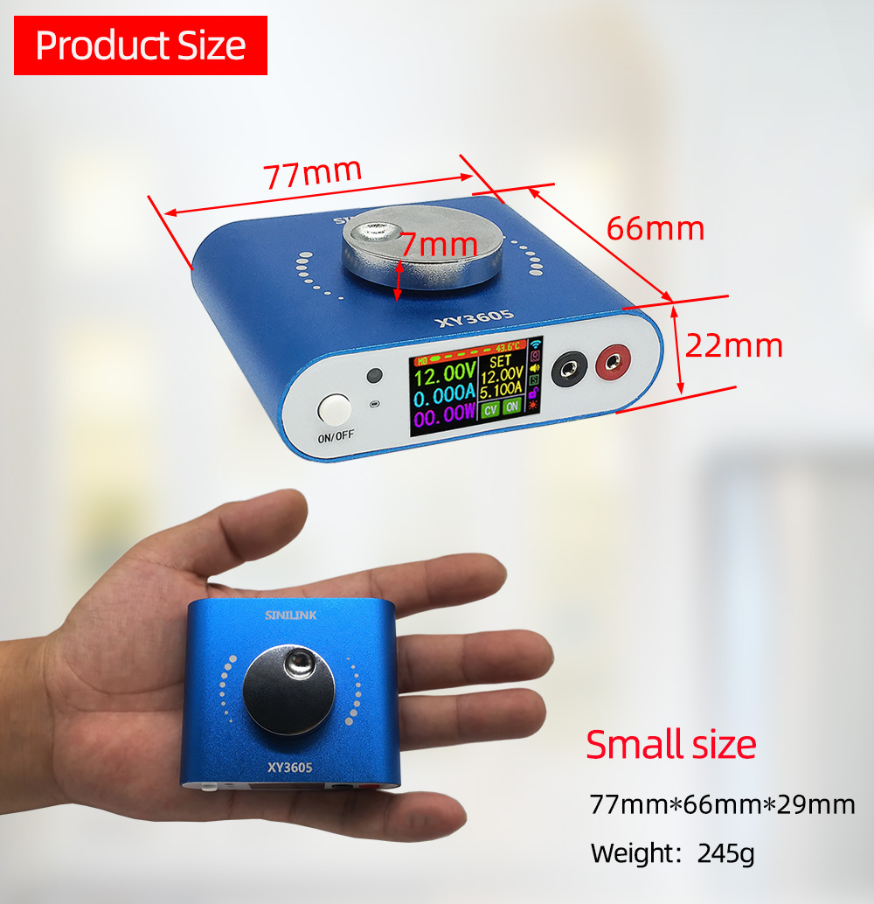
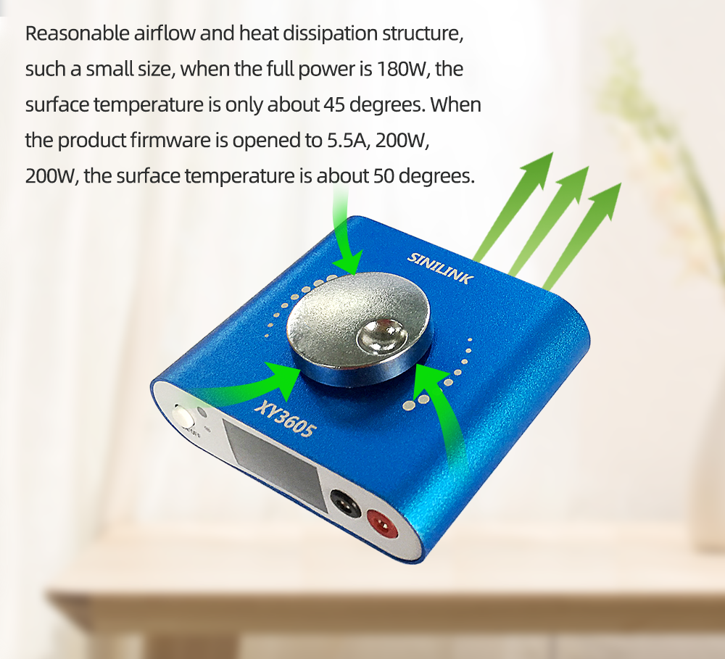
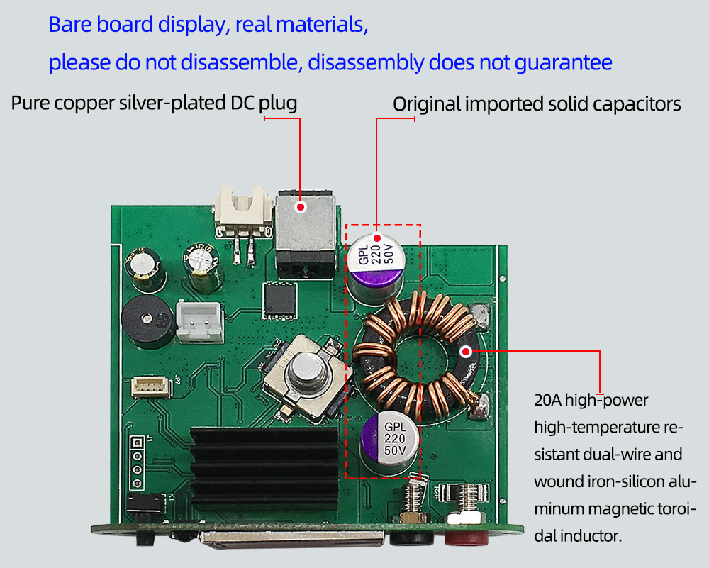
Free high-quality power cord and 1 meter long NTC temperature sensor

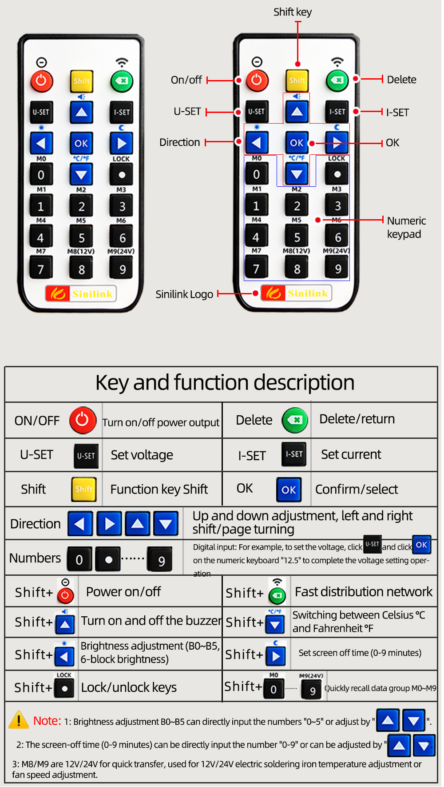
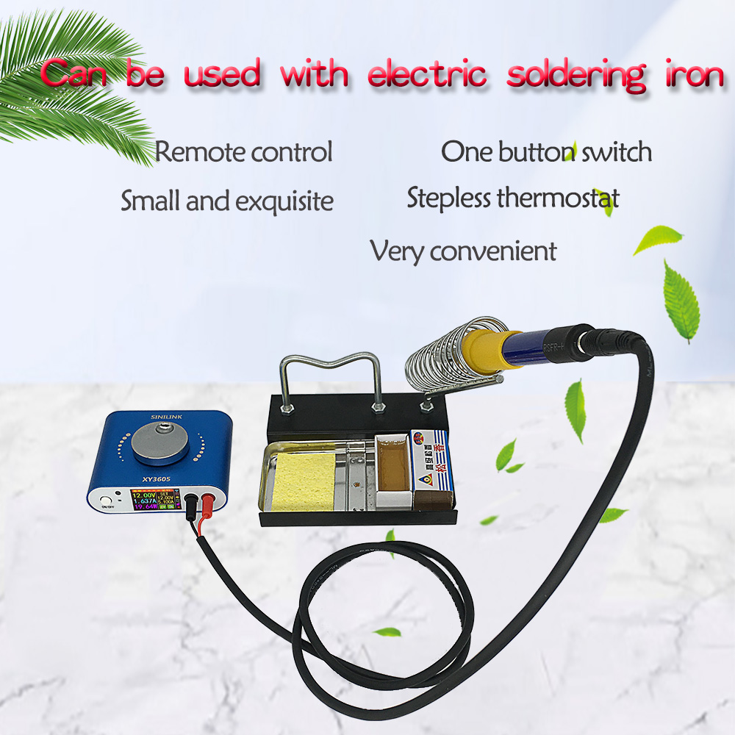
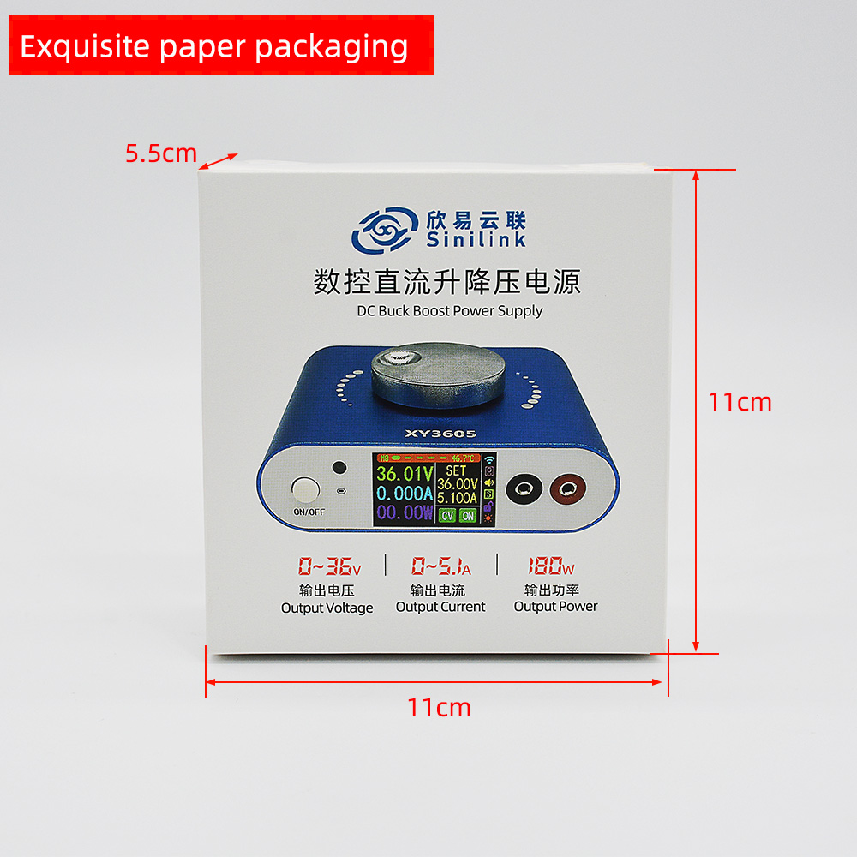
Introduction of high version XY3605-W
The product is connected to the Internet through the router 2.4G wifi, the internal network is directly transparent, real-time communication, and there is an external network server, so as long as the network status is connected, and the distance is unlimited, you can control and view data anytime and anywhere。
APP download address：
For foreign customers, please download from Google Market, search for ‘sinilink’ to download
Computer client software download address：
http://www.sinilink.com/download/tools/Sinilink-Setup.exe
APP interface can add multiple devices, support Android system and IOS system。
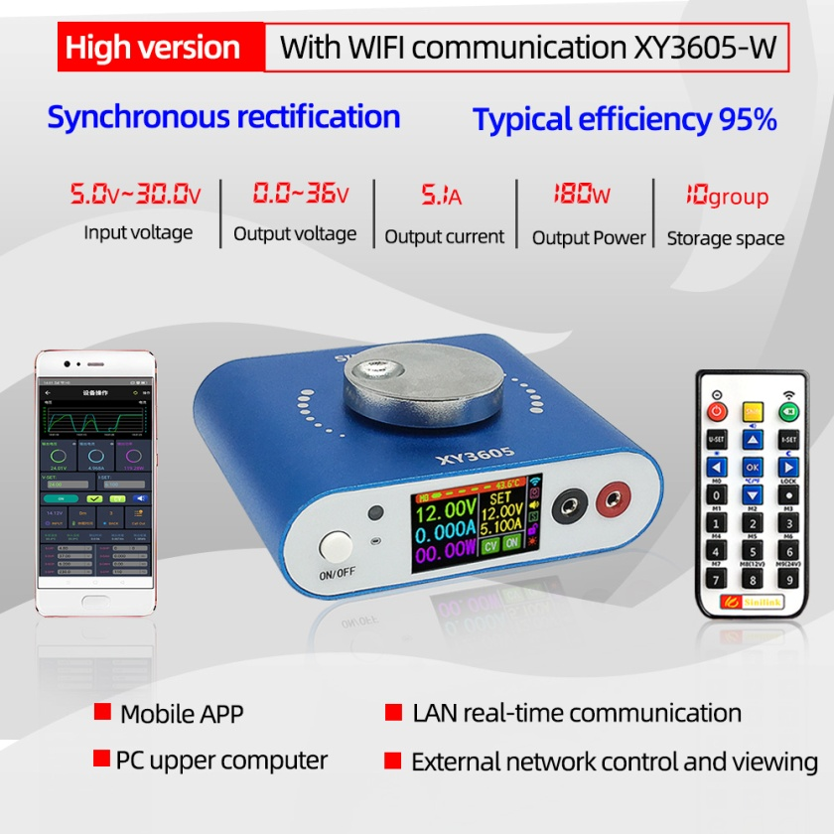
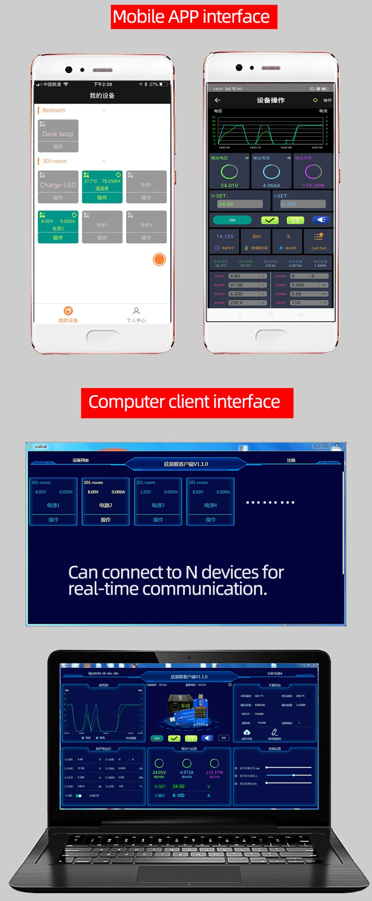
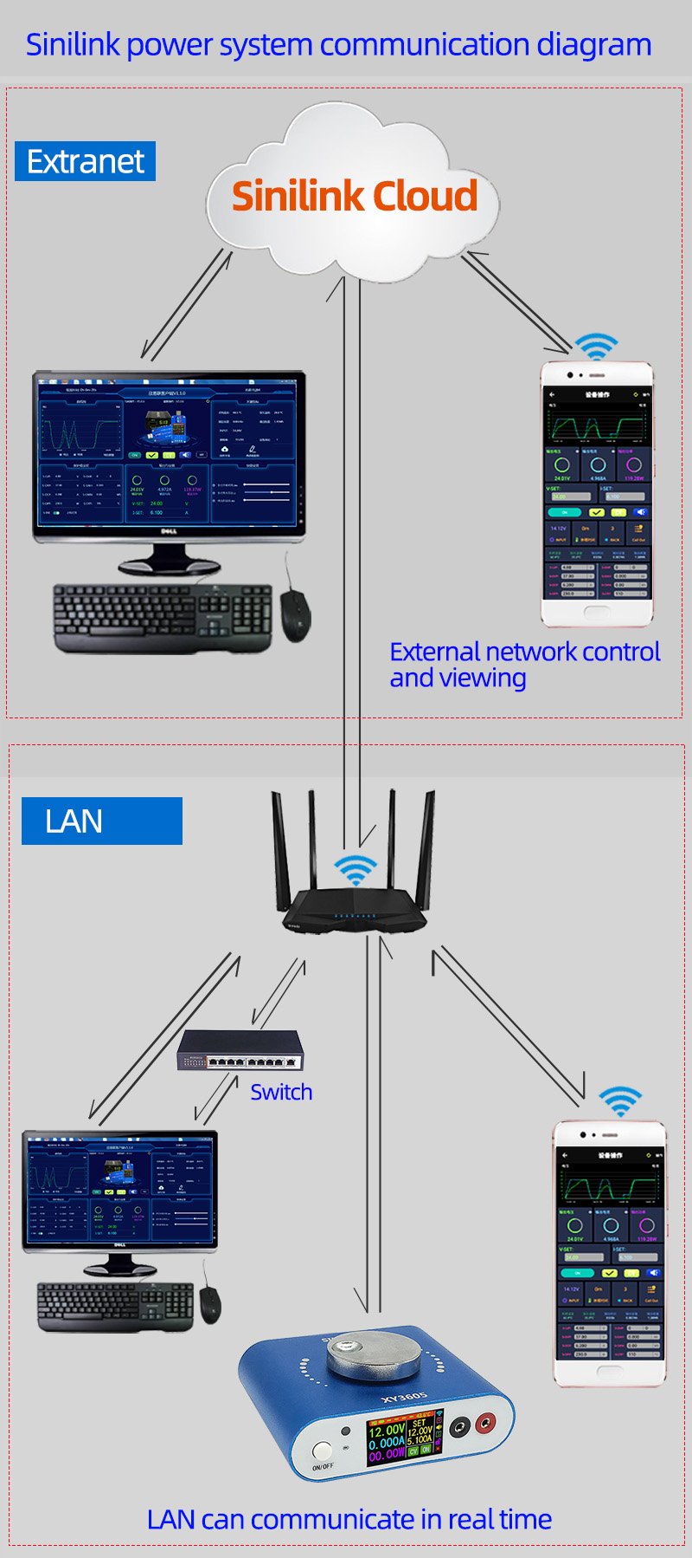
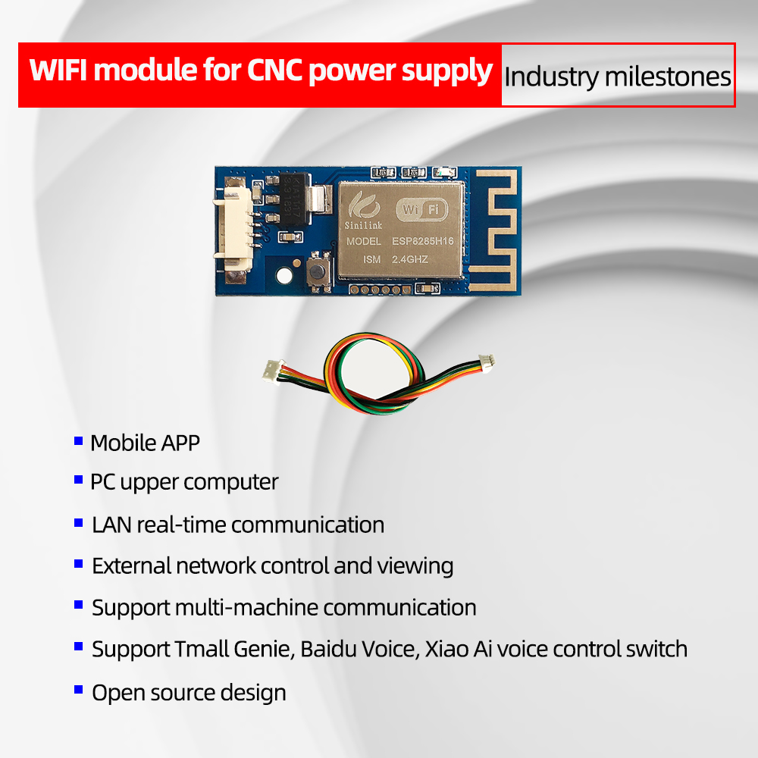
Detailed interface and key functions：
Short press the ‘ON/OFF’ button to turn on and off the power output, long press the ‘ON/OFF’ button for 2 seconds, the screen rotates and can be rotated 360° in four directions.
Rotary encoder potentiometer to realize fast page turning。
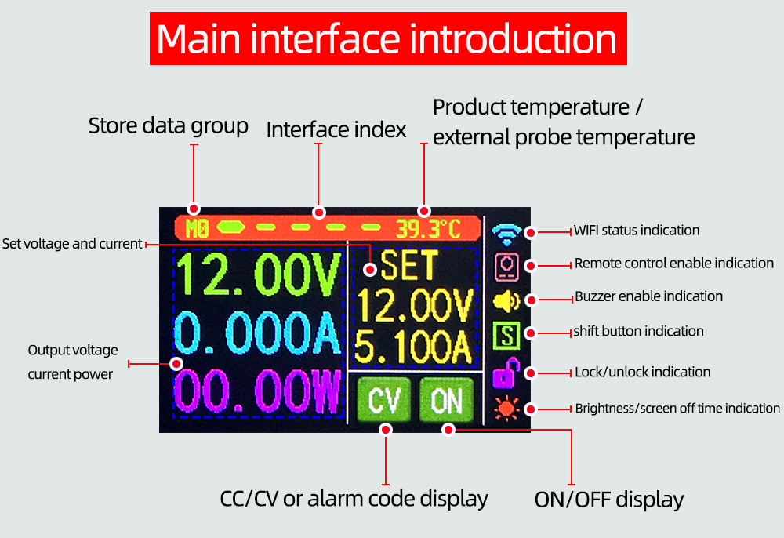
Short press the code potentiometer button to activate the parameter (voltage/current) to be set;
Switch between full selection and bit selection by short pressing the code potentiometer button;
After selecting all, all will be displayed in reverse blue, and the set voltage/set current can be switched through the rotary encoder;
After the bit is selected, the corresponding bit will be displayed in reverse blue, and the parameters can be set through the rotary encoder;
After the setting is completed, long press the code potentiometer button for 2 seconds or no button operation for more than 6 seconds will automatically exit the setting;
All parameters are automatically saved after exit。
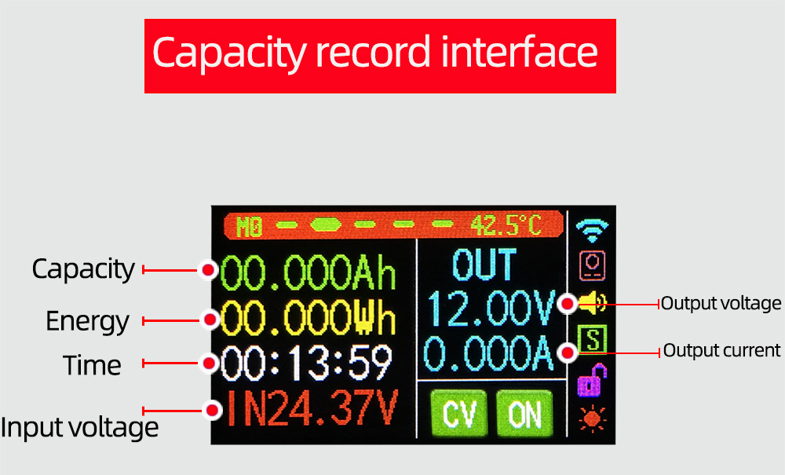
Short press the coding potentiometer button, select all'capacity/energy/time', and the corresponding ones will be displayed in reverse blue after all selections. Use the rotary encoder to switch the parameter to be cleared. After selecting, short press the coding potentiometer button, Clear the corresponding parameter; after selecting, long press the code potentiometer button for 2 seconds or no button operation for more than 6 seconds, it will automatically exit。
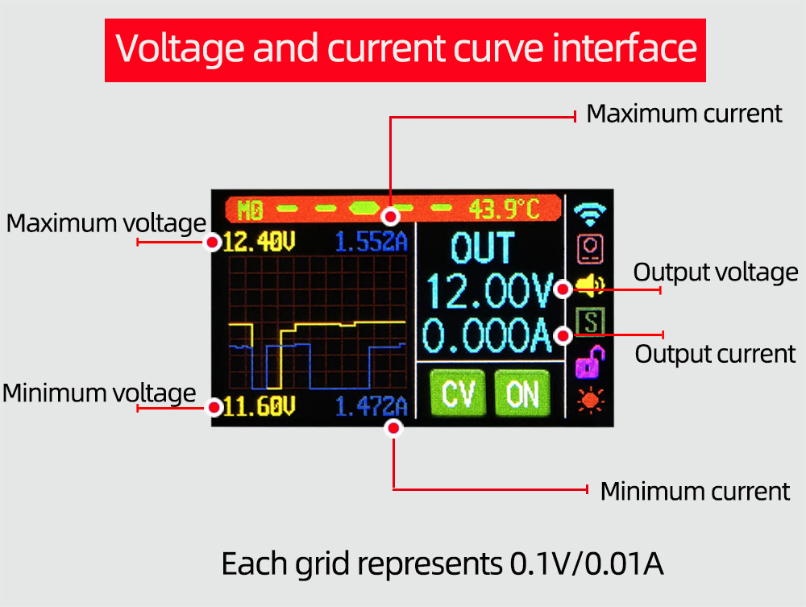
Short press the code potentiometer button to pause/start curve writing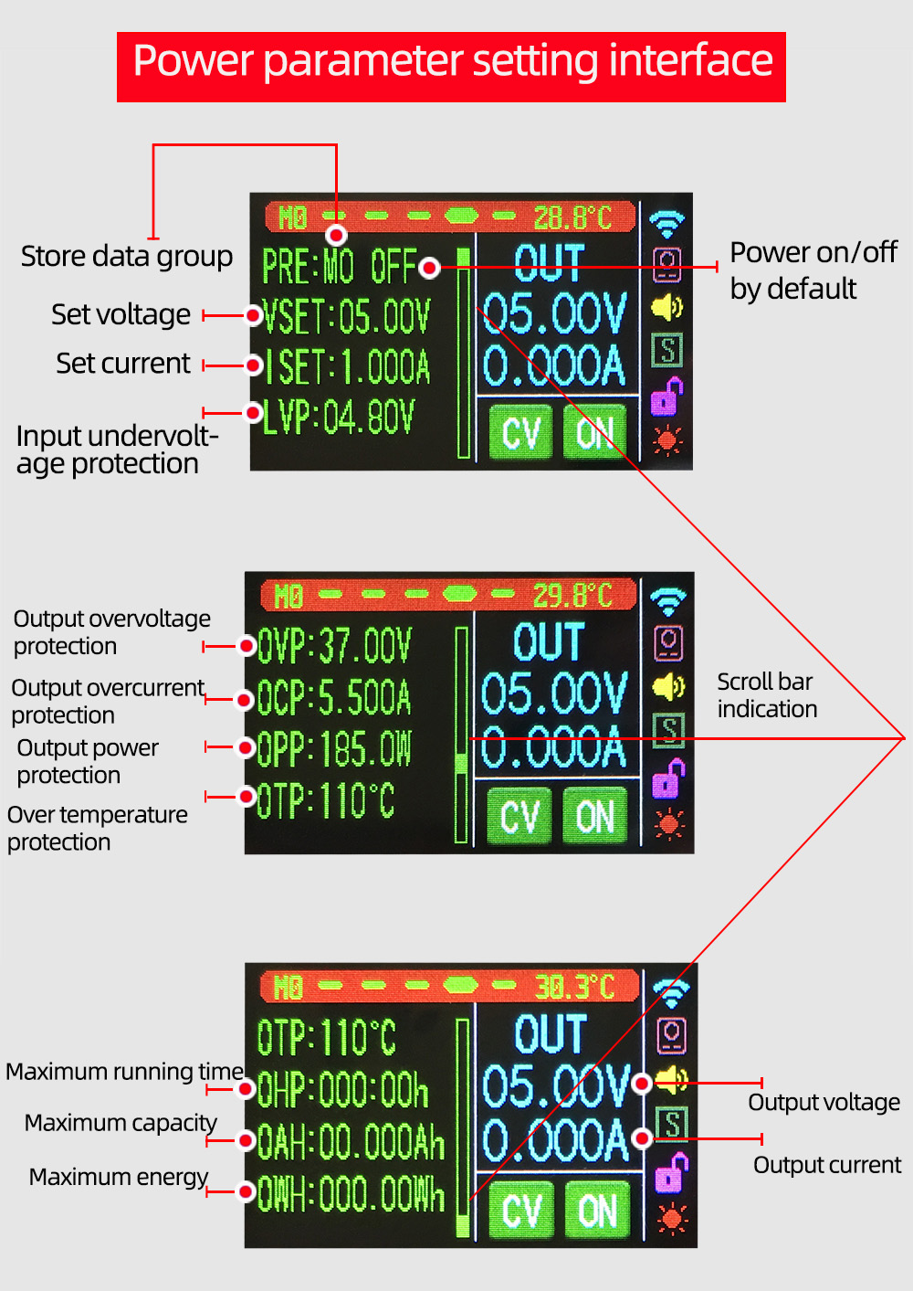
Short press the code potentiometer button to activate the parameter to be set;
Switch the parameter name and position selection by short pressing the key of the code potentiometer;
After selecting the parameter name, the parameter name will be displayed in reverse blue, and the parameter to be set can be switched by rotating the encoder potentiometer;
After the bit is selected, the corresponding bit will be displayed in reverse blue, and the parameters can be set through the rotary encoder;
After the setting is completed, long press the code potentiometer button for 2 seconds or no button operation for more than 6 seconds will automatically exit the setting;
All parameters are automatically saved after exit。
Data group function description：
You can save a total of 10 data groups M0-M9, and the default is saved to data group M0. Press and hold the code potentiometer button for 2 seconds on any interface to quickly call up the M1/M2 data group. The current data group serial number will be displayed at the interface index. ；
In the power supply parameter setting interface, after selecting the data group, rotate the encoder potentiometer to adjust the corresponding data group;
After the parameter modification in the data group is completed, the corresponding parameters will be stored in the current data group by default。
Note：The power output is turned off by default after switching the data group；
Set voltage U-SET: 0-36.00V;
Set current I-SET: 0-5.5A;
Input undervoltage protection LVP default: 4.0V, can be set by yourself;
Output overvoltage protection OVP default: 37V, can be set by yourself;
Output overcurrent protection OCP default: 5.6A, can be set by yourself;
Output over power protection OPP default: 205W, can be set by yourself;
Maximum operating time OHP: When the parameter is not set to 0, turn on this function, when it runs to the set time, the power supply will automatically turn off the output;
Maximum capacity OAH: When the parameter is not 0, turn on this function, and when the capacity reaches the set parameter, the power will automatically turn off the output;
Maximum energy OWH: When the parameter is not 0, turn on this function, when the energy reaches the set parameter, the power will automatically turn off the output;
OHP/OAH/OWH function, can well realize timing/quantitative power supply。
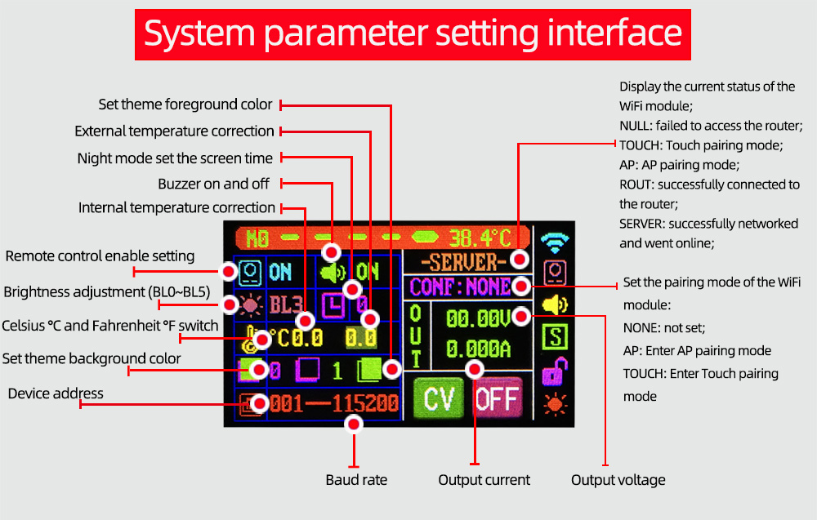
Short press the code potentiometer button to select/switch the parameter to be set. After selecting, the parameter will be reversed and set the parameter through the rotary encoder;
After the setting is completed, long press the code potentiometer button for 2 seconds or no button operation for more than 6 seconds will automatically exit the setting;
All parameters are automatically saved after exit。

