Hi-AT Technology CO.,LTD
This specification applies to all of the company's holding phase laser ranging and industrial control module.
Module assembly includes: host and LCD (industrial control module does not contain LCD).
1.Technical parameters
MODel | ^{HI50}
Measuring accuracy | +/-1mm
Typical accuracy（Non reflecting plate） | 0.02-50m
Measurement time | 0.3-2 s
Laser Class | Ⅱ
Votage | 2.0-3.0V (120mA-300mA)
Laser type | 635nm,<1mw
Item size | 45*25*12mmmm(without screen)
Weight | Approx 38g
use temperature | 0 C°～40 C°***
Storage temperature | -25 C°～60 C°
*Poor measurement conditions (such as ambient light is too strong, diffuse reflection coefficient is too large or too small), the measurement accuracy will have a greater error: + 3 mm+40PPM.
**In the case of strong sunlight or target reflection is not good, please use the reflection board.
it is back number,(F:38.XXXM) you only need to connect TX RX to your product,or will O D F programming to your Singlechip,adjust correct votage,
2、Communication and control
Communication interface: serial communication (TTL), 19.2K, baud rate parity bit: no parity, data bits: 8;
Function: send capital letters "O" to open the laser, capital letters "C" to close the laser, capital letters "D" (slow) or "F" (speed) for measuring distance,capital letters "S" to view the module temperature and power supply;
Connection mode: IT is Below (referring to the physical), the use of ordinary cables with the main board connection.

USB TO TTL VCC connect module DC,USB TO TTL TXconnect module RX,
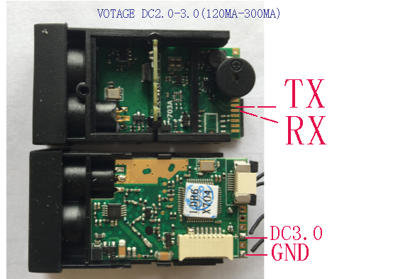

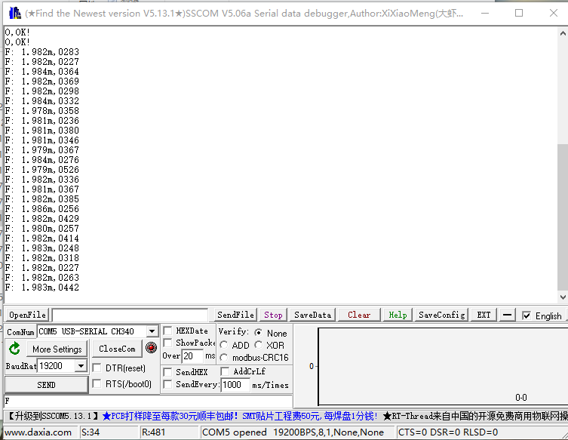
Nuber | command |  | function
 | ASCII code  (uppercase) | ASCIICode corresponding  Sixteen (HEX)
1 | O | 0x4F | Turn on the laser. After the laser opens, the module returns the string:",OK!"
2 | C | 0x43 | Turn off the laser, and the laser closes the module back to the string",OK!"
3 | S | 0x53 | Read the state of the module, and the module returns the status string:"18.0'C, 3.0V", Representing the current temperature and input voltage of the module, respectively
4 | D | 0x44 | The automatic measurement process is initiated, and the module returns a string containing measurement distance and measurement signal quality, such as："12.345m,0079"，The measurement distance is expressed as12.345M，Signal quality79。  NOTE：  1. If the measurement distance is less than 10 meters, then the 10 meter position is occupied by the space character to ensure that the distance of the returned string is unchanged2. The smaller the signal quality, the better the quality of the signal. The larger the value, the worse the reflected signal.3. Automatic measurement will automatically select different measuring speed under the premise of guaranteeing the accuracy of measurement according to the condition of reflector.4. When the ranging is not successful, the command will return the error report string "Er.XX!", where XX represents a different error number. Please check the error number list for the specific error number.
5 | M | 0x4D | Start the slow measurement process and return the string as the D command. This command has the slowest speed, but the highest accuracy.。
6 | F | 0x46 | Start the slow measurement process and return the string as the D command. This command has the fastest measurement speed, but the measurement accuracy is the lowest. In the case of poor reflector, the wrong measurement results may occur. Usually, this command is used to reflect good measurement conditions.
7 | V | 0x56 | Query module version information, return the string, such as: "170225002929456". Of these, 1702250029 is module serial number and 29456 is software version information.。
8 | X | 0x58 | Close the module, close the module and pull the PWR_ON pin low

