OSCA02/E/S/M/L/X/F/H USB Oscilloscope/Data logger
Device Family
August 26, 2020, Version 16.0 Data Sheet
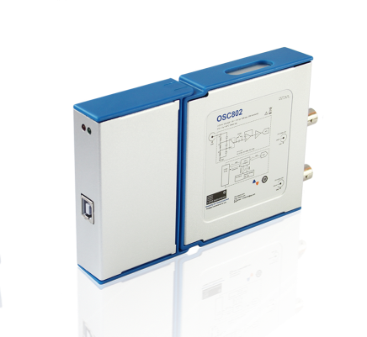
Features:
- Hand-held portable, 153(L) x 93(W) x 30(H) mm.
- 100M/200M Maximum sampling rate, 35M/60M bandwidth,2 channels.
- 8 Bit ~ 13 Bit vertical resolution.
- Open source hardware interface to support expansion modules.
- USB 2.0 interface, USB powered.Comes with PWM output.
- 72 hours long time data logger.
- Optional logic analyzer, signal generator, and isolated differential input support module.
- Waveform recording and playback review.
- Support waveform image import as the comparison reference for real-time waveform.
- Support Serial bus decoding (RS-232,RS-485/422, I²C, CAN,SPI).
- Supports a variety of current clamps and other physical volume custom probes.
- Support buffer waveform preview and mouse wheel operations.
- Historical change trend statistics and analysis functions.
- Pass / Fail detection.
- Optional Android Phone/ Tablet support.
- Support spectrum analysis and frequency response curve mapping.
- Support FIR Digital Filtering function.

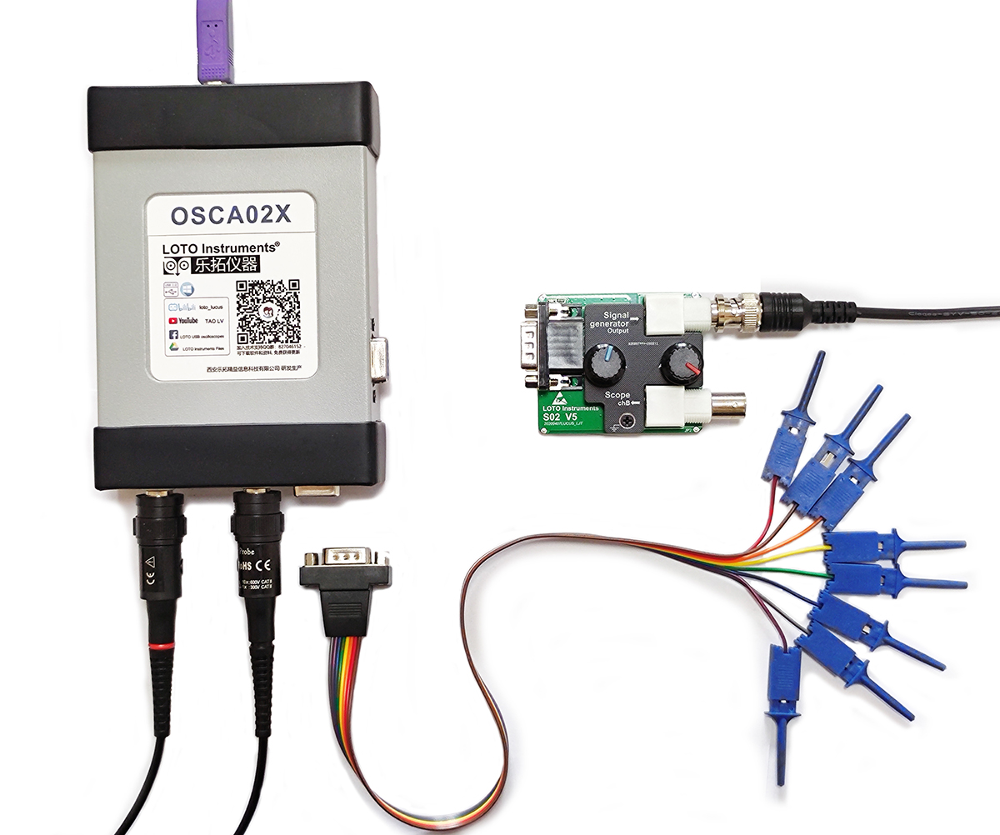
APPLICATIONS:

- General-purpose and precision testing.
- Embedded in industrial testing equipment for use.
- Embedded electronics courses for the educational market.
- Ripple and noise measurements for power supply characterization.
- Multi-sensor systems and Serial bus decoding.
- Car inspection and maintenance.
- Current/Voltage recording and analysis System for Solar Power Supply and Lighting System.
- Diagnosis device for field engineers.
- Basic equipment for DIY makers to develop their own modules.
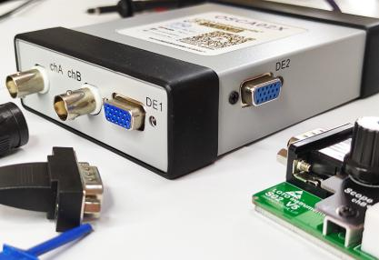
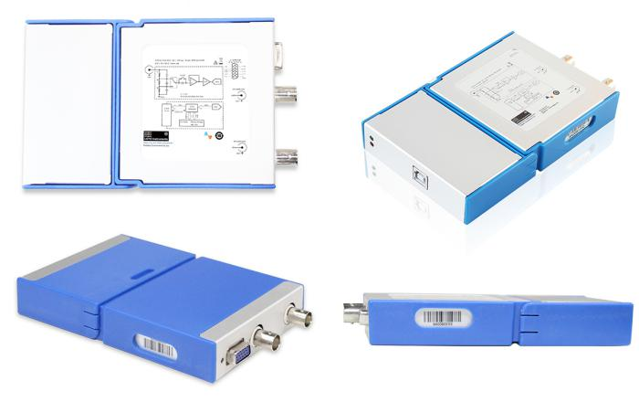
SPECIFICATIONS:
- Connector type : | 2 channels with BNC sockets, 20 mm spacing.
- Vertical resolution: | 8 Bit ~ 13 Bit .
- Maximum sampling rate (S/s): | 100M(OSCA02) /200M(OSCA02E)
- Bandwidth ( −3 dB): | 35M(OSCA02) /60M(OSCA02E)
- Input coupling: | AC/DC.
- Input characteristics: | 1MΩ || 25pF.
- PC OS requirements: | Windows XP, Win 7, Win 8.1, Win10 (32 bit and 64 bit).
- Overvoltage protection: | ±60.0v (x1), ±600.0v (x10). (DC + AC peak)
- Triggering type: | Rising/falling edge according to trigger level, Pulse width trigger.
- Triggering mode: | None, auto, normal, single.
- pre-trigger capture: | 1%~99% of capture size.
- Automatic measurements: | Maximum, minimum, average, RMS, frequency, period, positive pulse width, negative pulse width, duty cycle, rise time, peak-to-peak value.
- Measurement statistical curve: | The historical trend of the automatically measured quantities can be plotted for statistics and analysis.
- Frequency response mapping | Scanning the frequency, record the process frequency and magnification data, and draw the frequency response curve.
- Pass / Fail detection: | You can set the upper and lower limits of the measurement quantity, and perform Pass / Fail detection and fault alarm function on the measured signal.
- Deep measurement: | With this function, the waveform jump points are automatically numbered and marked, and the time difference between the two adjacent numbers is automatically displayed.
- Samples Interpolation: | Linear or sin(x)/x.
- FFT: | 1024 ~ 16K points.
- FFT window function: | Rectangle, Hanning, Hamming, Blackman.
- Math: | A+B, A-B, AxB, X-Y.
- Acquisition Modes: | Normal mode / High Resolution mode / Peak detect mode.
- Waveform recording  and playback: | File format : | *.oscxxx.
 | Record depth: | 50 ~ 450 frames.
 | File size: | 6 MB ~ 20GB.
- Save as file: | txt, csv, excel, oscxxx, jpg.
- Comparison reference | Support waveform image import and real-time waveform comparison reference. It can import waveform pictures, set gray level and transparency, move up and down, and zoom in and out horizontally and longitudinally.
- Data logger Sampling Interval: | 1 second to 1 hour.
- Data logger Record Duration: | 1 minute ~ 72 hours.
- Temperature range: | Operating: 0 °C to 40 °C (20 °C to 30 °C for stated accuracy). Storage: −20 °C to +60 °C.
- Reference Output: | 1K Hz, 1.5 V square wave output with 50% duty cycle. Software-configurable PWM output with adjustable frequency and duty cycle.
- Size: | 153(L) x 93(W) x 30(H) mm.
- Languages (full support): | English, Chinese (simplified).
- Compliance: | CE, FCC.
- Net weight: |  | 210 g.
- Input sensitivity (10 vertical divisions): |  | 20 mV/div to 2 V/div.
- Input ranges( probe x1): |  | ±100 mV to ±5 V full scale, in 7 ranges.
- Timebase selection (10 horizontal divisions): |  | 5 ns/div ~ 60 s/div, in 32 ranges.
- Typical noise (peak to peak voltage): | 20 mV/div | 2 mV
 | 50 mV/div | 5.8 mV
 | 100 mV/div | 8 mV
 | 200 mV/div | 22 mV
 | 500 mV/div | 38.8 mV
 | 1 V/div | 88.2 mV
- Memory depth  (byte /Ch): |  | 64K | ≤50 ms/div
 |  | 258K | 200 ms/div
 |  | 645K | 500 ms/div
 |  | 2M | 1 s/div
 |  | 8M | 2 s/div
 |  | 10M | 10 s/div
 |  | 20M | 20 s/div
 |  | 30M | 30 s/div
 |  | 40M | 40 s/div
 |  | 50M | 50 s/div
 |  | 60M | 60 s/div
- Trigger type: |  | Hardware
- Trigger source: |  | Channel A
- Power consumption: |  | 5 v || (248~279) mA
- Protocols decoding: |  | UART/RS-232/485/422, I²C,CAN,SPI
- FIR Filtering: |  | Band-pass, Band-stop
- Custom probes |  | Support two-point calibration of any current clamp on the market.

AT A GLANCE:
Model: | OSCA02 | OSCA02E | OSCA02M | OSCA02S | OSCA02L | OSCA02X | OSCA02F | OSCA02H
Detail: | Support Windows . | Support Windows | Support Windows + Android | OSCA02 + Signal generator. | OSCA02 + Logic analyzer. | OSCA02 +Signal generator + Logic analyzer. | OSCA02 X+ Android | OSCA02F+ Isolated differential input model.
Input channels: | 2 | 2 | 2 | 2 | 2 | 2 | 2 | 2
Maximum sampling rate (S/s): | 100M | 200M | 100M | 100M | 100M | 100M | 100M | 100M
Bandwidth (−3 dB): | 35M Hz | 60M Hz | 35M Hz | 35M Hz | 35M Hz | 35M Hz | 35M Hz | 35M Hz
FFT:
Data logger:
I/O extension:
Serial bus decoding:
Hardware trigger:
Pulse width triggersupport:
Signal generator module support:
Logic analyzer module :
Android Phone/ Tablet support
Isolated differential input model | Optional | Optional | Optional | Optional | Optional | Optional | Optional
Custom probes
Frequency response mapping
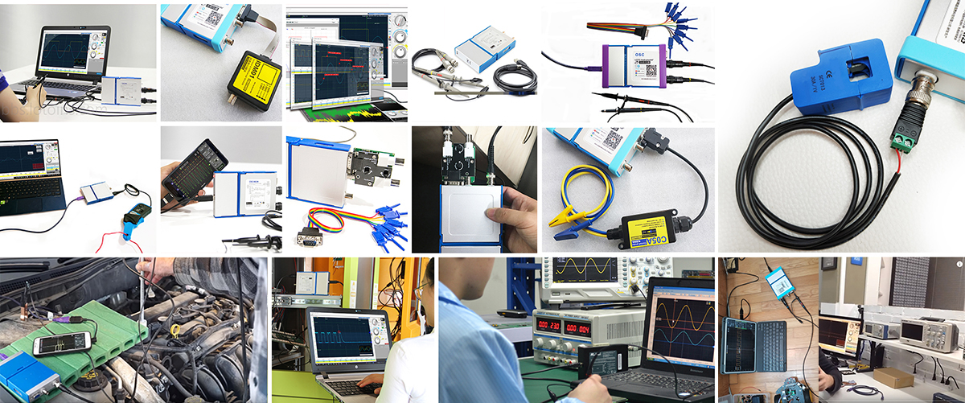
Expansion modules & Accessories:
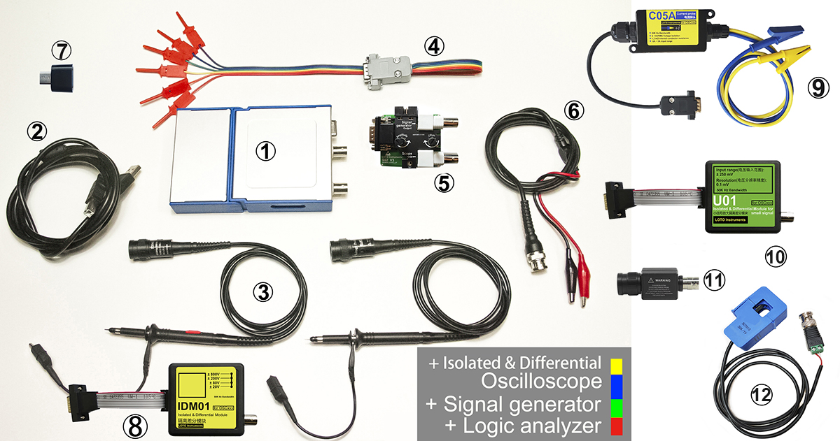
Model | Android phone support | Signal generator module | Logic analyzer module | Isolated differential input model | Bill of materials
OSCA02/E |  |  |  | Optional | ++
OSCA02M |  |  |  | Optional | +++
OSCA02L |  |  |  | Optional | +++
OSCA02X |  |  |  | Optional | +++++
OSCA02S |  |  |  | Optional | ++++
OSCA02F |  |  |  | Optional | ++++++
OSCA02H |  |  |  |  | +++++++

 | type | quantity | model | details
 | Oscilloscope host device | 1 | OSCA02/E | /
 | USB cable | 1 | U2100 | USB2.0 compliant, length: 1m (or whatever length it is), USB Type A Male to USB Type B Male
 | Passive voltage probe,  60 MHz x1/x10 | 2 | P2060 | 10x: 60M Hz,10MΩ,600 V CAT II
 |  |  |  | 1x: 6M Hz,1MΩ,300 V CAT II
 | Logic analyzer module | 1 | L06/L02 | 6/4 channels, TTL level, consistent with the performance of the host device.
 | Signal generator module | 1 | S02 | 1 channel, Sine wave, Triangle wave, Square wave.1 Hz ~ 13M Hz (Sine wave) output frequency range. 48M sampling rate.
 | Signal output cable | 1 | SO13 | /
 | Adapters for Android phone | 1 | A2C0 | When the customer selects a model that supports the Android mobile app, the adapter will be installed as an accessory on the support phone jack.
 | Isolated differential input module | 1 | IDM01 | Single channel, electrically isolated and differential input, can measure ± 20V to ± 800V high voltage, can be connected to the ground or reverse input. Bandwidth 50K Hz.
 | Current Probe | 1 | C05A/  C20A/  C30A | Current probe with 1.2 mΩ internal resistance and 1.2 KV isolation voltage protection. The range is ± 5A / ± 20A / ± 30A. Can be used with any LOTO oscilloscope host.
 | Small signal amplification module | 1 | U01 | Input range ± 250mV, isolated differential input, resolution 0.1mV, 50K Hz bandwidth.
 | 20:1 Attenuator | 1 | AN20 | 20: 1 attenuator. The external voltage signal can be attenuated by 20 times and input into the oscilloscope, effectively expanding the scope of the oscilloscope.
 | Current transformer module | 1 | AC05A/  AC20A/  AC30A/  AC50A/  AC100A | Current transformer module, open and close test, no need to access the circuit. Measuring frequency range 50Hz ~ 150K Hz. The model indicates the measurement range, such as AC100A, which means the range is 100A.
andare standard accessories, is either standard or optional, depending on the host you purchased. The host OSCA02L you purchased supports the feature of the module and provide it as standard.
,,,, are optional accessories, if necessary, you can contact your provider to buy them.
Users can also choose the carrying case to store the oscilloscope main unit and wiring and some modules, as shown below:
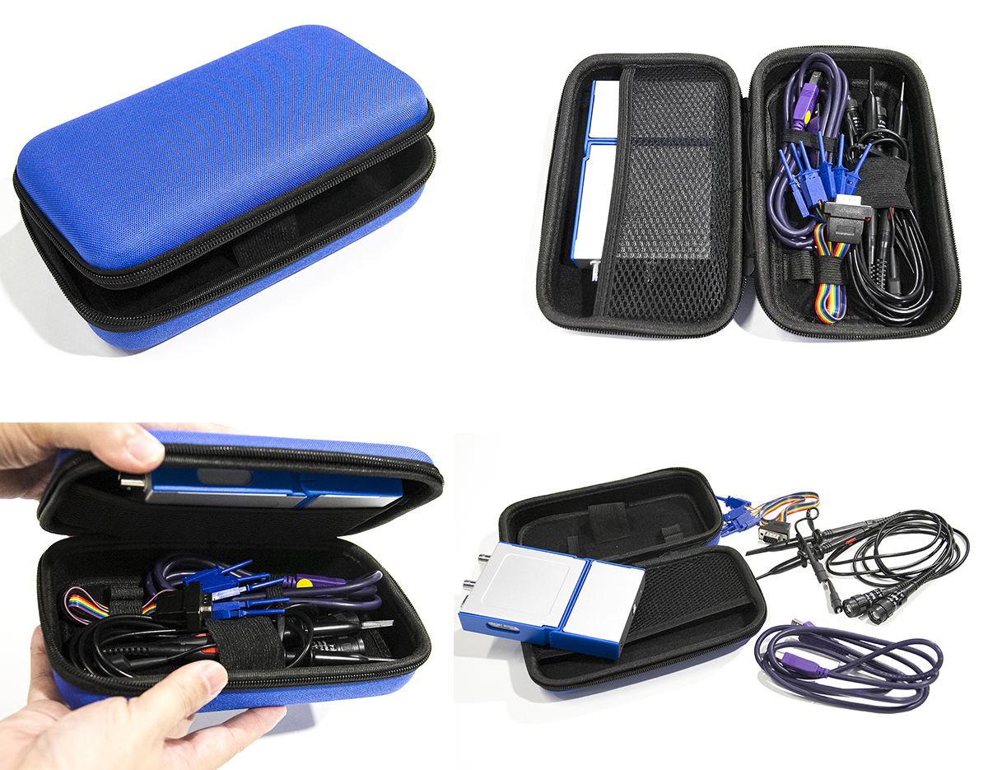
Or choose a box suitable for the user to display the scene, as shown below:
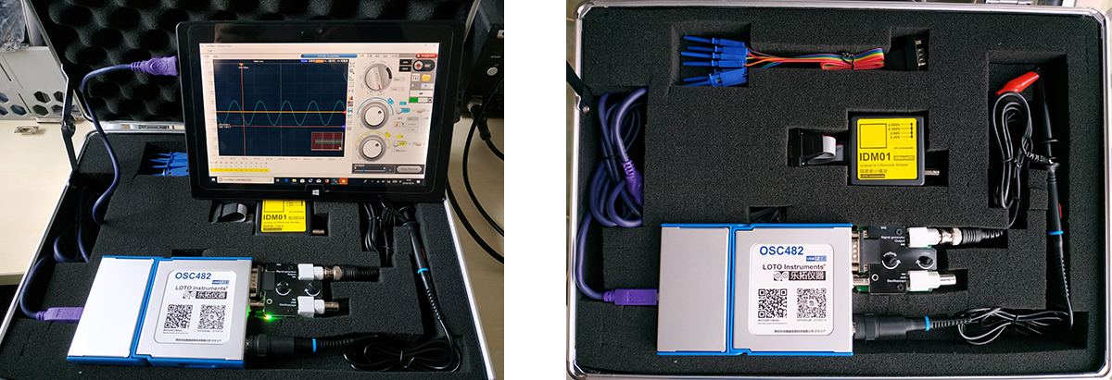
Logic Analyzer Module L06/L02:

If the module is purchased later, the host needs to be added back to the factory.
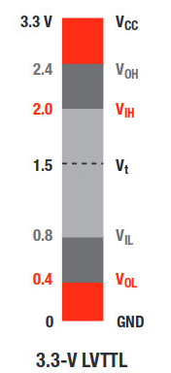
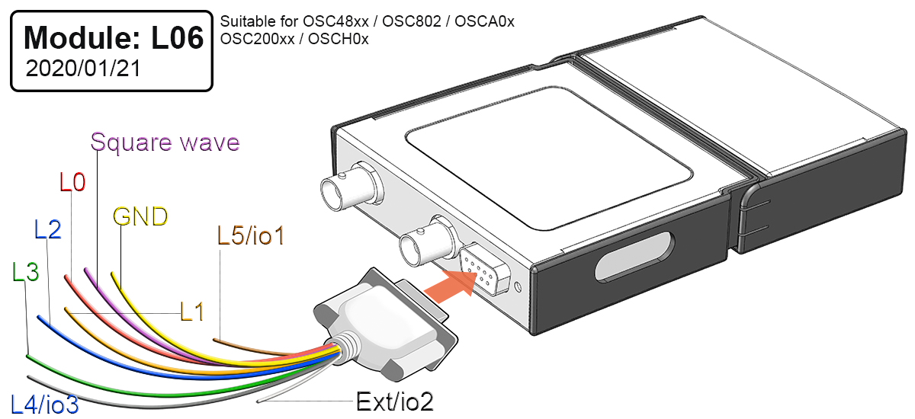

The input voltage between 2V and 3.3V is considered to be high and the input voltage between 0.8V and 0V is considered to be low for the four channels input L0~L3 of the logic analyzer shown above.
.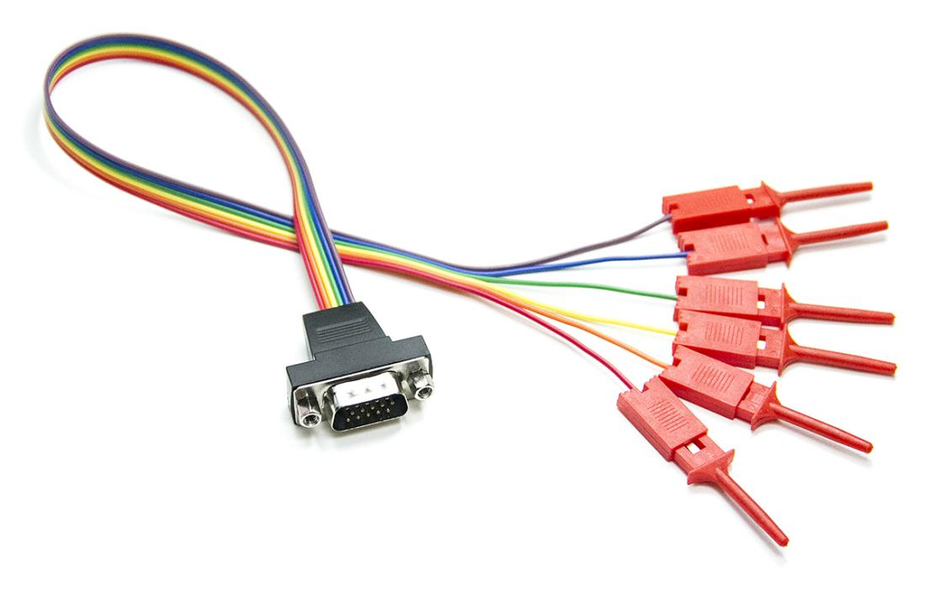
Isolated differential module IDM01:
This module can be purchased later and added by itself. It can be used with LOTO OSC482 series, OSC802, OSCA02 series, OSC2002 series, OSC980, OSCH02 to realize voltage measurement in high voltage or none-zero grounding circuit.
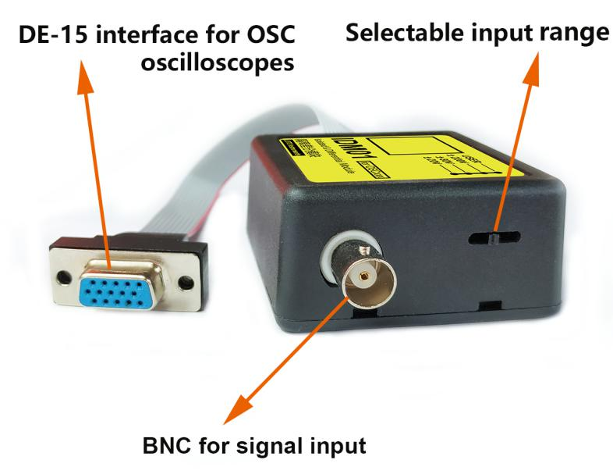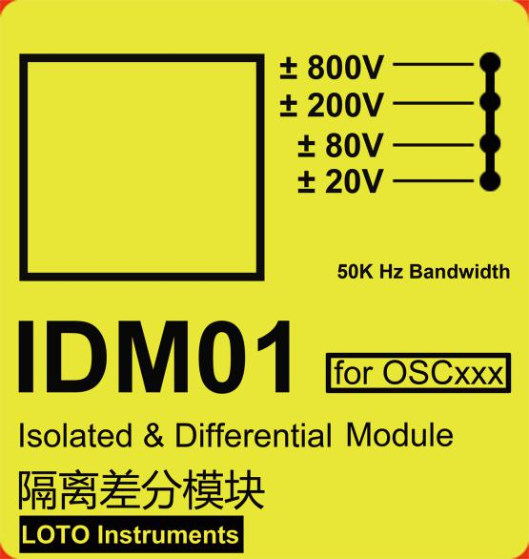

items | Isolated differential module
channel | 1（chB with OSCxxx Oscilloscope）
Input characteristics: | 1MΩ
Maximum working insulation voltage | 1200V
Bandwidth | 50K Hz
Input range(4 grades) | 20V | Input range -20V~+20V
 | 80V | Input range -80V~+80V
 | 200V | Input range -200V~+200V
 | 800V | Input range -800V~+800V
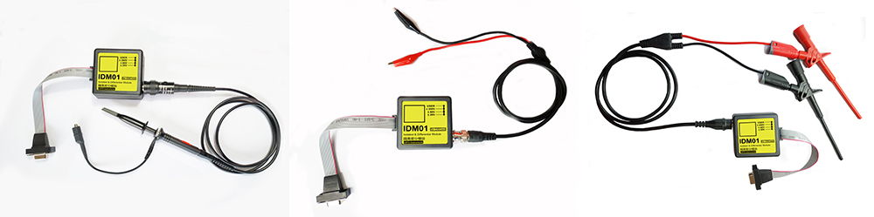

CxxA current probes:
The current probe is connected to the oscilloscope through the extended DE-15 interface of the LOTO oscilloscope, which can be used with any LOTO oscilloscope host, and can be used later. The oscilloscope software has corresponding settings to directly support this series of current probes.
Internal resistance |  | 1.2 mΩ
Isolation protection |  | 1.2 KV
Bandwidth |  | 50K Hz
Input range | C05A | ±5A
 | C20A | ±20A
 | C30A | ±30A
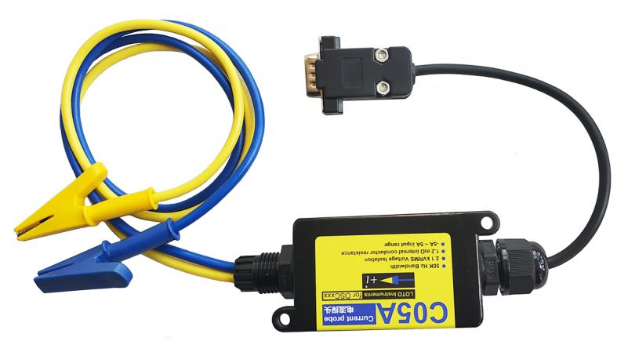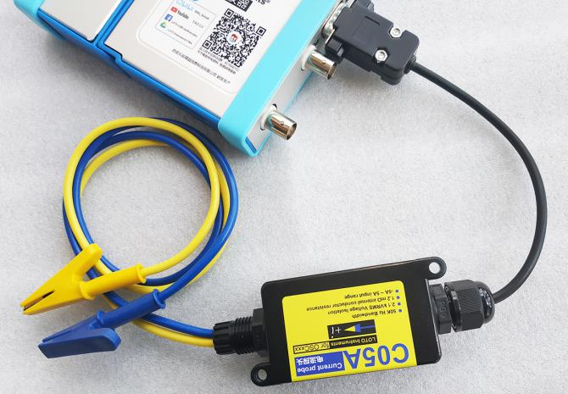

DIY expansion board components:
Users can make their own through open source materials or buy the components from vendors.
Use this DIY component to easily expand the parallel connection of positive and negative power supplies, IO ports, analog input and other functional modules.
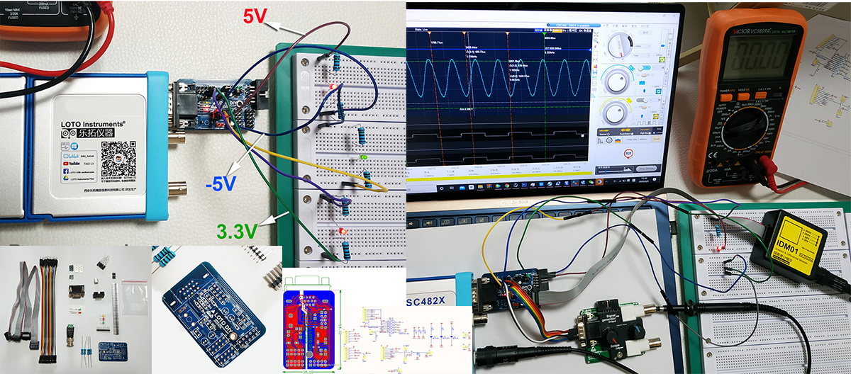
EMC electromagnetic interference detection module:
This model can be used with the module E01 to use the FFT function of the oscilloscope to perform spectrum analysis of EMC electromagnetic interference, so as to perform near-field testing of EMC interference on the PCB.
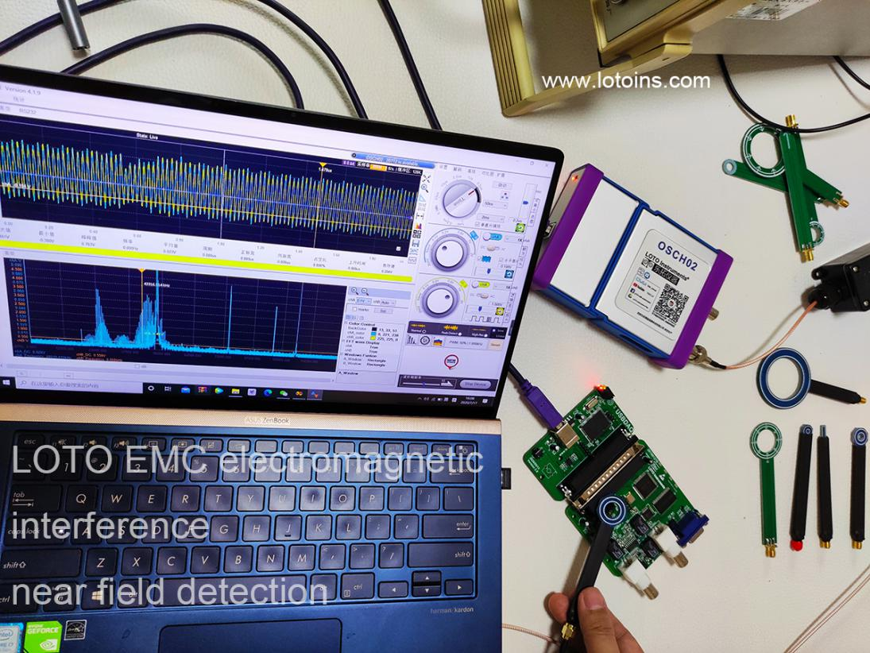
Custom probe:
Pure software features, no additional purchase required. The most typical applications are current clamps. The software interface provides two sets of data calibration functions for custom probes. It allows users to purchase other physical probes of any BNC interface, such as current clamps. After the software is set, it displays the curves and data of the corresponding physical quantities.
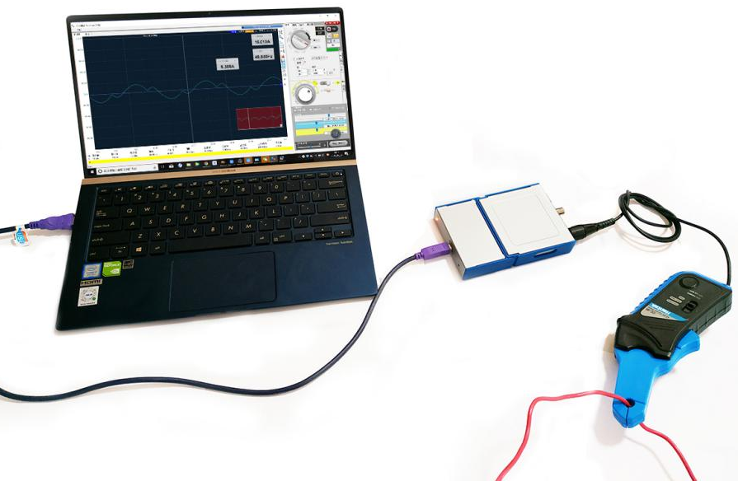
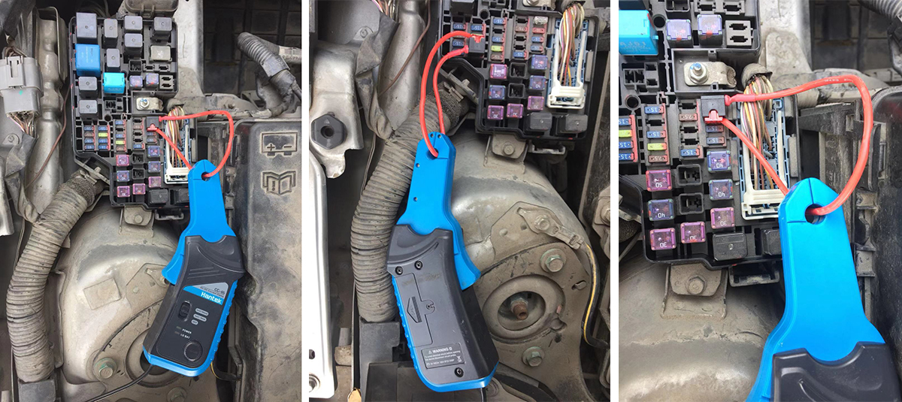

INTERFACES:

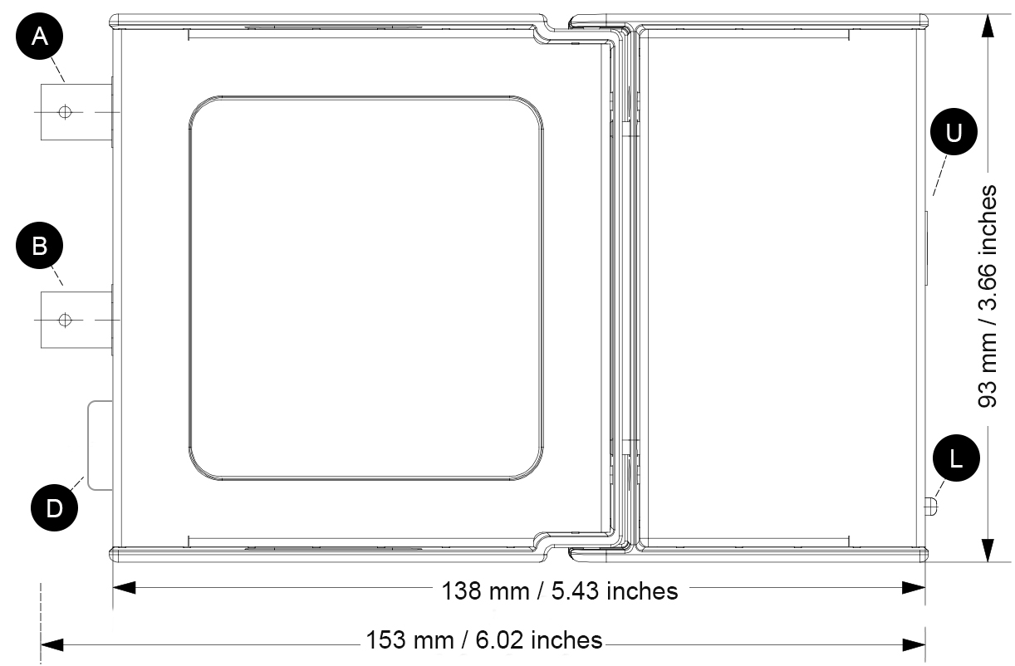

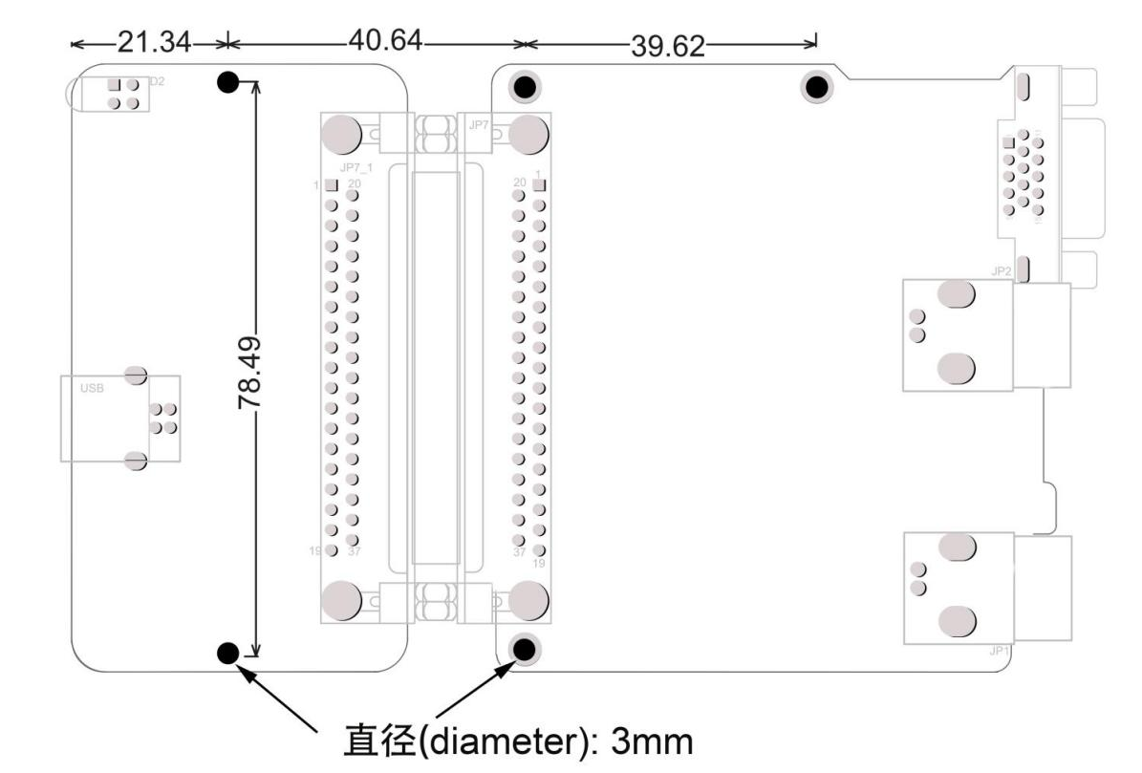

 | Description:
A | Input channel A.
B | Input channel B.
L | Power LED (red), Status LED (green).
U | USB 2.0 interface, Type B female.
D | DE-15 interface for expansion modules.
 | 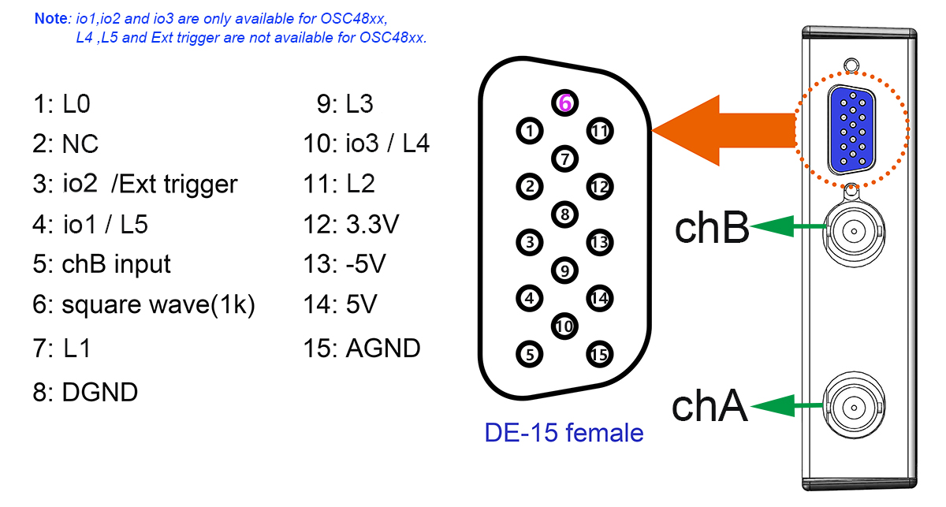
Windows Software
For the function of the PC software, please refer to the corresponding software manual, which will be described in detail. The following screen shots briefly show some of the features: Serial port decoding, X_Y drawing, carrier analysis, multi-purpose automatic measurement, logic analyzer, printing, FFT spectrum analysis, paperless recorder.
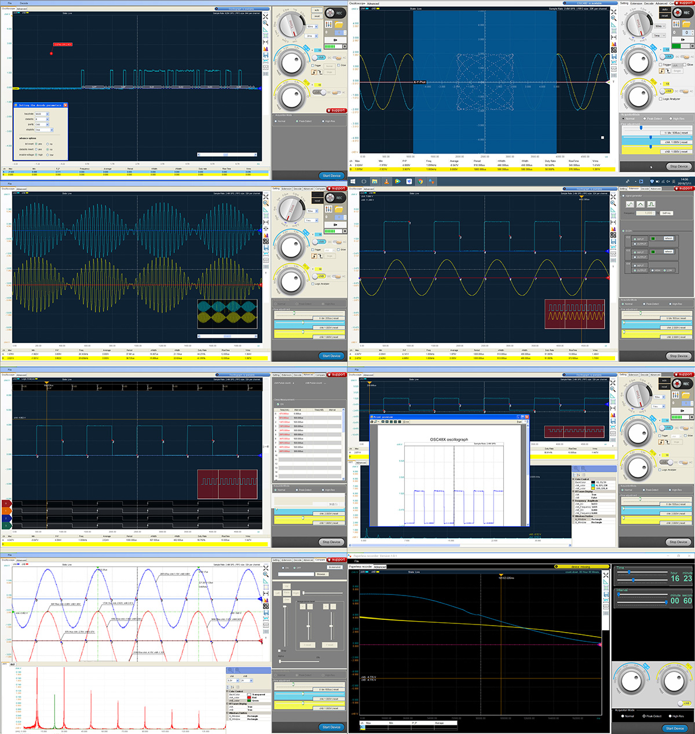
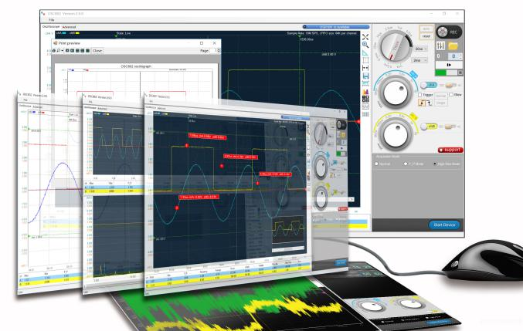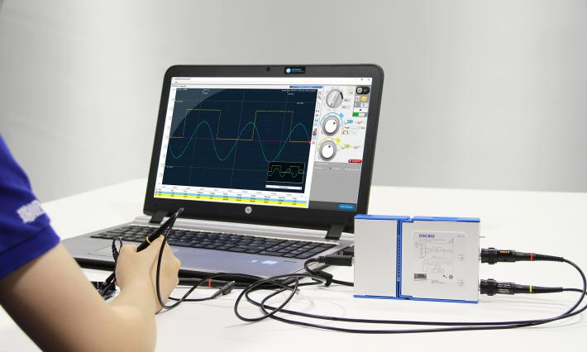
About the serial decoding function:
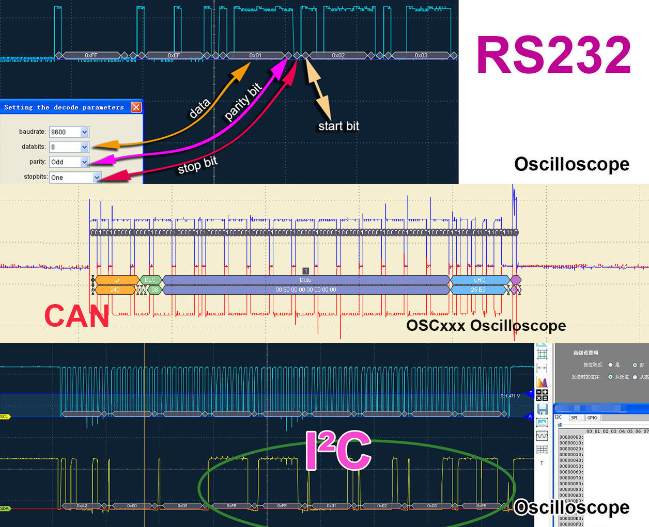

About 8~13 digits vertical resolution:
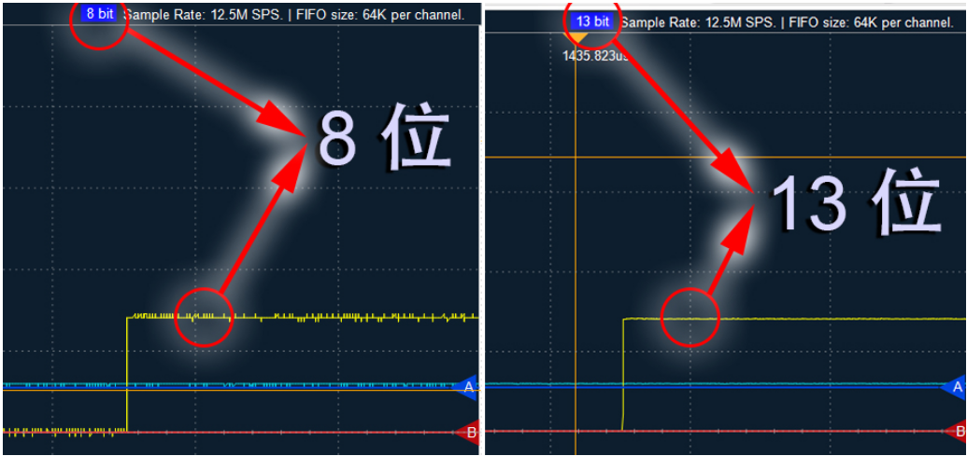

App for Android phone(OSCA02M/F/H)：
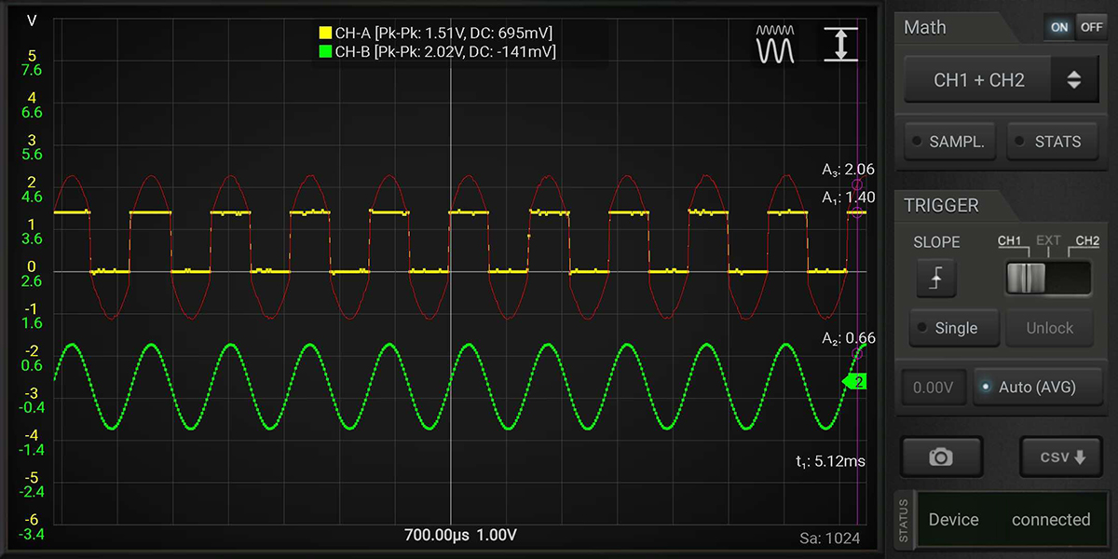
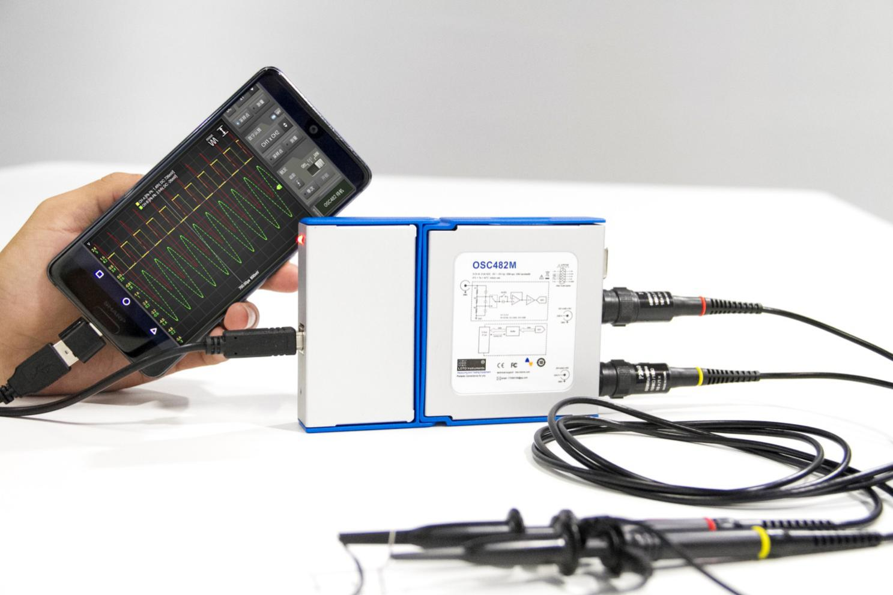
Note：
Although most Android phones/tablets are supported, it cannot be ruled out that individual models cannot be turned on due to the inability to enable OTG. We will maintain a list of tested phones and ask the supplier for the list before purchase.

