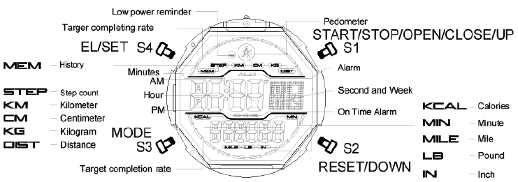
S1：Start, pause, open, close, increase, check
S2: write down, reset, check
S3: Mode conversion, switching selection, confirmation and saving
S4: EL backlight, setting

Functions
1. 12-digit display, normal time display screen: hour, minute, second, step count, percentage of target step;
In normal time display mode, press S1 to view the date;
With perpetual calendar function, year range: 2000 to 2099.
2. 12/24 hour setting options.
3. Step counting function:
1) Personal parameter input settings;
2) Manually turn on or off the step counting, in the step counting mode, there is the function of step counting sleep power saving and step counting data clearing;
3) Real-time query of accumulated step data for the day: steps, calories, exercise mileage, exercise time;
4) Historical step data storage and query function, can store 31 days of step data and query historical step data every day:
Steps, calories, exercise mileage, exercise time.
4. Alarm function: It can set the alarm, punctual time, snooze function.
5. Running seconds timing function: the maximum running seconds timing is 23 hours 59 minutes 59 seconds, the first 30 minutes is accurate to 1/100 second.
6. The second time function: the second country city time can be set.
7. Countdown function: The maximum countdown time is 24 hours.
8. Low voltage detection function: When the battery voltage is lower than 2.4V, a low voltage prompt icon appears.
Nine. EL light, press the light, and delay 3 seconds.
10. There is a full display test function.

Functions Switch
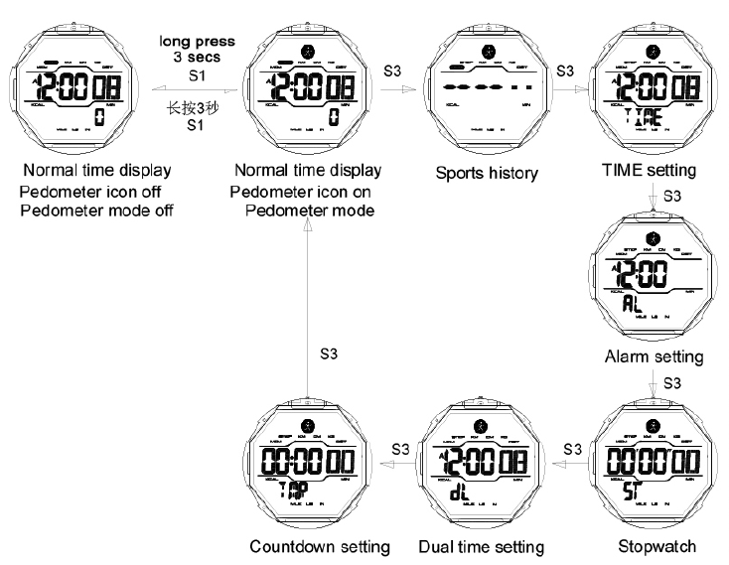
Remarks:
Without button operation, it will automatically return to the normal time display screen after 30 seconds (except for the running seconds setting mode).

2) Manually turn on or off pedometer, in pedometer mode, there is pedometer sleep power saving and reset function.

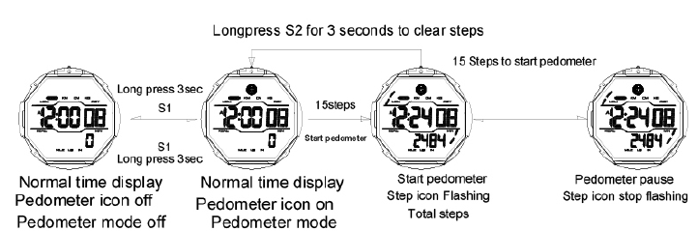

Remarks:
1. In the normal time display screen, press and hold the S1 button for 3 seconds to turn on or off the step counting function; when the step counting is on, the step counting is triggered for 15 consecutive steps, and the number of steps is included in the total number of steps; less than 15 consecutive steps Step counting will not be triggered, and the number of steps will not be counted in the total number of steps; during the step counting process, if there is no continuous action or motionless, it will enter the step counting sleep power saving state.
2. In the normal time display screen step counting mode, press and hold the S2 button for 2 seconds to clear all real-time step counting data in the current mode
(Steps, calories, kilometers walked, walking time and percentage completion rate icons for target steps). If the data is not cleared, the next step count will be accumulated on the current data.
3. The pedometer data of the day will be automatically saved and cleared automatically at 00:00 00 the next day.
4. When the completion rate of the target step percentage reaches 100%, ten grids (two columns) are displayed. At this time, the ten grids flicker and an alarm of "Bi, Bi, Bi" is emitted for 20 seconds. During the alarm and flashing, press the S1 button once to stop the alarm and stop flashing.
5. In abnormal walking state, you can manually turn off the pedometer function, cut off the power of the pedometer sensor, in order to save power and energy, and extend the battery life; when you count steps, manually turn on the pedometer function, the step data will be in the original Accumulate on step count data.

3) Real-time query of the accumulated step data of the day: steps, calories, exercise mileage, exercise time.

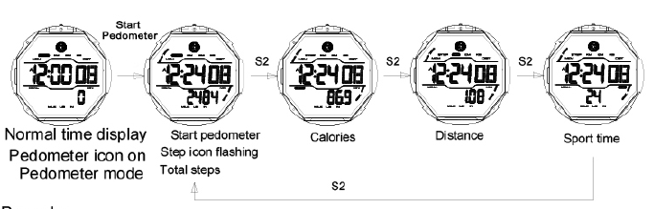

Remarks:
In the normal time display screen step counting mode, the accumulated step data of the day is displayed. Press the S2 key to query the accumulated steps, calories, kilometers walked, walking time and percentage completion rate of target steps in real time.

Time/Date/Hour setting

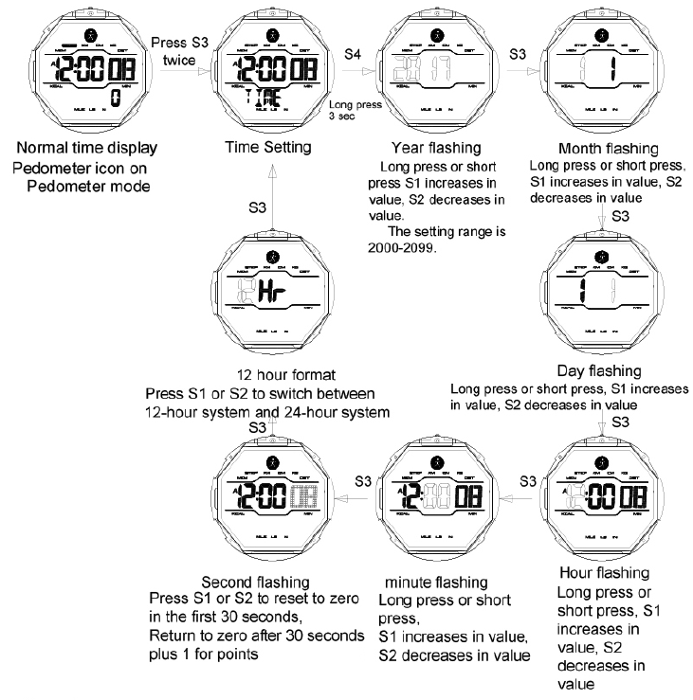

Remarks:
1. When the seconds are flashing, press the S1 or S2 button, the first 30 seconds to reset "00" and 30 seconds to reset "00" points plus one.
2. After the setting is completed, press the S3 key to save and return to the time setting mode screen, and then press the S3 key to enter the next mode.
3. No button operation, automatically save after 30 seconds and return to the normal time display screen.

Stopwatch setting

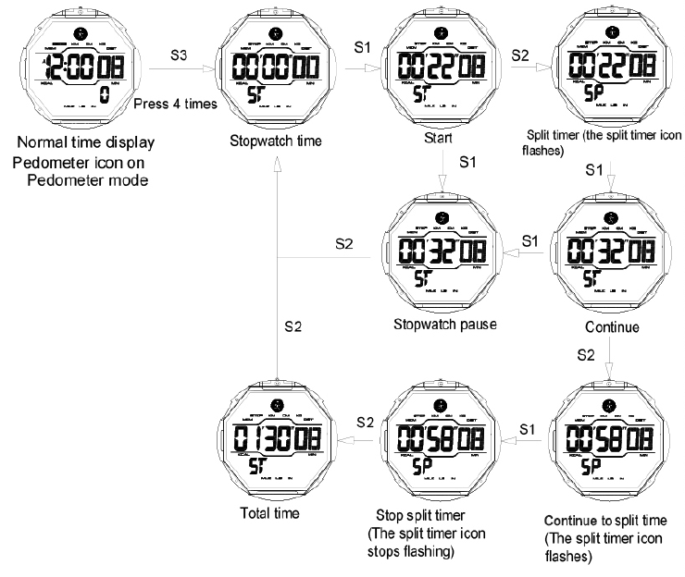

Remarks:
1. Split (segment timing) is a continuous cumulative record.
2. The maximum running time is 23 hours 59 minutes 59.99 seconds,
It is accurate to 1/100 second in the first half an hour, and 1/60 second in the second half hour.
3. When the running second timer reaches the maximum number, it will automatically restart the running second timer from zero.
4. If 不returns to zero, the running seconds will continue even if you switch to another mode.
5. After the operation is completed, press the S3 key to enter the next mode.

Countdown setting

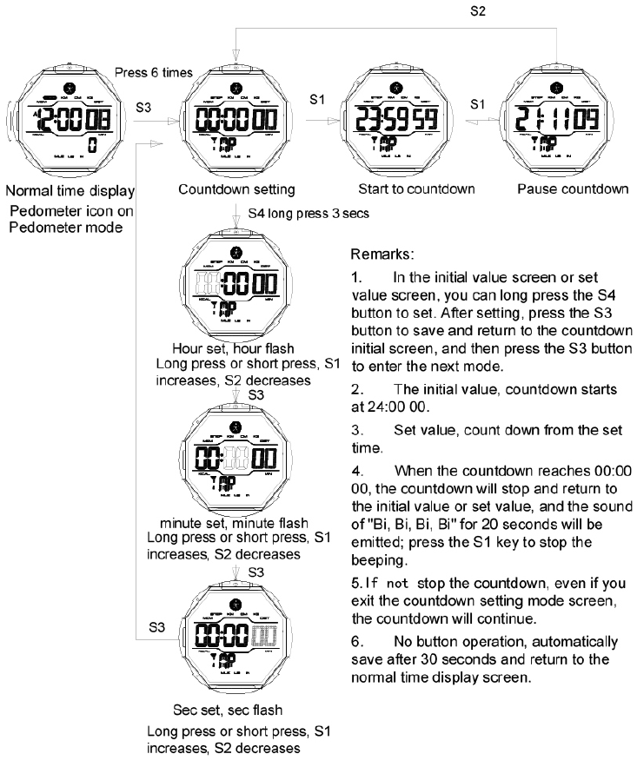

EL Backlight

In any mode, press the S4 to light up for 3 seconds
Low power reminder

When the battery voltage is less than 2.4V, the low voltage detection prompt icon is displayed.

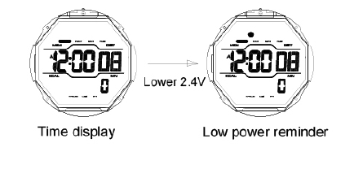
Month, day, week view screen
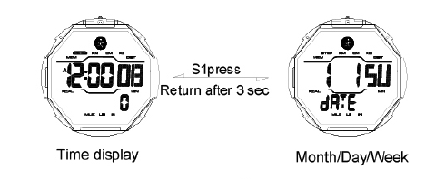

Pedometer setting

- Personal parameter input setting operation icon: (to ensure the accuracy of step counting data, must be set)

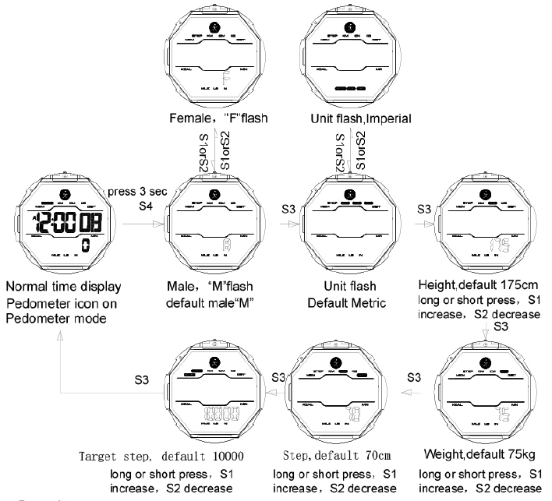

Remarks:
1. In the normal time display screen pedometer mode, the pedometer can be set on or off.
2. Each time you press the S3 key, confirm and save the last operation.
3. The default unit is metric.
4. Height setting range: 90cm-250m for metric system, 35in-99in for imperial system.
5. Weight setting range: 20kg-200kg for metric system, 44Lb-441Lb for imperial system.
6. Step distance setting range: 20cm-120cm for metric system, 8in-47in for imperial system.
7. Setting range of target steps: 1000-100000, set in units of 1000.
8. Without key operation, it will automatically return to the normal time display screen after 30 seconds.

History check

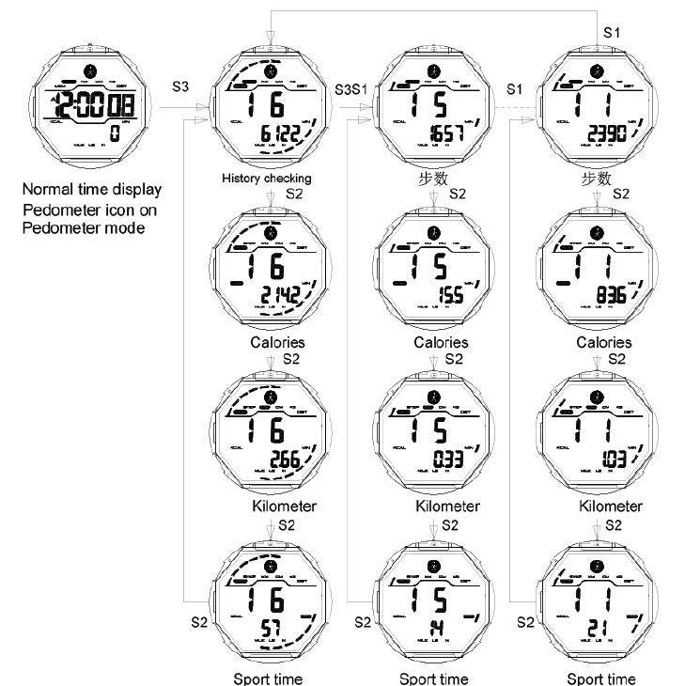

Remarks:
1. The current screen displays the step count data of the previous day and the percentage completion rate of the target step count. It can store 31 days of data, sorted from the day before to the previous 31 days. If the stored records are full, the oldest record will be automatically overwritten.
2. Press the S1 key to query the historical date, press the S2 key to query the step count data of the current query date: steps, calories,
Kilometers walked, walking time and percentage completion rate of target steps.
3. In the current screen, press and hold the S2 button for 2 seconds to clear all historical step data.
4. Without key operation, it will automatically return to the normal time display screen after 30 seconds.

Alarm setting
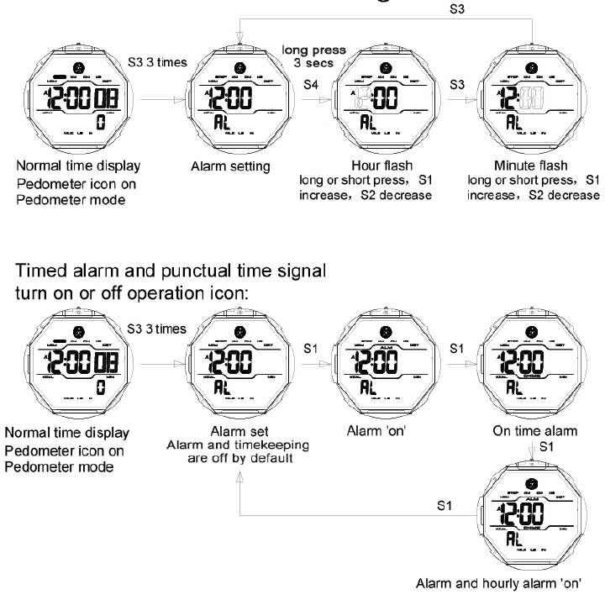
Snooze reminder setting instructions:
During the alarm process, press the S3 button to interrupt the alarm and turn on the snooze reminder function. After 5 minutes, it will automatically sound again. Can snooze operation three times.

Remarks:
1. After the setting is completed, press the S3 button to return to the alarm setting mode screen, and then press the S3 button to enter the next mode.
2. When the preset alarm time is reached, "Bi, Bi" will sound for 20 seconds. Press S1 or S2 to stop the alarm.
3. In the on-hour mode, a long "Bi" will be heard on the hour.
4. No button operation, automatically save after 30 seconds and return to the normal time display screen.

Dual time setting
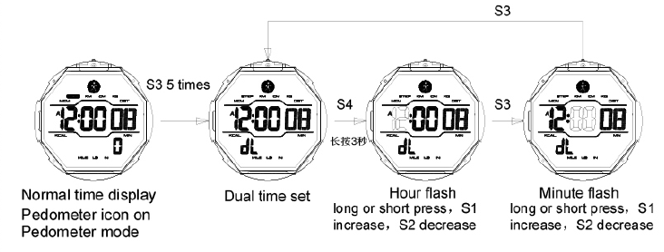

Remarks:
1. The second time seconds are synchronized with the first time seconds.
2. After the setting is completed, press the S3 key to save and return to the second time setting screen, and then press the S3 key to enter the next mode.
3. No button operation, automatically save after 30 seconds and return to the normal time display screen.

