Mini FPV Goggles
User's manual

Double Antennas
Built-in 3.7V 1200mAh Battery
Support a key search frequency
RaceBand 40 channel Auto-Searching
Real-time video return 5.8G FPV Receiver

Thank you for your choose and buy the products of this company.
Feature:
● Small size and light weight;
● Low power consumption, Working current 360~400mA;
● Double antenna reception to make the signal more stable;
● RaceBand 40 channel, Auto-Searching;
● 3.0 Inch 480*320 dot high brightness LCD screen;
● Built-in super sensitiveness 5.8GHz 40ch receiver, especially with RaceBand;
● Built-in 3.7V/1200mAh high-capacity Li-ion polymer Battery;
● Universal USB charging interface;
● Real-time video return, Very low time-delay;
● Bilingual menu in support of Chinese and English;
● Support external video signal input;
● Support AV signal output (Connect external DVR);
Specification:
Model
Name | Mini FPV Goggles
LCD Screen | Screen size: 3.0 Inch
 | Resolution: 480*320
 | Display Ratio: 16:9
 | View Angle: 6 o'clock
 | Brightness: 350cd/m² with high brightness backlight LED
Video delay | Video time-delay less than 20ms
Lens | 4X Fresnel Lens, 92% transparent rate no distort of light
Interface | Antenna | 2 X RP-SMA male
 | USB | To charge the battery
 | AV Jack | External video signals input or internals AV signal output
Languages | English and Chinese
Power Supply | Power adapter: DC5V/1A (USB interface)
Battery:
3.7V/1200mAh,Each full charge revive around 2.5hr working time
Power Consumption:
*The device operating current of 360~400mA at 3.7~4.2V;
*Built-in battery maximum charge current of 500mA;
Wireless | Frequency Table(MHz)
 |  | CH1 | CH2 | CH3 | CH4 | CH5 | CH6 | CH7 | CH8
 | Band A | 5865 | 5845 | 5825 | 5805 | 5785 | 5765 | 5745 | 5725
 | Band B | 5733 | 5752 | 5771 | 5790 | 5809 | 5828 | 5847 | 5866
 | Band E | 5705 | 5685 | 5665 | 5645 | 5885 | 5905 | 5925 | 5945
 | Band F | 5740 | 5760 | 5780 | 5800 | 5820 | 5840 | 5860 | 5880
 | Band R | 5658 | 5695 | 5732 | 5769 | 5806 | 5843 | 5880 | 5917
Body | Dimension: 13.5cm * 13.2cm * 6.5cm
 | Weight: 180g(with headband, not included antennas)
Controls Diagram:
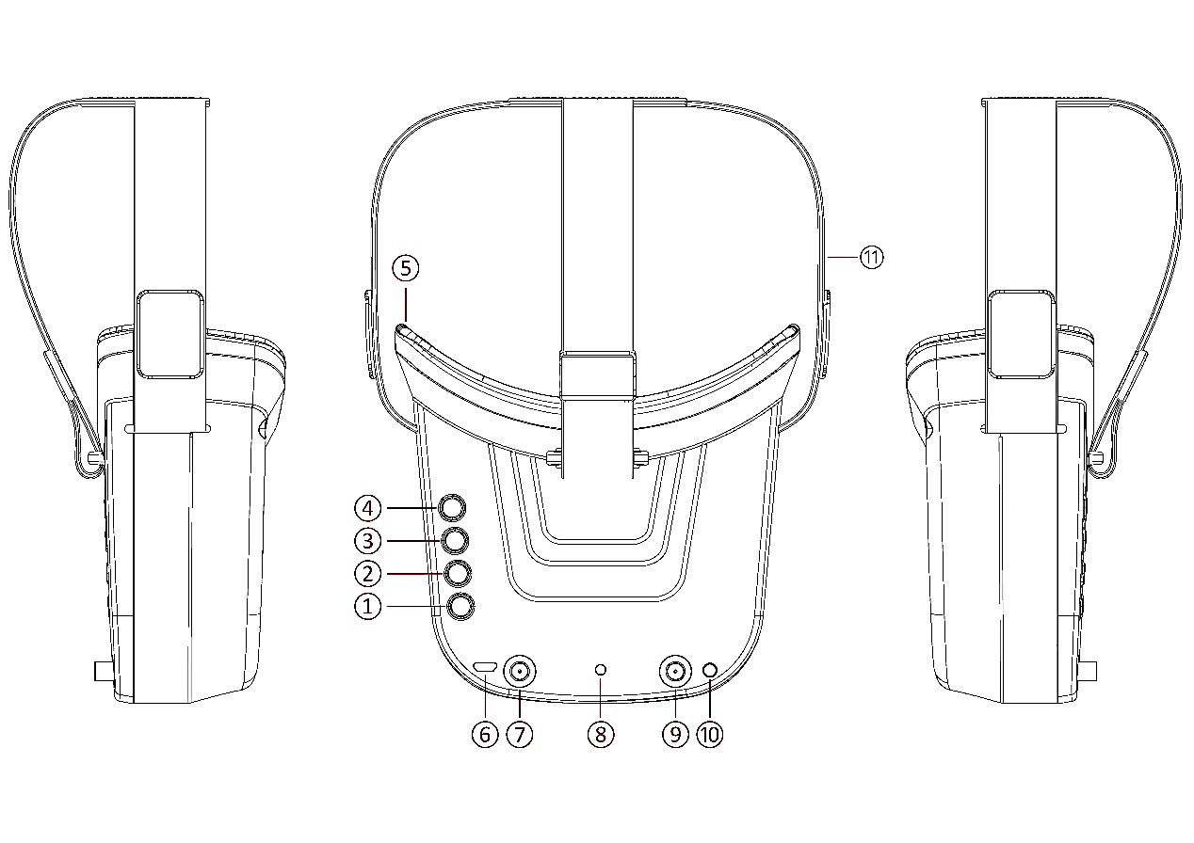
Description:
① Key 1: Short press for MENU mode; Long press (More than 3 sec) for Power ON/OFF.
② Key 2: Short press for Auto-Searching (Automatic selection of the strongest channel).
③ Key 3: Short press for Band+ (Change bands A-B-E-F-R circularly).
④ Key 4: Short press for Channel+ (Change channels 1-2-3-4-5-6-7-8 circularly).
⑤ Eye ring: protect the surrounding parts of the eyes, so that the wear more comfortable.
⑥ Micro-USB Charging port: Supports DC5V only.
⑦ Antenna port A: RP-SMA male.
⑧ Charging indicator: Red light when charging light; full power, the indicator goes off.
⑨ Antenna port B: RP-SMA male.
⑩ AV Jack: In RF receiving mode can output AV signal; In AV mode can enter the video signal.
⑪ Head band: Adjustable headband.

Menu Operation Instructions:
In normal mode, press Key 1 to enter the MENU mode.
In MENU mode:
① Key 1: Select the option bar.
② Key 2: Return to normal mode.
③ Key 3: Value -.
④ Key 4: Value +.

AV port Instructions:
Dimension Diagram:
Not included antennas and headband.
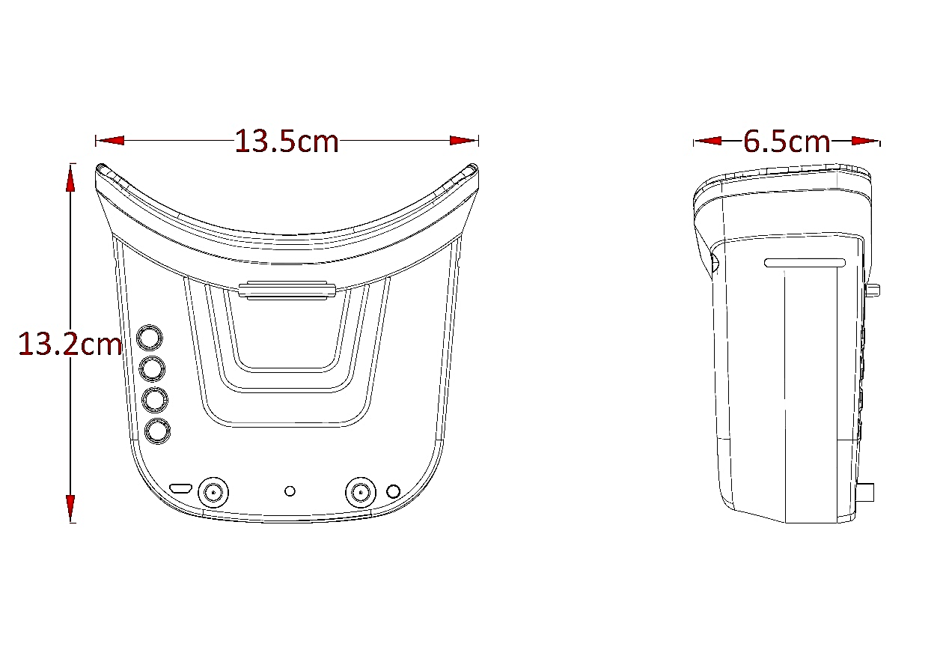

Safety instruction:
- Read the entire instruction manual to become familiar with the features of the product before operating.
- Age Recommendation: Over 14 years old. Using any near eye displays on children under 14 can cause eye development problems. This is not a toy.
- Please avoid wet or humid environments.
- Please use standard USB charger, charging voltage can only be 5V.
- AV output and Video input cannot work at the same time, It is forbidden to insert external video in RF receiving mode.

