5 Inch Remote Swivel Wireless Baby Monitor

User Manual

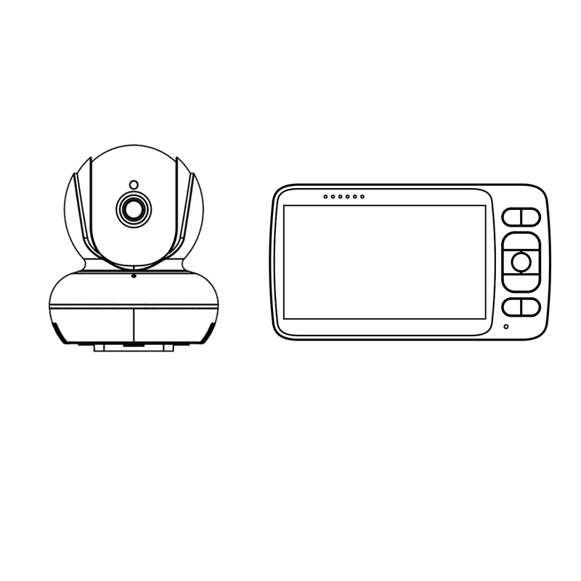

Buttons Function:

- Camera Instructions

Photoelectric Sensor
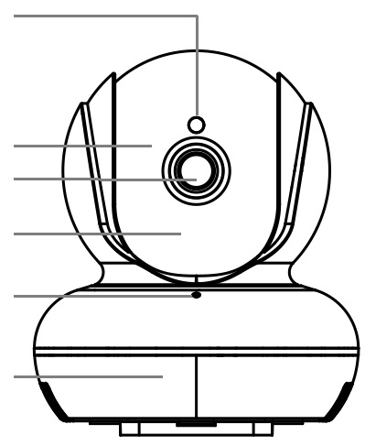
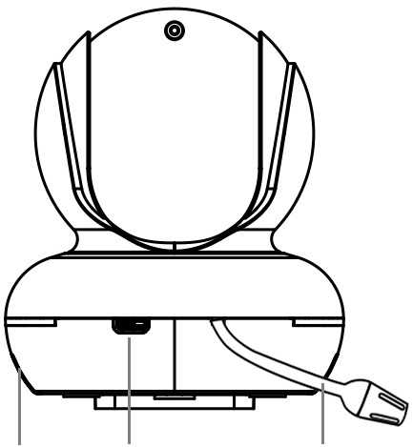
Stand
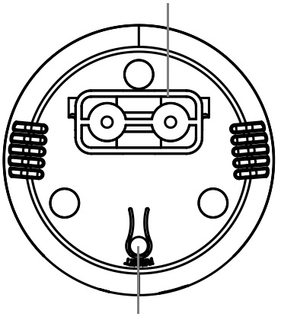
6 Infrared Lamp
Lens
Up and Down Rotation

Work Indicator

Right and Left Rotation

Pairing Button
Temperature Sensor
Speaker
Adapter Connection

- LCD Baby Monitor Receiver Instructions

Charging Indicator
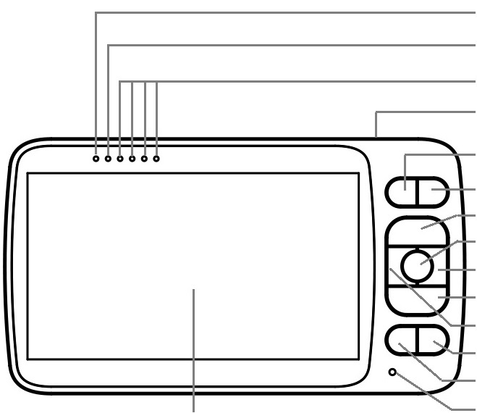
LED Indicator

- IR LED
- White LED
- MIC
- Temperature Sensor
- Speaker
- Power In
- White LED Switch
- Pairing Switch
- Volume Indicator
- Menu/ Back Button
- Channel Swithing Button
- Volume +/ Up Button
- Right Button
- Volume -/ Down Button
- Left Button
- Intercom Button
- Brightness and Volume Control
- MIC
- Power Button
- Wireless Aerial
- Speaker
- Holder

Volume Indicator
Wireless Aerial
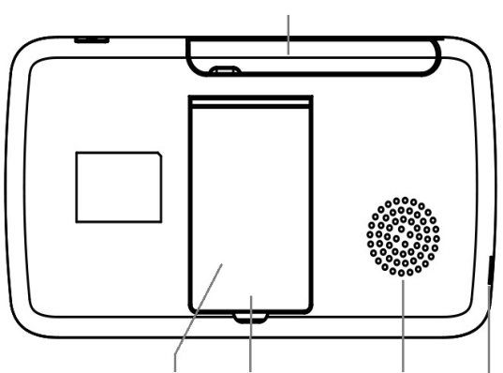
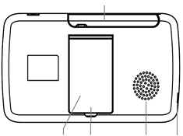
Power Button
Menu/Back
Channel Swithing
Volume +/ Up
OK Button
Right Button
Volume -/ Down
Left Button
Intercom Button
Brightness & Volume Control
MIC
LCD Screen
Adapter Connection
Holder
Reset Button
Speaker

Let’s try:

☞ Power ON

-CAMERA: connect camera to the included power adapter, the green indicator lights up means it works.

-THE MONITOR: after pressing the power button for 3 seconds, it will automatically enter live vide mode and start pairing for transmission. (no need to pair them for the first time)

☞ Learn Menu
-BACK to MAIN MENU: press button back to the main menu, the square outside the picture shows your current selection.

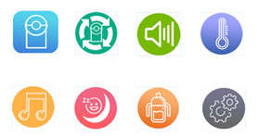

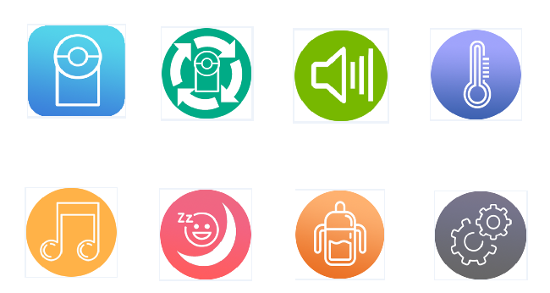
-SHIFT OPTIONS: press “” “” “” “” to change your selection, then press ”OK” button to confirm your choice and enter the submenu.

☞ Set Up
-SCREEN BRIGHTNESS and VOLUME ADJUSTMENT: press button to adjust the screen brightness and volume up and down. Press “” and “” button to control volume, press “” and “” button to adjust screen brightness.

-PAIRING: confirm icon to enter submenu, press “” and “” button to select the channel to be paired and press “OK” to confirm it, icon will show. NEXT, hold the camera’s “Pairing” button until the screen shows icon . FINALLY, you can see the live picture from the monitor. (If the channel has been paired before, press “OK” button will delete the previous paired status, you can repeat the above steps for pairing.)

-MUTIPLE CAMERAS’ PICTURES LOOP DISPLAY: confirm icon to enter submenu. Press “” and “” to shift cameras, press “” and “” to select cameras you want. (The blue camera icon means the camera has been paired and the black camera icon means it has not been paired.) Then press “OK” button move to the icon 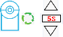 and set up loop interval you need. (There are 4 choices: 5s, 10s, 30s, 60s.) Finally press “OK” to confirm and the setting is successful when the color of the square returns to black. (ATTENTION: The channel cycle setting requires two or more cameras.)
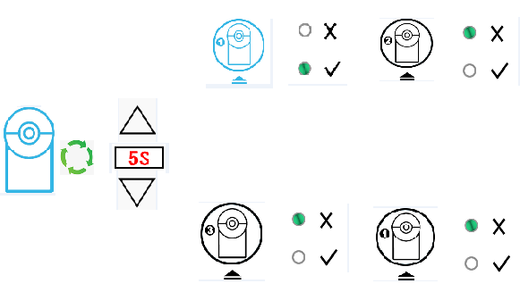

-VOICE CONTROL FUNCTION (VOX): confirm icon to enter submenu, there are four gears: high level , medium level , low level and off . When the voice control is turned on, the top task bar on the screen will show icon. When the volume of the camera reaches the alarm threshold you set and is lasting for 0.5 seconds, the monitor will ring out three times and voice alarm icon will flash (high sensitivity corresponds to volume indicator 1, medium sensitivity to volume indicator 2, and low sensitivity to volume indicator 3) Flashing prompt: if the automatic shutdown screen is set, the screen will be opened automatically when the volume of the camera reaches the alarm threshold under this VOX function.

-TEMPERATURE ALARM SETTING: confirm icon to enter submenu, Press “” and “” to shift selection, press “” and “” to adjust parameters. You can select a temperature unit 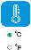 and turn on/off the temperature alarm function.
Set the upper limit of temperature alarm (setting range: 23-37 ℃) by selecting the 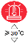 icon. If the temperature exceeds the set value, a temperature alarm will ring out and a temperature alarm icon will flash. Until the temperature returns to the normal or the temperature alarm is turned off. Press “” and “” to set parameters, then press “OK” to confirm and the color of data will return to black when the setting is successful.
Set the lower limit of temperature alarm (setting range: 1-22 ℃) by selecting the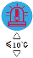icon. If the temperature is lower than the set value, a temperature alarm will ring out and a temperature alarm icon will flash. Until the temperature returns to normal or the temperature alarm is turned off. Press “” and “” to set parameters, then press “OK” to confirm and the color of data will return to black when the setting is successful.
-MUSIC PLAY: confirm to enter submenu, Press “” and “” to choose music and “OK” button to play and stop music. There are three songs in total, you can choose to play one of them or all of them in a cycle. When it is playing music, the live-picture interface will show the music icon.

-SLEEP-MODEL SETTING: confirm icon to enter submenu, Press “” and “” to select 5 minutes, 30 minutes, 60 minutes time model or turn off the function. If turn on it, there is a sleep icon on the taskbar at the top of the live-picture interface. When the LCD screen is closed under the model, you can press any button to light the screen. (When the voice control is on, the screen will be opened automatically when the volume is reach the alarm threshold.)

-TIMING NURSING REMINDING FUNCTION: confirm icon to enter submenu, Press “” and “” to select a 2H, 3H, 3.5H, 4H, 4.5H, 5H, 6H time interval to remind the mother to feed baby. If turn on the function, there is an icon on the taskbar at the top of the live-picture interface. When the preset time is reached, there will be an alarm ring out and the icon will flash. You can press any button to cancel, it will stop automatically after 30 seconds without pressing any button.

-TIME and DATE SETTING: confirm the icon to enter the submenu, Press “” and “” button for shifting your selection and then press “OK” button to select icon to enter the time and date setting menu.

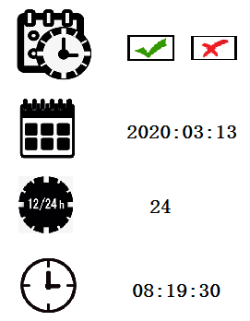

Press “” and “” to shift your selection (Time and Date display or not / Date set / 24-hour time format or 12-hour format 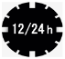/ Time set). Press “” and “” to adjust parameters, press “OK” to confirm and the color of data will return to black when the setting is successful.

-RESTORE FACTORY SETTINGS: confirm the icon to enter the submenu, Press “” and “” button for shifting your selection and then press “OK” button to select icon to enter restore factory setting. After the factory settings are restored, except for the pairing data, others will return to the initial state.

-CHECK VERSION INFORMATION: confirm the icon to enter the submenu, Press “” and “” button for shifting your selection and then press “OK” button to select icon to enter version information interface. You can view the version information of the receiver and the camera. The version information of the camera can be displayed only when the camera is connected.

-CHANNEL SWITCHING: In live-picture interface, press thebutton to switch channels. Only two or more cameras are paired can use this function, single camera paired cannot achieves switching function.

-INTERCOME FUNCTION: In live-picture interface, press and hold button to speak and transmit, then release it for reception.

- REMOTE PAN & TILT: In live-picture interface, Press “” and “” to adjust the camera rotation angle. Select about 110 degrees up and down. Press “” and “” to adjust the camera left and right rotation, and the left and right rotation angle is about 350 degrees. Press the corresponding button and the corresponding arrow will be displayed on the screen to prompt the rotation direction.

☞ Troubles and Solutions

1. The monitor is too loud.
The camera uses a high sensitivity MIC phone to pick up tiny sound from the baby, when the sound is too loud, you can turn down the volume by pressing button and adjust it.

2. The monitor won’t power on.
Please check the battery first and use the included adapter to charge the monitor.

3. A howling from the monitor when the camera is nearby.
It is caused by the acoustic feedback, since the audio signal received by MIC with the voice around camera mixed and emitted, the receiver will make greater invoice. Again and again, howling formed.
Please lower the monitor’s volume and put it away from the camera.

4. The image and voice transmission is not smooth, the video or audio jams.
The wireless transmission can be affected by obstructions like walls/ doors/ glasses/ trees and other high power devices like microwave oven or wireless router have certain influence on the transmission.

5. There is no video signal.
- Please check whether the monitor pairs a wrong channel, press the button to switch channels.
- Please check the power supply of the camera.
- Please make sure the camera and the monitor is in range, the transmission range is up to 200 meters in an empty area. However when used indoor, the range will be affected by the wireless interference and obstructions like walls/ doors/ glasses/ trees.

6. Can I connect multiple cameras with one monitor?
Yes, 1 single monitor can be connected up to 4 cameras, you can follow the instructions to connect them.

☞ Specification

Specification | Detail
FPS | 15-25 FPS
Signal intensity | 5 level
Volume Control | 10 level
intercom | Two-way communication
Voice control | Auto, with alarm function
One receiver multiple emitters | One receiver with four emitters，switch display and loop display support
Screen size and resolution | 5-inch, 720*1280 RGB, color LCD
Secure transmission | Code needed
Working Time | 5 hours of continuous discharge, 8 hours of sleep mode

LCD receive voltage | DC：5V/1000MA
Battery | Built-in 3.7V/2020MAH Li-battery
Transmission Frequency | 2.4GHz ISM Band
Wireless working method | FHSS
Transmission power | 17+-1dBm
Transmission speed | 4MHz BER<1E-3
Transmission distance | 150-200 meters in open area
Working Electric current | TX：500mA MAX，RX：500mA MAX , stand-by 340MA (without charging Electric current)
Charging Electric current | 300-400MA
Camera resolution | 720P
Image resolution | 720P
Video frame rate | 15-25FPS
Total Harmonic distortion | <5.0%
Signal to Noise Ratio | 46dB
Reception sensitivity | -89dBm(Typ.)@4MHz BER<1E-3
Night vision distance | 3—5 meter (6 LED Lights)
Humidity | 20--80% RH
Temperature | 0℃--45℃

