RS-WD-HW-I20
Infrared
Temperature Sensor
User Manual

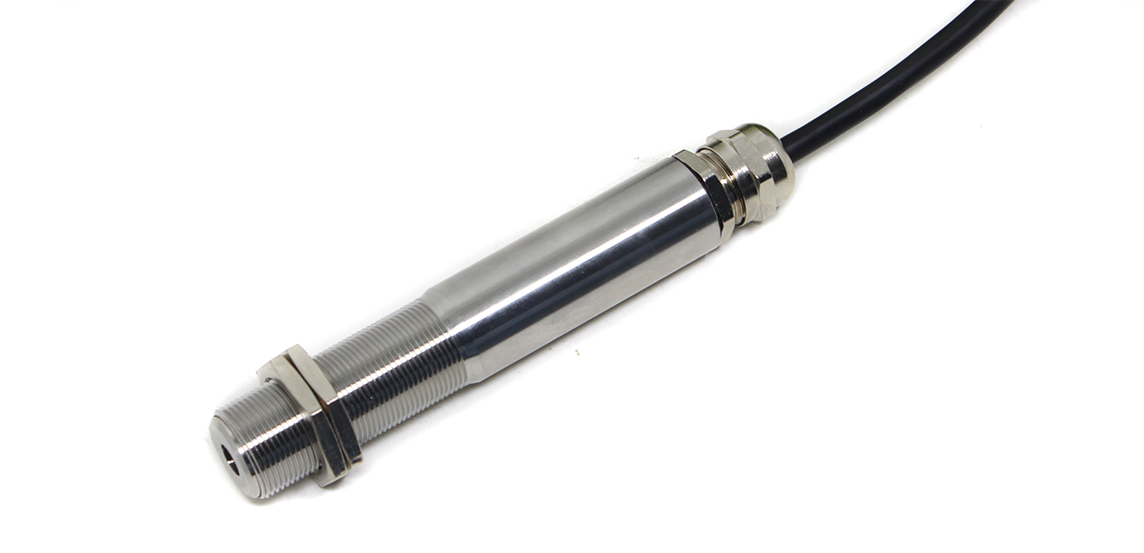

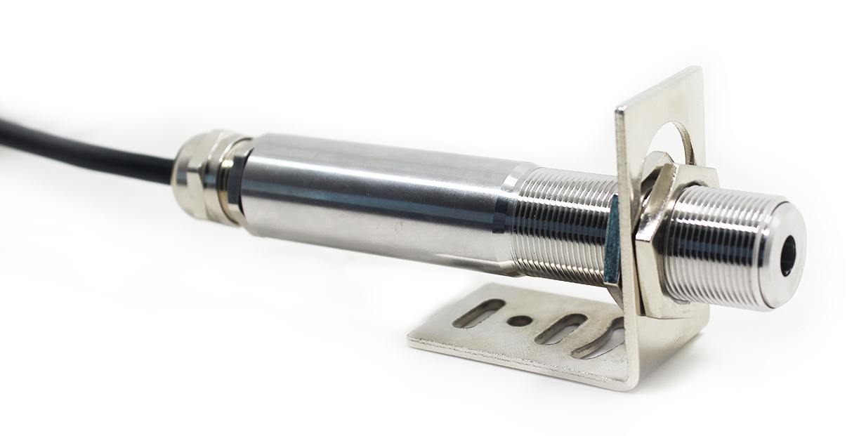
Table of Contents
1. product description 4
2. Working principle and precautions 5
3. device installation 5
4. Calculation method 6
5. Common problems and solutions 6
6. Contact information 7
7. Document history 7
Appendix: Product Size 8

1. product description
1.1product description
The infrared temperature sensor can calculate the surface temperature of the object by measuring the intensity of the infrared radiation emitted by the target without contacting the target. Non-contact temperature measurement is the biggest advantage of infrared thermometers, allowing users to easily measure targets that are difficult to access or move.
The temperature sensor is an integrated integrated infrared temperature sensor. The sensor, optical system and electronic circuit are integrated in a stainless steel housing. Easy to install, the standard thread on the metal housing can be quickly connected to the mounting part. There are also options (installation) Brackets) to meet the requirements of various working conditions.

1.2 Main Specifications

DC power supply (default) | 10V-24V DC
Maximum power consumption | 1.2W
Precision  (default) | ±1% of the measured value or ±1.5 °C, taking a large value
Transmitter circuit working environment | Temperature: 0 ~ 60 ° C  Relative humidity 10 – 95% (no condensation)
Measuring temperature range | 0-1000°C（default 0-600℃）
Spectral range | 8 ~ 14 µm
Optical resolution | 20:1
Response time | 150 ms (95%)
size | 113mm×ф18mm(Length * diameter)
Emissivity | 0.95fixed
output signal | 4~20mA
load capacity | ≤600Ω
1.3Light path map

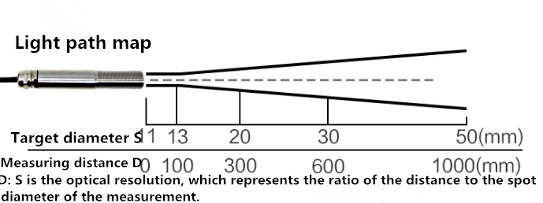

2. Working principle and precautions
2.1Infrared temperature measurement principle
Any object radiates infrared energy outward, and the intensity of the radiation changes with temperature. Infrared thermometers typically use infrared radiation energy having a wavelength in the range of 0.8 μm to 18 μm. An infrared temperature sensor is an optoelectronic sensor that receives infrared radiation and converts it into an electrical signal that is displayed or output temperature via an electronic line amplifier, linearization, signal processing.
2.2Maximum distance and size of the point being measured
The size of the target to be measured and the optical characteristics of the infrared thermometer determine the maximum distance between the target and the measuring head. In order to avoid measurement errors, the target to be measured should be as full as possible to fill the field of view of the probe. Therefore, the measured point should always be smaller than the measured object or at least the same size as the measured target.
2.3Lens cleaning
The lens of the instrument must be kept clean to avoid measurement errors or even damage the lens due to dust, smoke and other contaminants. If the lens is dusty, wipe it with a mirror paper and alcohol.
2.4Electromagnetic interference

In order to prevent electromagnetic interference, please keep the infrared temperature sensor away from the electromagnetic field source (such as motor, motor, high-power cable, etc.) during installation, and add metal bushing if necessary.

3. device installation
3.1 Equipment inspection before installation
Equipment List:
■ Infrared temperature sensor (including 1.5 meters long cable) equipment 1
■ 24V/1A waterproof power supply 1 (optional)
■ Fixing nut, user manual, etc.
3.2installation method
Infrared temperature sensor with M18×1 thread can be used for direct installation or installation using a mounting bracket. The adjustable mounting bracket makes adjustment of the measuring head more convenient. When adjusting the target and the measuring head, you must ensure that the light path is unobstructed.
3.3 wiring
Types of | Line color | Features
Output 4～20mA | brown | ＋24V
Output 4～20mA | blue | Signal output 4-20mA+
3.4 Wiring example
For 4~20mA analog signal output. For the two-wire loop current output mode, its connection to the display or controller has the following two typical applications (connection method):
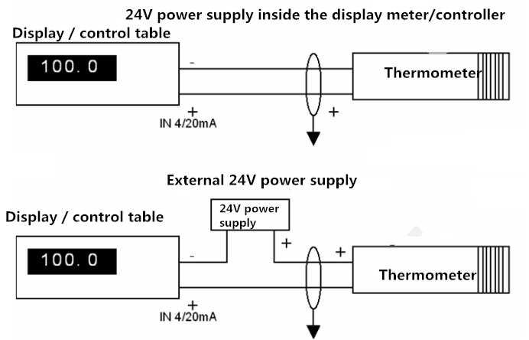

4. Calculation method
The range is 0-1000 degrees Celsius, 4~20mA output, when the output signal is 12mA, the current temperature value is calculated. This temperature range spans 1000 degrees and is expressed by a 16 mA current signal, 1000 degrees / 16 mA = 62.5 degrees / mA, that is, a current of 1 mA represents a temperature change of 62.5 degrees, and a measured value of 12 mA - 4 mA = 8 mA. 8 mA * 62.5 degrees / mA = 500 degrees. 500+(0)=500 degrees, the current temperature is 500 degrees.

5. Common problems and solutions
No output or output error
possible reason：
1) The range corresponding error causes the PLC to calculate the error. Please refer to the technical indicators in the first part for the range.
2) The wiring method is incorrect or the wiring sequence is wrong.
3) The power supply voltage is incorrect.
4) The distance between the transmitter and the collector is too long, causing signal disturbance.
5) The PLC collection port is damaged.
6) Equipment damage.
6. Contact information
Shan dong Renke Measurement & Control Technology Co., Ltd.
Address: 2886 Feng jing Road, High-tech Zone, Jinan City, Shan dong Province
Zip code: 250101
Phone: 400-085-5807
Fax: (86)0531-67805165
Website: www.jnrsmcu.com
Cloud platform address: www.0531yun.cn

7. Document history
V1.0 document creation
V2.0 documentation update
Appendix: Product Size

