CNC 金属无刷3轴云台
品名：GOPRO3 /GOPRO4 CNC 金属无刷3轴云台。
电机型号：2206/100T 无刷电机：2只，2805/100T无刷电机：1只
驱动板：STORM32BGC
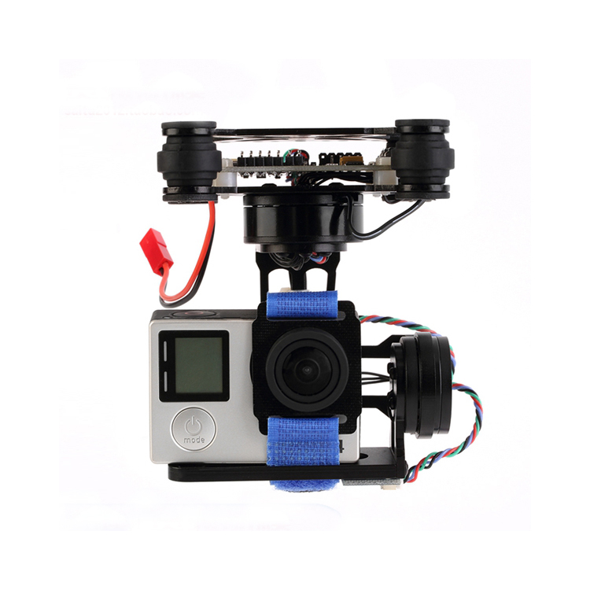
固件版本：o323bgc-release-v090
硬件版本：V130
工作电压/电流：16.8V/350mA
摇杆控制角度：PITCH:-25度+25度 / ROLL;-25度+25度 / YAW:-90度+90度。
开关控制模式：锁定/跟随
规格尺寸：80*80*100mm（L*W*H）
重量：180g
适用范围：GOPRO系列兼容摄像机。
电源接头：JST和HX
如何安装：
- 删除减震球，打开顶部安装板
- 将安装板用螺丝锁在飞行器下部
- 安装减震球
- 安装摄像机，用带子绑紧相机
使用说明
装好摄像机（务必装摄像机，否则会不停抖动）后，通电后稳定云台大约20秒（不要晃动云台，保持云台挂起，离地），听到一声响后，就可以正常使用
可以控制俯仰通过接收机或者其他单独PWM通道
可以设置跟随模式或者锁定模式
可以设置角度模式或者速度模式
接线示意图
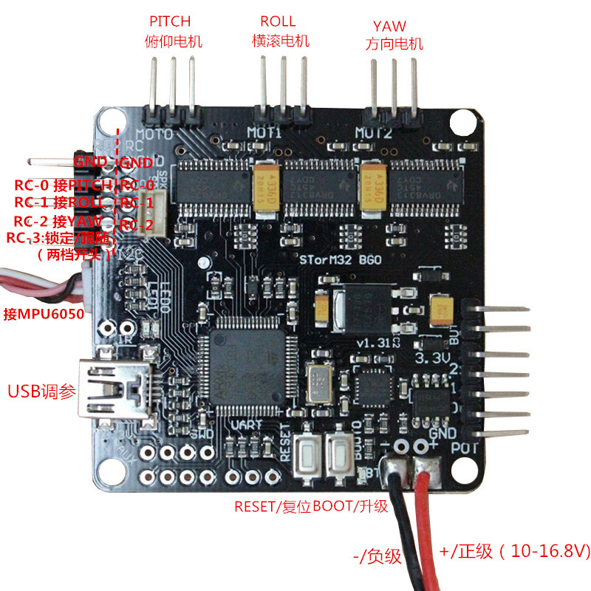

Brushless yuntai 3 axis CNC metal
Item description:GOPRO3 / GOPRO4 brushless yuntai 3 axis CNC metal.

T brushless motor motor models:2206/100:2,only 2805/100 t brushless motor:1 only
The driver bodrd:STORM32BGC
Firmware version: o323bgc – release – v090
Hardware version:V130
Working voltage:3-4 s (11.1 to 16.8 V)
Working current:350 ma
Joystick control Angle:PITCH: 25+25 degrees/ROLL: 25+25 degrees/YAW: +90 degrees-90 degrees.
Switch control mode:lock/follow
Size: 80*80*100mm (L*W*H)
Weight: 180 g
Scope of application:GOPRO series is compatible with the camera.
Electrical connections: JST and HX
How to install:
- Remove vibration ball, open at the mounting plate
- Lock mounting plate with screws at the bottom of the craft
- Install the damping ball
- Install the camera, with a girdle bond compact camera
Directions for use
Packed the camera (be sure to install cameras, otherwise will be shaking),after electrify stable yuntai about
20 seconds(don’t be shaking yuntai, keep yuntai hangs,) from the ground,after hearing a sound,can be
normal use
Can control the pitch by a receiver or other individual PWM channels
You can set the following mode or lock mode
Can set the Angle mode or speed
Wiring diagram

