HDMI EXTENDER
User Manual

HDMI to USB3.0 Video Capture
(with HDMI Loopout)

Bring High-Definition to your life!

Thank you for purchasing HDMI to USB3.0 Video Capture This dongle is easy to carry and has a superior performance, good compatibility. It can capture 1080p@60Hz video. It meets UVC and UAC standard. No need to install drivers. Real plug and play.

This dongle can be connected with WiiU, Xbox 360, Xbox One, PS4. HDMI Camera, Medical device etc. and used for Game streaming, Video Conferencing, Movie Making, Lecture Capture, Telemedicine, Live.

1.0 Features
- Support input max resolution 4K@60Hz;
- Support output max resolution 1080P@60Hz;
- Support HDCP2.2;
- Support 8/10/12bit deep color;
- Support 26AWG HDMI standard cable(Input up to 15 meters)
- Support most acquisition software,such as VLC,OBS,Amcap,etc;
- Support Windows,Android and Mac OS;
- Conform to USB Video and UVC standard;
- Conform to USB Audio UAC standard;
- Without external power supply,compact and portable.

2.0 Hardware requirements(Recommended)
Intel Core solo (Intel Core i5).1G Ram(2G Ram)Available USB3.0 interface.

3.0 System requirements(Recommended)
Windows 7/8/10/Server 2008,Linux Kernel version 2.6.38 and above,OS X 10.8 and above,Android.5.0 or above (only video)

4.0 Compatible software
Adobe Flash Media Live Encoder (Windows, OS X),Real Producer Plus
(Windows),Quick Time Broadcaster (OS X),Quick Time Player (OS X),Windows Media Encoder (Windows),Daum Pot player (Windows, OS
X),X split Broadcaster (Windows, OS X), VLC (Windows, OS X, Linux)Wire cast (Windows, OS X), OBS etc.

5.0 Packaging accessories
HDMI Video Capture ---------------------------------------------- 1PCS
USB Power Cable -------------------------------------------------- 1PCS
USB Data Cable ---------------------------------------------------- 1PCS
Operation Manual -------------------------------------------------- 1PCS

6.0 Specifications
HDMI resolution -----------------------------Max input can be 4K@60Hz
Support video format --------------------------------8/10/12bit Deep color
Video output format -----------------------------------------------YUV,JPEG
Video output resolution --------------Max output can be 1080p@60Hz
Support audio format ---------------------------------------------------L-PCM
Input cable distance ----------------15m,AWG26 HDMI standard cable
Max working current ---------------------------------------------------0.4A/5V
Operating Temperature range -------------------------------(-10 to +55℃)
Dimension(L×W×H)-----------------------------------------107x71x16mm
Weight -------------------------------------------------------------------------140g

7.0 Panel descriptions
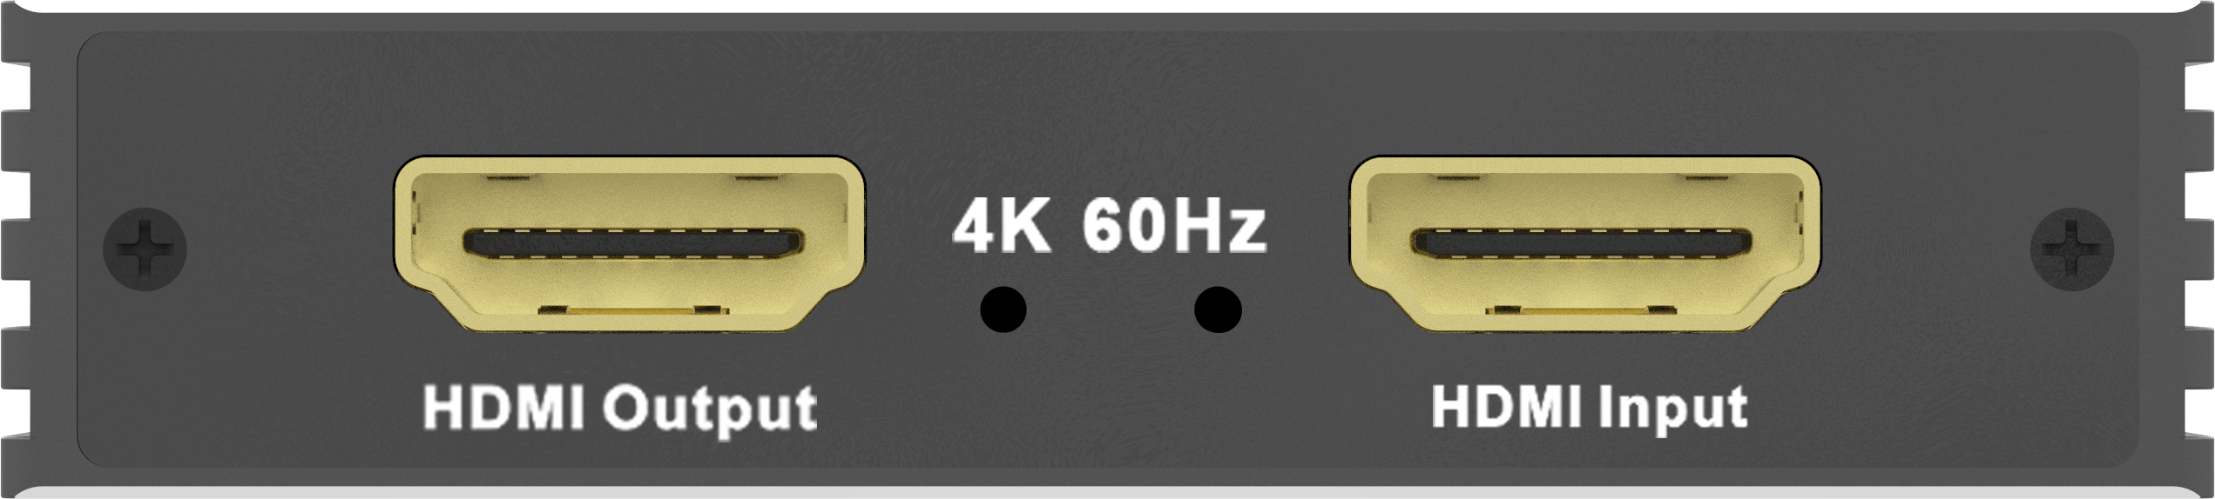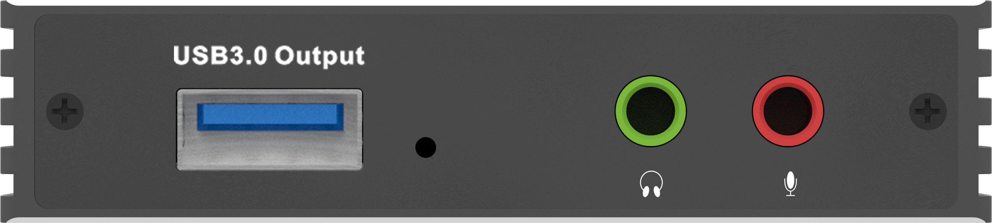
HDMI Output -----------HDMI Output interface
HDMI Input ----------------HDMI input interface
USB3.0 Output ----------USB Output interface
Stereo/MIC -----------------------Audio Interface
8.0 Connect and Operate
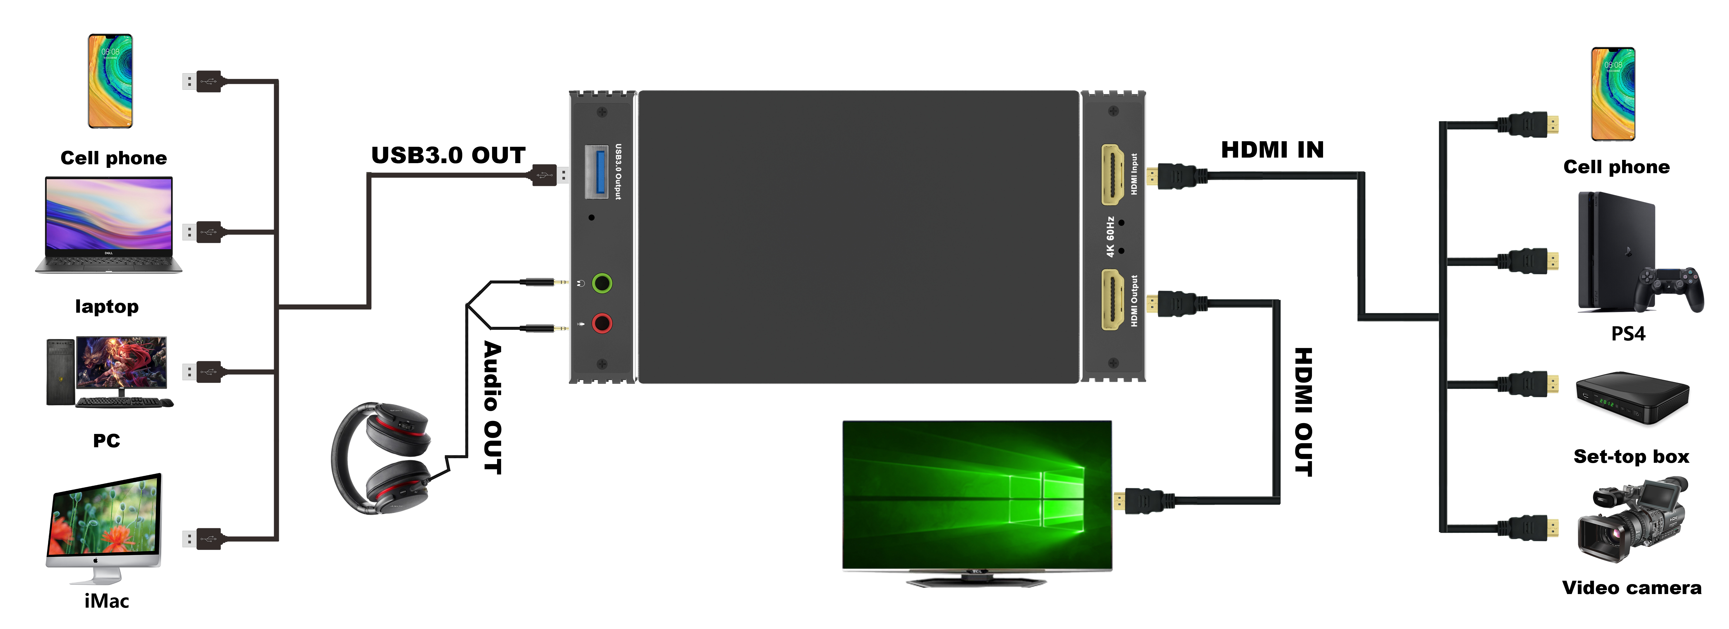
1.Use HDMI cable to connect HDMI input to HDMI output of PC.
2. Use HDMI cable to connect HDMI output to HD display.
3. Connect the player to the audio input port and connect the speaker and other equipment to the output port.
4. Start PC and display to use.

9.0 Installation and precautions
To avoid electric shock , product damage and to protect your safety , please notice the following:
- Please slowly plug or unplug signal cables and do not often plug , unplug , or shake them.
- 2.The equipment should not be placed under the sun , rain and damp or unventilated environment.
- Liquid items should not be placed on the equipment.
- Do not install the equipment near heat sources such as fire , power , or other amplifiers that produce heat.
- Do not insert the metal or other objects to the equipment in addition to connecting cables to ports.
- Do not demolish the equipment by yourself ; it should be maintained by professional maintenance staff.

