TX BG-4P 4 Band Phone Signal Booster
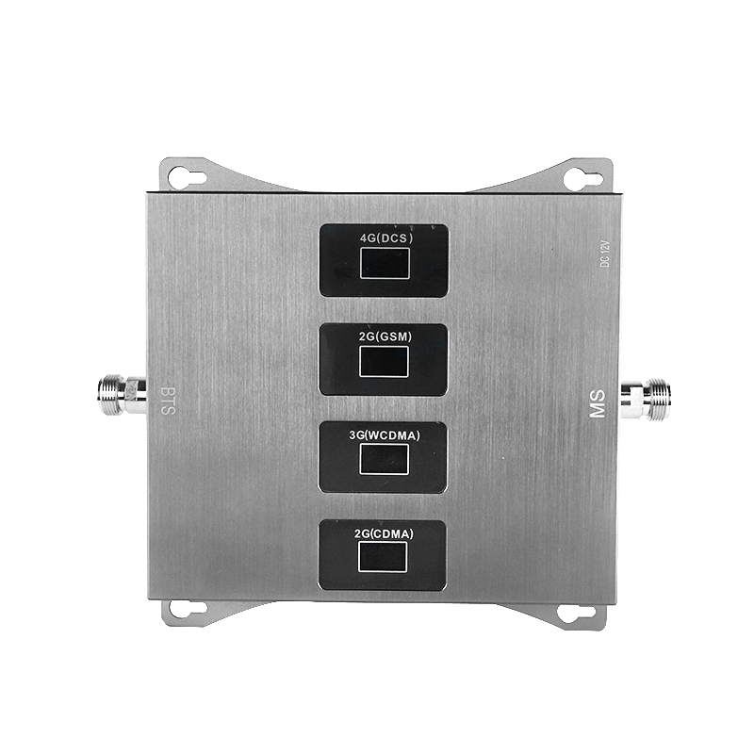
Application
All areas with poor indoor signal and normal outdoor calls such as: Home, Office, Meeting room, Restaurant, Shopping mall, Basement, High building, Elevator, Mining Area, Mountain Area, Rural Area, Well Road, Tunnel，Warehouse, high-rise buildings elevators, office buildings, basements, KTV, yachts, urban villages, remote mountain area etc.

Feature
* Easy to install and operate
* Ultra low noise preamplifier, full duplex design, high isolation band up/down, advanced digital filtering technology, good out-of-band supression.
* High-performance stability of ALC signal automatic control quality system, when the output power reaches 100%, the outdoor input signal is 30dB input, the amplifier is also the best state of operation
* Reliable coverage max. 800m² by different accessory
* Automatic and Stable high gain adjustment 70dBm
* Receiving signal strength display on 4 LCD screen
* Durable alluminum alloy outshell material
* Environementally friendly no harm even to the pregnant

Photo Display
BS- outdoor antenna interface
MS- indoor antenna interface
Power Input- DC 12V 2A

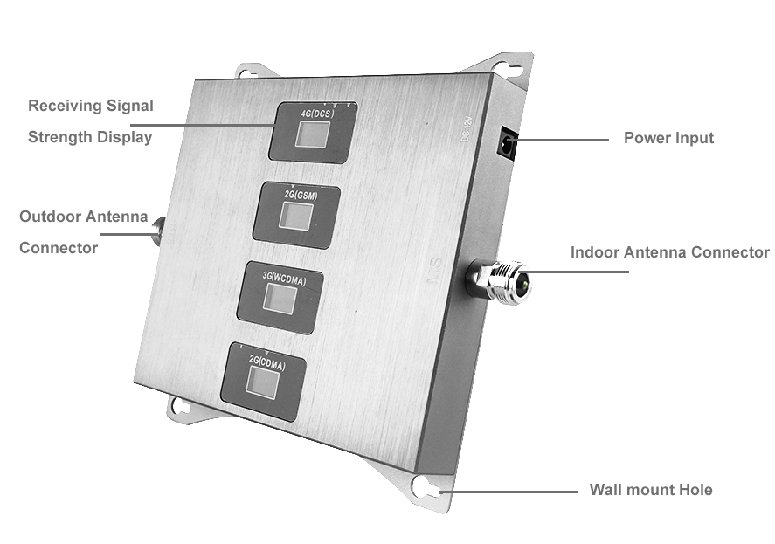
Installation
- Use mobile phone to find a place where the signal is the strongest usually at top of building, balcony, etc, and install the outdoor antenna there;
Let the antenna point to the base station and fix it tightly;
The feeder connector inserted into the antenna socket tightened, with waterproof tape tied, in order to prevent the connection from damp oxidation, to avoid the reduced effective area of signal radiation after using a period of time.
the feeder connector from the outdoor antenna is inserted into the repeater socket (BS) and tighten it.
- Connect the feeder from the repeater port(MS) to the indoor antenna
- Antenna, Feeder, Host and so on must be fixed, so as not to cause danger or signal instability.

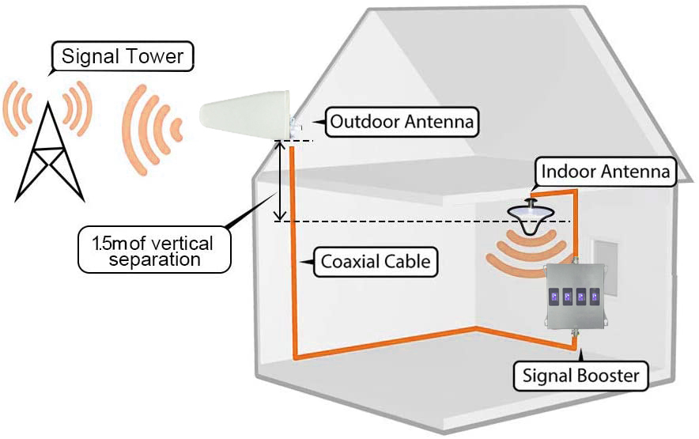
Techinical Data
Model | TX BG-4P
Frequency Range | Uplink | Donwlink
E-GSM 900 | 880-915 | 925-960
DCS/B3 1800 | 1710-1785 | 1805-1880
B1 2100 | 1920-1980 | 2110-2170
TLTE800 | 832-862MHz | 791-821MHz
Gain (db) | 70
Output Power | 1W/30dBm
Input Power (dBm) | -100~30
ALC (db) | 30db
Size/Weight | 165*143*25mm/1.0kg
Outshell Material | Durable Aluminum Alloy
VSWR (db) | <1.8
Noise Figure (db) | <6.0
In-band ripple (db) | <5
OPI3 (dbc) | ≤-40
Stray Emission | 9KHz-1GHz: ≤-36dbm/100KHz  1GHz-12.75GHz: ≤-30dbm/1MHz
Connector | N type
Impedance (Ω) | 50
Working Temperature (℃) | -10~+45
Power Consumption (W) | about 15W
Power Supply | 12V 2A

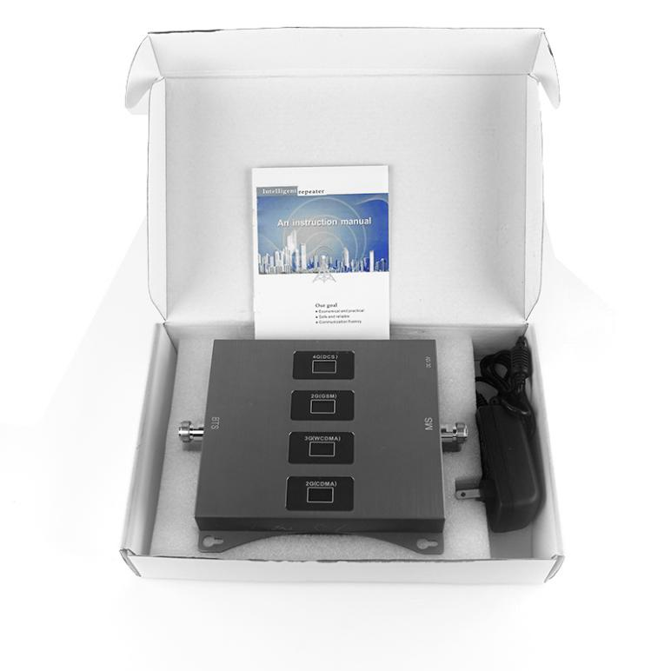

Packing List
1) Repeater Host*1pcs
2) Power Adapter*1pcs
3) Power Line*1pcs
4) English User Manual*1pcs
5) Mounting Bracket*1 pairs
6) Certificate*1pcs

Problem Shooting
- After installation, the booster host is completely useless
- Check whether LCD screen light is on;
Check whether the distance between the outdoor antenna and the indoor antenna is too close, check whether the interface is firmly connected.
- Confirm the outdoor antenna is at a place where the mobile phone signal is received and strong.
- Check the input and output ports are reversed
- Confirm that all lines, connectors, distributors, antennas and amplifiers are connected correctly
- After installation, signal improvement is improved, but no phone calls can be made
- Check whether LCD screen light is on;
Check whether the antenna is too close to the antenna outside and indoor, check whether the interface is firmly connected
- Confirm whether outdoor antenna is installed correctly
- Confirm that the connector is firmly connected
- After installation, the quality of call is not good
- Check whether LCD screen light is on;
Check whether the antenna is too close to the antenna outside and indoor, check whether the interface is firmly connected
- Change the installation position and ajust the direction of outdoor antenna
- The signal after installation is improved, but the coverage is not large
- Determine the signal strength of the outdoor antenna installation position
- Adjust the direction of outdoor antenna to the base station
- Confirm that the joint is firmly connected
- Check whether the wire is of poor quality, and whether the line is too long
- Choose a larger power amplifier
- Sometimes there is no signal
Make sure the input and output connector is securely connected and whether the cable is short circuited

